SUPPLEMENTAL MATERIAL

1. Supplemental Figures 1-8

2. Supplemental Tables 1-4

3. Supplemental Methods

Supplementary Figures
Figure S1. GO analyses of the host genes of differentially expressed circRNAs. (A-B) GO annotations of the host genes of significantly upregulated expressed circRNAs. (C-D) GO annotations of the host genes of significantly downregulated expressed circRNAs.

Figure S2. KEGG analyses of the host genes of differentially expressed circRNAs. (A-B) KEGG analyses of the host genes of significantly upregulated expressed circRNAs. (C-D) KEGG analyses of the host genes of significantly downregulated expressed circRNAs.
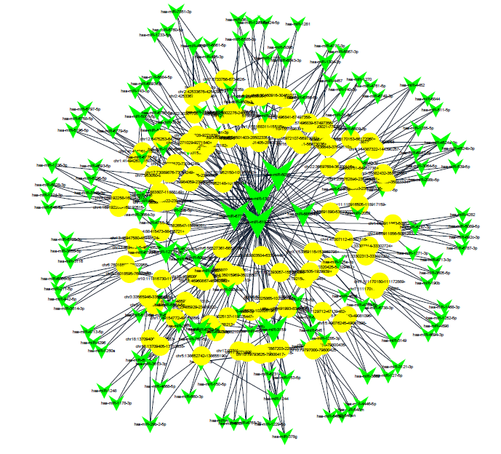
Figure S3. CircRNA-miRNA network maps were constructed using Cytoscape software based on significant differential expression of circRNAs to demonstrate their interaction.
Figure S4. Analysis of circRNA_0000392 expression in CRC patients with or without lymph node metastasis (A) and CRC patients with or without distant metastasis (B). (C) qRT-PCR analysis of circRNA_0000392 and YAF2 mRNA in RKO cells treated with actinomycin D at the indicated time points.
Figure S5. (A) The top five miRNAs may regulated by circRNA_0000392 base on the miRNA prediction and bioinformatics analyses were showed and measured by qRT-PCR after the pull – down assay in SW620 cells. (B) Relative expression of miR-193a-5p after transfected with the mimics or inhibitor was measured by qRT-PCR. (C) Relative expression of circRNA_0000392 after transfected with the mimics or inhibitor was measured by qRT-PCR.
Figure S6. (A-B) Relative expression of miR-193a-5p in 40 pairs of CRC and ANT tissues measured by qRT-PCR.
Figure S7. (A) The relative mRNA expression of EPHA2, PIK3R3, EGFR, USP22 and DDX58 after transfected with the miR-193a-5p mimics was detected in SW620 cells by qRT-PCR. (B-C) Relative mRNA expression of PIK3R3 in 40 pairs of CRC and ANT tissues measured by qRT-PCR. (D) The correlation between miR-193a-5p and PIK3R3 in CRC tissues was analyzed by Spearman correlation coefficients.

Figure S8. Apoptosis rate was analyzed by flow cytometry after transfection the indicated plasmids in SW620 and RKO cells.

Supplementary Tables
Table S1. Primers and RNA sequences used in this study
Gene name | Forward primer | Reverse primer
hsa_circ_0000392 | GCTGAACAGAAGGGCAAGAG | TTGGAAATTTCAACGGTTCC
hsa_circ_0001535 | CAATGAAGCTATGCAGCAAGA | CACACCACACTTTGCTGTTGTA
hsa_circ_0003007 | GCTTTTCTGCCCTCAGACAC | GGTTGGAACCCAACTACCTG
hsa_circ_0002483 | GATATGGGCGTCTCCAGTGT | GCAGCTGCCATTATTTTGCT
β-actin | GTGGCCGAGGACTTTGATTG | CCTGTAACAACGCATCTCATATT
YAF2 | ATGAGGGTTACTGGGACTGTAG | CCTTCCGCACATCGCACAT
EPHA2 | AGAGGCTGAGCGTATCTTCAT | GGTCCGACTCGGCATAGTAGA
PIK3R3 | TACAATACGGTGTGGAGTATGGA | TCATTGGCTTAGGTGGCTTTG
EGFR | TTGCCGCAAAGTGTGTAACG | GTCACCCCTAAATGCCACCG
USP22 | GGAAAATGCAAGGCGTTGGAG | GTGCAGTTCGAGGTGATCTTT
DDX58 | TGTGCTCCTACAGGTTGTGGA | CACTGGGATCTGATTCGCAAAA
miR-193a-5p | TATATGGGTCTTTGCGGGCG | GTGCAGGGTCCGAGGT
U6 | CGCAAGGATGACACGCAA | GTGCAGGGTCCGAGGT
miRNA mimics and inhibitors
hsa-miR-193a-5p mimics sense | UGGGUCUUUGCGGGCGAGAUGA
hsa-miR-193a-5p mimics anti-sense | AUCUCGCCCGCAAAGACCCAUU
hsa-miR-193a-5p inhibitor | UGGGUCUUUUUUGCGGGCGAGAUG
siRNA
Si-hsa_circ_0000392-1 sense | CUCAAGUUACUGAGAAGAATT
Si-hsa_circ_0000392-1  anti-sense | UUCUUCUCAGUAACUUGAGTT
Si-hsa_circ_0000392-2  sense | GUUACUGAGAAGAAAAAGCTT
Si-hsa_circ_0000392-2  anti-sense | GCUUUUUCUUCUCAGUAACTT

Table S2. CircRNA Expression Profiling in this study (please see the attached excel spreadsheet)

Table S3. Differentially Expressed circRNAs between the two groups (please see the attached excel spreadsheet)

Table S4. The top 10 upregulated circRNAs and top 10 downregulated circRNAs from the circRNA-seq
CircRNA ID | CircBase ID | Gene symbol | Fold  changes | P-value
chr12:42604157-42604482- | circRNA_0000392 | YAF2 | 24.7743759 | 0.0045230371643
chr13:33091994-33101669- | circRNA_0000471 | N4BP2L2 | 13.5247731 | 0.0069716912671
chr14:32559708-32563592+ | circRNA_0031583 | ARHGAP5 | 12.9699781 | 0.0068609932778
chr19:49994751-49995003+ | NA | RPL13A | 9.2143207 | 0.0385458492475
chr11:65267947-65268121+ | NA | MALAT1 | 7.6726098 | 0.00347182725
chr5:137320946-137324004- | circRNA_0001535 | FAM13B | 7.5234613 | 0.0243299719178
chr20:57014001-57016139+ | circRNA_0001173 | VAPB | 5.9031048 | 0.0214436499341
chr15:101104897-101105470- | circRNA_0003007 | LINS | 5.4840268 | 0.0291610480461
chr3:195415404-195416309+ | circRNA_0008267 | LINC00969 | 5.2272882 | 0.0326334735724
chr8:141874411-141900868- | NA | DNAJC3 | 5.1256745 | 0.0461082775399
chr6:131247745-131277639- | circRNA_0077837 | EPB41L2 | -16.5373925 | 0.0160833348308
chr21:9826186-9826580+ | NA | MIR3687-1 | -12.4397176 | 0.0331224378607
chr5:76758920-76760634- | circRNA_0001498 | WDR41 | -9.1724693 | 0.0310305925516
chr14:50320581-50329515- | NA | Metazoa_SRP | -8.5730967 | 0.0149285105264
chr8:131370263-131374017- | circRNA_0085616 | ASAP1 | -6.556057 | 0.0184800508094
chr8:68117578-68118947- | NA | ARFGEF1 | -5.4591184 | 0.0438781345434
chr11:65267861-65268260+ | NA | MALAT1 | -5.4591184 | 0.0428605568472
chr7:24663285-24720139+ | circRNA_0001687 | MPP6 | -4.8635216 | 0.0485052074575
chr11:65267937-65268108- | NA | XLOC_009474 | -4.4665897 | 0.0487781568928
chr11:65267941-65268112- | NA | XLOC_009474 | -4.4665897 | 0.0487781568928

Supplementary Materials and Methods
Cell transfection
The SW620 and RKO cells were transfected with indicated siRNA, microRNA mimics or inhibitors (GenePharma, Shanghai, CHN) using the Lipofectamine 2000 (Invitrogen, Carlsbad, CA) according to the manufacturer’s recommendations. Cells were harvested 48 hours after transfection and were selected with 2 μg/ml puromycin in order to obtain the stable cell line.
Western blot analysis
The total proteins were extracted with RIPA buffer and quantidied using BCA Protein assay kit(Thermo Scientific, USA). Then electrophoresis and electransferred onto a PVDF membrane (Bio-Rad, CA, USA). The membranes were blocked with 5% skimmed milk powder and incubated with primary antibodies at 4 °C overnight. Then wash and incubated with secondary antibodies (1:5000) (Santa Cruz Biotechnology USA) at room temperature for 1 h. Finally, the relevant protein was visualized by enhanced chemiluminescence system (PerkinElmer) according to the manufacturer’s instructions.
Cell proliferation assay
For the cell proliferation assay, SW620 and RKO cells transfected with the indicated plasmids were seeded into 96-well plates, and cell viability was assessed by premix WST-1 cell proliferation assay (TaKaRa, Japan). The absorbance of each well was read at a wavelength of 450 nm on a spectrophotometer.
Cell apoptosis assay
Cell apoptosis assay was implemented in SW620 and RKO cells after transfection. The cells were double stained with fluorescein isothiocyanate (FITC)-conjugated Annexin V and propodium iodide (PI). Then, the percentage of early apoptotic cells was analyzed on a flow cytometer ( BD FACSCanto, USA).

