Extended data table 1. Seasonal prediction system and their corresponding ocean reanalysis for initialisation.
Centre | Seasonal prediction system | Ocean reanalysis used for initialisation | Number of members
CMCC | SPS3.5 ³⁷ | C-GLORSv7 ³⁸ | 40
DWD | GCFS-2.1 ³⁹ | ORAS5 ⁴⁰ | 30
Meteo-France | MF System 8 ⁴¹ | GLORYS12V1 ^{42,43} | 25

Extended data table 2. Evaluation of forecast skill of EUWS (DJF) activity using RPSS
Model | Initialisation month | Month of OHC300 | ENS | SENS | OPF | OPF-Reanalysis
CMCC | 9 | 9 | -0.102 | -0.255 | -0.079 | 0.525
CMCC | 9 | 10 | -0.102 | -0.163 | -0.191 | --
CMCC | 9 | 11 | -0.102 | -0.158 | -0.186 | --
CMCC | 10 | 10 | -0.033 | -0.081 | 0.343 | 0.715
CMCC | 10 | 11 | -0.033 | -0.152 | -0.025 | --
DWD | 9 | 9 | -0.126 | -0.270 | 0.113 | 0.430
DWD | 9 | 10 | -0.126 | -0.233 | 0.016 | --
DWD | 9 | 11 | -0.126 | -0.108 | -0.083 | --
DWD | 10 | 10 | 0.008 | -0.102 | 0.150 | 0.430
DWD | 10 | 11 | 0.008 | -0.027 | -0.017 | --
Meteo_France | 9 | 9 | 0.024 | -0.044 | -0.167 | 0.715
Meteo_France | 9 | 10 | 0.024 | 0.047 | 0.145 | --
Meteo_France | 9 | 11 | 0.024 | -0.112 | -0.090 | --
Meteo_France | 10 | 10 | -0.008 | -0.123 | 0.428 | 0.810
Meteo_France | 10 | 11 | -0.008 | -0.110 | -0.016 | --

Extended data table 3. Statistics of observed EUWS activity categories
Activity category | Number of years | Probability of Occurrence
Inactive | 7 | 0.304
Normal | 6 | 0.261
Active | 10 | 0.435

Extended data figure 1. Accuracy (ACC) evaluation of forecast of EUWS (DJF) activities for different models and different forecast approaches, i.e. atmospheric ensemble forecast (ENS), selected atmospheric ensemble forecast (SENS), and Ocean proxy forecast (OPF, light green background). Left column (panels a, b, d) shows forecast based on September initialisations of different forecasted months (Top to bottom); right column shows forecast based on October initialisations of different forecasted months (Top to bottom). Dots indicate the evaluation of the target domain. Black bars indicate interquartile range derived from the sensitivity study. Crosses indicate extremum of individual sensitivity study. Colours indicate different EUWS activity categories: Inactive (blue), Normal (black), and Active (red).
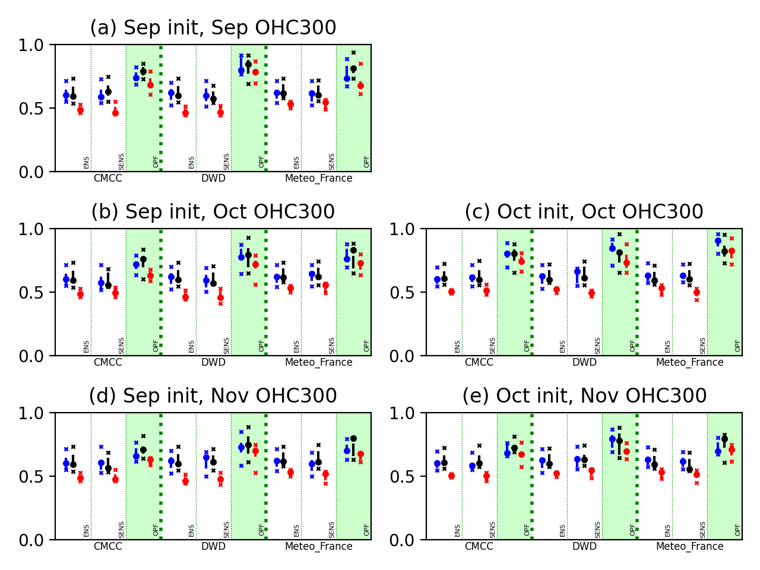

Extended data figure 2. Difference of composite of the θ_{ot300} between (top to bottom) seasonal prediction systems and their respective reanalysis for (a) September and (b) October initialisations of (left to right) different forecasted months.
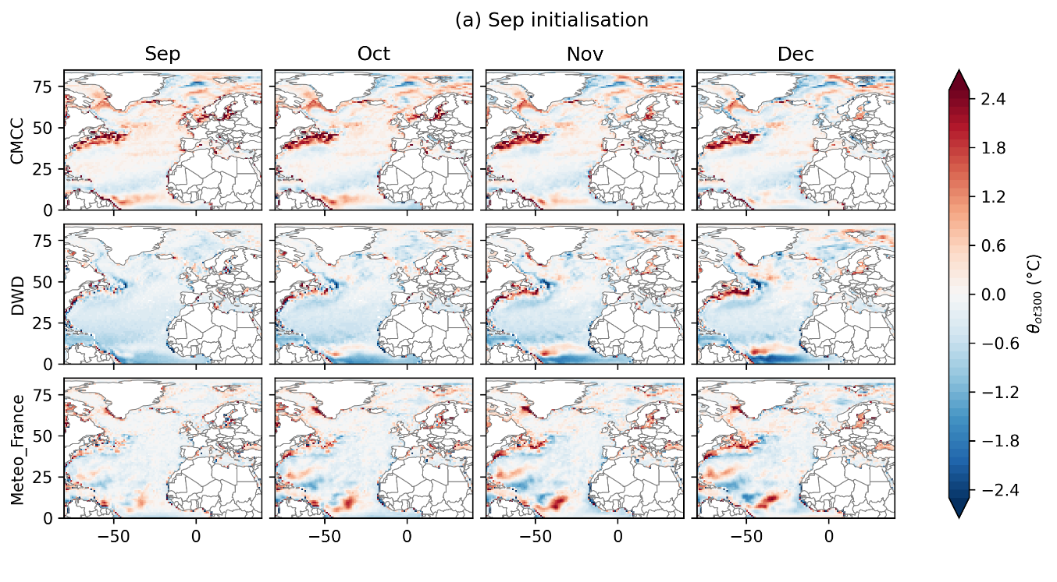
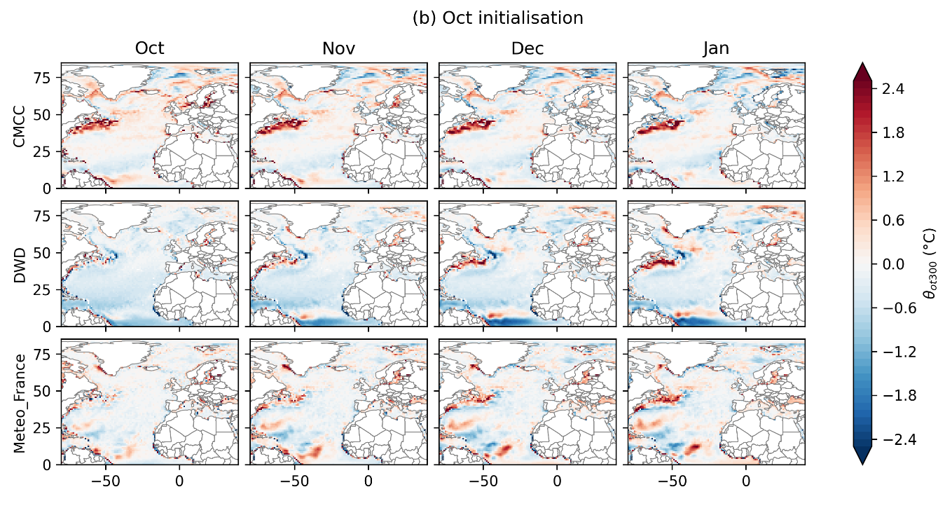

Extended data figure 3. Ranked probability skill scores (RPSS) between observed EUWS (DJF) activities and forecasted EUWS activities for different models and different forecast approach, i.e. atmospheric ensemble forecast (ENS), selected atmospheric ensemble forecast (SENS), and Ocean proxy forecast (OPF, light green background). Left column (panels a, b, d) shows forecast based on September initialisations of OHC states in different lead months (Top to bottom); right column shows forecast based on October initialisations of OHC states in different lead months (Top to bottom). Dots indicate the evaluation of the target domain. Black bars indicate interquartile range derived from the sensitivity study. Crosses indicate extremum of individual sensitivity study.
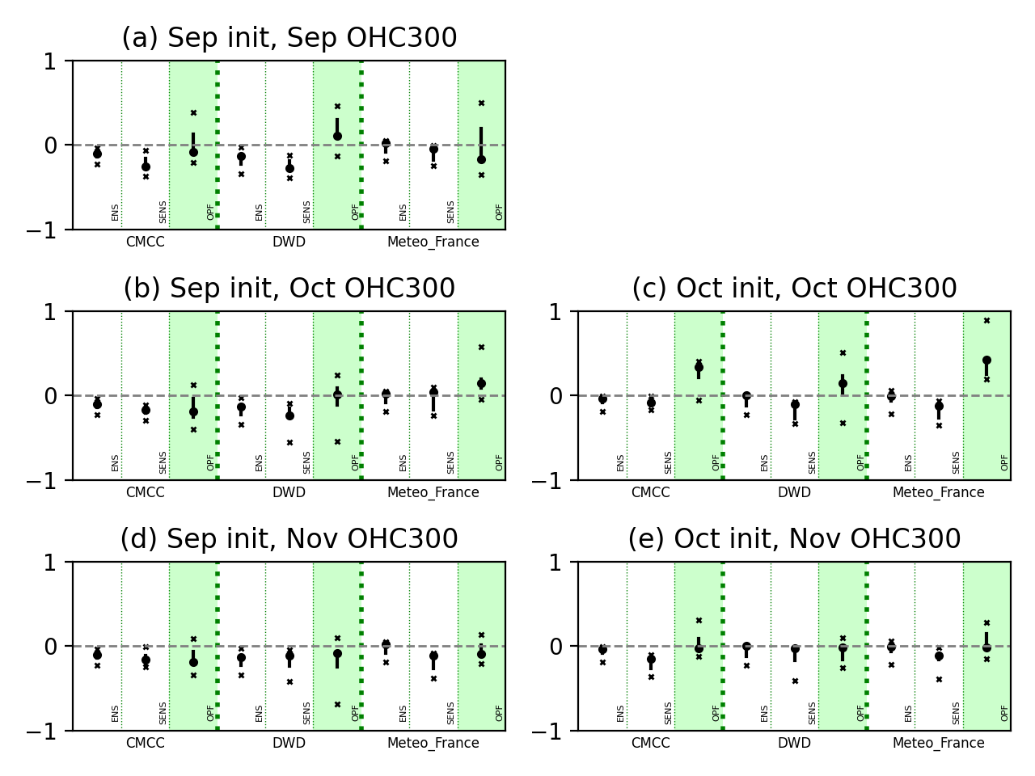
Extended data figure 4. Red box indicates the domain that is used in the defining regional EUWS activity category (See methodology). Blue box indicates the maximum extent of the domain that is used in sensitivity study. Magenta box indicates the region where ocean pattern correlation are calculated.
