Data and Methods Supplement to:

NEUROMETABOLOMIC IMPACTS OF MODELED WILDFIRE SMOKE AND PROTECTIVE BENEFITS OF ANTI-AGING THERAPEUTICS IN AGED FEMALE C57BL/6J MICE

David Scieszka¹, Jonathan Hulse², Haiwei Gu³, Amanda Barkley-Levenson¹, Ed Barr¹, Marcus Garcia¹, Jessica G Begay¹, Guy Herbert¹, Mark McCormick⁴, Jonathan Brigman⁵, Andrew Ottens⁶, Barry Bleske⁷, Kiran Bhaskar², Matthew J Campen^{1*}
¹Department of Pharmaceutical Sciences, University of New Mexico College of Pharmacy, Albuquerque, NM 87131
²Department of Molecular Genetics and Microbiology, School of Medicine, University of New Mexico Albuquerque, NM 87131
³Florida International University Center for Translational Sciences, Port St. Lucie, FL 34987
⁴Department of Biochemistry and Molecular Biology, School of Medicine, University of New Mexico Health Sciences Center, Albuquerque, New Mexico 87131
⁵Department of Neurosciences, Albuquerque, University of New Mexico School of Medicine, NM 87131
⁶Department of Anatomy and Neurobiology, Virginia Commonwealth University, PO Box 980709, Richmond, VA 23298
⁷Department of Pharmacy Practice and Administrative Sciences, University of New Mexico College of Pharmacy, Albuquerque, NM 87131

Tables.
Supplemental Table 1. Pathways resulting from differential changes in metabolites (Figure 2). Overlapping metabolites of shared Venn diagram region (196 metabolites) and WS-exclusive (162 metabolites).
Overlap
Pathway | Total | Hits | Expected | Impact | Raw p | -log₁₀(p) | FDR
Alanine, aspartate and glutamate metabolism | 28 | 6 | 0.781 | 0.274 | 0.000 | 4.11 | 0.007
Purine metabolism | 66 | 8 | 1.841 | 0.066 | 0.000 | 3.50 | 0.012
Arginine biosynthesis | 14 | 4 | 0.390 | 0.732 | 0.000 | 3.37 | 0.012
Pyrimidine metabolism | 39 | 5 | 1.088 | 0.118 | 0.004 | 2.42 | 0.079
Nicotinate and nicotinamide metabolism | 15 | 3 | 0.418 | 0.478 | 0.007 | 2.14 | 0.099
Histidine metabolism | 16 | 3 | 0.446 | 0.420 | 0.009 | 2.06 | 0.099
Aminoacyl-tRNA biosynthesis | 48 | 5 | 1.339 | 0.078 | 0.009 | 2.03 | 0.099
Nitrogen metabolism | 6 | 2 | 0.167 | 1.992 | 0.011 | 1.97 | 0.099
D-Glutamine and D-glutamate metabolism | 6 | 2 | 0.167 | 1.992 | 0.011 | 1.97 | 0.099
Pantothenate and CoA biosynthesis | 19 | 3 | 0.530 | 0.298 | 0.014 | 1.84 | 0.120
Glycerophospholipid metabolism | 36 | 4 | 1.004 | 0.111 | 0.016 | 1.79 | 0.123
beta-Alanine metabolism | 21 | 3 | 0.586 | 0.244 | 0.019 | 1.72 | 0.124
Valine, leucine and isoleucine biosynthesis | 8 | 2 | 0.223 | 1.121 | 0.019 | 1.72 | 0.124
Glutathione metabolism | 28 | 3 | 0.781 | 0.137 | 0.041 | 1.39 | 0.244
Glyoxylate and dicarboxylate metabolism | 32 | 3 | 0.892 | 0.105 | 0.057 | 1.24 | 0.320
Butanoate metabolism | 15 | 2 | 0.418 | 0.319 | 0.063 | 1.20 | 0.328
Glycine, serine and threonine metabolism | 34 | 3 | 0.948 | 0.093 | 0.066 | 1.18 | 0.328
Arginine and proline metabolism | 38 | 3 | 1.060 | 0.074 | 0.087 | 1.06 | 0.404
Ether lipid metabolism | 20 | 2 | 0.558 | 0.179 | 0.105 | 0.98 | 0.465
Taurine and hypotaurine metabolism | 8 | 1 | 0.223 | 0.560 | 0.203 | 0.69 | 0.852
One carbon pool by folate | 9 | 1 | 0.251 | 0.443 | 0.225 | 0.65 | 0.860
Vitamin B6 metabolism | 9 | 1 | 0.251 | 0.443 | 0.225 | 0.65 | 0.860
Ascorbate and aldarate metabolism | 10 | 1 | 0.279 | 0.359 | 0.247 | 0.61 | 0.892
Biosynthesis of unsaturated fatty acids | 36 | 2 | 1.004 | 0.055 | 0.266 | 0.58 | 0.892
Arachidonic acid metabolism | 36 | 2 | 1.004 | 0.055 | 0.266 | 0.58 | 0.892
Glycerolipid metabolism | 16 | 1 | 0.446 | 0.140 | 0.365 | 0.44 | 1.000
Fructose and mannose metabolism | 18 | 1 | 0.502 | 0.111 | 0.401 | 0.40 | 1.000
Citrate cycle (TCA cycle) | 20 | 1 | 0.558 | 0.090 | 0.434 | 0.36 | 1.000
Pyruvate metabolism | 22 | 1 | 0.614 | 0.074 | 0.466 | 0.33 | 1.000
Glycolysis / Gluconeogenesis | 26 | 1 | 0.725 | 0.053 | 0.524 | 0.28 | 1.000
Folate biosynthesis | 27 | 1 | 0.753 | 0.049 | 0.537 | 0.27 | 1.000
Galactose metabolism | 27 | 1 | 0.753 | 0.049 | 0.537 | 0.27 | 1.000
Metabolism of xenobiotics by cytochrome P450 | 64 | 2 | 1.785 | 0.018 | 0.541 | 0.27 | 1.000
Inositol phosphate metabolism | 30 | 1 | 0.837 | 0.040 | 0.576 | 0.24 | 1.000
Porphyrin and chlorophyll metabolism | 30 | 1 | 0.837 | 0.040 | 0.576 | 0.24 | 1.000
Cysteine and methionine metabolism | 33 | 1 | 0.920 | 0.033 | 0.611 | 0.21 | 1.000
Amino sugar and nucleotide sugar metabolism | 37 | 1 | 1.032 | 0.026 | 0.653 | 0.18 | 1.000
Valine, leucine and isoleucine degradation | 40 | 1 | 1.116 | 0.022 | 0.682 | 0.17 | 1.000
Tyrosine metabolism | 42 | 1 | 1.171 | 0.020 | 0.700 | 0.15 | 1.000
Primary bile acid biosynthesis | 46 | 1 | 1.283 | 0.017 | 0.733 | 0.13 | 1.000
WS Only
Pathway | Total | Hits | Expected | Impact | Raw p | -log₁₀(p) | FDR
Aminoacyl-tRNA biosynthesis | 48 | 4 | 0.542 | 0.154 | 0.002 | 2.80 | 0.092
Taurine and hypotaurine metabolism | 8 | 2 | 0.090 | 2.768 | 0.003 | 2.49 | 0.092
Alanine, aspartate and glutamate metabolism | 28 | 3 | 0.316 | 0.339 | 0.003 | 2.48 | 0.092
Arginine biosynthesis | 14 | 2 | 0.158 | 0.904 | 0.010 | 2.00 | 0.194
Starch and sucrose metabolism | 15 | 2 | 0.169 | 0.787 | 0.012 | 1.94 | 0.194
D-Glutamine and D-glutamate metabolism | 6 | 1 | 0.068 | 2.461 | 0.066 | 1.18 | 0.698
Nitrogen metabolism | 6 | 1 | 0.068 | 2.461 | 0.066 | 1.18 | 0.698
Arginine and proline metabolism | 38 | 2 | 0.429 | 0.123 | 0.066 | 1.18 | 0.698
Valine, leucine and isoleucine biosynthesis | 8 | 1 | 0.090 | 1.384 | 0.087 | 1.06 | 0.812
Phenylalanine metabolism | 12 | 1 | 0.135 | 0.615 | 0.128 | 0.89 | 1.000
Glycerolipid metabolism | 16 | 1 | 0.181 | 0.346 | 0.167 | 0.78 | 1.000
Pantothenate and CoA biosynthesis | 19 | 1 | 0.214 | 0.245 | 0.195 | 0.71 | 1.000
Sphingolipid metabolism | 21 | 1 | 0.237 | 0.201 | 0.213 | 0.67 | 1.000
Galactose metabolism | 27 | 1 | 0.305 | 0.122 | 0.266 | 0.58 | 1.000
Glutathione metabolism | 28 | 1 | 0.316 | 0.113 | 0.274 | 0.56 | 1.000
Glyoxylate and dicarboxylate metabolism | 32 | 1 | 0.361 | 0.087 | 0.307 | 0.51 | 1.000
Cysteine and methionine metabolism | 33 | 1 | 0.373 | 0.081 | 0.315 | 0.50 | 1.000
Glycine, serine and threonine metabolism | 34 | 1 | 0.384 | 0.077 | 0.323 | 0.49 | 1.000
Glycerophospholipid metabolism | 36 | 1 | 0.406 | 0.068 | 0.339 | 0.47 | 1.000
Pyrimidine metabolism | 39 | 1 | 0.440 | 0.058 | 0.361 | 0.44 | 1.000
Valine, leucine and isoleucine degradation | 40 | 1 | 0.452 | 0.055 | 0.369 | 0.43 | 1.000
Primary bile acid biosynthesis | 46 | 1 | 0.519 | 0.042 | 0.412 | 0.39 | 1.000
Purine metabolism | 66 | 1 | 0.745 | 0.020 | 0.535 | 0.27 | 1.000
Supplemental Figures:
A
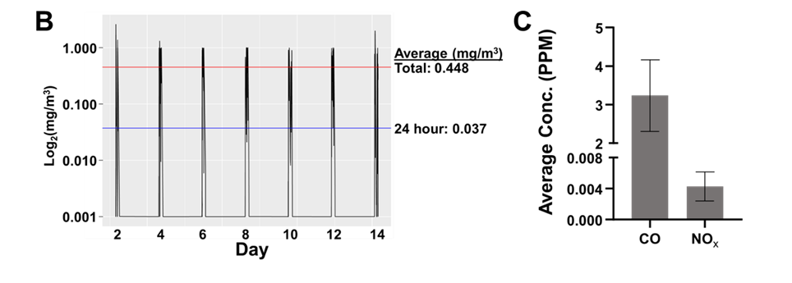
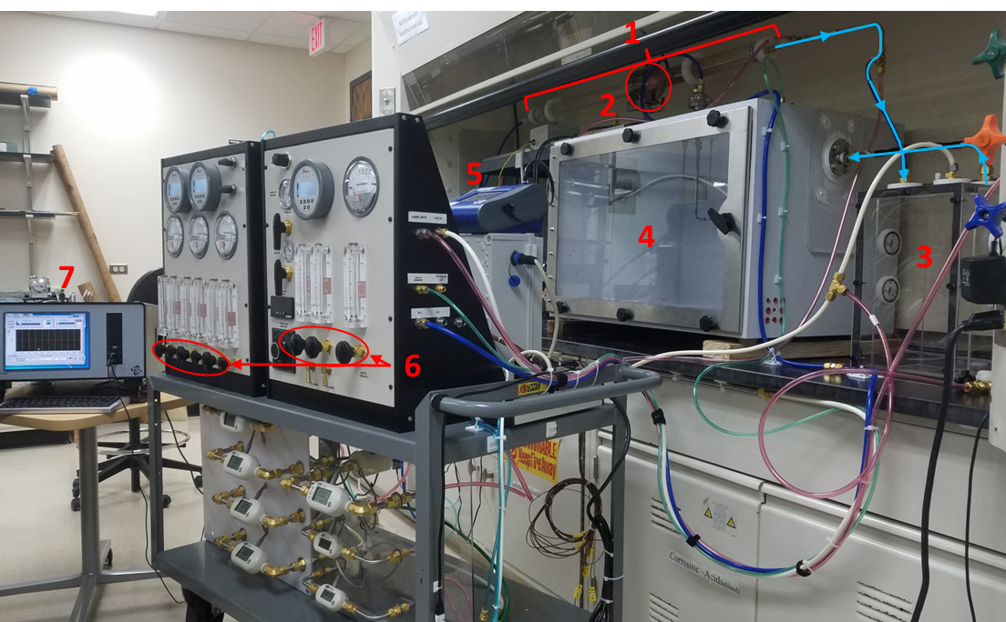
Figure S1. Schematic of wood smoke system and exposure characterization. A) Exposure chamber included: 1) Pre-weighed combustible material is placed inside of quartz boats that are lined inside of the quartz tube. 2) Furnace that runs along the length of the quartz tube; temperature can be altered in real time or set to a desired endpoint temperature. 3) Dilution chamber where smoke can enter via suction or pressurization from the quartz tube. 4) Exposure chamber that contained mouse cages; Smoke can enter via pressurization or vacuum suction. 5) Dust Trak was used to measure particle concentration in real time. 6) Banks of dials used to alter pressure and vacuum for increased or decreased smoke exposure. 7) TSI Laser Aerosol Spectrometer was used to measure particle size distribution. Arrows: direction of smoke flow. B) Concentration measuring during each 4-hour exposure. Top line: average across all exposures. Bottom line: average across all exposures, taking 24 hours per day into account. C) Levels of carbon monoxide (CO) and oxides of nitrogen (NOX). PPM: parts per million. Plotted are mean +/- SD.

Figure S2. Body weight trends across the exposure and intervention regimens. No significant deviations from control groups were noted for any of the treatment groups. Mean +/- SD are shown.
B.
A.
Figure S3. Principal Component Analyses for PFC metabolomic data. A. Comparing the effects of WS to FA in the 18 mo and 21 mo mice. Aging from 18 to 21 months represented a major overall neurometabolomic shift. B. Overlapping pathways for FA vs WS in each of the drug regimens.

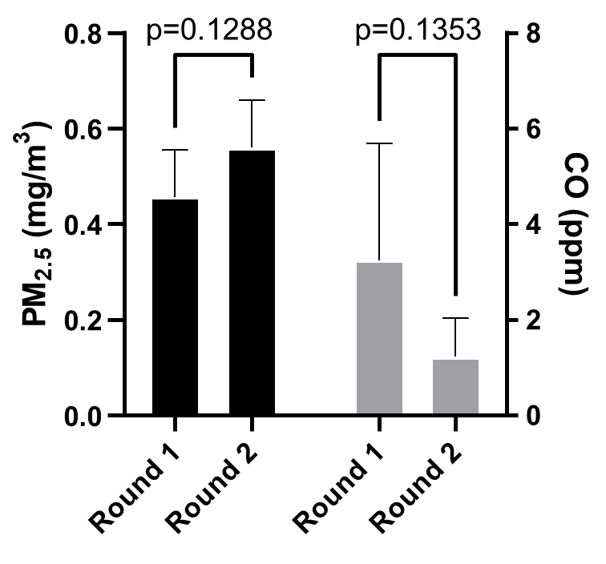
Figure S4. Comparison of exposures between 1st cohort and 2nd cohort of animals used in forced swim tests. Exposure paradigms shown as not significantly different between each other. Left axis: PM_{2.5} in mg/m³. Right axis: carbon monoxide in parts per million. Plotted are mean +/- SD.

Figure S5. Inflammatory cytokine levels are not altered 70 days after exposure. Multiplex ELISA panel of 10 inflammatory cytokines assessed in hippocampal lysates collected 10 weeks after exposure illustrating no sustained differences in neuroinflammation between filtered air control (FA; n=9) and wood smoke (WS) exposed mice (N=7). Student’s t-test was used to compare groups. Plotted are mean +/- SEM.

Figure S6. Overlapping metabolite pathways between aging and wood smoke exposure. A) Pathway analysis from statistically significant metabolites for each, Aging (i), and Exposure (ii) illustrating overlap between conditions based on age-related pathway alterations. Depression pathway and Longevity Regulation pathway were significantly altered in exposure and aging conditions. (colors: overlapping metabolites that were statistically significant; black: age-related pathways, yellow: depression pathway, red: longevity regulation pathway). B) Upset plot for numerical representation of overlapping and non-overlapping pathways from (A). Age-Related Pathway overlap (38) is lower than general pathway overlap between aging and exposure (53), illustrating similarities between aging and exposure that are not age-related. Exposure had 5 general pathways and 4 age-related pathways perturbed that were not observed in the aging condition. C) Venn diagrams showing overlap between Woodsmoke exposure and Aging pathway analysis for long-term depression (top) and Longevity (bottom). Long-term depression pathway metabolites that differed between by woodsmoke and filtered air groups included GLRA4, LDHA, EPRS, MLNR, F2RL3, NGF, SLC29A3, PEMT, LCT, and ALDH2. The long-term depression metabolites that were different in different age groups included GLRA4, LDHA, EPRS, P2RY10, FFAR1, NGF, NTHL1, ADORA2B, VIP, CDS1, CKM, PRDM2. The metabolites for longevity regulating pathway metabolites that were different between woodsmoke and filtered air groups included MPO, IL1B, CAD, GLUD2, GRIK5, SLC1A4, GOT1, BDKRB1, MLNR, KISS1R, FFAR1, F2RL3. The longevity regulating pathway metabolites that were different between ages included MPO, IL1B, CAD, GLUD2, UROD, EEF1E1, AKT1, GNRH1, P2RY10, PROKR2, FFAR2, FFAR1, ADORA2B.

References

1. Scieszka, D. et al. Biomass smoke inhalation promotes neuroinflammatory and metabolomic temporal changes in the hippocampus of female mice. J Neuroinflammation 20, 192 (2023).
2. Bachmanov, A. A., Reed, D. R., Beauchamp, G. K. & Tordoff, M. G. Food Intake, Water Intake, and Drinking Spout Side Preference of 28 Mouse Strains. Behav Genet 32, 435–443 (2002).
3. Mills, K. F. et al. Long-Term Administration of Nicotinamide Mononucleotide Mitigates Age-Associated Physiological Decline in Mice. Cell Metabolism 24, 795–806 (2016).
4. Whole‐body senescent cell clearance alleviates age‐related brain inflammation and cognitive impairment in mice - Ogrodnik - 2021 - Aging Cell - Wiley Online Library. https://onlinelibrary.wiley.com/doi/10.1111/acel.13296.
5. DBscorer. (2023).
6. Takeshita, H. et al. Modified forelimb grip strength test detects aging-associated physiological decline in skeletal muscle function in male mice. Sci Rep 7, 42323 (2017).
7. Justice, J. N. et al. Battery of behavioral tests in mice that models age-associated changes in human motor function. AGE 36, 583–595 (2014).
8. Gu, H., Zhang, P., Zhu, J. & Raftery, D. Globally Optimized Targeted Mass Spectrometry: Reliable Metabolomics Analysis with Broad Coverage. Anal. Chem. 87, 12355–12362 (2015).
9. Gu, H. et al. Quantitative Method to Investigate the Balance between Metabolism and Proteome Biomass: Starting from Glycine. Angew Chem Int Ed Engl 55, 15646–15650 (2016).
10. COMPARE LISTS - MULTIPLE LIST COMPARATOR - Venn diagram generator, free online tool to find set intersections. https://molbiotools.com/listcompare.php.

