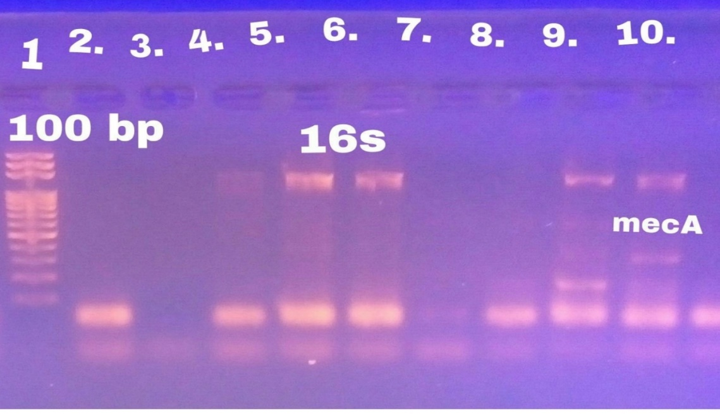
Additional figure 1. PCR amplification of 16S rRNA gene and mecA gene products of S. aureus on 2% agarose gel electrophoresis. Lane 1 DNA ladder: MW 100-1500 bp fragments. Lane 5 show a typical band size of (756 bp) corresponding to 16S rRNA of positive control isolate. Lane 2 show control negative. Lane 6,9,10 show a positive band of samples S. aureus16S rRNA gene product. Lane 10 show atypical band size (310 bp) of Staphylococcal mecA gene.

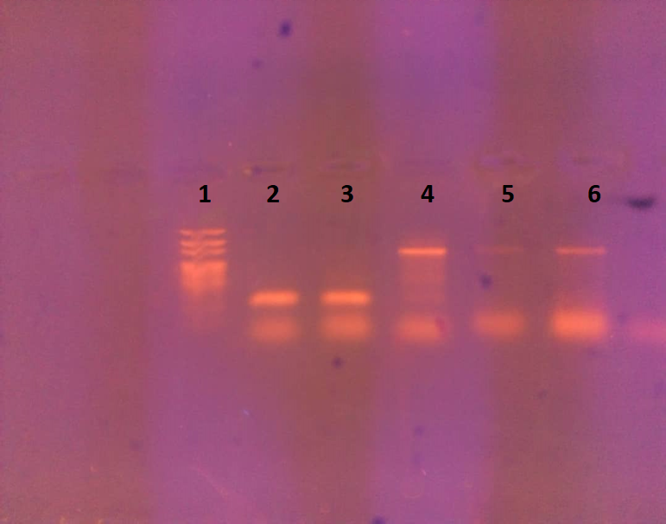

Additional figure 2. Agarose gel electrophoresis for multiplex PCR product of enterotoxin B gene (165pb). Lane 1, DNA ladder 50 pb. Lane 2 show a typical band of the positive control S. aureus enterotoxin B seb gene. Lane 3 show a positive enterotoxin B gene product of S. aureus isolated from cheese samples. Band 5 show a negative control. Band 4,6 show a negative sample.

