Supplement

Actinospongicola halichondriae gen. nov. sp. nov., the first sponge-derived cultivated representative of a new genus within the class Acidimicrobiia

Jing Huang, Jutta Wiese, Leon X. Steiner, Tanja Rahn, Erik Borchert, Ute Hentschel

Figure S1 Polar lipids profile of strain Hal317^{T}
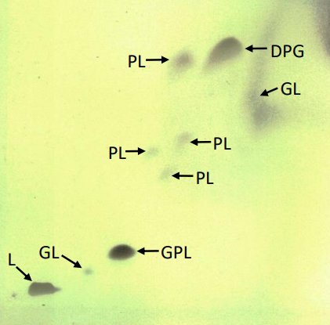
Legend: DPG, diphosphatidylglycerol; GL, glycolipid; GPL, glycophosholipid; L, lipid; PL, phospholipid

