Supplementary information

Supplementary tables
Table S1. Sequences of IDPs in simulations.
Protein | N | Sequence | Box length (nm)
CspM34 | 34 | CEGFKTLKEGQVVEFEIQEGKKGGQAAHVKVVEC | 5.0
(AAQAA)₃ | 15 | Ace-AAQAAAAQAAAAQAA-NH₂ | 5.0
Histatin5 | 24 | DSHAKRHHGYKRKFHEKHHSHRGY | 5.0
RS-peptide | 24 | GAMGPSYGRSRSRSRSRSRSRSRS | 5.0
S(124-146) | 21 | SEEEEKKEESAGEEQVAKKKD | 5.0
TDP43₃₁₀₋₃₅₀ | 41 | GMNFGAFSINPAMMAAAQAALQSSWGMMGMLASQQNQSGPS | 6.5
FUS₀₋₄₃* | 44 | GMASNDYTQQATQSYGAYPTQPGQGYSQQSSQPYGQQSYSGYSQ | 6.5
FUS₁₂₀₋₁₂₆ | 44 | SSYGQPQSGSYSQQPSYGGQQQSYGQQQSYNPPQGYGQQNQYNS | 6.5
RNAPII₁₉₂₇₋₁₉₇₀ | 44 | SPTYSPTSPKGSTYSPTSPGYSPTSPTYSLTSPAISPDDSDEEN | 6.5
H16 | 38 | MATLEKLMKAFESLKSFQQQQQQQQQQQQQQQQPPPPP | 6.5
*a glycine residue was included in FUS₀₋₄₃ as residue 0.
Table S2. Helix fraction RMSD between the simulation and the experiment of H16.
Force field | RMSD (%)
ff99SBws​ | 8.9​
ff99SB-disp​ | 10.4​
ff99SBws-STQ k_{ψ}(S/T/Q) = 1.0​ | 12.7​
ff99SBws-ST - k_{ψ}(Q) = 2.00​ | 6.2​
ff99SBws-ST - k_{ψ}(Q) = 1.75​ | 8.8​
ff99SBws-ST - k_{ψ}(Q) = 1.50​ | 5.1​
ff99SBws-ST - k_{ψ}(Q) = 1.25​ | 9.0​
In the ff99SBws-ST, k_{ψ}(S/T) = 1.0 kJ/mol.

Supplementary Movies
Movie S1. Representative all-atom (AA) simulations of Ubiquitin and Villin HP35 using ff03ws force field.
Movie S2. Representative AA simulations of Ubiquitin and Villin HP35 using ff99SBws force field.
Movie S3. Representative AA simulations of Ubiquitin under different scaling condition derived from ff03ws force field.
Movie S4. Representative AA simulations of Villin HP35 using ff03ws and the sidechain scaling of uncharged residues.
Movie S5. Representative AA simulation of protein complex, Barnase/Barstar, using ff03w-sc and ff99SBws-STQ′ force fields.
Movie S6. Representative AA simulation of protein complex, SGPB/OMTKY3, using ff03w-sc and ff99SBws-STQ′ force fields.
Supplementary figures
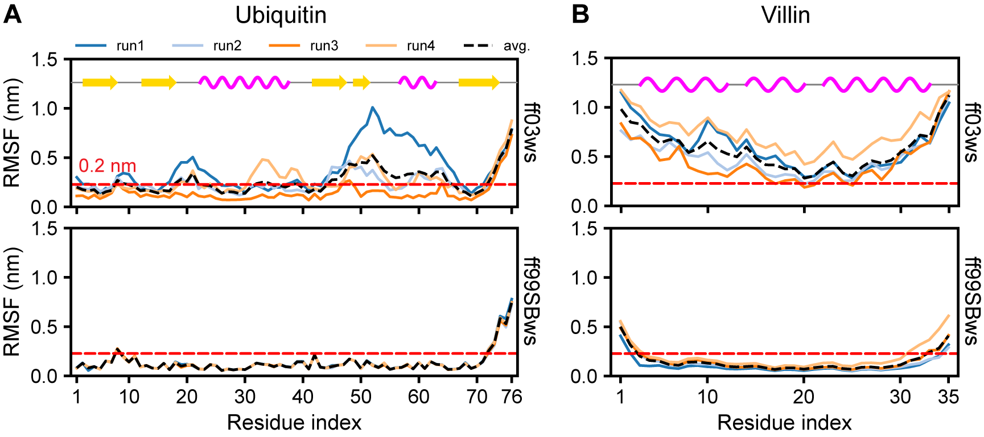
Figure S1: Root-mean-square fluctuation (RMSF) as a function of residue index for (A) Ubiquitin and (B) Villin simulated with Amber ff03ws and ff99SBws force fields. The black dashed line represents the average RMSF across all independent simulations.

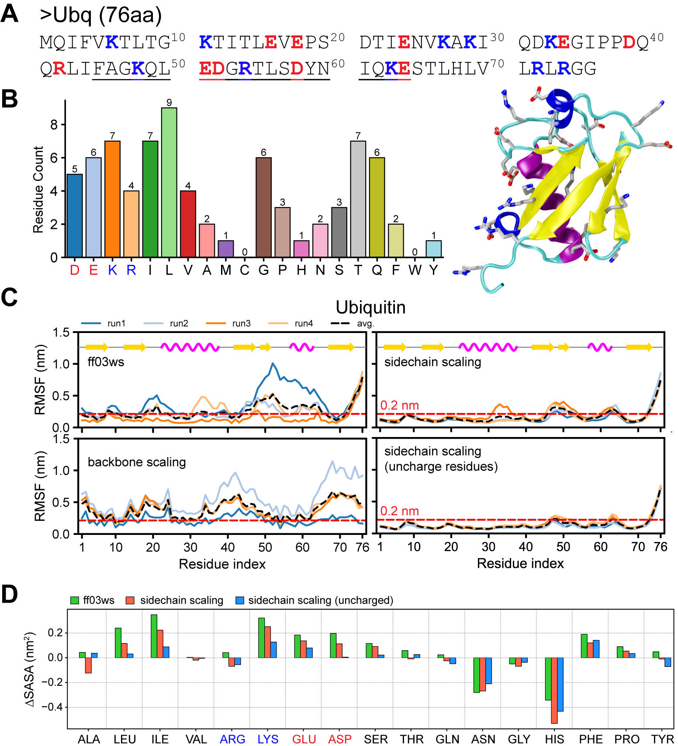
Figure S2. A. Amino acid sequence of ubiquitin (76 residues). The loop (aa:45-65) is underlined in the sequence. B. Bar plot showing the amino acid composition of ubiquitin. The x-axis represents amino acids using their one-letter codes, and the y-axis represents the residue count for each amino acid type. The snapshot shows a 3D structure of ubiquitin (PDB 1D3Z), with secondary structures highlighted: α-helices in purple, 3-10 helix in blue, β-sheets in yellow, and unstructured regions in cyan. The charged residues are shown in the licorice presentation. (c) RMSF of ubiquitin residues as a function of residue index for four independent simulation runs using the amber ff03ws, backbone scaling, sidechain scaling, and sidechain scaling (uncharged residues). The black dashed line represents the average RMSF across all runs. (d) Difference in solvent-accessible surface area (SASA) of ubiquitin relative to the X-ray structure conducted with ff03ws, sidechain scaling, and sidechain scaling of uncharged residues.

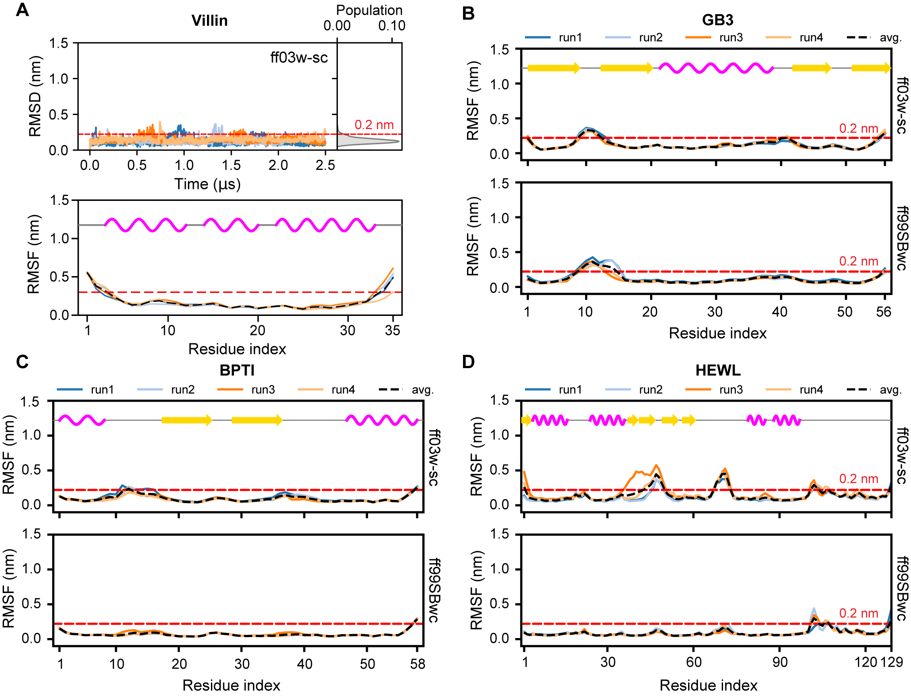
Figure S3. A. Backbone RMSD/F of the Nle-double mutant of Villin HP35 simulated using ff03w-sc. B-D. Comparison of RMSF of GB3, BPTI, and HEWL, using AMBER ff03w-sc and ff99SBws force fields.

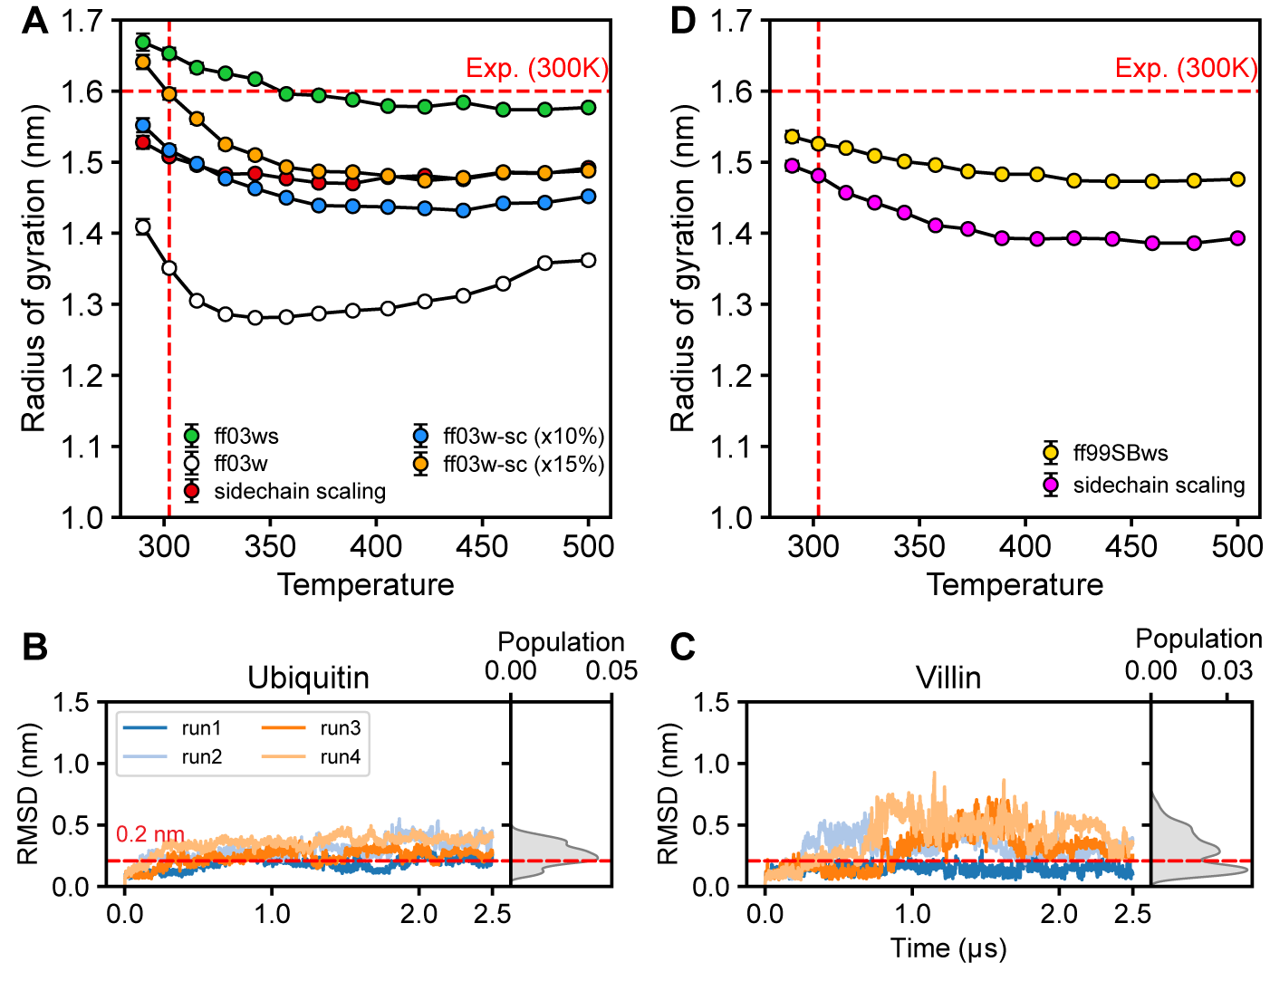
Figure S4. A. Radius of gyration of CspM34 as a function of temperature for AMBER ff03w, ff03ws, and ff03w-sc with two different scaling factors, 1.10 and 1.15. The red dashed line indicates the experimental value at 300 K. B, C. Backbone RMSD for ubiquitin and villin HP35 simulated with ff03w-sc with the scaling factor of 1.15. The red dashed line indicates an RMSD of 0.3 nm, serving as a reference threshold for stability. D. Radius of gyration of CspM34 as a function of temperature for AMBER ff99SBws and its side-chain scaling variant for all residues (except glycine).

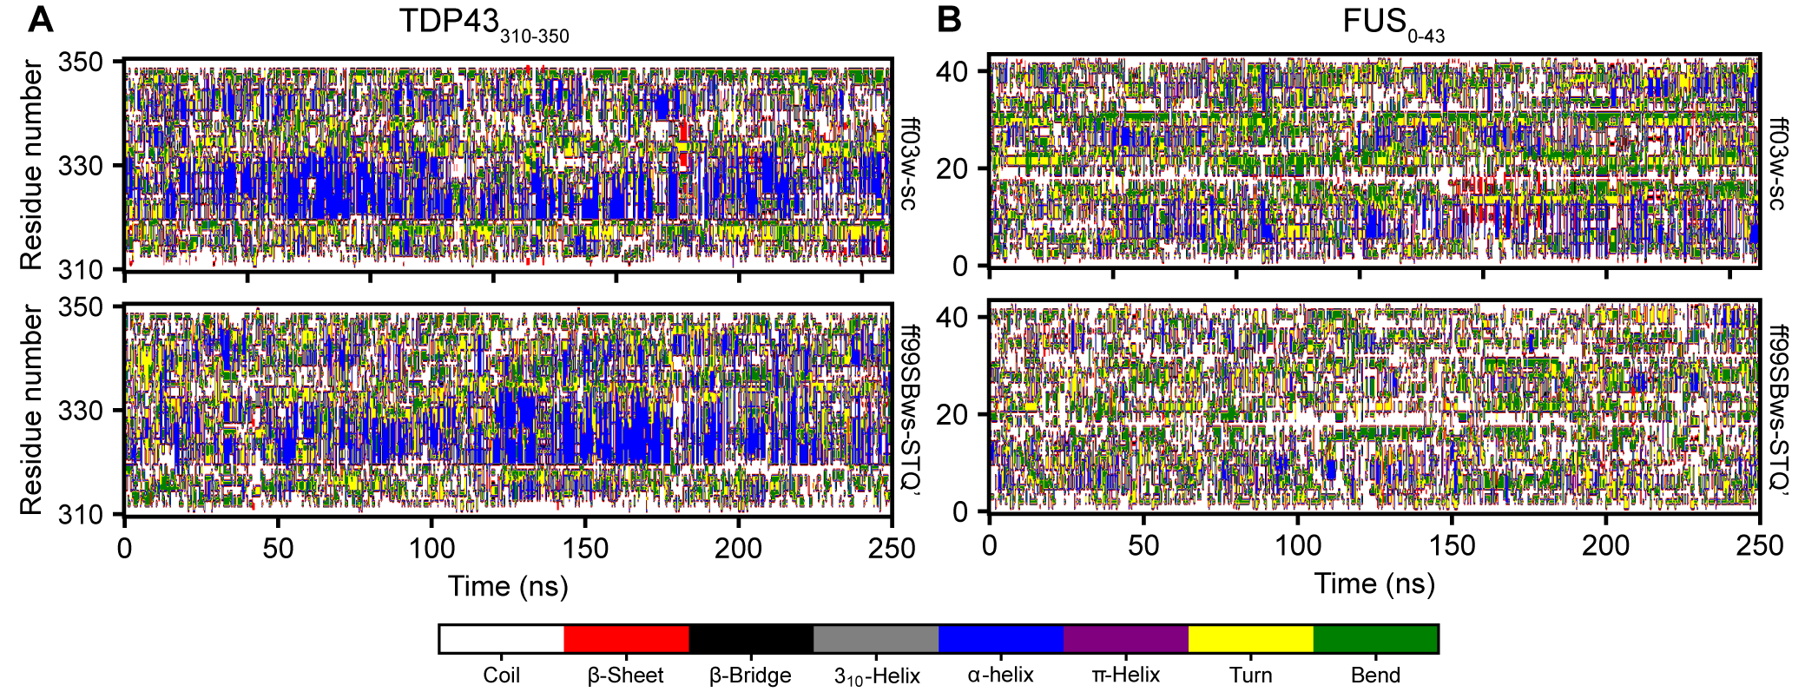
Figure S5. Secondary structure variation (DSSP) as a function of time for (A) TDP43₃₁₀₋₃₅₀ and (B) FUS₀₋₄₃ simulated in AMBER ff03w-sc and ff99SBws-STQ′ at the temperature of 302 K.

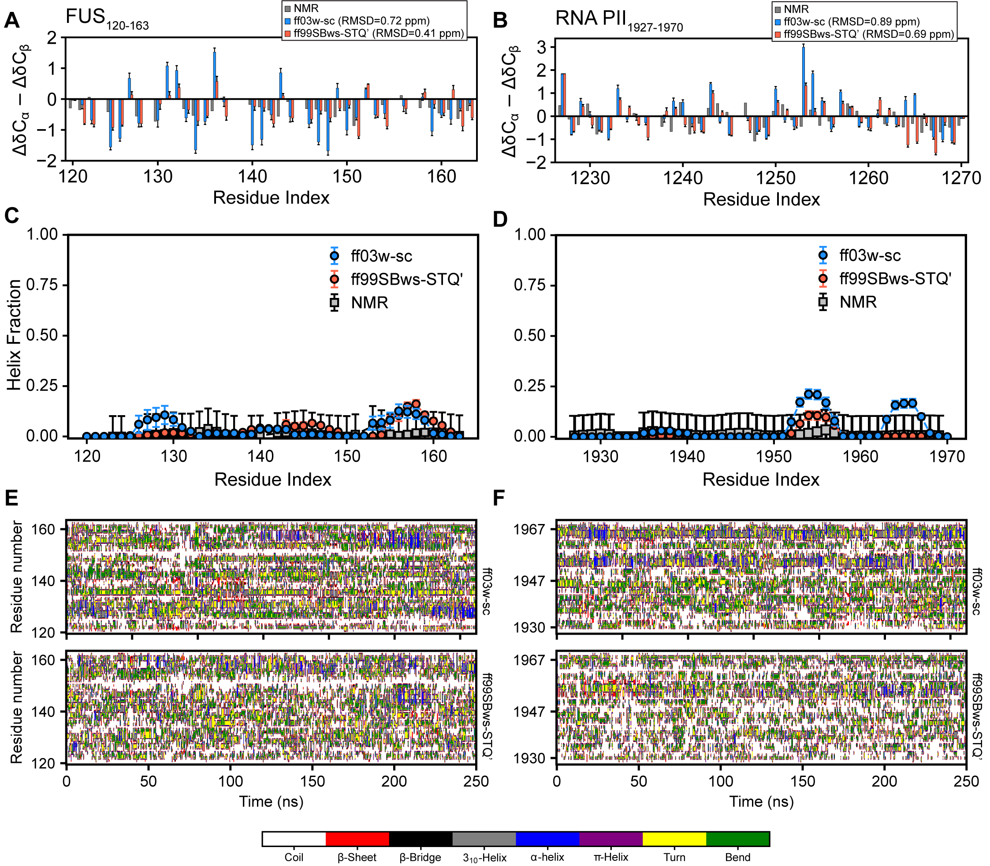
Figure S6. Chemical shift deviations (Δ𝛿Cα − Δ𝛿Cβ) (A, B), residual helix fraction (C, D), and secondary structure variation (E, F) for FUS₁₂₀₋₁₆₃ and RNA PII₁₉₂₇₋₁₉₇₀ simulated with ff03w-sc and ff99SBws-STQ′ at the temperature of 302 K.

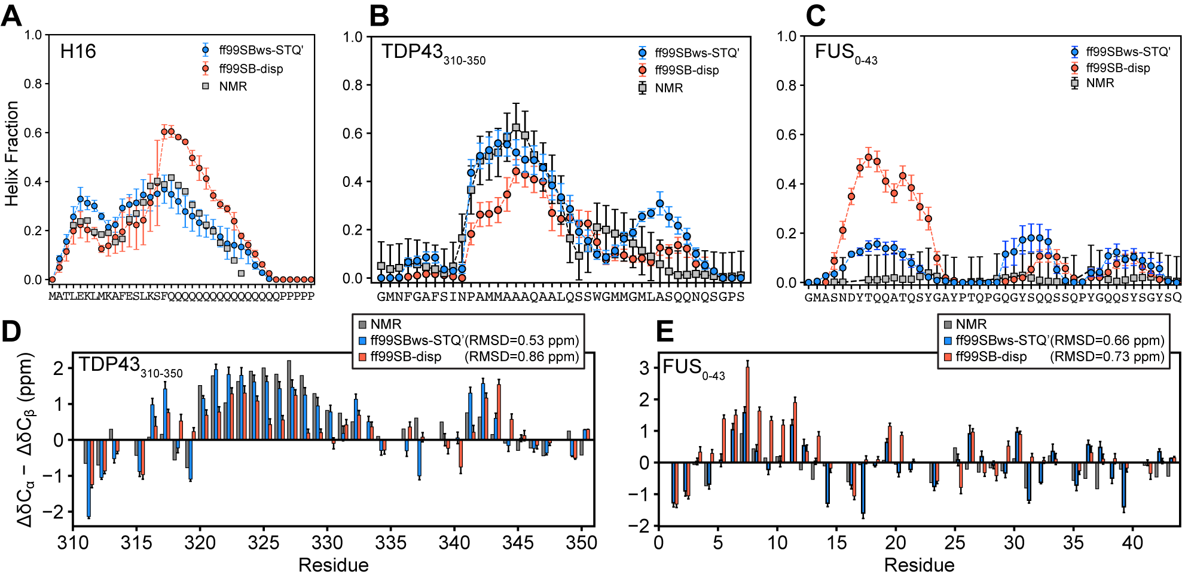
Figure S7. A-C. Residual helix fraction of Httex1-Q16 (A), TDP43₃₁₀₋₃₅₀ (B), and FUS₀₋₄₃ (C), simulated in three Amber ff99SBws-STQ′ and ff99SB-disp. NMR-derived results were taken from Urbanek et al. for H16,^{1,2} for TDP43₃₁₀₋₃₅₀, and ref. for FUS0-43. Error bars for the NMR-derived 𝛿2D population per residue for TDP43₃₁₀₋₃₅₀ and FUS₀₋₄₃ are 0.1 (10%). Residual helix fraction of Httex1-Q16 from the simulation using AMBER ff99SB-disp was taken from Mohanty et al.³ while the results for TDP43₃₁₀₋₃₅₀ and FUS₀₋₄₃ using AMBER ff99SBws-STQ′ was calculated from 302 K replica of PT-WTE simulations. D-E. Chemical shift deviations (Δ𝛿Cα − Δ𝛿Cβ) for TDP43₃₁₀₋₃₅₀ (D) and FUS₀₋₄₃ (E) calculated from 302 K replica of PT-WTE simulations using AMBER ff99SBws-STQ′ and ff99SB-disp compared to the experimental results.

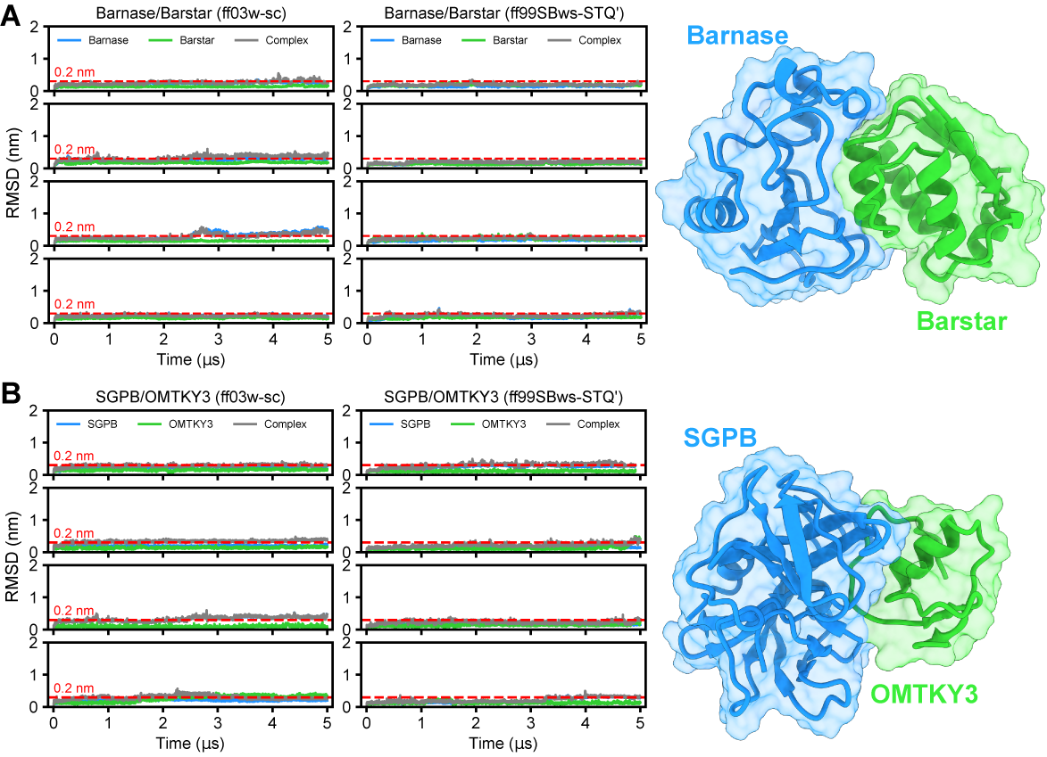
Figure S8. Protein complexes stability. Backbone-based RMSD as a function of time of two protein complexes Barnase/Barstar and SGPB/OMTKY3 for four independent simulations using ff03w-sc and ff99SBws-STQ′ force fields. The RMSD of each protein monomer is shown in blue and green and the RMSD for the complex is shown in gray. The red dashed line indicates an RMSD of 0.2 nm, serving as a reference threshold for stability.

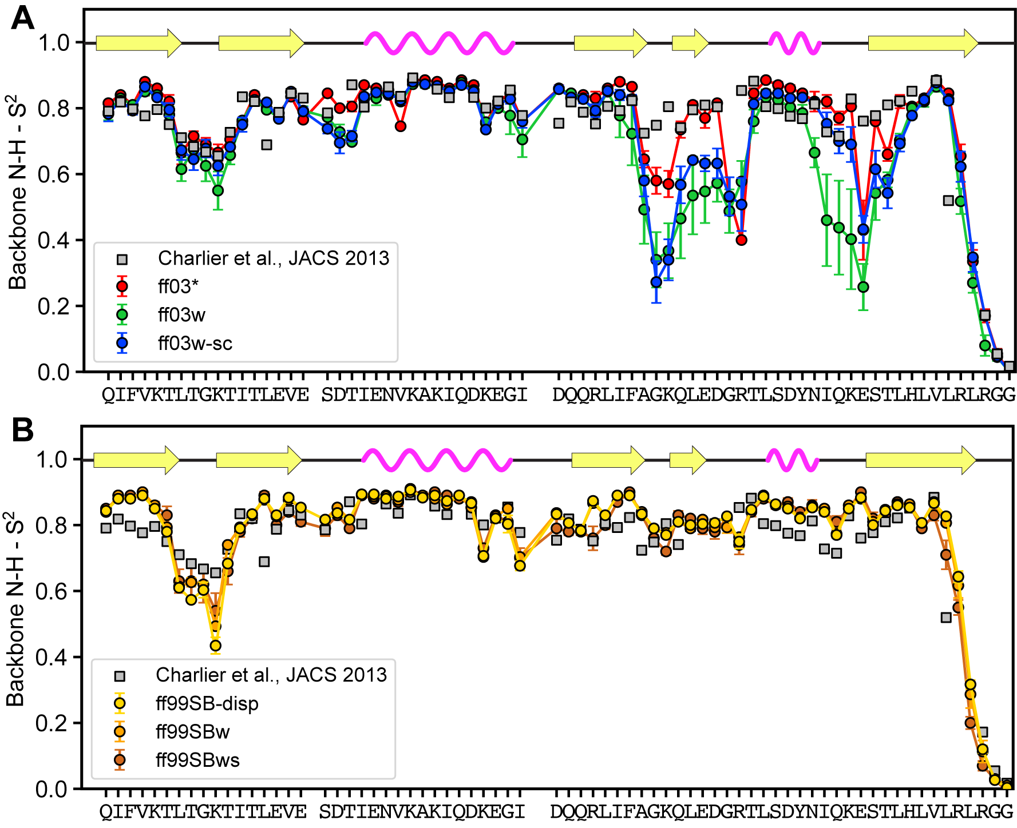
Figure S9. NMR order parameters for Ubiquitin simulated with (A) amber ff03-based and (B) amber ff99SB-based force fields. Square symbols are experimental data taken from Charlier et al.⁴

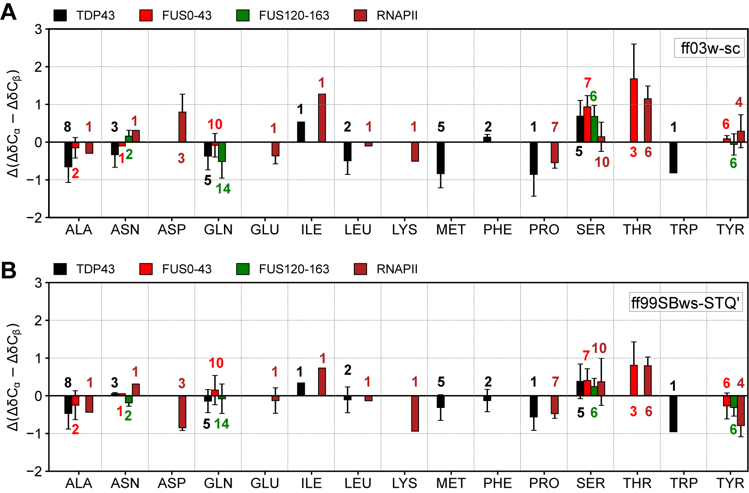
Figure S10: Chemical shift deviations, Δ(Δ𝛿C_{α} − Δ𝛿C_{β}) in ppm, from NMR ¹³C chemical shifts in simulations of low complexity fragments using ff03w-sc (A) and ff99SBws-STQ′ (B) force fields. Error bars represent the standard deviations across the sampled residues. Annotated numbers next to the bars indicate the number of residues of each type present in the chosen fragment.

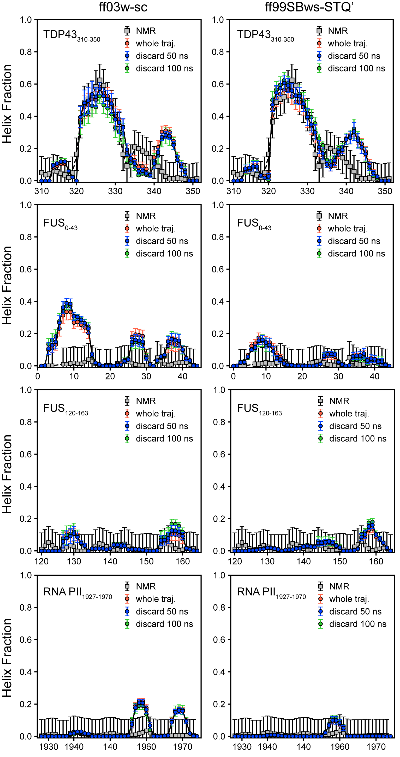
Figure S11. Residual helix fraction of TDP43₃₁₀₋₃₅₀, FUS₀₋₄₃, FUS₁₂₀₋₁₆₃, and RNA PII₁₉₂₇₋₁₉₇₀ analyzed on the entire trajectory, and after removing the first 50 and 100 ns. Error bars for helix fraction indicate the standard deviations between 50 ns periods in simulation trajectories. Error bars for NMR-derived 𝛿2D population per residue are 0.1 (10%).

