Supplemental materials:

Table A.1. Sources of the referred grape phenology dates (including bud break, flowering, veraison, berry maturation, and leaf fall) in all the study areas.
Area | Reference | Journal
Anhui province | Zhou et al. (2015) | Modern Agricultural Science and Technology
Anhui province | Chen (2009) | Subtropical Agriculture Research
Fujian province | Liu et al. (2018) | Southeast Horticulture
Fujian province | Zheng et al. (2016) | Bulletin of Agricultural Science and Technology
Fujian province | Yao et al. (2013) | Agricultural Research in the Arid Areas
Gansu province | Xu et al. (2019) | Journal of China Agricultural University
Gansu province | Wang et al. (2018) | Journal of Anhui Agricultural Sciences
Gansu province | Chen (2017) | Gansu Agricultural University
Guangxi province | Zhang et al. (2016) | Southern Horticulture
Guizhou province | Zhou et al. (2014) | Northern Horticulture
He’nan province | Wang et al. (2009) | Journal of Henan Forestry Science and Technology
He’nan province | Li et al. (2018) | Deciduous Fruits
Hebei province | Chai et al. (2005) | China Fruits
Hu’nan province | Shi et al. (2002) | Journal of Hunan Agricultural University (Natural Sciences)
Hubei province | He and Wang (2005) | Guizhou Agricultural Sciences
Jiangsu province | Zhou (2017) | Agricultural Equipment & Technology
Jilin province | Sun and Liu (2006) | Deciduous Fruits
Liaoning province | Yin (2019) | Bulletin of Agricultural Science and Technology
Ningxia Hui Autonomous Region | Shi (2012) | Ningxia Journal of Agriculture and Forestry Science and Technology
Shaannxi province | Wu et al., (2012) | Northern Horticulture
Shandong province | Jia et al., (2014) | Sino-Overseas Grapevine & Wine
Shanxi province | Ren (2015) | Shanxi Agricultural University
Sichuan province | Liu (2009) | Sichuan Agricultural University
Xinjiang Uygur Autonomous Region | Liu (2008) | Xinjiang Farm Research of Science and Technology
Yunnan province | Yu (2015) | Agricultural Engineering Technology
Yunnan province | Jin et al., (2019) | China Fruits
Zhejiang province | Jin et al., (2019) | China Fruits
Zhejiang province | Yang (2013) | Sino-Overseas Grapevine & Wine

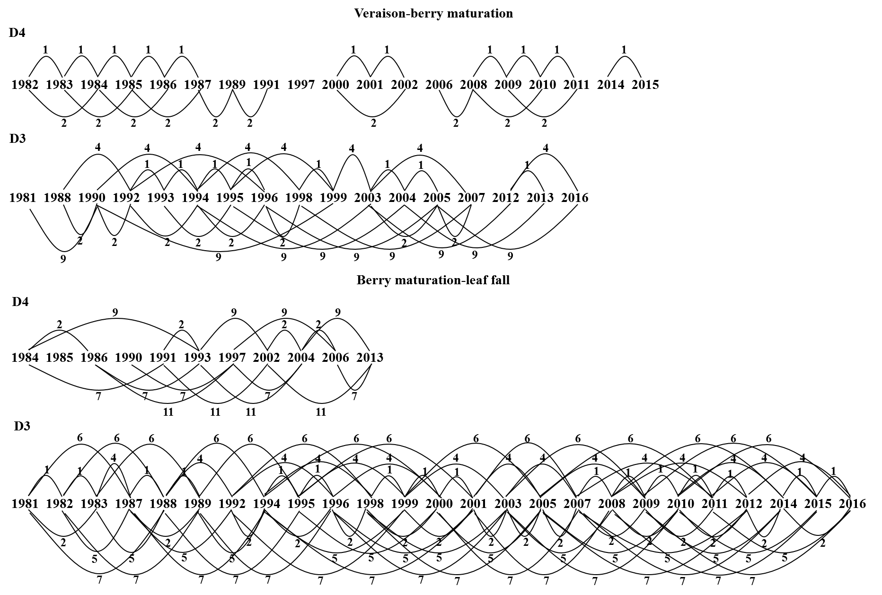

Fig. A.2. The butterfly diagram patterns of exceptional and extreme droughts (D4 and D3) during veraison-berry maturation and berry maturation-leaf fall from 1981 to 2016 in Northwest China.
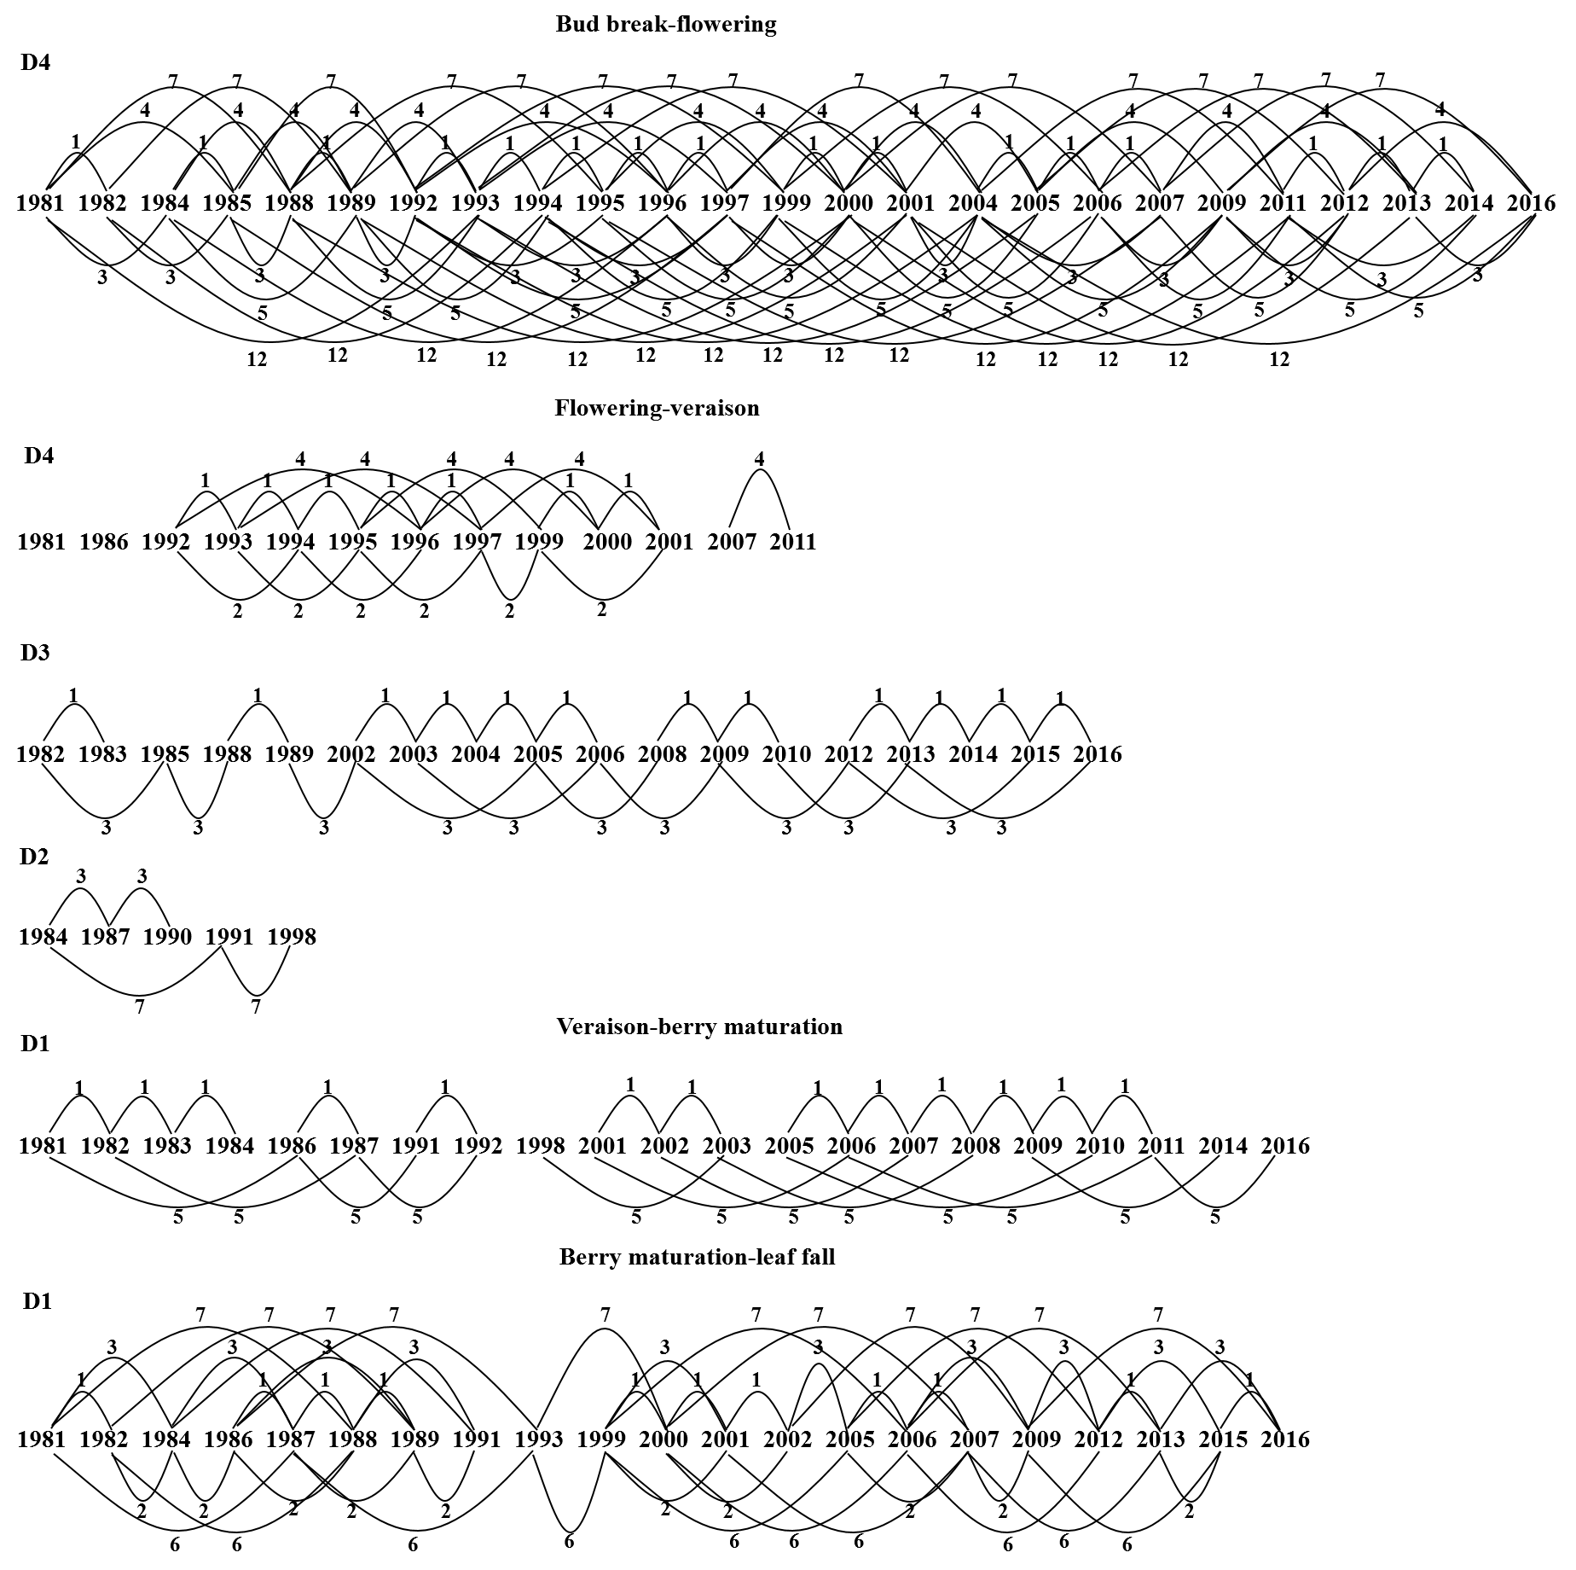

Fig. A.3. The butterfly diagram patterns of exceptional drought (D4) during bud break-flowering, exceptional, extreme, and severe droughts (D4, D3, and D2) during flowering-veraison, and moderate drought (D1) during veraison-berry maturation and berry maturation-leaf fall from 1981 to 2016 in North China.
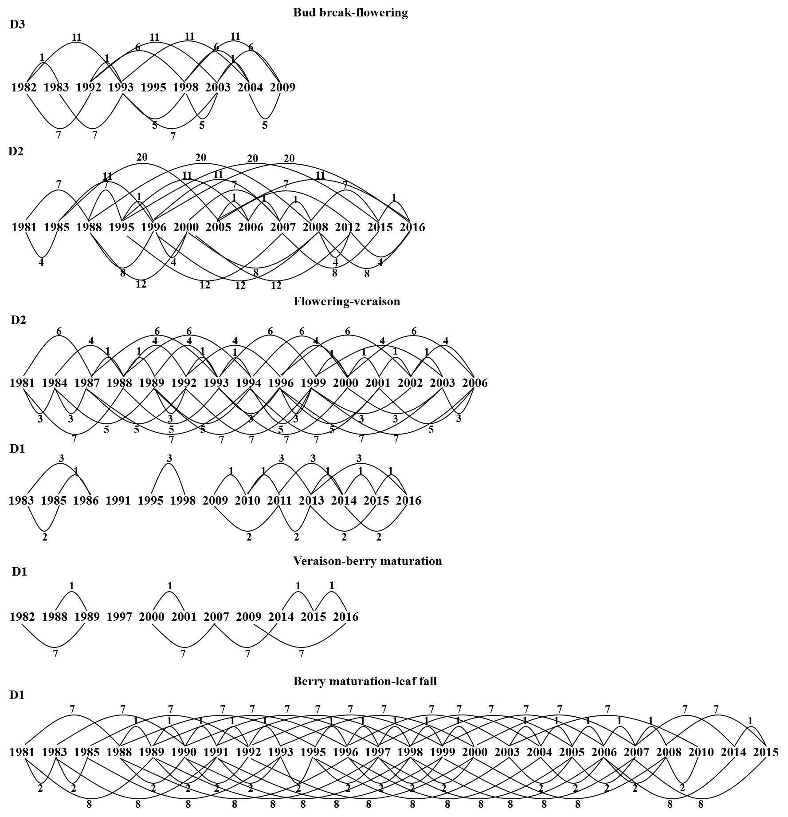

Fig. A.4. The butterfly diagram patterns of extreme and severe droughts (D3 and D2) during bud break-flowering, severe and moderate droughts (D2 and D1) during flowering-veraison, and moderate drought (D1) during veraison-berry maturation and berry maturation-leaf fall from 1981 to 2016 in Northeast China.
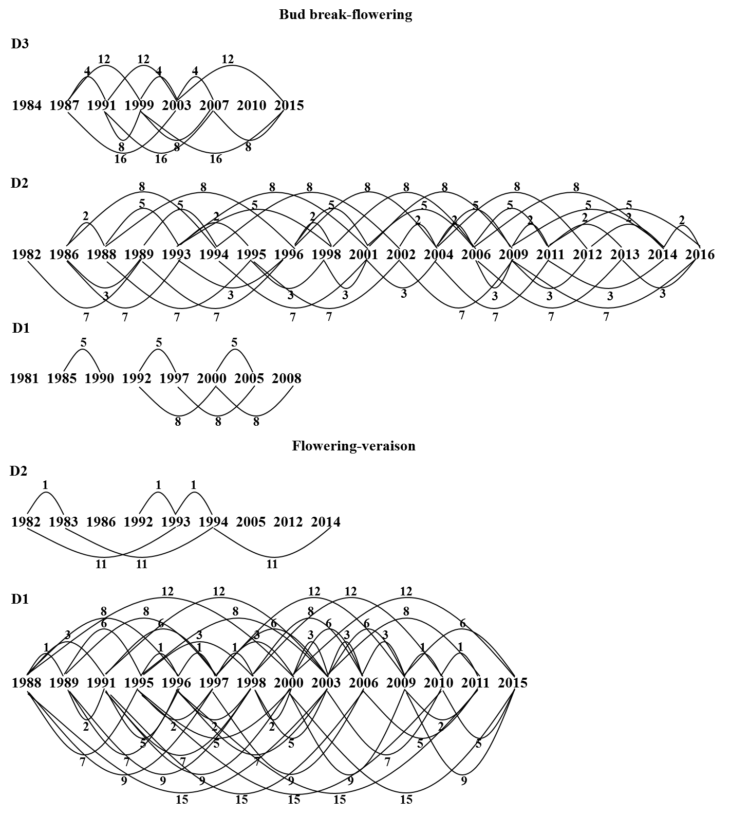

Fig. A.5. The butterfly diagram patterns of extreme, severe, and moderate droughts (D3, D2, and D1) during bud break-flowering, and severe and moderate droughts (D2 and D1) during flowering-veraison from 1981 to 2016 in Southwest China.
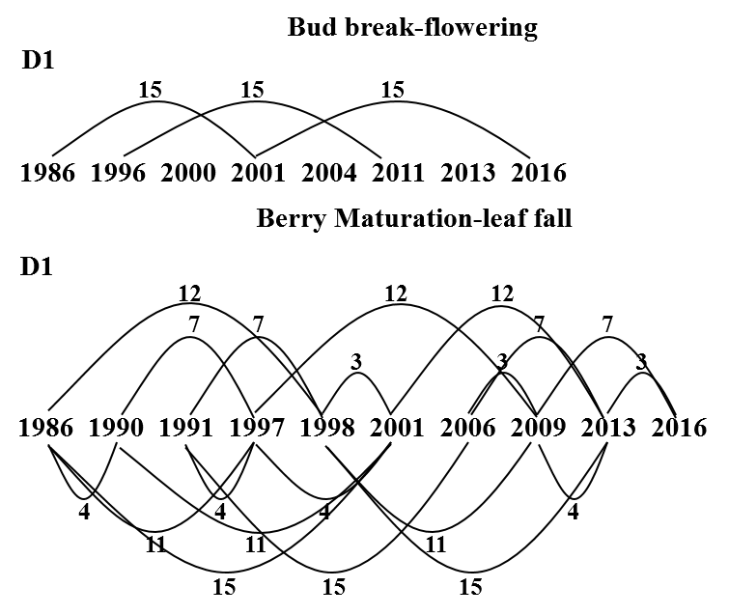

Fig. A.6. The butterfly diagram patterns of moderate drought (D1) during bud break-flowering and berry maturation-leaf fall from 1981 to 2016 in Southeast China.

