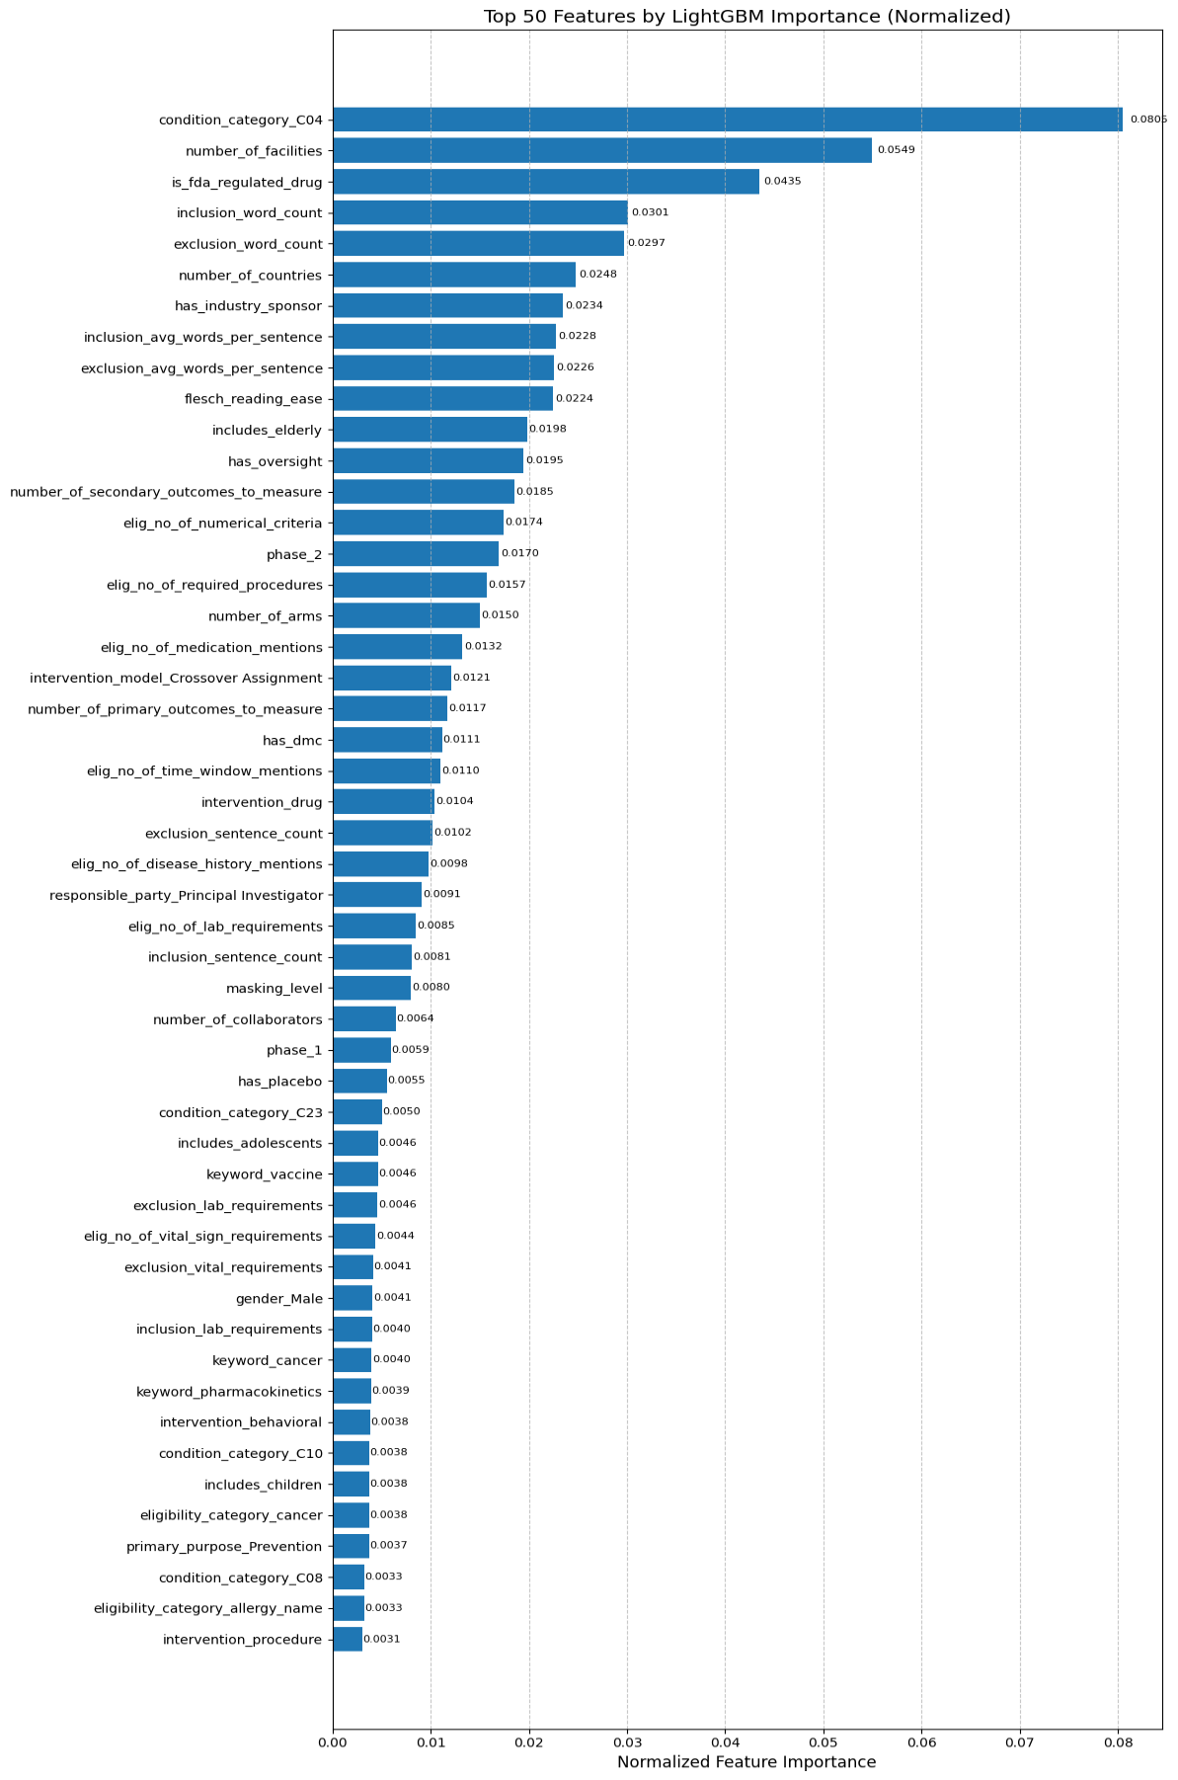
Supplementary Figure 1. Top 50 Features Ranked by the Model by Importance

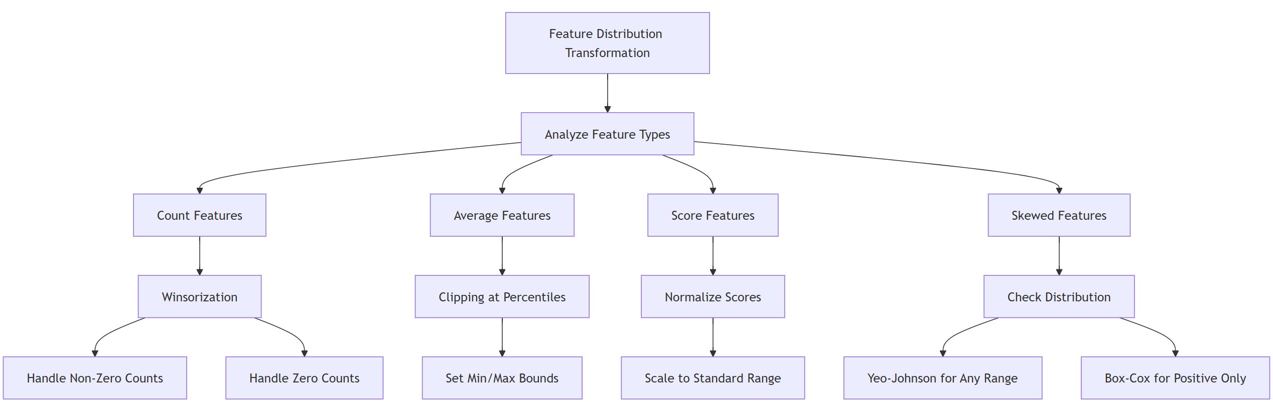
Supplementary Figure 2. Numerical Feature Processing Pipeline

Supplementary Table 1. Trial Population Age Coverage
Population Group | Age Definition | Trial Coverage (%)
Neonatal | < 1 month | 3.0
Infant | < 2 years | 5.5
Children | < 12 years | 9.9
Adolescent | 12-17 years | 10.6
Adult | >= 18 years | 94.9
Elderly | >= 65 years | 72

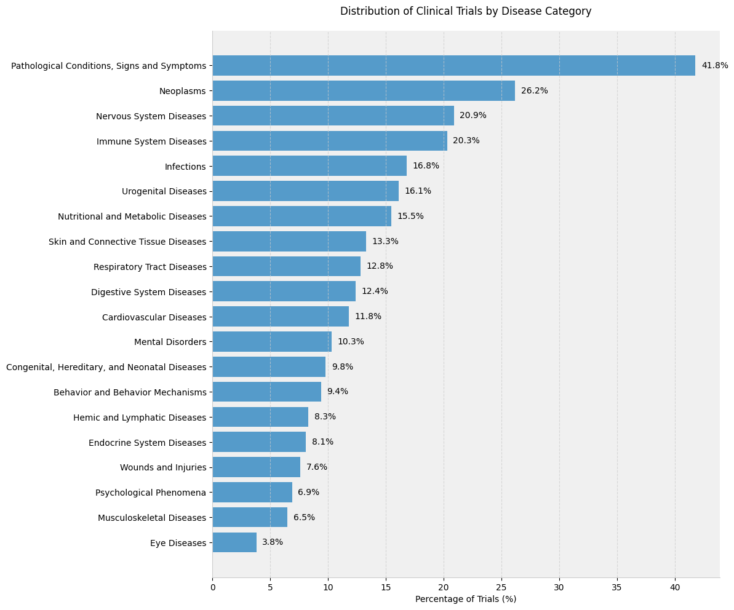
Supplementary Figure 3. Disease Category Distribution
Figure Legend. Disease coverage metrics showed that trials were classified into an average of 2.3 categories, with 31.2% assigned to a single category, 44.7% to multiple categories, and 24.1% remaining uncategorized. Disease categorization of trials with documented conditions revealed significant research priorities, with Pathological Conditions, Signs, and Symptoms accounting for 41.8% of trials, Neoplasms for 26.2%, and Nervous System and Immune System Diseases for 20–21%. Supplementary Figure 1 presents the distribution of disease categories.

Supplementary Note 1. Comparative Analysis of Trials with and without Documented Conditions
A total of 68,878 studies with documented conditions were successfully mapped to one or more of the standardized disease categories, while 14,985 studies (17.9%) had missing condition data. A comprehensive analysis of study characteristics revealed systematic differences between trials with and without documented conditions. Phase 1 trials were overrepresented among those lacking condition data (56.8% vs 21.0%), as were trials involving healthy volunteers (67.9% vs 18.5%). Substantial disparities in trial complexity metrics were also observed, with studies missing condition data showing markedly different characteristics in the number of facilities (78.8% difference), participating countries (45.1% difference), and primary outcomes (37.6% difference). Basic science studies were more prevalent among trials without conditions (16.9% vs 3.4%). These findings suggest that condition data are not Missing At Random (MNAR) but are structurally linked to specific study designs, particularly early-phase trials, basic science research, and trials including healthy volunteers.

Supplementary Note 2. Medical Pattern Features Encoding Methodology
Eligibility criteria medical patterns features were generated through systematic pattern recognition using regular expressions (regex). Specifically, counts were derived for laboratory requirements (e.g., blood tests, chemistry panels), vital sign specifications (e.g., blood pressure, oxygen saturation), medication mentions (including routes and dosing), disease history references (e.g., comorbidities, pre-existing conditions), temporal specifications (e.g., time windows for prior treatments), procedural requirements (e.g., imaging, surgeries), and numerical criteria (e.g., measurement thresholds). Each category was identified using comprehensive regex patterns designed to capture relevant medical terminology and common linguistic patterns in clinical trial protocols. For instance, laboratory patterns encompassed common test abbreviations (e.g., CBC, BMP) and measurement units, while vital sign patterns included standard physiological parameters and their typical measurement formats.

Supplementary Table 2. Eligibility Criteria Medical Patterns Analysis Features
Feature | Mean | Std Dev | Min-Max | Description
Lab Requirements | 2.02 | 2.93 | 0-10 | Laboratory test specifications
Vital Sign Requirements | 0.93 | 1.99 | 0-7 | Physiological measurements
Medication Mentions | 6.59 | 6.85 | 0-24 | Drug and treatment references
Disease History Mentions | 0.59 | 0.87 | 0-3 | Prior condition specifications
Time Window Mentions | 3.85 | 4.69 | 0-16 | Temporal specifications
Required Procedures | 4.92 | 5.07 | 0-18 | Medical procedure requirements
Numerical Criteria | 6.83 | 6.26 | 0-22 | Quantitative thresholds

Supplementary Table 3. Text Analysis, Readability and Complexity Metrics
Feature | Mean | Std Dev | Min-Max | Description
Flesch Reading Ease | 15.42 | 16.26 | 0-86.71 | Text accessibility score
Flesch-Kincaid Grade | 17.20 | 3.42 | 3.7-20.0 | U.S. grade level required to comprehend the text
Medical Complexity Score | 4.87 | 3.62 | 0-10 | Composite medical sophistication score
Words per Inclusion | 111.02 | 107.77 | 4-396 | Inclusion criteria verbosity
Words per Exclusion | 167.89 | 156.98 | 1-552 | Exclusion criteria verbosity

Supplementary Note 3. Eligibility Criteria Medical Complexity Scoring Methodology
The medical complexity score for eligibility criteria was developed to quantify the sophistication and potential recruitment impact of trial requirements. The scoring system implements a weighted pattern recognition approach that evaluates six key components of eligibility criteria text: laboratory requirements, vital sign requirements, medication requirements, disease history, temporal specifications, and procedural requirements.
The weighting system was designed to reflect the relative impact of different components on trial implementation complexity and participant screening burden. Laboratory requirements and procedural specifications carry the highest weights (2.0) due to their objective nature, resource intensity, and direct impact on participant screening and monitoring processes. Vital sign requirements and medication specifications are assigned intermediate weights (1.5), reflecting their importance in ongoing participant monitoring and the complexity of medication management. Disease history and temporal specifications receive standard weights (1.0), as they represent common baseline eligibility factors and typical timeline requirements in clinical trials.
The final complexity score is calculated as the weighted sum of pattern matches normalized to a 0-10 scale:
$$Score =min(10, \frac{(2⋅L + 1.5⋅V + 1.5⋅M + D + 2⋅P)}{5})$$
Where L, V, M, D, T, and P represent the number of pattern matches for laboratory, vital sign, medication, disease history, temporal, and procedural requirements, respectively. The denominator of 5 was empirically determined to achieve a reasonable distribution across the 0-10 scale based on analysis of trial protocols. The minimum function ensures the final score is capped at 10, preventing outliers with excessive requirements from skewing the metric.

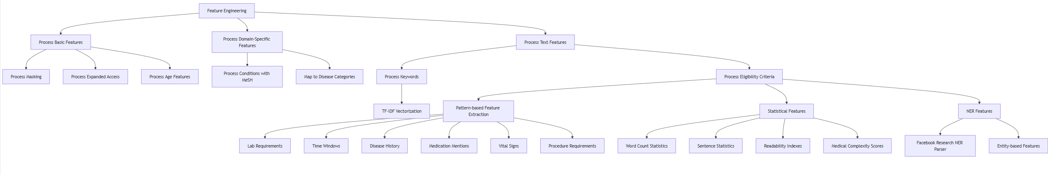
Supplementary Figure 4. Feature Engineering Pipeline
Supplementary Table 4. The List of Binary, Numerical, and Categorical Features from the AACT Dataset and Features Derived from the Dataset
Feature | Category | Type | Description | Values
has_dmc | Administrative | Binary | Presence of Data Monitoring Committee | Yes/No
has_oversight | Administrative | Binary | Presence of study oversight | Yes/No
has_industry_sponsor | Administrative | Binary | Industry sponsorship status | Yes/No
has_industry_collaborator | Administrative | Binary | Industry collaboration status | Yes/No
has_expanded_access | Administrative | Binary | Availability of expanded access protocol | Yes/No
is_fda_regulated_drug | Administrative | Binary | FDA regulation status for drug trials | Yes/No
is_fda_regulated_device | Administrative | Binary | FDA regulation status for device trials | Yes/No
responsible_party_type | Administrative | Categorical | Type of responsible party | Sponsor/Principal Investigator/Sponsor-Investigator
phase_{1-4} | Administrative | Categorical | Trial phase indicators | 1/2/3/4
number_of_facilities | Organizational | Numeric | Count of participating facilities | 1-1746
number_of_countries | Organizational | Numeric | Count of participating countries | 1-59
number_of_collaborators | Organizational | Numeric | Count of collaborating organizations | 0-6
number_of_arms | Methodological | Numeric | Number of study arms | 1-44
number_of_primary_outcomes_to_measure | Methodological | Numeric | Count of primary outcomes | 1-217
number_of_secondary_outcomes_to_measure | Methodological | Numeric | Count of secondary outcomes | 1-324
intervention_model_{type} | Methodological | Categorical | Trial design type | Parallel Assignment/Crossover Assignment/Factorial Assignment/Sequential Assignment/ Single Group Assignment
randomized | Methodological | Binary | Randomization status | Yes/No
masking_level | Methodological | Numerical | Number of blinded entities | 0-4
has_placebo | Methodological | Binary | Presence of placebo arm | Yes/No
primary_purpose_{type} | Methodological | Categorical | Primary purpose categories | Basic Science/Device Feasibility/Diagnostic/Health Services Research/Prevention/Screening/Supportive Care/Treatment/Other
healthy_volunteers | Methodological | Binary | Eligibility of healthy volunteers | Yes/No
intervention_behavioral | Methodological | Binary | Behavioral intervention status | Yes/No
intervention_biological | Methodological | Binary | Biological intervention status | Yes/No
intervention_combination_product | Methodological | Binary | Combination product intervention status | Yes/No
intervention_device | Methodological | Binary | Device intervention status | Yes/No
intervention_diagnostic_test | Methodological | Binary | Diagnostic test intervention status | Yes/No
intervention_dietary_supplement | Methodological | Binary | Dietary supplement intervention status | Yes/No
intervention_drug | Methodological | Binary | Drug intervention status | Yes/No
intervention_genetic | Methodological | Binary | Genetic intervention status | Yes/No
intervention_procedure | Methodological | Binary | Procedure intervention status | Yes/No
intervention_radiation | Methodological | Binary | Radiation intervention status | Yes/No
intervention_other | Methodological | Binary | Other intervention status | Yes/No
condition_category_C{XX} | Topic | Binary | MeSH disease category indicators (C01-C26)¹ | Yes/No
condition_category_F{XX} | Topic | Binary | MeSH psychiatry and psychology category indicators (F01-F04)¹ | Yes/No
includes_neonatal | Eligibility Criteria-Demographics | Binary | Includes participants <2 months | Yes/No
includes_infants | Eligibility Criteria-Demographics | Binary | Includes participants <2 years | Yes/No
includes_children | Eligibility Criteria-Demographics | Binary | Includes participants <12 years | Yes/No
includes_adolescents | Eligibility Criteria-Demographics | Binary | Includes participants 12-17 years | Yes/No
includes_adults | Eligibility Criteria-Demographics | Binary | Includes participants ≥18 years | Yes/No
includes_elderly | Eligibility Criteria-Demographics | Binary | Includes participants ≥65 years | Yes/No
gender_{category} | Eligibility Criteria-Demographics | Categorical | Gender eligibility indicators | Female/Male/All
eligibility_{MeSH code} | Eligibility Criteria-Medical Terms | Binary | Presence of specific MeSH terms in eligibility criteria | Yes/No
elig_no_of_lab_requirements | Eligibility Criteria-Medical Patterns | Numeric | Count of laboratory test requirements in the eligibility criteria | 0-10
elig_no_of_vital_sign_requirements | Eligibility Criteria-Medical Patterns | Numeric | Count of vital sign specifications in the eligibility criteria | 0-7
elig_no_of_medication_mentions | Eligibility Criteria-Medical Patterns | Numeric | Count of medication references in the eligibility criteria | 0-24
elig_no_of_disease_history_mentions | Eligibility Criteria-Medical Patterns | Numeric | Count of disease history mentions in the eligibility criteria | 0-3
elig_no_of_time_window_mentions | Eligibility Criteria-Medical Patterns | Numeric | Count of temporal specifications in the eligibility criteria | 0-16
elig_no_of_required_procedures | Eligibility Criteria-Medical Patterns | Numeric | Count of required procedures in the eligibility criteria | 0-18
elig_no_of_numerical_criteria | Eligibility Criteria-Medical Patterns | Numeric | Count of numerical specifications in the eligibility criteria | 0-22
inclusion_word_count | Eligibility Criteria-Complexity | Numeric | Word count in inclusion criteria | 4-396
inclusion_sentence_count | Eligibility Criteria-Complexity | Numeric | Sentence count in inclusion criteria | 1-130
inclusion_avg_words_per_sentence | Eligibility Criteria-Complexity | Numeric | Average words per sentence in inclusion criteria | 1-721
exclusion_word_count | Eligibility Criteria-Complexity | Numeric | Word count in exclusion criteria | 1-552
exclusion_sentence_count | Eligibility Criteria-Complexity | Numeric | Sentence count in exclusion criteria | 1-114
exclusion_avg_words_per_sentence | Eligibility Criteria-Complexity | Numeric | Average words per sentence in exclusion criteria | 1-826
medical_complexity_score | Eligibility Criteria-Complexity | Numeric | Weighted medical complexity score | 0-10
flesch_reading_ease | Eligibility Criteria-Readability | Numeric | Flesch Reading Ease score (0-100) | 0-86.71
flesch_kincaid_grade | Eligibility Criteria- Readability | Numeric | Flesch-Kincaid Grade Level score | 3.7-20.0
keyword_{term} | Keywords | Numeric | TF-IDF scores for extracted keywords | Top 200 keywords

Note: Binary features are encoded as 0/1, categorical features are one-hot encoded, and numeric features are scaled using standardization. Features derived from MeSH terms (condition_category_* and eligibility_*) represent the presence of specific medical concepts and conditions within the trial documentation. ¹Categories from MeSH tree, available at: https://meshb.nlm.nih.gov/treeView.

Supplementary Note 4. Custom scoring function used during hyperparameter tuning
The model optimization process employed a custom scoring function designed to address the specific challenges of clinical trial outcome prediction, particularly the class imbalance problem and the importance of accurately identifying potentially failing trials (Class 0). The scoring function incorporates multiple performance metrics with weighted penalties to achieve balanced predictive performance.
The custom score S is computed as:
$$S=0.35⋅ACC_{bal}+0.25⋅P_{f1}+0.2⋅ACC_{0}+0.1⋅ACC_{1}+0.1⋅ P_{bal}$$
Where ​ $ACC_{bal}$ is the balanced accuracy, $P_{f1}$​ is the F1-score target penalty, $ACC_{0}$​ is the accuracy for Class 0 (terminated trials), $ACC_{1}$​ is the accuracy for Class 1 (completed trials), $P_{bal}$​ is the class balance penalty. The F1-score target penalty${ P}_{f1}$​ is calculated as:
$$P_{f1} = 1 - min({F1}_{0} - 0.435|, 0.1)$$
Where ${F1}_{0}$ is the F1-score for Class 0. This penalty term encourages the model to maintain Class 0 F1-scores within an optimal range around 0.435, based on empirical optimization. The class balance penalty $P_{bal}$is defined as:
$$P_{bal = \frac{1}{1+ 2|{ACC}_{0}-{ACC}_{1}| }}$$
This term penalizes large disparities between class-specific accuracies, promoting balanced performance across both outcome classes.
The weighting scheme (0.35, 0.25, 0.2, 0.1, 0.1) was determined through empirical testing to prioritize overall balanced accuracy (0.35), maintain optimal Class 0 F1-score performance (0.25), emphasize accurate identification of trial termination (0.2) and balance performance between classes (0.2 combined for $ACC_{0} and P_{bal}$)

