This file contains the Supplementary materials to the article: ‘Integrative learning through student-led transdisciplinary investigation of Belgium’s COVID-19 pandemic preparedness’.

Supplementary Document S1: Stakeholder Guide

This supplementary document contains the preparatory material sent out to all stakeholders participating in the workshop. Alongside the document a video was shared which explained the 20 gaps list. The video can be viewed here: [redacted link]

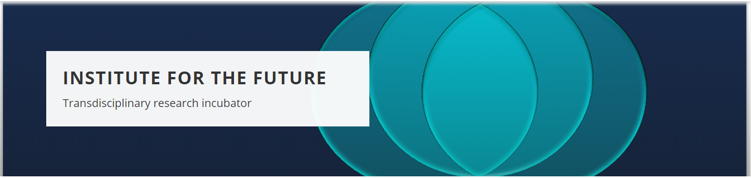
Stakeholder guide
Dear stakeholder,
Thank you very much for your willingness to participate in our co-creation workshop on Pandemic Preparedness in Belgium.
We are very excited to explore your views and experiences during the pandemic and make them a starting point for change in how our country is addressing the problems that occurred.
This introductory document provides a small overview to prepare you for our workshop on Saturday, 27 March 2021, 9 am - 1 pm.
The main goal of this guide is to familiarise you with the problems or gaps observed during the course of the pandemic, which are the topic of the workshop. Alongside this document, you will find a link to a YouTube video as an introduction to the gaps listed below. Please take your time to watch this video and read this document carefully to prepare for the workshop. By doing so, you can acquaint yourself with the gaps and consider whether any additional gaps are missing.
If you have any questions, feel free to contact us at: pandemicpreparedness@kuleuven.be
We look forward to meeting you virtually on Saturday!
The Pandemic Preparedness Workshop Team

Ethics and privacy
We are planning to record all sessions for academic note-keeping purposes only (see further information below). For this, we need your approval. If you agree that we can record the audio of the sessions, you do not have to do anything. However, if you disagree, please let us know. Then we will do written note-keeping of the sessions in which you will be participating.
There is no obligation to share any personal information. If at any point you feel uncomfortable with the recording or discussion, please let us know. Leaving the workshop at any time has no repercussions. Please note that we have no ethical approval to work with minors during the workshop. If you are a minor, we kindly ask you not to participate in the workshop.

What do we expect from you?
The goal of this workshop is to co-create a list of gaps, and identify deeper causes and core issues regarding the COVID-19 pandemic with stakeholders from the Belgian society.
To prepare for the workshop, we would like you to take a close look at the gaps listed below by watching our introductory video and consider whether any important gaps are missing. We acknowledge that there is no end to identifying gaps, so we ask you to consider only the three most important missing gaps.

Layout of the workshop
During the workshop, you will be assigned into ‘outbreak’ rooms with 4 or 5 other stakeholders to perform a total of 3 exercises about problems we have observed during the pandemic. The exercises are designed to be very engaging, so this will not be a 4-hour lecture. Every room has a moderator who will guide you through the exercise. After every exercise, there will be a short break, followed by a return to the plenary room where the results will be discussed.
It goes without saying that we expect you to be respectful to your fellow participants and that there are no right or wrong questions or answers.
On the next page, you can find all the gaps (mentioned in the video) listed again. Please feel free to print out this image to use during the exercises.
Thank you for taking the time to read this document and to prepare for our workshop. We look forward to welcoming you on Saturday!
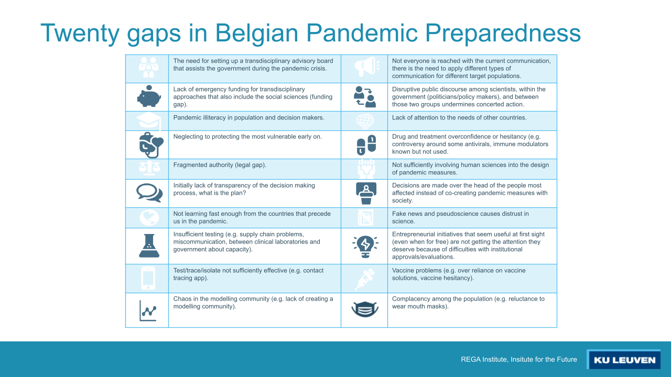

Supplement Figure S2: Actor Constellation
The figure shows the actor constellation made by the students. The complete actor constellation was created with Miro. Accessible here:https://miro.com/app/board/uXjVL1jmC-4=/?share_link_id=673672394843

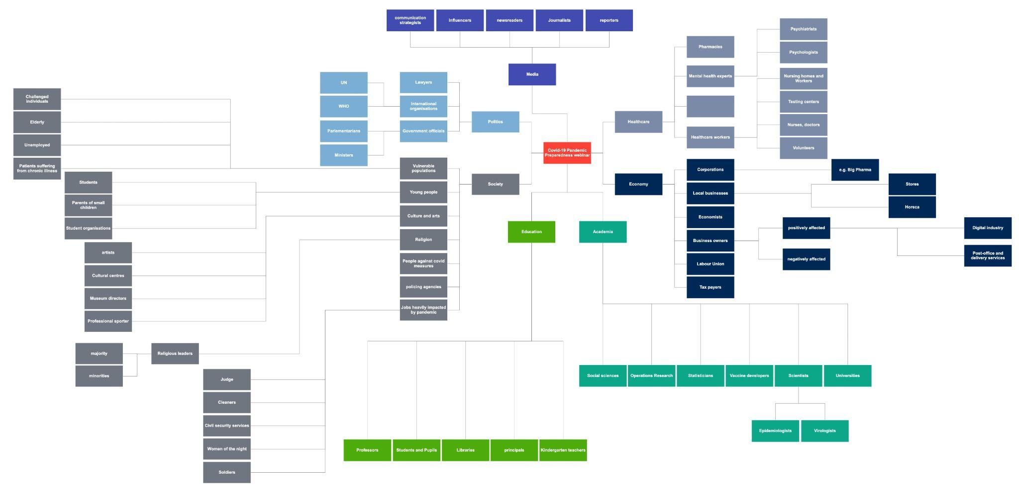
Supplementary Document S3: Workshop Invitation E-mail
The supplementary document shows the invitiation e-mail sent to all stakeholders.
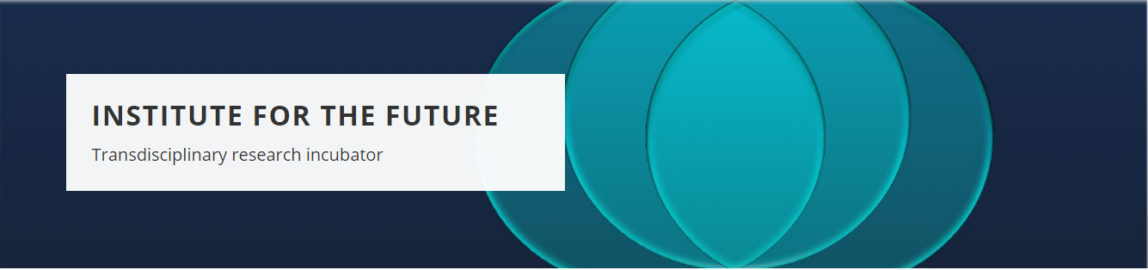
The Institute for the Future at the REGA Institute, KU Leuven is pleased to invite you to its first co-creation workshop on the topic of BELGIAN PANDEMIC PREPAREDNESS!

WHEN: Saturday, March 27, 2021 @ 9am – 1pm CET
WHERE: Online (link will be provided)
WHAT: Gaps in Belgian Pandemic Preparedness
WITH: Stakeholders from different sections of society

The overall goal of the Coronavirus Pandemic Preparedness project is to learn from the current pandemic to be better prepared for future pandemics. As with many societal challenges, such as inequality or climate change, pandemic preparedness is a wicked problem: it involves multiple problems that compete and conflict with each other. Many months into the pandemic, society still struggles with issues that remain unresolved and thus re-emerge. As a pandemic is not only a medical crisis, but above all a societal crisis, one or separate disciplines working together does not suffice. Instead, a transdisciplinary approach is required which not only transgresses the boundaries between academic disciplines but also engages in mutual learning with societal actors based on their knowledge and lived experiences.
The purpose of this workshop would be to listen to your opinion on the gaps in COVID-19 pandemic preparedness and to identify deeper issues that might compromise Belgian pandemic preparedness in the future. We believe that your experience and background are very valuable for our project and would like to invite you to become a stakeholder in it.
Please confirm your willingness to participate in our project and/our co-creation workshop by the 1st of March, 2021 by responding to this email.
Please confirm your participation to the Pandemic Preparedness team:
pandemicpreparedness@kuleuven.be

THANK YOU

We look forward to your participation! Should you have any questions or think of another relevant stakeholder or colleague to recommend, please feel free to let us know by email.
Supplementary Table S4: Participant demographics
The table shows the list of stakeholders that participated in the workshop, with a description of their profession and region. The third column shows the domain in which the participant was mapped for the creation of diverse groups.

 | Description | Region | Domain
1 | Former Belgian and Flemish Minister | Flanders | Law and Politics
2 | Bailiff | Flanders | Law and Politics
3 | Business manager | Flanders | Business and Economy
4 | Professor Business and Economy | Flanders | Business and Economy
5 | Professor of Economics | Flanders | Business and Economy
6 | Human Resources worker | Flanders | Business and Economy
7 | Human Resources worker | Flanders | Business and Economy
8 | Representative of the Belgian hairdressing employer’s federation Febelhair, and the European federation Coiffure EU | Flanders | Other
9 | Professor in Mathematical Engineering | Flanders | Other
10 | Innovation Manager | Flanders | Other
11 | Professor in Linguistics | Wallonia | Other
12 | Psychology Student | Flanders | Mental Health
13 | Psychology Student | Flanders | Mental Health
14 | Professor in virology and epidemiology | Flanders | Medical Research
15 | Virologist | Flanders | Medical Research
16 | Medical scientist | Brussels | Medical Research
17 | Doctor and PhD researcher clinical bacteriology and mycology | Flanders | Medical Research
18 | Microbiologist | Wallonia | Medical Research
19 | Medical doctor in public health | Flanders | Healthcare
20 | General Practitioner | Flanders | Healthcare
21 | Former Covid-19 patient | Flanders | Healthcare
22 | Representative of the Belgian Union of nursing specialists | Flanders | Healthcare
23 | Representative of the Belgiun Union of nursing specialists | Flanders | Healthcare
24 | Director-general, representative for organistation Belgian biopharmaceutical industry | Flanders | Medicine
25 | General Council member at EFPIA (European federation of Pharmaceutical Industries and Associations) | Flanders | Medicine
26 | Statistical Modeler | Flanders | Social Sciences
27 | Anthropologist | Flanders | Social Sciences
28 | Philosopher of Science | Flanders | Social Sciences
29 | Ass. Professor in Health, Ethics and Society | Flanders | Social Sciences
30 | Professor in Philosophy and Sociology of Public Health | Flanders | Social Sciences

Supplementary Figure S5: Miro exercise Sheet
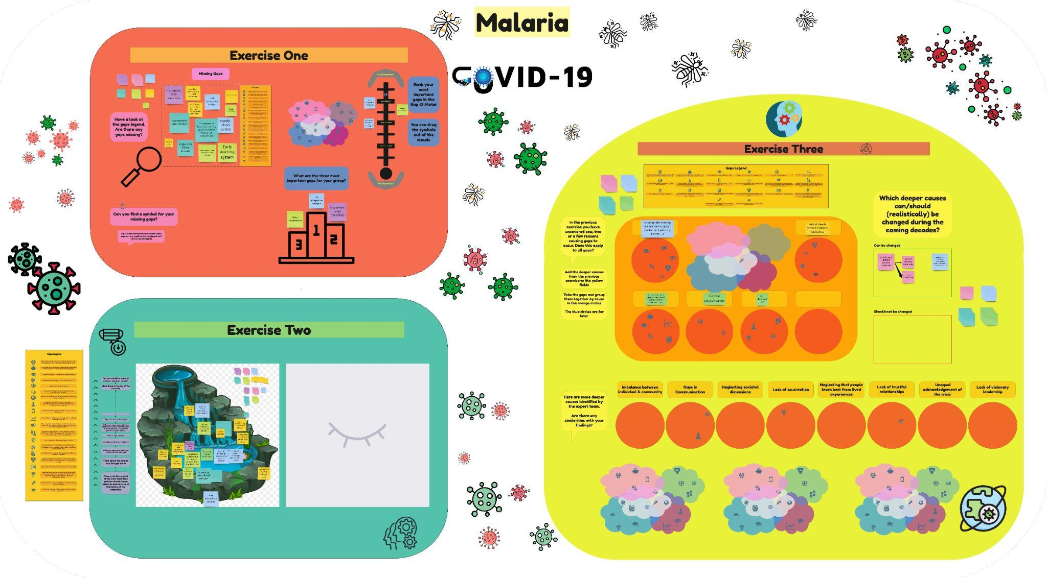
The figure shows one of the exercise sheets from the workshop. The exercises were created on the MIRO platform. This example displays the exercises performed by the ‘Malaria’ team. For each exercise the gaps list was provided in the orange tab.

Supplementary Table S6: Results exercise 1
Group | Missing gaps
Malaria | - Involvement of all disciplines  - Stop massive deforestation  - No academically trained nurses in advisory board  - Insufficient use of nursing clinical leadership  - Lack of financial and jurdicial framework or clinical nursing specilialists  - Large scale animal industry  - Prevention of future pandemics by taking care of ecological environment  - Risk analysis acceptance  - Supply-chain control  - Early warning system  - Multidimensional communication strategy  - Global corporation  - Scientific nursing is needed
Ebola | - The neglect of other no-brainer crises like climate in the conscience of the population  - More than just a procurement issue - create an integrated vision away from 'crisis mode' reactivity  - Learn from pandemic history  - The research for new crises in the sideline of this crisis, provoked by it  - Communication: Create a community that feels it's important to follow the rules  - Places to discuss among different fields of science to support decision-making  - Cross-border and cross-regional collaboration. Data communication. Public health professionals are not familiar with IDC across the border/region.  - Guided interaction between hospitals and other care centers (homes for elderly, ...)  - Relation experts – government  - National strategy to encounter the lack of PPE
Plague | - Patient-caregiver ratio in nursing homes  - Integration primary care - nursing homes – hospitals  - Clear role/responsabilities / hierarchies -> clear communication  - Smaller living groups instead of big nursinghomes  - Lack of transdisciplinary teaching and still silo thinking approaches to problems
Smallpox | - Lack of communication of guidlines to 1st line healthcare workers (before it appears in the media)  - Advice on social, psychological, financial and logistical support, massively, was not implemented  - Measures were invented ad-hoc, on short notice; nobody had time to plan/prepare  - Boots on the ground: need data to make models/decisions (intelligence)  - Emergency plans for acute mental health problems  - Ideology (neoliberal) inhibited strongly the investment in psycho- social "support" and interverntions towards the population. The advice was strongly given, repetitively, but not implemented massively  - Logistics fast track distribution  - More attention should be devoted to side effects of pandemic
Spanish Flu | - Lack of nursing research  - Lack of commitment of nursing leadership  - Lack of use of master educated nurses in advisory board  - Lack of systemic knowledge of biology. Reflecting on the implications of Mass Vaccination vs. emergence of Super Virus  - Missing legal framework  - Don’t look to far east for pandemic control, why?  - The attention spend towards mental health and the risks that come with the isolation caused by quarantine, the fear for getting sick  - Neglecting student wellness  - Accessible and 'easy' to understand information about how the virus and how vaccines work

The table shows the missing gaps identified by each group in exercise 1.

Supplementary Table S7: Results exercise 3

The table shows the deeper causes identified by each group and the gaps that they caused.
Group | Deeper causes | Gaps
Malaria | Lack of clearly defined common objectives | - The need for setting up a transdisciplinary advisory board that assists the government during the pandemic crisis.  - Initially lack of transparency of the decision making process, what is the plan?  - Neglecting to protecting the most vulnerable early on.  - Complacency among the population (e.g. reluctance to wear mouth masks).
Malaria | Doubt on the existing representation system (parliament, advisory bodies, ...) | - Pandemic illiteracy in population and decision makers.  - Not everyone is reached with the current communication, there is the need to apply different types of communication for different target populations.  - Disruptive public discourse among scientists, within the government (politicians/policy makers), and between those two groups undermines concerted action.  - Initially lack of transparency of the decision making process, what is the plan?  - Decisions are made over the head of the people most affected instead of co-creating pandemic measures with society.  - Fragmented authority (legal gap).
Malaria | lack of importance given to/ awareness complex system thinking in science | - Lack of emergency funding for transdisciplinary approaches that also include the social sciences (funding gap.)  - Pandemic illiteracy in population and decision makers.  - Chaos in the modelling community (e.g. lack of creating a modelling community).  - Disruptive public discourse among scientists, within the government (politicians/policy makers), and between those two groups undermines concerted action.  - Not sufficiently involving human sciences into the design of pandemic measures.
Malaria | Global cooperation | - Lack of attention to the needs of other countries.  - Not learning fast enough from the countries that precede us in the pandemic
Malaria | Not discussed | - Drug and treatment overconfidence or hesitancy (e.g. controversy around some antivirals, immune modulators known but not used.  - Vaccine problems (e.g. over reliance on vaccine solutions, vaccine hesitancy).  - Fake news and pseudoscience causes distrust in science.  - Insufficient testing (e.g. supply chain problems, miscommunication, between clinical laboratories and government about capacity).

Table continued on next page
Group | Deeper causes | Gaps
Ebola | Lack of long term vision meeting broader societal needs | - Entrepreneurial initiatives that seem useful at first sight (even when for free) are not getting the attention they deserve because of difficulties with institutional approvals/evaluations.  - Chaos in the modelling community (e.g. lack of creating a modelling community).  - Lack of emergency funding for transdisciplinary approaches that also include the social sciences (funding gap.)  - Insufficient testing (e.g. supply chain problems, miscommunication, between clinical laboratories and government about capacity).
Ebola | Equitable treatment of different people / disciplines/ social groups | - Access to resources  - Not everyone is reached with the current communication, there is the need to apply different types of communication for different target populations.  - Lack of attention to the needs of other countries.  - Vaccine problems (e.g. over reliance on vaccine solutions, vaccine hesitancy).
Ebola | wrong focus and types of thinking in gov | - Lack of attention to the needs of other countries.  - Initially lack of transparency of the decision making process, what is the plan?  - Nationalism  - Lack of emergency funding for transdisciplinary approaches that also include the social sciences (funding gap.)  - Initially lack of transparency of the decision making process, what is the plan?  - Chaos in the modelling community (e.g. lack of creating a modelling community).  - Insufficient testing (e.g. supply chain problems, miscommunication, between clinical laboratories and government about capacity).
Ebola | bringing the right people together on the right time | - The need for setting up a transdisciplinary advisory board that assists the government during the pandemic crisis.  - Disruptive public discourse among scientists, within the government (politicians/policy makers), and between those two groups undermines concerted action.  - Drug and treatment overconfidence or hesitancy (e.g. controversy around some antivirals, immune modulators known but not used).  - Vaccine problems (e.g. over reliance on vaccine solutions, vaccine hesitancy).  - Complacency among the population (e.g. reluctance to wear mouth masks).  - Fake news and pseudoscience causes distrust in science.  - Pandemic illiteracy in population and decision makers.  - Decisions are made over the head of the people most affected instead of co-creating pandemic measures with society.
Ebola | Learn from pandemic history | - Pandemic illiteracy in population and decision makers.  - Test/trace/isolate not sufficiently effective (e.g. contact tracing app)  - Complacency among the population (e.g. reluctance to wear mouth masks).  - Vaccine problems (e.g. over reliance on vaccine solutions, vaccine hesitancy).  - Chaos in the modelling community (e.g. lack of creating a modelling community).  - Neglecting to protecting the most vulnerable early on.
Ebola | Harnessing a culture of risk (shared) leadership | - Fake news and pseudoscience causes distrust in science.  - Fragmented authority (legal gap).  - Initially lack of transparency of the decision making process, what is the plan?  - Disruptive public discourse among scientists, within the government (politicians/policy makers), and between those two groups undermines concerted action.

Table continued on next page
Table continued on next page
Group | Deeper causes | Gaps
Plague | Lack of inter-disciplinaary vision on patient centeredness | - The need for setting up a transdisciplinary advisory board that assists the government during the pandemic crisis.  - Not sufficiently involving human sciences into the design of pandemic measures.  - Neglecting to protecting the most vulnerable early on.  - Pandemic illiteracy in population and decision makers.
Plague | Lack of (trans-disciplinary) educational reform | - Fake news and pseudoscience causes distrust in science.  - Not sufficiently involving human sciences into the design of pandemic measures.  - The need for setting up a transdisciplinary advisory board that assists the government during the pandemic crisis.  - Lack of emergency funding for transdisciplinary approaches that also include the social sciences (funding gap.)  - Pandemic illiteracy in population and decision makers.  - Neglecting to protecting the most vulnerable early on.  - Initially lack of transparency of the decision making process, what is the plan?
Plague | Dissociation/ lack of compassion | - Not sufficiently involving human sciences into the design of pandemic measures.  - Neglecting to protecting the most vulnerable early on.  - Complacency among the population (e.g. reluctance to wear mouth masks).  - Test/trace/isolate not sufficiently effective (e.g. contact tracing app)
Plague | Exposure to meaning of dealing with pandemy | - Not sufficiently involving human sciences into the design of pandemic measures.  - Pandemic illiteracy in population and decision makers.
Plague | Lack of interdisciplinary ethical reflection | - Not sufficiently involving human sciences into the design of pandemic measures.  - Neglecting to protecting the most vulnerable early on.
Plague | Lack of common viaion | - Initially lack of transparency of the decision making process, what is the plan?  - Fragmented authority (legal gap).

Group | Deeper causes | Gaps
Smallpox | fear of appearing weak and losing votes (and therefore power) | - Decisions are made over the head of the people most affected instead of co-creating pandemic measures with society.  - Not sufficiently involving human sciences into the design of pandemic measures.  - Test/trace/isolate not sufficiently effective (e.g. contact tracing app)  - The need for setting up a transdisciplinary advisory board that assists the government during the pandemic crisis.  - Initially lack of transparency of the decision making process, what is the plan?
Smallpox | there is competition over control and power at all levels | - Initially lack of transparency of the decision making process, what is the plan?  - Test/trace/isolate not sufficiently effective (e.g. contact tracing app)  - Disruptive public discourse among scientists, within the government (politicians/policy makers), and between those two groups undermines concerted action.  - Chaos in the modelling community (e.g. lack of creating a modelling community).  - Fragmented authority (legal gap).
Smallpox | Ideology consciously created distrust in government worldwide / expertise | - Pandemic illiteracy in population and decision makers.  - Complacency among the population (e.g. reluctance to wear mouth masks).  - Not learning fast enough from the countries that precede us in the pandemic  - Neglecting to protecting the most vulnerable early on.  - Vaccine problems (e.g. over reliance on vaccine solutions, vaccine hesitancy).  - Fake news and pseudoscience causes distrust in science.
Smallpox | individualism vs community care  population risk vs individual risk | - Lack of prevention  - Complacency among the population (e.g. reluctance to wear mouth masks).  - Vaccine problems (e.g. over reliance on vaccine solutions, vaccine hesitancy).  - The need for setting up a transdisciplinary advisory board that assists the government during the pandemic crisis.  - Neglecting to protecting the most vulnerable early on.  - Not sufficiently involving human sciences into the design of pandemic measures.  - Test/trace/isolate not sufficiently effective (e.g. contact tracing app)  - Lack of attention to the needs of other countries.  - Not learning fast enough from the countries that precede us in the pandemic
Smallpox | 0 risk is non-existing, is not grasped | - Not everyone is reached with the current communication, there is the need to apply different types of communication for different target populations.  - Initially lack of transparency of the decision making process, what is the plan?  - Pandemic illiteracy in population and decision makers.  - Test/trace/isolate not sufficiently effective (e.g. contact tracing app)
Smallpox | GDP-focused policies instead of wellbeing Centered Politics | - Only valorise financial economy - Undervalorise Health  - Drug and treatment overconfidence or hesitancy (e.g. controversy around some antivirals, immune modulators known but not used).  - Entrepreneurial initiatives that seem useful at first sight (even when for free) are not getting the attention they deserve because of difficulties with institutional approvals/evaluations.  - Lack of emergency funding for transdisciplinary approaches that also include the social sciences (funding gap.)  - Disruptive public discourse among scientists, within the government (politicians/policy makers), and between those two groups undermines concerted action.  - The need for setting up a transdisciplinary advisory board that assists the government during the pandemic crisis.  - Not learning fast enough from the countries that precede us in the pandemic  - Disruptive public discourse among scientists, within the government (politicians/policy makers), and between those two groups undermines concerted action.  - Pandemic illiteracy in population and decision makers.  - Neglecting to protecting the most vulnerable early on.  - Test/trace/isolate not sufficiently effective (e.g. contact tracing app)

Table continued on next page

Group | Deeper causes | Gaps
Spanish Flu | Little trust in leadership | - Fragmented authority (legal gap).  - Complacency among the population (e.g. reluctance to wear mouth masks).  - Vaccine problems (e.g. over reliance on vaccine solutions, vaccine hesitancy).  - Fake news and pseudoscience causes distrust in science.
Spanish Flu | lack of solidarity  Individualism, gov is not popular, lack of citizenship!  Fundamental Belief: "Sky is the limit" | - Belief that opposite opinions/ beliefs cannot live together  - Misunderstanding between COMPLEXITY & COMPLICATED  - Complacency among the population (e.g. reluctance to wear mouth masks).  - The need for setting up a transdisciplinary advisory board that assists the government during the pandemic crisis.  - Decisions are made over the head of the people most affected instead of co-creating pandemic measures with society.  - Lack of attention to the needs of other countries.  - Neglecting to protecting the most vulnerable early on.  - Not everyone is reached with the current communication, there is the need to apply different types of communication for different target populations.  - Not learning fast enough from the countries that precede us in the pandemic  - Pand emic illiteracy in population and decision makers.
Spanish Flu | Democratic system is not capable to cope with globalisation issues | - Not learning fast enough from the countries that precede us in the pandemic  - Initially lack of transparency of the decision making process, what is the plan?
Spanish Flu | Lack of acceptance to navigate on a Crisis Century | - Not learning fast enough from the countries that precede us in the pandemic  - Lack of attention to the needs of other countries.  - Pandemic illiteracy in population and decision makers.
Spanish Flu | Democracy is based on non-crisis situation | - Lack of emergency funding for transdisciplinary approaches that also include the social sciences (funding gap.)  - Initially lack of transparency of the decision making process, what is the plan?  - The need for setting up a transdisciplinary advisory board that assists the government during the pandemic crisis.

