Tables
Table 1. List of 20 gaps in Belgium’s pandemic preparedness identified by the CPP learning team and made available to the students.
 | - The need for setting up a transdisciplinary advisory board that assists the government during the pandemic crisis. | 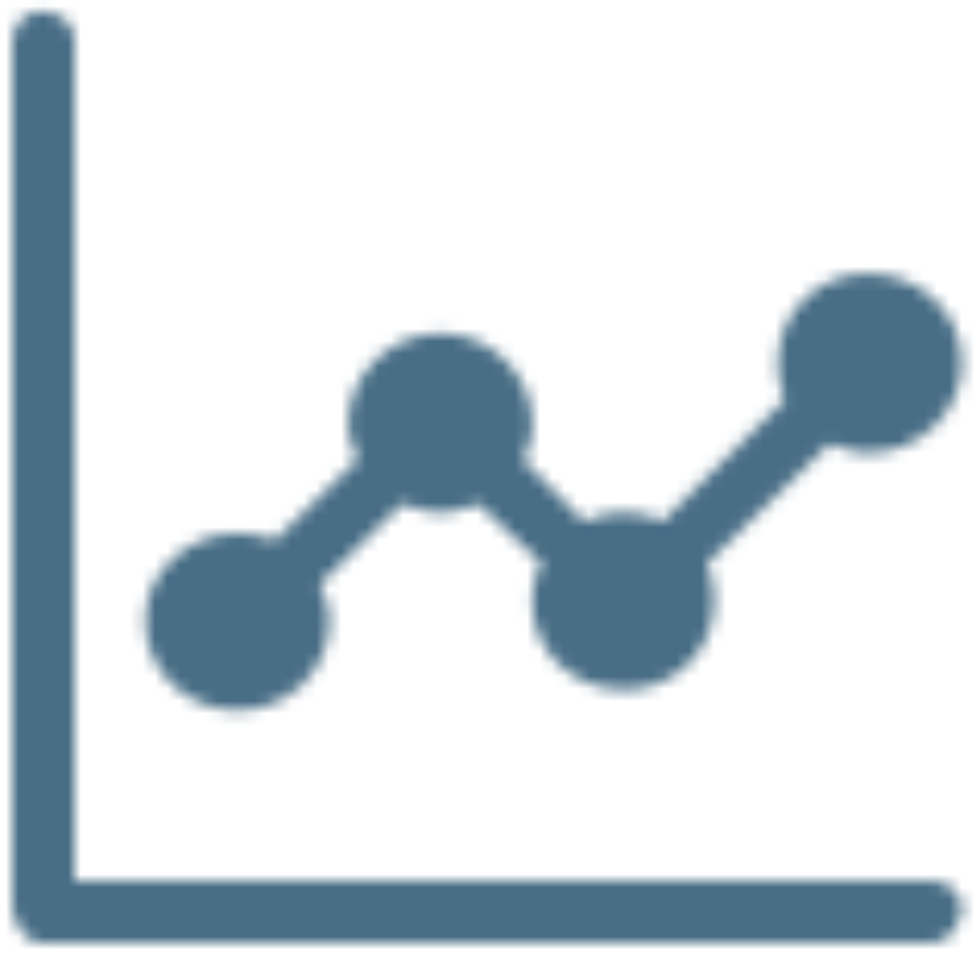 | - Chaos in the modelling community (e.g. lack of creating a modelling community).
 | - Lack of emergency funding for transdisciplinary approaches that also include the social sciences (funding gap.) |  | - Not everyone is reached with the current communication, there is the need to apply different types of communication for different target populations.
 | - Pandemic illiteracy in population and decision makers. |  | - Disruptive public discourse among scientists, within the government (politicians/policy makers), and between those two groups undermines concerted action.
 | - Neglecting to protecting the most vulnerable early on. |  | - Lack of attention to the needs of other countries.
 | - Fragmented authority (legal gap). |  | - Drug and treatment overconfidence or hesitancy (e.g. controversy around some antivirals, immune modulators known but not used).
 | - Initially lack of transparency of the decision making process, what is the plan? |  | - Not sufficiently involving human sciences into the design of pandemic measures.
 | - Complacency among the population (e.g. reluctance to wear mouth masks). |  | - Decisions are made over the head of the people most affected instead of co-creating pandemic measures with society.
 | - Not learning fast enough from the countries that precede us in the pandemic |  | - Fake news and pseudoscience causes distrust in science.
 | - Insufficient testing (e.g. supply chain problems, miscommunication, between clinical laboratories and government about capacity). |  | - Entrepreneurial initiatives that seem useful at first sight (even when for free) are not getting the attention they deserve because of difficulties with institutional approvals/evaluations.
 | - Test/trace/isolate not sufficiently effective (e.g. contact tracing app) |  | - Vaccine problems (e.g. over reliance on vaccine solutions, vaccine hesitancy).

Table 2. Diversity of fields of expertise in each group.
Group | Fields of expertise
Malaria | Mental health; nursing; pharmaceutical legislation; sustainability; innovation management; biomedicine; events services industry.
Ebola | Psychology; healthcare; pharmaceutical legislation; Health, Ethics and Society; primary care; crisismanagement.
Plague | Mental health; COVID-19 patient; philosophy; nursing; human resources; linguistics.
Smallpox | Psychology; healthcare; health policy; law; hairdressing; mathematical engineering.
Spanish Flu | Psychology; nursing; biomedicine; law; business; circular economy.

Table 3. The refined gap list with three new gaps identified by stakeholders included.
 | - Lack of transdisciplinary collaboration in policy making |  | - Chaos in the modelling community (e.g. lack of creating a modelling community).
 | - Lack of emergency funding for transdisciplinary approaches that also include the social sciences (funding gap). |  | - Not everyone is reached with the current communication, there is the need to apply different types of communication for different target populations.
 | - Pandemic illiteracy in population and decision makers about infectious disease control |  | - Disruptive public discourse among scientists, within the government (politicians/policy makers), and between those two groups undermines concerted action.
 | - Neglecting to protecting the most vulnerable early on. |  | - Lack of attention to the needs of other countries.
 | - Fragmented authority and responsibility across societal levels. |  | - Drug and treatment overconfidence or hesitancy (e.g. controversy around some antivirals, immune modulators known but not used).
 | - Initially lack of transparency of the decision making process, what is the plan? |  | - Not sufficiently involving human sciences into the design of pandemic measures.
 | - Complacency among the population (e.g. reluctance to wear mouth masks). |  | - Decisions are made over the head of the people most affected instead of co-creating pandemic measures with society.
 | - Insufficient learning from previous pandemic experience such as other countries or historical pandemics. |  | - Fake news and pseudoscience causes distrust in science.
 | - Insufficient testing (e.g. supply chain problems, miscommunication, between clinical laboratories and government about capacity). |  | - Entrepreneurial initiatives that seem useful at first sight (even when for free) are not getting the attention they deserve because of difficulties with institutional approvals/evaluations.
 | - Test/trace/isolate not sufficiently effective (e.g. contact tracing app) |  | - Vaccine problems (e.g. over reliance on vaccine solutions, vaccine hesitancy).
 | - Insufficient involvement of, communication with, and funding for primary care workers |  | - Lack of strategic logistical supply chains
 | - Lack of taking care of the natural environment
Note. Gaps in bold were redefined or added through the group discussions.

Table 4. Most important gaps identified by each team.
Group | Most important gaps  (corresponding gap)
Malaria | - Risk acceptance analysis  (Lack of transdisciplinary collaboration in policy making)  - Involvement of all disciplines  (Lack of involving human sciences)  - Global cooporation  (Lack of attention to the needs of other countries)
Ebola | - Not sufficiently involving human sciences into the design of pandemic measures.  - Decisions are made over the head of the people most affected instead of co-creating pandemic measures with society.  (Lack of transdisciplinary collaboration in policy making)  - Not learning fast enough from the countries that precede us in the pandemic  (Not seeking to learn from other countries)  - Learn from pandemic history  (Not seeking to learn from other countries)  - The research for new crises in the sideline of this crisis, provoked by it  (Lack of transdisciplinary information for policy making)
Plague | - Transdisciplinary working together  (Lack of transdisciplinary collaboration in policy making)  - Lack of use of behavioral science insights  (Not sufficiently involving human sciences into the design of pandemic measures)  - The mind in causality of the COVID phenomenon, individually and socially  (Lack of transdisciplinary collaboration in policy making)
Smallpox | - The need for setting up a transdisciplinary advisory board that assists the government during the pandemic crisis.  (Lack of transdisciplinary collaboration in policy making)  - Pandemic illiteracy in population and decision makers.  (Pandemic illiteracy in population and decision makers about infectious disease control)  - Not sufficiently involving human sciences into the design of pandemic measures.
Spanish Flu | - Fragmented authority (legal gap).  (Fragmented authority and responsibility across societal levels)  - Not learning fast enough from the countries that precede us in the pandemic  (Not seeking to learn from other countries)  - Not sufficiently involving human sciences into the design of pandemic measures.  - Lack of commitment of nursing leadership  (Insufficient involvement of, communication with, and funding for primary care workers)

Note. We present the original phrasing used by the groups and added the corresponding gap from the list in between brackets where phrasing was different. Some teams had an equal amount of importance for several gaps. In group Ebola votes for second and third place were spread over many different gaps. We have therefore only included the gaps that received the most and the second most votes for this group.

Table 5. Deeper cause(s) identified for the most important gap(s) by each group in exercise 2.
Group | Most important gap | Deeper cause(s)
Malaria | - Lack of risk acceptance analysis  (Lack of transdisciplinary collaboration in policy making) | - lack of clearly defined common objectives  - doubt on the existing representation system (parliament, advisory bodies, ...)
Ebola | - Not sufficiently involving human sciences into the design of pandemic measures. | - Lack of long term vision meeting broader societal needs  - Equitable treatment of different people / disciplines/ social groups  - wrong focus and types of thinking in gov  - not bringing the right people together at the right time
Plague | - Transdisciplinary working together  (Lack of transdisciplinary collaboration in policy making) | - lack of inter-disciplinary vision on patient centeredness  - Lack of (trans-disciplinary) educational reform  - Dissociation/ lack of compassion  - lack of interdisciplinary ethical reflection  - exposure to meaning of dealing with pandemic
Smallpox | - The need for setting up a transdisciplinary advisory board that assists the government during the pandemic crisis.  (Lack of transdisciplinary collaboration in policy making) | - there is competition over control and power at all levels  - fear of appearing weak and losing votes (and therefore power)  - lack of Literacy and trust  - (which?) ideology consciously created distrust in government worldwide / expertise
 | - Pandemic illiteracy in population and decision makers.  (Pandemic illiteracy in population and decision makers about infectious disease control) | - Insufficient consideration of population risk vs individual risk  - 0 risk is non-existing, is not grasped  - undervalorisation (societal and economical) of being healthy  - experts do not necessarily say what people want to hear; this is difficult to accept
Spanish Flu | - Fragmented authority (legal gap).  (Fragmented authority and responsibility across societal levels) | - Little trust in leadership
Spanish Flu | - Not sufficiently involving human sciences into the design of pandemic measures. | - Little trust in leadership
Note. The table shows the original wording of the teams with the corresponding gap from the list in between brackets.

