SUPPLEMENTARY INFORMATION

Aerosol inhibition on photochemical surface ozone formation under future climate and air quality scenarios
G S Gopikrishnan^{1,2}, D. M. Westervelt^{2,*} and J. Kuttippurath¹
¹ CORAL, Indian Institute of Technology Kharagpur, Kharagpur–721302, India.
² Lamont‐Doherty Earth Observatory, Columbia University, New York - 10964, NY, USA

* To whom correspondence should be addressed. Email: danielmw@ldeo.columbia.edu

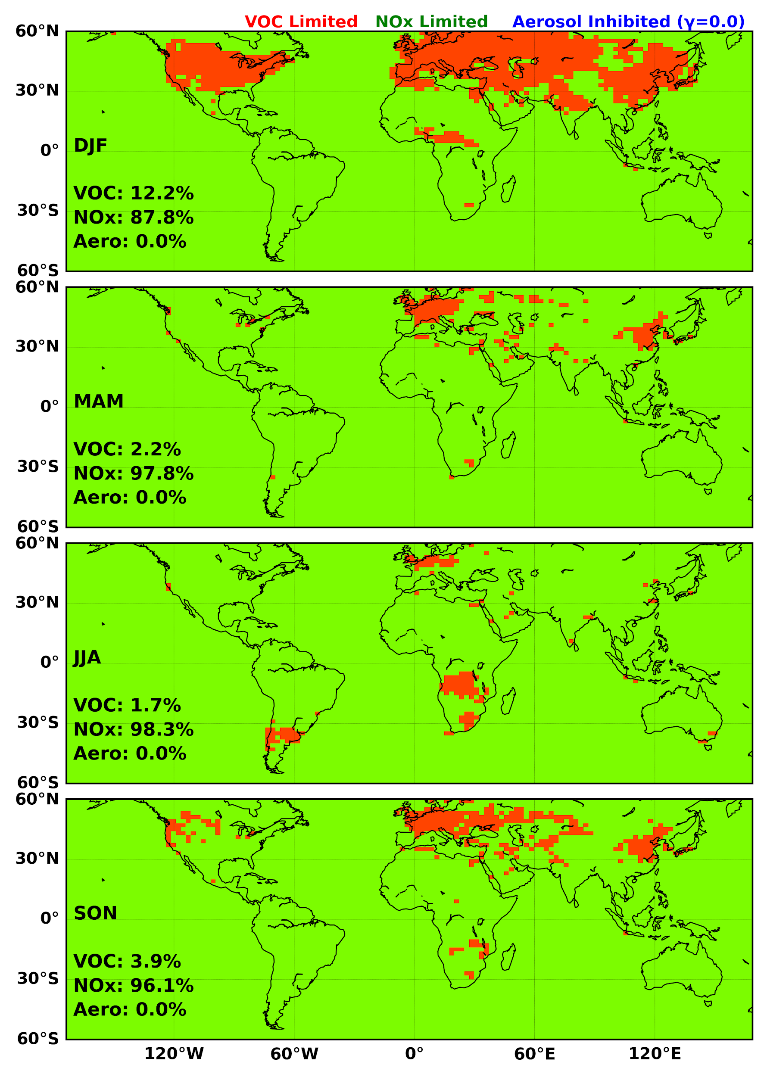
Supplementary Fig. 1| The regional distribution of various ozone generation photochemical regimes modelled with an aerosol uptake coefficient of 0 in 2018.

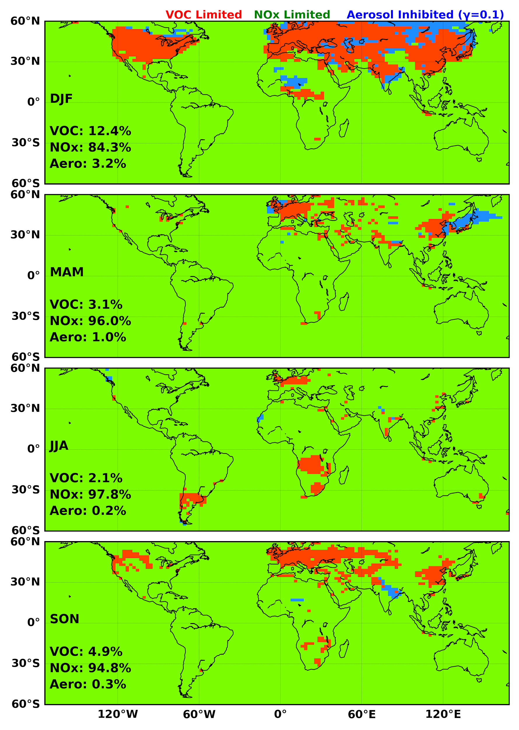
Supplementary Fig. 2| The regional distribution of various ozone generation photochemical regimes modelled with an aerosol uptake coefficient of 0.1 in 2018.

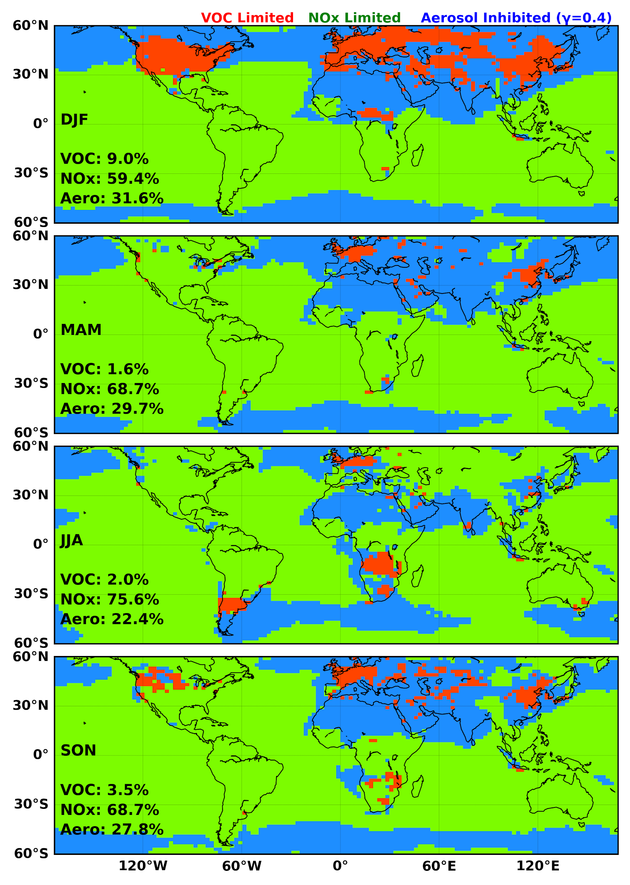
Supplementary Fig. 3| The regional distribution of various ozone generation photochemical regimes modelled with an aerosol uptake coefficient of 0.4 in 2018.

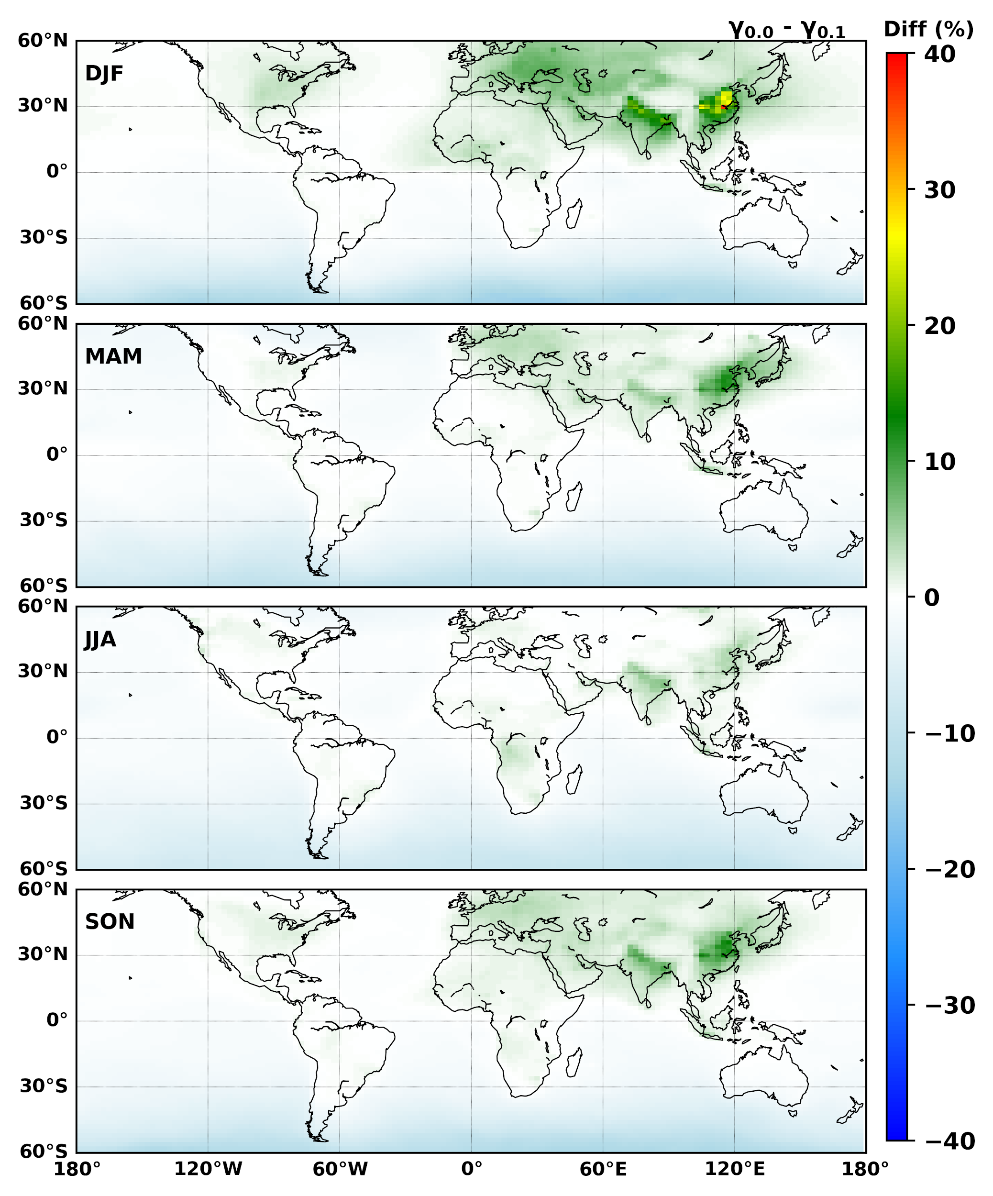
Supplementary Fig. 4| The percentage change in surface ozone between 0 aerosol uptake and 0.1 aerosol uptake values in 2018.

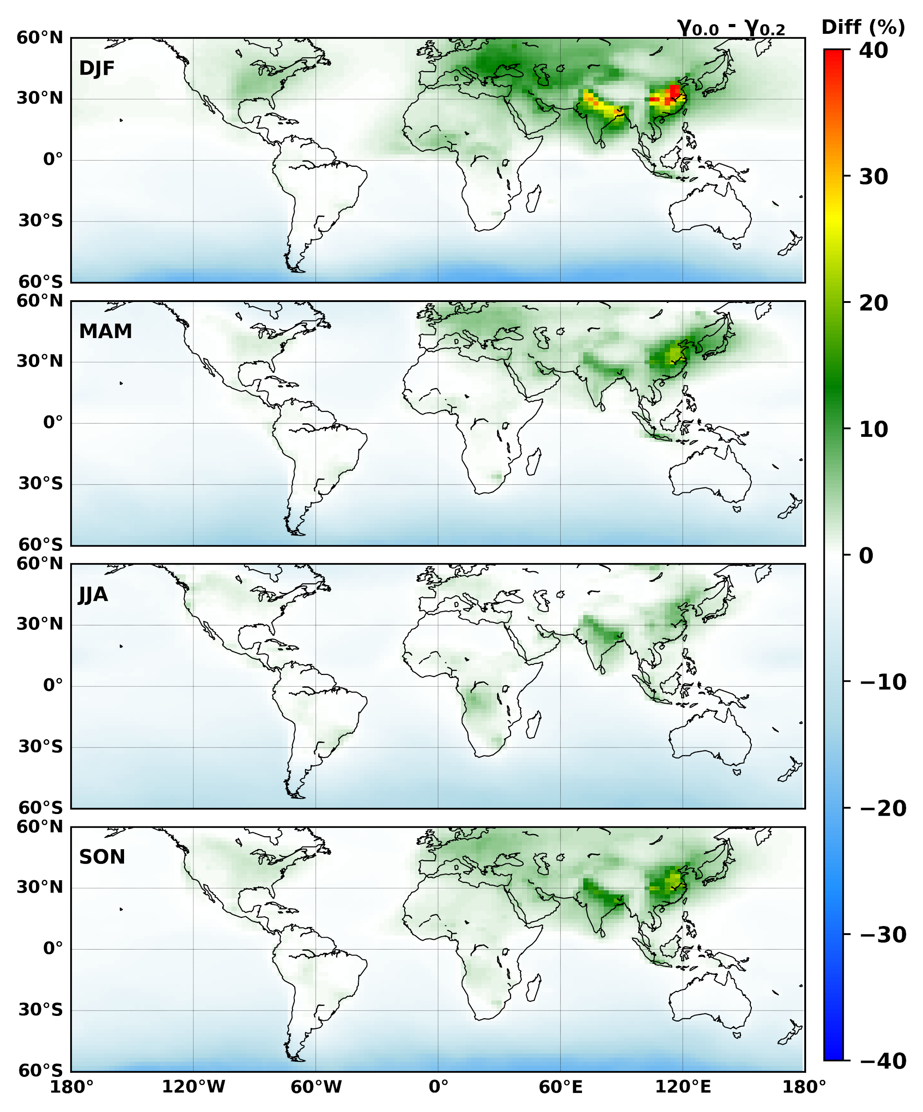
Supplementary Fig. 5| The percentage change in surface ozone between when γHO₂ is 0 and 0.2 in 2018.

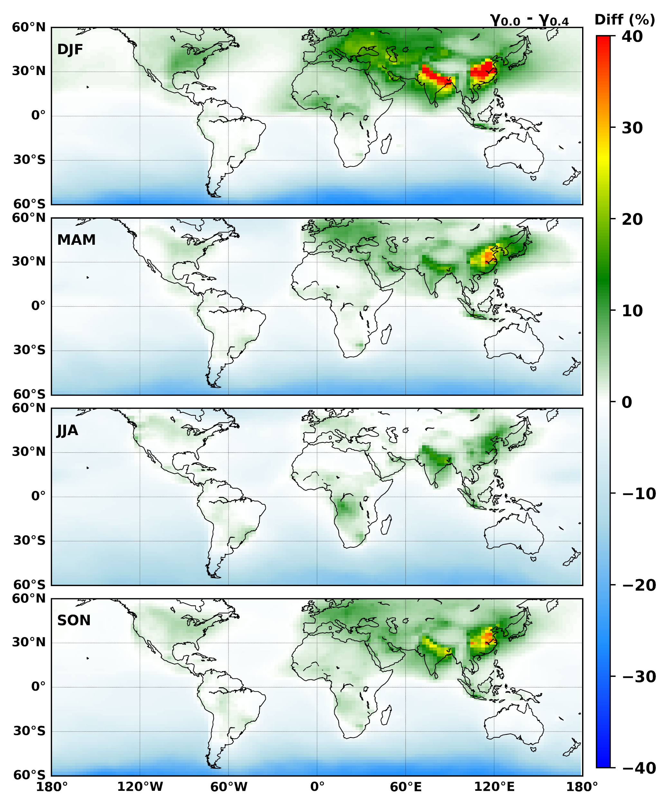
Supplementary Fig. 6| The percentage change in surface ozone between 0 aerosol uptake and 0.4 aerosol uptake values in 2018.

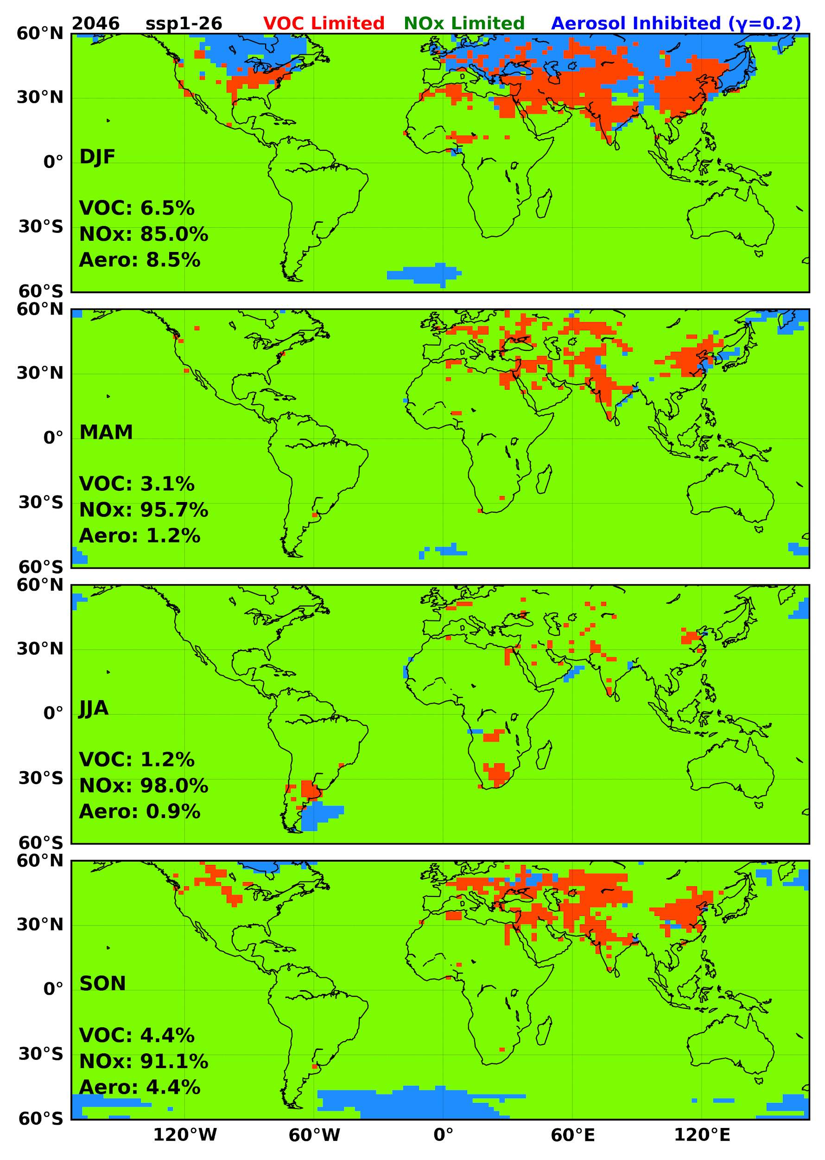
Supplementary Fig. 7| The regional distribution of ozone generation photochemical regimes modelled with an aerosol uptake coefficient of 0.2 in the SSP 1-2.6 scenario for 2046

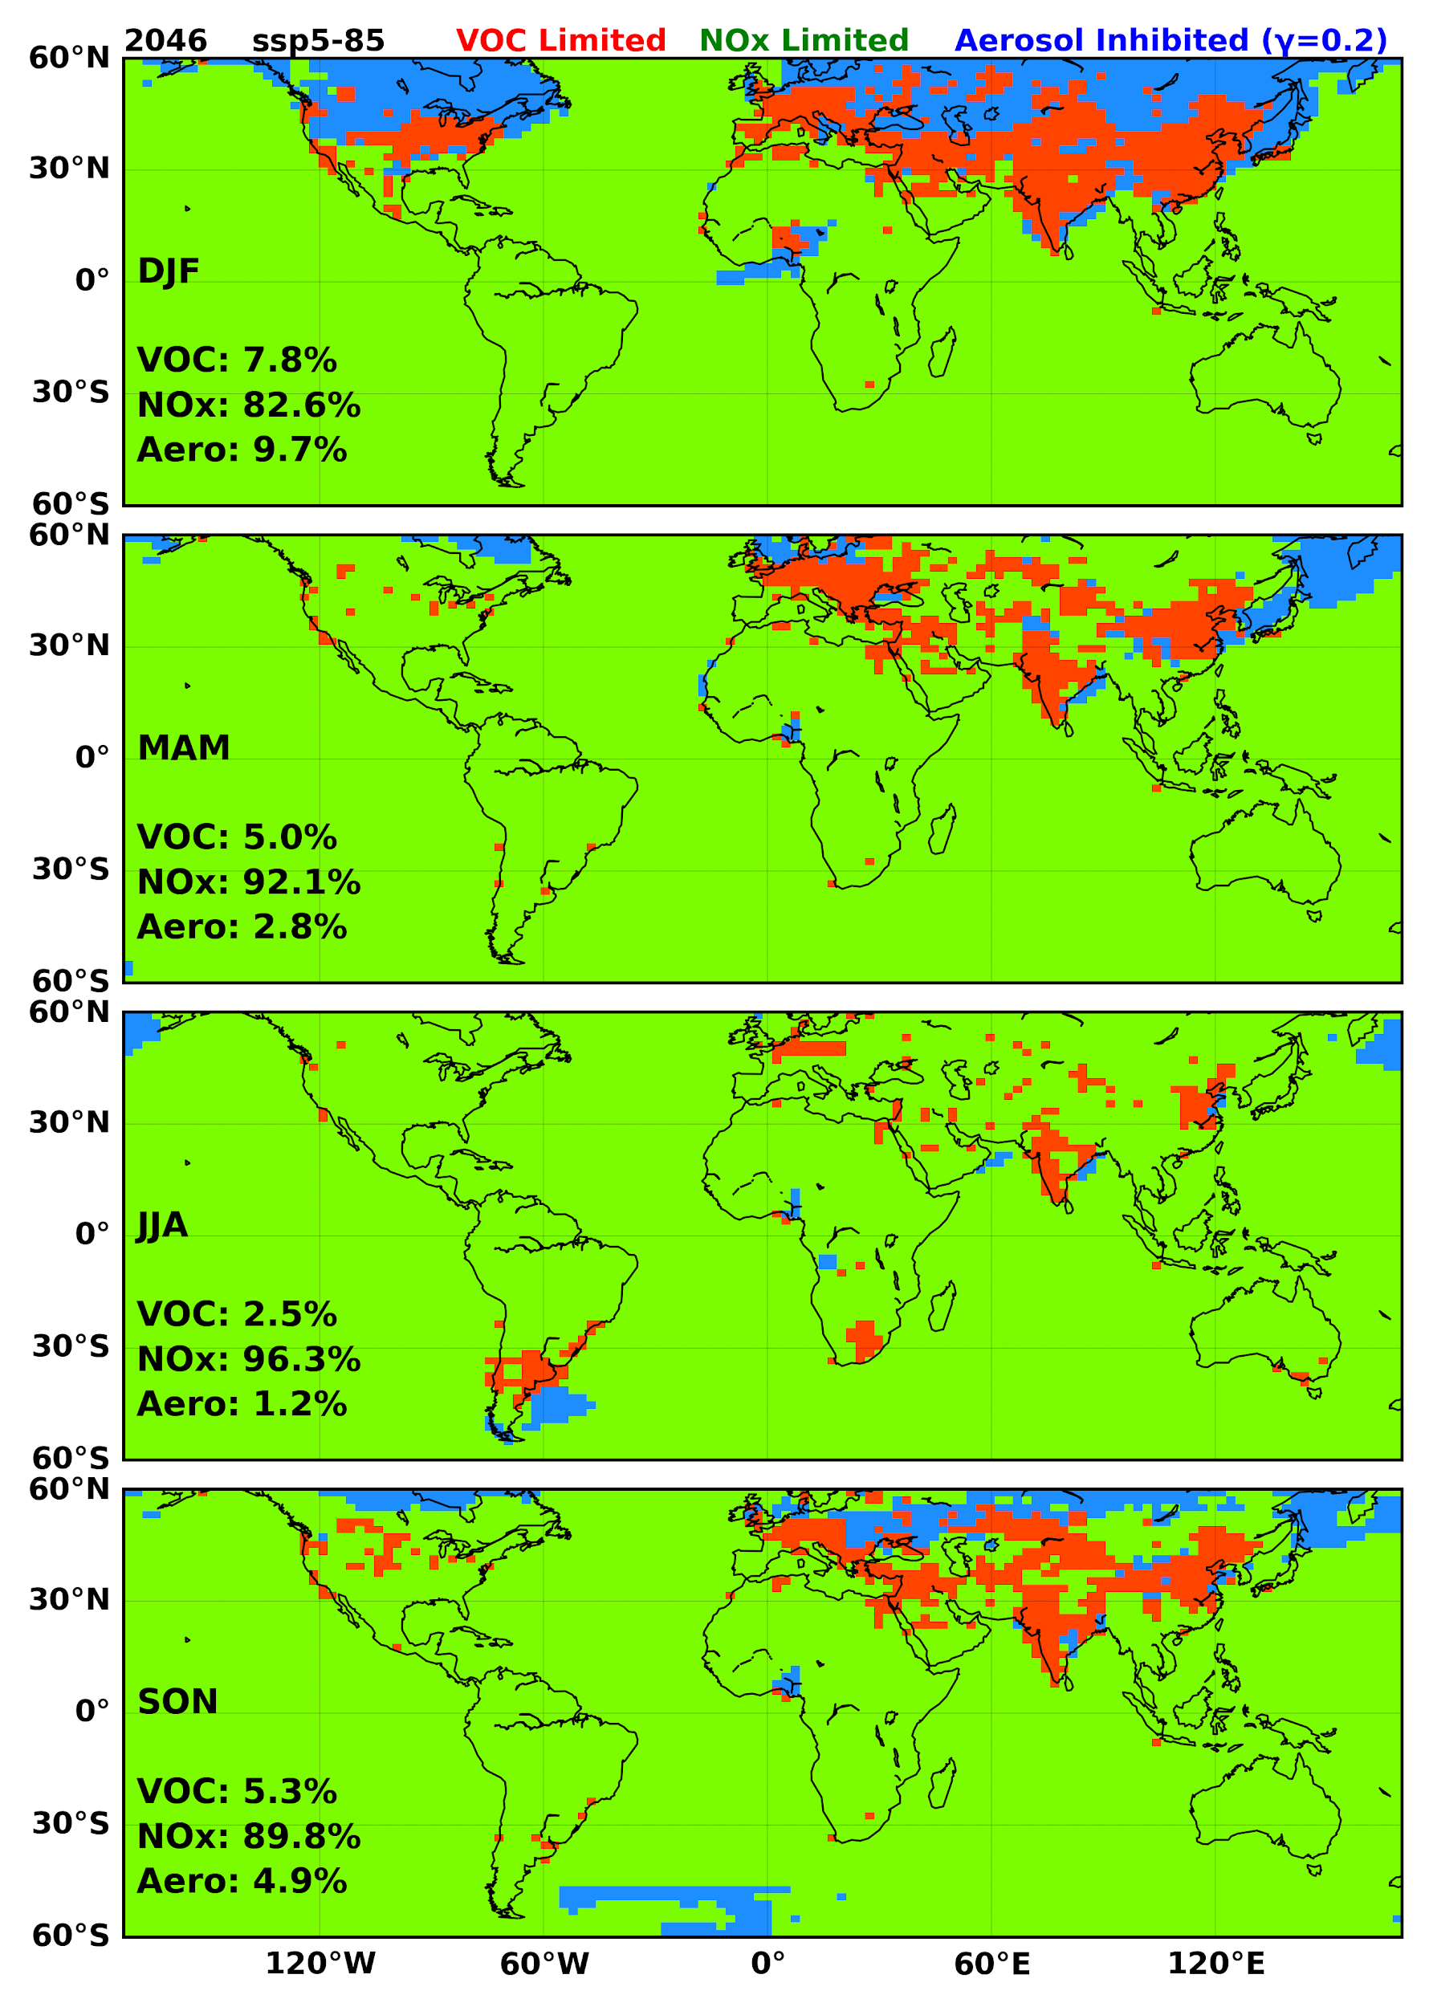
Supplementary Fig. 8| The regional distribution of ozone generation photochemical regimes modelled with an aerosol uptake coefficient of 0.2 in the SSP 5-8.5 scenario for 2046

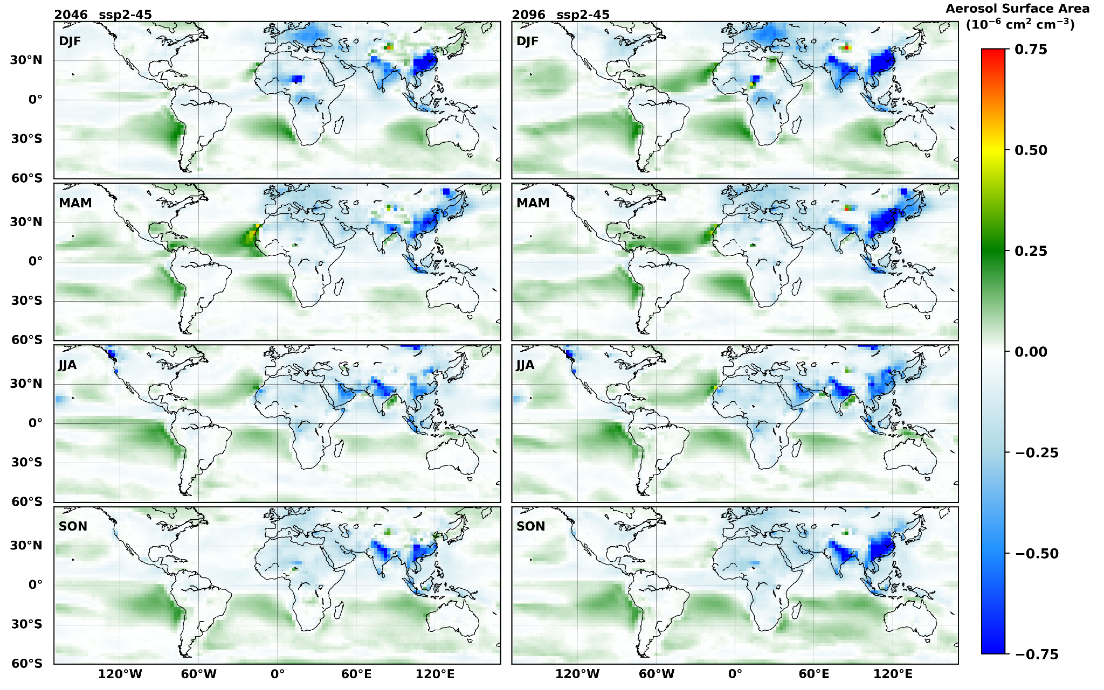
Supplementary Fig. 9| The change in Aerosol surface area density in SSP 2-4.5 for [left] 2046 and [right] 2096 when compared to that of 2018.

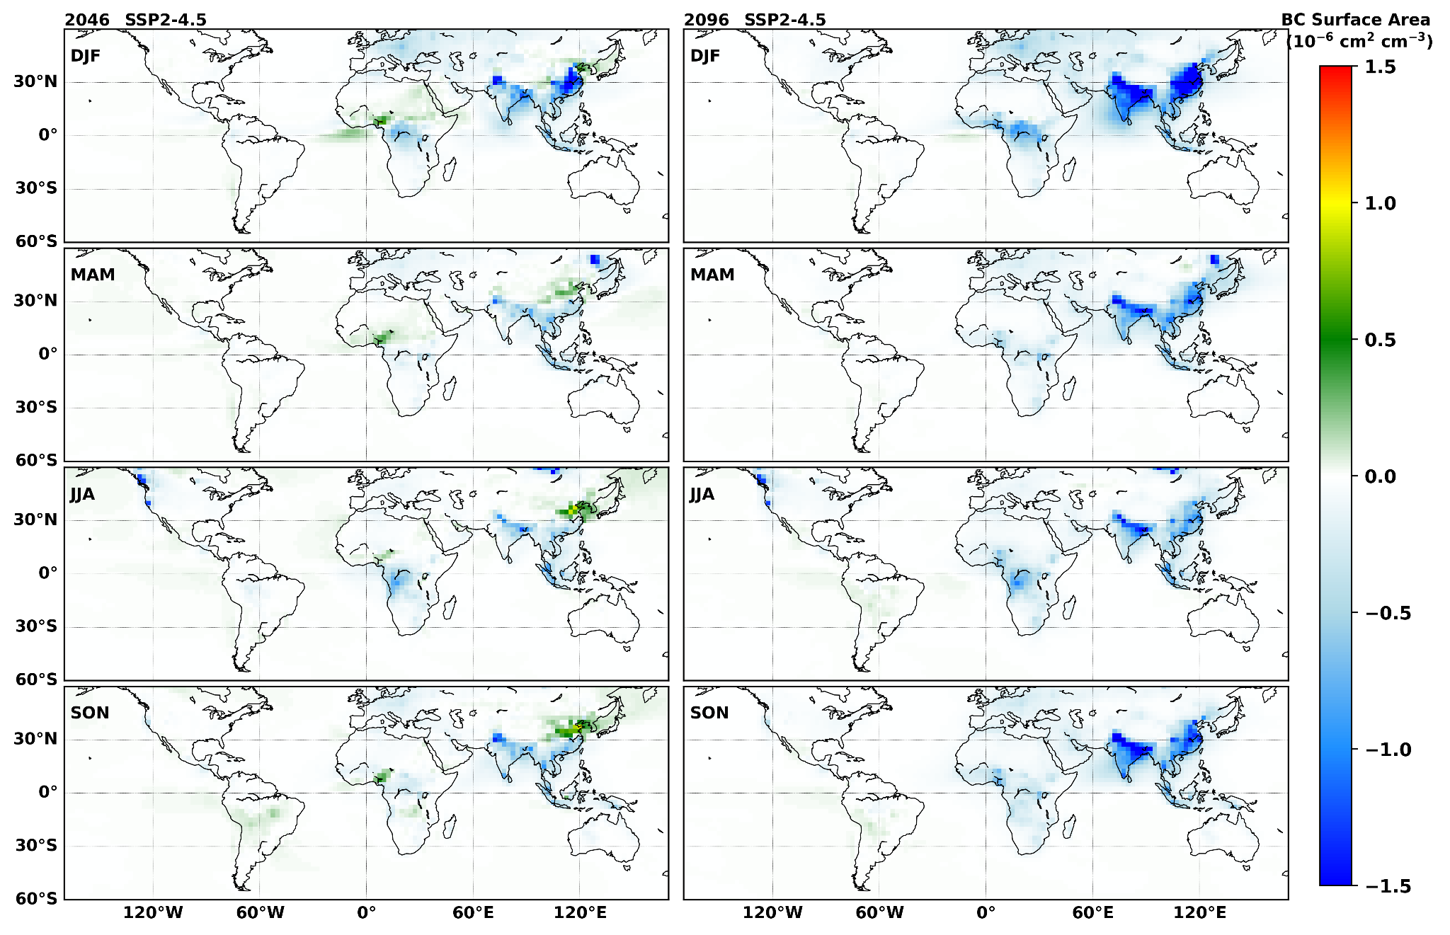
Supplementary Fig. 10| The change in Black Carbon Aerosol surface area density in SSP 2-4.5 for [left] 2046 and [right] 2096 when compared to that of 2018.

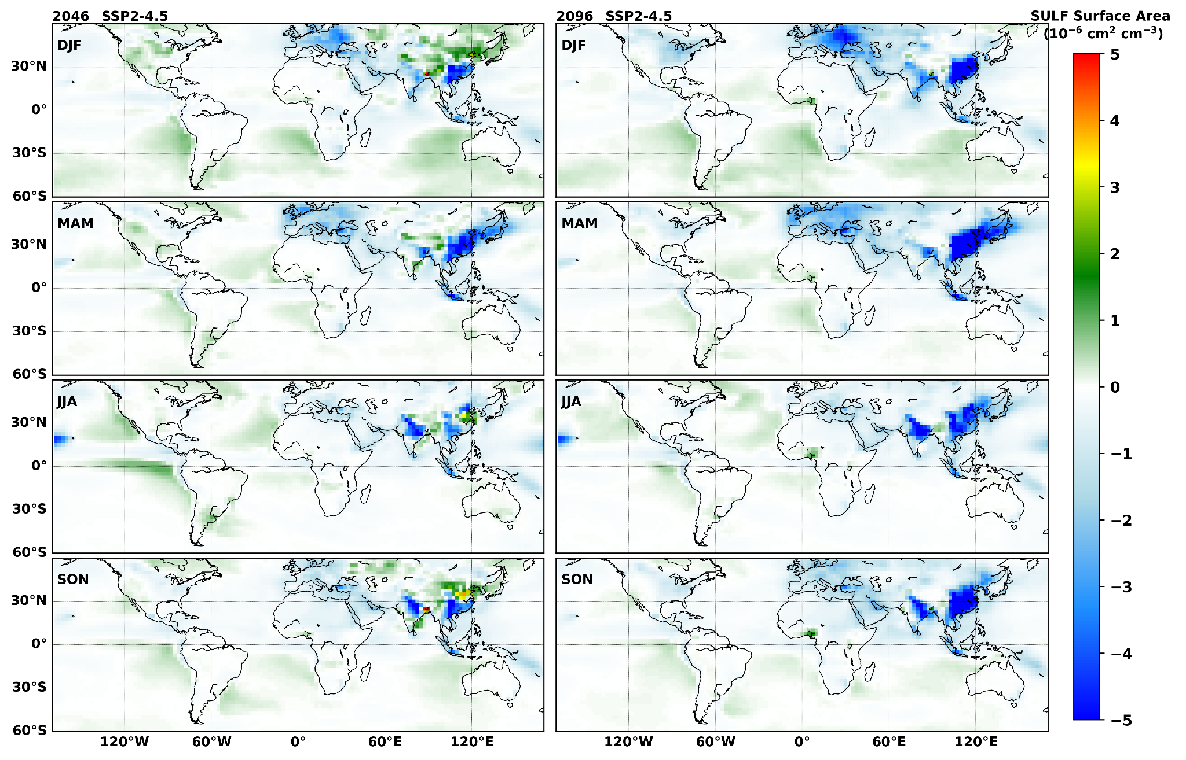
Supplementary Fig. 11| The change in Sulphate Aerosol surface area density in SSP 2-4.5 for [left] 2046 and [right] 2096 when compared to that of 2018.

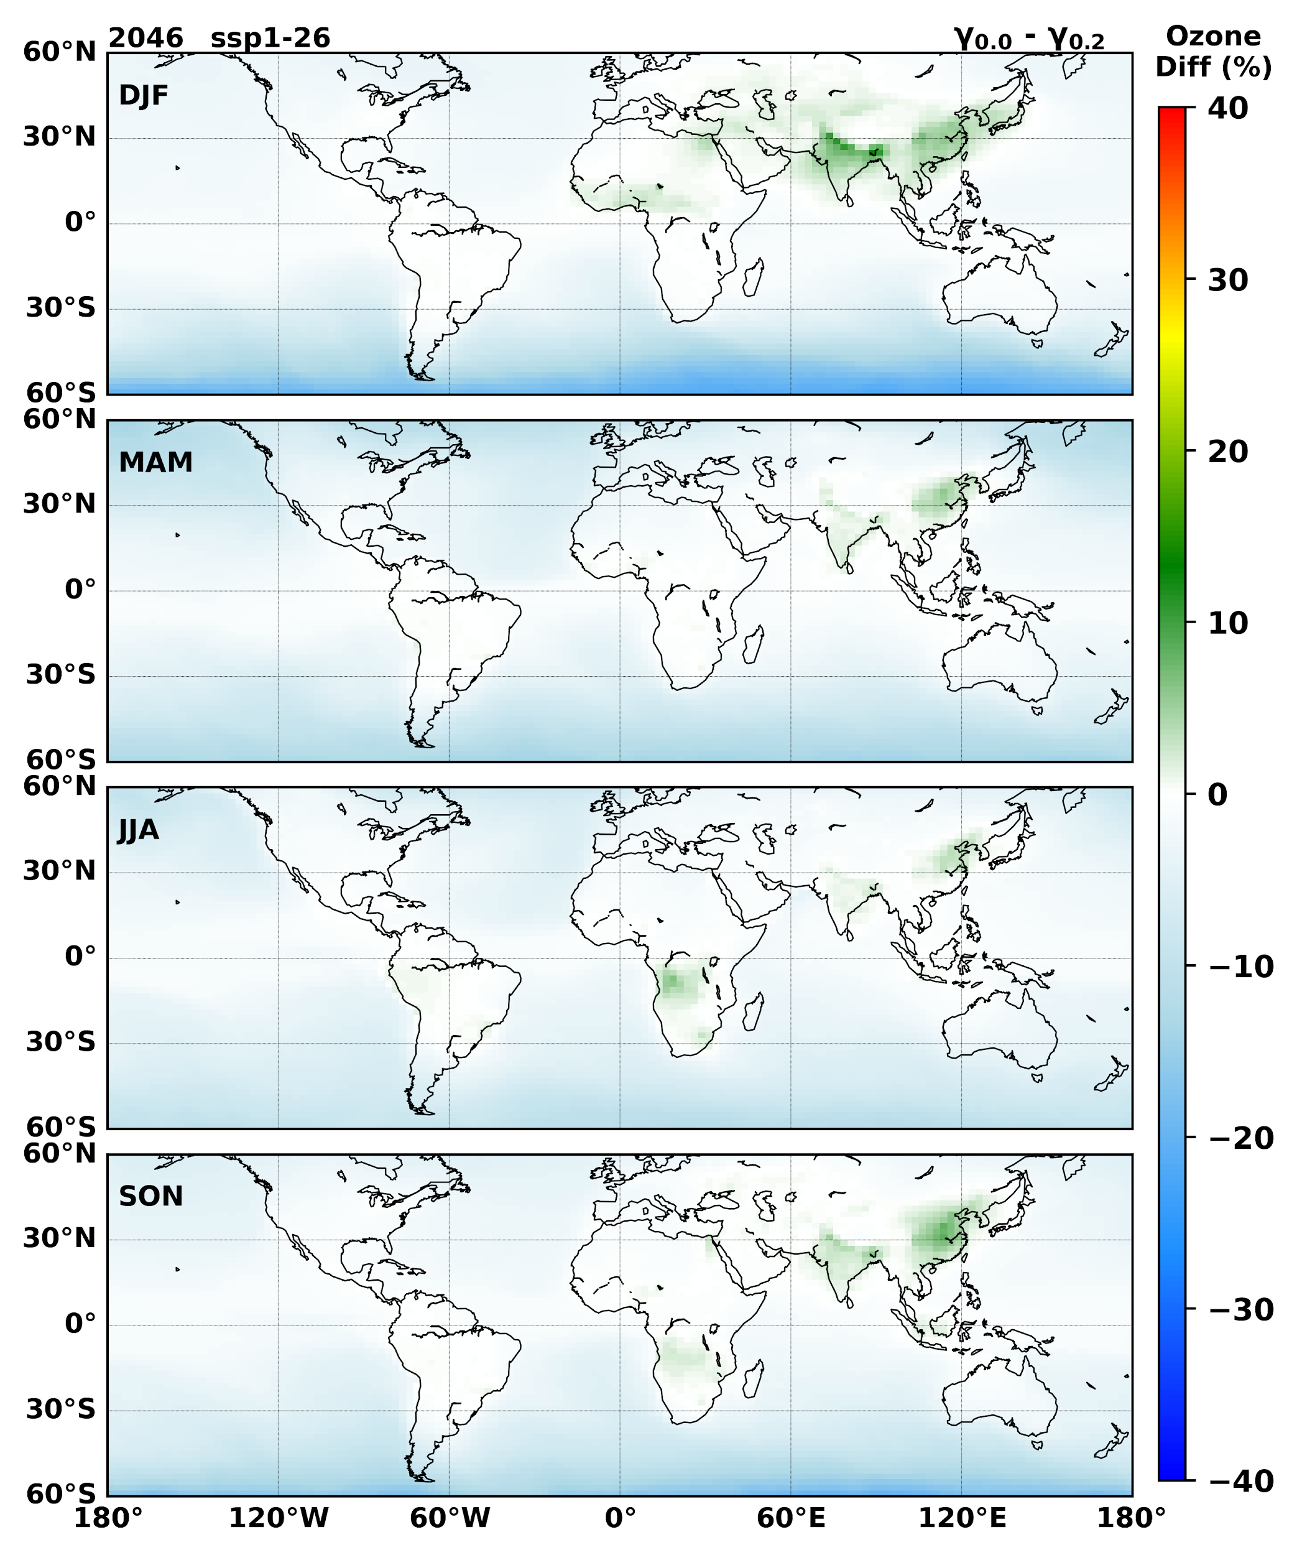
Supplementary Fig. 12| The percentage change in surface ozone between 0 aerosol uptake and 0.2 aerosol uptake values for the SSP 1-2.6 scenario in 2046.

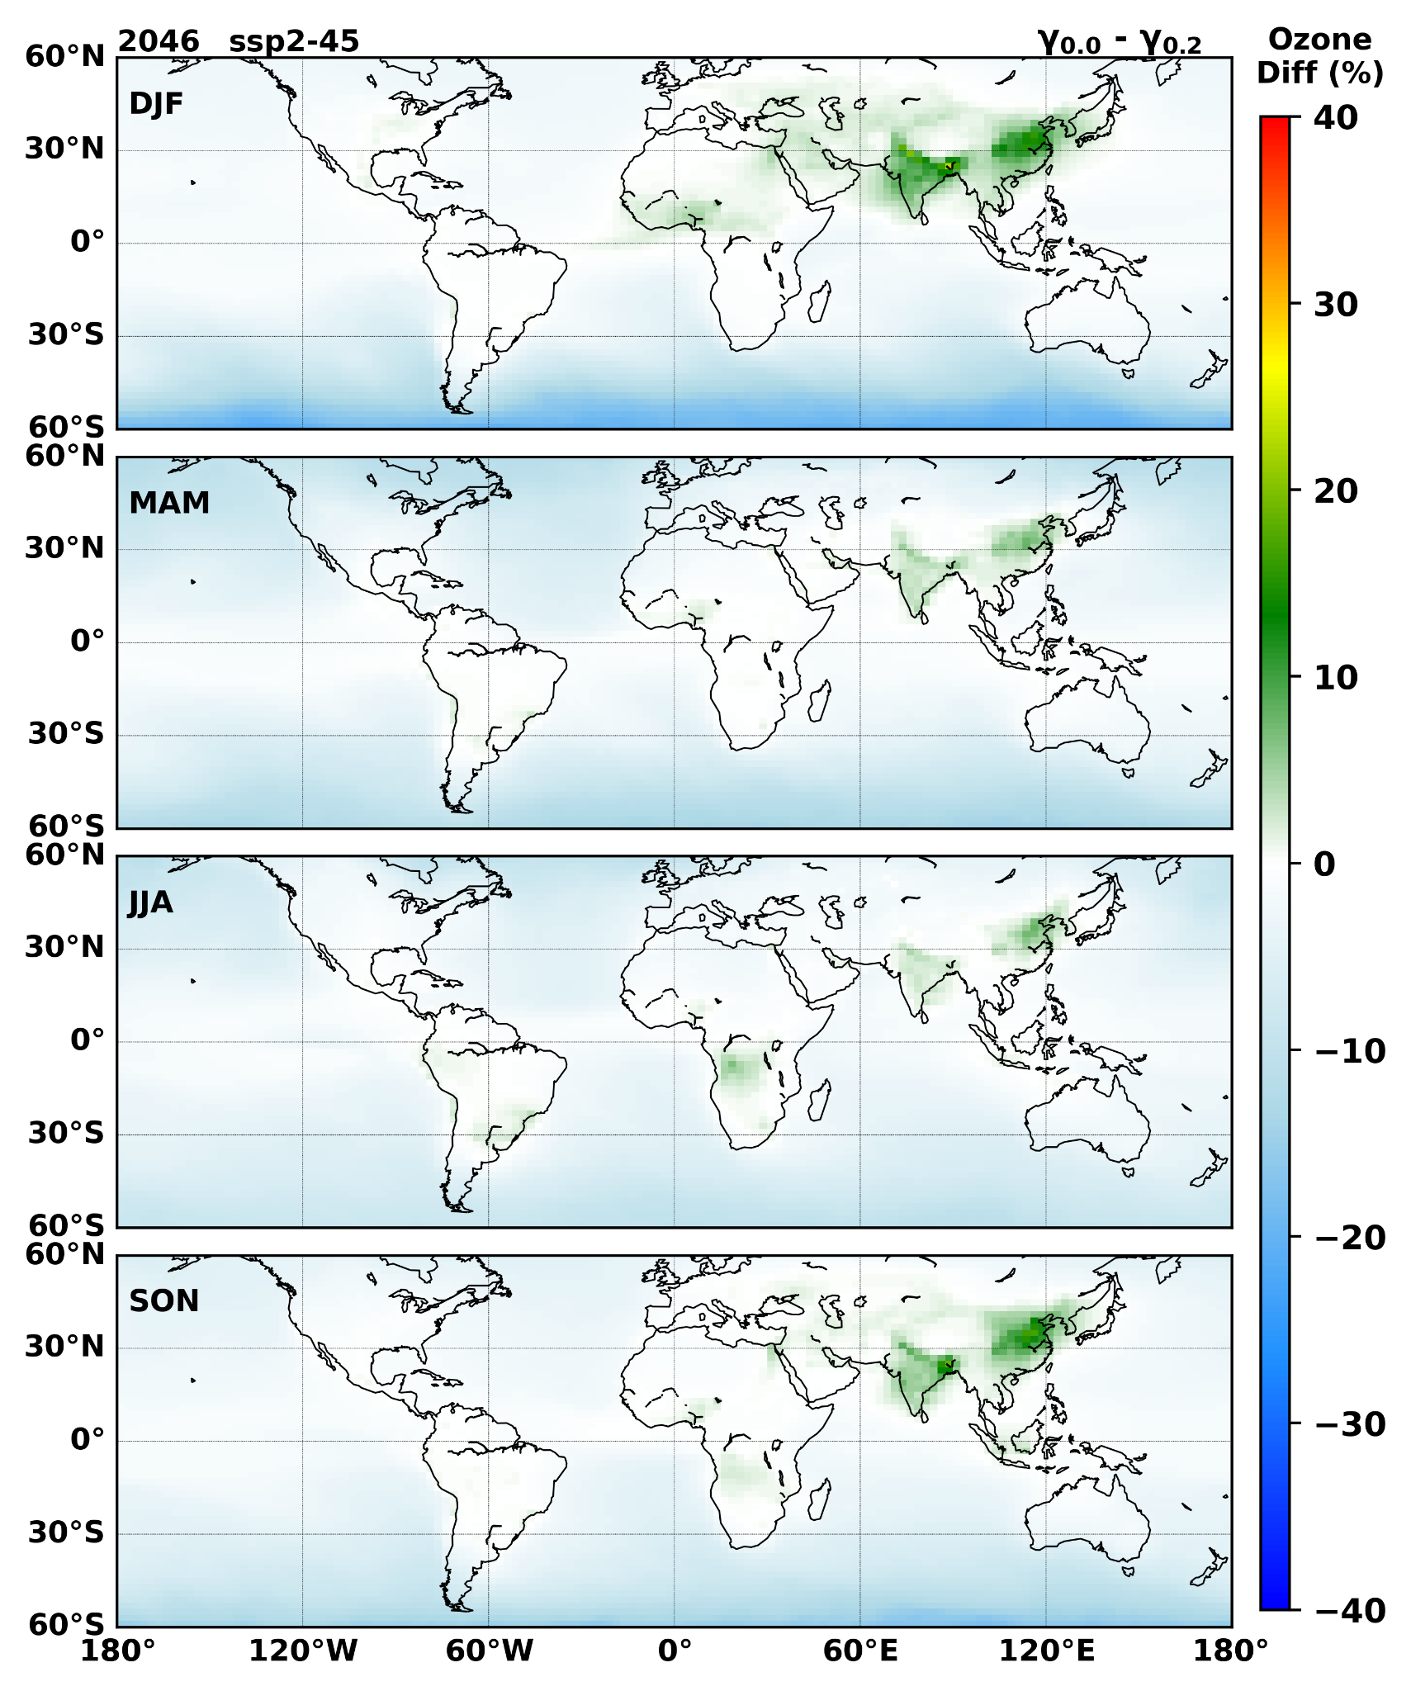
Supplementary Fig. 13| The percentage change in surface ozone between 0 aerosol uptake and 0.2 aerosol uptake values for the SSP 2-4.5 scenario in 2046.

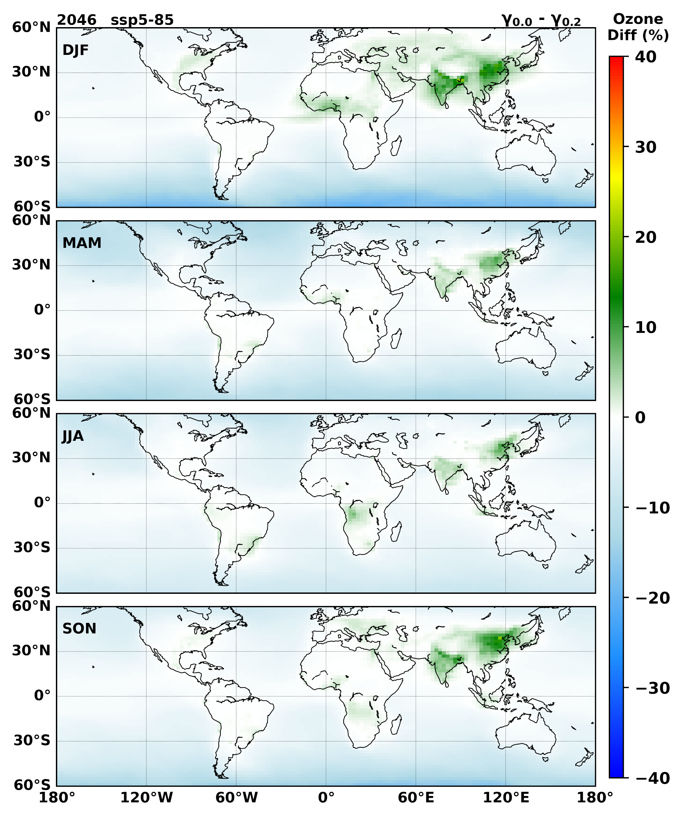
Supplementary Fig. 14| The percentage change in surface ozone between 0 aerosol uptake and 0.2 aerosol uptake values for the SSP 5-8.5 scenario in 2046.

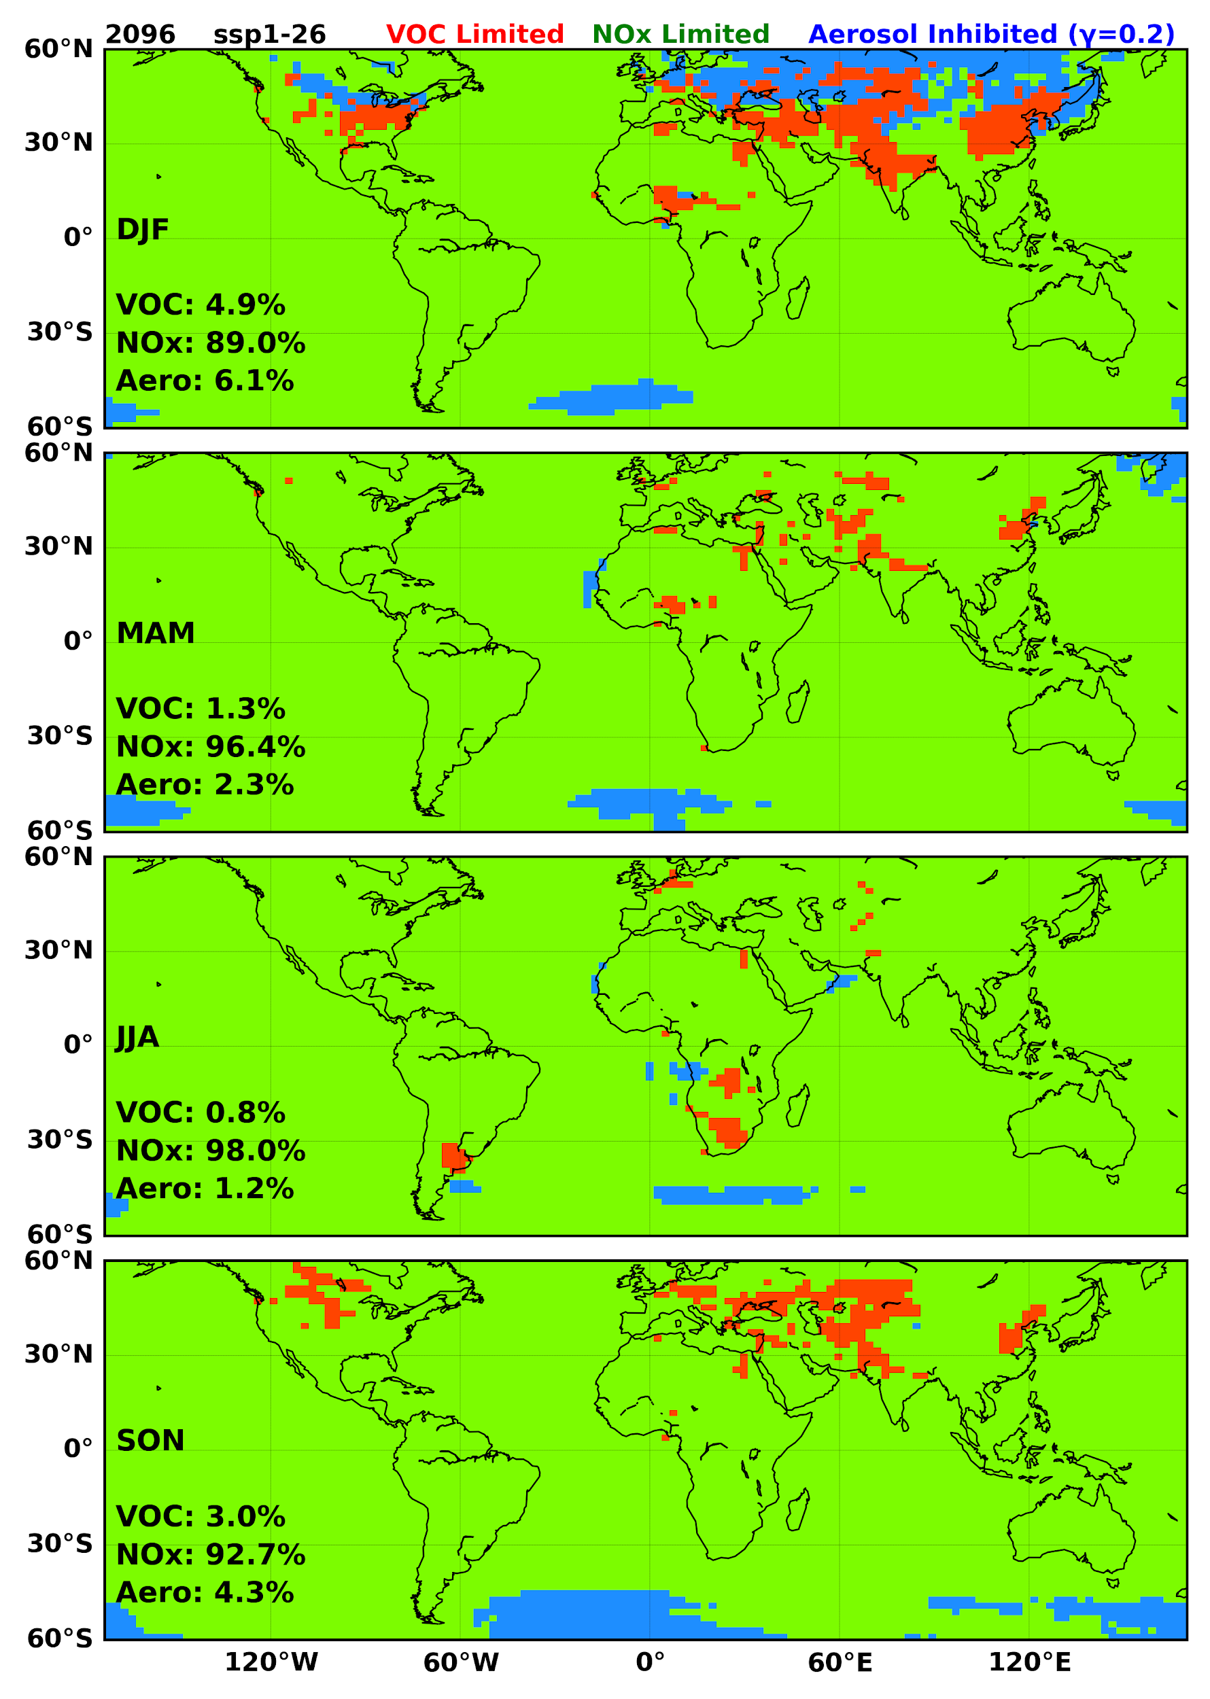
Supplementary Fig. 15| The regional distribution of ozone generation photochemical regimes modelled with an aerosol uptake coefficient of 0.2 in the SSP 1-2.6 scenario for 2096.

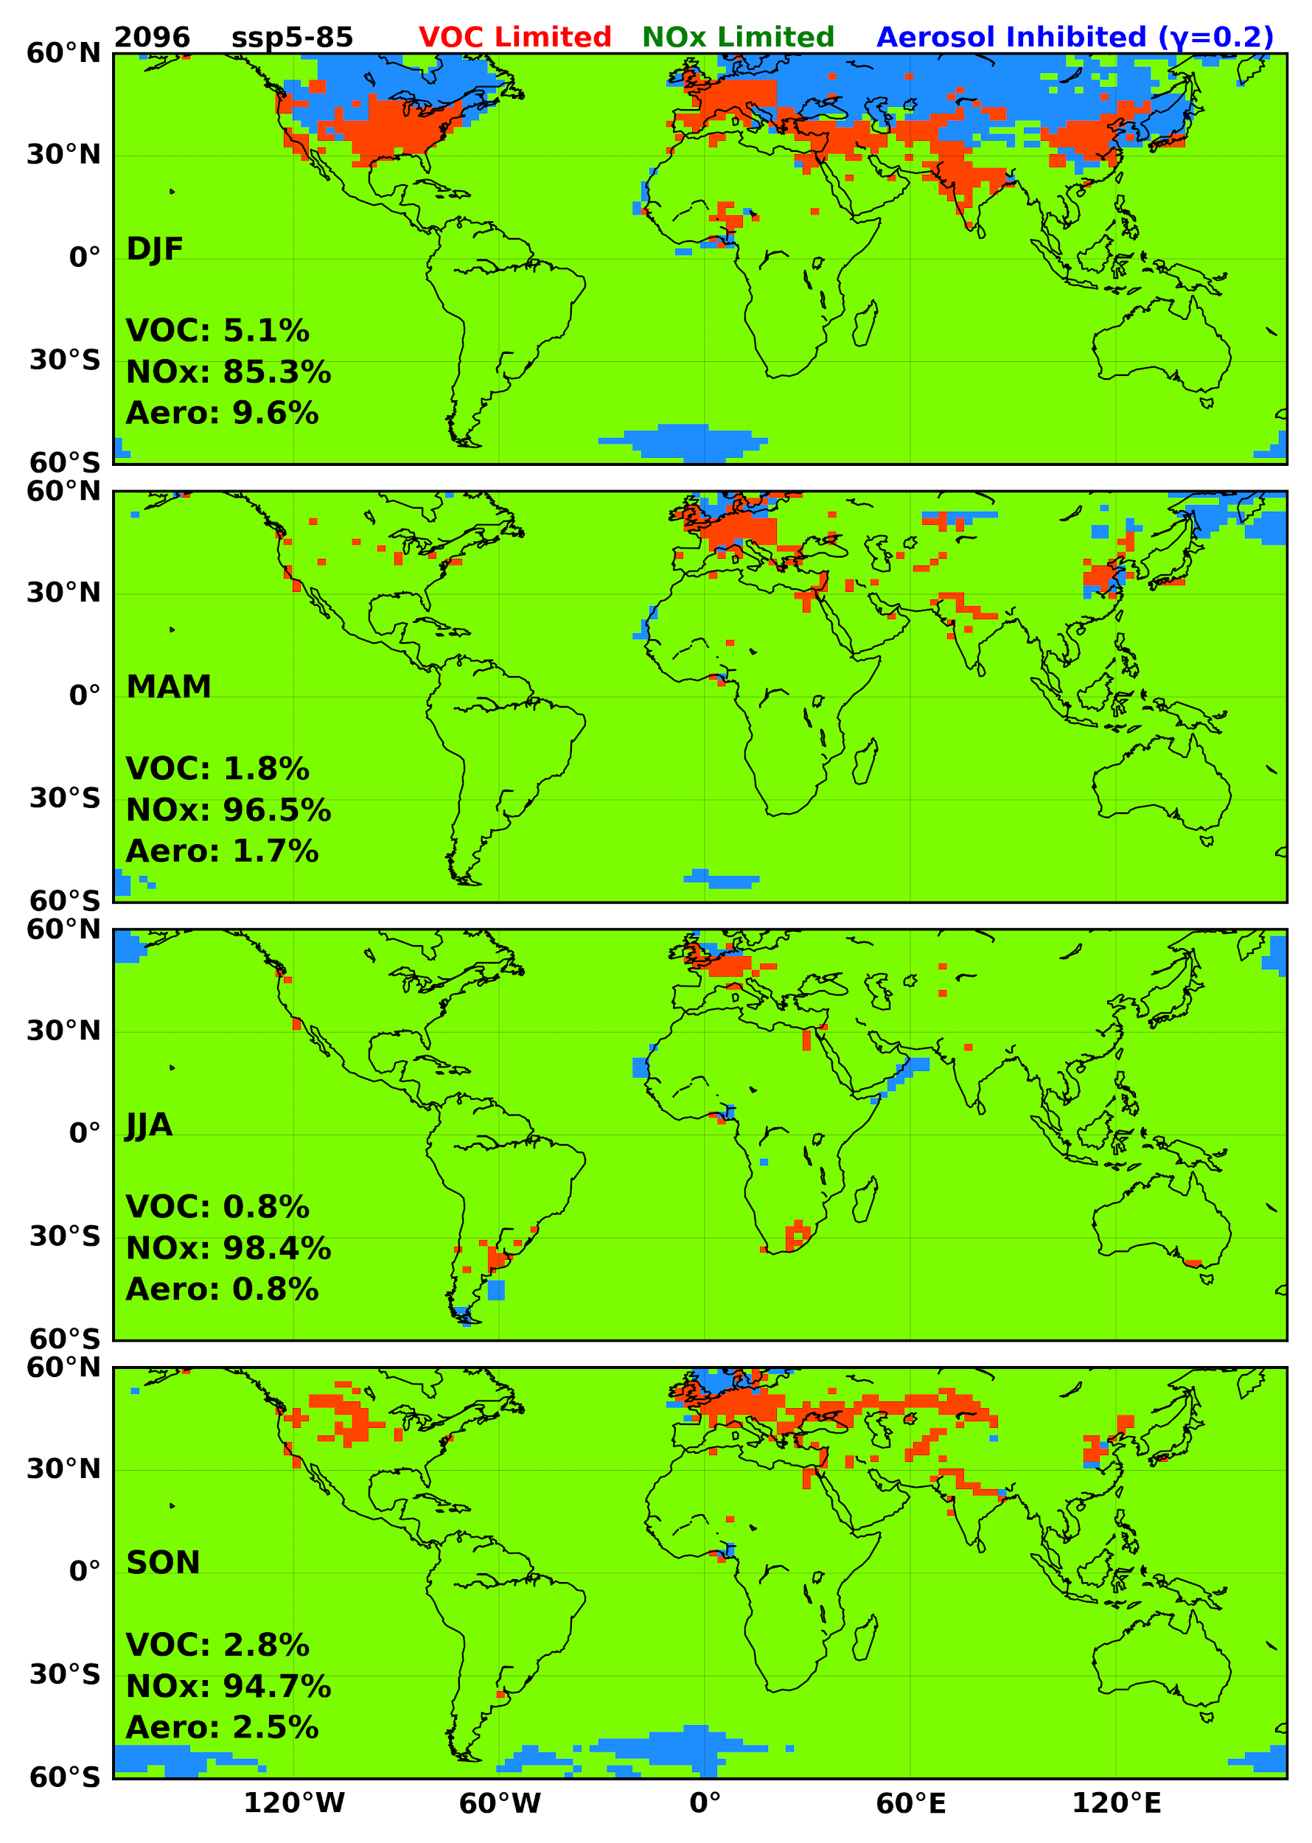
Supplementary Fig. 16| The regional distribution of ozone generation photochemical regimes modelled with an aerosol uptake coefficient of 0.2 in the SSP 5-8.5 scenario for 2096

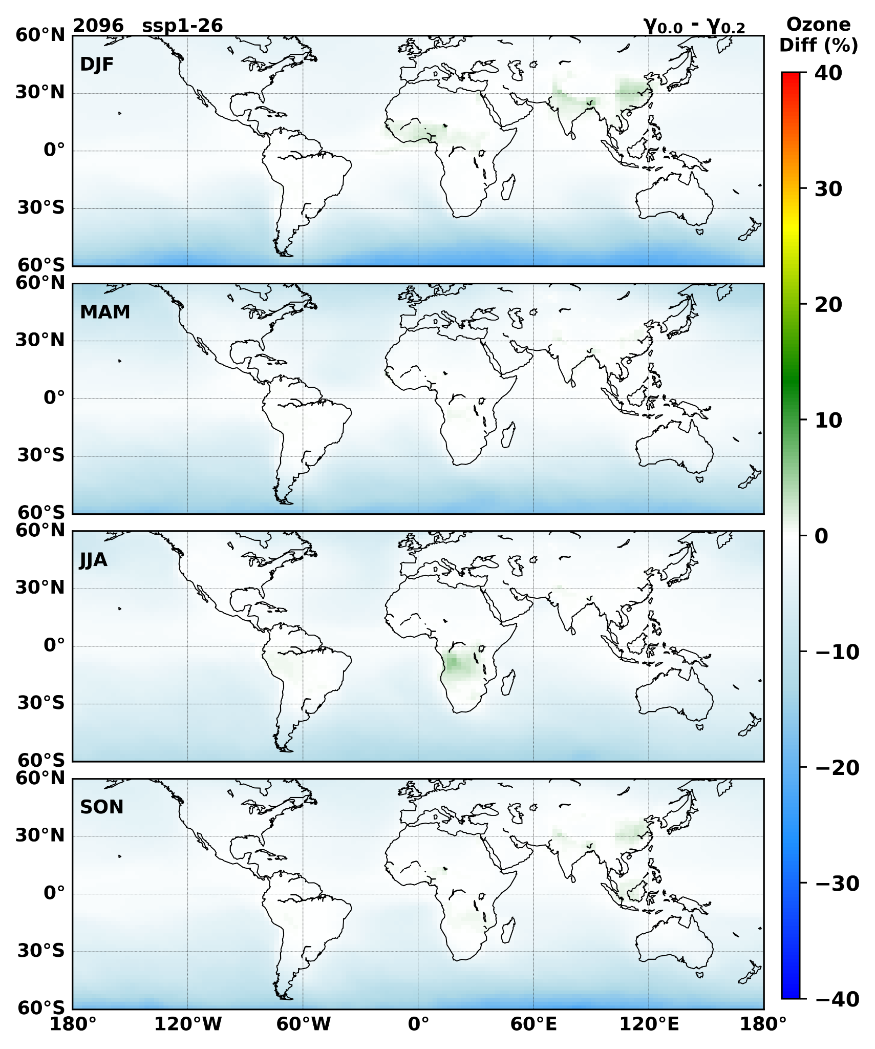
Supplementary Fig. 17| The percentage change in surface ozone between 0 aerosol uptake and 0.2 aerosol uptake values for the SSP 1-2.6 scenario in 2096.

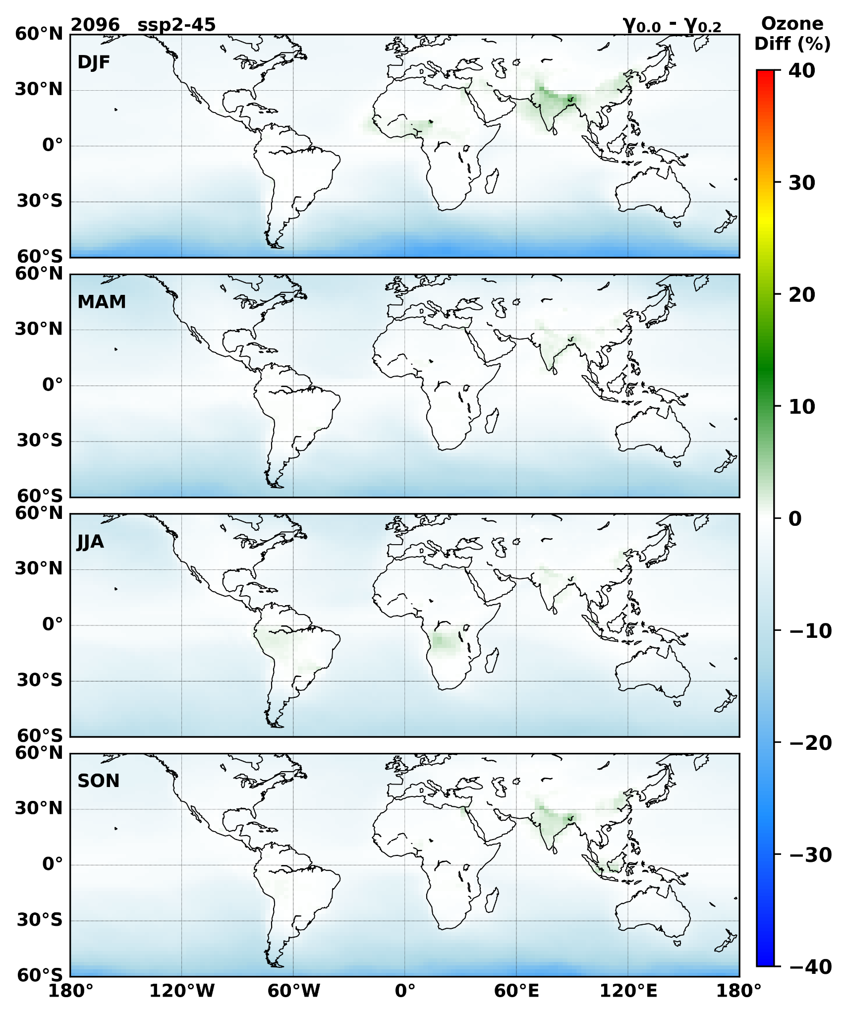
Supplementary Fig. 18| The percentage change in surface ozone between 0 aerosol uptake and 0.2 aerosol uptake values for the SSP 2-4.5 scenario in 2096.

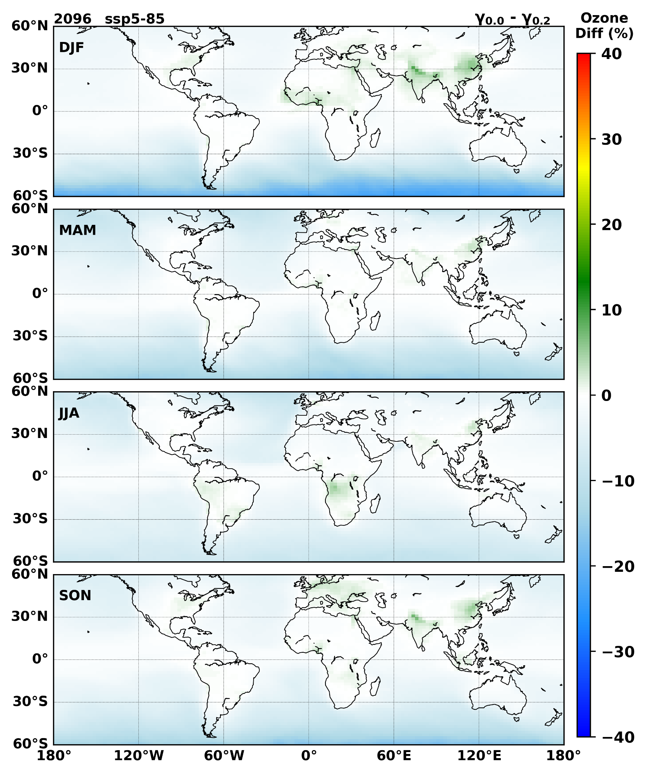
Supplementary Fig. 19| The percentage change in surface ozone between 0 aerosol uptake and 0.2 aerosol uptake values for the SSP 5-8.5 scenario in 2096.

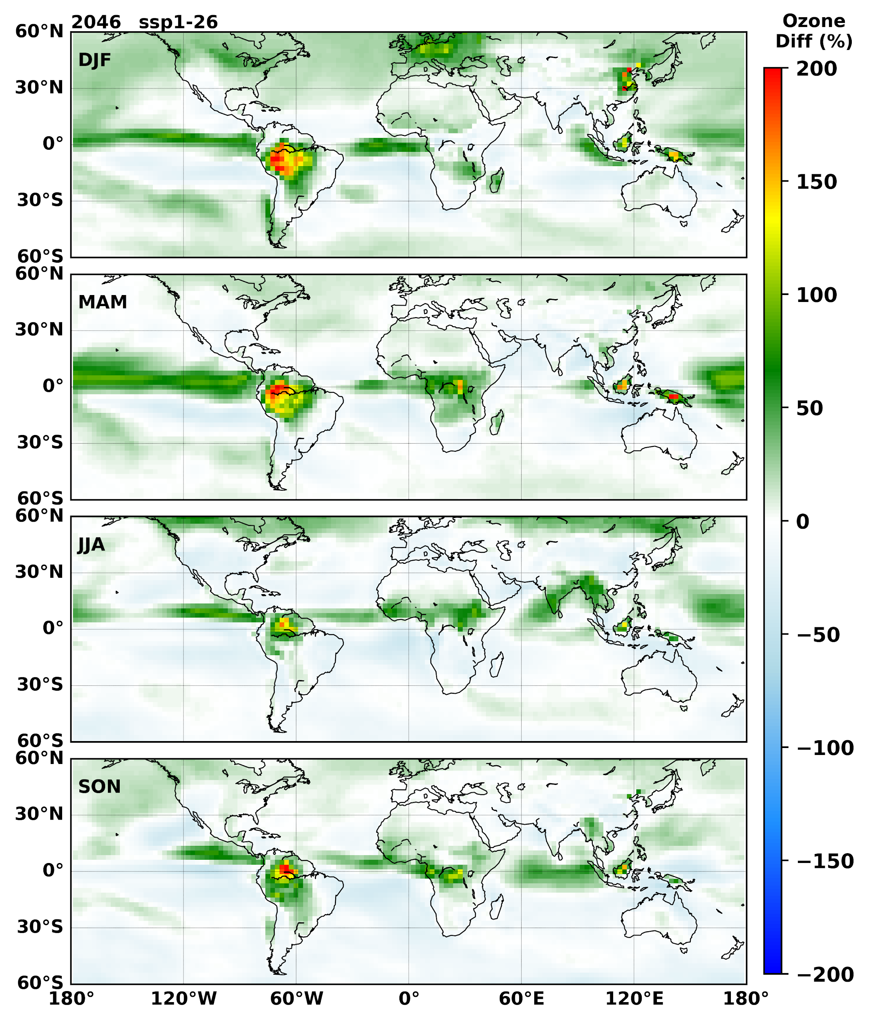
Supplementary Fig. 20| The percentage change in surface ozone for the year 2046 when compared to that of 2018 for the SSP 1-2.6 scenario.

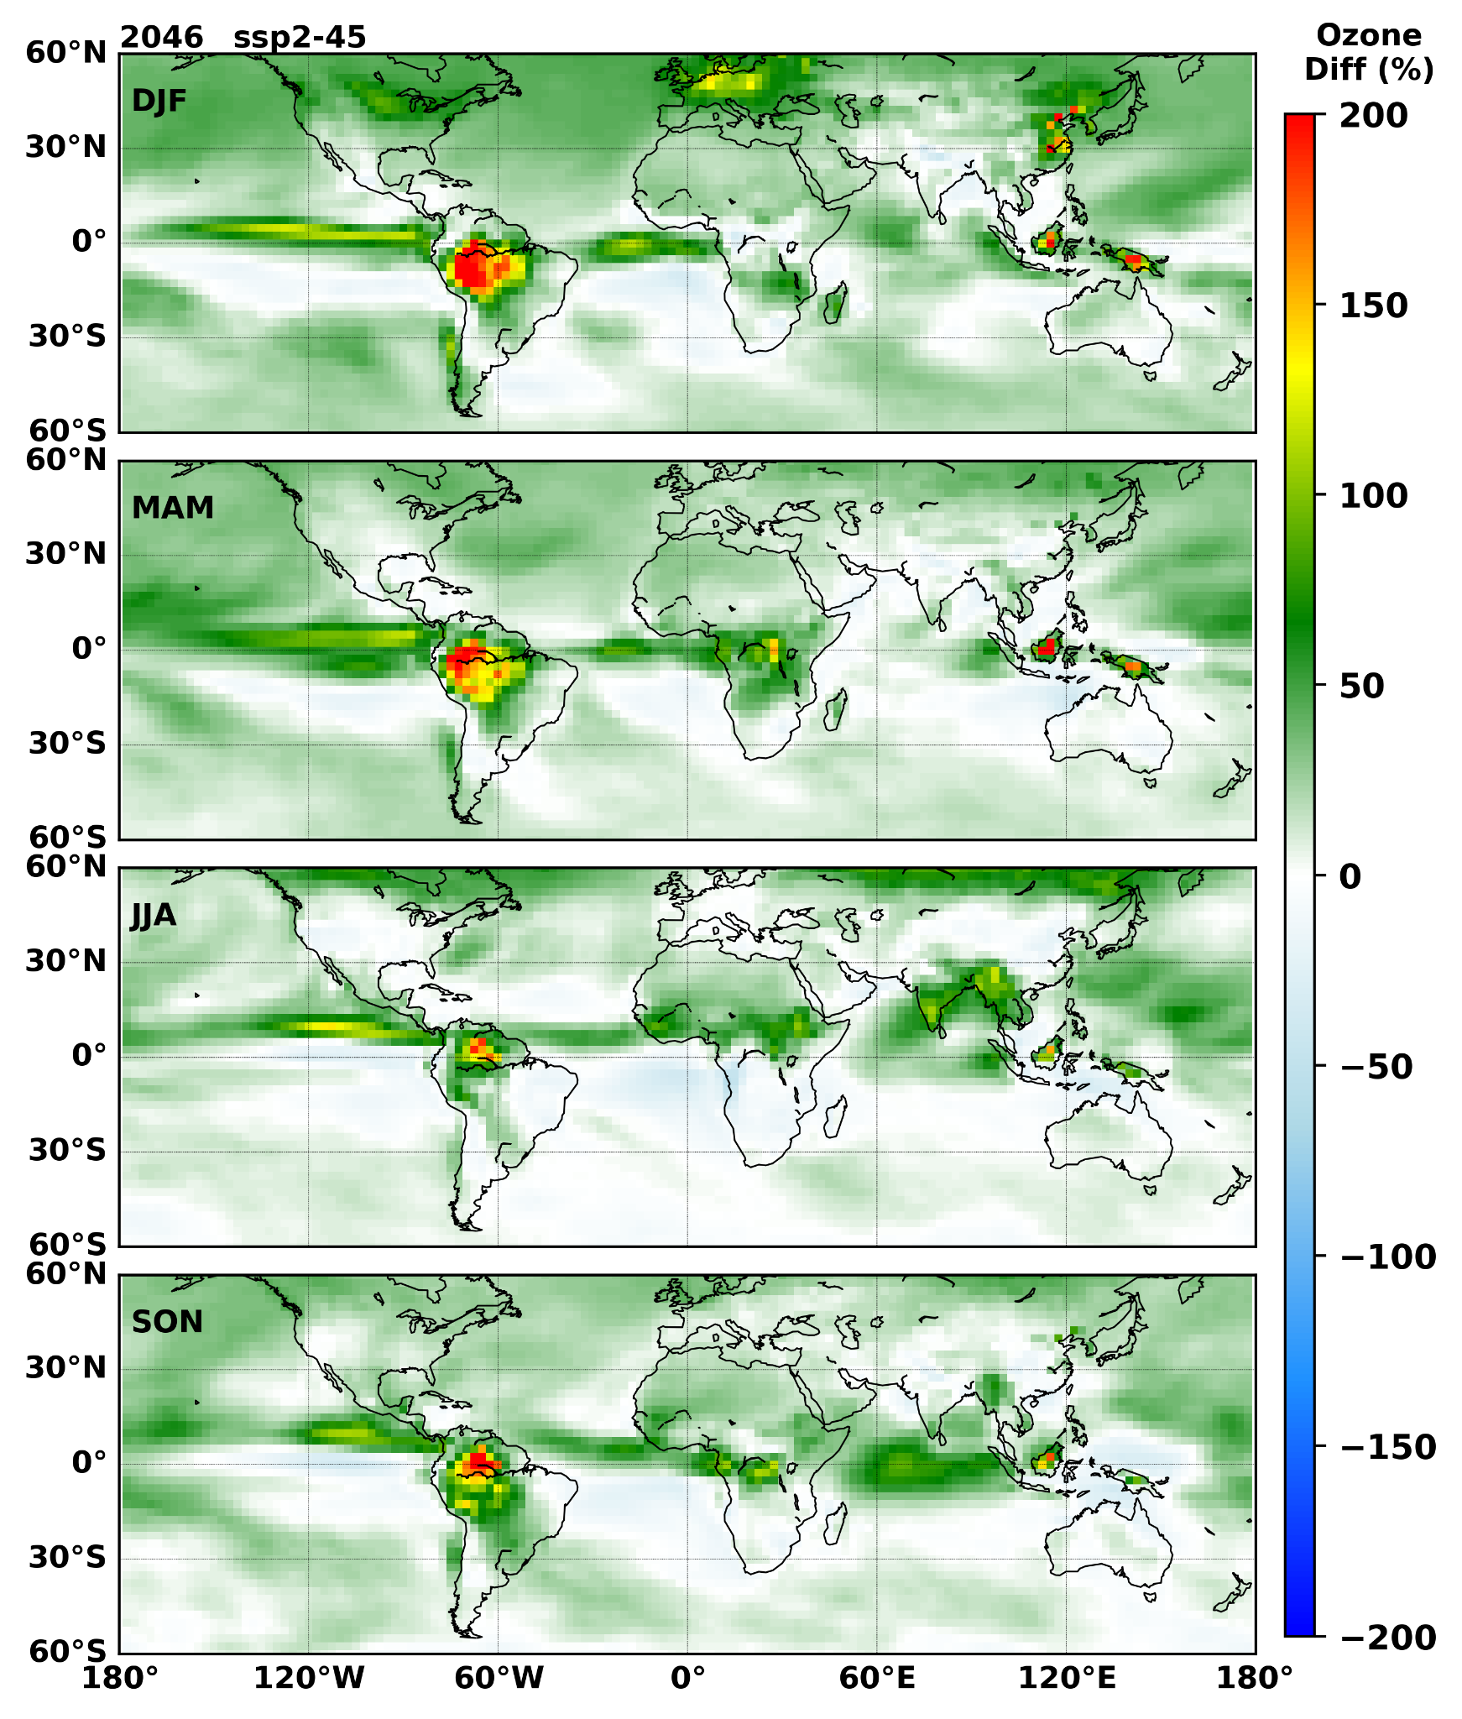
Supplementary Fig. 21| The percentage change in surface ozone for the year 2046 when compared to that of 2018 for the SSP 2-4.5 scenario.

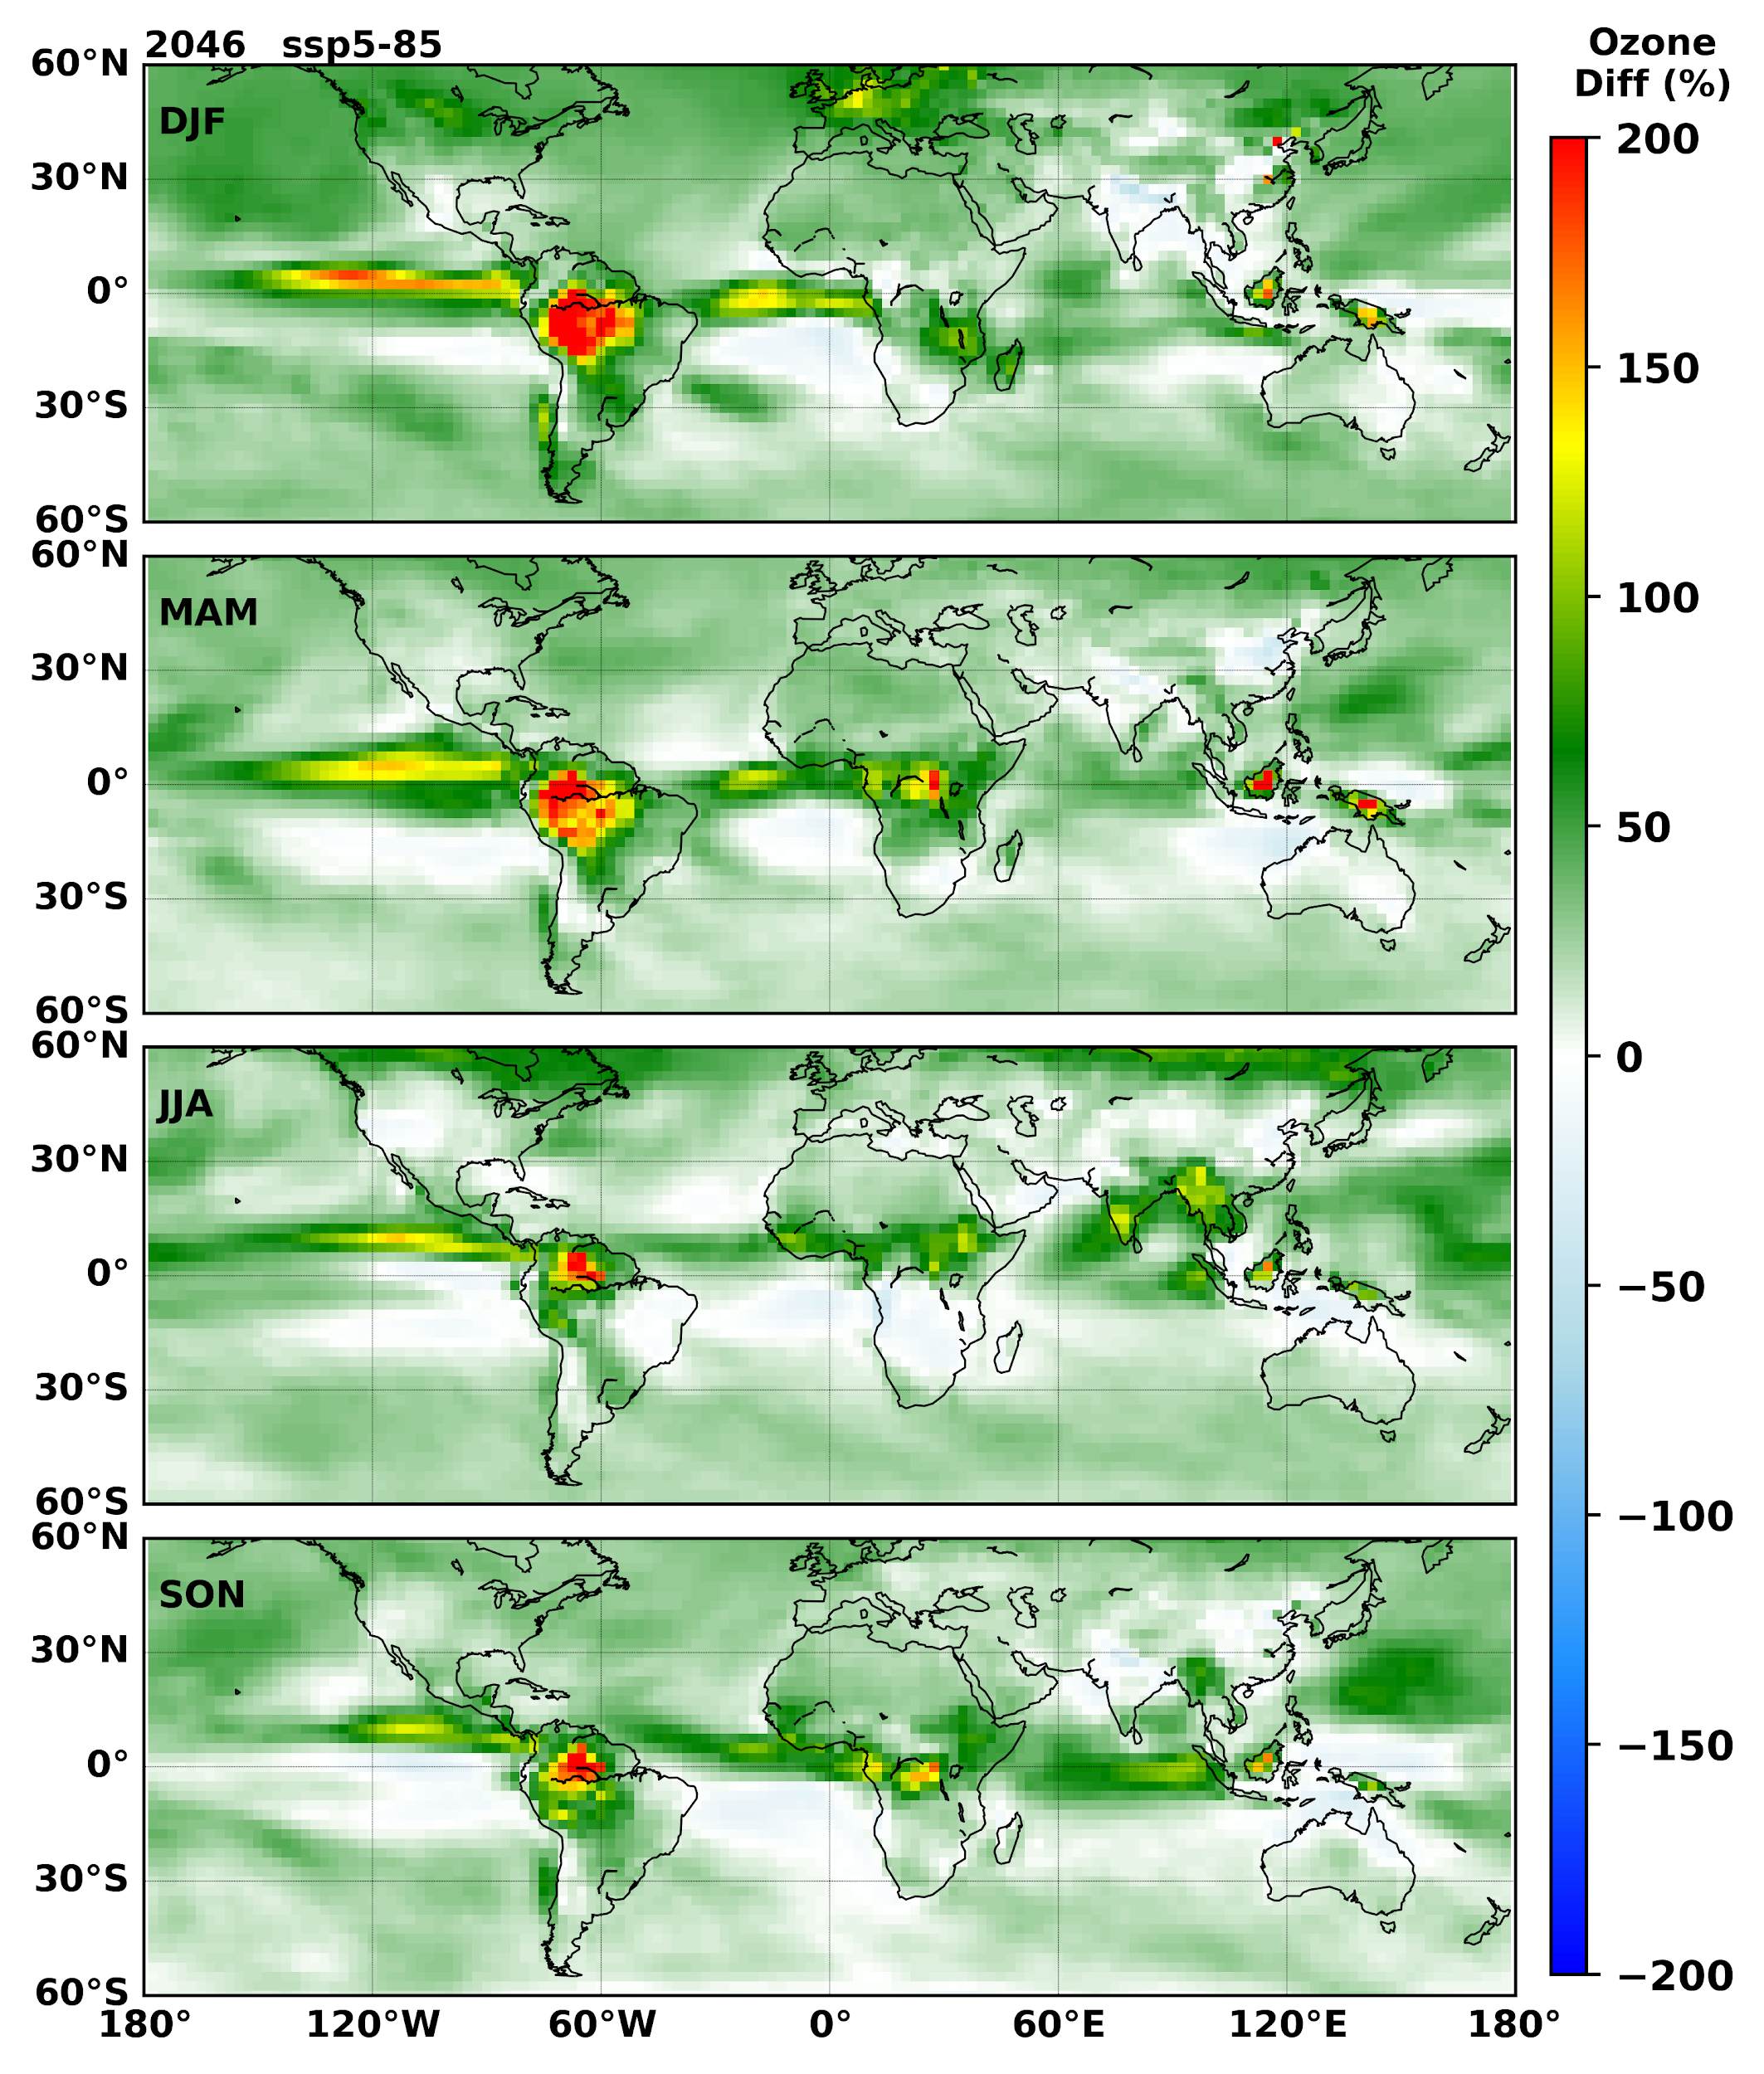
Supplementary Fig. 22| The percentage change in surface ozone for the year 2046 when compared to that of 2018 for the SSP 5-8.5 scenario.

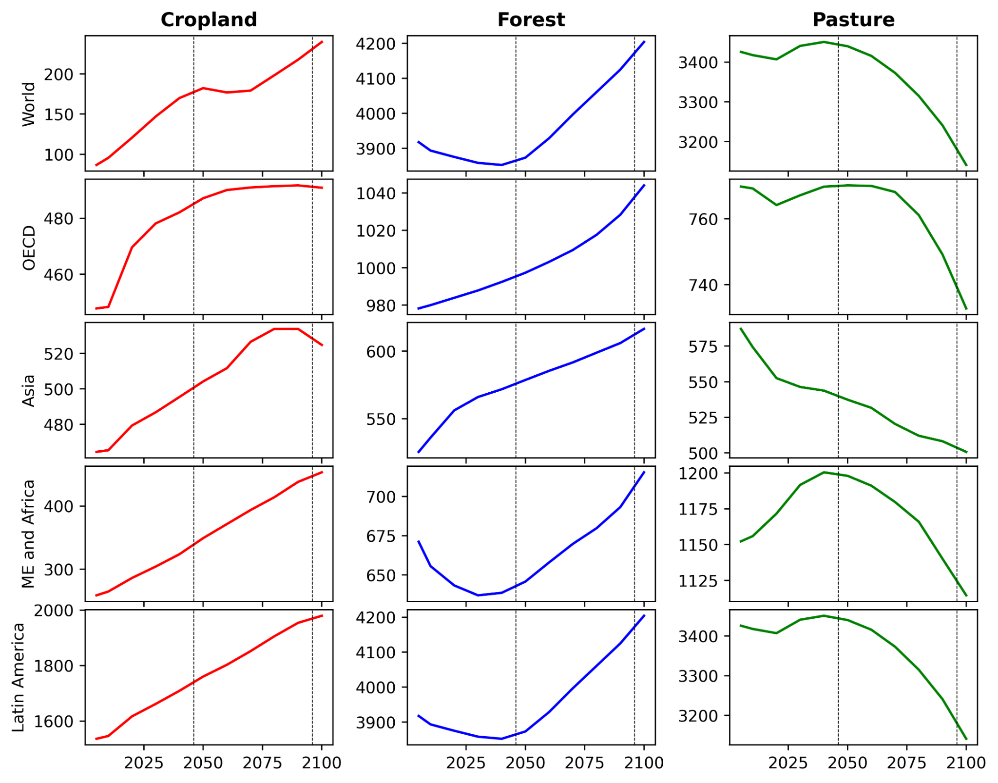
Supplementary Fig. 23|The land cover changes from the Integrated assessment models (IAMs) for the SSP 2-4.5 scenario for the period from 2005 to 2100.
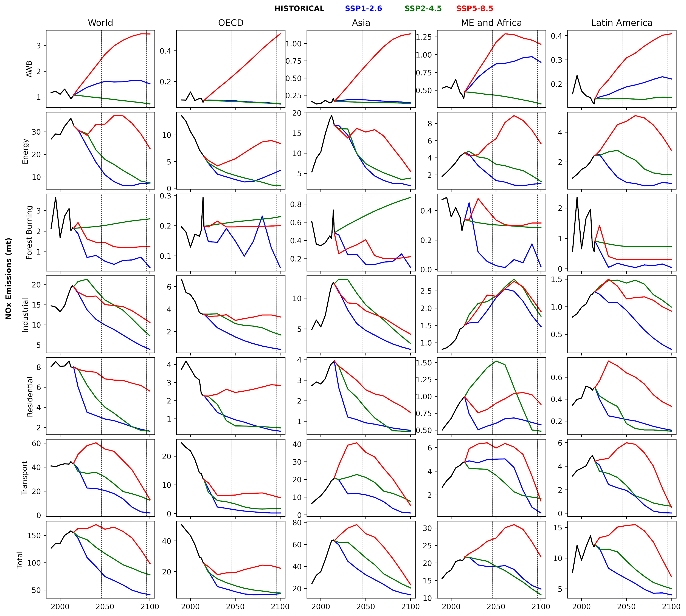
Supplementary Fig. 24| The time series of NO_{x} emissions from different sectors in different SSP scenarios for the period from 1980 to 2100

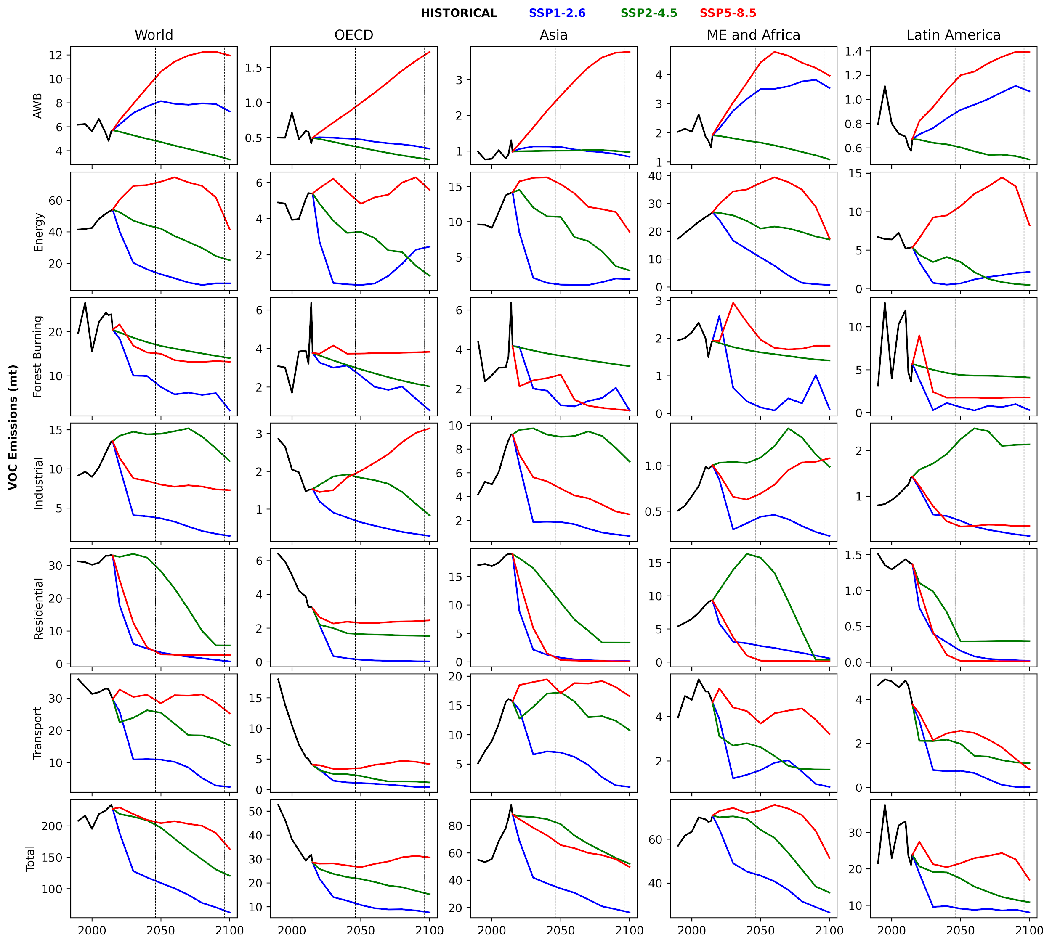
Supplementary Fig. 25| The time series of VOC emissions from different sectors in different SSP scenarios for the period from 1980 to 2100

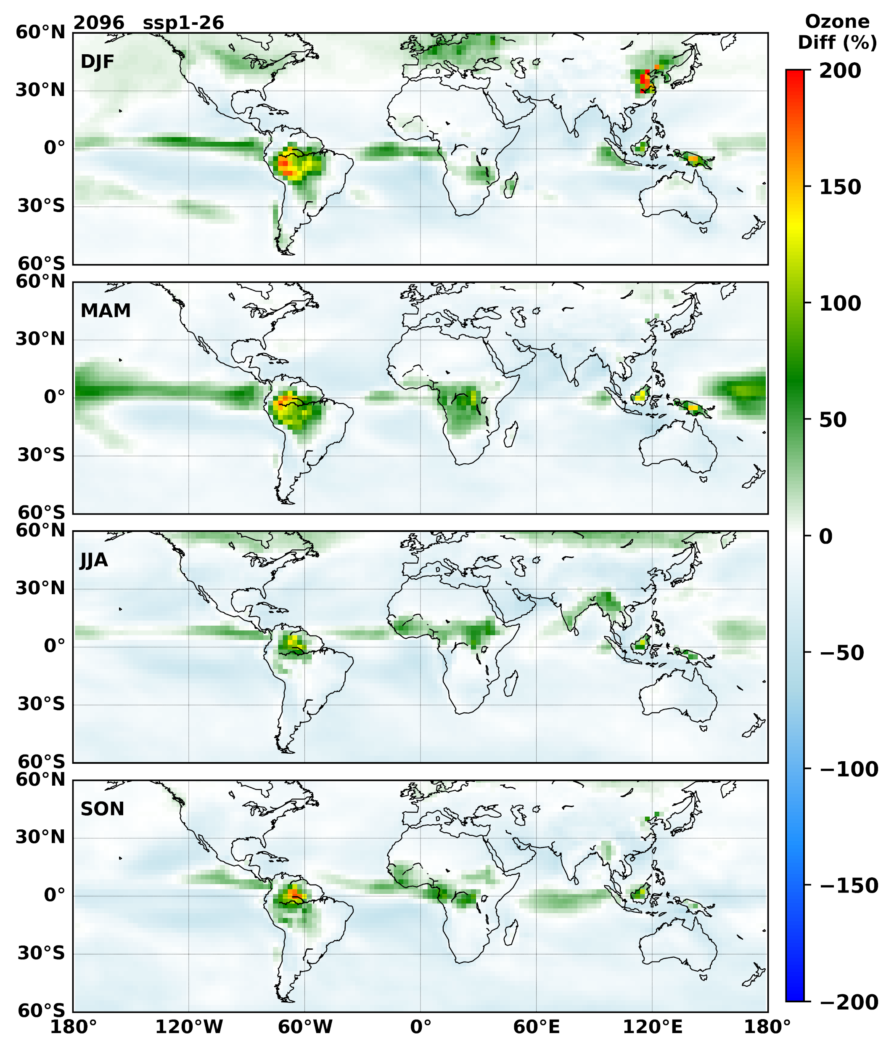
Supplementary Fig. 26| The percentage change in surface Ozone for the year 2096 when compared to that of 2018 for the SSP 1-2.6 scenario.

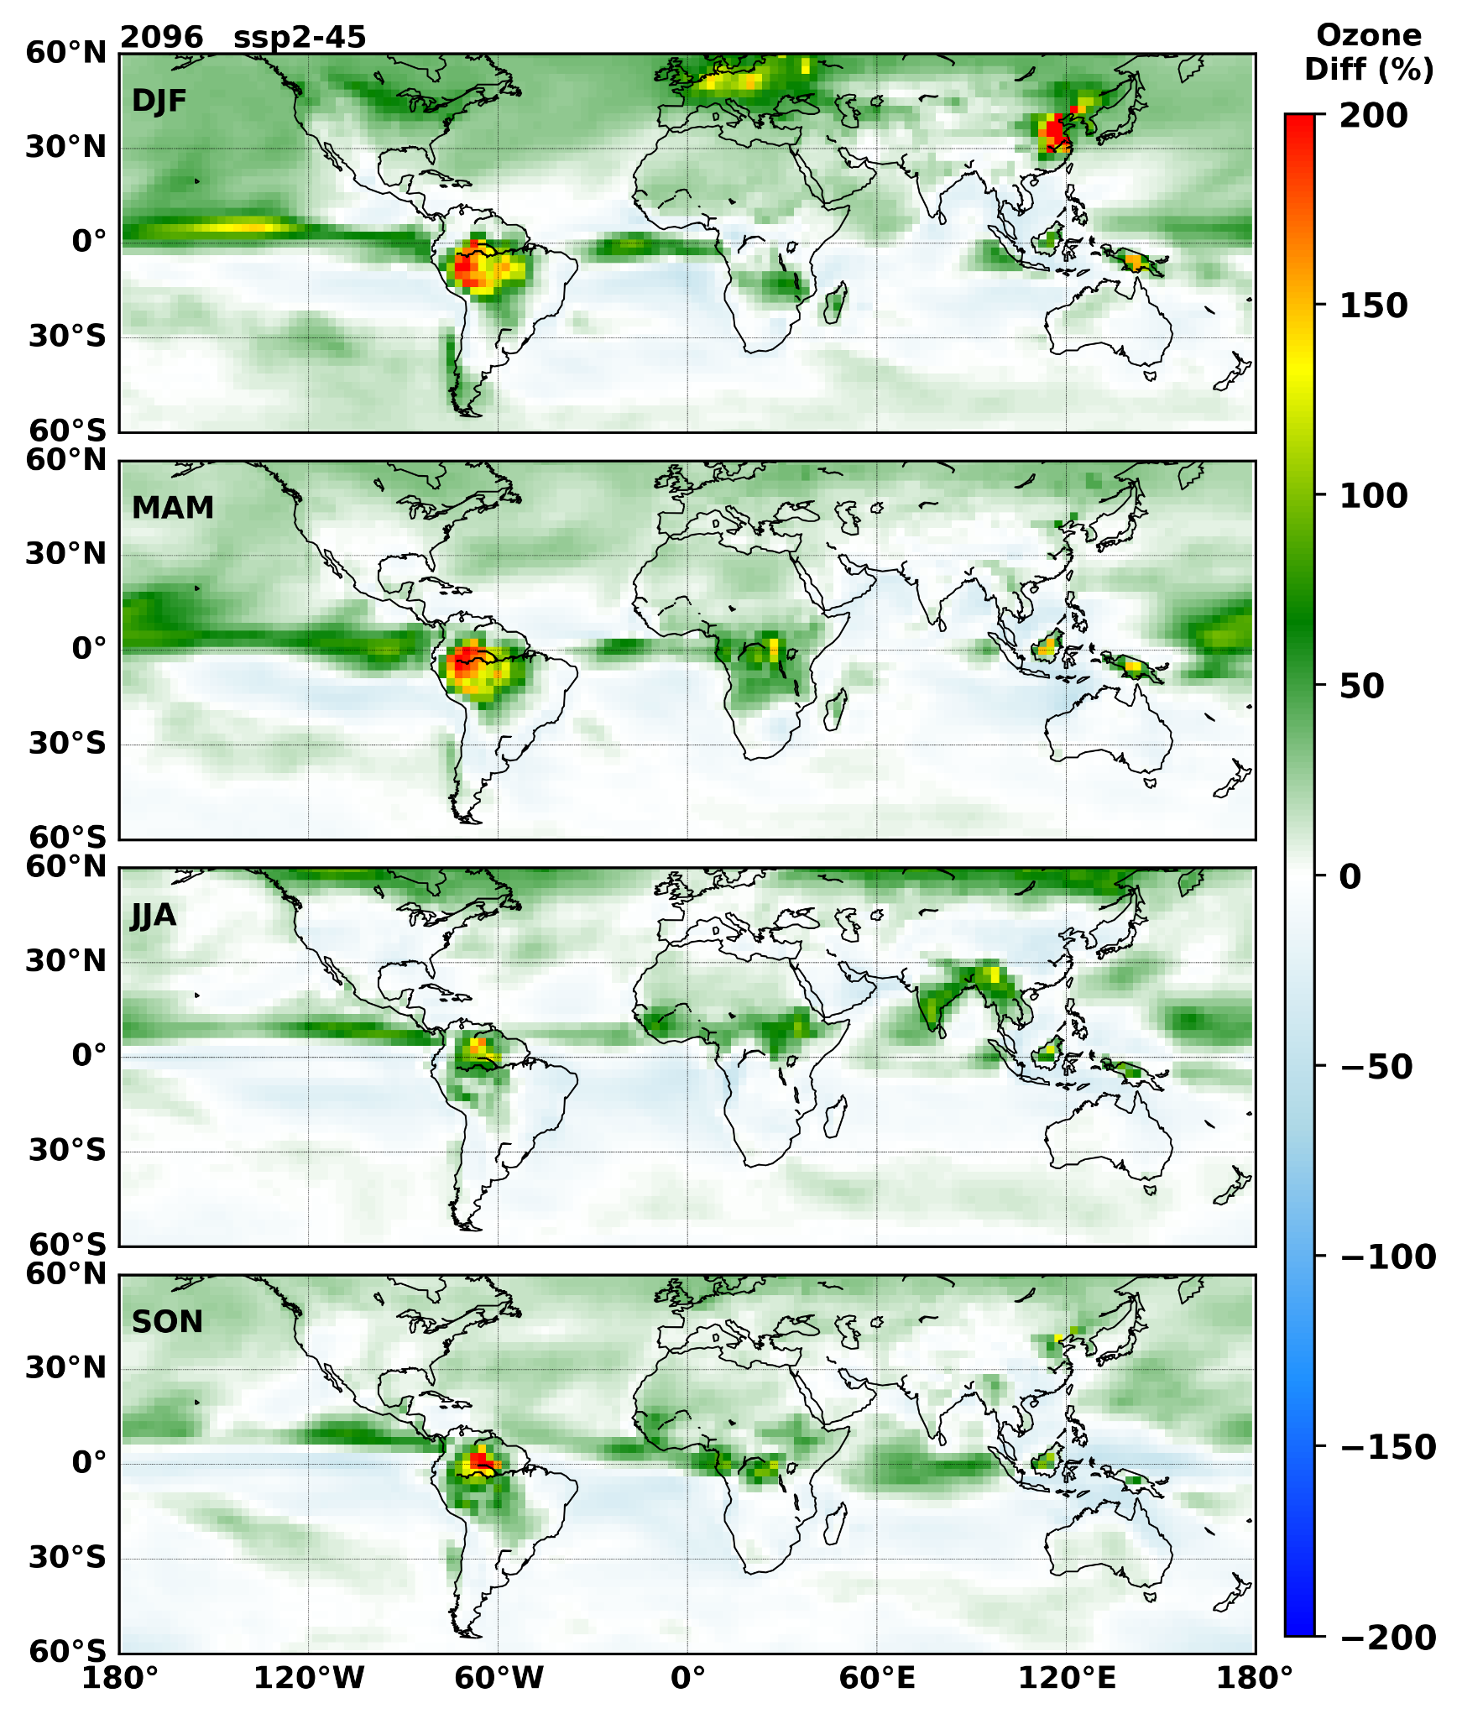
Supplementary Fig. 27| The percentage change in surface Ozone for the year 2096 when compared to that of 2018 for the SSP 2-4.5 scenario.

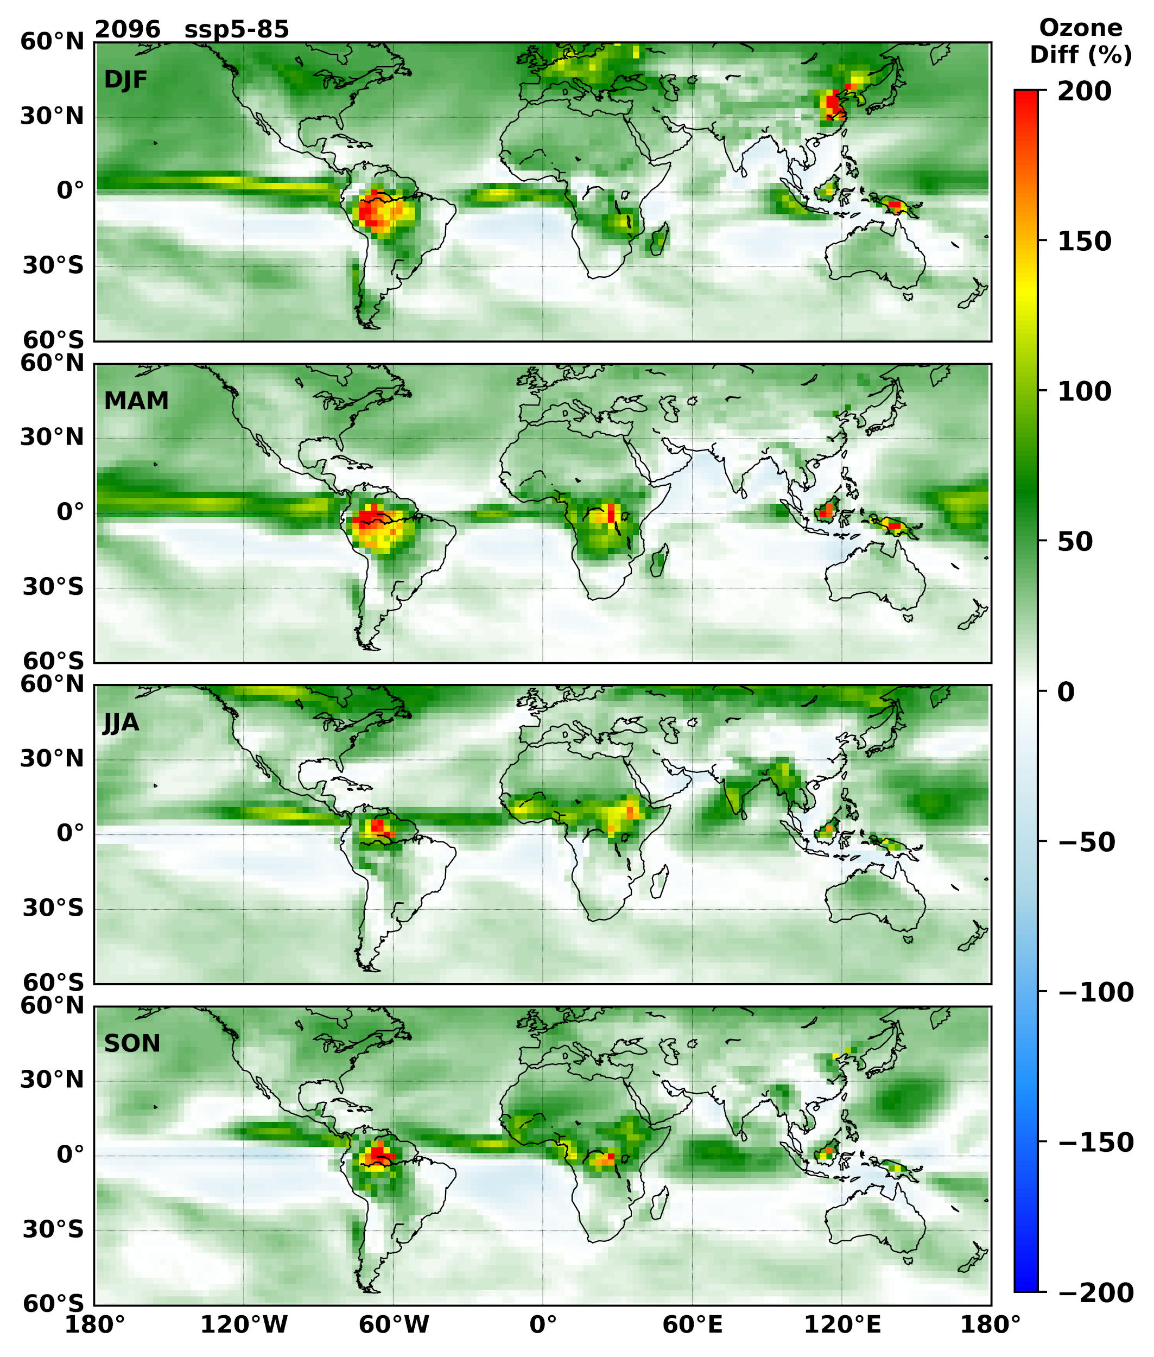
Supplementary Fig. 28| The percentage change in surface Ozone for the year 2096 when compared to that of 2018 for the SSP 5-8.5 scenario.

Table S1: Total energy demand in EJ/yr from Integrated Assessment Modelling (IAM) models.
Sectors | 2005 | 2010 | 2020 | 2030 | 2040 | 2050 | 2060 | 2070 | 2080 | 2090 | 2100
Total Primary Energy | 464 | 501 | 576 | 645 | 707 | 771 | 825 | 875 | 937 | 1005 | 1100
Primary Total Biomass Energy | 48 | 55 | 63 | 62 | 62 | 67 | 73 | 80 | 89 | 100 | 116
Primary Total Coal Energy | 121 | 140 | 138 | 139 | 121 | 111 | 120 | 138 | 157 | 192 | 247
Primary Total Oil Energy | 173 | 173 | 208 | 223 | 234 | 231 | 199 | 153 | 116 | 78 | 52
Primary Total Gas Energy | 100 | 106 | 123 | 157 | 204 | 247 | 283 | 303 | 316 | 297 | 283
Primary Total Fossil Energy | 394 | 419 | 469 | 519 | 558 | 590 | 601 | 595 | 589 | 567 | 582
Secondary Total Electricity | 65 | 75 | 95 | 116 | 139 | 169 | 211 | 251 | 289 | 335 | 394
Secondary Total Gases | 87 | 95 | 108 | 131 | 163 | 197 | 225 | 243 | 272 | 276 | 294
Secondary Total Heat | 13 | 13 | 15 | 19 | 18 | 18 | 21 | 28 | 34 | 42 | 50
Total Energy | 323 | 362 | 439 | 509 | 571 | 618 | 651 | 693 | 745 | 798 | 855
Total Energy Electricity | 54 | 64 | 82 | 102 | 123 | 150 | 187 | 221 | 251 | 286 | 334
Total Energy Gases | 48 | 53 | 56 | 56 | 65 | 79 | 93 | 124 | 181 | 242 | 282
Total Energy Industry | 117 | 135 | 166 | 190 | 211 | 230 | 249 | 265 | 273 | 278 | 282
Total Energy Residential | 120 | 131 | 153 | 173 | 189 | 205 | 226 | 249 | 274 | 302 | 333
Total Energy Transport | 87 | 96 | 121 | 147 | 170 | 182 | 177 | 179 | 198 | 218 | 240

