Supporting Information
Origins of rapid solvated-calcium ion co-intercalation in graphite anodes

Yuyang Yi^{[a]}, Yide Chang^{[b]}, Renjie Li^{[a]}, Linlong Lyv^{[a]}, Zeyu Zhang^{[c]}, Qi Meng^{[a]}, Huijun Lin^{[a]}, Pengyan Jiang^{[a]}, Di Lu,^{[d]} Yanming Wang*^{[b,c]}, Xiulin Fan,^{[d]} Zheng-Long Xu*^{[a]}

[a] Y. Y. Yi, R. J. Li, L. L. Lyv, Q. Meng, H. J. Lin, P. Y. Jiang, and Z. L. Xu
Department of Industrial and Systems Engineering, the Hong Kong Polytechnic University, Hung Hom, Hong Kong SRA, China
E-mail: zhenglong.xu@polyu.edu.hk
[b] Y. D. Chang and Y. M. Wang
University of Michigan-Shanghai Jiao Tong University Joint Institute, Shanghai Jiao Tong University, Shanghai 200240, China
[c] Z. Y. Zhang and Y. M. Wang
Global Institute of Future Technology, Shanghai Jiao Tong University, Shanghai 200240, China
[d] D. Lu and X. L. Fan
State Key Laboratory of Silicon and Advanced Semiconductor Materials, School of Materials Science and Engineering, Zhejiang University, Hangzhou, 310027 China

Yuyang Yi anad Yide Chang contributed equally to this work.

Experimental section:
Electrochemical measurements
A slurry consisting of 80 wt% graphite, 10 wt% super P carbon, and 10 wt% polyvinylidene fluoride (PVDF, DoDoChem) in N-methyl-2-pyrrolidone (NMP, DoDoChem) was prepared and pasted onto copper foil. The electrode was dried overnight at 80 °C, and active material loading of the graphite electrodes was ca. 3 mg cm⁻². The Prussian blue (K_{0.22}Fe[Fe(CN)₆]_{0.805}.4.01H₂O) cathode electrodes were prepared in the same way with a weight ratio of 8:1:1 for active material: super P: binder. All the electrochemical characterizations were performed in CR2032 coin cells. The cells were assembled in an Ar-filled glovebox. For the assembly of Ca ion half cells, activated carbon (AC) on carbon cloth and a glass fiber membrane were used as the counter electrode and the separator, respectively. To determine the number of solvents molecules per Ca ion co-intercalating into graphite galleries, cycled electrodes were dissembled, washed with DMAc, and dried in an Ar-filled glovebox before measuring their weights.
CV and EIS profiles were recorded on the Bio-Logic-SAS (VSP-3e) electrochemical workstation. The frequency in the EIS measurement was conducted in the frequency region of 10 mHz−100 kHz and an amplitude of 5 mV. EIS plots were used to calculate the Ca²⁺ diffusion coefficient using the following equation: $D=R^{2}T^{2}/2A^{2}n^{4}F^{4}C^{2}σ^{2}$, where R is the gas constant, T is the absolute temperature, A is the surface area of the graphite electrode (0.78 cm²), n is the number of electrons transferred in the half-reaction for the redox couple, F is the Faraday constant, C is the concentration of Ca ion (0.5x10⁻³ mol cm⁻³), D is the diffusion coefficient (cm² s⁻¹), and σ is the Warburg factor, which is relative to Z_{re} (values at the low frequency region of EIS curves). σ can be obtained from the slope of the below equation: $Z_{re}=σ\frac{1-j}{\sqrt{ω}}$, where σ is the Warburg coefficient, ω is the angular frequency, and j is the imaginary unit.
Galvanostatic charge/discharge profiles and cycling curves were collected on a Neware battery testing system. GITT experiment was carried out by cycling the cells at a current density of 20 mA g⁻¹ for 40 min and resting for 20 min between each step. The simplified Fick’s second law was employed for the calculations: $D_{{Ca}^{2+}}=\frac{4L^{2}}{πτ}{(\frac{∆E_{s}}{∆E_{t}})}^{2}$, where τ is the duration of the current pulse, ∆E_{s} is the quasi-thermodynamic equilibrium potential difference before and after the current pulse, ∆E_{t} represents the potential difference during the current pulse, and L is the thickness of graphite electrodes.
Materials characterizations
The morphological structures of graphite electrodes were inspected by SEM (Hitachi S-4800 field-emission SEM operated at an accelerating voltage of 10 kV). The crystal phaes were probed by XRD (Rigaku SmartLab 9kW) using Cu-Kα radiation. In-situ XRD tests were performed on X-ray diffractometer equipped with a planar detector employing a special cell with an X-ray transparent Be window. Every scan was collected in 0.01° increments between 10° and 60° at a scanning speed of 5° per minute. The home-made cells were continuously charged and discharged without interval between XRD scanning. In-situ Raman spectroscopy measurements were carried out on the Renishaw Micro-Raman Spectroscopy System with an excitation wavelength of 532 nm. NMR measurements were collected by Jeol ECZ500R 500 MHz NMR spectrometer.
Theoretical calculations
DFT calculation within VASP: Density functional theory (DFT) calculations were performed with plane-wave basis sets, periodic boundary conditions, and projector augmented wave pseudopotentials as implemented in the Vienna Ab initio Simulation Package (VASP).¹⁻³ Exchange and correlation effects were included at the generalized gradient approximation (GGA) level using the Perdew-Burke-Ernzerhof (PBE) functional.⁴ The solvent-graphene van der Waals interaction was taken into account by applying DFT-D3 correction.⁵ The maximum cutoff energy for the plane wave basis sets was 500 eV. Reciprocal space sampling was performed on Monkhorst-Pack grids⁶ with dimensions of 2 × 2 × 2 for t-GICs, 2 × 2 × 4 for graphite models, 8 × 8 × 8 for the solvent models, and 12 × 12 × 12 for Ca bulk models. Each structure was first optimized until the force on every atom was below 0.02 eV/Å before performing further calculations. Single-point energy calculations were performed with an energy convergence criterion of 10⁻⁷ eV. The resulting total energies of the optimized structures were then used to calculate intercalation energies.
AIMD calculation and diffusion barrier within VASP: Ab initio molecular dynamics (AIMD) simulations were carried out to determine the stable structures of t-GIC. Simulations were performed in the NPT ensemble at 300 K with a time step of 1 fs for a total period of 3 ps, followed by an NVT ensemble simulation at 300 K for 12 ps. Several randomly chosen structures from the AIMD trajectory were then fed back into VASP for geometry and cell optimization.
To explore diffusion mechanisms, the Climbing Image Nudged Elastic Band (CI-NEB) method⁷ was applied to calculate energy barriers along the proposed diffusion pathways. For each pathway, 3–5 intermediate images were linearly interpolated between the initial and final states, and the forces were minimized to below 0.03 eV/Å.
DFT calculation within Gaussian: The solvents and Ca-solvent complexes were optimized at the B3LYP/6-311G (3df, 3p) level of theory in Gaussian 16 code. ⁸⁻¹⁰ Single-point energy calculations were carried out on the optimized geometries to obtain electrostatic potential and binding energy information.
Model construction and selection: The [2Ca-8DMAc/DMF/NMAc]C₁₄₄ models were constructed using a 6×6×1 hexagonal supercell containing two graphene sheets, each composed of 72 carbon atoms. 2 Ca atoms and 8 solvent molecules were placed between the graphene sheets. Several randomly chosen structures obtained from AIMD simulations were re-optimized in VASP with respect to the atomic positions, cell shape, and cell volume. The configurations with the lowest total energy were considered to represent the global energy minimum structures and were used for further calculations.

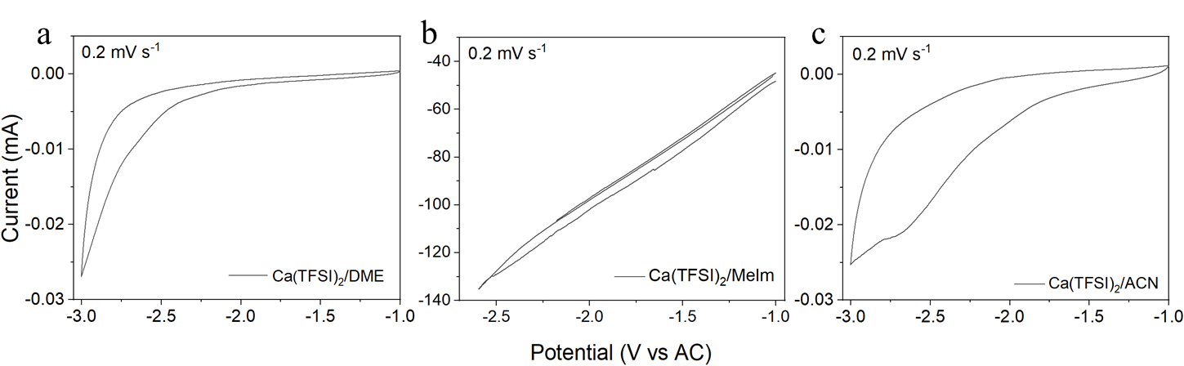
Figure S1. CV curves for graphite electrodes cycled in 0.5 M Ca(TFSI)₂ (a) DME, (b) Melm, (c) ACN electrolyte.

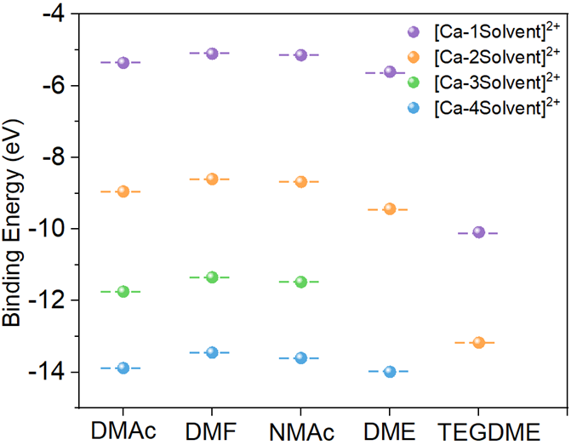
Figure S2. Binding energy between Ca²⁺ and different solvents (i.e., DMAc, DMF, NMAc, DME and TEGDME). Different colored balls represent different numbers of solvent molecules.

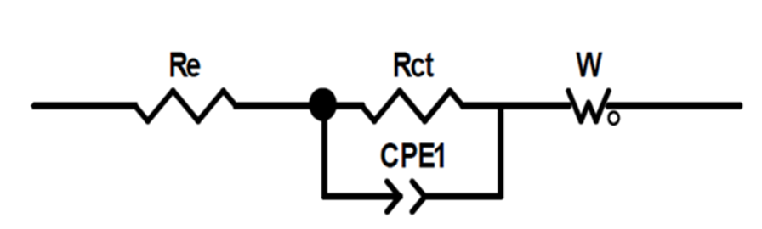
Figure S3. The equivalent circuit of EIS curves. R_{e} and R_{ct} represent electrolyte resistance and charge transfer resistance, respectively. Constant phase element (CPE) is used to model non-ideal capacitive behavior and Warburg element (W) for the diffusion-controlled processes.

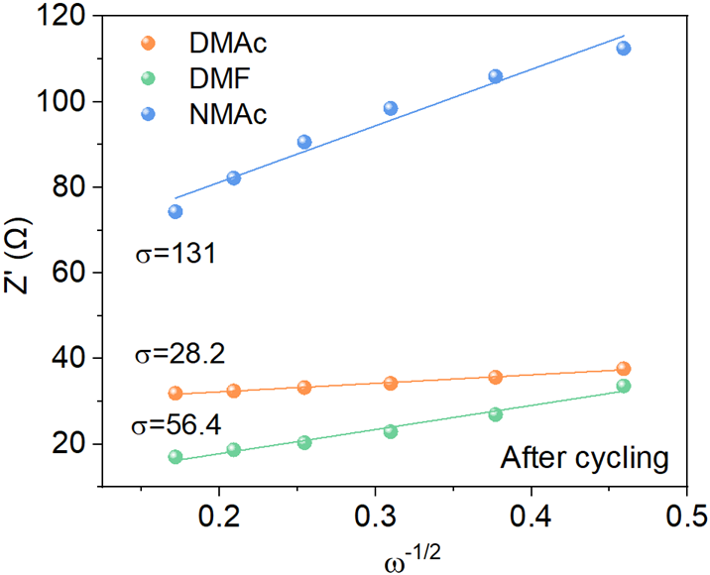
Figure S4. Real parts of the complex impedance versus $ω^{-1/2}$. σ is the Warburg factor, which is relative to Z_{re} and can be obtained from the slope of the lines in equation: $Z_{re}=σ\frac{1-j}{\sqrt{ω}}$ . The lower the slope, the greater the calculated diffusion coefficient.

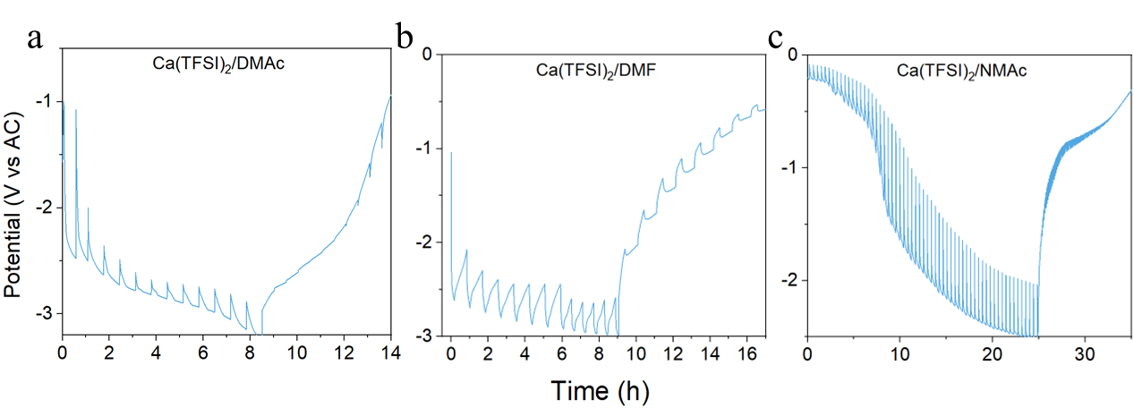
Figure S5. Galvanostatic intermittent titration technique profiles of graphite cycling in different electrolytes: (a) Ca(TFSI)₂/DMAc, (b) Ca(TFSI)₂/DMF, and (c) Ca(TFSI)₂/NMAc.

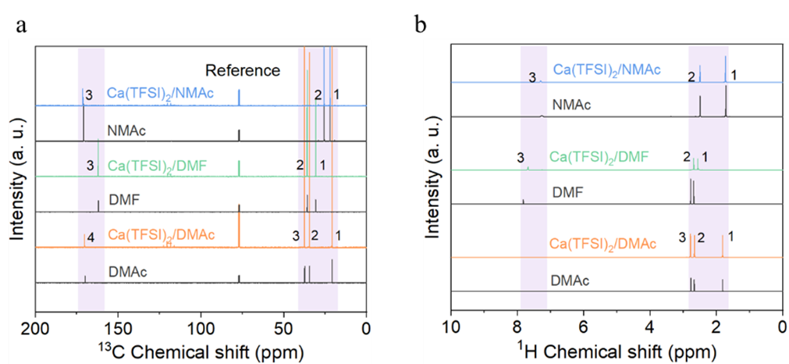
Figure S6. (a) ¹³C and (b) ¹H NMR spectra of different electrolytes and solvents including DMAc, DMF, and NMAc solvents and their Ca(TFSI)₂ electrolytes. Calibration was performed before plotting these curves.

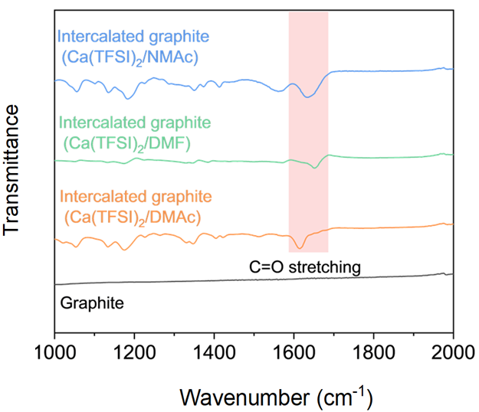
Figure S7. FTIR spectra of graphite and intercalated graphite with different electrolytes. The C=O stretching in t-GICs indicates the cointercalation of solvent molecules in graphite.

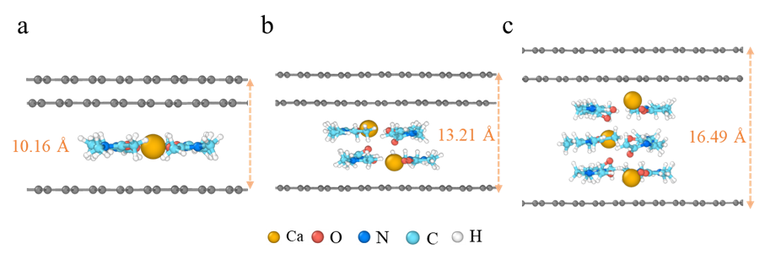
Figure S8. Optimized structures of (a) one, (b) two, and (c) three [Ca-4DMAc]²⁺ complexes intercalated in graphite and the corresponding lattice parameters.

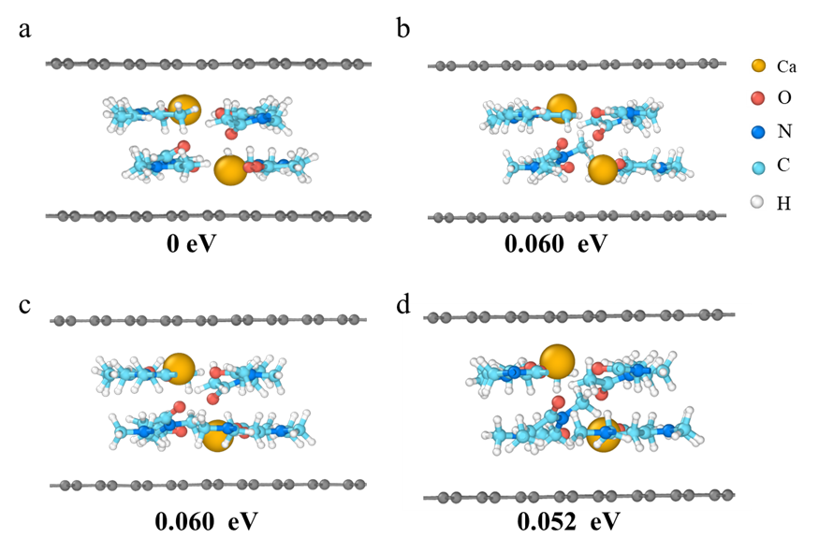
Figure S9. Optimized structures of [Ca-4DMAc]C₇₂ with different intercalant configurations. (a) presents the lowest energy, suggesting the plausibility of this structure.

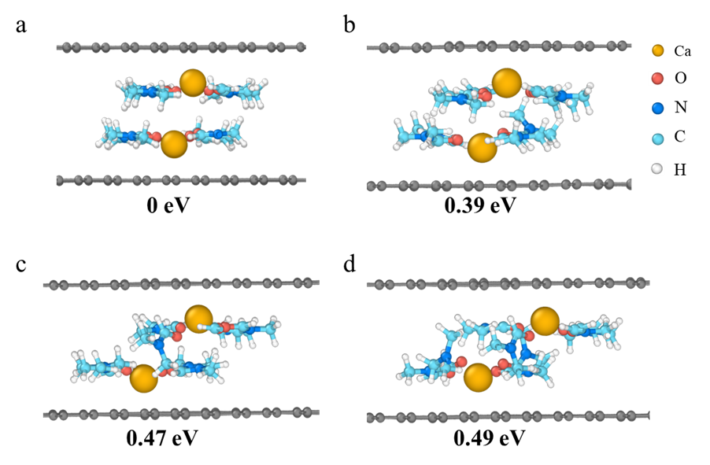
Figure S10. Optimized structures of [Ca-4DMF]C₇₂. (a) presents the lowest energy, suggesting the plausibility of this structure.

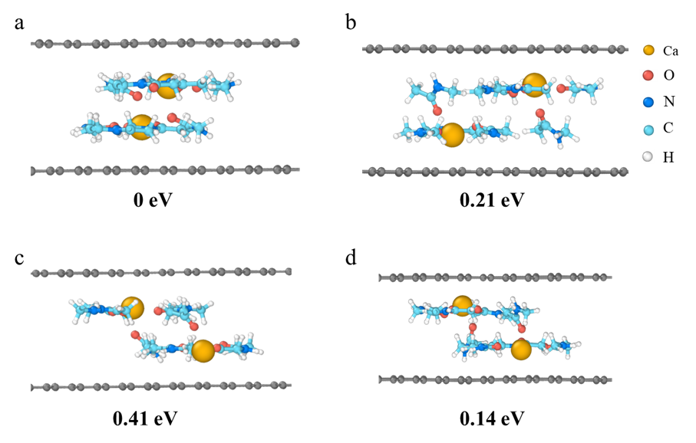
Figure S11. Optimized structures of [Ca-4NMAc]C₇₂. (a) presents the lowest energy, suggesting the plausibility of this structure.

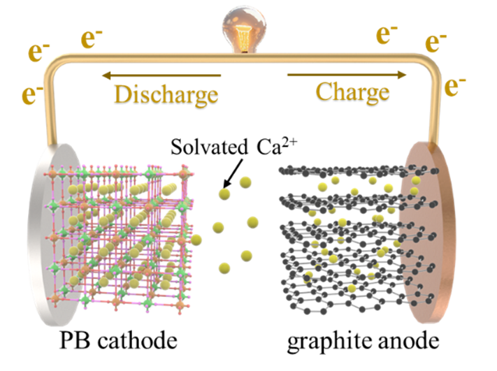
Figure S12. Configuration and working mechanism of the Ca ion full cells made of graphite anode and PB cathode.

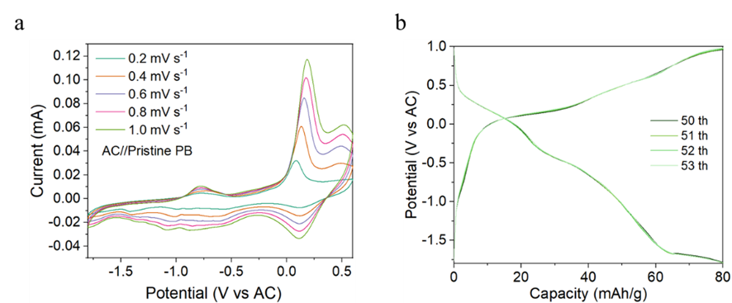
Figure S13. (a) CV profiles of AC//PB at different scan rates. (b) Discharge/charge curves of AC//PB half-cell for 53 cycles showing excellent reversibility.

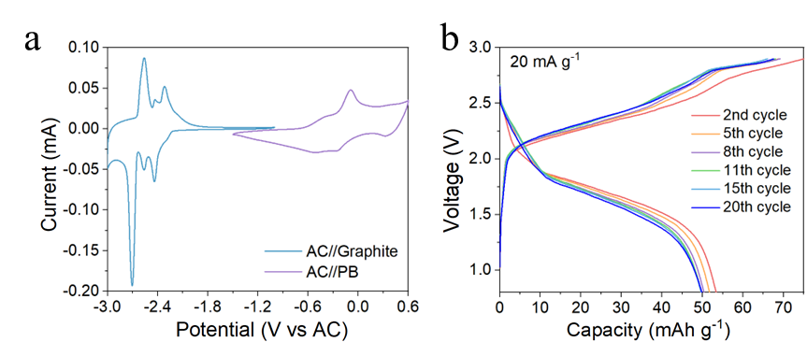
Figure S14. (a) CV curves of graphite and PB electrodes in half cells in Ca(TFSI)₂ DMAc electrolyte. (b) Discharging/charging voltage profiles of graphite//PB full cells for 20 cycles at 20 mA g⁻¹.

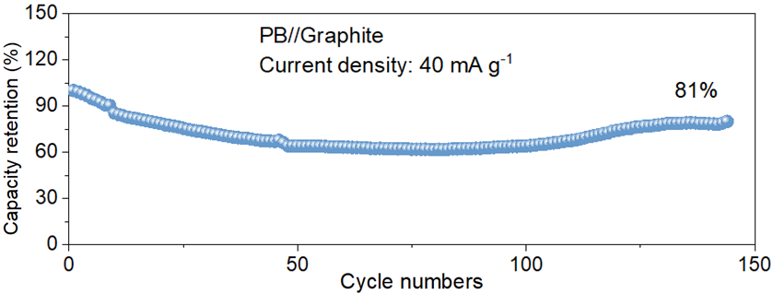
Figure S15. Capacity retentions of PB//graphite full cells cycling at 40 mA g⁻¹.

Table S1. Comparison of the lattice parameters (I_{c}) of calciated graphite in different electrolytes at stages n, o, and p.

Electrolyte | I_{c} (Å) of stage n | I_{c} (Å) of stage o | I_{c} (Å) of stage p
Ca(TFSI)₂/DMAc | 21.4 | 17.7 | 14.5
Ca(TFSI)₂/DMF | 19.5 | 17.2 | 19.8
Ca(TFSI)₂/NMAc | 24.1 | 23.6 | /

Table S2. Calculated intercalation parameters in graphite in terms of sheath size of [Ca-solvent]²⁺, intercalation energy barriers (E_{int}), and diffusion energy barriers (E_{diff}).
Composition | d_{[Ca-solvent]2+} (Å) | E_{int.} (eV) | E_{diff} (eV)
[Ca-4DMAc]C₇₂ | 9.86 | -7.97 | 0.19
[Ca-4DMF]C₇₂ | 9.71 | -7.12 | 0.21
[Ca-4NMAc]C₇₂ | 9.61 | -7.09 | 0.59

Video S1. Presented the (100) transport path of the [Ca-solvent]²⁺ structural models.

References
- Kresse, Georg, and Jürgen Furthmüller. Efficient iterative schemes for ab initio total-energy calculations using a plane-wave basis set. Physical review B, 1996, 54, 11169.
- Kresse, Georg, and Jürgen Furthmüller. Efficiency of ab-initio total energy calculations for metals and semiconductors using a plane-wave basis set. Computational materials science, 1996, 6.
- Blöchl, Peter E. Projector augmented-wave method. Physical review B, 1994, 50, 17953.
- Perdew, John P., Kieron Burke, and Matthias Ernzerhof. Generalized gradient approximation made simple. Physical review letters, 1996, 77, 3865.
- Grimme, Stefan, Stephan Ehrlich, and Lars Goerigk. Effect of the damping function in dispersion corrected density functional theory. Journal of computational chemistry, 2011, 32, 1456-1465.
- Monkhorst, Hendrik J., and James D. Pack. Special points for Brillouin-zone integrations. Physical review B, 1976, 13, 5188.
- Gaussian 16, Revision B.01, M. J. Frisch, G. W. Trucks, H. B. Schlegel, G. E. Scuseria, M. A. Robb, J. R. Cheeseman, G. Scalmani, V. Barone, G. A. Petersson, H. Nakatsuji, X. Li, M. Caricato, A. V. Marenich, J. Bloino, B. G. Janesko, R. Gomperts, B. Mennucci, H. P. Hratchian, J. V. Ortiz, A. F. Izmaylov, J. L. Sonnenberg, D. Williams-Young, F. Ding, F. Lipparini, F. Egidi, J. Goings, B. Peng, A. Petrone, T. Henderson, D. Ranasinghe, V. G. Zakrzewski, J. Gao, N. Rega, G. Zheng, W. Liang, M. Hada, M. Ehara, K. Toyota, R. Fukuda, J. Hasegawa, M. Ishida, T. Nakajima, Y. Honda, O. Kitao, H. Nakai, T. Vreven, K. Throssell, J. A. Montgomery, Jr., J. E. Peralta, F. Ogliaro, M. J. Bearpark, J. J. Heyd, E. N. Brothers, K. N. Kudin, V. N. Staroverov, T. A. Keith, R. Kobayashi, J. Normand, K. Raghavachari, A. P. Rendell, J. C. Burant, S. S. Iyengar, J. Tomasi, M. Cossi, J. M. Millam, M. Klene, C. Adamo, R. Cammi, J. W. Ochterski, R. L. Martin, K. Morokuma, O. Farkas, J. B. Foresman, and D. J. Fox, Gaussian, Inc., Wallingford CT, 2016.
- Becke, Axel D. Density‐functional thermochemistry. I. The effect of the exchange‐only gradient correction. The Journal of chemical physics, 1992, 96, 2155-2160.
- Wu, Qin, and Weitao Yang. Empirical correction to density functional theory for van der Waals interactions. The Journal of chemical physics, 2002, 116, 515-524.
- Henkelman, Graeme, Blas P. Uberuaga, and Hannes Jónsson. A climbing image nudged elastic band method for finding saddle points and minimum energy paths. The Journal of chemical physics, 2000, 113, 9901-9904.

