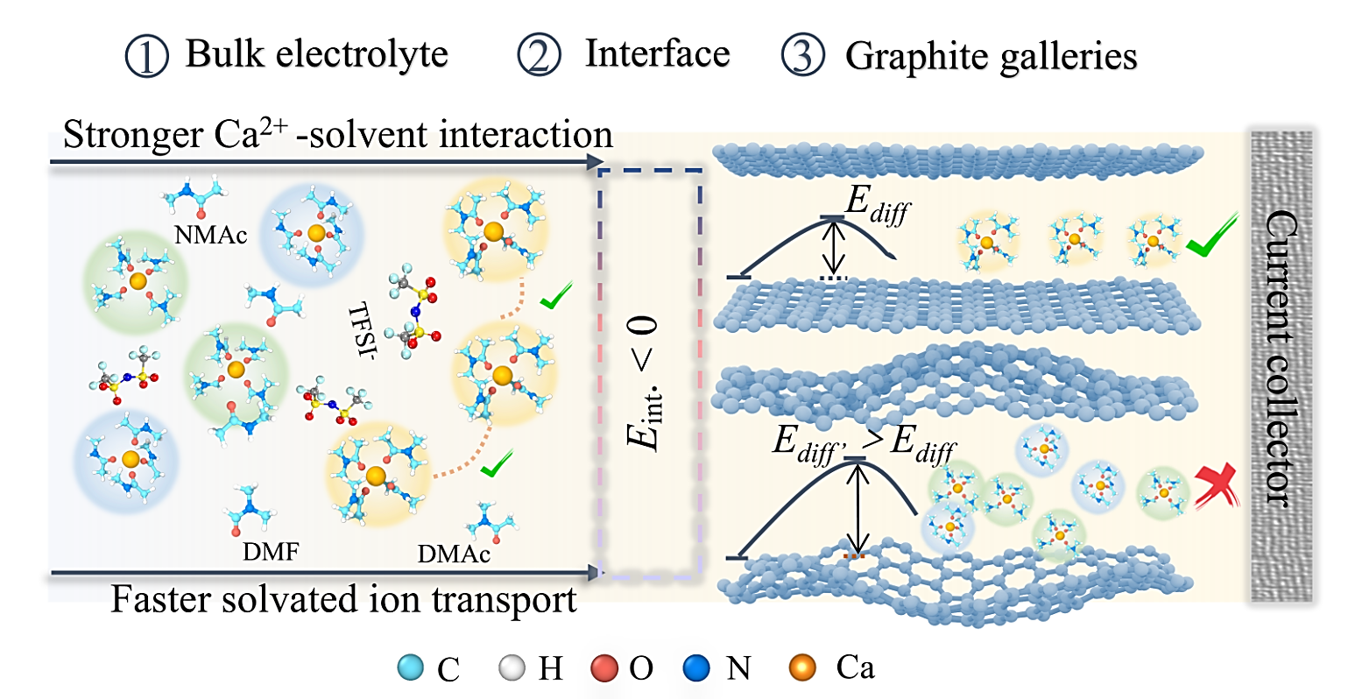
Scheme 1. Schematic illustration of the criteria for Ca ion co-intercalation in graphite (left: bulk electrolyte, middle: electrolyte/electrode interface, right: graphite galleries). Green, blue and yellow shadows represent DMF, NMAc and DMAc-based solvation sheaths. E_{int} and E_{diff} represent the intercalation energy barriers at the electrode/electrolyte interface and the energy barriers for Ca ion diffusion in graphite, respectively.

