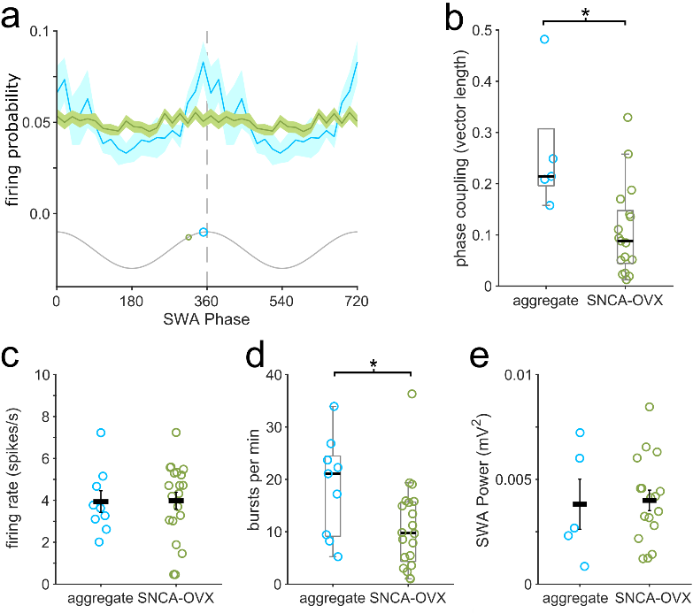
Supplementary Fig. S1. α-synuclein overexpressing mice do not mirror the changes in burst-firing or phase-coupling in PFF-injected mice. a Linear-phase histograms of the firing of DA neurons in relation to the cortical slow wave activity. b Aggregate-bearing DA neurons (cyan; 3-months after PFF-injection in wild-type mice) are more strongly coupled to cortical activity than DA neurons in 18-month old synuclein overexpressing mice (SNCA-OVX). While a similar reduction in firing rate is observed in both groups c, aggregate-bearing DA neurons exhibit more burst-firing than those in SNCA-OVX mice d. e Mean SWA power (0.5–1.5 Hz) measured from the electrocorticogram was not different between the two groups. * P < 0.05.

