Supplementary tables 1. Questionnaire to predict seminal quality
Variable Names | Value Ranges (min – max)
Season | Winter, Spring, Summer, Fall
Age | in years like 18 – so on
Body Mass Index (BMI) | 17 – 34
Marital Status | Unmarried (without a partner), unmarried (with partner), married, other
Childern | Yes or No
Birth city | City where a person lives
City of the family home | Native city where family lives
Residence City while doing a course | Current residence while doing a course
Number of siblings | 0 – so on
Birth defect, heredity disease or any genetic disorder | Yes or No
Childish disease (like chicken pox, mumps, measles, polio) | Yes or No
Vacines received | Childern calendar, childern calendar and tetanus, tetanus only
Allergy | Yes or No
Accident or any serious injury | Yes or No
Surgical intervention | Yes or No
Significant disease | Yes or No
High fever in last year | Less than 3 months ago, more than three months ago, no
Chemotherapy | Yes or No
Radiations (like X-Ray) | Yes or No
Time since radiations exposure | Less than three months, more than three months
No. of exposures | 0 – so on
Alcohol consumption rate | Several times in a day, everyday, several times in a week, once in a week, hardly ever or never
Alcohol consumption (grams/week) | 0 – so on
Smoking habit | Daily, ocasionly, never
Average no. of cigerates/day | 0 – so on
Exposure to cigerate in years | 0 – so on
Coffee consumption | 1 – 2 coffees in a day, 3 – 5 coffees in a day, more than 5 coffees in a day, none
Drugs consumption | Yes or No
No. of hours spent sitting/day | 1 – so on
Average hours sleepiing/day | 1 – so on
Wearing tight clothes | Yes or No
Warm baths | Yes or No
Average hours plyaing sports/week | 0 – so on
Average ejaculations/week | 1 – so on
supplementary tables 2 .
Ref. | Year | Techniques Used | Accuracy Measures
[17] | 2019 | ANN | Uses ANN to predict seminal quality and gives a comparative study on sperm motality.
[18] | 2019 | ANN | Uses 10-k fold cross validatio with ANN to predict seminal quality and gives 89% accuracy
[22] | 2019 | MLP, DT, SVM, NB, AdaBoost | Make comparison with different techniques and proposed accuracy 95.1% with AdaBoost.
[38] | 2014 | DT, NB, MLP, SVM, SVM+PSO | Uses different classification algorithms plus feature selection techniques to predict seminal quality.
[21] | 2018 | SVM, DT | Breifly explained feature extraction techniques and applied different classification algorithms to predict chronic heart disease patients.
[26] | 2018 | Genetic Approach and SVM | Uses optimized feature extraction techniques to predict heart disease patients.
[14] | 2019 | Ensemble Learning | Uses ensemble learning approaches to predict living environment based on life index.
[22] | 2019 | Evolutionary Algorithms, SMOTE | Uses safe level evolutionary algorithms with SMOTE to predict the seminal quality and produces accuracy value of 95.1%.
[24] | 2018 | (Rules, Trees, Lazy, Function, Ensemble) Voting, Random Forest | Uses multiple algorithms and evaluates Dissimilarity Performance (DP) to evaluate which classifier outperforms. Voting outperformed in proposed research.
[15] | 2020 | Ensemble Learning | Uses extreme machine learning algorithm for oxygen dissolve prediction.
[23] | 2017 | Deep Neural Network (DNN) | Uses DNN to predict fertility quality and gives 90 % of accuracy value.
[33] | 2019 | SMOTE Algorithm | Uses smote to analysis different applications to handle imbalanced dataset.
[36] | 2018 | Genetic Algorithm | Uses genetic algroithm to handle the imbalance dataset to predict diabetic patients.
[37] | 2019 | Hybrid data handling approaches | Uses hybrid approach to perform pre-processing in order to handle the imbalanced dataset.

Supplementary tables 3. Description of fertility dataset
Attributes | Attribute Description
Season | In which the analysis is being done (winter, spring, summer or fall)
Age | In which age the analysis of a patient is being done (18 to 36)
Chidesh-Disease | Whether a patient have any childesh disease such as chicken pox, polio, measles (Yes or No) ?
Accident or Serious Injuries | Whether a patient have any serious injury or not (Yes or No) ?
Surgical Intervention | Whether a patient have surgical intervention or not (Yes or No)?
High Fever | (Less than 3-months ago, more than 3-months ago, No)
Alcohol Consumption | Whether a patient used alcohol (several times a day, every day, many times in a week, once in a week, hardly ever or never)
Smoking habits | (Never, occasionally, daily)
No. of hours spent sitting/day | 1 to 16
Class Labels | Normal or Altered

supplementary tables 4 . Accuracy comparison with previous work.
Literature | Pre-processing | Classifier | Precision | Recall | Accuracy
Sahoo et al. [38] | - | SVM | 0.874 | 0.200 | 0.860
Sahoo et al. [38] | - | SVM + PSO | 0.911 | 0.333 | 0.850
Sahoo et al. [38] | - | DT | 0.874 | 0.200 | 0.860
Sahoo et al. [38] | - | NB | 0.899 | 0.250 | 0.830
Sahoo et al. [38] | Feature Extraction | MLP | 0.922 | 0.417 | 0.920
Sahoo et al. [38] | Feature Extraction | SVM | 0.916 | 0.330 | 0.910
Sahoo et al. [38] | Feature Extraction | SVM + PSO | 0.955 | 0.667 | 0.940
Sahoo et al. [38] | Feature Extraction | DT | 0.923 | 0.416 | 0.890
Sahoo et al. [38] | Feature Extraction | NB | 0.905 | 0.250 | 0.890
J Ma. et al. [22] | ESLSMOTE | BPNN | 0.927 | 0.913 | 0.923
J Ma. et al. [22] | ESLSMOTE | AdaBoost | 0.955 | 0.972 | 0.951
J Ma. et al. [22] | ESLSMOTE | SVM | 0.845 | 0.922 | 0.861
Proposed | Imbalanced Learning + Feature extraction | Bagging | 0.867 | 0.867 | 84.91
Proposed | Imbalanced Learning + Feature extraction | RF | 0.935 | 0.967 | 0.943
Proposed | Imbalanced Learning + Feature extraction | XG-Boost | 1.000 | 0.931 | 0.962

Supplementary tables 5. Subset evaluation of feature selection method
Attributes Evaluators | CFS-Subset-Eval
Attributes Evaluators | Classifier-Attribute-Eval
Attributes Evaluators | Correlation-Attribute-Eval
Attributes Evaluators | Info-Gain-Attribute-Eval
Attributes Evaluators | Gain-Ratio-Attribute-Eval
Attributes Evaluators | One-RAttribute-Eval
Attributes Evaluators | Symmetric-Attribute-Eval
Attributes Evaluators | Relief-Attribute-Eval
Attributes Evaluators | Wrapper-Subset-Eval
Subset Searching Approaches | Best-First
Subset Searching Approaches | Greedy-Stepwise
Subset Searching Approaches | Ranker

supplementary tables 6. Feature selection techniques
Method | Advantages | Disadvantages | Examples
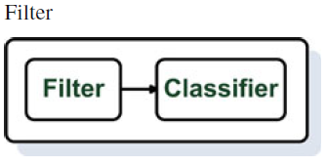 | Independence of classifier  Lower computational cost thann wrappers  Fast  Good generalization ability | No interaction with the classifer | Consistensy-based CFS  M_{d}  INTERACT  ReliefF
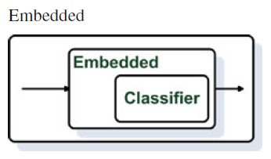 | Interaction with classifier  Lower computational cost thann  wrappers  Captures feature dependencies | Classifier-dependent selection | FS-Perceptron  SVM_RFE
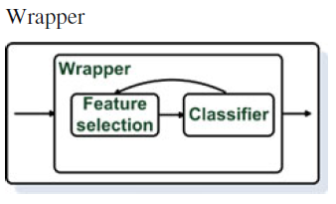 | Interaction with classifier  Captures feature dependencies | Computationally expensive  Risk of overfitting  Classifier dependent selection | Wrapper-C4.5  Wrapper SVM

Supplementary figure 1. Feature Extraction using Optimized Machine Learning Approaches
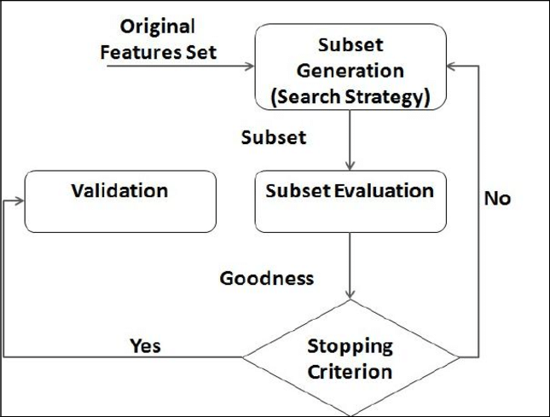

supplementary figure 2. Decision Making Tree
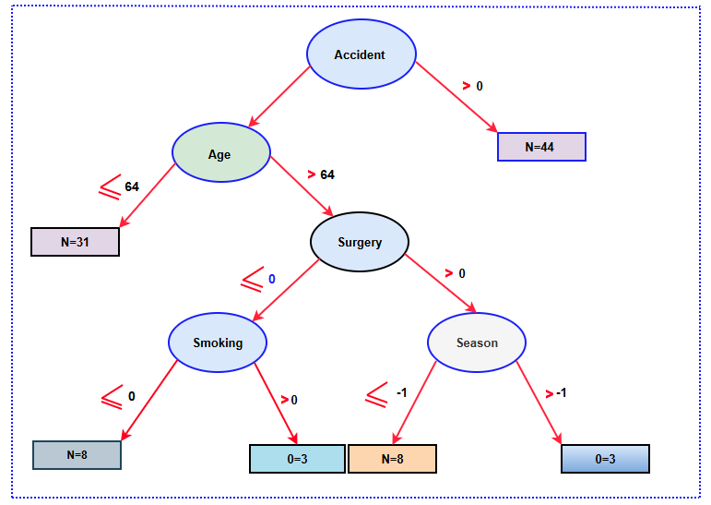

supplementary figure 3. A general procedure for feature extraction
