Supplementary figure 1. Kaplan–Meier survival curves of primary and secondary stent patency (stent exchange vs. stent-in-stent)
Kaplan–Meier survival curves of secondary stent patency according to the secondary stenting method. A statistically significant difference was found in the secondary stent patency rate curves according to the secondary stenting method obtained through log-rank analysis (p = 0.035).

Supplementary figure 2. Kaplan–Meier survival curves of overall survival time (stent exchange vs. stent-in-stent)
Kaplan–Meier survival curves of the overall survival time according to the secondary stenting method. The survival curves according to the overall survival time obtained by log-rank analysis did not suggest any statistically significant differences (p = 0.294). SEMS, self-expandable metallic stent

Supplementary figure 3. Kaplan–Meier survival curves of primary and secondary stent patency by stent-in-stent method (covered SEMS vs. uncovered SEMS)
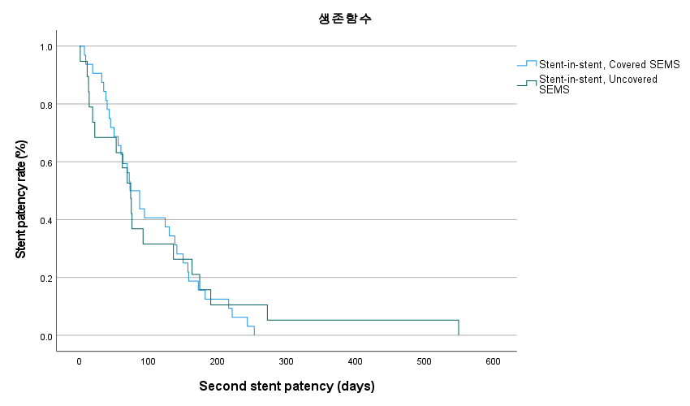
Kaplan-Meier survival curves of secondary stent patency according to the method of secondary stent insertion. No statistically significant difference was found in the curve of secondary stent patency according to the method of secondary stent insertion determined by the log-rank test (p = 0.782).

Supplementary figure 4. Kaplan–Meier survival curves for overall survival by the stent-in-stent method (covered SEMS vs. uncovered SEMS)
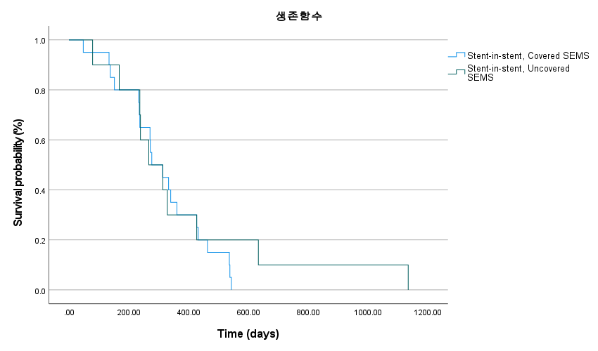
Kaplan-Meier survival curves for overall survival according to the method of secondary stent insertion. The survival curves obtained by log-rank analysis showed no statistically significant difference in overall survival (p = 0.654). SEMS, self-expandable metallic stent

Supplementary figure 5. Kaplan–Meier survival curves for overall survival by the stent-in-stent method (covered SEMS vs. uncovered SEMS)
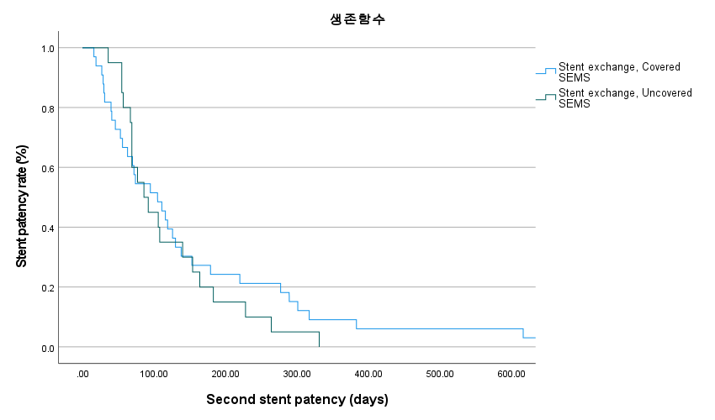
Kaplan-Meier survival curves of secondary stent patency according to the method of secondary stent insertion. No statistically significant difference was found in the curve of secondary stent patency according to the method of secondary stent insertion determined by the log-rank test (p = 0.498). SEMS, self-expandable metallic stent

Supplementary figure 6. Kaplan–Meier survival curves for overall survival by stent exchange method (covered SEMS vs. uncovered SEMS)
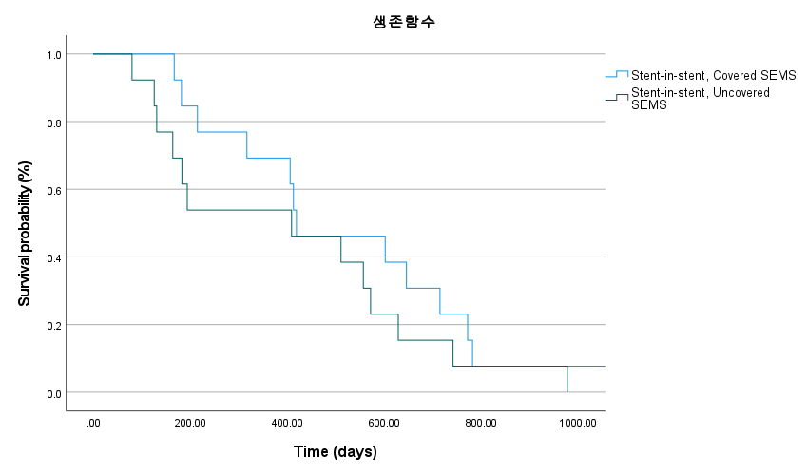
Kaplan-Meier survival curves for overall survival according to the method of secondary stent insertion. The survival curves obtained by log-rank analysis showed no statistically significant difference in overall survival (p = 0.276). SEMS, self-expandable metallic stent

