SUPPLEMENTAL TABLES AND SUPPLEMENTAL FIGURES

Table S1 Details of 198 soybean accessions. (Attached in the supplemental file)

Table S2 Phenotypic data for qualitative and quantitative DRTs of 198 soybean accessions in E1 and E2. (Attached in the supplemental file)

Table S3 SNP distribution by chromosome (Chr.) and the average distance between SNPs on 20 soybean chromosomes (Mb). (Attached in the supplemental file)

Table S4 List of significant marker‒trait associations with –log10(p) ≥ 4.0 for nine DRTs of 198 soybean accessions grown in E1 and E2 analyzed by the FarmCPU and BLINK GWAS models. (Attached in the supplemental file)

Table S5 Epistatic SNP × SNP interactions for nine DRTs of 198 soybean accessions grown in E1 and E2. (Attached in the supplemental file)

Fig. S1 Differences in qualitative traits associated with DRTs.
Fig. S2 Circos plot showing the Manhattan plot genome-wide association plot for identifying MTAs associated with (A) seed size–length, thickness and width upper panel for E1 and lower panel for E2. The analysis employs both the FarmCPU and BLINK models. The red dotted line in the plot represents the genome-wide significance threshold set at a –log10(p) value ≥ 5.67 (Bonferroni correction set at 0.05 (5%)). The quantile‒quantile (Q‒Q) corresponds to the dataset depicted in the Manhattan plot.
Fig. S3 Circos plot showing the Manhattan plot of the genome-wide association plot for identifying MTAs associated with (B) seed coat color, (C) cotyledon color, (D) hypocotyl color, and (E) stem growth habits in the upper panel and (F) flower color, (G) pod color, and (H) pubescence in the lower panel. The analysis employs both the FarmCPU and BLINK models. The red dotted line in the plot represents the genome-wide significance threshold set at a –log10(p) value ≥ 5.67 (Bonferroni correction set at 0.05 (5%)). The quantile‒quantile (Q‒Q) corresponds to the dataset depicted in the Manhattan plot. We used the –log10 (p)-value for the stem growth habit trait to detect common SNPs across GWAS models and both environments.

Fig. S4 Circos plot showing the Manhattan plot genome-wide association plot for identifying MTAs associated with (I) pod-shattering (AVRDC scale) in the left panel for E1 and E2 and pod-shattering (oven-based) in the right panel for E1 and E2. The analysis employs both the FarmCPU and BLINK models. The red dotted line in the plot represents the genome-wide significance threshold set at a –log10(p) value ≥ 5.67 (Bonferroni correction set at 0.05 (5%)). The quantile‒quantile (Q‒Q) corresponds to the dataset depicted in the Manhattan plot.

Fig. S1 Differences in qualitative traits associated with DRTs.

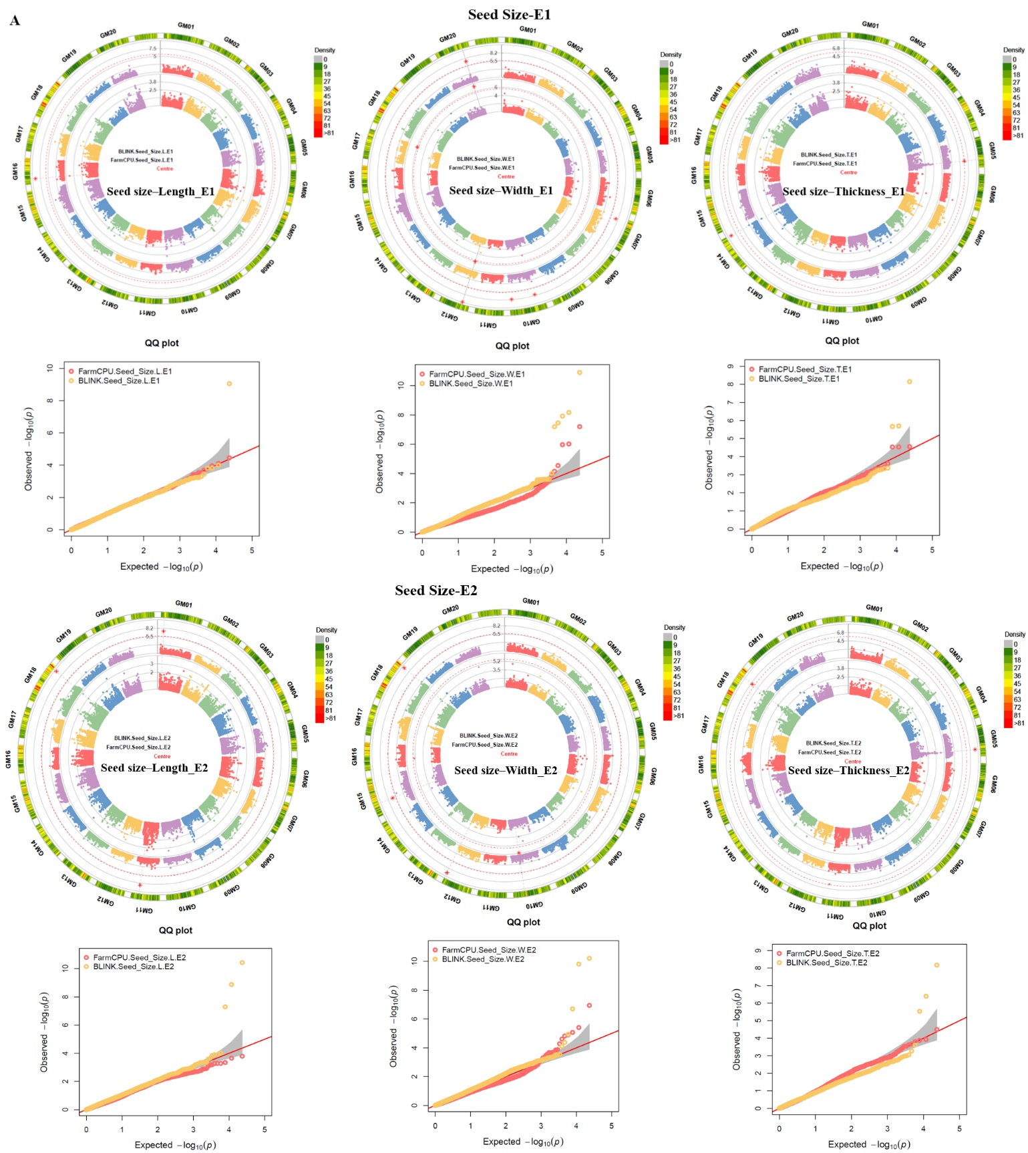
Fig. S2 Circos plot showing the Manhattan plot genome-wide association plot for identifying MTAs associated with (A) seed size–length, thickness and width upper panel for E1 and lower panel for E2. The analysis employs both the FarmCPU and BLINK models. The red dotted line in the plot represents the genome-wide significance threshold set at a –log10(p) value ≥ 5.67 (Bonferroni correction set at 0.05 (5%)). The quantile‒quantile (Q‒Q) corresponds to the dataset depicted in the Manhattan plot.

Fig. S3 Circos plot showing the Manhattan plot of the genome-wide association plot for identifying MTAs associated with (B) seed coat color, (C) cotyledon color, (D) hypocotyl color, and (E) stem growth habits in the upper panel and (F) flower color, (G) pod color, and (H) pubescence in the lower panel. The analysis employs both the FarmCPU and BLINK models. The red dotted line in the plot represents the genome-wide significance threshold set at a –log10(p) value ≥ 5.67 (Bonferroni correction set at 0.05 (5%)). The quantile‒quantile (Q‒Q) corresponds to the dataset depicted in the Manhattan plot. We used the –log10 (p)-value for the stem growth habit trait to detect common SNPs across GWAS models and both environments.

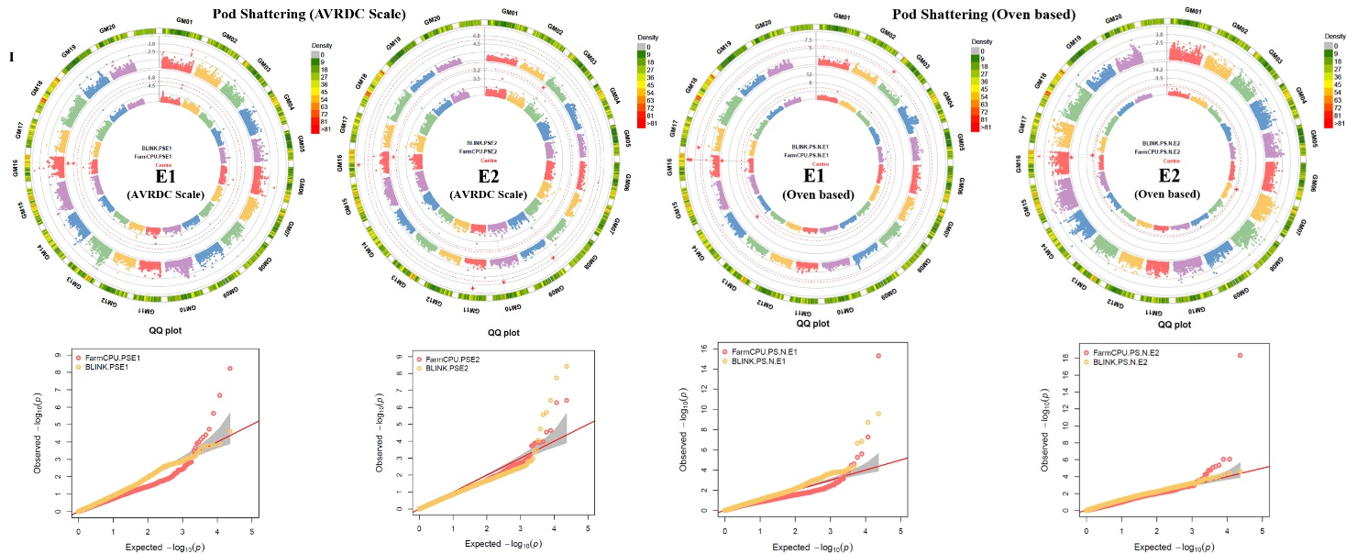
Fig. S4 Circos plot showing the Manhattan plot genome-wide association plot for identifying MTAs associated with (I) pod-shattering (AVRDC scale) in the left panel for E1 and E2 and pod-shattering (oven-based) in the right panel for E1 and E2. The analysis employs both the FarmCPU and BLINK models. The red dotted line in the plot represents the genome-wide significance threshold set at a –log10(p) value ≥ 5.67 (Bonferroni correction set at 0.05 (5%)). The quantile‒quantile (Q‒Q) corresponds to the dataset depicted in the Manhattan plot.

