Supplementary materials for

Nonlinear Optical Vector Processing at 50 Gb/s using Linear Silicon Photonic Circuits
T. Moschos*^{1,2}, C. Pappas^{1,2}, S. Kovaios^{1,2}, I. Roumpos^{1,2}, A. Prapas^{1,2}, A. Tsakyridis^{1,2}, M. Moralis-Pegios^{1,2}, C. Vagionas^{1,2}, Y. London³, B. Tossoun⁴, T. Van Vaerenbergh³ and N. Pleros^{1,2}
¹Department of Informatics, Aristotle University of Thessaloniki, 54124, Thessaloniki, Greece
²Center for Interdisciplinary Research and Innovation, 57001, Thessaloniki, Greece
³Hewlett Packard Labs, 820 N McCarthy Blvd, Milpitas, CA 95035, USA
⁴Hewlett Packard Labs, Santa Barbara, CA 93106, USA
*moschost@csd.auth.gr

- Principle of operation for single and WDM optical comparison cells
The proposed layouts of the single and multi-wavelength comparison cell, along with their basic principle of operation are demonstrated in Sup. Figure 1. Sup. Figure 1 (a) presents the schematic of the single comparison unit, which consists of a pair of thermo-optic (TO) intensity modulator (IM)-based nodes, followed by TO phase shifters (PS). The optical search vector encoding unit (SVEU) is responsible for generating the search bit values as a complementary non-return-to zero (NRZ) pattern ($Βιt$ and $\overline{Βιt}$). The cell is configured by adjusting the biasing of the IMs, enabling it to encode three distinct target symbol information states: i) “0”, ii) “1”, and iii) the ternary value, or ‘don’t care’ state “X”, which is widely utilized in ternary content addressable memories (TCAMs). Sup. Figure 1(b) illustrates the configuration of the WDM comparison cell, which encodes different target symbol values by assigning each value to a specific wavelength. In both cases, the final output of the column reflects the result of the logical comparison operations based on the cell's configured static information, indicating either a logical “match” or the degree of “mismatch” in terms of optical power. Specifically, a zero-power pulse amplitude represents a logical “match”, signifying identical compared values, whereas a non-zero power indicates the degree of “mismatch”, revealing the power-level difference between the incoming search value and the target symbol. Sup. Figure 1(c) shows the logical cell assignment for the respective symbol values. In the single-cell unit, the incoming optical signals for the search bit and its complement i.e. $Βιt$ and $\overline{Βιt}$, propagate through the two optical branches of the cell, each containing an electro-absorption modulator (EAM), denoted as S₁ and S₂. The TO phase shifters (PSs) following the EAM modules ensure proper phase matching by facilitating the constructive interference of the optical branches at the common output. The EAMs are configured to either the OFF or ON state by controlling their bias to activate or deactivate the absorption condition. In the single wavelength case, by applying a reverse voltage of 4V to the respective EAMs the output optical signal is suppressed, ensuring the signal does not exit the EAM. Conversely, if no voltage is applied, the propagated signal remains unsuppressed and is visible at the module's output. Subsequently, the two coherent optical beams are being coupled together via a 2:1 combiner, with the resulting output signal carrying the dot-product between the target symbol and the search bit value. In the case of the WDM cell, the search information is distributed to all respective S₁ and S₂ EAM pairs for parallel comparison. The cell symbol assignments follow the same configuration logic as the single wavelength comparison cell, with the key difference being that the EAMs are reverse-biased with a voltage of 3V. The multiplexer modules forward the results of the three different comparisons to the common output of the cell, where each specific case can be monitored by isolating the corresponding wavelength using a filtering element (demultiplexer or optical filter). As shown in Sup. Fig. 1 (c), to configure the logical “0” symbol, the two EAMs have to be set as [S₁=ON, S₂=OFF]. Following the same rationale, the logical “1” is represented by [S₁=OFF, S₂=ON] configuration, while the logical “X” state corresponds to the [S₁=OFF, S₂=OFF] configuration.
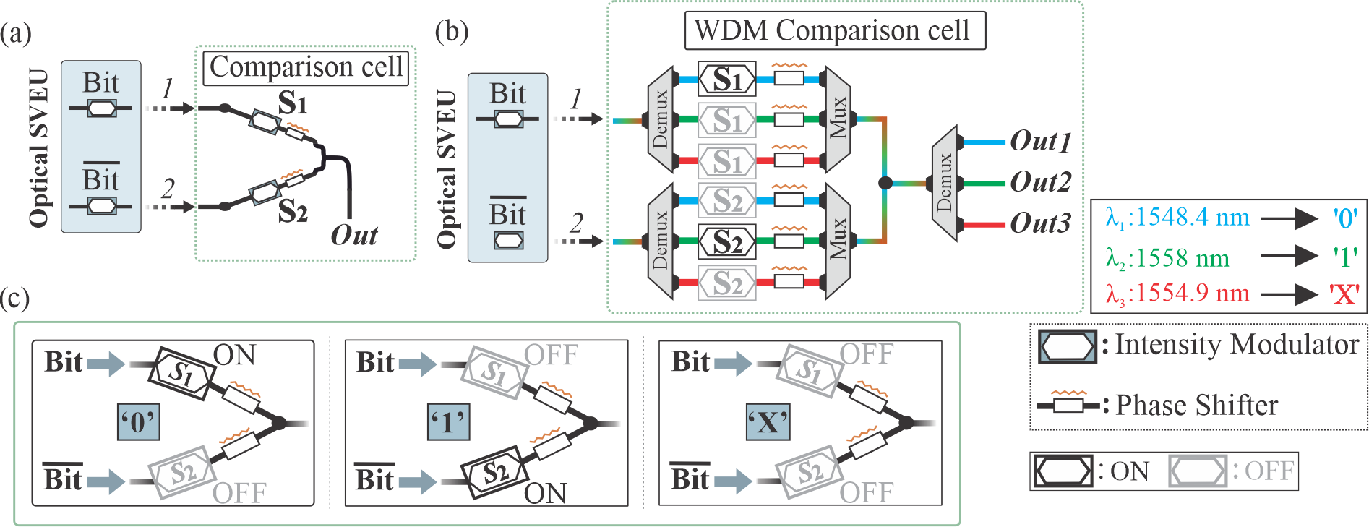
Supplementary Fig. 1. (a) Optical single comparison cell and (b) WDM comparison cell configuration. (c) Logical symbol content assignment for the logical symbol values of “0”, “1” and “X”.
Supplementary Table 1: Truth table of Binary and Ternary symbol encoding of the comparison cells
Search Bit | Search Bit Optical Encoding |  | Stored Symbol | Stored Value Optical Encoding |  | Logical Decision | Comparison cell Output
 | Bit | $$\overline{Βιt}$$ |  | S₁ | S₂
0 | 0 | 1 | 0 | ON | OFF | Match | 0
1 | 1 | 0 | 0 | ON | OFF | Mismatch | 1
0 | 0 | 1 | 1 | OFF | ON | Mismatch | 1
1 | 1 | 0 | 1 | OFF | ON | Match | 0
0 | 0 | 1 | X | OFF | OFF | Match | 0
1 | 1 | 0 | X | OFF | OFF | Match | 0

Supplementary Table 1 provides a detailed truth table of the proposed layout, summarizing all possible combinations of the incoming search and target symbol values, the respective encoding, and the final cell comparison outputs. In this table, a “0” value represents a zero-level output power, indicating a logical “match” while a “1” value represents a non-zero output power, indicating a logical “mismatch”. This table represents all combinations derived from a 1-bit/symbol comparison and can be extended by using larger optical SVEUs, with each pair of complementary modulated values providing additional search capacity. The number of target vectors that can be encoded in this architecture can be increased either physically, by incorporating additional columns, as in the case of the 4×4 Xbar architecture, or by utilizing the wavelength degree of freedom provided by WDM.

- Multiplexer and Demultiplexer modules of the WDM Comparison cell
The multiplexer and demultiplexer components that are used in the implementation of the WDM-enabled HD circuit, comprise 2nd order micro ring resonators (μRRs) [1], operating as filtering elements. Sup. Figure 2(a) presents the circuit layout of the proposed WDM-based interferometric cell, including the respective multiplexer and demultiplexer (Mux/Demux) elements. Sup. Figure 2 (b) shows the layout of the three channel μRR stages of the filter structures. In the demultiplexer case, the WDM stream consisting of the wavelengths λ₁=1548.4 nm, λ₂=1558 nm and λ₃=1554.9 nm, enters through a common input into the structure, with each of the three wavelengths being filtered at the output of every double ring channel. On the other hand, in the multiplexer scenario, the separated signals are inserted into each double ring channel and are then multiplexed in a common bus output. Towards investigating the spectral response of the demux/mux, we have exploited the electro-absorption effect of EAMs to capture the photocurrent generated by an incident optical beam. Initially, an optical signal, generated by a tunable laser source (TLS), was injected through the input port, to evaluate the De-mux₁ and De-mux₂ spectral behaviour. Once the optical signals reach the respective EAM modules, after the demultiplexing stage, the photocurrent produced by the EAMs in response to different wavelength values is measured, with the corresponding diagrams shown in Sup. Figure 2 (c). To test the spectral response of Mux₁ and Mux₂, we injected an optical signal from the output port (respective filtering port for every wavelength case) while again monitoring the EAMs' photocurrent. The diagrams indicate a misalignment in the wavelength tuning between the Mux/Demux modules, requiring adjustments to fully align the structure grid. By tuning the modules of De-mux₁, De-mux₂ and Mux₁ (De-mux₁ 18 mA current applied, De-mux₂ 15 mA current applied and Mux₂ 12 mA current applied), through dedicated thermo-optic PS elements, while keeping Mux₂ as a reference, complete alignment can be achieved. Sup. Figure 2 (d) presents the wavelength shifting response of every Mux and De-mux module along with its TO PS current requirements. One of the EAMs in each branch of the interferometer is indicatively selected as a reference element for its photocurrent response for each μRR filter. In every Mux and Demux, current values in the range of [0-40 mA] have been applied, revealing a maximum wavelength shift of: 1.7 nm for the De-mux₁, 1.5 nm for the De-mux₂, 1.75 nm for the Mux₁ and 1.5 nm for the Mux₂.
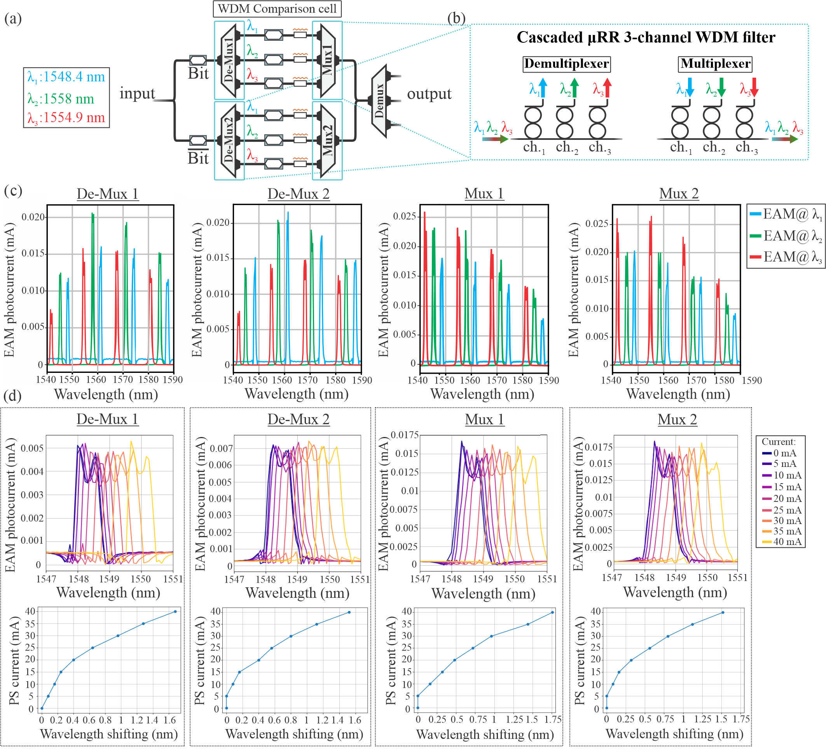
Supplementary Fig. 2. (a) Circuit layout of the WDM comparison cell, (b) Layout of cascaded 3-channel μRR filters as Multiplexer and Demultiplexer modules, (c) EAM photocurrent (mA) in response to wavelength, for all the Mux/Demux modules, (d) Wavelength shifting response of the respective ring structures for specific applied current values.

- Noise analysis of single wavelength and WDM-enabled HD processors
The architectures under study are evaluated both as CAM operators that validates the matching conditions when the HD=0, as well as HD calculation units producing multi-level signals that correspond to the HD between the two optical vectors. The evaluation of the single wavelength and WDM Xbar approaches has been performed for different crossbar (Xbar) scales ranging from [4,128], as well as for the different operational rates of 20 and 50 GHz. The performance is validated through the calculation of match error rate (MER) when CAM operation is targeted and the symbol error rate (SER) when HD calculation is performed. In the current analysis three different noise sources are considered, specifically being: (i) the relative intensity noise (σ_{RIN}) that stems from the noise contribution of the laser source, (ii) the shot noise (σ_{SHOT}), produced by the current random fluctuations of electrons that occur into the photodiode (PD) module and (iii) the thermal noise (σ_{THERMAL}) which is mainly produced by the transimpedance amplifier (TIA), at the receiver site [2]. Supplementary Figure 3 shows a layout approach that includes all the noise components and their contributing noise factors. The noise components are approached and modeled as zero-mean additive white Gaussian noise sources, based on the central limit theorem [3].
Moreover, different signal power levels have been taken into consideration for the calculation of noise, depending on the different match/mismatch levels of the Hamming distance/CAM comparison operations. This approach allows for more accurate estimations of the noise profiles for the multi-level comparison outputs, since the shot and RIN noise closely depend on the received power of the signal, meaning that different noise characteristics will be assigned to different signal levels, following accurately the principle of the Hamming distance calculator. In the current implementation, the signal levels correspond to comparisons of different symbol lengths supported by different crossbar scales [4,128].
For the calculation of the discrete signal comparison levels, the following equation is followed:
P_{Signal level} (mW) = P_{laser} (mW) – (crossbar losses (dB) + signal level losses (dB) + 3 dB) ₍₁₎,
where P_{laser} is the input laser power that is inserted into the crossbar table, for every different laser power under study in a range of 40 dB (-10 to 30 dB). The Xbar losses are calculated using the mathematical equation presented in [4], while the signal level losses correspond to the differences in signal power levels. These losses assume an equal power distribution, where the highest level of “mismatch” corresponds to the highest power value, and the “match” state results in a near-zero power output. Finally, the additional 3 dB losses are attributed to the driving conditions of the search encoding EAMs, as half of them will be configured to “0” values at any given time instance, based on the Bit and its complementary $\overline{Βιt}$ value.
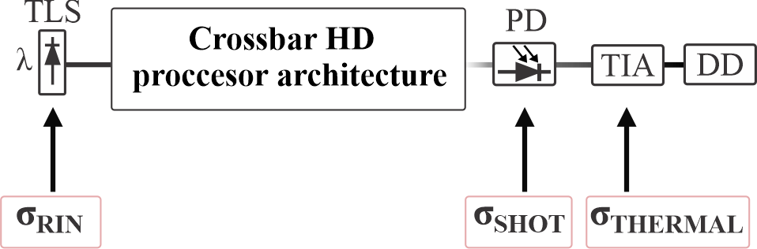
Supplementary Fig. 3. Layout of the Crossbar Hamming Distance processor architecture’s noise sources. The electro-optic components that contribute to the overall noise profile are: the laser diode (TLS), the photodiode module (PD) and the transimpedance amplifier (TIA).
After calculating all the respective signal levels, the calculated powers are converted to a receiver photo current (I_{received}), based on the responsivity (R) of the photodiode (PD), which in our case is considered to be 0.8 A/W, based on the equation:
I_{received} = P_{Signal level} (mW) $⋅$ R ₍₂₎,
Based on the previous calculations, the noise parameters can be calculated through the following equations:
σ_{RIN} = I_{received} $⋅\sqrt{RIN⋅B}$
σ_{SHOT} = $\sqrt{2⋅e⋅I_{received}⋅B}$
σ_{THERMAL} = spectral density $⋅\sqrt{B}$ ₍₃₎,
where B stands for the operational bandwidth, e for the electron charge parameter in the photodiode, RIN for the relative intensity noise density of the laser source, while the spectral density refers to the TIA module. Based on state-of-the-art high-bandwidth electro-optic components we considered the following values of: RIN = -150 dB/Hz, e = 1.602 e⁻¹⁹ and spectral density = 15.084 pA/$\sqrt{Hz}$. The total noise value for every signal level is then calculated as:
σ_{total} _{noise} = $\sqrt{ σ_{RIN}^{2}+ σ_{SHOT}^{2} + σ_{THERMAL}^{2}}$ ₍₄₎
The comparison performance relies on XOR logical operations, which are summed at each comparison output. Specifically, the XOR operation is performed between the search and stored words, each consisting of n symbols, whose values follow a uniform distribution. The bit-by-bit comparison yields a '1' when the values differ and a '0' when they are equal. For every compared symbol stream, the count of positions that have a difference, is described as a Binomial distribution when assuming a uniform distribution of the binary values of the two compared binary strings. This is expressed as Binomial (n, p), where n is the respective number of symbols and p is the probability of success, with an equal probability of 0.5 (p=0.5) for the bits 0 and 1. The binomial distribution can then be expressed as:
P(Hamming distance = k) = $\left(\begin{aligned}n \\ k\end{aligned}\right)⋅p^{k}⋅{\left(1-p\right)}^{n-k}$,
with the binomial coefficient, representing the number of ways to choose k successes out of n trials, with p^{k} being the probability of each symbol differing and ${\left(1-p\right)}^{n-k}$ the probability of n-k failures. Based on the different length of the sequences that can be supported by every crossbar scale, a different probability of occurrence characterizes every different signal level at the output of the HD matching operator. For an example case of a 4-symbol word, the following probability responses are shown:
- For an n value equal to 4 (n = 4), the binomial distribution is configured as P(Hamming distance = k) = $\left(\begin{aligned}4 \\ k\end{aligned}\right)⋅{0.5}^{k}⋅{\left(0.5\right)}^{4-k}⇒$P(Hamming distance = k) = $\left(\begin{aligned}4 \\ k\end{aligned}\right)⋅{0.5}^{4}$, with the following cases characterizing the probability of every Hamming distance occurrence:
- P(k=0) = $\left(\begin{aligned}4 \\ 0\end{aligned}\right)⋅{0.5}^{4}$ $⇒$P(k=0) = 0.0625, refers to the case of a complete match, with a Hamming distance that equals to “0” (HD=0)
- P(k=1) = $\left(\begin{aligned}4 \\ 1\end{aligned}\right)⋅{0.5}^{4}$ $⇒$P(k=1) = 0.25, refers to the case where 1 compared symbol differs, with a Hamming distance that equals to “1” (HD=1)
- P(k=2) = $\left(\begin{aligned}4 \\ 2\end{aligned}\right)⋅{0.5}^{4}$ $⇒$P(k=2) = 0.375, refers to the case where 2 compared symbols differ, offering a Hamming distance that equals to “2” (HD=2)
- P(k=3) = $\left(\begin{aligned}4 \\ 3\end{aligned}\right)⋅{0.5}^{4}$ $⇒$P(k=3) = 0.25, refers to the case where 3 compared symbols differ, meaning that the Hamming distance will equal to “3” (HD=3)
- P(k=4) = $\left(\begin{aligned}4 \\ 4\end{aligned}\right)⋅{0.5}^{4}$ $⇒$P(k=4) = 0.0625, refers to the case of a complete mis-match, with the highest value of Hamming distance (HD=4)
Following the same principle for all the different crossbar cases and their supported words, Sup. Figure 4 presents all the different Binomial distribution histograms.
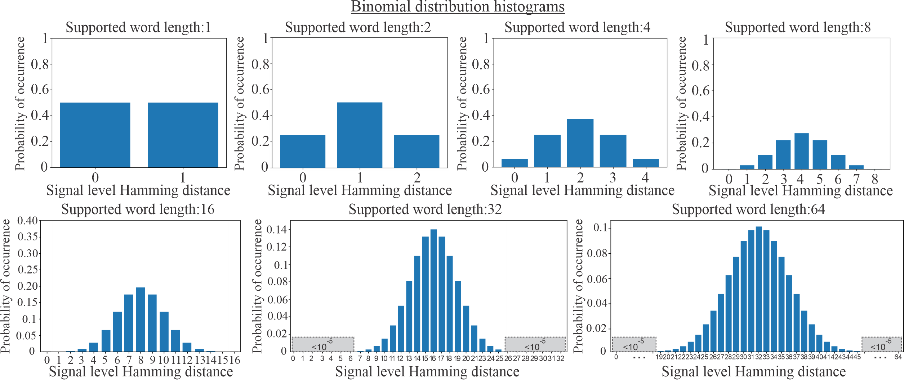
Supplementary Fig. 4. Hamming distance Binomial distribution histograms of signal level’s/symbol sequence probability of occurrence at the comparison output of the multi-word comparison operator.
Following the calculation method for the signal level probabilities and the noise parameters that correspond to each power level, the error rates calculation method is expalined.
The calculation of the MER is based in the following equation:
$MER=P\left(x∕0\right)+P\left(0∕x\right)$ ₍₅₎,
where P(x / 0) expresses the bound false positive probability of detecting an x symbol instead of the actual symbol “0”, while the P(0 / x) is the false negative probability of detecting a “0”, when expecting another x symbol. Every probability is calculated using the complementary error function (erfc), representing the tail probability of a Gaussian distribution. The extracted probabilities of occurrence for every symbol are used to weight the partial bound probabilities, with p(0) used for the signal’s 0-level, while for all the other cases the respective probabilities are summed for the multiple i levels (from 1 to M-1), weighting each bound probability by the respective p(i) probability of occurrence.
Additionally, in order to optimize the MER measurements, we calculate the optimum threshold value, noted as t, between the zero-level and all the other signal levels, using the derivative of the MER with respect to the threshold, as follows:
$\frac{∂(MER)}{∂(t)}=\frac{∂(P\left(x∕0\right))}{∂(t)}+\frac{∂(P\left(0∕x\right))}{∂(t)}$ ₍₆₎,
where the $\frac{∂(P\left(x∕0\right))}{∂(t)}$ is expressed as:
$$\frac{∂(P\left(x∕0\right))}{∂(t)}=p\left(0\right)∙0.5∙\left(-\frac{1}{\sqrt{π}}e^{-{\left(\frac{t-μ\left(0\right)}{\sqrt{2}∙σ\left(0\right)}\right)}^{2}}\right)∙\frac{1}{\sqrt{2}∙σ\left(0\right)}=-\frac{p(0)}{2∙\sqrt{2π}∙σ(0)}e^{-{\left(\frac{t-μ\left(0\right)}{\sqrt{2}∙σ\left(0\right)}\right)}^{2}}$$
and $\frac{∂(P\left(0∕x\right))}{∂(t)}$ as:
$$\frac{∂(P\left(0∕x\right))}{∂(t)}=\sum_{i=1}^{M-1}{\frac{p(i)}{2∙\sqrt{2π}∙σ(i)}∙e^{-{\left(\frac{μ\left(i\right)-t}{\sqrt{2}∙σ\left(i\right)}\right)}^{2}}},$$
where M is the number of levels for every discrete case and μ(i) and σ(i) are the mean level value of the signal and its respective total noise parameter (σ_{total} _{noise}), expressed as a Gaussian standard deviation.
Based on the calculation method that is followed, setting the respective derivative to zero, allows for the calculation of the optimum threshold (f(t) = 0):
$$f\left(t\right)= -\frac{p\left(0\right)}{2∙\sqrt{2π}∙σ\left(0\right)}e^{-{\left(\frac{t-μ\left(0\right)}{\sqrt{2}∙σ\left(0\right)}\right)}^{2}}+\sum_{i=1}^{M-1}{\frac{p\left(i\right)}{2∙\sqrt{2π}∙σ\left(i\right)}∙e^{-{\left(\frac{μ\left(i\right)-t}{\sqrt{2}∙σ\left(i\right)}\right)}^{2}}}=0$$
By applying the natural logarithm and rearranging the equation, it then can be expressed in a standard quadratic form, as follows: $A∙t^{2}+B∙t+C=0$, where the coefficients are defined as:
$$A=\frac{1}{2∙{σ\left(0\right)}^{2}}-\sum_{i=1}^{M-1}{\frac{p\left(i\right)}{2∙{σ\left(i\right)}^{2}}}$$
$$B=-\frac{μ\left(0\right)}{{σ\left(0\right)}^{2}}+\sum_{i=1}^{M-1}{\frac{μ\left(i\right)}{{σ\left(i\right)}^{2}}}$$

$$C=\frac{{μ\left(0\right)}^{2}}{{2∙σ\left(0\right)}^{2}}-\sum_{i=1}^{M-1}{\frac{{μ\left(i\right)}^{2}}{{2∙σ\left(i\right)}^{2}}-\ln\left(\frac{p(0)}{\sum_{i=1}^{M-1}{p(i)}}\frac{\prod_{i=1}^{M-1}{σ(i)}}{σ(0)}\right)}$$
Solving this equation allows for yielding the optimum threshold, for the calculation of the MER.
Finally, based on all the previously presented methods the equation (5) for the calculation of the MER is expressed as:
$$MER=P\left(x∕0\right)+P\left(0∕x\right)= p\left(0\right)∙0.5∙erfc\left(\frac{t-μ\left(0\right)}{\sqrt{2}∙σ\left(0\right)}\right)+\sum_{i=1}^{M-1}{p(i)∙0.5∙erfc\left(\frac{μ\left(i\right)-t}{\sqrt{2}∙σ\left(i\right)}\right)}$$

Conversely, the calculation of the total SER of the signal is based on the following equation:
${SER }_{total}=\sum_{i=0}^{M-1}{p(i)}∙SER\left(i\right)$ ₍₇₎
where SER(i) expresses the symbol error rate of each output word comparison (signal level).
The calculation of the overall SER incorporates the respective MER of each case, assuming that SER(0) = MER and is calculated with the method mentioned above. For all the signal levels that range between the levels 1 to M-2 [1, M-2], the calculation of the respective SER(i) is based on the following equation:
$SER\left(i\right)=p\left(i\right)∙0.5∙erfc\left(\frac{μ\left(i\right)-t\left(i-1\right)}{\sqrt{2}∙σ\left(i\right)}\right)+p\left(i\right)∙0.5∙erfc\left(\frac{t\left(i\right)-μ\left(i\right)}{\sqrt{2}∙σ\left(i\right)}\right)+\sum_{j=i+1}^{M-1}{p\left(j\right)}∙0.5∙erfc\left(\frac{μ\left(j\right)-t\left(j\right)}{\sqrt{2}∙σ\left(j\right)}\right)+\sum_{k=i-1}^{0}{p\left(k\right)}∙0.5∙erfc\left(\frac{t\left(k-1\right)-μ\left(k\right)}{\sqrt{2}∙σ\left(k\right)}\right)$ ₍₈₎,
while in the case of the last signal level (i.e. M-1) the calculation of the SER(M-1) is expressed as:
$SER\left(M-1\right)=p\left(M-1\right)∙0.5∙erfc\left(\frac{μ\left(M-1\right)-t\left(M-2\right)}{\sqrt{2}∙σ\left(M-1\right)}\right)+\sum_{j=M-2}^{0}{p\left(j\right)}∙0.5∙erfc\left(\frac{t\left(j-1\right)-μ\left(j\right)}{\sqrt{2}∙σ\left(j\right)}\right)$ (9),
The optimal thresholds are also calculated in order to acquire the most accurate SER measurements. Towards determining the optimal thresholds, the numerical iterative approach of the Newton-Raphson method is exploited [6]. Specifically, this method is employed for the approximation of the root of the threshold function that equals to 0, by using the iterative formula:
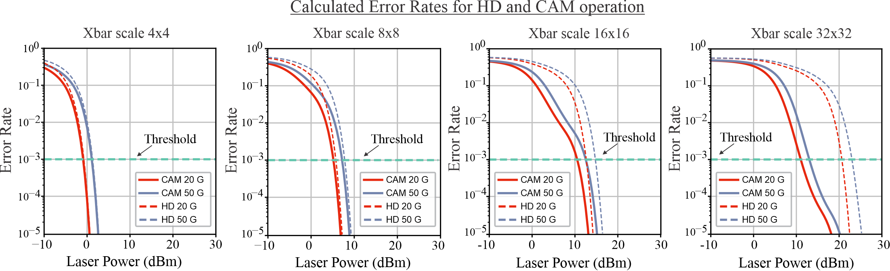
Supplementary Fig. 5. Calculated HD and CAM error rate values for crossbar scales of 4x4, 8x8, 16x16 and 32x32 for the data rates of 20 to 50 GHz. The diagrams indicate the error rate response across a laser power range of 40 dB (from -10 to 30 dB), indicating the required laser power in order to achieve error rates of 10⁻³ (threshold).
X_{n+1} = X_{n} - $\frac{f\left(x\right)}{f^{'}\left(x_{n}\right)}$ ₍₁₀₎,
where X_{n} is the current approximation, while X_{n+1} is the new approximation value of the respective function. In the current implementation, after approximately 100 iterations, the optimal thresholds corresponding to the minimum SER values are selected. By applying the respective threshold values in the equation (7), the total SER of the system can be calculated.
Sup. Figure 5 demonstrates the diagrams of the acquired error rate values of the analysis, compared to the required laser input power of the system for the Xbar scale cases of 4x4, 8x8, 16x16 and 32x32 when targeting a single λ architecture, for performing the respective HD and CAM operations, at both 20 and 50 GHz. The diagrams indicate the need for higher power as the scale of the Xbar implementation and the operational data rates increase, in order to achieve error rate values of 10⁻³, comparing the capabilities of the current layouts with state-of-the-art electronic demonstrated devices. This mainly occurs due to the increase of the overall losses of the architecture for the larger Xbar scales, as well as the enhanced noise contribution of the higher rate operations. In the crossbar scale cases of 16x16 and 32x32, a relatively different response characterises the error rate curves that are assigned to the respective CAM operations of the two different operational rates under study. Specifically, as the laser power increases, the noise percentage characterizing the error rate response of each signal level decreases more slowly from the highest to the lowest power signal levels. Considering also that each signal level is associated with unequal probabilities of occurrence (follows a binomial distribution) at the output of the HD comparison architecture, this effect is reflected in the corresponding graphs. The current analysis showcases that the single-wavelength layout can efficiently perform comparison operations up to a 32x32 Xbar scale, especially for the cases of the CAM-only matching functionalities at high operational data rates, since the required laser powers for these operations at both data rates, do not exceed the values of 13 dBm for 10⁻³ error rate values.
The error rate analysis of the WDM HD and CAM operator follows the same principles, regarding the contributed noise sources of the architecture and the calculation of the respective MER and SER measurements.
Additionally, the experimental MERs and SERs, provided in the main manuscript, are calculated following the same methodology mentioned above, with the difference being that the signal levels and the respective noise parameters of every experimentally measured case, are extracted from the acquired experimental signals.

- Power consumption analysis of single wavelength and WDM-enabled HD processors
The overall power requirements of the architectures have been evaluated for all the mentioned cases. The power consumption parameters that are included in the current implementation are the respective required laser sources (TLSs), the total power consumption of the Xbar layout, the respective transimpedance amplifiers (TIAs) as receiver circuitry, and the decision units (DDs) responsible for distinguishing the logical comparison operations, as shown in Sup. Figure 3.
Starting with the laser consumption, different laser powers are considered for the single λ and the WDM cases, with the values being selected based on the threshold required powers (P_{laser}), for 10⁻³ operations. The laser consumption is then calculated using the following equation:
Laser_{consumption} (mW) = P_{laser} (mW) / wall-plug efficiency ₍₁₁₎,
with a laser wall-plug efficiency of 0.1 (10 % output laser power compared to the electrical power that the device receives in order to operate).
The consumption of the crossbar-based architectures includes the switching energy of statically biased EAMs, the power consumption of the PSs modules, as well as the respective digital to analog (DAC) modules that are required to drive the respective components. The consumption of the thermos-optic PS components has been assigned to constant values of 4 mW [7], while the consumption of the static DACs to 1.74 nW [8].
Regarding the EAMs, we consider that the biasing voltage for every component will be -1.5V (V_{bias}), given that half of the EAMs will be biased at -3V (i.e. the “OFF” state) and the others will be biased at 0V (i.e. the “ON” state) at a specific time. Moreover, we consider that the responsivity (R) of the EAMs is 0.8 A/W, and the inserted input power values (P_{input}) are calculated based on the total path losses of the layout, taking into consideration all the splitting factors of the Xbar. Hence, the total power consumption for each EAM has been calculated based on the equation:
EAM_{consumption} (mW) = $\frac{1}{2}⋅$ P_{input} $⋅$ R $⋅$ Vbias (12)
Additional information can be found in [9].
Basen on the calculation of every Xbar component consumption, the total consumption of every different Xbar-scale layout can be computed as follows:
Crossbar_{consumption} (mW) = N² $⋅$ (EAM_{consumption} + PS_{consumption}) + 2 $⋅$ N² $⋅$ DACconsumption (13),
where N² is the total number of EAM and PS modules of every different crossbar case, along with the 2 $⋅$ N² static DACs.
Following the crossbar consumption, the energy requirements of the TIA components are also taken into account. Specifically, a constant consumption is considered for the TIAs, with a consumption of 3.5 mW [10] for the data rate of 20 GHz, and a consumption of 59 mW for the data rate of 50 GHz [11].
Moreover, the consumption of the comparator decision units (DDs) is also considered in the total consumption of the architecture. The comparator unit is based on a strong-arm latch topology [12], with the following equation expressing its consumption profile:
DD_{consumption} (mW) = $B$/2 $⋅$ (2 $⋅$C_{P,Q} + C_{X,Y}) $⋅$ V_{DD}² ₍₁₄₎,
where B is the operational data rate, C_{P,Q} and C_{X,Y} being the comparator capacitors with values of 200F each and V_{DD} the supply voltage of the device with a value of 0.9V. Based on the equation (14) the consumption increases as the operational data rate increases as well.
Following the equations (11), (12), (13) and (14), the total power consumption is calculated as:
Total_{consumption} (mW) = Laser_{consumption} (mW) + Crossbar_{consumption} (mW) + M $⋅$ TIA_{consumption} (mW) + M $⋅$ DD_{consumption} (mW) ₍₁₅₎,
with M being the number of TIAs and DDs at every output column of the crossbar.
After calculating the consumption for all the different crossbar scales and data rates, the energy efficiency (pJ/bit) is also calculated for all the respective cases. The efficiency values are calculated based on the total power consumption of the architecture and the respective data rate value (B), taking also into account the total number of output compared words at every specific scale architecture, as well as the number of symbols (symbol-length) of every output word. Particularly, the energy efficiency is calculated as:
Energy Efficiency (pJ/bit) = $\frac{Total consumption (W)}{K ⋅ L ⋅ B (bits/second)}⋅$ ${10}^{12}$ ₍₁₆₎,
where L is the total number of output words and K is the length of every specific word.
The WDM-enabled architecture can introduce an increase in the capacity of the comparison layout, since the utilization of additional wavelengths can offer additional comparison operations at a given Xbar scale layout. Specifically, an additional analysis is performed, considering the use of four distinct wavelength cases (λ=4). Based on that, the single-wavelength scale layouts can be reduced according to the capacity wavelength factor of four. Following this principle the Xbar scale of the single λ cases of 4x4 to 128x128 can be adjusted to scales of 4x1 to 128x32, for the proposed WDM-enhanced architectures. This approach allows for minimization in the splitting and combination required components, as well as the required crossings of the conventional Xbar layouts (Losses_{total}), resulting in a significant reduction in the overall insertion losses of the architecture, especially when scaling to 32 and 64-bit long comparison schemes. Taking also into consideration state-of-the-art low-loss Multiplexer and demultiplexer components that can be utilized in the WDM-architectures, with minimal losses of 0.2dB per Mux/De-Mux module [13], the overall loss reduction for every scale can be calculated as:
WDM loss reduction (dB) = Losses_{total} + N$⋅$0.2 (dB) – (splitting losses (dB) + crossings losses (dB)) ₍₁₇₎,
where N is the total number of multiplexer and demultiplexer components, required in every different Xbar layout. The losses reduction for every respective scale case of [4-128] are the following:
- Xbar scale 4x1 5.66 dB loss reduction
- Xbar scale 8x2 5.86 dB loss reduction
- Xbar scale 16x4 6.4 dB loss reduction
- Xbar scale 32x8 7.6 dB loss reduction
- Xbar scale 64x16 10.9 dB loss reduction
- Xbar scale 128x32 19.8 dB loss reduction
Based on the loss reduction parameters introduced by the WDM layouts, the required laser powers for the newly proposed schemes can be calculated. The laser power reduction is performed according to the loss reduction factor offered by every WDM-Xbar based layout adjusted to a specific power number (P_{reduction}). Following the equation (11) the calculation of the laser consumption in the WDM cases is configured as:
WDM laser_{consumption} (mW) = [(P_{laser} (mW) – P_{reduction} (mW)) / wall-plug efficiency] $⋅$λ ₍₁₈₎,
where in the specific case the total laser consumption of the WDM layout will be equal to the consumption of all the utilized laser sources (λ=4).
Ιn Sup. Figure 6 the required laser powers when utilizing the single or 4-λ layouts for the HD and CAM operations are presented, along with the respective energy efficiency values across the different Xbar scales, for both 20 and 50 Gb/s. The diagrams indicate that the use of multiple wavelengths (four in the specific case), instead of a single wavelength can significantly reduce the overall losses as well as the consumption requirements of the layouts, especially when the Xbar scales up to the 64 and 128 implementations. As also shown in Sup. Figure 6 (b) and (d) energy efficiencies of 400 fJ/bit and 200 fJ/bit can be achieved respectively, for the WDM CAM operations, while for the WDM HD operations the energy efficiency values remain below the 800 fJ/bit, thus highlighting the efficiency of the WDM-layouts even for the largest Xbar scale. Furthermore, the higher scale word-length CAM and HD functionalities can realistically be performed, especially in the 32-bit comparison case, using state-of-the-art laser technologies (referenced in the main manuscript). In that case, the laser consumption of the WDM cases can still be compensated compared to the single λ cases, were the laser becomes the dominant consumption factor of the architecture, with this effect being presented in the energy efficiency diagrams.
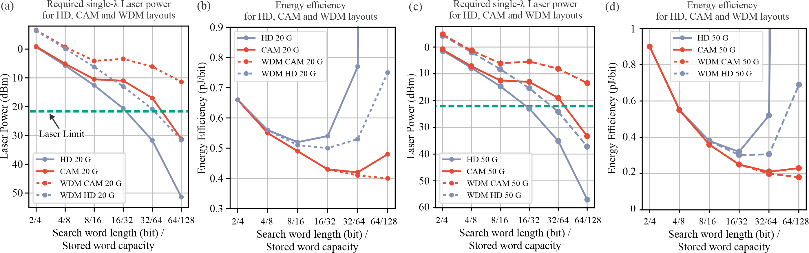
Supplementary Fig. 6. (a) Required laser power for single-λ and WDM HD,CAM layouts for search word length of [2-64] and capacity of [4-128], for the 20 Gb/s operations, (b) Energy efficiency (pJ/bit) for the respective layouts at 20 Gb/s. (c) and (d) Respective cases for the 50 Gb/s operations.

References of the Supplementary Materials
- P. De Heyn, J. De Coster, P. Verheyen, G. Lepage, M. Pantouvaki, P. Absil, W. Bogaerts, J. Van Campenhout and D. Van Thourhout, "Fabrication-Tolerant Four-Channel Wavelength-Division-Multiplexing Filter Based on Collectively Tuned Si Microrings," Journal of Lightwave Technology, vol. 31, pp. 2785-2792, 2013. DOI: 10.1109/JLT.2013.2273391.
- https://www.svphotonics.com/pub/pub029.pdf
- https://en.wikipedia.org/wiki/Central_limit_theorem
- G. Giamougiannis et. al., "A Coherent Photonic Crossbar for Scalable Universal Linear Optics," in JLT, vol. 41, no. 8, pp. 2425-2442, 15 2023
- https://en.wikipedia.org/wiki/Binomial_distribution
- https://www.sciencedirect.com/topics/mathematics/newton-raphson-method
- IMEC’S Silicon Photonics Platform Services, 2022. [Online]. Available: https://www.imec-int.com/sites/default/files/imported/SILICONPHOTONICS-V06.pdf. [Accessed: 19- Feb- 2022].
- I. B. Sharuddin and L. Lee, "An ultra-low power and area efficient 10 bit digital to analog converter architecture," 2014 IEEE International Conference on Semiconductor Electronics (ICSE2014), Kuala Lumpur, Malaysia, 2014, pp. 305-308, doi: 10.1109/SMELEC.2014.6920858.
- M. Pantouvaki et al., "Active Components for 50 Gb/s NRZ-OOK Optical Interconnects in a Silicon Photonics Platform," in Journal of Lightwave Technology, vol. 35, no. 4, pp. 631-638, 15 Feb.15, 2017.
- S. Saeedi, S. Menezo, G. Pares and A. Emami, "A 25 Gb/s 3D-Integrated CMOS/Silicon-Photonic Receiver for Low-Power High-Sensitivity Optical Communication," in Journal of Lightwave Technology, vol. 34, no. 12, pp. 2924-2933, 15 June15, 2016, doi: 10.1109/JLT.2015.2494060.
- L. Wang, X. Luo, D. Xu, Z. Qiu, Y. Yan and Q. Pan, "A 160-Gb/s 0.37-pJ/bit PAM4 Optical Receiver in 28-nm CMOS," 2022 IEEE Asia Pacific Conference on Circuits and Systems (APCCAS), Shenzhen, China, 2022, pp. 333-336, doi: 10.1109/APCCAS55924.2022.10090288.
- B. Razavi, "The Strong-ARM Latch [A Circuit for All Seasons]," in IEEE Solid-State Circuits Magazine, vol. 7, no. 2, pp. 12-17, Spring 2015, doi: 10.1109/MSSC.2015.2418155.
- L. Chenlei et. al., "Low-loss and low-crosstalk multi-channel mode (de)multiplexer with ultrathin silicon waveguides," Opt. Lett., 2017.

