SUPPLEMENTARY MATERIALS
 | High-performing | Low-performing
Mean degree of flavonoids | 1.31 | 7.98
Total number of nodes | 388 | 500
Modularity score | 0.43 | 0.28
Mean degree of metabolites | 1.93 | 5.16
Mean degree of OTUs | 25.8 | 39.47

Supplementary Table S1. Flavonoids exhibit a higher degree of connectivity in the low-performing network. Characteristics of each metabolite-OTU network for each performance class.

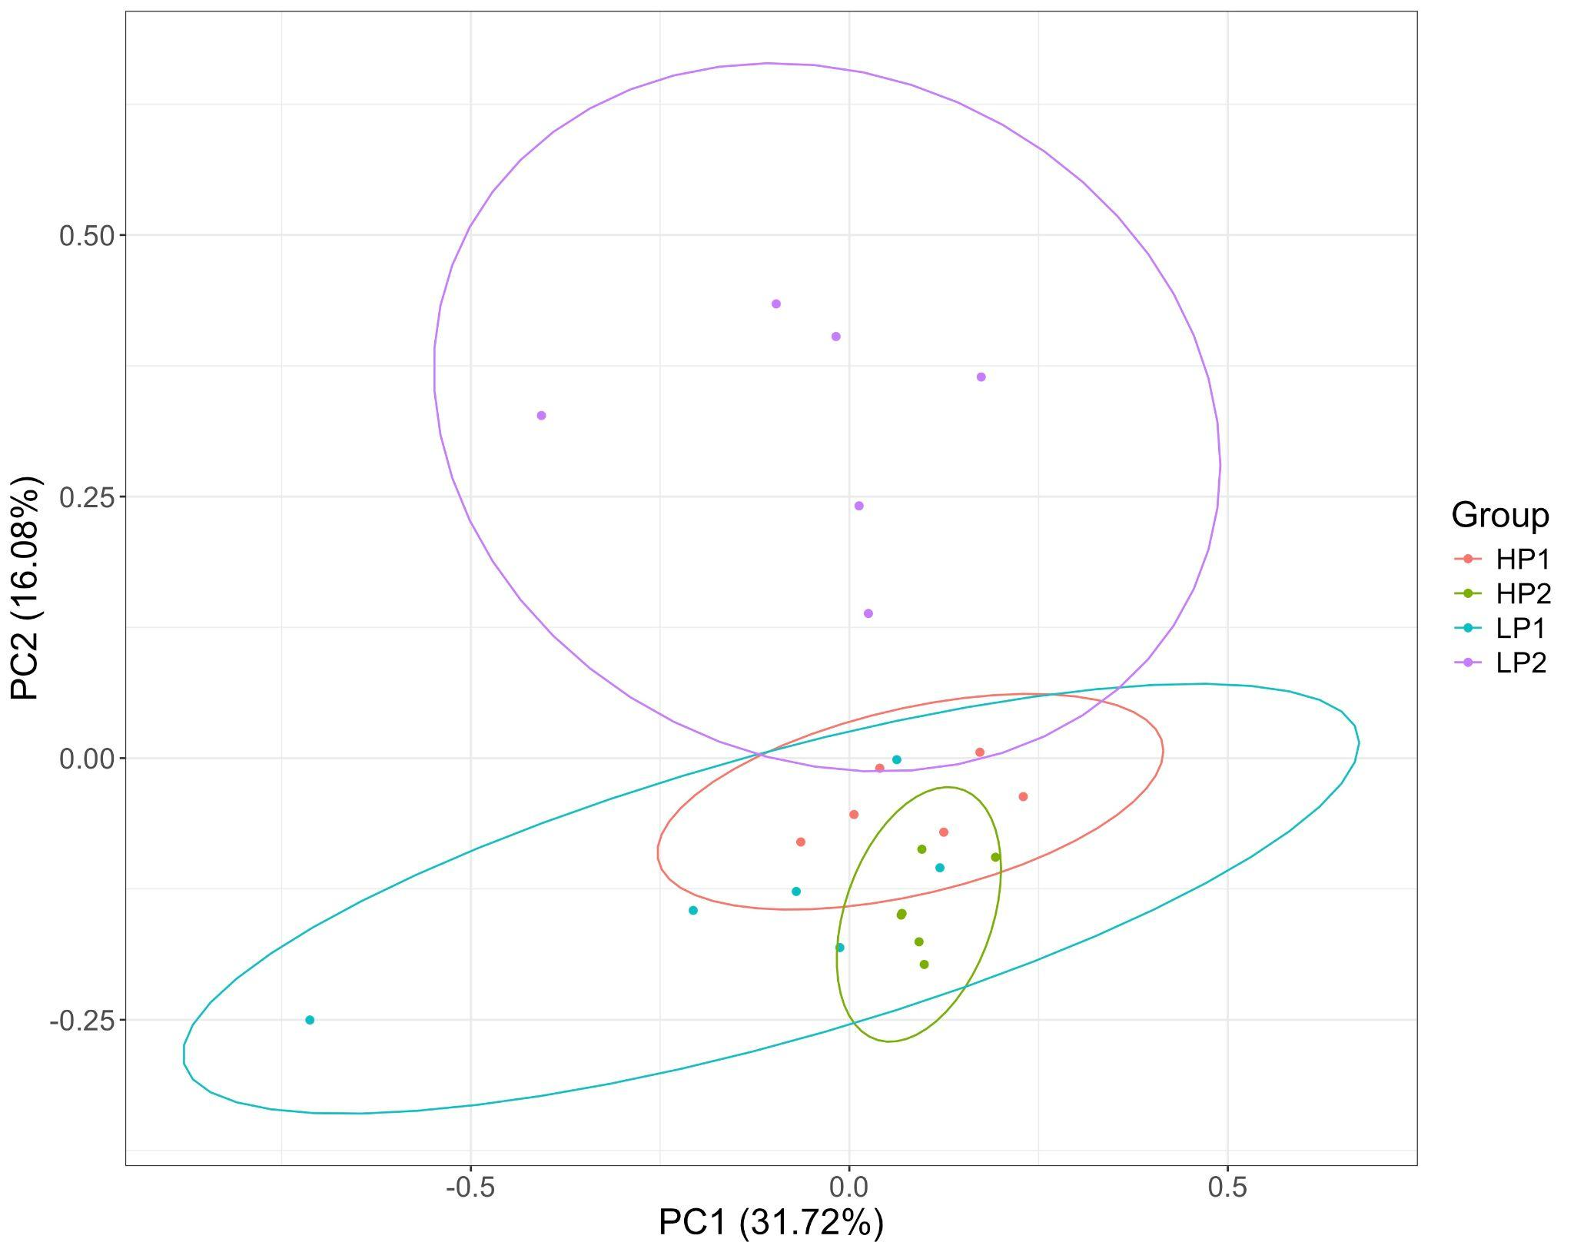
Supplementary Fig. S1. Non-polar metabolites in the root metabolome of sorghum also differ by genotype. The sorghum root metabolome differed significantly as a function of plant genotype (PERMANOVA, P ≤0.001), as visualized with a principal component analysis (PCA) of 192 log2-transformed MSI Level 2 metabolites from the HILIC dataset.

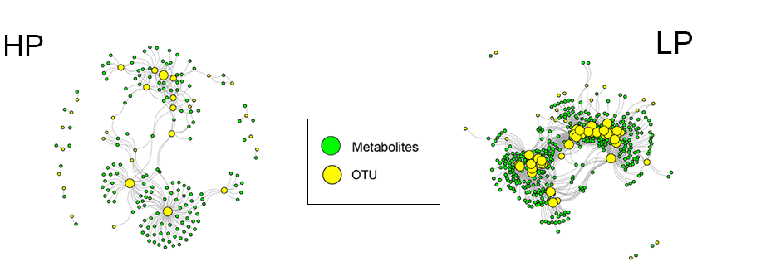
Supplementary Fig. S2. The metabolite-OTU network of higher-performers differs from that of lower-performers, regardless of method. Alternative network analysis via significant (FDR adjusted P ≤0.05) Spearman’s correlations (>0.6) reveal the same broad patterns in modularity and degree.

