Anthropogenic metal storage in wetland soils across the conterminous United States

Matthew Dietrich^{1,2}, Michael Dumelle³, Amanda M. Nahlik³, Heather E. Golden², Jay R. Christensen², Charles R. Lane⁴, Eric M. Moore^{1,2}, Gabriel M. Filippelli⁵

¹Oak Ridge Institute for Science and Education, Oak Ridge, Tennessee, 37830, USA

²Office of Research and Development, U.S. Environmental Protection Agency, Cincinnati, Ohio, 45268, USA

³Office of Research and Development, U.S. Environmental Protection Agency, Corvallis, Oregon, 97333, USA

⁴Office of Research and Development, U.S. Environmental Protection Agency, Athens, Georgia, 30605, USA

⁵Department of Earth and Environmental Sciences and Environmental Resilience Institute, Indiana University, Indianapolis, IN, 46202, USA

*Corresponding author. E-mail: dietrich.matthew@epa.gov

Supplementary Text

Text S1:
We focused on the elements Cr, Cu, and Pb in this study for four key reasons: (1) they are potential biotoxins,¹ (2) their concentrations are typically higher than instrument detection limit, (3) they are often immobile in wetland soils,² and (4) they have similar concentrations in both 2011 and 2016, suggesting limited variability over time. The strong correlations between concentrations of each one of these metals at resampled wetland sites [R > 0.65 and p < 0.001 (Fig. 12-1 in USEPA³)] reflects little post-depositional alteration on short timescales in the upper soil horizon.

Text S2:
We spatially joined the NWI dataset with the NWCA dataset in ArcGIS Pro, where the NWCA sample initial site visit centroid sample points intersected within a 20-meter buffer of an individual NWI wetland polygon. A total of 1,440 out of 1,629 (88.4%) NWCA sites were matched with a NWI wetland polygon, as not all NWCA sites were in areas identified by the NWI as being an active wetland site. At matched NWCA sites, we used NWI water regime definitions⁴ (e.g., irregularly flooded, subtidal) to classify the wetlands into three categories of tidal influence (tidal, tidal-freshwater, or non-tidal) and three categories of redox state (primarily oxic, primarily anoxic, or frequent oxic/anoxic shifts) (Supplementary Table S2). State-by-state NWI data is available publicly online.⁵ The geographic location of the NWCA sample sites was used to determine ecoregion subpopulations, based on the NWCA classifications for the five primary aggregated ecoregions throughout the CONUS.³

Text S3:
Urban land cover is based on data of land cover within the small-scale (HUC12) watershed that a wetland resides in, with urban defined as urban land cover classified by the National Land Cover Database (NLCD) 2019 Land Cover dataset.⁶ Greater urban land cover was categorized as “High Urban,” while less urban watersheds were classified as “Low Urban.” High Urban is specifically defined as > 15% urban land cover, consistent with when adverse effects (e.g., ecological condition deterioration, decline in sediment and water quality variables) tend to occur based on urban impacts such as the percent of impervious surface.^{7,8} We also analyzed agricultural land cover within HUC12 watersheds and found it was essentially inversely related to urban land cover.

Text S4:
Most anthropogenically emitted metals tend to accumulate within the upper portion of soil profiles, although over time, downward migration can occur.^{9,10} However, this is more prevalent with redox-sensitive elements such as manganese, iron, and arsenic.¹¹ Ultimately, there are differing total (air, soil, and water) metal deposition rates and wetland soil conditions that can influence metal sediment profiles across the CONUS.^{10,12} Our estimates of total anthropogenic metal mass and mean loadings will differ if we utilized different depth cutoffs of anthropogenic metal accumulation within soil profiles. For example, if we only considered the upper 10 cm, the estimated total anthropogenic metal mass in wetland soils would be less, but any anthropogenic metal contributions deeper than 10 cm would be excluded. If we only considered the upper 10 cm for excess metal loadings, we may bias our mean estimates towards greater values in areas with lower sediment deposition rates and/or lower rates of downward metal migration. Due to the nature of our population-based survey data, it is difficult to make variable anthropogenic metal depth cutoffs within soil profiles and reliably apply that across the different survey population(s). We contend that focusing on the upper half-meter of wetland soils conservatively includes most, if not all anthropogenic metals, and that adjusting calculations of anthropogenic metals based on regional background concentrations helps control for contributions of naturally occurring metals from weathering in deeper soil layers.

Text S5:
When considering the retention of anthropogenic metals in wetland soils and any potential health and ecological risks associated with these metals, the properties of both soils and metals are important to consider.¹³ For example, if the soil is rich in metal oxides and within a mostly neutral pH and oxic environment, metals such as Pb and Cu may be fairly immobile and coprecipitate with carbonates or metal oxides.¹³ However, different valence states of the metals or changing environmental conditions, such as oscillations between oxidizing and reducing environments, may release these metals into more mobile, bioavailable forms.¹⁴ Wetland soils typically retain Pb, Cr, and Cu in less labile forms, although limited potential for remobilization does exist.^{2,14,15} In wetland soils across the CONUS, the pH of soil-water tends to be neutral to slightly acidic, and organic carbon content tends to be high (especially in the EMU ecoregion) relative to soil organic carbon across the CONUS [NWCA wetland soil weighted population mean in the upper 40 cm. of 12,501 ± 1,534 (95% MOE) g/m² vs. the reported estimate of 4,980 g/m² across CONUS topsoil (0-30 cm) from Guevara et al.¹⁶] (Supplementary Fig. S7). These conditions collectively tend to favor metal sequestration in soil¹⁷ and thus higher metal loads (mass/area).

Supplementary Figures
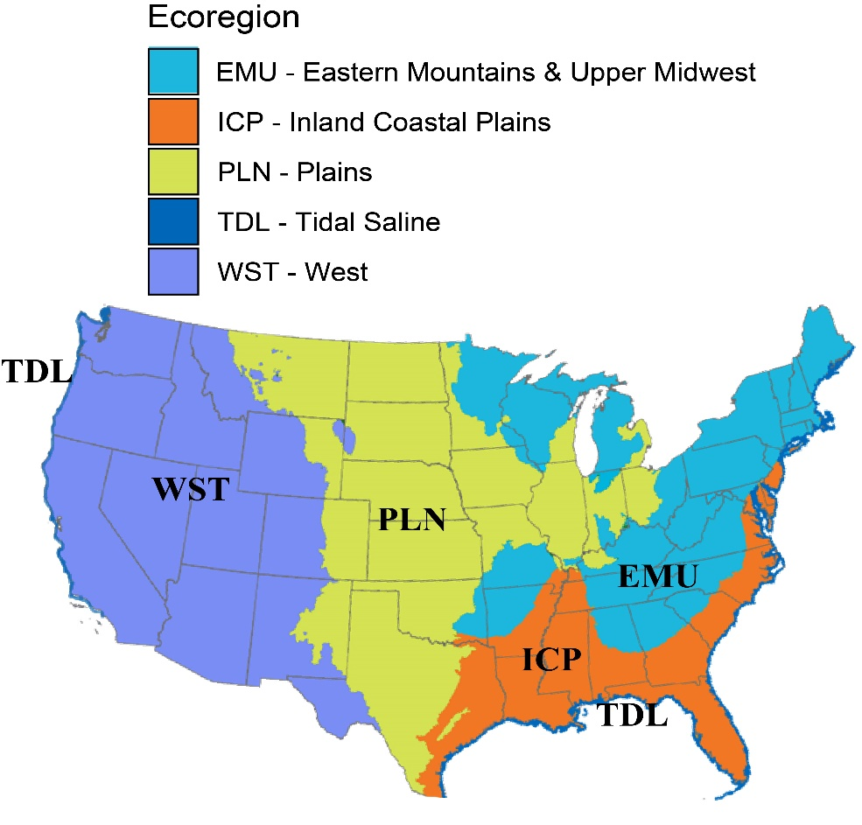
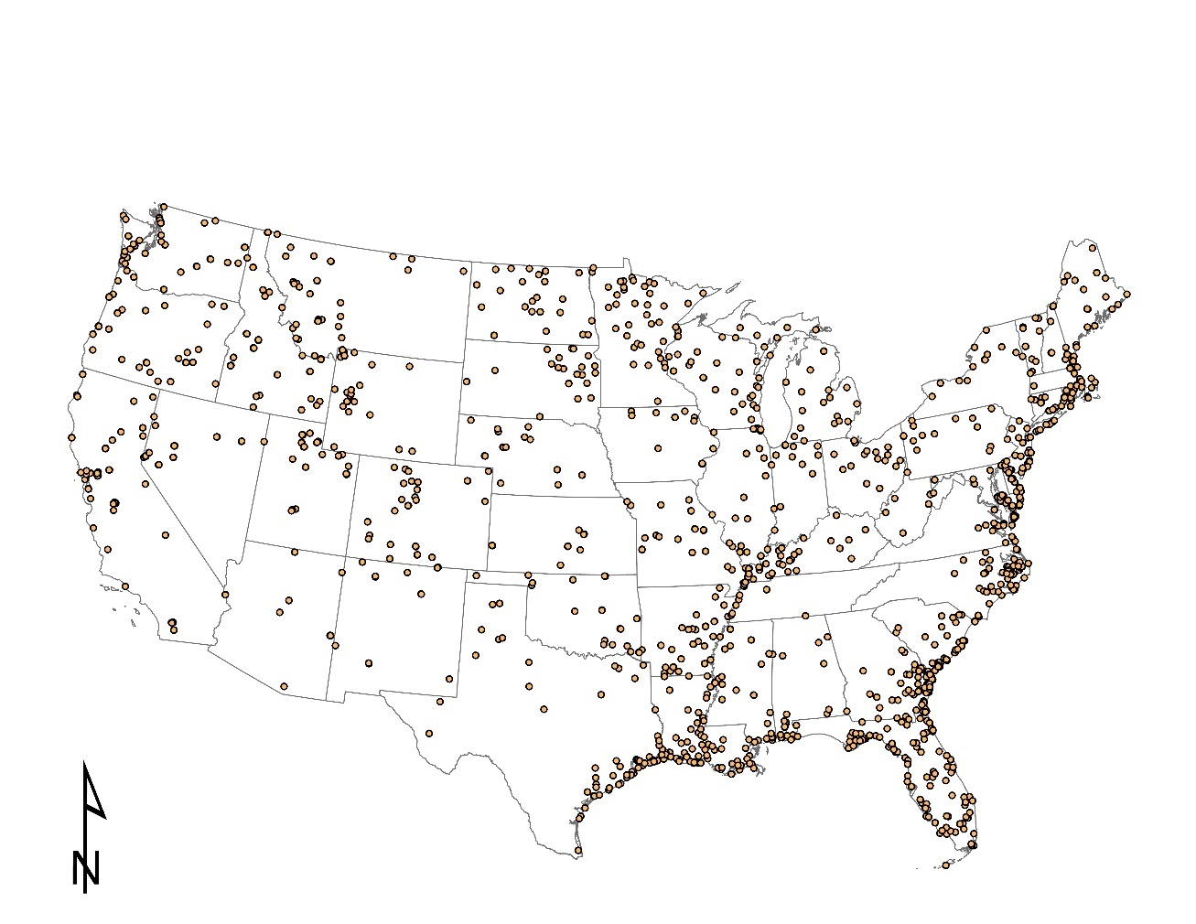
a
b

Figure S1: (a) Locations of the 1,629 National Wetland Condition Assessment (NWCA) sites from 2011 and 2016 analyzed in this study as part of the conterminous U.S. target population and (b) map of the five designated NWCA ecoregions throughout the conterminous U.S. TDL = Tidal Saline (along the Gulf Coast, West Coast, and East Coast), ICP = Inland Coastal Plains, EMU = Eastern Mountains and Upper Midwest, PLN = Plains, and WST = West.

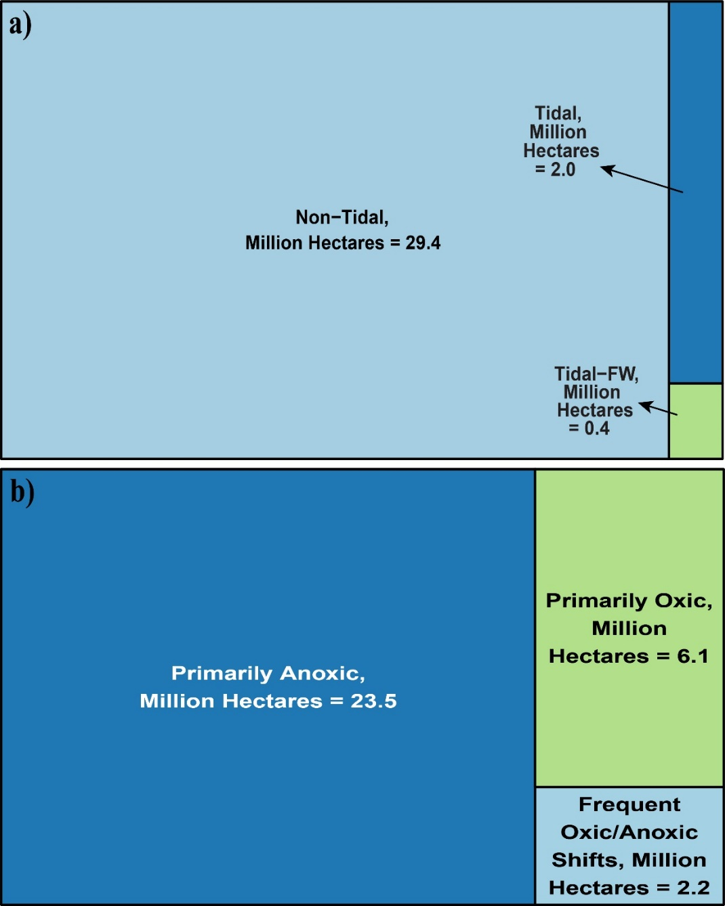

Figure S2: Tree maps of the proportions of subpopulation wetland land area for (a) tidal influence on wetlands and (b) redox categories.

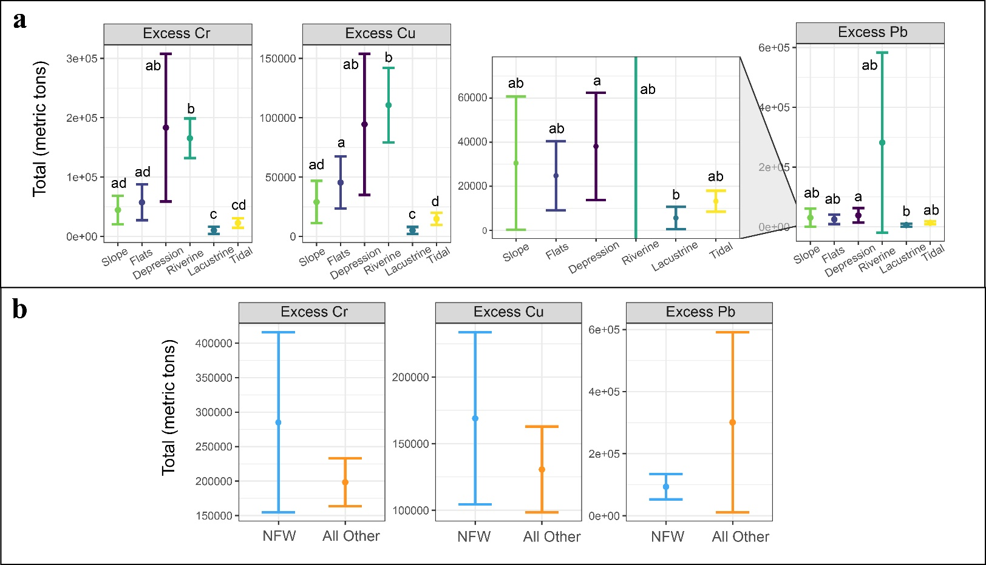
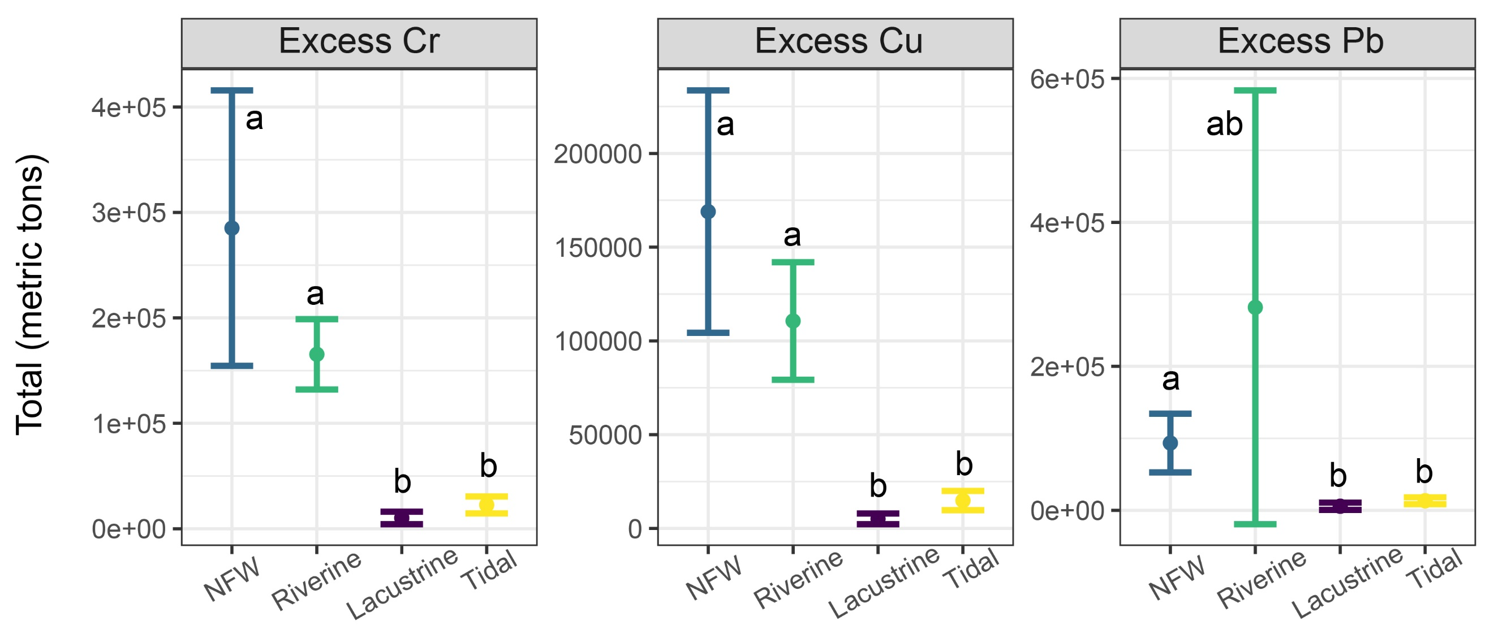
c

Figure S3: Dot plots of total excess metal mass within the upper 40 cm of soil for (a) subpopulations of each hydrogeomorphic (HGM) wetland class, where “Lacustrine” is Lacustrine Fringe and Excess Pb is zoomed into its lower y-axis range, (b) aggregated non-floodplain wetlands (NFW—Slope, Flats, Depression wetlands) compared to all other aggregated wetland types (Riverine, Lacustrine, Tidal), and (c) NFW compared to all other wetland types, with 95% confidence interval (CI) error bars provided. Letters notate overlap of error bars between groups when more than two groups are compared, with similar letters denoting overlap. Notice the difference in y-axis limits for each metal/graph.

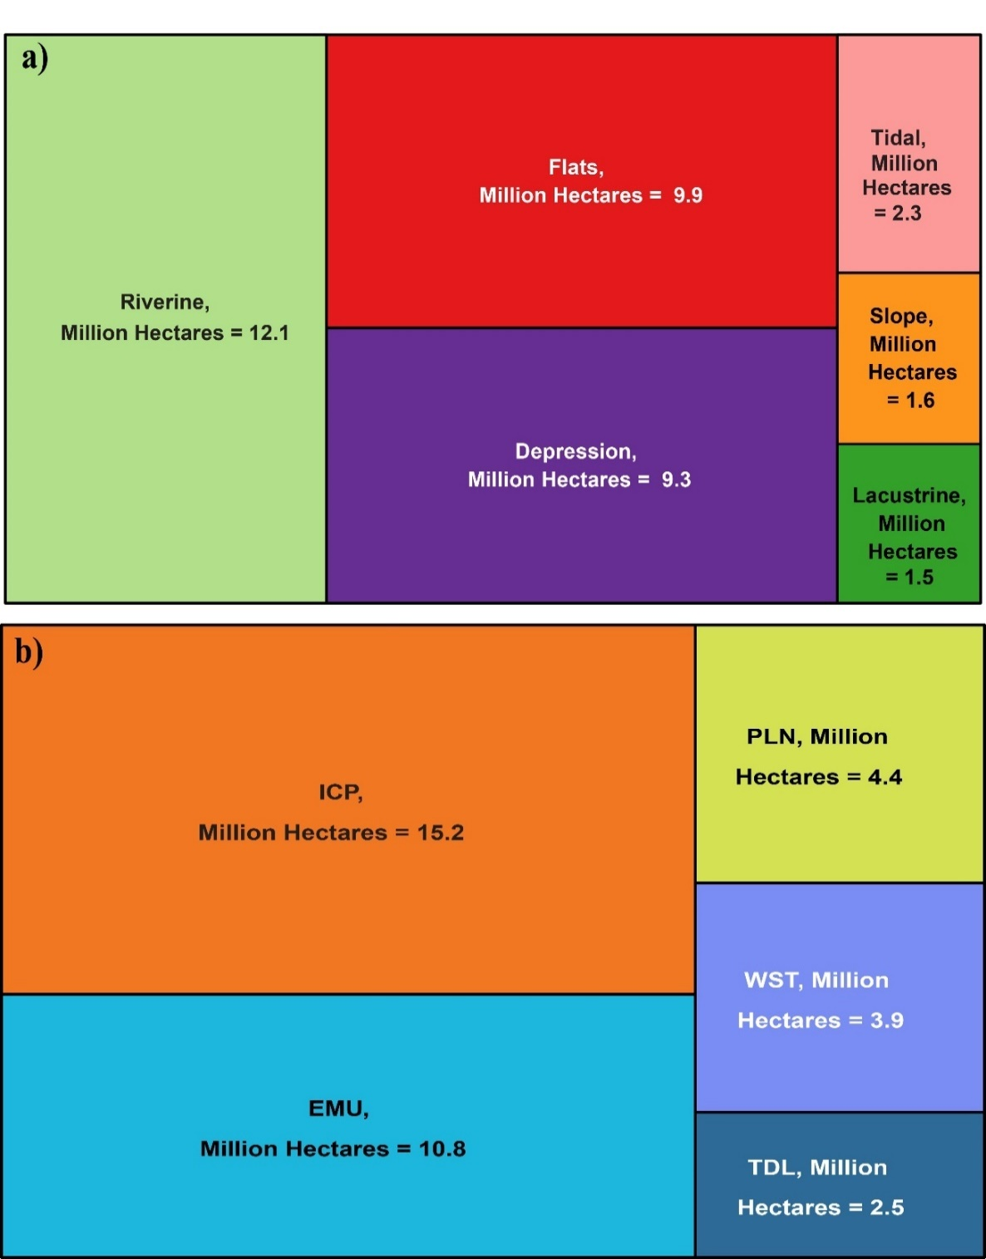

Figure S4: Tree maps of the proportions of wetland hydrogeomorphic (HGM) subpopulations (a) and NWCA aggregated ecoregion subpopulations (b) based on hectares of land area throughout the CONUS. TDL = Tidal Saline, ICP = Inland Coastal Plains, EMU = Eastern Mountains & Upper Midwest, PLN = Plains, and WST = West.

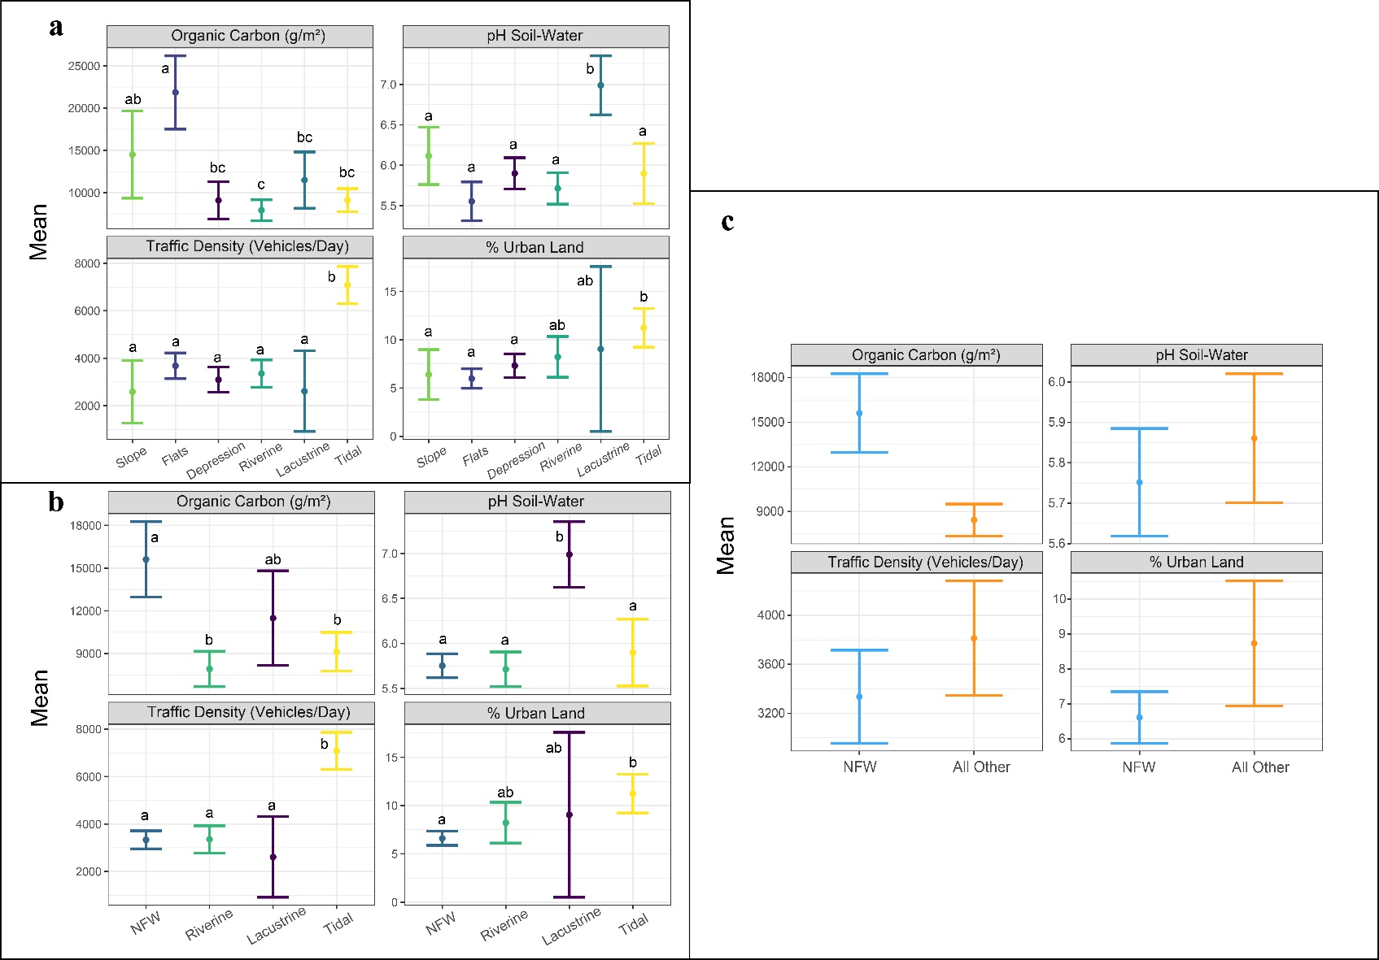
Figure S5: Dot plots of mean variable values for (a) subpopulations of each hydrogeomorphic (HGM) wetland class, where “Lacustrine” is Lacustrine Fringe, (b) aggregated non-floodplain wetlands (NFW—Slope, Flats, Depression wetlands) compared to all other aggregated wetland types (Riverine, Lacustrine, Tidal), and (c) NFW compared to an aggregation all other wetland types, with 95% CI error bars provided. Letters notate overlap of error bars between groups when more than two groups are compared, with similar letters denoting overlap. Organic carbon and soil-water pH are for the first 40 cm of soil. Notice the difference in y-axis limits for each variable/graph.

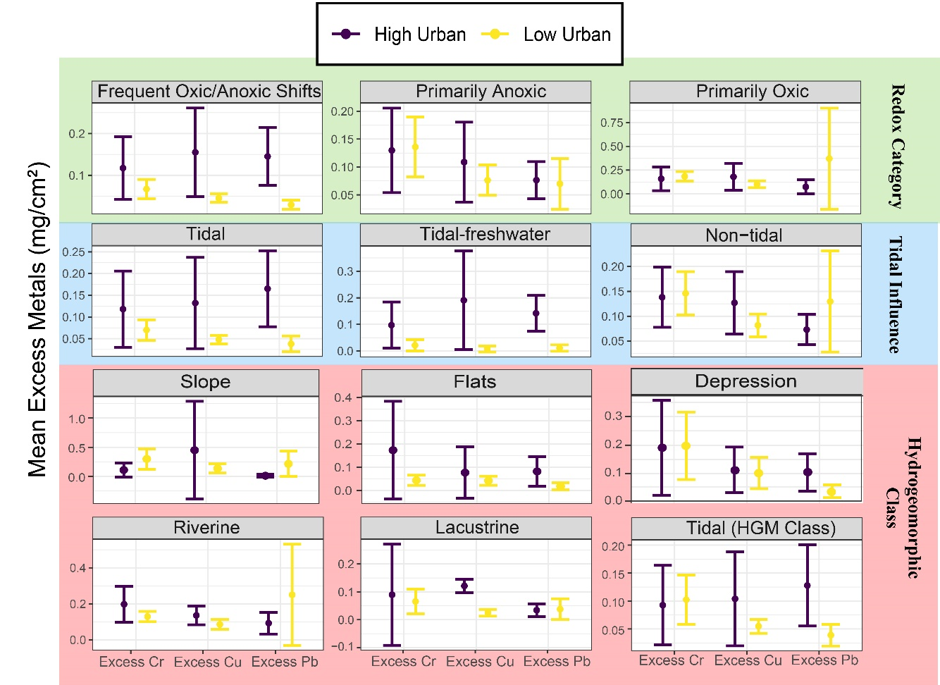
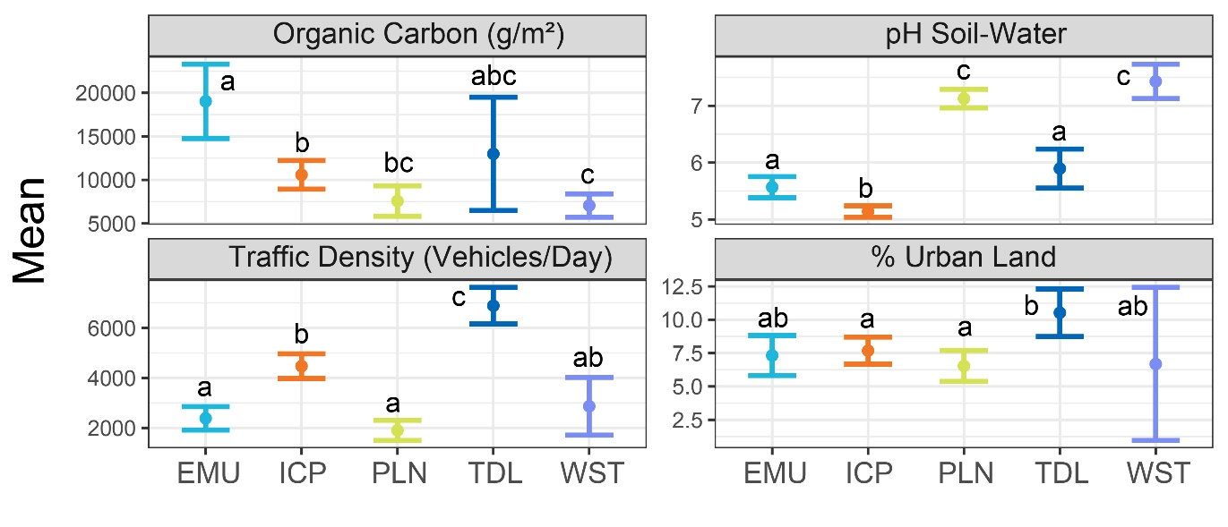
Figure S6: Dot plots of mean excess metal loadings within the upper 40 cm of soil for different wetland subpopulations, colored based on whether the wetland subpopulation was within a high (> 15%) or low urban land cover HUC12 watershed where the wetland lies, with 95% CI error bars. Lacustrine represents Lacustrine Fringe. Notice the difference in y-axis limits for each graph.

Figure S7: Dot plots of mean parameters for different wetland ecoregion subpopulations, with 95% CI error bars. Letters notate overlap of error bars between groups, with similar letters denoting overlap. Organic carbon and soil-water pH are for the first 40 cm of soil. Notice the difference in y-axis limits for each variable. TDL = Tidal Saline, ICP = Inland Coastal Plains, EMU = Eastern Mountains & Upper Midwest, PLN = Plains, and WST = West.
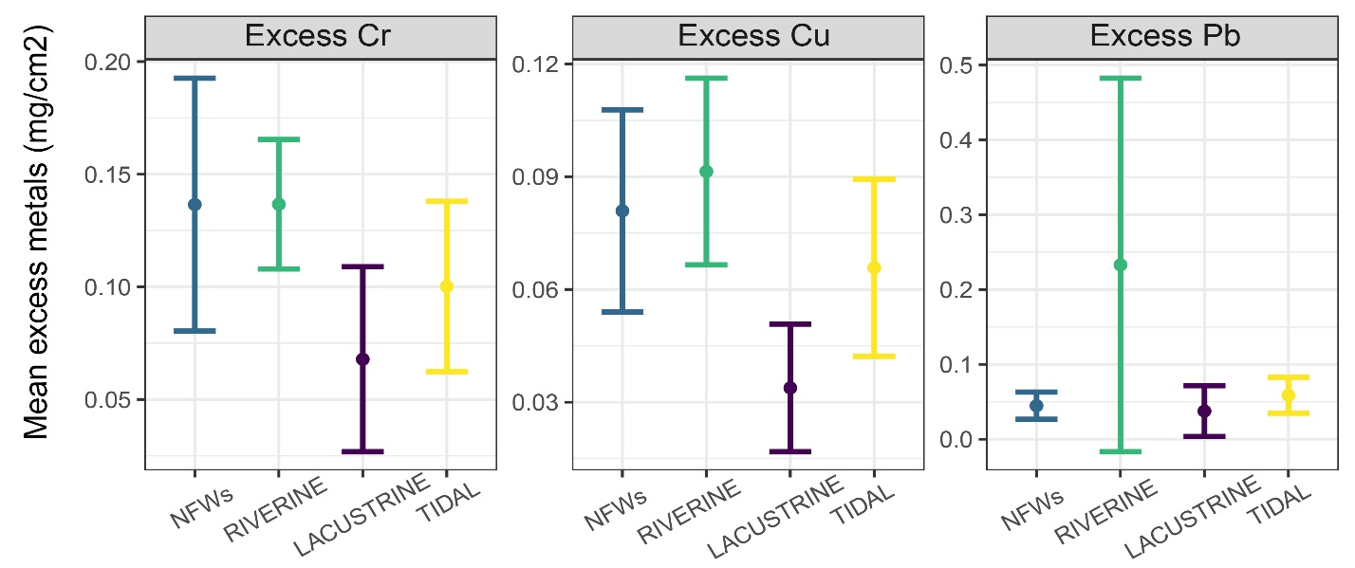
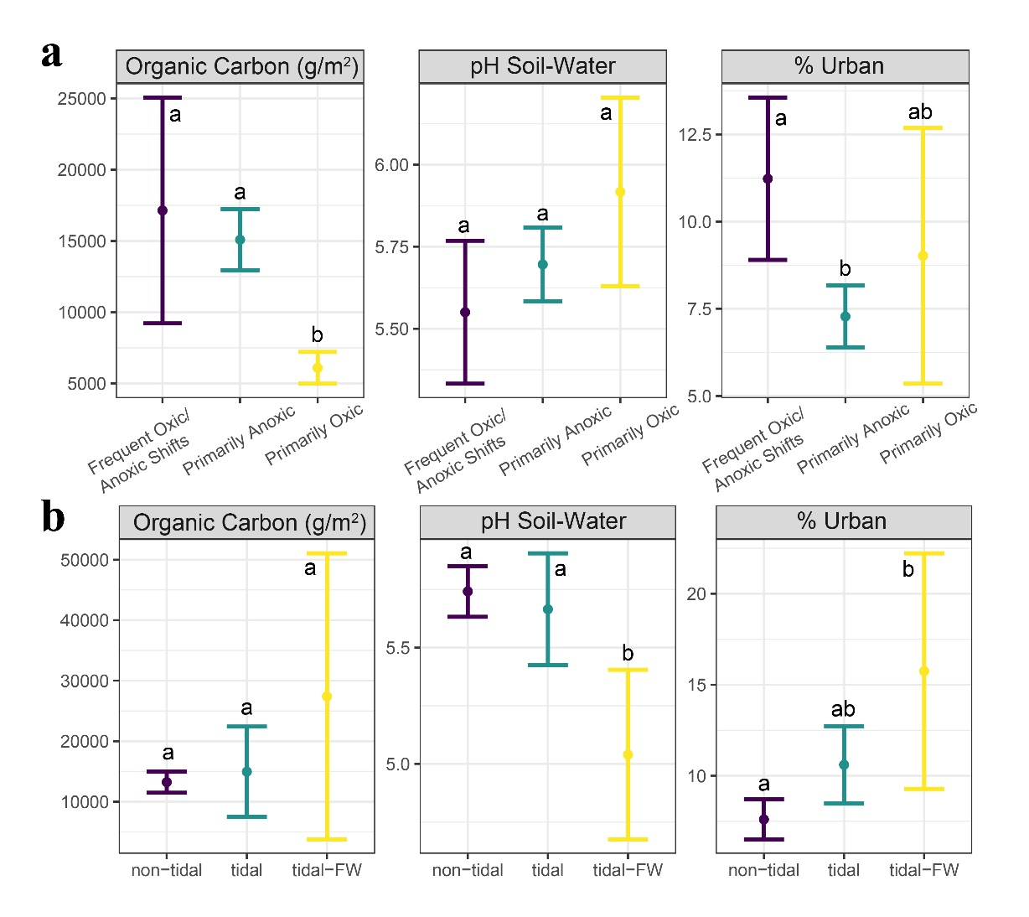
Figure S8: Dot plots of (a) mean parameters for each wetland redox category, and (b) for each wetland tidal influence group, with 95% CI error bars. Letters notate overlap of error bars between groups, with similar letters denoting overlap. Organic carbon and soil-water pH are for the first 40 cm of soil. Notice the difference in y-axis limits for each parameter/graph.
a
a
a
a
a
a
b
ab
a
a
a
a
Figure S9: Dot plots of mean excess metal loadings within the upper 40 cm of soil for subpopulations of aggregated non-floodplain wetlands (NFW—Slope, Flats, Depression wetlands) compared to all other wetland types (Lacustrine = Lacustrine Fringe), with 95% CI error bars provided. Letters notate overlap of error bars between groups, with similar letters denoting overlap. Notice the difference in y-axis limits for each metal.

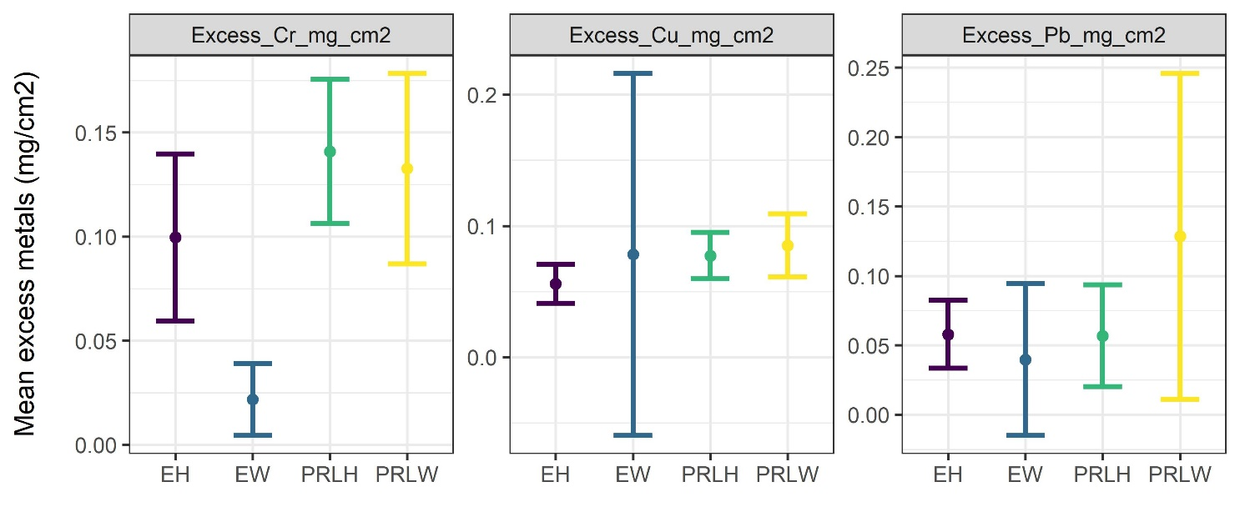
a
a
a
a
a
a
a
a
a
a
a
b
Figure S10: Dot plots of mean excess metal loadings within the upper 40 cm of soil for subpopulations of different wetland aggregated vegetation types: estuarine herbaceous (EH), inland herbaceous (PRLH), estuarine woody (EW) and inland woody (PRLW). 95% CI error bars are provided. Letters notate overlap of error bars between groups, with similar letters denoting overlap. Notice the difference in y-axis limits for each metal.

Supplementary Tables

Table S1: The definitions of wetland subpopulations analyzed for excess heavy metals across the CONUS.

Redox Category |  | Hydrogeomorphic (HGM) Class |  | Ecoregion |  | Tidal Influence
Subpopulation | Definition | Subpopulation | Definition | Subpopulation | Definition | Subpopulation | Definition
Frequent Oxic/Anoxic Shifts | Wetlands undergo frequent wetting and drying cycles, likely causing frequent redox changes in the upper soil profile. | Non-Floodplain Wetlands | Wetlands that are occasionally or regularly disconnected from downstream surface waters; includes depression, flats, and slope wetland hydrogeomorphic classes. | EMU | Eastern Mountains & Upper Midwest ecoregion. | Non-Tidal | No tidal influence on the wetlands.
Primarily Anoxic | Wetlands are mostly inundated with water or permanently saturated, leading to likely anoxic, reducing conditions. | Depression | Hydrogeomorphic class of wetlands that form in topographical depressions. A type of non-floodplain wetland. | ICP | Inland Coastal Plains ecoregion. | Tidal | Tidal influence on the wetlands.
Primarily Oxic | Wetlands are only periodically flooded and not inundated with water for large portions of the year. | Flats | Hydrogeomorphic class of wetlands that are level or near-level in topography. A type of non-floodplain wetland. | PLN | Plains ecoregion. | Tidal-FW | Tidal influence on the wetlands, but the water remains fresh.
 |  | Slope | Hydrogeomorphic class of wetlands that often occur on sloping land with a range of elevation gradients, where groundwater discharges to the surface. A type of non-floodplain wetland. | TDL | Tidal Saline ecoregion.
 |  | Lacustrine | Hydrogeomorphic class of wetlands that lie within a topographical depression, but are directly connected to a lake or another body of water. | WST | West ecoregion.
 |  | Riverine | Hydrogeomorphic class of wetlands that are reliant upon flowing water from natural or artificial channels.
 |  | Tidal (HGM Class) | Hydrogeomorphic class of wetlands that are influenced by sea level changes via the tides, located along coasts and estuaries.

Table S2: National Wetlands Inventory (NWI) original water regime classifications and the consolidated tidal influence and redox category classifications based on the definitions of the original wetland water regimes.

Water Regime Name | Tidal Influence | Redox Category
Seasonally Saturated | Non-tidal | Primarily Anoxic
Seasonally Flooded | Non-tidal | Primarily Anoxic
Semipermanently Flooded | Non-tidal | Primarily Anoxic
Intermittently Exposed | Non-tidal | Primarily Anoxic
Continuously Saturated | Non-tidal | Primarily Anoxic
Permanently Flooded | Non-tidal | Primarily Anoxic
Seasonally Flooded/Saturated | Non-tidal | Primarily Anoxic
Temporary Flooded | Non-tidal | Primarily Oxic
Intermittently Flooded | Non-tidal | Primarily Oxic
Artificially Flooded | Non-tidal | Primarily Oxic
Irregularly Flooded | Tidal | Frequent Oxic/Anoxic Shifts
Subtidal | Tidal | Primarily Anoxic
Irregularly Exposed | Tidal | Frequent Oxic/Anoxic Shifts
Regularly Flooded | Tidal | Frequent Oxic/Anoxic Shifts
Seasonally Flooded-Tidal | Tidal-freshwater | Frequent Oxic/Anoxic Shifts
Permanently Flooded-Tidal | Tidal-freshwater | Primarily Anoxic
Semipermanently Flooded-Tidal | Tidal-freshwater | Frequent Oxic/Anoxic Shifts
Temporary Flooded-Tidal | Tidal-freshwater | Frequent Oxic/Anoxic Shifts
Table S3: The wetland redox category, tidal influence, and hydrogeomorphic subpopulations broken down further by high (highlighted rows) or low urban classification. The cutoff for high versus low was 15% urban land cover based on the HUC12 (small-scale) watershed that the sampled wetland lies within. The number of sample sites and estimated total area of each subpopulation in acres are also provided.

Redox Category |  |  | Hydrogeomorphic (HGM) Class |  |  | Tidal Influence
Subpopulation | Number of sites (n) | Estimated area (acres) | Subpopulation | Number of sites (n) | Estimated area (acres) | Subpopulation | Number of sites (n) | Estimated area (acres) | Urban classification
Frequent Oxic/Anoxic Shifts | 106 | 1.34E+06 | Non-Floodplain Wetlands | 100 | 5.44E+06 | Non-Tidal | 141 | 8.30E+06 | High Urban
Frequent Oxic/Anoxic Shifts | 261 | 4.19E+06 | Non-Floodplain Wetlands | 539 | 4.62E+07 | Non-Tidal | 904 | 6.43E+07 | Low Urban
Primarily Anoxic | 120 | 6.30E+06 | Lacustrine | 8 | 3.44E+05 | Tidal | 104 | 9.81E+05 | High Urban
Primarily Anoxic | 668 | 5.17E+07 | Lacustrine | 80 | 3.39E+06 | Tidal | 259 | 3.89E+06 | Low Urban
Primarily Oxic | 33 | 2.08E+06 | Riverine | 62 | 3.29E+06 | Tidal-FW | 14 | 4.46E+05 | High Urban
Primarily Oxic | 252 | 1.29E+07 | Riverine | 469 | 2.66E+07 | Tidal-FW | 18 | 5.18E+05 | Low Urban
 |  |  | Tidal (HGM Class) | 111 | 1.25E+06 |  |  |  | High Urban
 |  |  | Tidal (HGM Class) | 260 | 4.33E+06 |  |  |  | Low Urban

References

1 Tchounwou, P. B., Yedjou, C. G., Patlolla, A. K. & Sutton, D. J. Heavy Metal Toxicity and the Environment. Molecular, Clinical and Environmental Toxicology (2012). https://doi.org:10.1007/978-3-7643-8340-4_6
2 Perkins, S. M. et al. Airborne Trace Metal Contamination of Wetland Sediments at Indiana Dunes National Lakeshore. Water, Air, and Soil Pollution 122 (2000). https://doi.org:10.1023/A:1005254916966
3 USEPA. National Wetland Condition Assessment: 2016 Technical Support Document, <https://www.epa.gov/system/files/documents/2023-04/NWCA%202016%20Technical%20Support%20Document_20230216.pdf> (2023).
4 WSFDGC. Classification of Wetlands and Deepwater Habitats of the United States, <https://www.fws.gov/sites/default/files/documents/Classification-of-Wetlands-and-Deepwater-Habitats-of-the-United-States-2013.pdf> (2013).
5 Service, U. S. F. W. Wetlands Data: Download Seamless Wetlands Data, <https://www.fws.gov/program/national-wetlands-inventory/data-download> (
6 EPA, U. S. WSIO Indicator Data Library, <https://www.epa.gov/wsio/wsio-indicator-data-library> (2023).
7 Walsh, C. J. et al. The urban stream syndrome: current knowledge and the search for a cure. Journal of the North American Benthological Society 24 (2005-09). https://doi.org:10.1899/04-028.1
8 Kim, H. et al. The Impact of Impervious Surface on Water Quality and Its Threshold in Korea. Water 2016, Vol. 8, Page 111 8 (2016-03-23). https://doi.org:10.3390/w8040111
9 Souch, C. J., Filippelli, G. M., Dollar, N., Perkins, S. & Mastalerz, M. Accumulation Rates of Airborne Heavy Metals in Wetlands. Physical Geography 23 (2002-1-1). https://doi.org:10.2747/0272-3646.23.1.21
10 Yifan Lin, J. W., Chunye Lin Vertical changes in the geochemical distributions of iron, manganese and heavy metals in wetland soil cores from cold temperate zones in northeastern China. Journal of Hazardous Materials Advances 6 (2022/05/01). https://doi.org:10.1016/j.hazadv.2022.100085
11 Granmo, M. N., Reavie, E. D., Post, S. P. & Zanko, L. M. Anthropocene geochemistry of metals in sediment cores from the Laurentian Great Lakes. PeerJ 8 (2020-05-06). https://doi.org:10.7717/peerj.9034
12 Harikumar, P. S. et al. Distribution of heavy metals in the core sediments of a tropical wetland system. International Journal of Environmental Science & Technology 2009 6:2 6 (2009-03-01). https://doi.org:10.1007/BF03327626
13 R. Carrillo‐González, Jirka Šimůnek, Sébastien Sauvé & Adriano, D. Mechanisms and Pathways of Trace Element Mobility in Soils. Advances in Agronomy 91 (2006/01/01). https://doi.org:10.1016/S0065-2113(06)91003-7
14 Nancy L. Dollar, C. J. S., Gabriel M. Filippelli, and Maria Mastalerz. Chemical Fractionation of Metals in Wetland Sediments: Indiana Dunes National Lakeshore. Environmental Science & Technology 35 (August 10, 2001). https://doi.org:10.1021/es0105764
15 Knox, A. S. et al. Metal Distribution and Stability in Constructed Wetland Sediment. Journal of Environmental Quality 35 (2006/09/01). https://doi.org:10.2134/jeq2006.0017
16 Guevara, M. et al. Soil Organic Carbon Across Mexico and the Conterminous United States (1991–2010). Global Biogeochemical Cycles 34 (2020/03/01). https://doi.org:10.1029/2019GB006219
17 Nahlik, A. M. et al. Use of national-scale data to examine human-mediated additions of heavy metals to wetland soils of the US. Environmental Monitoring and Assessment 2019 191:1 191 (2019-06-20). https://doi.org:10.1007/s10661-019-7315-5

