EXTENDED DATA
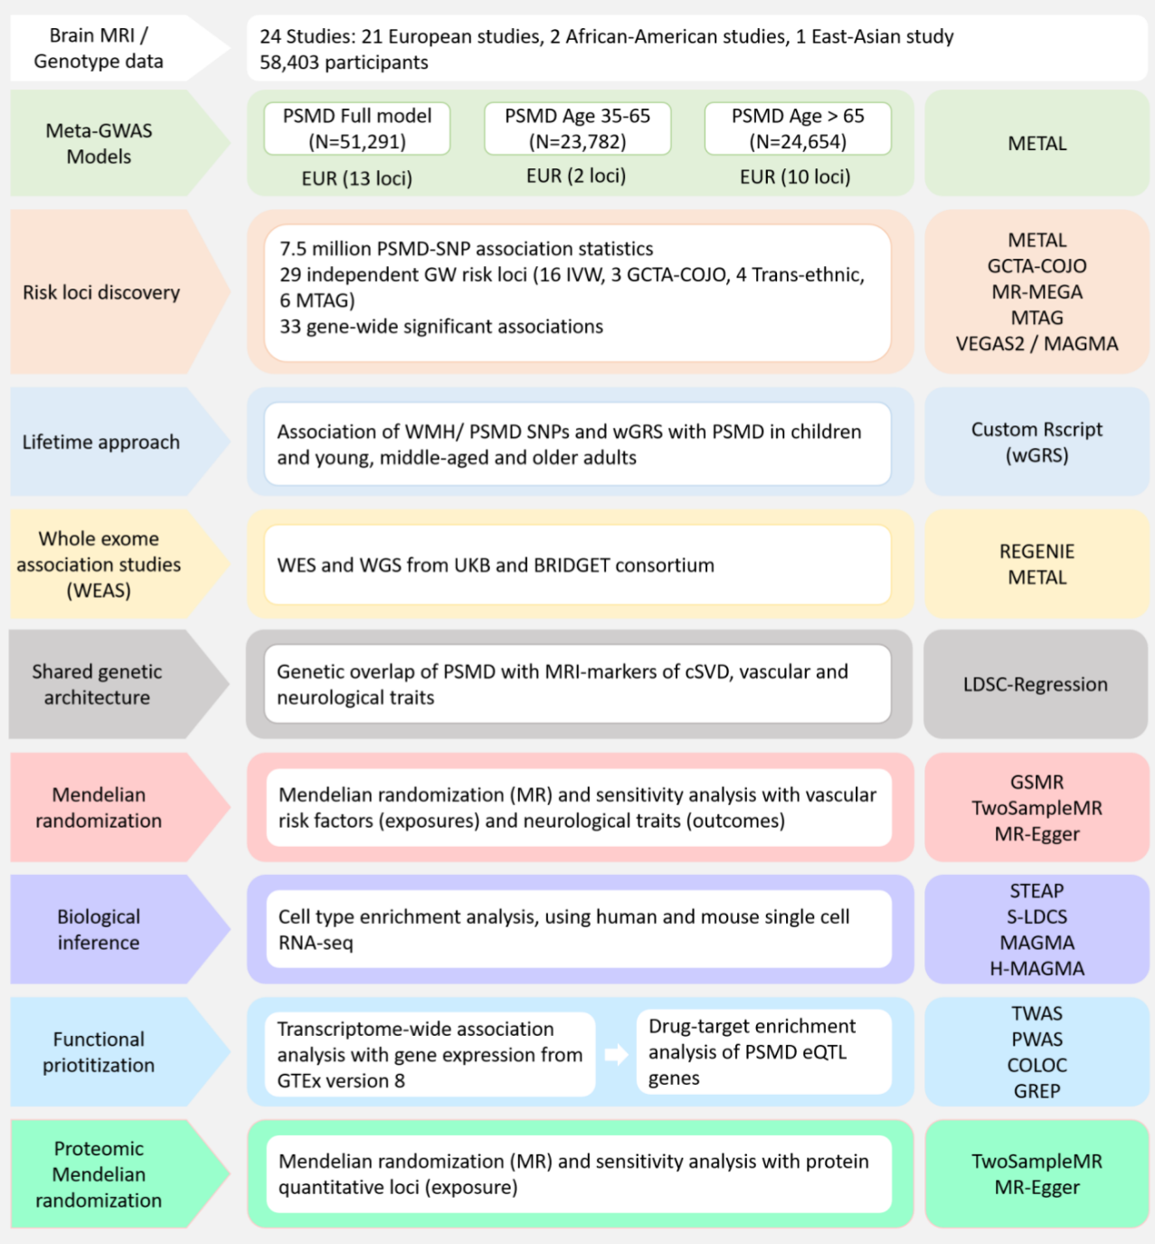
Extended Data Fig. 1 Study Workflow
Study workflow and rationale. EUR: European; EAS: East-Asian; AFR: African; GWAS: genome-wide association study; IVW: inverse-variance weighted; MR-MEGA: meta-regression of multi-ethnic genetic association; COJO: conditional and joint analysis; VEGAS2: versatile gene-based association study 2; MTAG: multi-trait analysis of GWAS; TWAS: Transcriptome-wide association study; coloc: Colocalisation Test; PWAS: Proteome-wide association studies; pQTL-MR: protein quantitative trait loci Mendelian Randomization; SuSiE: sum of single effects model; LDSC: LD score regression; MR-Egger: Mendelian randomization-Egger.
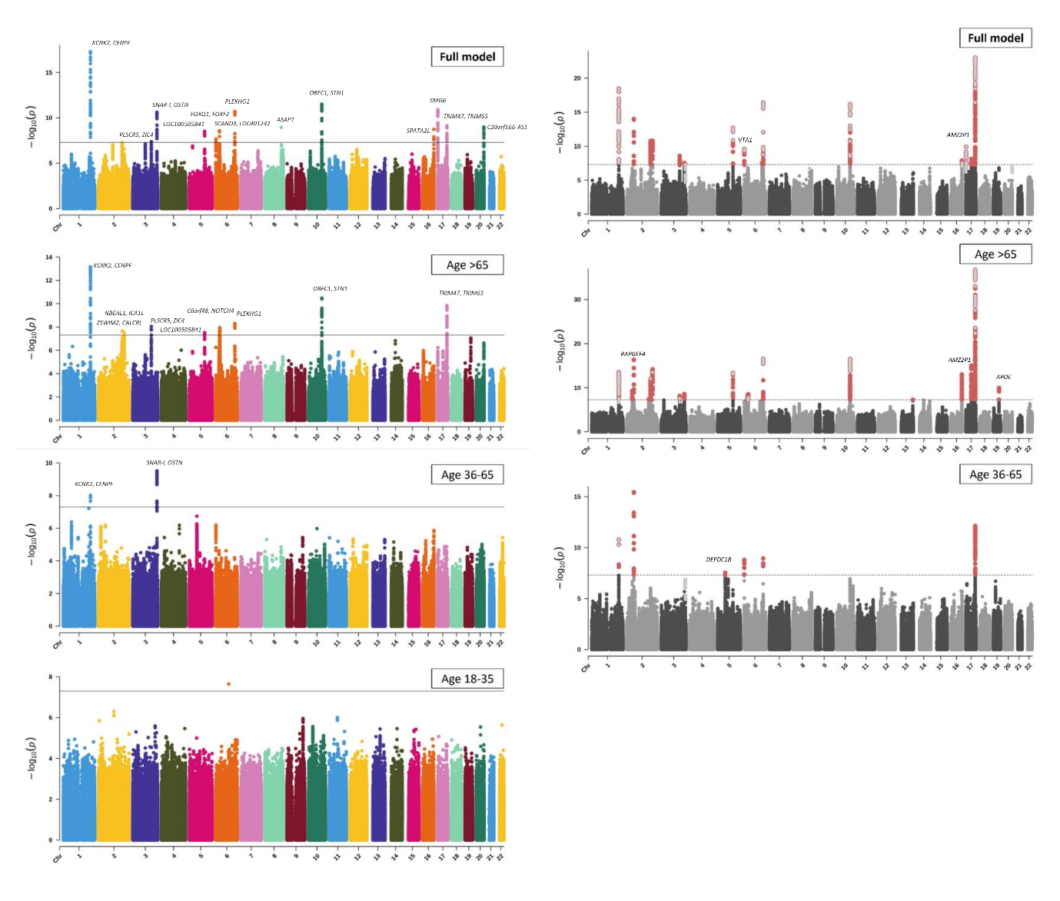
Extended Data Fig. 2 Manhattan plots for GWAS and MTAG
Manhattan plots of the p-values (observed versus expected) in the European GWAS meta-analyses (left panel) and MTAG (right panel) are presented. The dotted line corresponds to the genome-wide significance threshold (p = 5×10⁻⁸, two sided). Novel loci identified in MTAG are in red and SNPs already found in the IVW analysis are in grey.
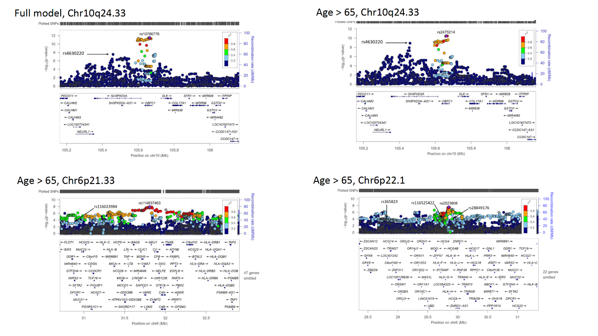
Extended Data Fig. 3 Regional association plots for loci with multiple signals on GCTA-COJO
The regional plots encompass the region flanking (+ 500kb) the lead PSMD risk variant for loci with multiple signals on GCTA-COJO (on chr10q24.33 in full model and the age >65 years stratum (top panel), and on chr6p21.33 and chr6p22.1 in the age >65 years stratum (bottom panel). SNPs are plotted according to their chromosomal position based on UCSC hg19/NVBI build 37. SNP IDs on each figure correspond to independent signals. The –log₁₀(p values) of the SNPs are shown on each plot. LD values between the lead SNPs and the other markers are indicated by color. Genes located in the region of interest are indicated at the bottom. Plots were generated using LocusZoom.

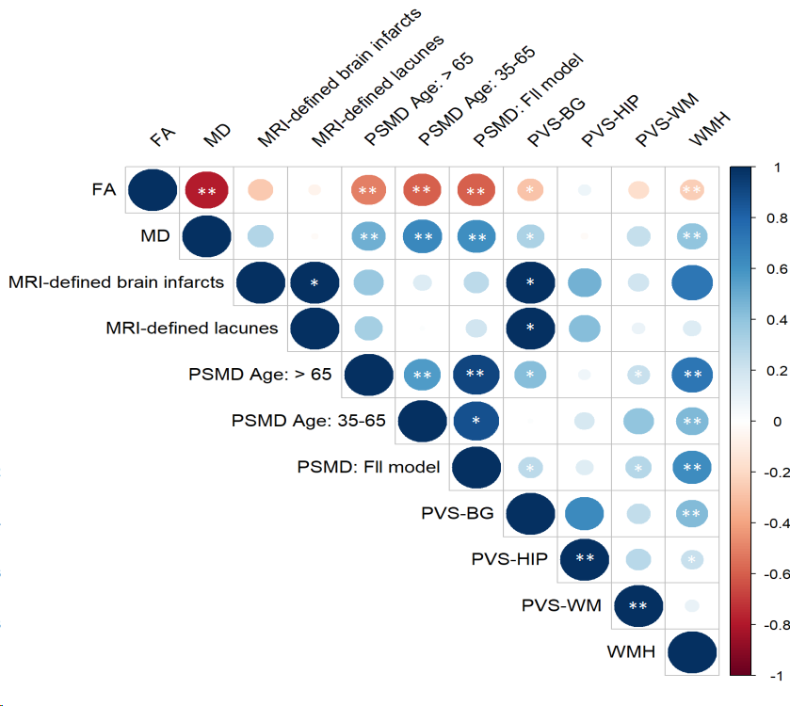
Extended Data Fig. 4 Genetic correlation between PSMD and other MRI-markers of cSVD
Figure shows triangle heatmap of pairwise genetic correlation between PSMD and other MRI-markers of cSVD based on LD score regression. Circles display the strength of correlation and significant associations passing P<4.17x10⁻³ with ** and P<0.05 with *. The shade of each circle denotes a positive (blue) or negative (red) correlation, varying in shade by magnitude of correlation.

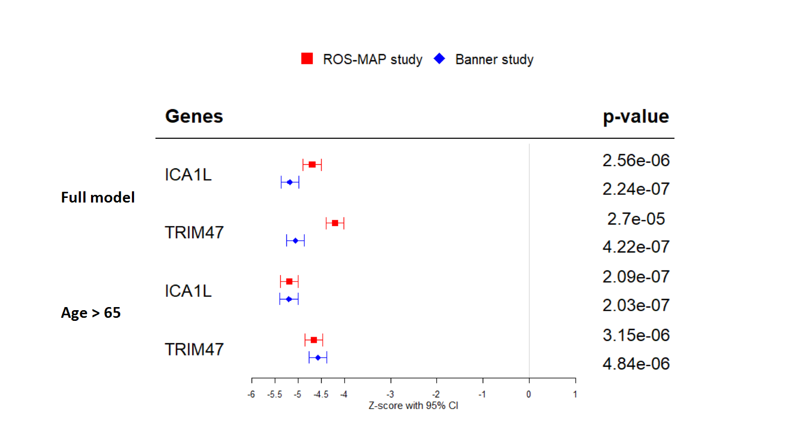

Extended Data Fig. 5 Brain tissue proteome-wide association study (PWAS) of PSMD
Proteome-wide association study (PWAS) of PSMD in brain tissue; Box plot showing effect estimates (Z-score) for associations of pQTL in ICA1L and TRIM47 in the ROS-MAP (N=376 independent samples) and Banner (N=172 independent samples) studies with PSMD in the full model, and the age >65 years stratum, identified after multiple testing correction. Effect estimates and 95% CI are shown. Two-sided p-values were computed using the TWAS-COLOC approach.
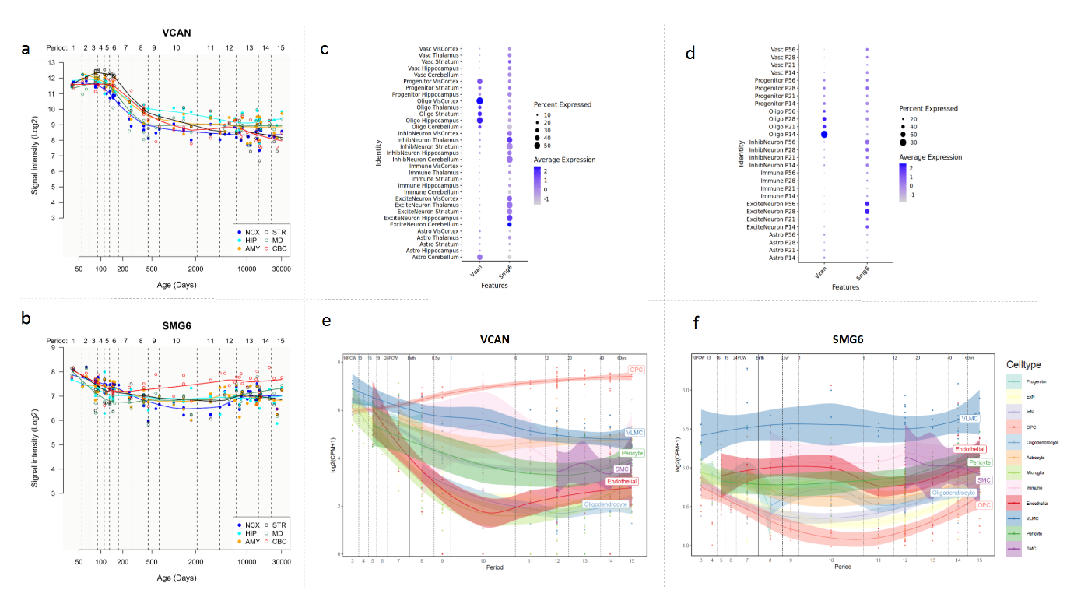
Extended Data Fig. 6 Brain expression pattern across the lifespan of genes at genome-wide significant WMH and PSMD loci with lifespan effect
(a, b) Lifespan effects here were defined by the presence of significant associations with PSMD in children or young adults. Within each locus with lifespan effects, we focused on genes also identified in TWAS or alternatively the nearest gene in the locus.
The figure displays brain expression patterns across the lifespan of the genes from genome-wide significant WMH GWAS loci and the genes closest to the 19 loci associated with PSMD across the adult lifespan. The spatio-temporal gene expression level is plotted as log2-transformed exon array signal intensity (y-axis) against the post conception days (x-axis) as provided by the Human Brain Transcriptome project database. Periods of human development and adulthood are indicated by vertical dashed lines: 4-8 post conception weeks [PCW] (period 1), 8-10 PCW (period 2), 10-13 PCW (period 3), 13-16 PCW (period 4), 16-19 PCW (period 5), 19-24 PCW (period 6), 24-38 PCW (period 7), birth- 6 postnatal months (period 8), 6-12 postnatal months (period 9), 1-6 years (period 10), 6-12 years (period 11), 12-20 years (period12), 20-40 years (period 13), 40-60 years (period 14), and 60 years+ (period 15). The boundary between pre-and postnatal periods is indicated by the solid vertical line. Each colored point represents the expression level of each gene across 16 anatomical brain regions and ages. Brain structure includes 11 neocortical areas (NCX, blue), and 5 subcortical regions: hippocampus (HIP, cyan), amygdala (AMY, orange), striatum (STR, black), mediodorsal nucleus of thalamus (MD, dark green), and cerebellar cortex (CBC, red). (e, f) The bottom middle and right panels illustrate the spatio-temporal expression patterns of the SMG6 and VCAN genes from unpublished single-nuclei RNA sequencing data from the dorsolateral prefrontal cortex (DLPFC) across the human lifespan. The y-axis represents the logarithmic transformation of Counts per Million (CPM) plus one (Log2(CPM+1)), while the x-axis shows distinct periods of human development and adulthood. Vertical dashed lines indicate developmental periods: 10-13 PCW (period 3), 13-16 PCW (period 4), 16-19 PCW (period 5), 19-24 PCW (period 6), 24-38 PCW (period 7), birth to 6 months (period 8), 6-12 postnatal months (period 9), 1-6 years (period 10), 6-12 years (period 11), 12-20 years (period 12), 20-40 years (period 13), 40-60 years (period 14), and 60 years+ (period 15). The solid vertical line denotes the boundary between prenatal and postnatal periods. Each colored line represents the gene expression levels across these defined periods for corresponding cell types, as indicated by the color legend. Progenitor, progenitor cells; ExN, excitatory neurons; InN, interneurons; Immune, immune cells; OPC, oligodendrocyte progenitor cells; VLMC, vascular and leptomeningeal cells; SMC, smooth muscle cells.

