Supplementary documents
Table S1. Presentation of model comparison results for potential category 1 to 5 groups.
Table S2. MIMIC-IV average posterior probabilities
Figure S1. heat map of correlations between different variables.

Table S1. Presentation of model comparison results for potential category 1 to 5 groups
 | BIC | %class1 | %class2 | %class3 | %class4 | %class5
Model 1 | 182873.50 | 100
Model 2 | 177798.27 | 64.21 | 35.79
Model 3 | 175872.33 | 27.26 | 11.98 | 60.77
Model 4 | 175134.90 | 8.91 | 52.87 | 33.17 | 5.05
Model 5 | 174919.26 | 2.80 | 27.75 | 48.83 | 17.41 | 3.20

Table S2. MIMIC-IV average posterior probabilities
 | prob1 | prob2 | prob3 | prob4
Class1 | 0.84 | 0.16 | 0 | 0
Class2 | 0.05 | 0.85 | 0.10 | 0
Class3 | 0 | 0.13 | 0.85 | 0.02
Class4 | 0 | 0 | 0.11 | 0.89

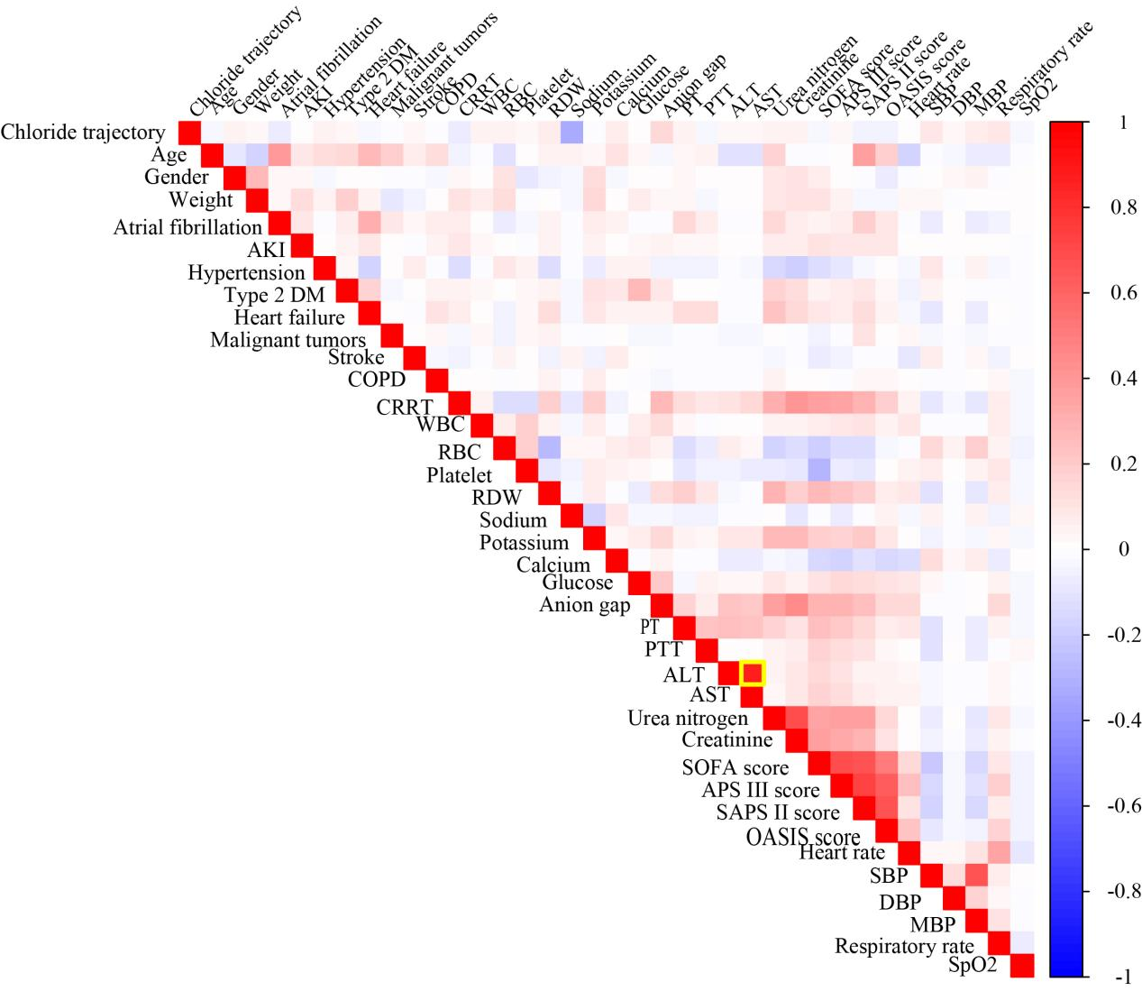
Figure S1. heat map of correlations between different variables.

