Supplementary Information
Journal of Cluster Science

Sustainable synthesis of copper oxide nanoparticles with antibacterial activity using siderophores produced by Pseudomonas sp. ABC1

Walter Cañón Mancisidor ^{1,2,*}; Bárbara Rodríguez Escalona ^{3,4}; Katherine Delgado Vargas ¹; Omara Salinas Valdés ⁵; Joaquín Sánchez Cataldo ⁵; Daniel Valenzuela-Heredia ^{3,5,*}
¹ Ingeniería Civil en Medio Ambiente y Sustentabilidad, Facultad de Ingeniería, Ciencia y Tecnología. Universidad Bernardo O’Higgins, Santiago, Chile
² Center for the Development of Nanoscience and Nanotechnology (CEDENNA), Santiago, Chile.
³ Escuela de Química y Farmacia, Facultad de Ciencias Médicas. Universidad Bernardo O’Higgins, Santiago, Chile.
⁴ Centro de Investigación en Recursos Naturales y Sustentabilidad. Universidad Bernardo O’Higgins, Santiago, Chile
⁵ Escuela de Tecnología Médica, Facultad de Ciencias Médicas. Universidad Bernardo O’Higgins, Santiago, Chile.

* Corresponding author at: Universidad Bernardo O’Higgins. Avenida Viel 1497, Santiago, Chile.
* Email address: danvalher@gmail.com (ORCID:0000-0002-4028-4461)

Table of Contents

1. XRD Difracction of the CuO NPs. | Figure S1
2. Transmission electron microscopy (TEM) images and size distribution. | Figures S2-S5
3. Scanning electron microscopy (SEM) images. | Figures S6-S8

1. XRD Difracction of the CuO NPs

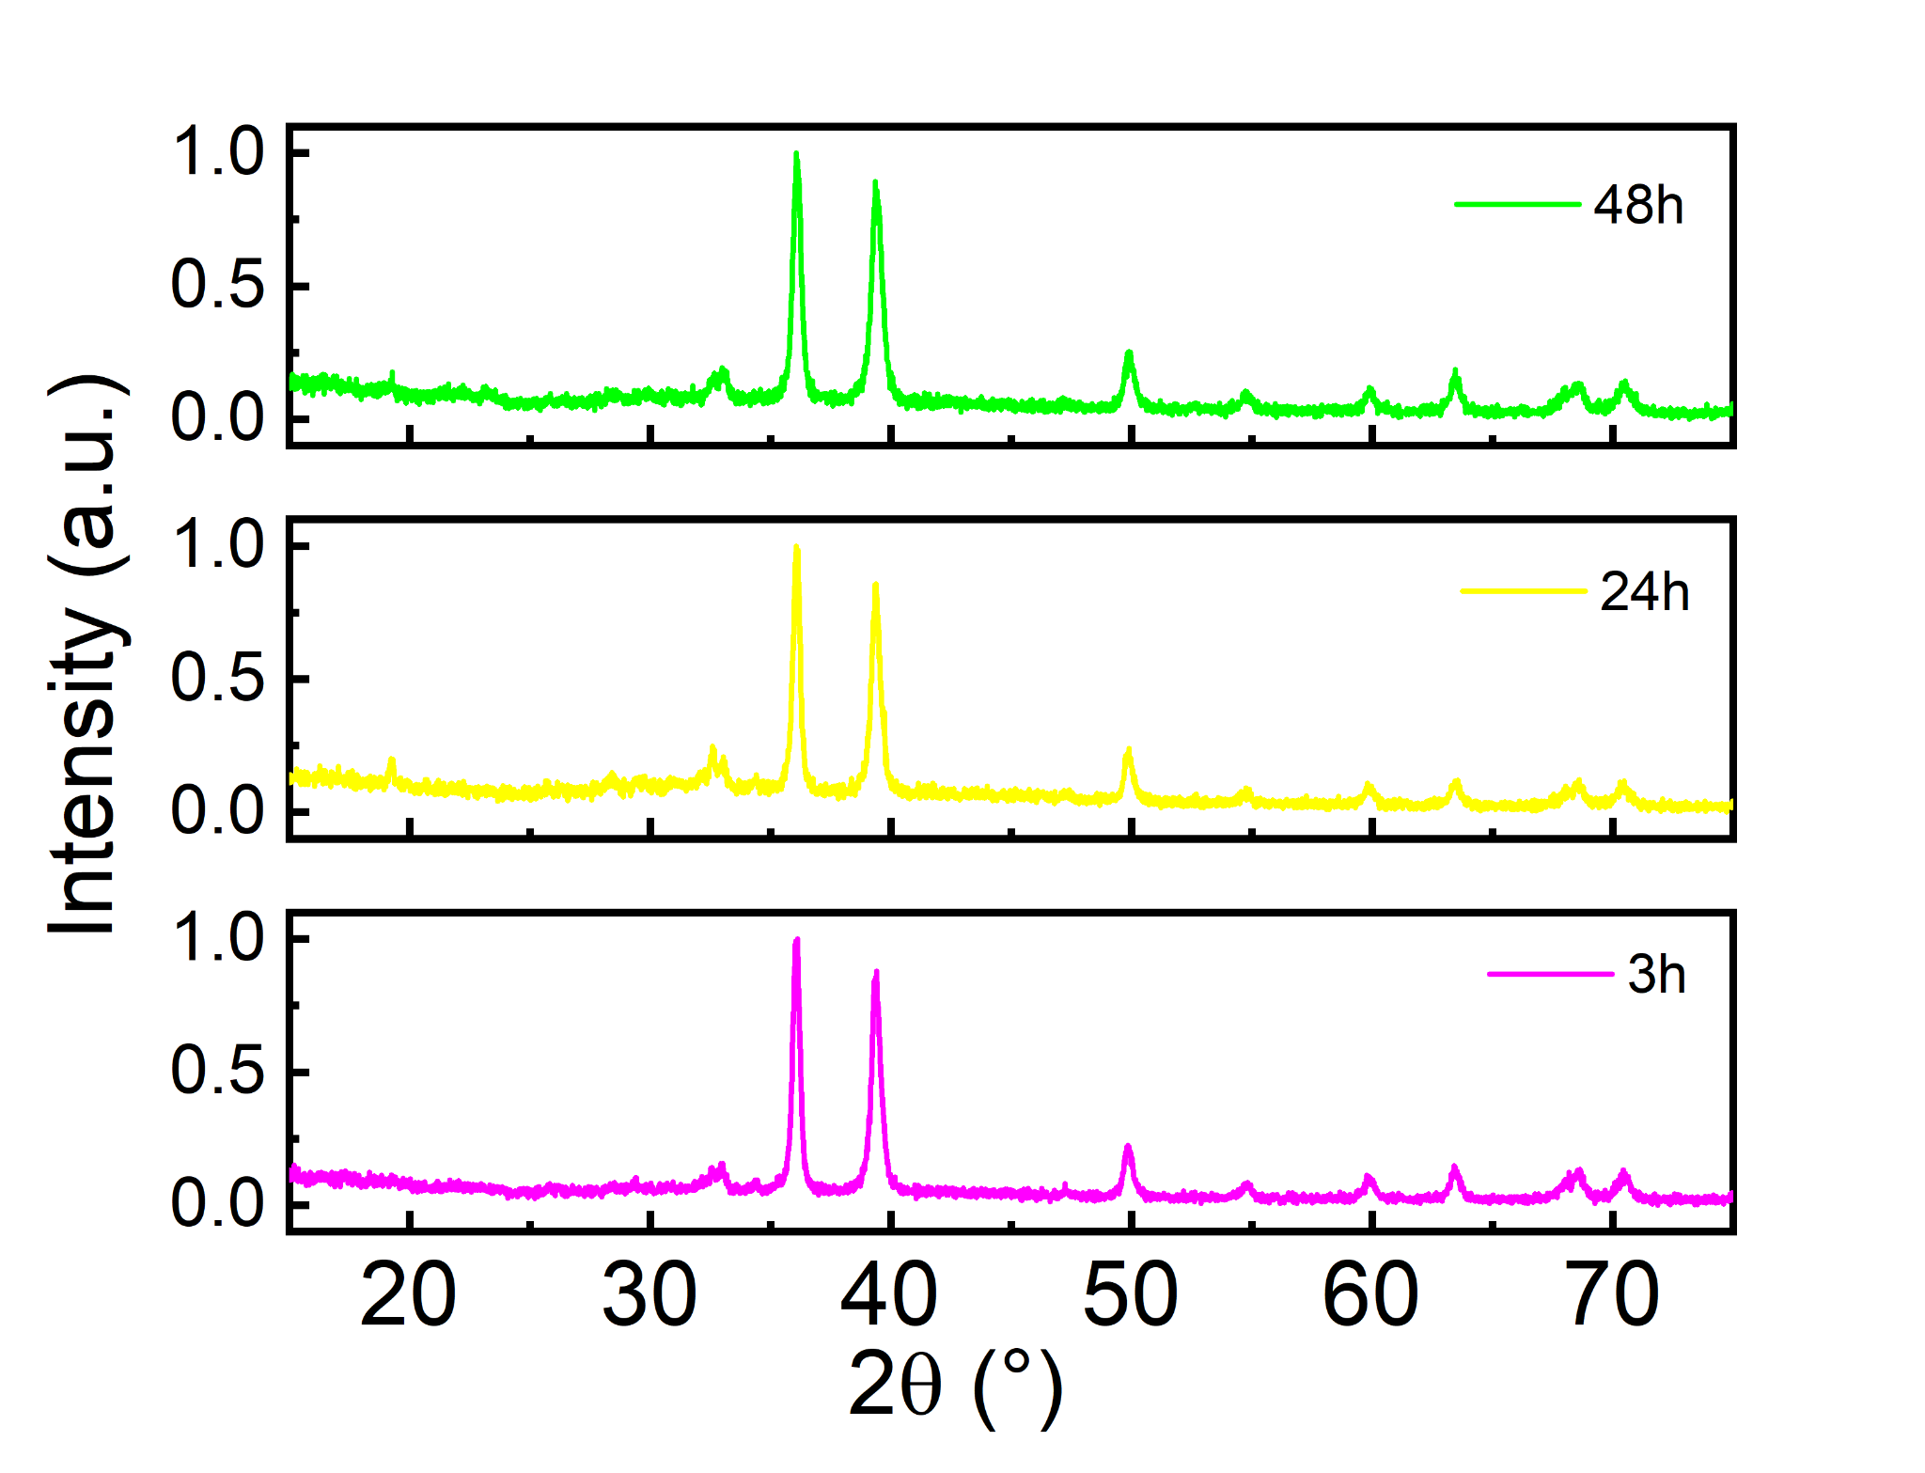
Figure S1. PXRD pattern of X-ray diffraction for CuO NPs after 3h, 24h and 48h of calcination.

2. Transmission electron microscopy (TEM) images and size distribution.

Figure S2. Transmission electron microscopy (TEM) image at scale 100 nm of CuO NPs (24h).
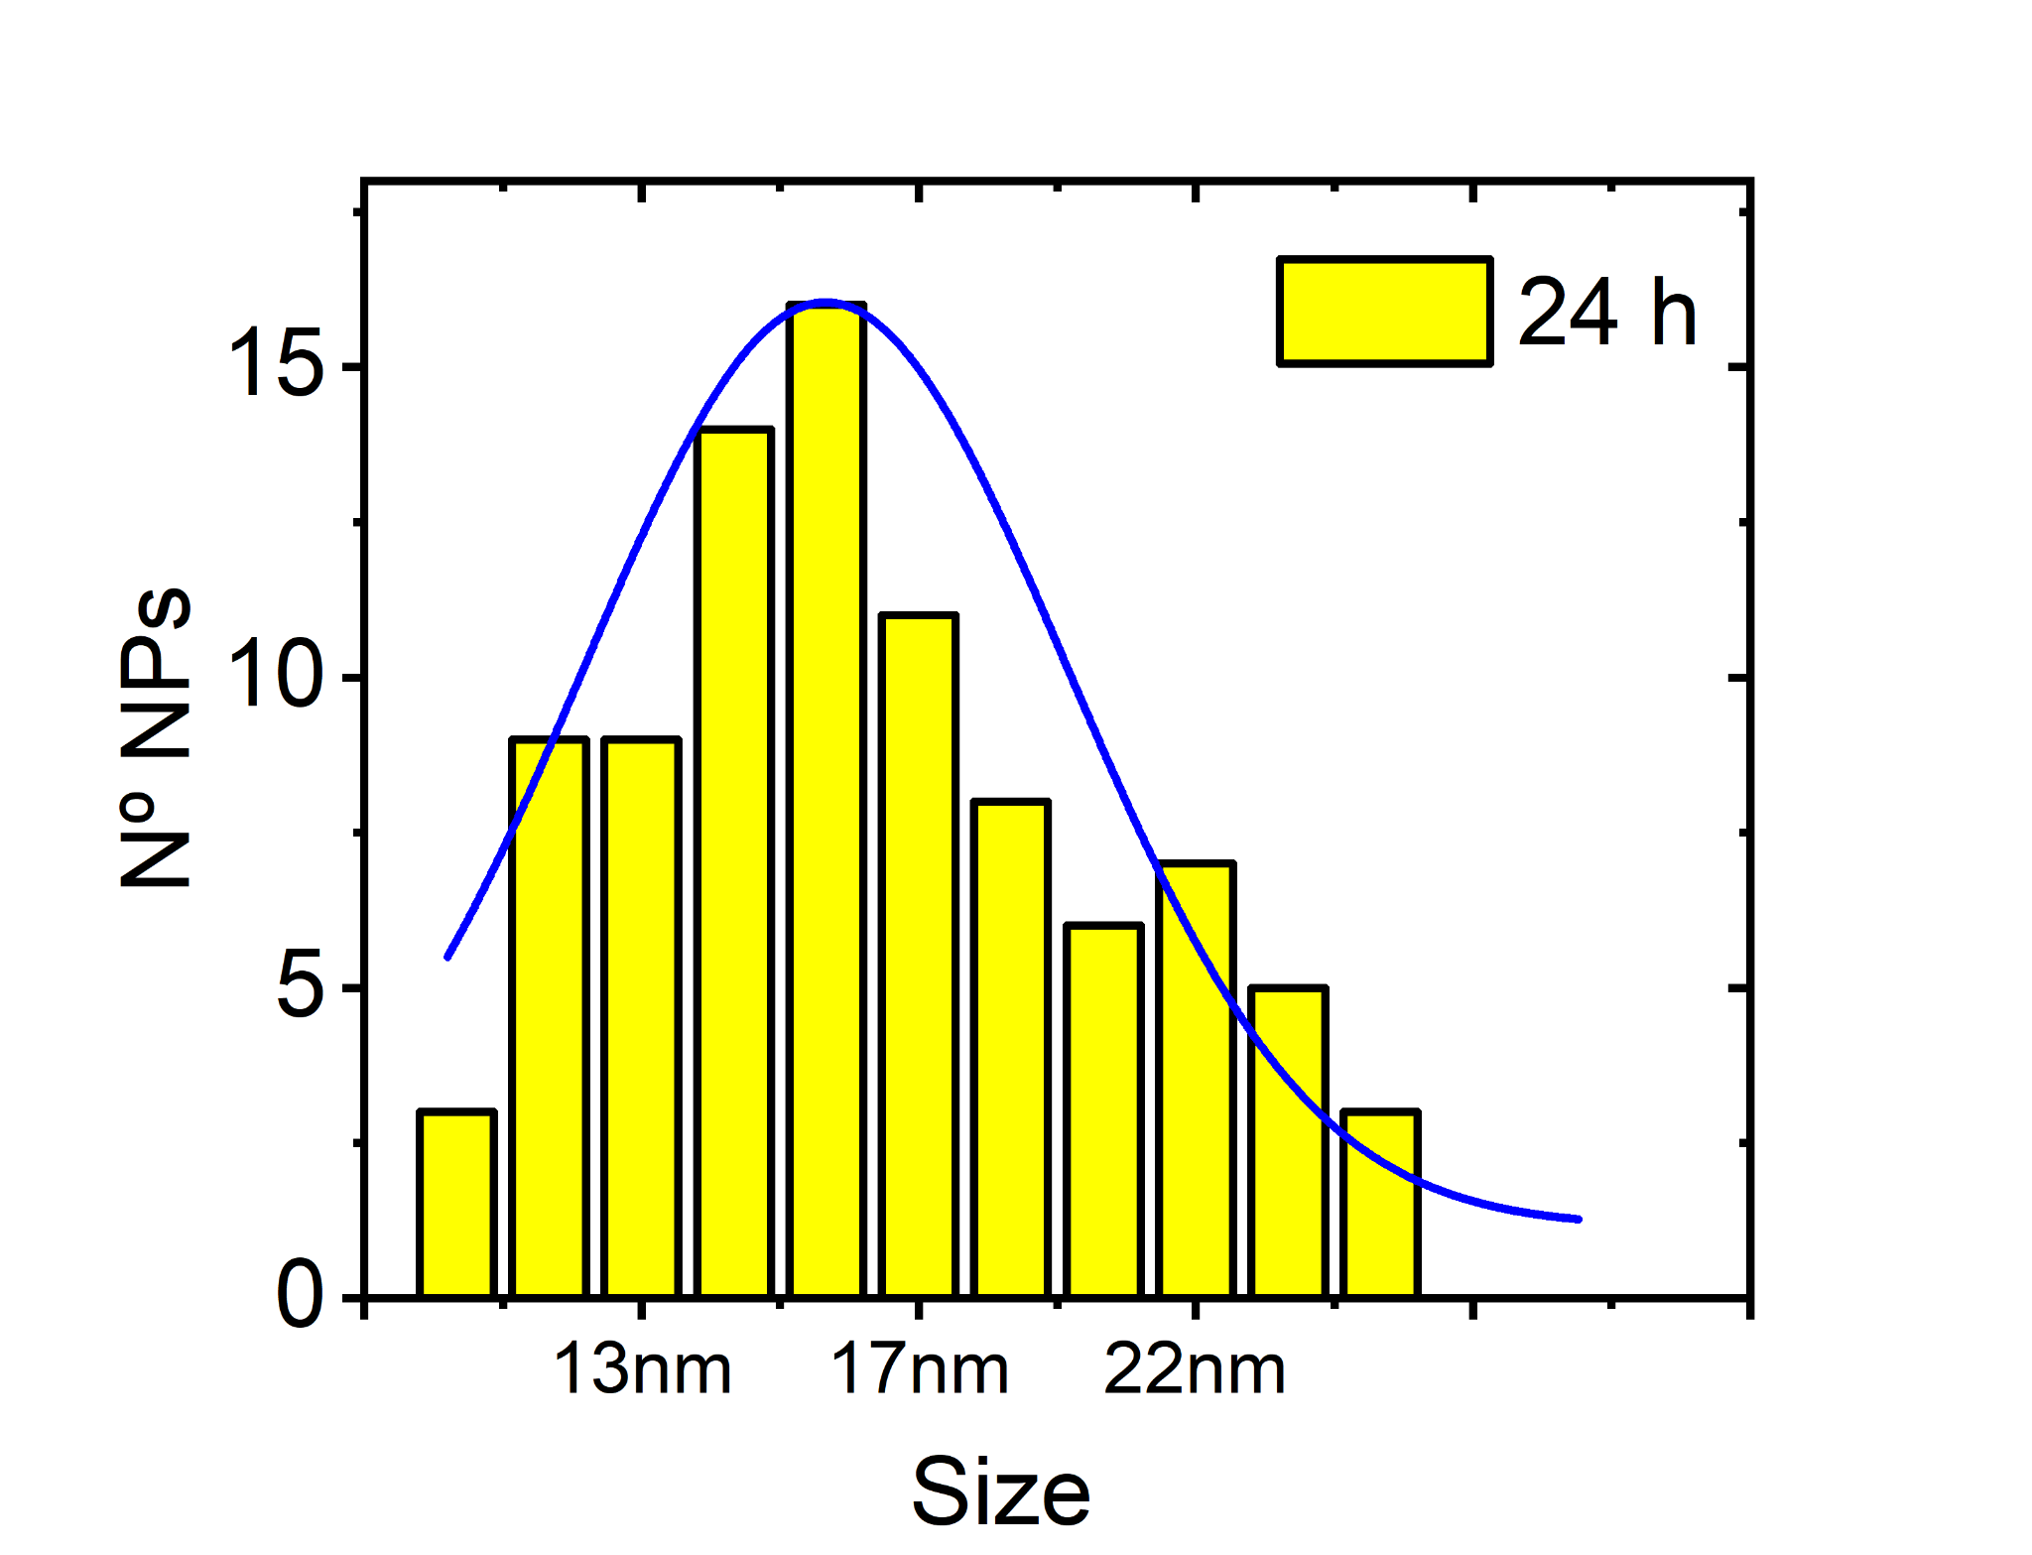
Figure S3. Distribution size in sample 24h calculated by TEM images.

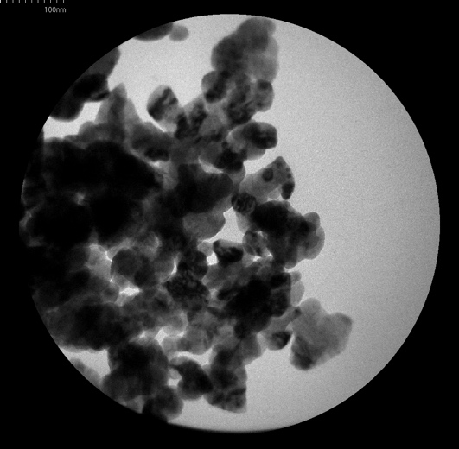
Figure S4. Transmission electron microscopy (TEM) image at scale 100 nm of CuO NPs (48h).
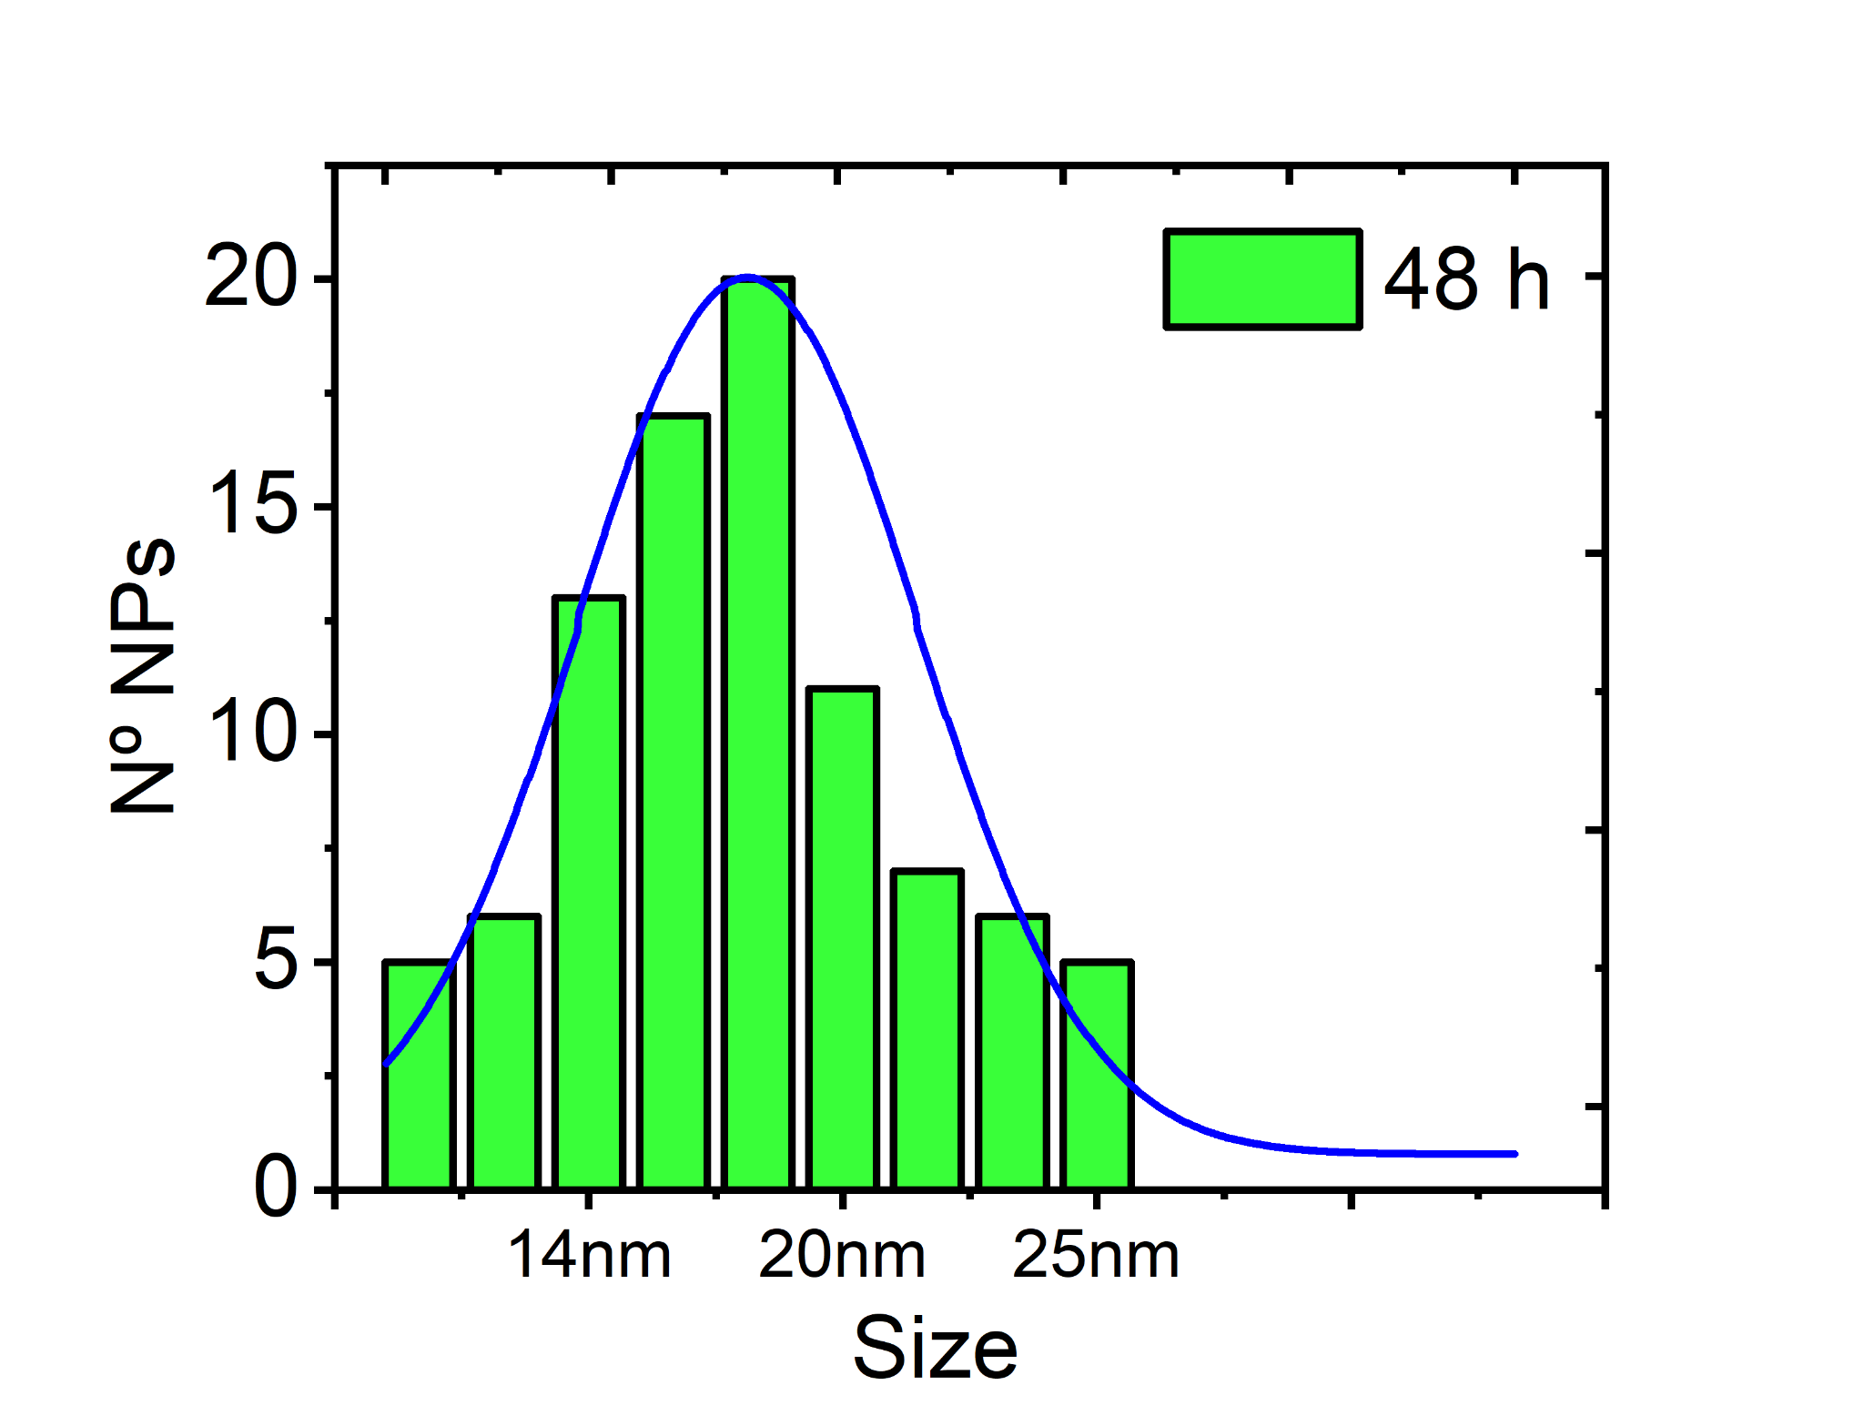
Figure S5. Distribution size in sample 48h calculated by TEM images.

3. Scanning electron microscopy (SEM) images.

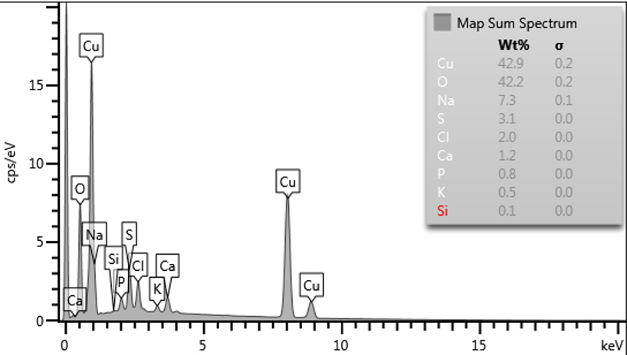 | 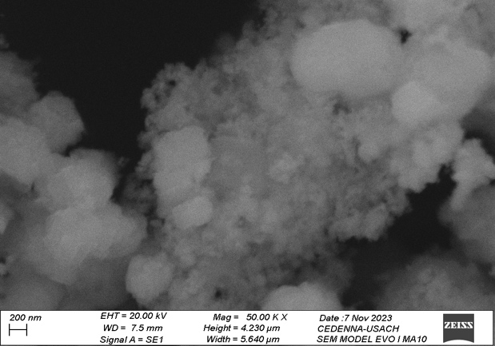
Figure S6. Scanning electron microscopy (SEM) image (Scale red bar 200 nm) and EDX elemental analysis for sample of CuO NPs (3h)

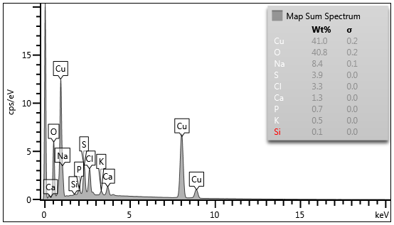 | 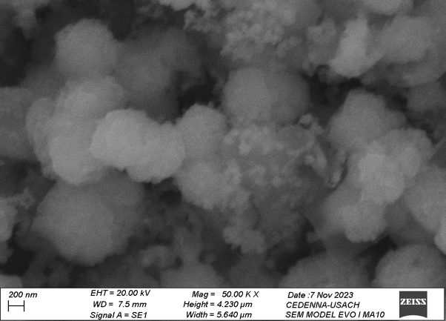
Figure S7. Scanning electron microscopy (SEM) image (Scale red bar 200 nm) and EDX elemental analysis for sample of CuO NPs (24h)

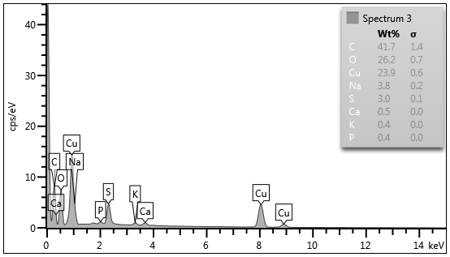 | 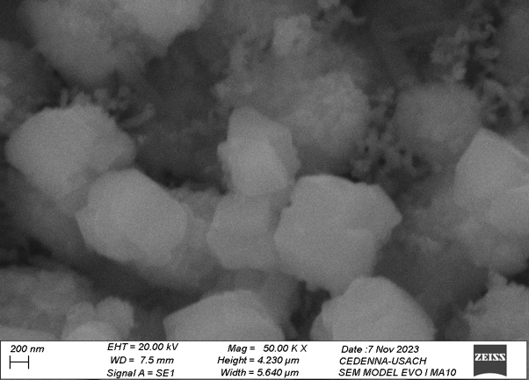
Figure S8. Scanning electron microscopy (SEM) image (Scale red bar 200 nm) and EDX elemental analysis for sample of CuO NPs (48h)

