Table 1 Main chemical components of BSCO
No. | Compounds | Formula | Chemical Structure | ion mode | Found  mass | Theo.  Mass | Error/×10⁻⁶
1 | L-tyrosine | C₉H₁₁NO₃ | 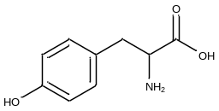 | [M+Na]⁺ | 204.0602 | 204.0637 | -17.15
2 | Purine | C₅H₄N₄ | 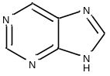 | [M+H]⁺ | 136.0663 | 136.0623 | 29.40
3 | Adenosine | C₁₀H₁₃N₅O₄ | 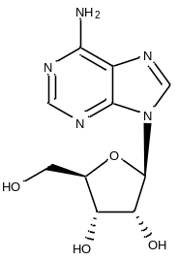 | [M+H]⁺ | 268.1082 | 268.1046 | 13.43
4 | Caffeic acid phenethyl ester | C₁₇H₁₆O₄ | 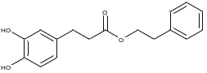 | [M+NH₄]⁺ | 302.1380 | 302.1392 | -3.97
5 | Limonin | C₂₆H₃₀O₈ | 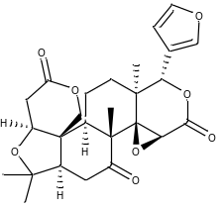 | [M+H]⁺ | 471.2026 | 471.2019 | 1.49
6 | Naringin | C₂₇H₃₂O₁₄ | 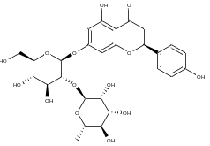 | [M+H]⁺ | 581.1862 | 581.1870 | -1.38
7 | Nobiletin | C₂₁H₂₃O₈ | 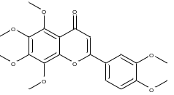 | [M+H]⁺ | 403.1416 | 403.1393 | 5.71
8 | Daidzin | C₂₁H₂₀O₉ | 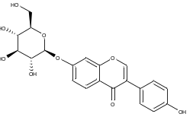 | [M+H]⁺ | 417.1206 | 417.1186 | 4.79
9 | delta-Carotene | C₄₀H₅₆ | 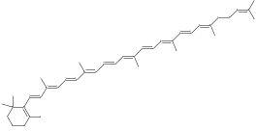 | [M+H]⁺ | 537.4372 | 537.4460 | -16.37
10 | Methyl gallate | C₈H₈O₅ | 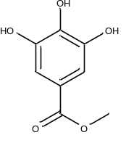 | [M+NH₄]⁺ | 202.0754 | 202.0715 | 19.30
11 | Hesperidin | C₂₈H₃₄O₁₅ | 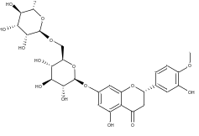 | [M+H]⁺ | 611.1968 | 611.1976 | -1.31
12 | Neohesperidin | C₂₈H₃₄O₁₅ | 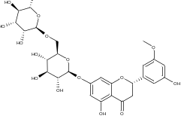 | [M+H]⁺ | 611.1968 | 611.1976 | -1.31
13 | Rutin | C₂₈H₃₄O₁₅ | 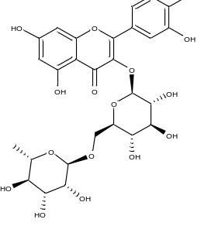 | [M+H]⁺ | 611.1968 | 611.1976 | -1.31
14 | Amygdalin | C₂₀H₂₇NO₁₁ | 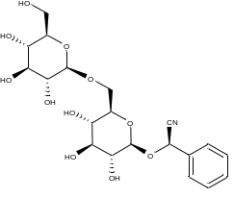 | [M+NH₄]⁺ | 475.1950 | 475.1928 | 4.63
15 | beta-Sitosterol | C₂₉H₅₀O | 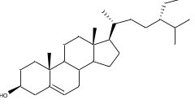 | [M+K]⁺ | 453.3460 | 453.3499 | -8.60
16 | Ononin | C₂₂H₂₂O₉ | 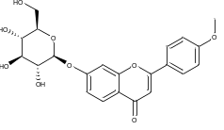 | [M+H]⁺ | 431.1372 | 431.1342 | 6.96
17 | alpha-Lactose | C₁₂H₂₂O₁₁ | 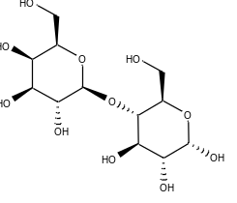 | [M+H]⁺ | 343.1279 | 343.1240 | 11.37
18 | poricoic acid AM | C₃₂H₄₈O₅ | 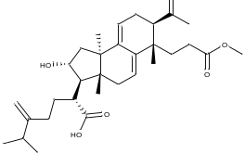 | [M+NH₄]⁺ | 530.3837 | 530.3845 | -1.51
19 | poricoic acid D | C₃₁H₄₆O₆ | 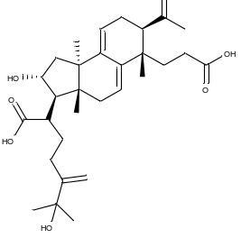 | [M+NH₄]⁺ | 532.3700 | 532.3638 | 11.65
20 | Sucrose | C₁₂H₂₂O₁₁ | 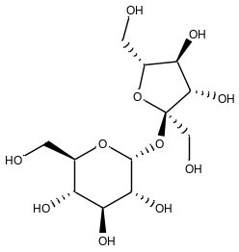 | [M+K]⁺ | 381.0817 | 381.0799 | 4.72

