Suppl. Table 1. Morin and its derivatives used in this study: codes, synonyms, chemical structure, empirical formula, and molecular weight.
Compound  Code* | Synomyms | Chemical structure | Empirical formula  Molecular weight
Morin (Mo)  M4008 (Sigma) | 2′,3,4′,5,7-Pentahydroxyflavone | 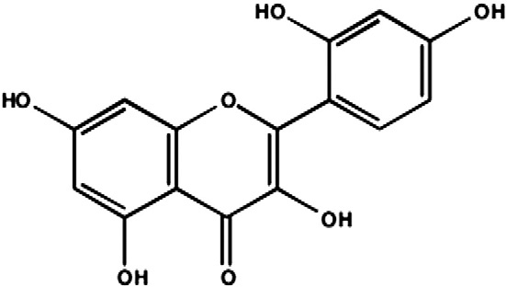 | C₁₅H₁₀O₇  302.24
Pentacetylated Morin  (Ac-Mo) ** |  | 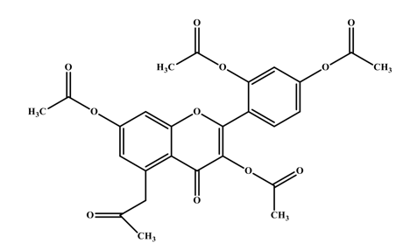 | C₂₆H₂₂O₁₁  510.45
Sr–morin complex  (Sr-Mo) *** |  | 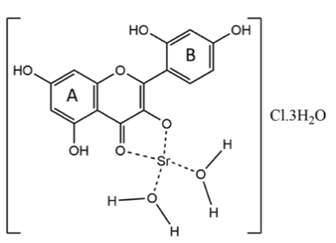 | [(C₁₅H₉O₇)Sr(H₂O)₂]Cl·3H₂O  494.33
*Sigma-Aldrich company website (https://www.sigmaaldrich.com).
**Synthetized at Laboratory of Antibiotics and Chemotherapeutics, IBILCE-UNESP.
***Synthetized at Laboratory of Colloids and Surface Physical-Chemistry of the Department of Chemistry - Faculty of Pharmaceutic Sciences, USP

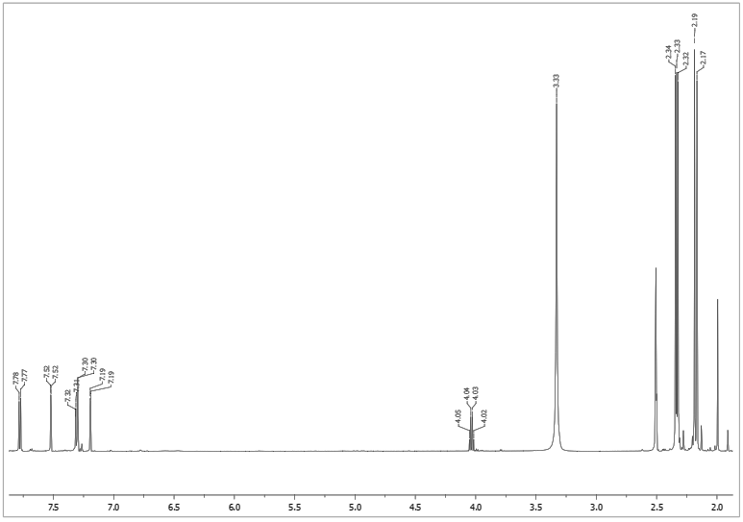
A
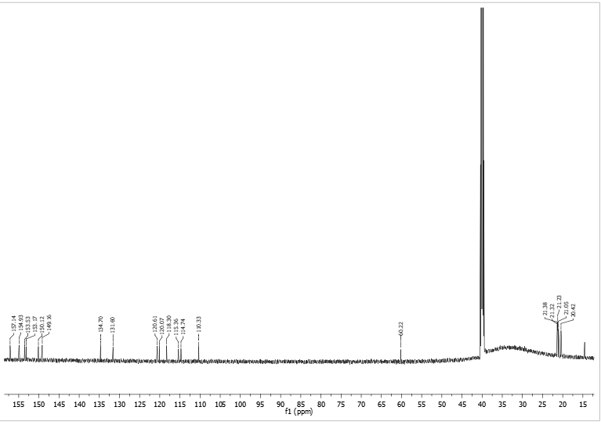
B
Suppl. Figure 1. ¹H-NMR (A) and ¹³C-NRM (B) spectrum for penta-acetylated morin (Ac-Mo) synthetized for this study.

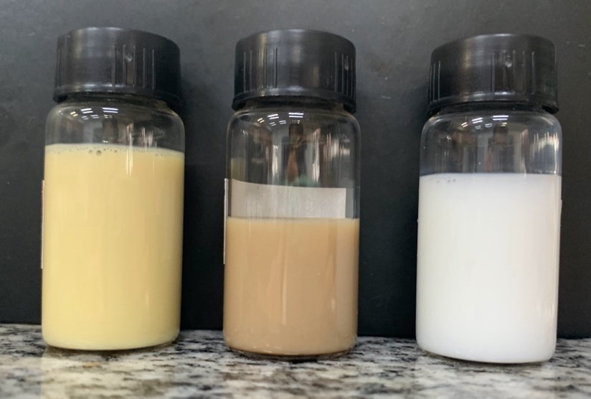
Suppl. Figure 2. Visual appearance of nanoemulsions with A: Morin (NE+Mo), B: Sr-Mo (NE+Sr-Mo) e C: Ac-Mo (NE+Ac-Mo).

