SUPPLEMENTARY INFORMATION
S Table 1 | siRNA primer sequence
Gene Name | sense primer (5´-3´) | anti-sense primer (5´-3´)
SMAD2 | GGAUUGAACUUCAUCUGAA | UUCAGAUGAAGUUCAAUCC
TGF-β1 | GCAAGACUAUCGACAUGGA | UCCAUGUCGAUAGUCUUGC

S Table 2 | Antibodies used for immunohistochemistry
Antibody | Dilution | Incubation time | Source
CD163 | 1:300 | 1 h | Ab182422, abcam
FoxP3 | 1:100 | 2 h | 98377, Cell Signalling
CD68 | 1:200 | 1 h | 76437, Cell Signalling
CD19 | 1: 50 | 4 h | 3574, Cell Signalling
CD3 | 1: 100 | 1 h | 85061, Cell Signalling
CD4 | 1: 50 | 4 h | 25229, Cell Signalling
CD8 | 1: 200 | 1 h | 85336, Cell Signalling
PD-L1 | 1:200 | 2 h | 13684, Cell Signalling
CHK1 | 1:100 | Overnight | 40866, abcam
TGFβ1 | 200 µg/ml | Overnight | sc-130348，Santa Cruz

S Table 3 | qRT-PCR primer sequence list
Gene | Oligo | Primer sequences
MyoD1 | Forward primer | 5’- GATGCACCGGTTATTTGGGG-3’
MyoD1 | Reverse primer | 5’- ATTCCCTGTAGCACCACACA-3’
Myogenin | Forward primer | 5’- GCCAGACTATCCCCTTCCTC-3’
Myogenin | Reverse primer | 5’- TGGAATTAGAGGCCGCGTTA-3’
Myosin | Forward primer | 5’-ATCTGGAAAGACGTGGAGGG-3’
Myosin | Reverse primer | 5’-ATCACGTCCTCCATCATCCC-3’
Desmin | Forward primer | 5’- ACGAGGGATGGCCAGTGA -3’
Desmin | Reverse primer | 5’- GATGGGCTATGTCGCTGT -3’
TGF-β1 | Forward primer | 5’- GCGTGCTAATGGTGGAAACC -3’
TGF-β1 | Reverse primer | 5’- CCGGTAGTGAACCCGTTGATG -3’
SMAD2 | Forward primer | 5’- AACCTGGAGTGCAGTGGT -3’
SMAD2 | Reverse primer | 5’- TGGTTCACTGCAAGCTCC -3’
GAPDH | Forward primer | 5’-TGCAGTGCCAGGTGAAAATC-3’
GAPDH | Reverse primer | 5’-ATCACGTCCTCCATCATCCC-3’

S Table 4 | Antibodies used for Western blot
Antigen (clone) | Concentration/Amount | Source
MyoD1 (18943-1-AP) | 200 μg/ml | Proteintech
Myogenin(NB100-56510) | 1mg/ml | Novus
Desmin（ab32362） | 0.405 mg/ml | Abcam
Myosin (bs-5885R) | 1mg/ml | Bioss, Beijing, China
SMAD2 (GTX111131) | 1 mg/ml | Gene Tex
TGFβ1（sc-130348） | 200 µg/ml | Santa Cruz
α-actinin(69758) | 200 μg/ml | Cell signaling
Vinculin(13901) | 100 μg/ml | Cell Signalling
CHK1 | 1:100 | 40866, abcam

Supplementary Figure & Legends

Supplementary Figure 1
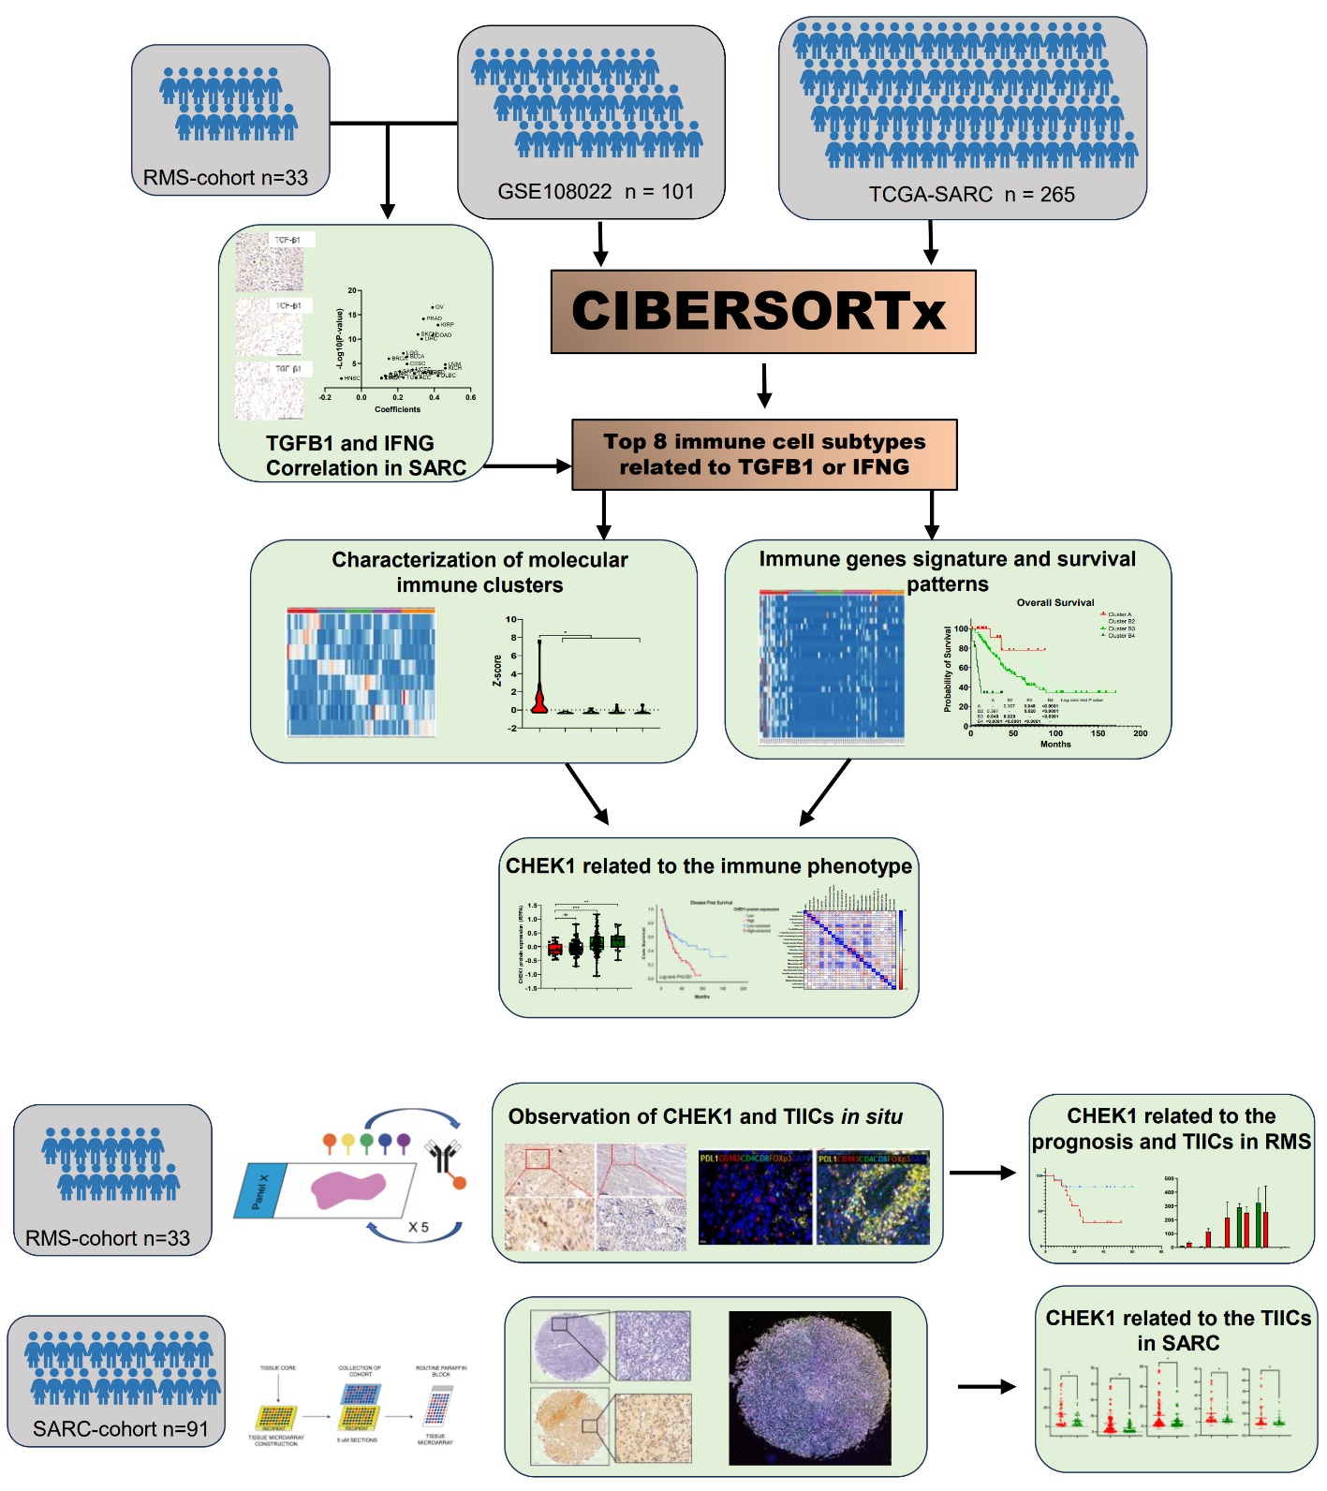
Supplemental Figure 1. Diagram of analytic workflow.

Supplemental Figure 2.
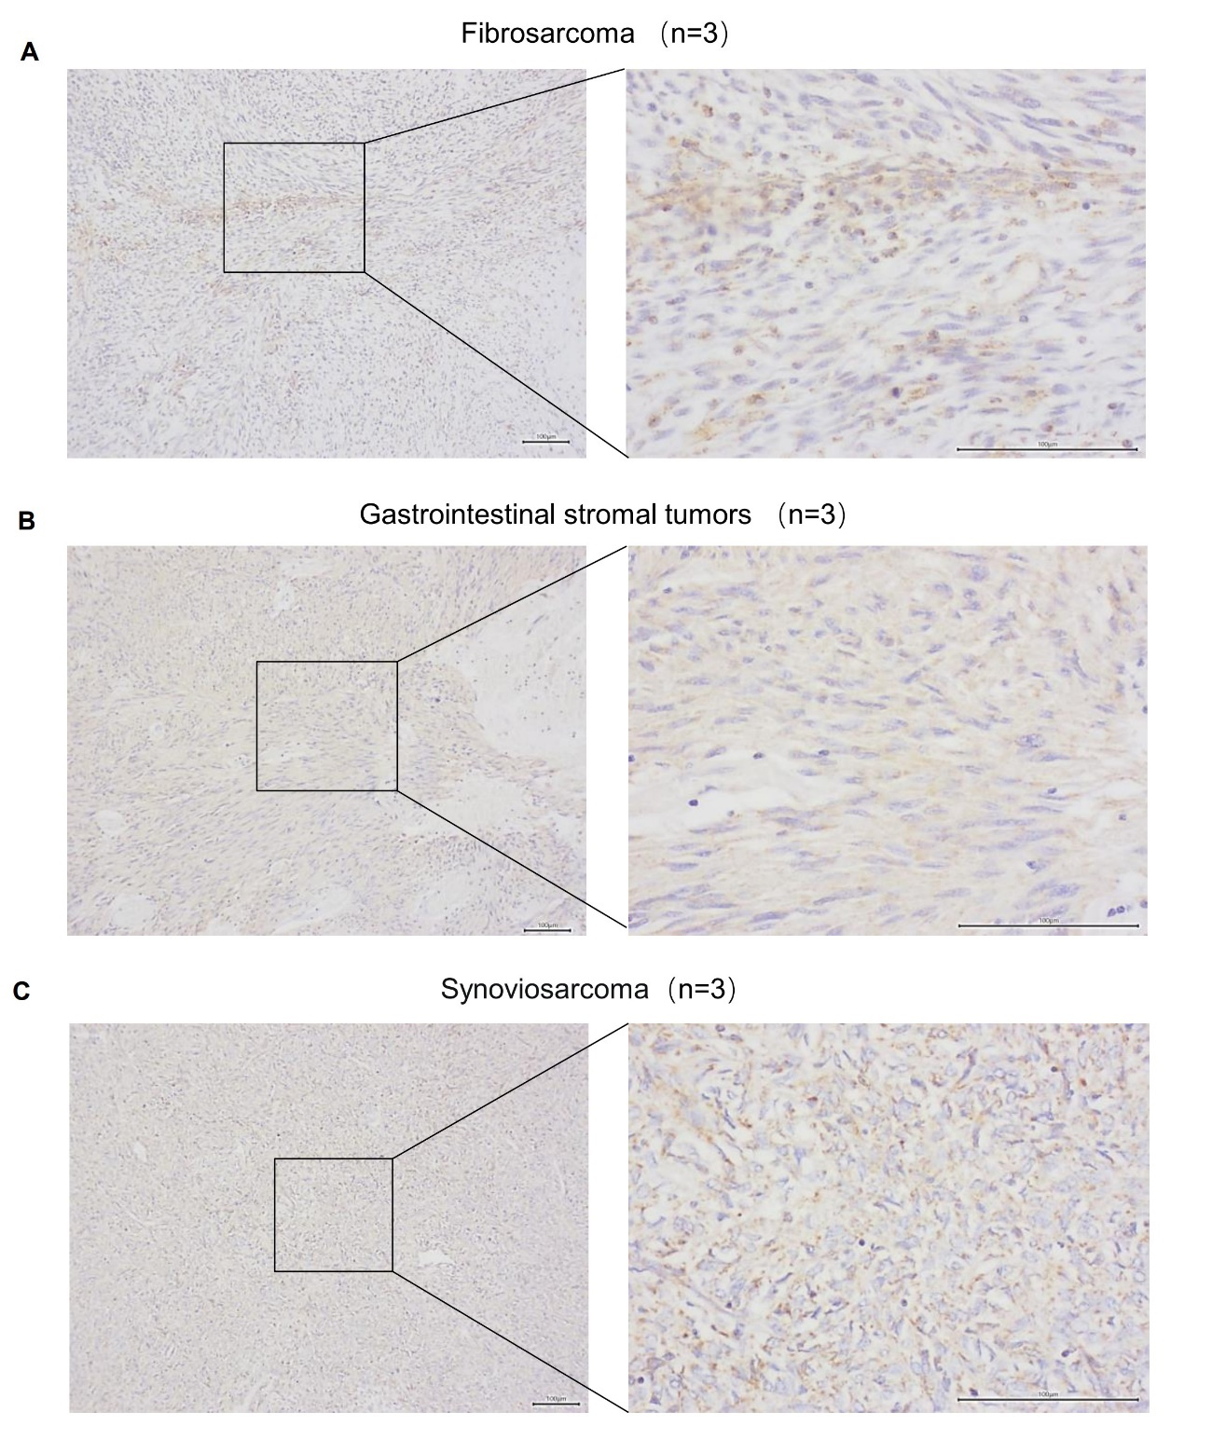
Supplemental Figure 2. TGFβ1 protein expression evaluation by Immunohistochemical staining in fibrosarcoma （A）, gastrointestinal stromal tumours (B), synovial sarcoma (C).

Supplemental Figure 3
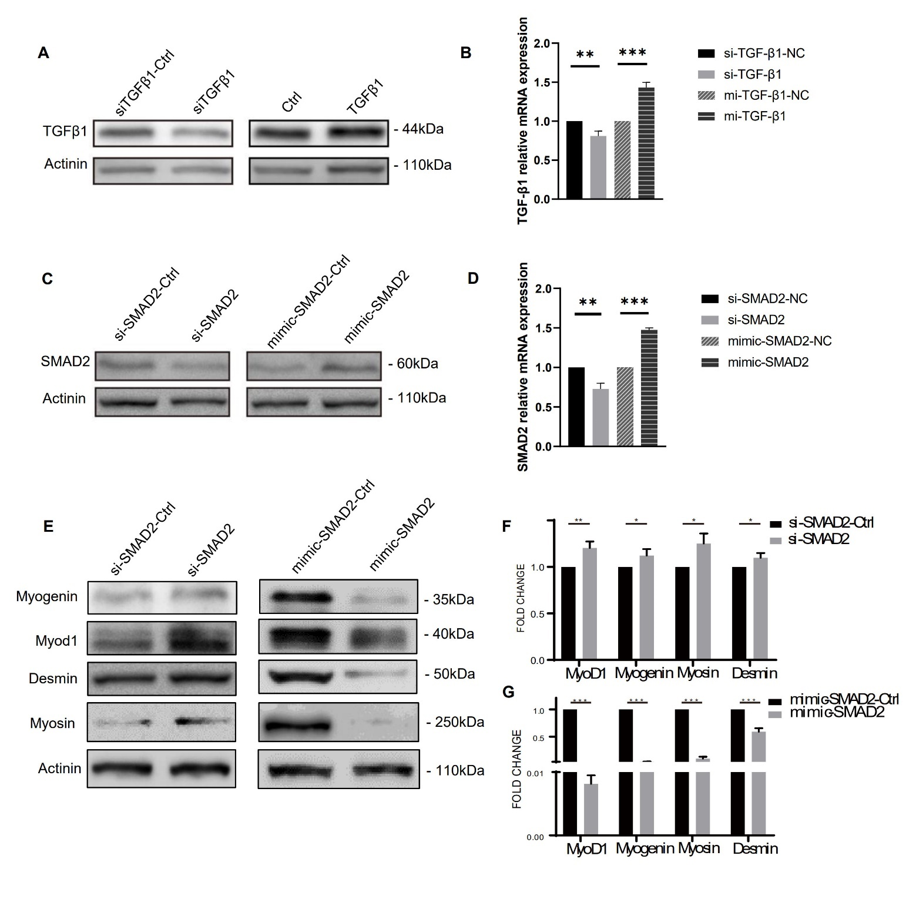
Supplemental Figure 3. RMS myogenic differentiation was regulated by TGFβ1/SMAD2 signalling in RD cells. The expression levels of TGF-β1 after transfecting siRNA sequences and cytokine stimulation were detected by Western blotting (A) and Real-time PCR (B). The expression levels of SMAD2 after transfecting siRNA sequences and mimic transient plasmid were detected by Western blotting (C) and Real-time PCR (D). Expression levels of muscle differentiation indicators were detected by Western blotting (E) and Real-time PCR (F-G) after transfecting siRNA sequences and mimic transient plasmid. Two-sided t test（*p < 0.05, **p < 0.01, ***p < 0.001）

Supplemental Figure 4
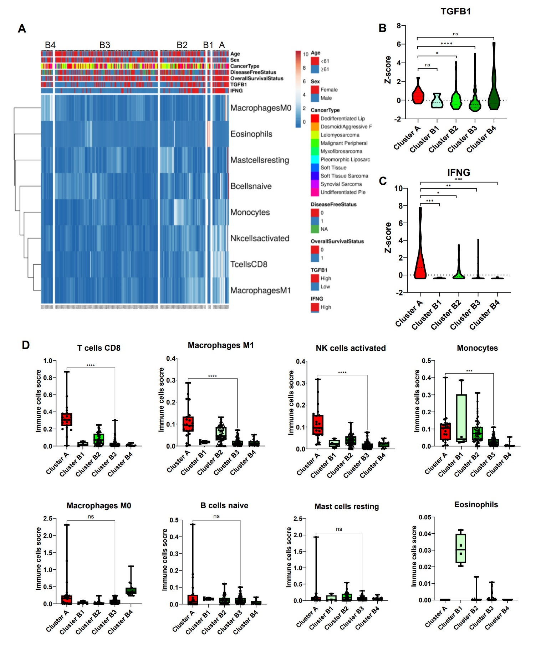
Supplemental Figure 4. Distinct immune cell types related to TGFβ1 and IFNγ expression in TCGA-SARC cohort. (A) Unsupervised hierarchical cluster analysis revealed five subclusters based on the eight selected immune cell subtypes. Violin plots described the transcript levels of TGFB1 (B) and IFNG (C) among the five subclusters. (D) Eight significant relevant immune cell subtypes were compared among the five subclusters. Two-sided t test（*p < 0.05, **p < 0.01, ***p < 0.001, ****p < 0.0001, ns: nonsignificant）

Supplemental Figure 5
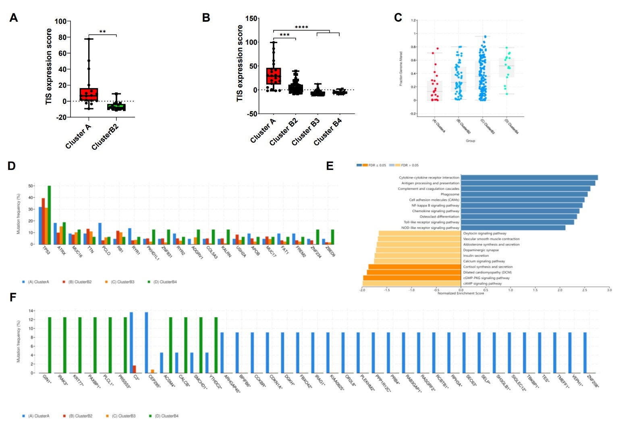
Supplemental Figure 5. Differences in tumour inflammation signature (TIS) and gene mutations related to the immune phenotypes. TIS scores were also compared among subclusters from RMS (A) and TCGA-SARC cohorts (B). The fraction of genome altered (FGA) (C) and tumour mutational count (TMC) (D-F) were compared among subclusters from TCGA-SARC cohorts by cBioportal. (E) Differentially expressed genes (DEGs) among cluster A and subcluster B2 or B3 in TCGA-SARC and RMS cohorts were selected for Gene Set Enrichment Analysis.

Supplemental Figure 6
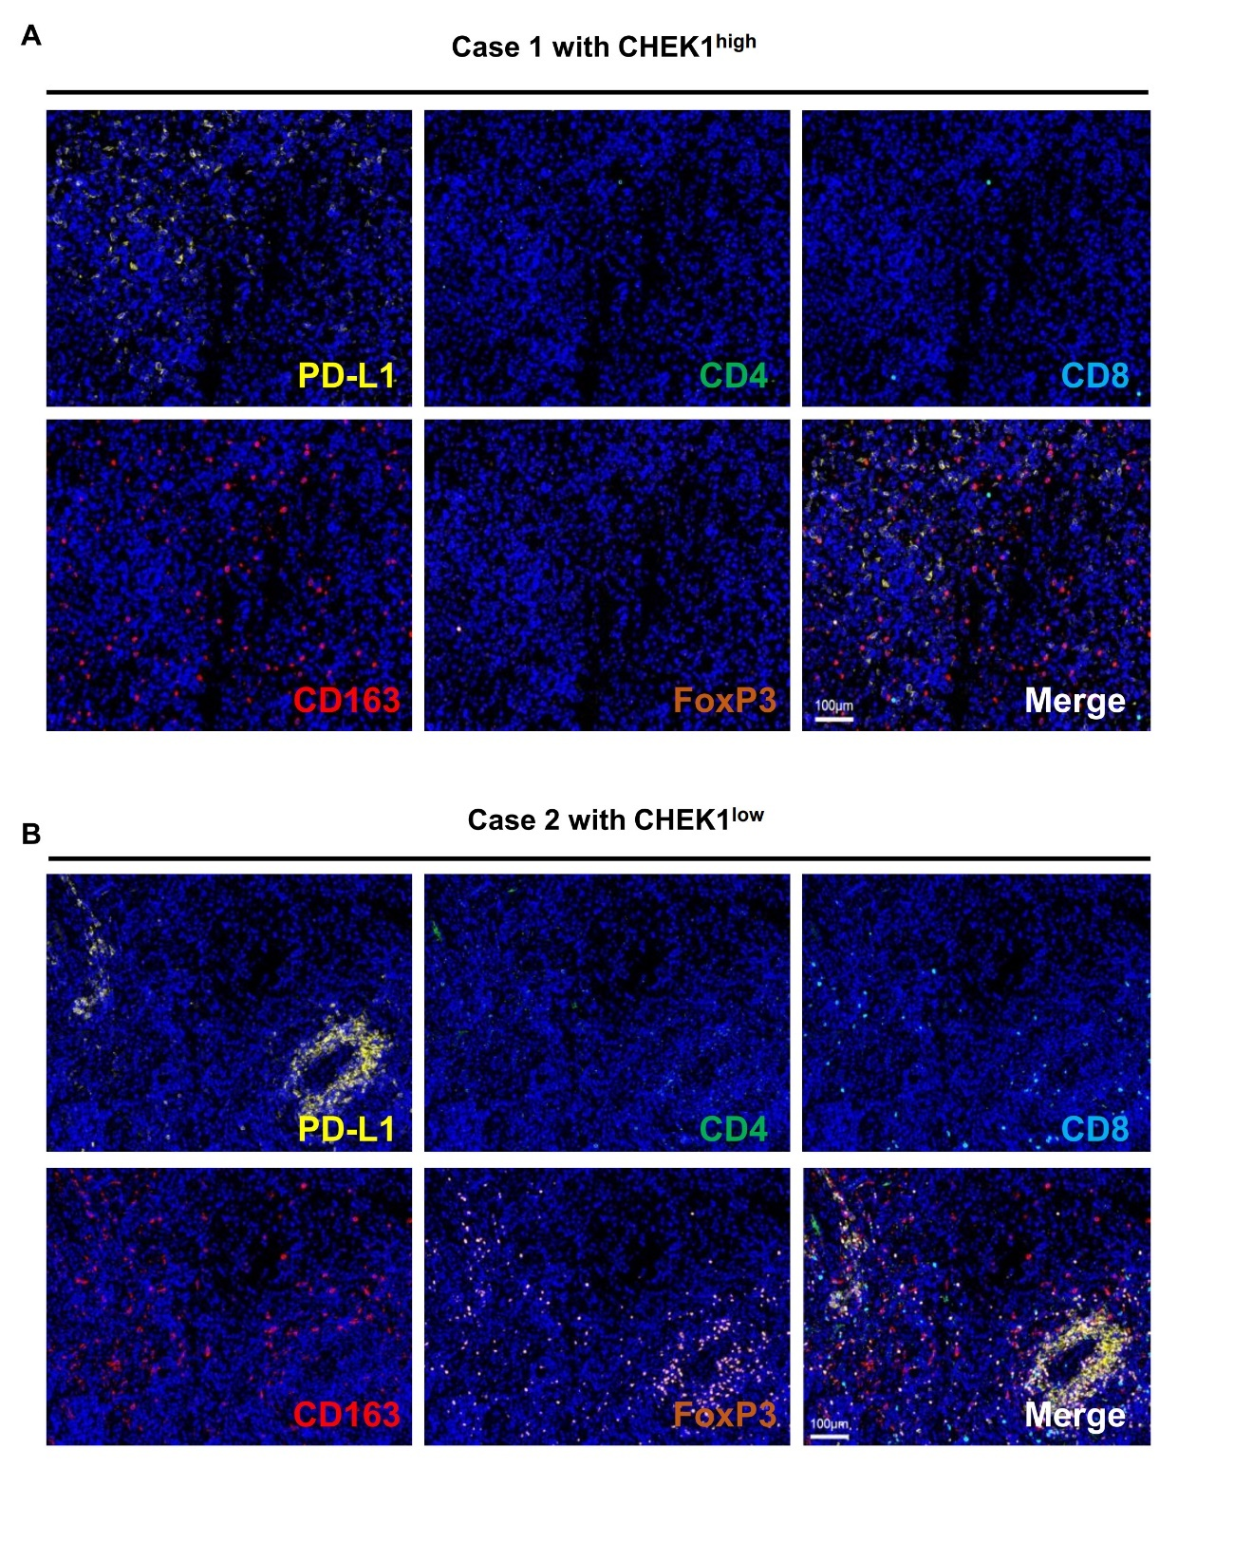
Supplemental Figure 6. Representative composite image of Opal five-colour multiplex staining in human rhabdomyosarcoma tissues with low (A) and high (B) CHEK1 protein expression. Scale bar, 100μm.

