TABLE 2. Numerical and experimental analysis of all the experimental track study
Run No. | Numerical Analysis | Macroscopic features |  | Inference
1 | 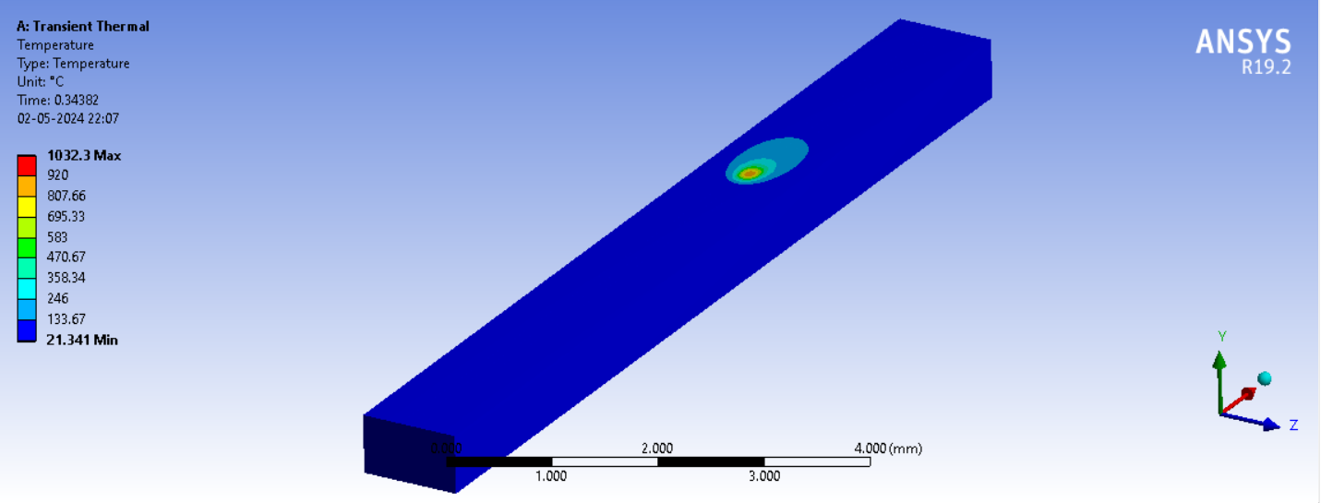 | 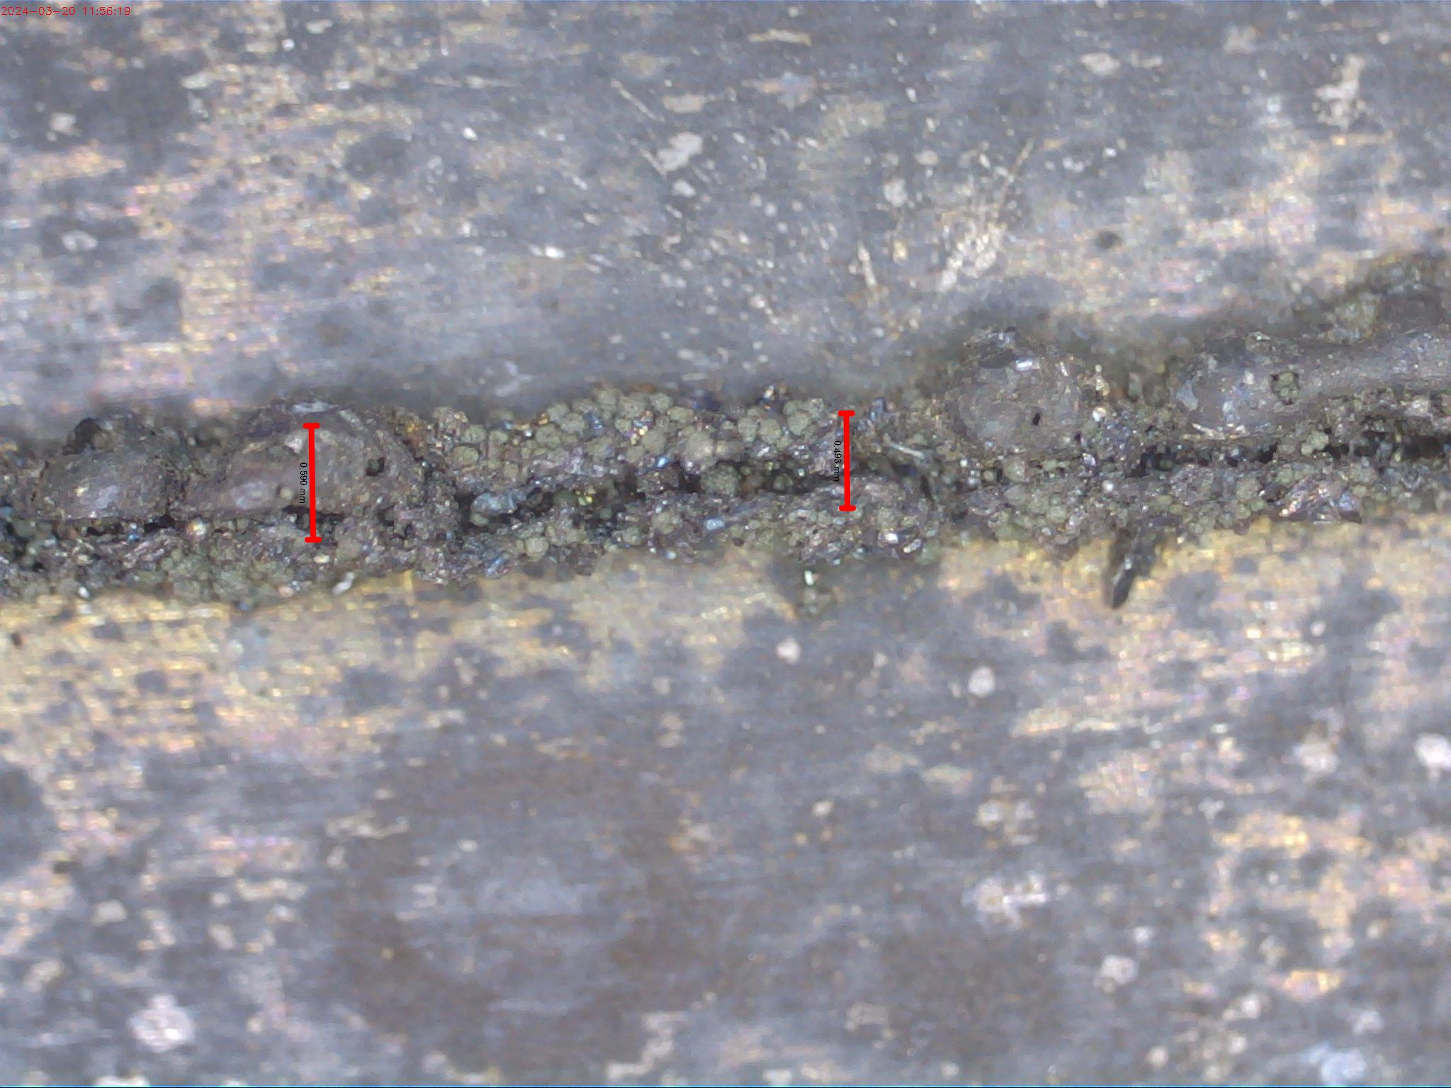 | 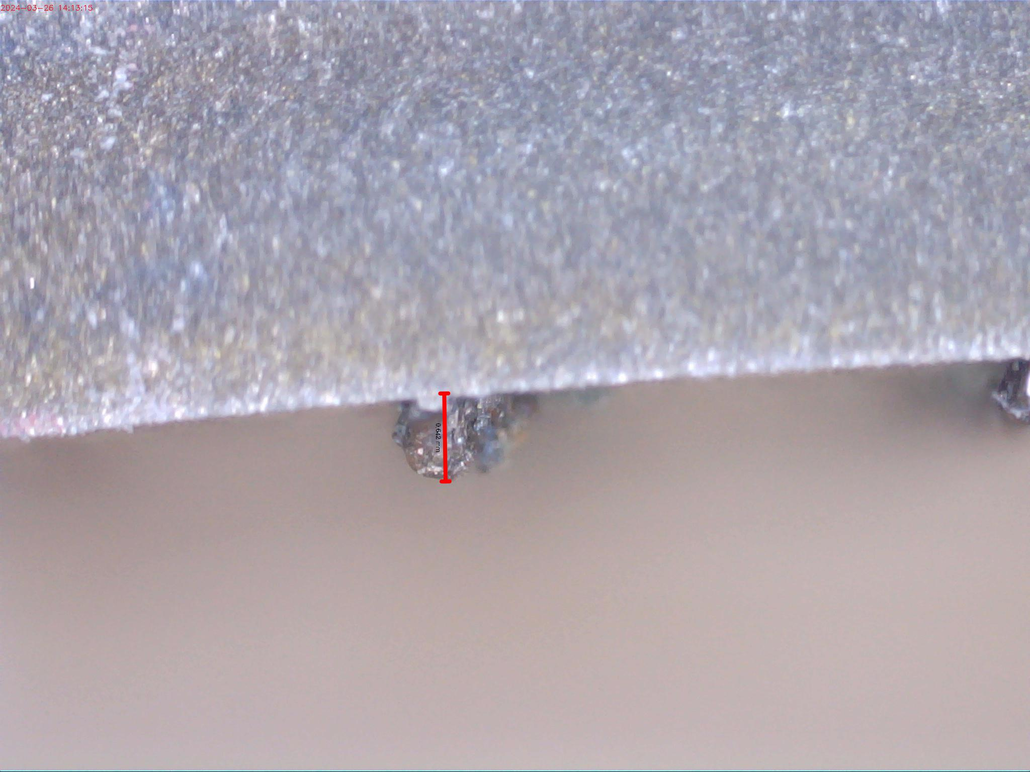 | Presence of unmelted powder particles were observed on the surface of the track which was due to lower energy density
2 | 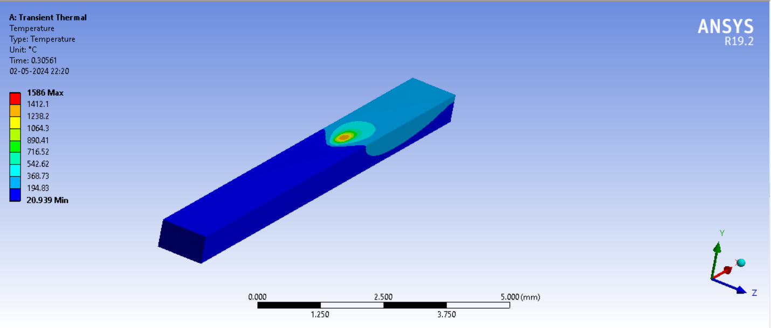 | 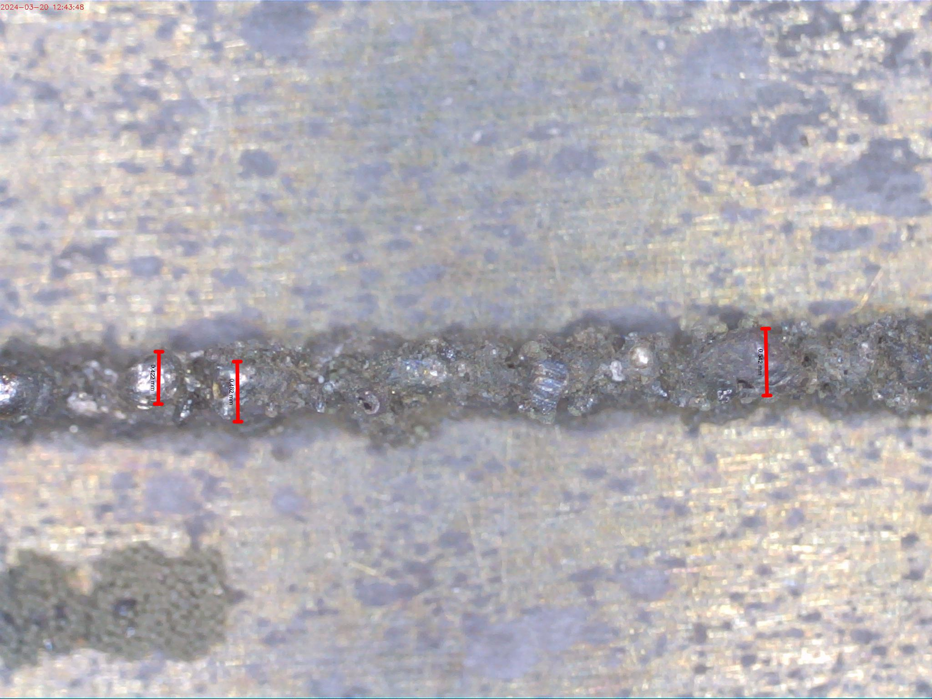 | 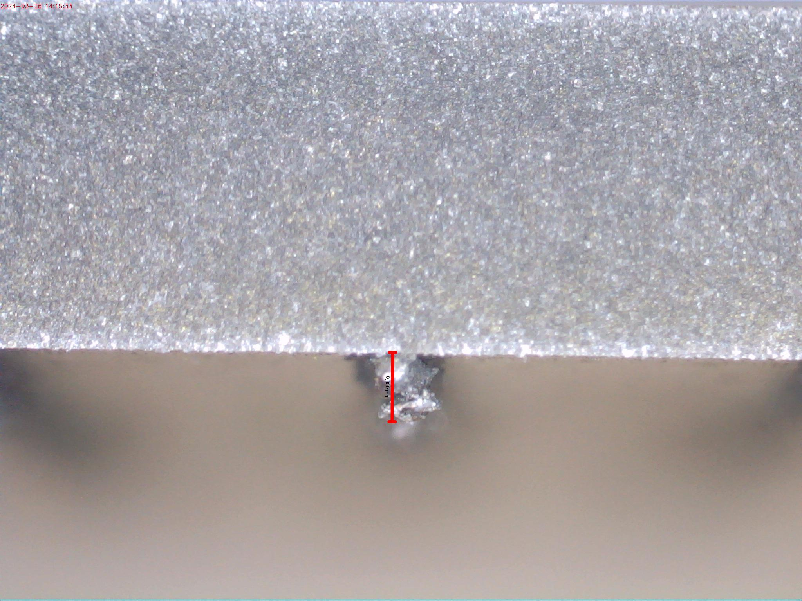 | The formed track was non-continuous and from the cross-sectional image it was observed that the track was not properly fused to the previous layer.
3 | 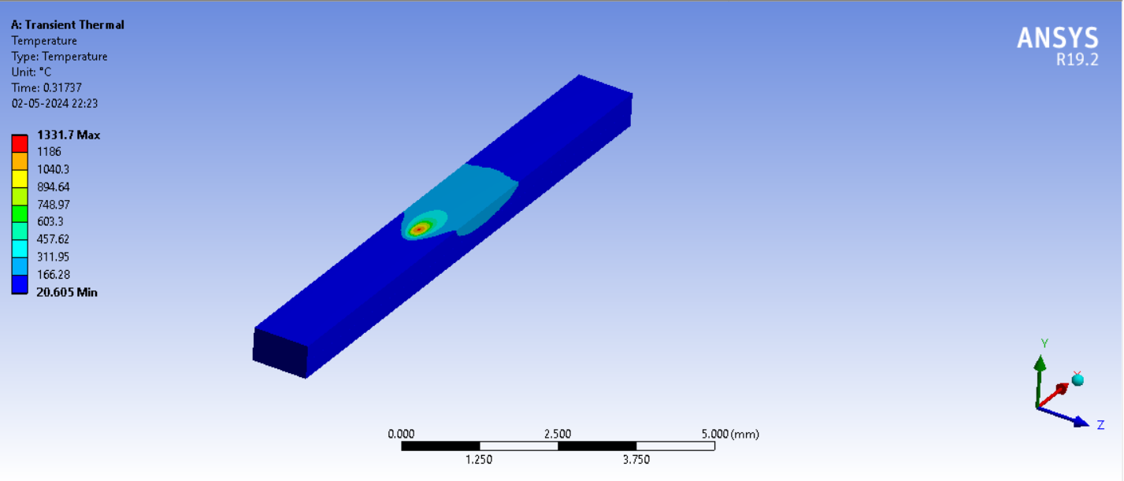 | 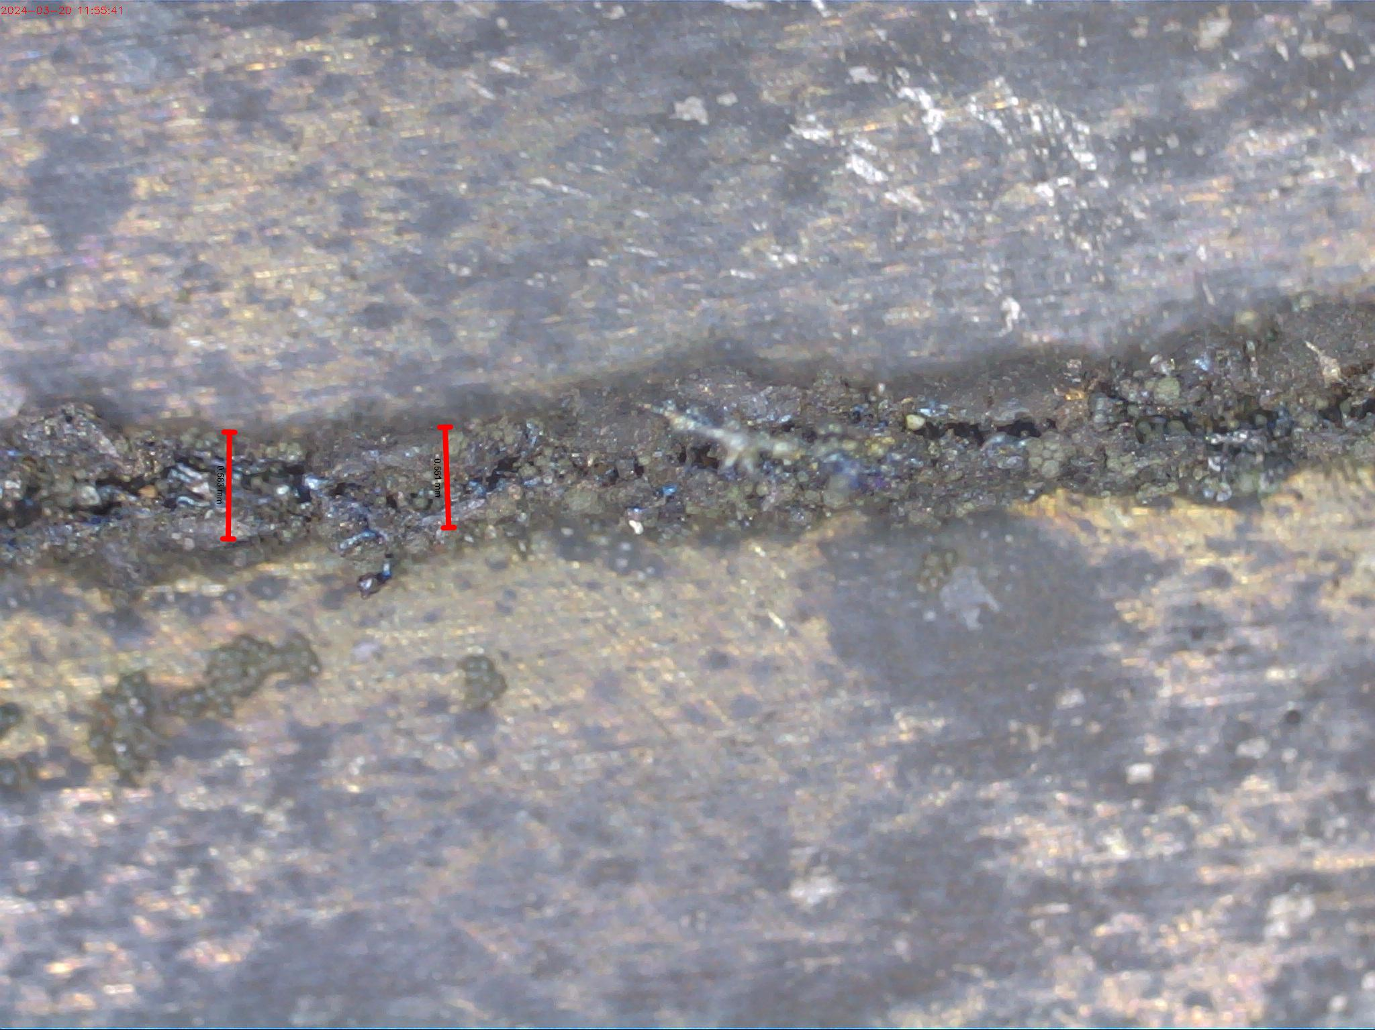 | 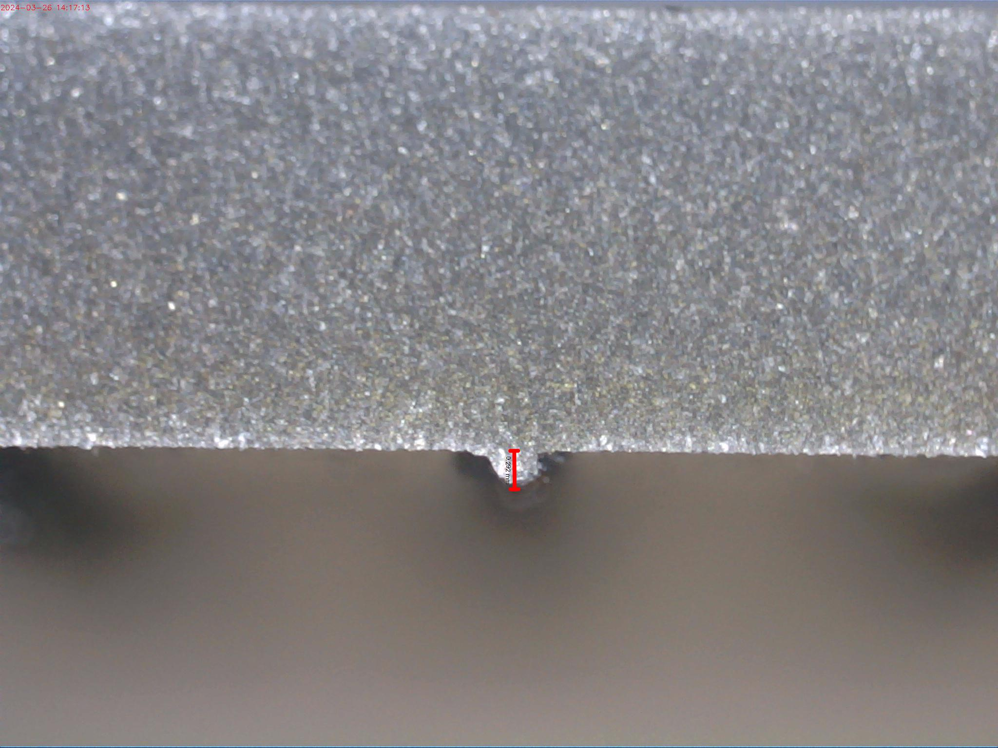 | Due to lower energy density the formed track was discontinuous, and powder particles were visible on the surface of the track.
4 | 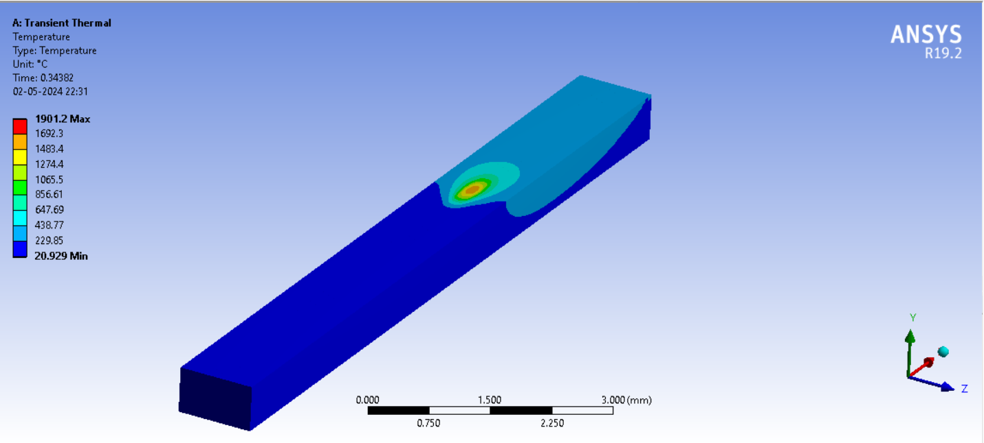 | 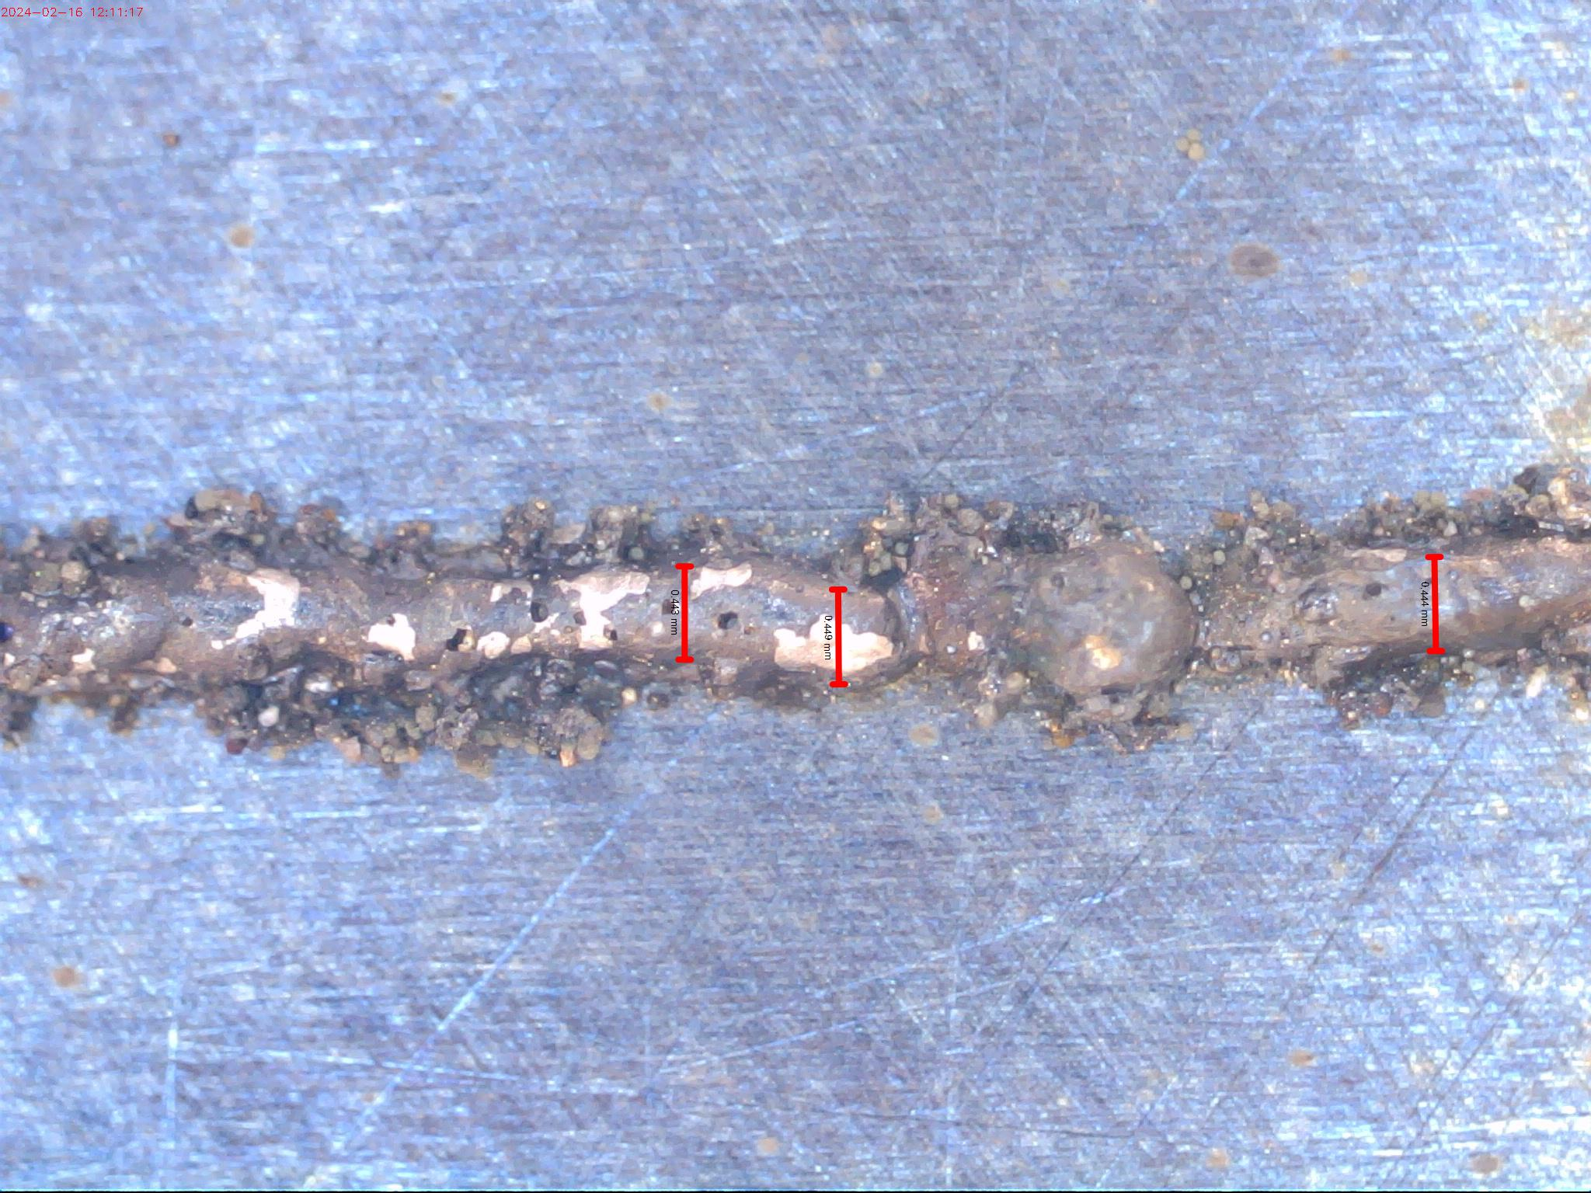 | 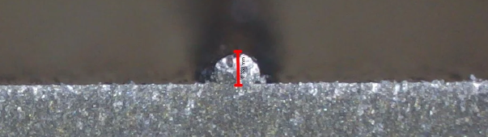 | The formed track was continuous but small pores were present in the track which indicates improper melting condition.
5 | 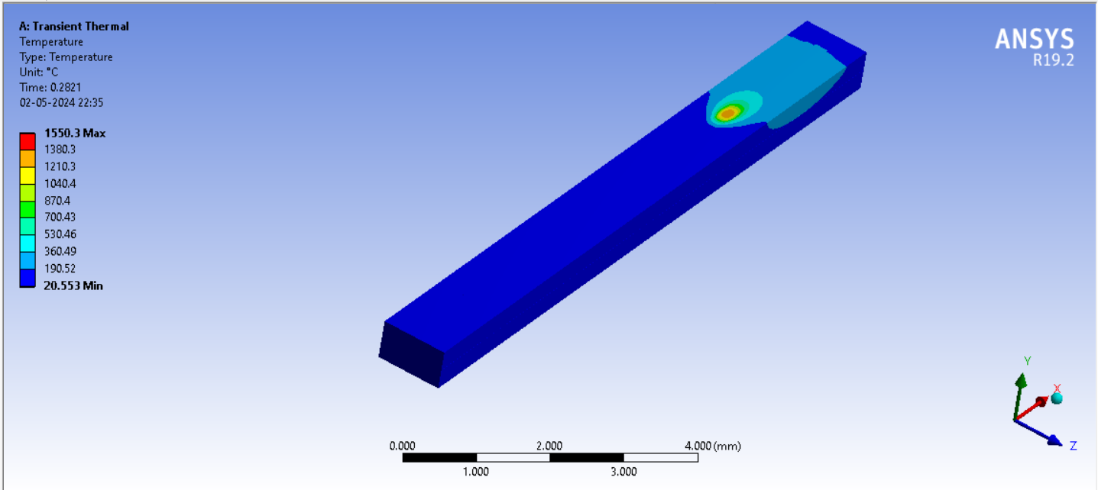 | 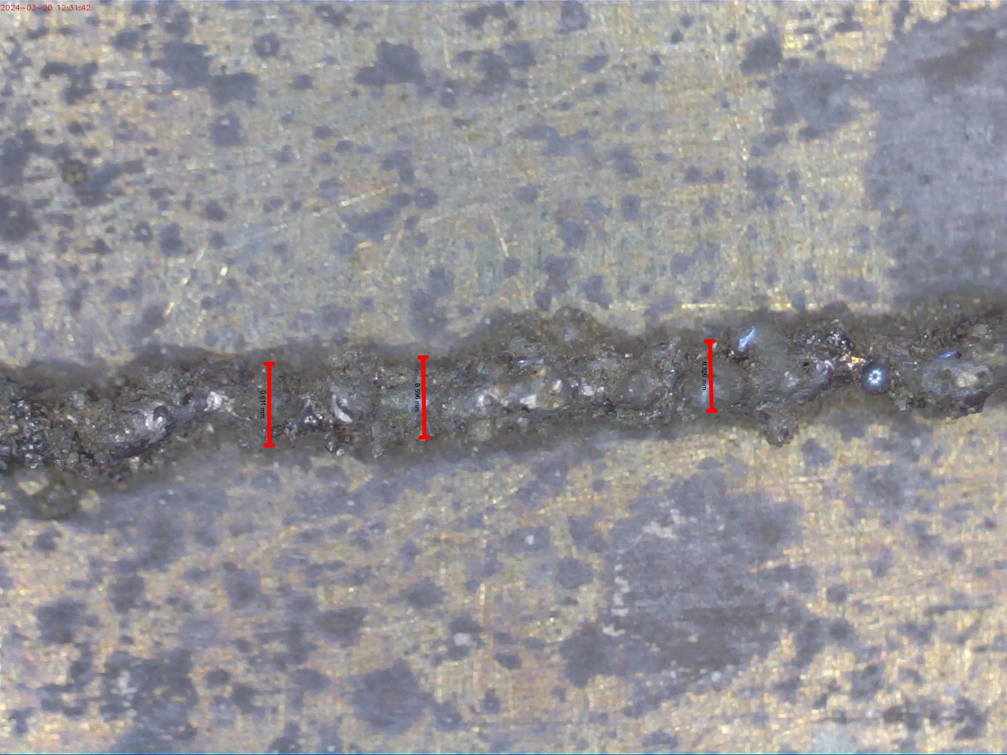 | 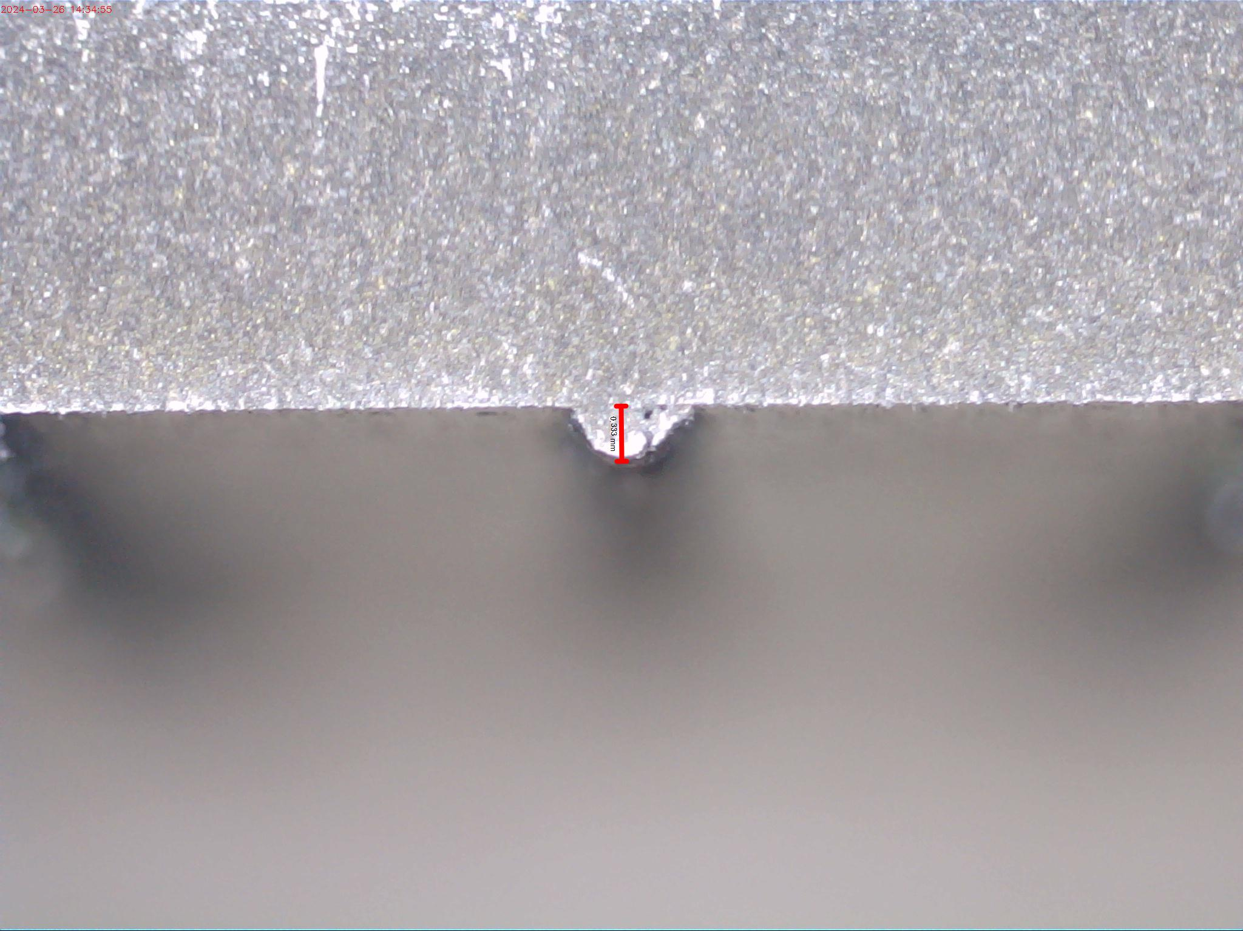 | The formed track was continuous but was not properly fused due to lower energy density.
6 | 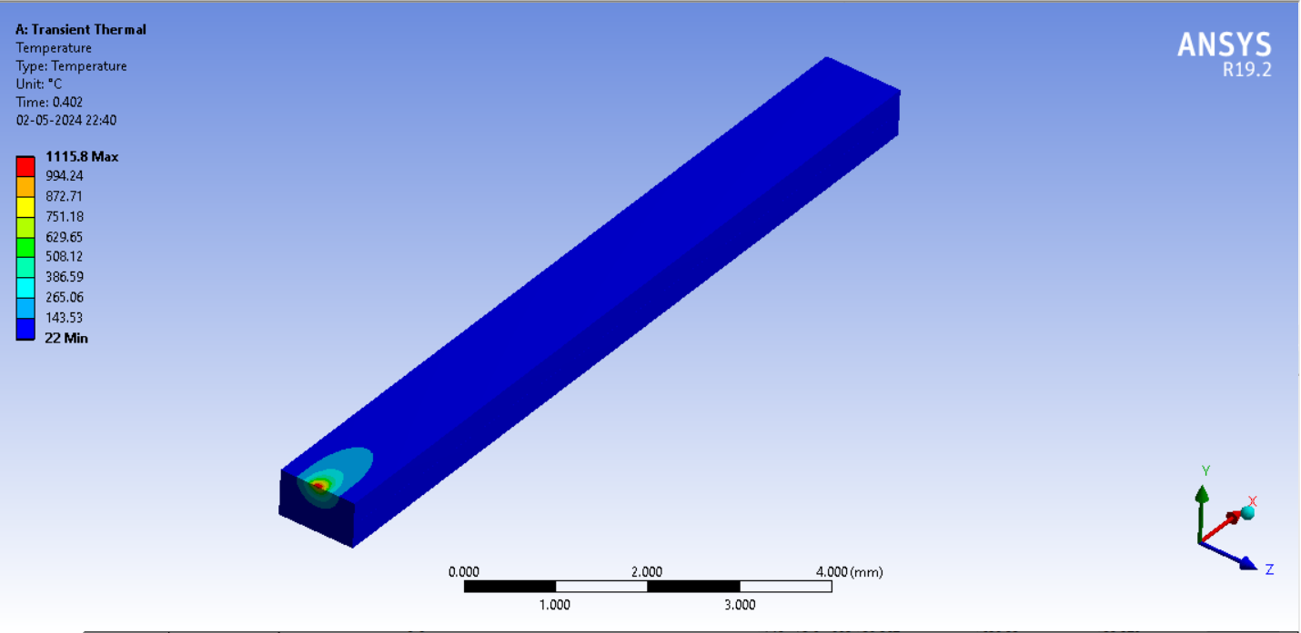 | 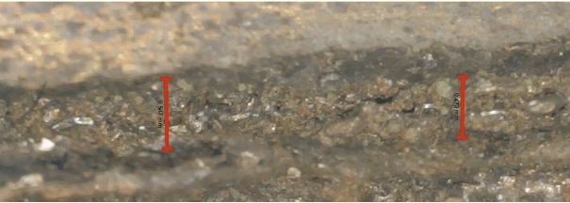 | 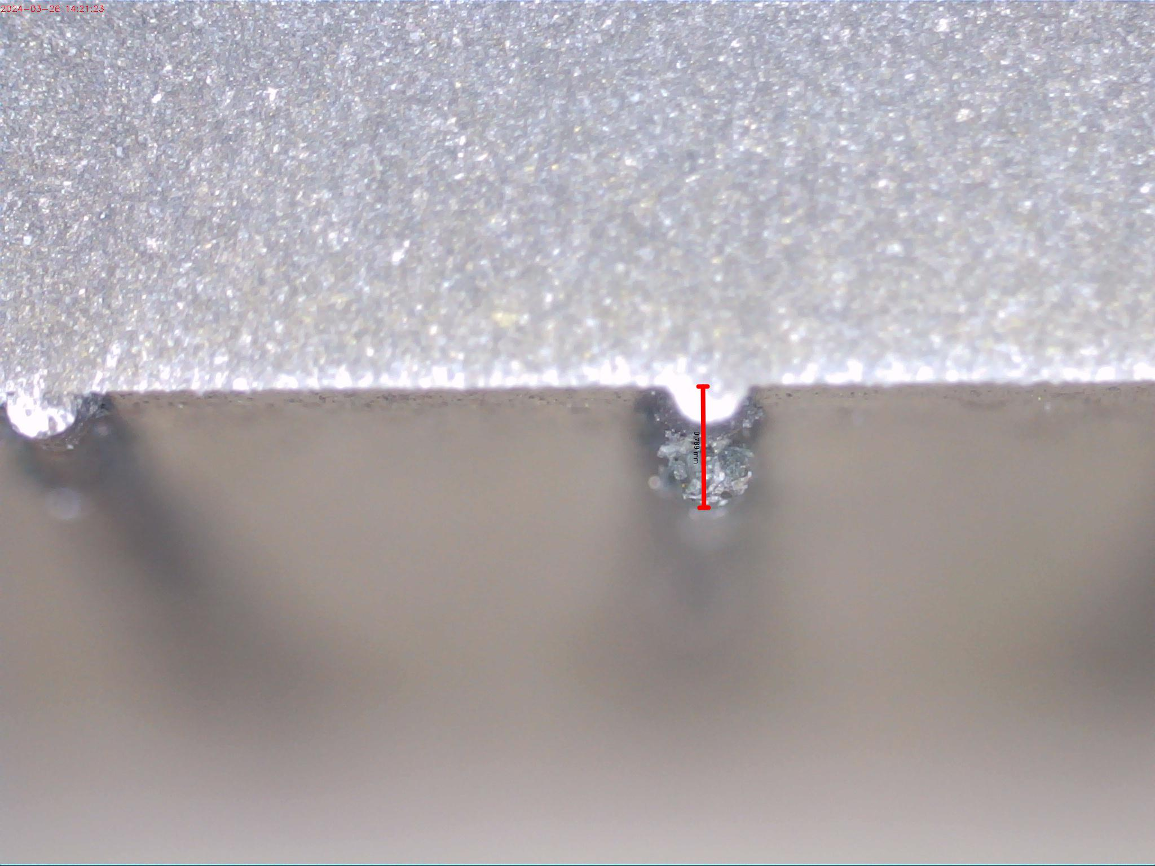 | The formed track was discontinuous and unmelted powder particles were observed owing to higher scan speed.
7 | 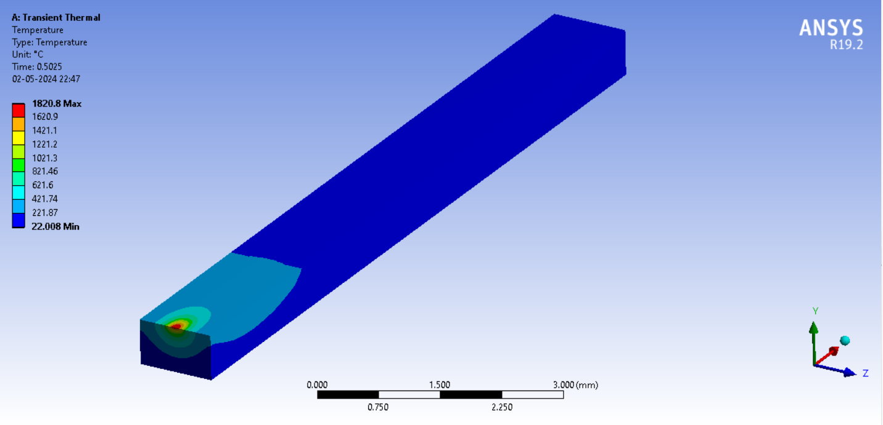 | 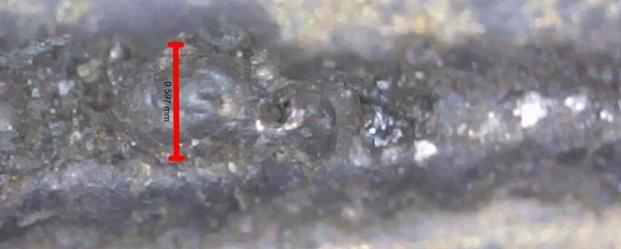 | 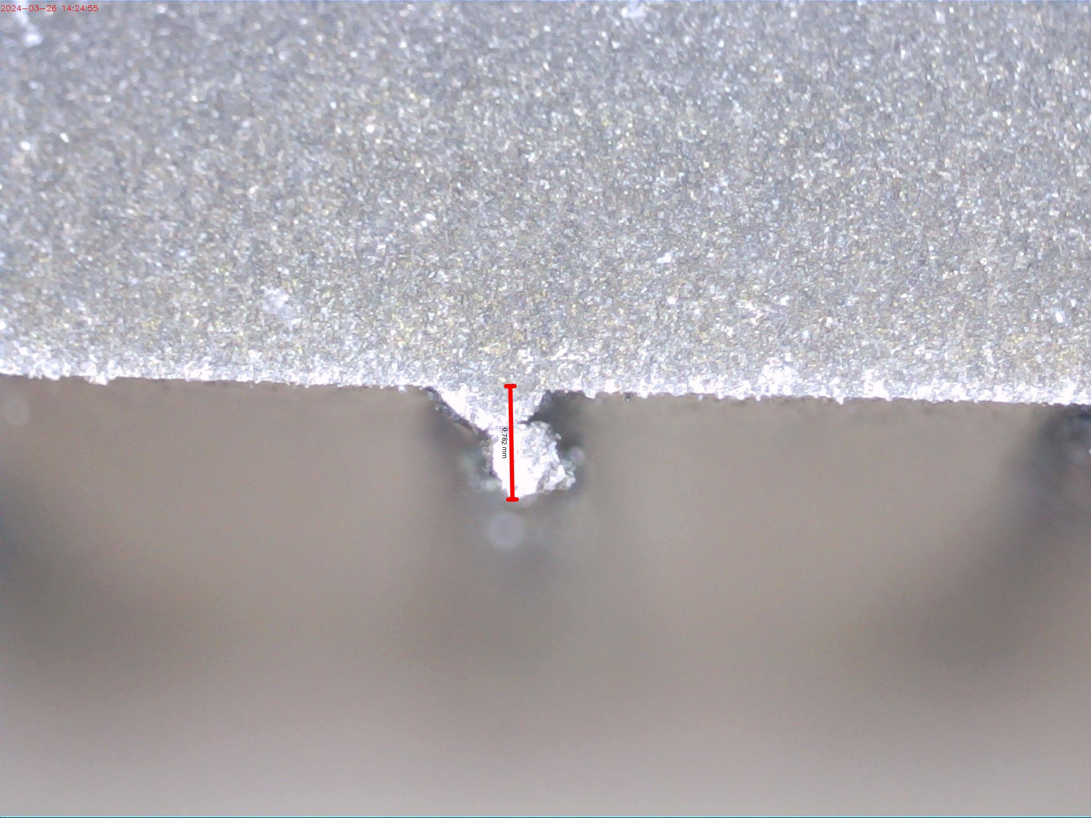 | The track formed was observed to be distorted due to higher laser power and lower scan speed
8 | 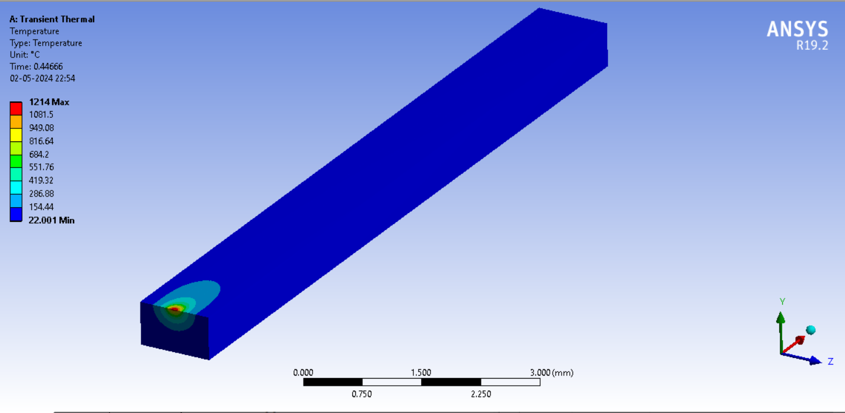 | 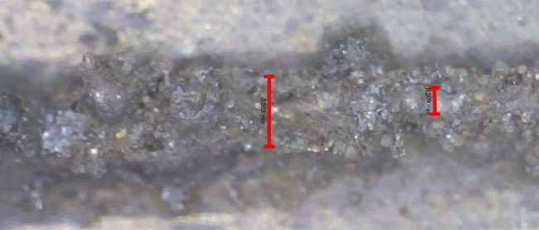 | 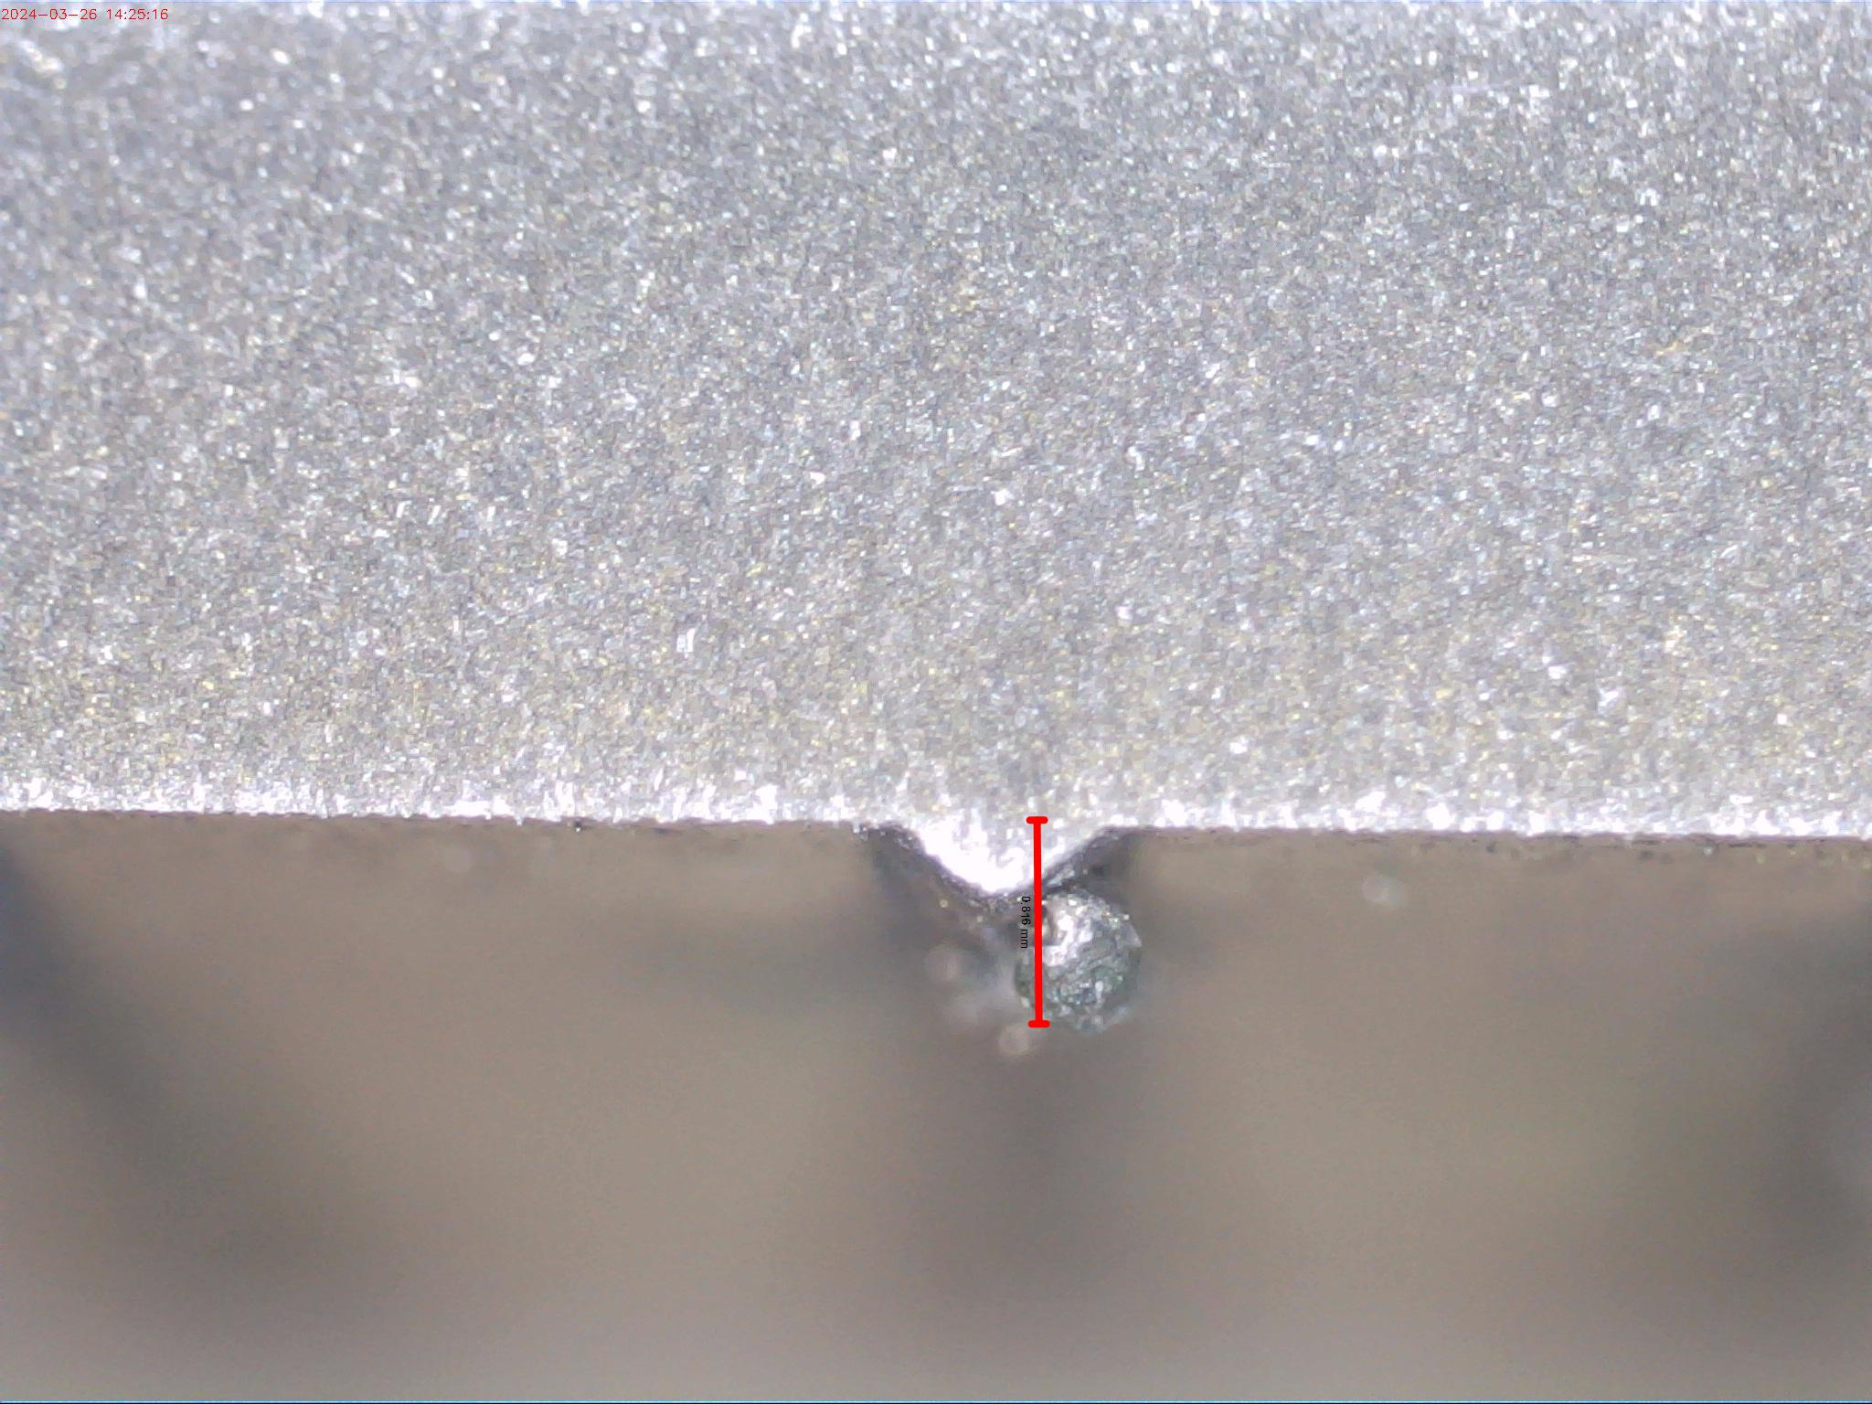 | The track formed was discontinuous and distorted due to insufficient energy density
9 | 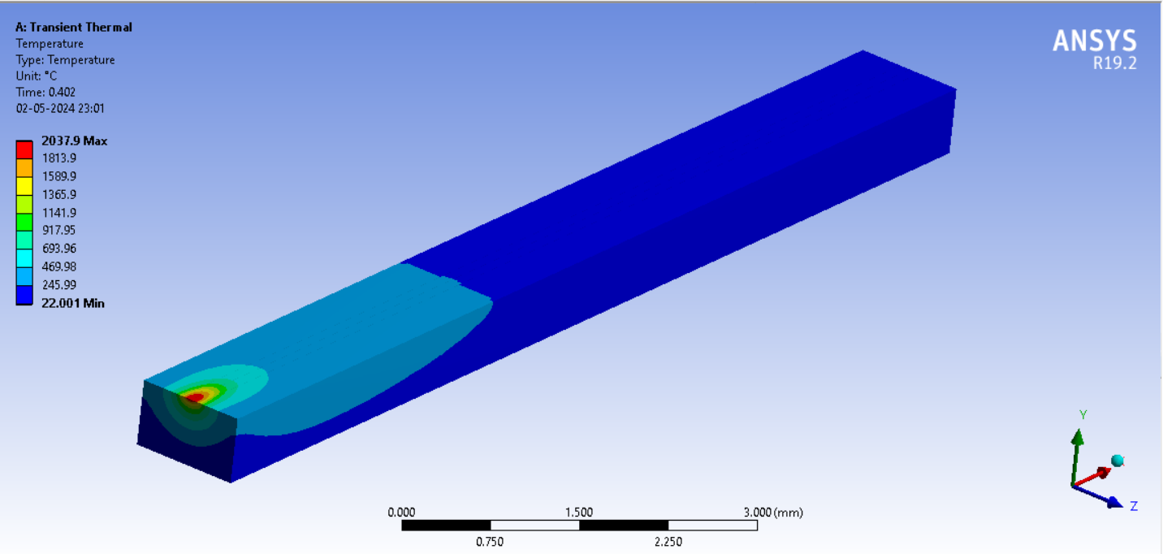 | 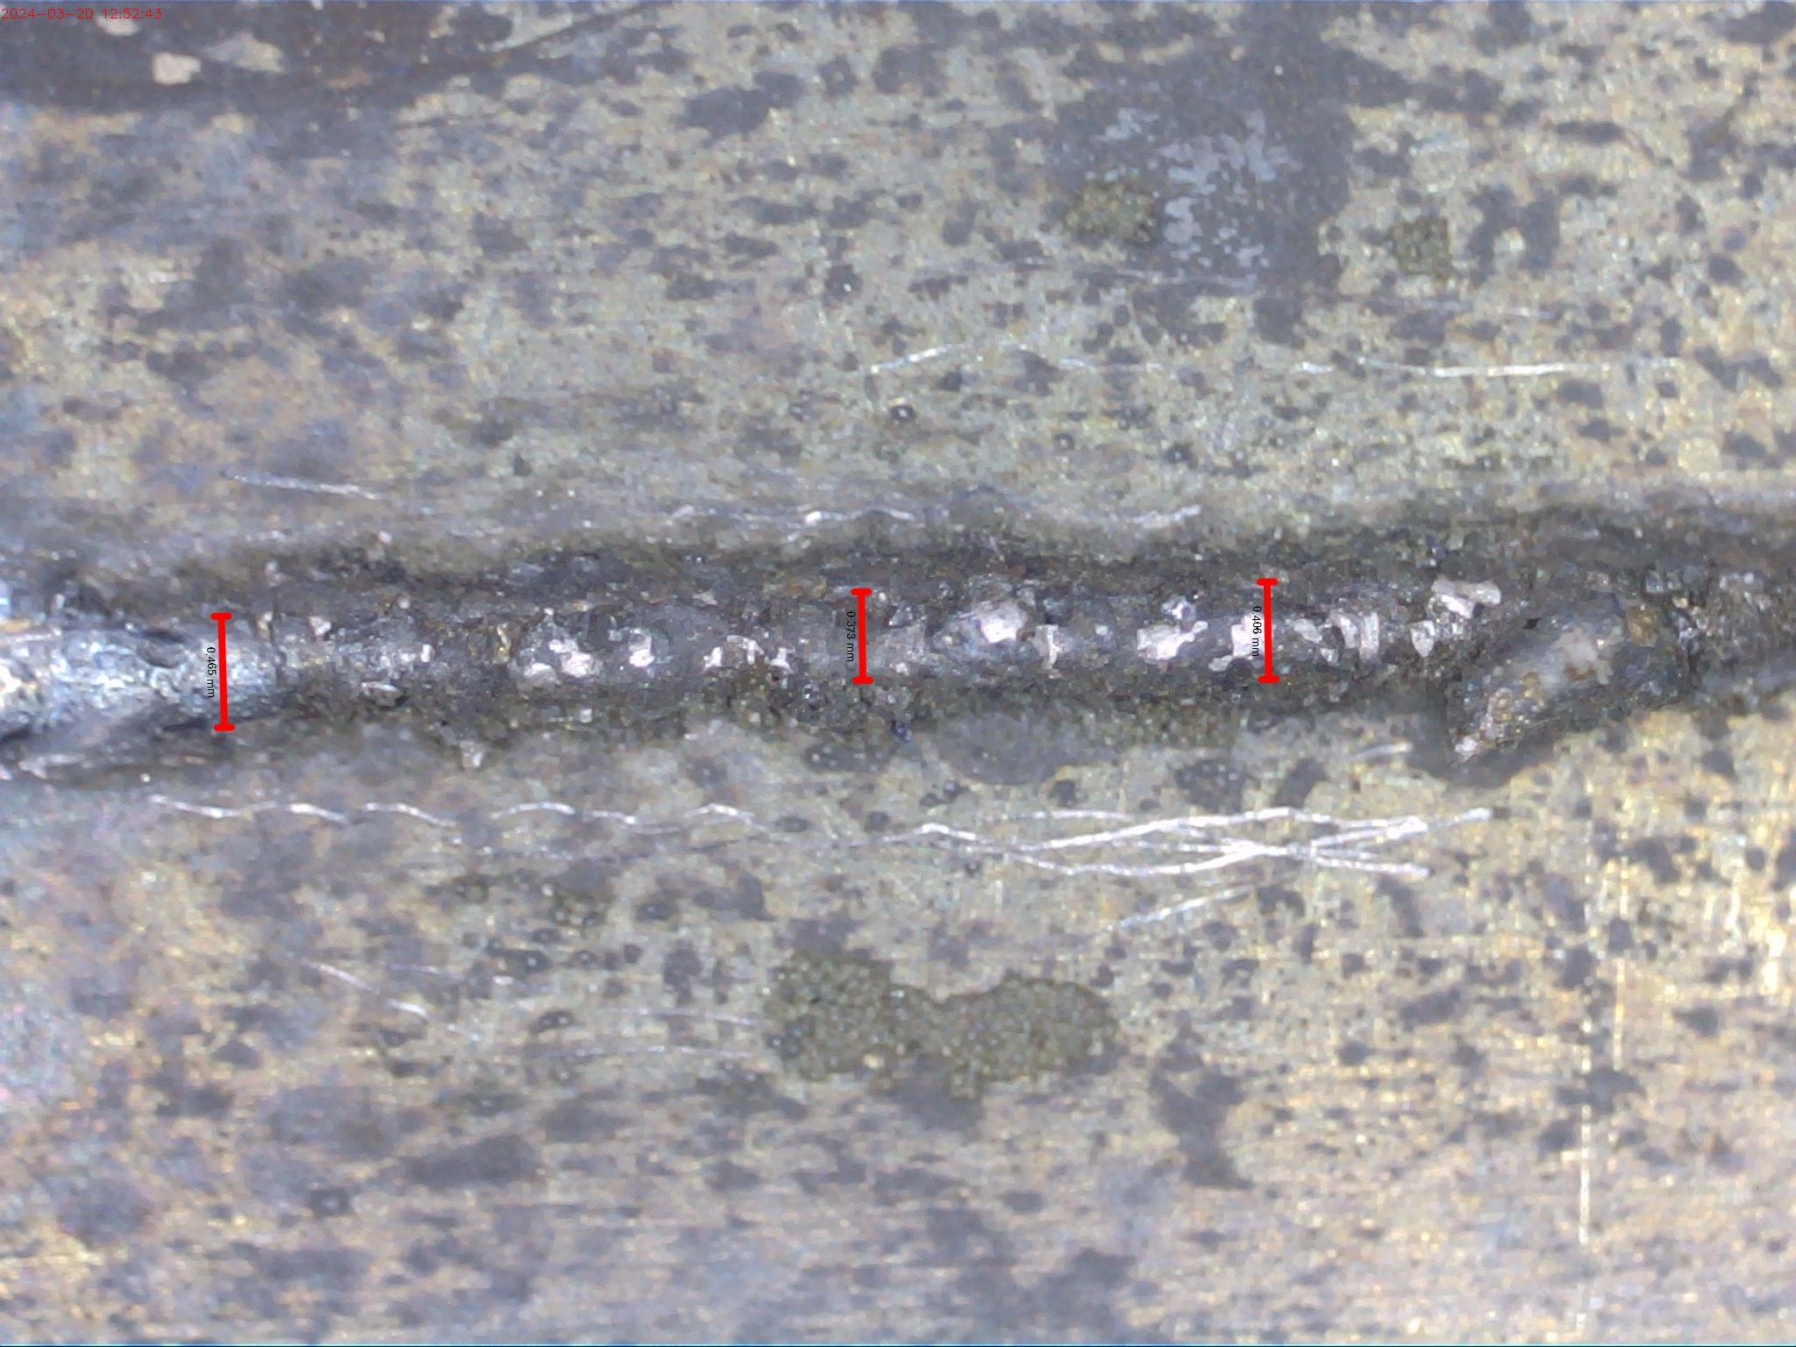 | 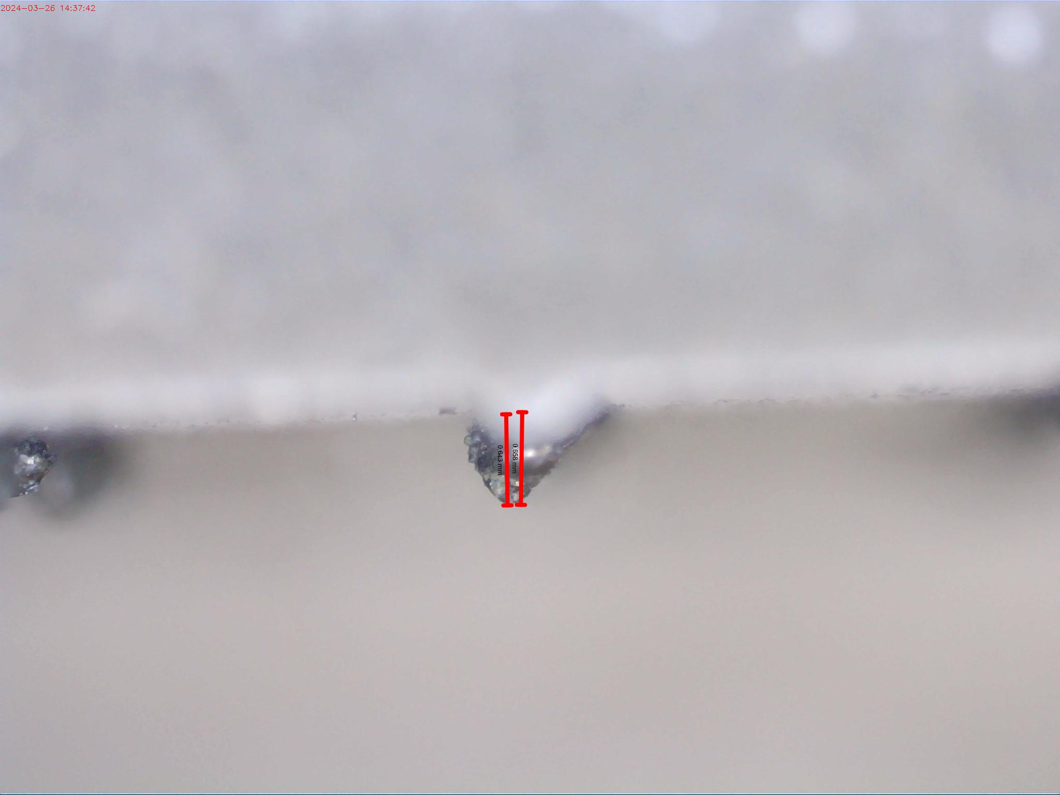 | The track formed was continuous and of good quality owing to optimum combination of the process parameters.

