Additional Files
Additional file 1: Conceptual diagram of residual and range. The figure shows the specific indicators of residual and range. Residual means values of variation between observed values and liner predictions. Range means the gap between maximum and minimum of observed value.
Additional file 2: Elbow method used to estimate the number of clusters. The SSE was calculated to visually confirm the number of clusters with low error. Based on this analysis, the data was divided into three clusters. Furthermore, a sensitivity analysis was performed by considering four clusters.
Additional file 3: Parameters of eGFR change based on four groups. The figure shows mean residual (mean value of residual between observed eGFR values and linear predictions during the follow-up period), maximum residual (maximum value of residual between observed eGFR values and linear predictions during the follow-up period), and range in eGFR (difference between maximum and minimum values during the follow-up period) in the four groups. Cluster 1 showed high variability.
Additional file 4: eGFR change over time based on four groups. The figure shows plots of eGFR and nonlinear predictions with 95% confidence intervals for four groups. Cluster 1 showed high variability with a large decline in eGFR, as well as the three groups.

Additional file 1. Conceptual diagram of residual and range.

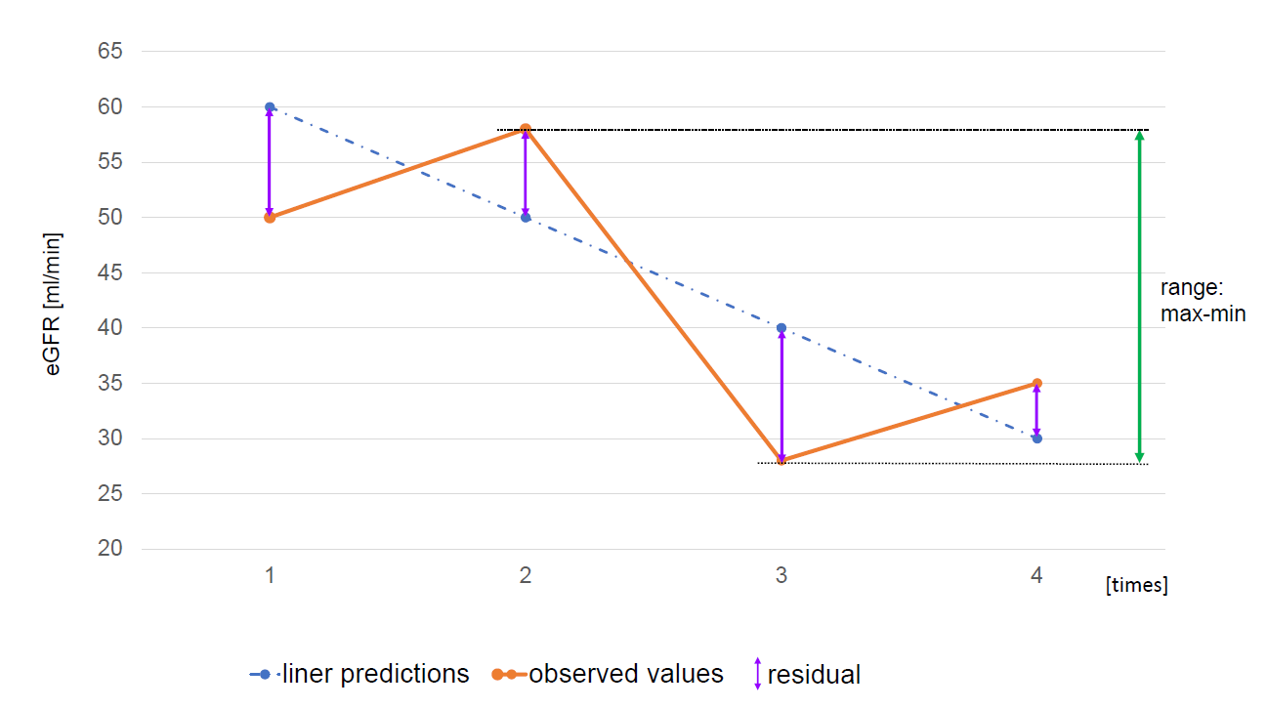

Additional file 2. Elbow method used to estimate the number of clusters.

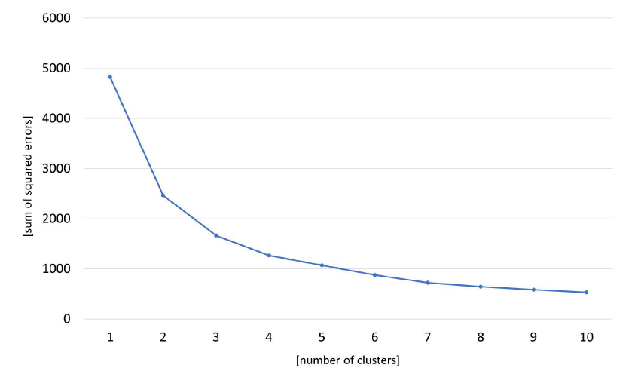

Additional file 3. Parameters of eGFR change based on four groups.

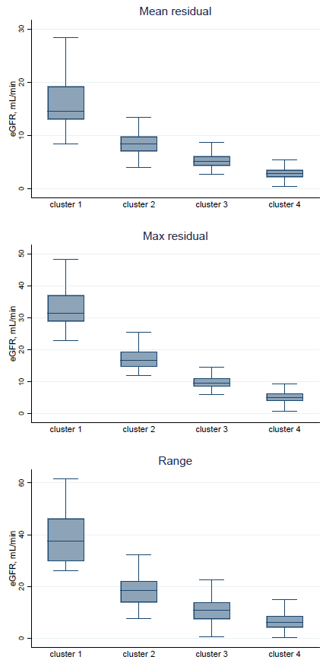

Additional file 4. eGFR change over time based on four groups.

