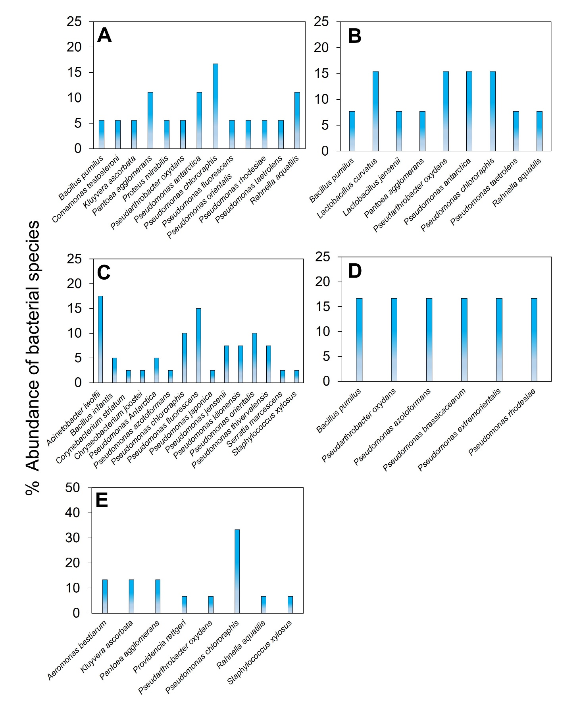
Fig. Suplemental 1 Abundances of bacterial spp. obtained from anuran spp. in skin samples collected in the Ecuadorian provinces of: (A) Zamora Chinchipe, (B) Loja, (C) Cañar, (D) Azuay and (E) Morona Santiago.

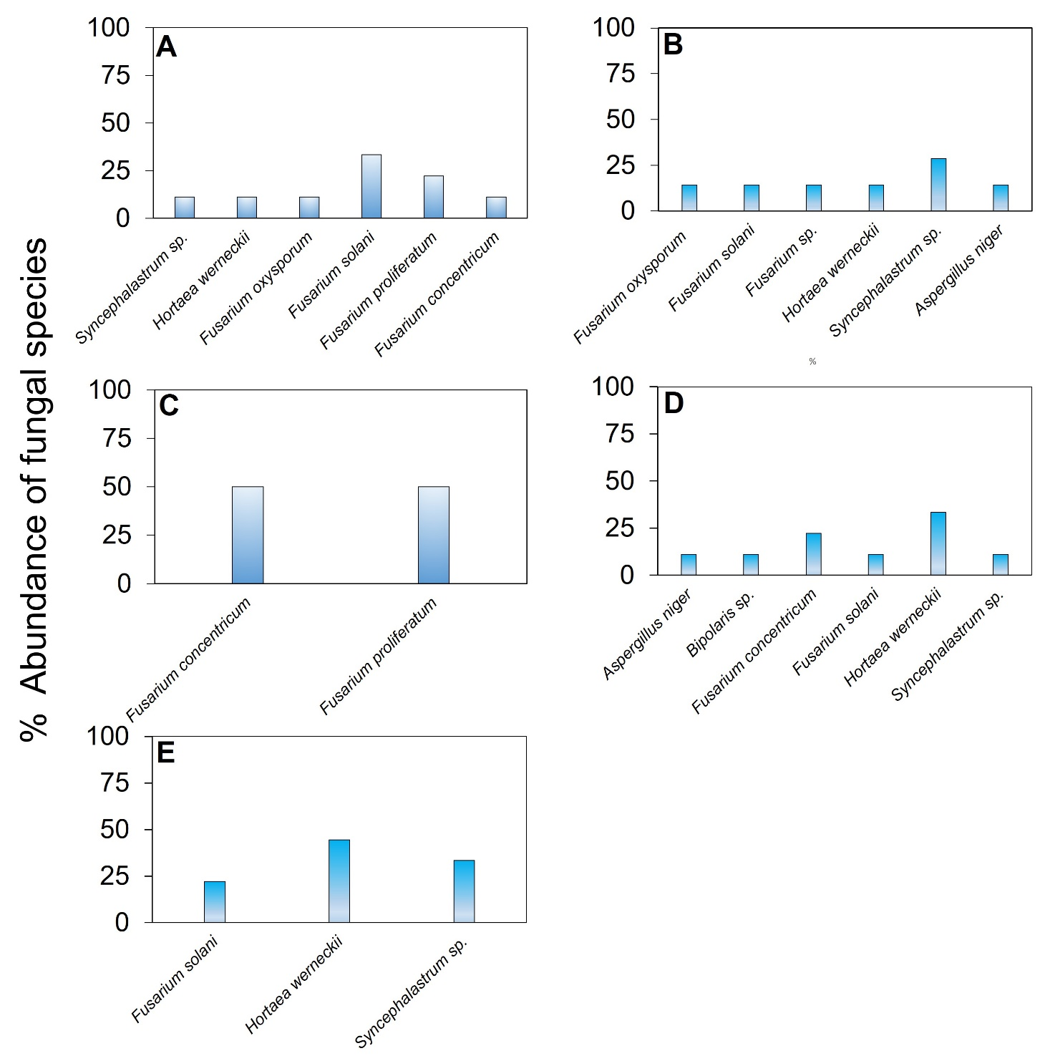
Fig. Suplemental 2 Abundances of fungal species on anuran skin collected in the Ecuadorian provinces of: (A) Zamora Chinchipe, (B) Loja, (C) Cañar, (D) Azuay and (E) Morona Santiago.

