Table 1 Supplementary Material
Composition of the Solid Diets Used (calculated in 100g)
 | Dieta Control | MFD
Moisture (max) | 12,0% | 10,0%
Proteins (min) | 23,0% | 28,0%
Carbohydrates* | 50,0% | 39,5%
Crude Fiber (max) | 6,0% | 3,5%
Fat (min) | 5,0% | 15,0%
Total minerals | 10,0% | 7,5%
Calcium (min. - max.) | 1% - 1,4% | 1,5% - 1,7%
Phosphorus (min. - max.) | 0,5% - 0,8% | 1,1% - 1,4%
Online Supplemental Materials

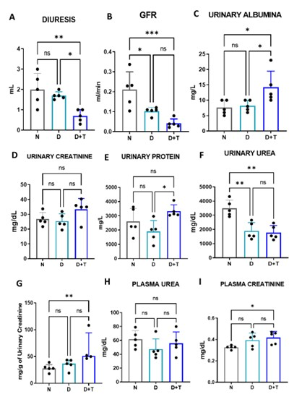
Supplementary Figure 1. Analysis of urinary parameters in a diabetic model during an 18- hour time window utilizing a metabolic cage. (A) urine output volume, (B) glomerular filtration rate (GFR), (C) urinary albumin, (D) urinary creatinine, (E) total urinary protein, (F) urinary urea, (G) plasma creatine rate and urinary creatinine ratio, (H) plasma urea, (I) plasma creatinine. N (n= 5), D (n= 5), D+T (n=5). (*) p ≤ 0.05; (**) p< 0.01; ns: non-significant.

