Supplementary information

Chronic Suppression of a Multidrug-Resistant Pseudomonas aeruginosa in Prosthetic Joint Infection Using Personalized Bacteriophage Treatment

Rekha Arya¹, Nadine M Sadaka¹, Andrew J. Frear¹, Jewelia J. Rempuszewski ¹, Dong Zhu Ma¹, Beth Knapick¹, Dana Parker¹, Vaughn S. Cooper⁴, Daria Van Tyne⁵, Neel Shah⁵, James B. Doub⁶, Umit Akbey⁷, Joseph Fackler⁸, Subhendu Basu⁸, Arkadiy Garber⁹, Kenneth L. Urish^{1,2,3}*

¹Department of Orthopedic Surgery, Arthritis and Arthroplasty Design Lab, University of Pittsburgh, Pittsburgh, Pennsylvania, United States of America,
²The Bone and Joint Center, Magee Women’s Hospital of the University of Pittsburgh Medical Center, Pittsburgh, Pennsylvania, United States of America,
³Department of Bioengineering, and Clinical and Translational Science, University of Pittsburgh, Pittsburgh, Pennsylvania, United States of America
⁴Department of Microbiology and Molecular Genetics, University of Pittsburgh, School of Medicine, Pittsburgh, Pennsylvania, USA
⁵Division of Infectious Diseases, Department of Medicine, University of Pittsburgh School of Medicine, Pittsburgh, Pennsylvania, United States of America
⁶Division of Clinical Care and Research, Institute of Human Virology, University of Maryland School of Medicine, Baltimore, Maryland, USA.
⁷Department of Structural Biology, School of Medicine, University of Pittsburgh, Pittsburgh, Pennsylvania, USA
⁸Adaptive Phage Therapeutics, Gaithersburg, MD 20878, USA
⁹Middle Author Bioinformatics, LLC Tempe, AZ.

*Corresponding author; Email: ken.urish@pitt.edu

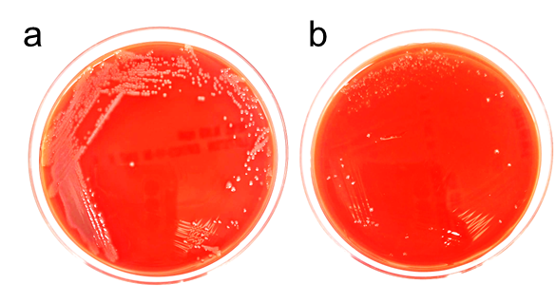

Supplementary Figure 1. Morphological difference between the pre-phage and post-phage isolates obtained from the patient. The patient isolates were cultured on a blood agar plate and incubated for 18h.
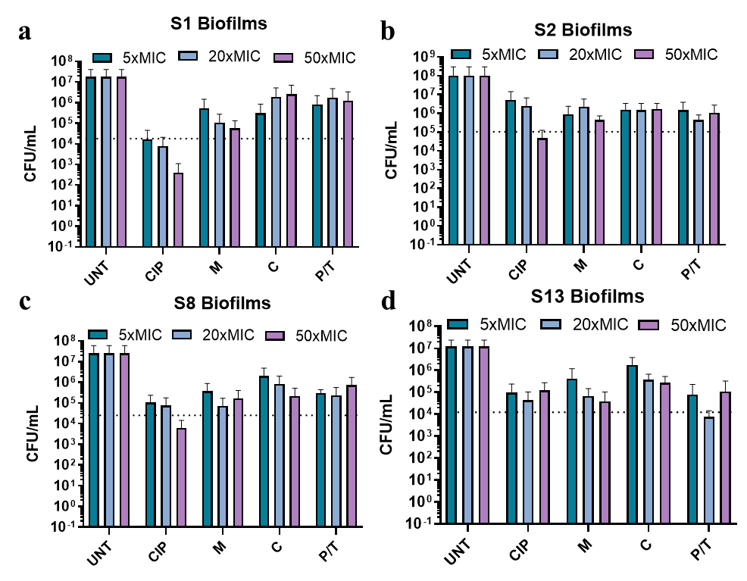
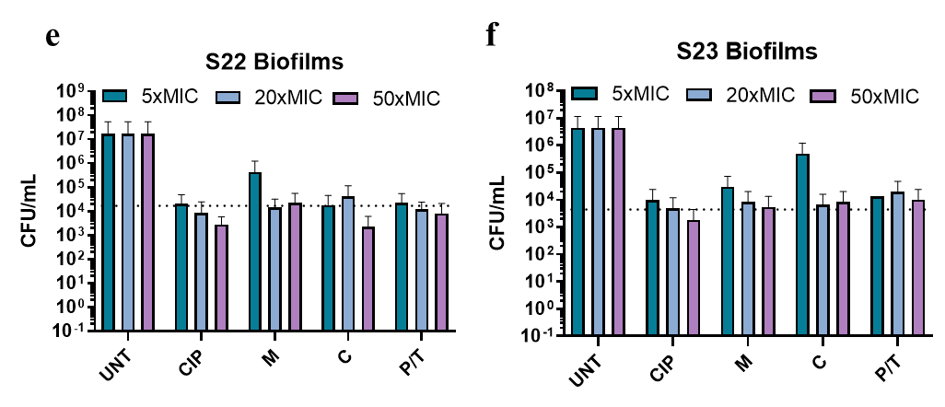
Supplementary Figure 2. Biofilm-forming capacity and antibiotic susceptibility of patient-derived Pseudomonas aeruginosa isolates were quantitatively assessed. Biofilms were established on titanium rods over 48 hours and subsequently challenged with antibiotics for an additional 24-hour period. The untreated group served as a baseline for comparison against four antibiotic treatments: Ciprofloxacin (CIP), Cefepime (FEP), Meropenem (MEM), and Piperacillin/Tazobactam (P/T). Bacterial burdens were quantified as colony-forming units per milliliter (CFU/mL) and graphically represented through bar graphs, employing a log reduction of 3 as the threshold for significant biofilm disruption, as analyzed by GraphPad Prism version 9.5. a, Biofilm formation of patient isolates, untreated and treated with CIP, FEP, MEM, P/T (isolates plated at 10⁶ CFU/mL and treated with antibiotics at 5x, 20x, 50x MIC) in sample S1; b, Biofilm formation of sample S2; c Biofilm formation of sample S8; d, Biofilm formation of sample S13; e, Biofilm formation of sample S22; f, Biofilm formation of sample S23.

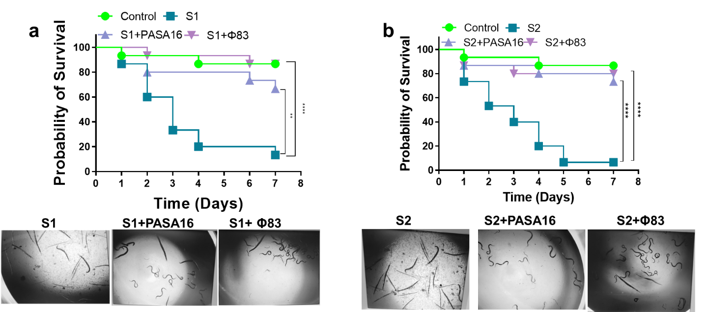

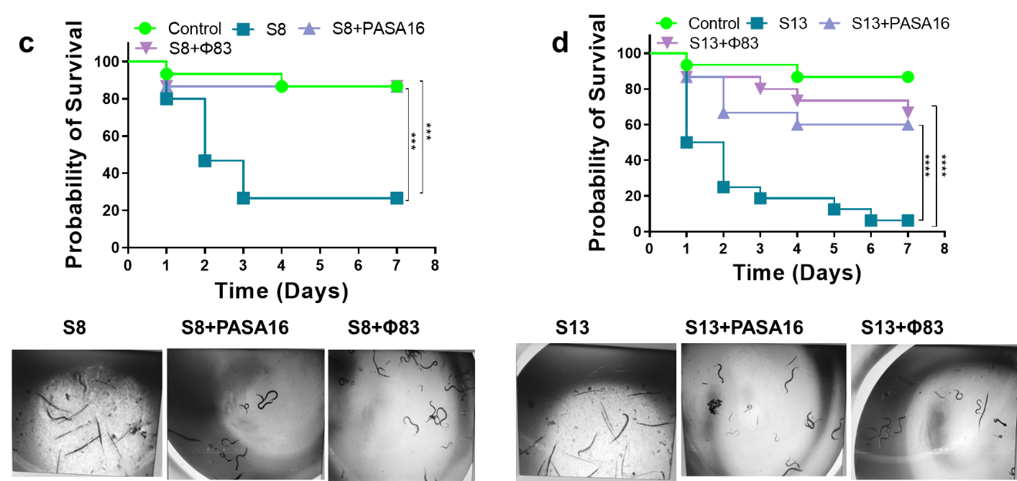

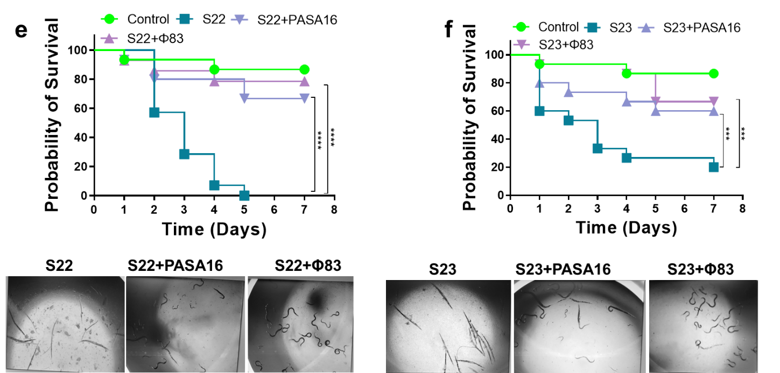

Supplementary Figure 3. Phage therapy in C. elegans infected with patient isolates. Patient isolates were tested for their virulence in C. elegans infection model. The control group consisted of C. elegans feed with E. coli OP50 and patient isolates (P. aeruginosa) was used to kill C. elegans and the survival was followed up to 7 days. Untreated strain was used as a reference strain (>90% killing at 7 days p.i.). Fifteen nematodes were used in each group. Bacteria and phage ratio MOI of 1:100, i.e., 10⁵ CFU/mL and 10⁷ PFU/mL were used for the experiment. a, b Survival curves of C. elegans infected with pre-phage isolate S1, S2 and treated with PASA16 and Φ83. c, d Mid-phage treated isolates S8 and S13 treated with PASA16 and Φ83. e, f Survival curves of C. elegans infected with post phage treated samples S22, S23 and treated with PASA16 and Φ83. The survival curves were plotted using the Kaplan-Meier method, and the log-rank test was used to analyze the difference in survival rates using GraphPad Prism 9.5.

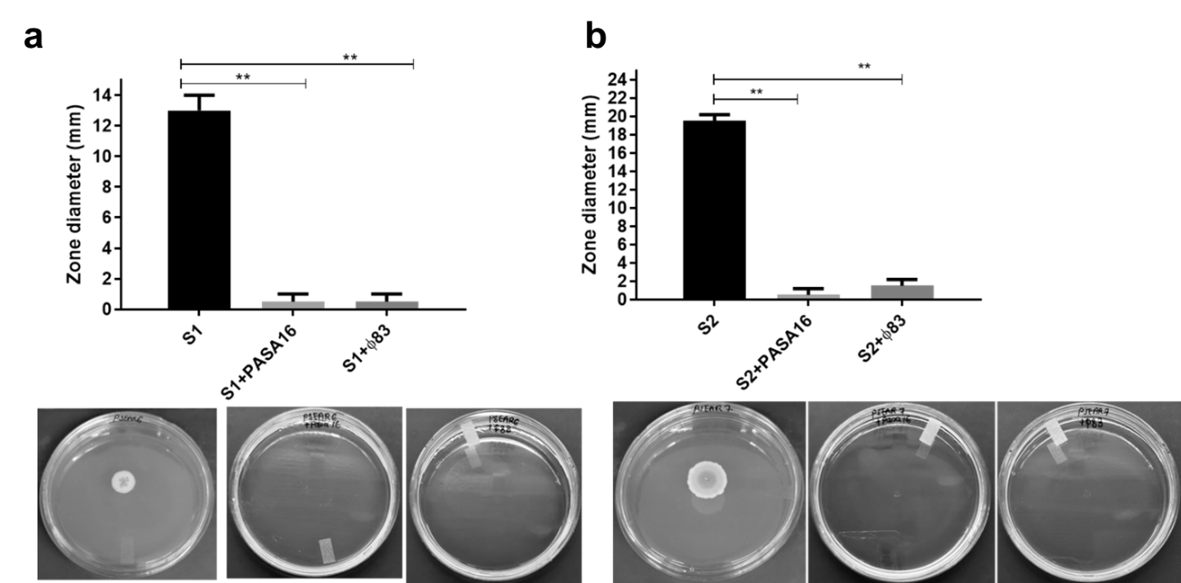

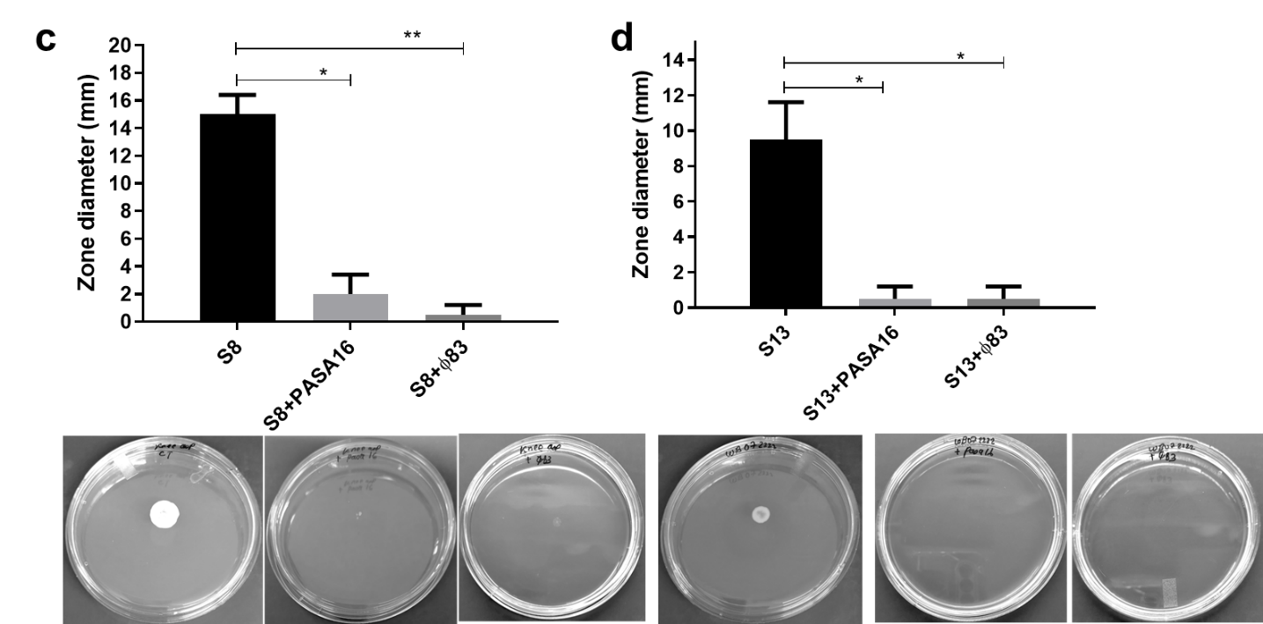

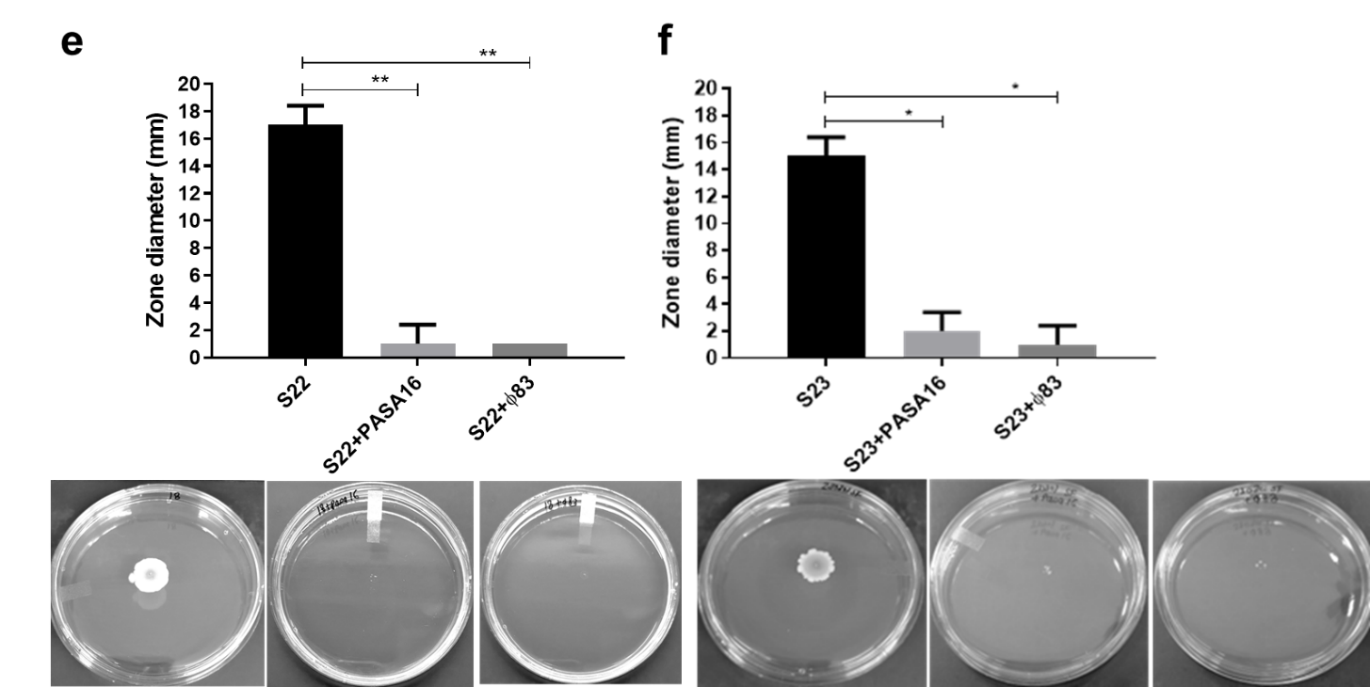

Supplementary Figure 4. Bacteriophage inhibits swarming motility in P. aeruginosa clinical isolates. a, Pre-phage isolates S1, S2 treated with bacteriophage PASA16, Φ83 and swarming motility were analysed after 16 to 18 h of growth at 37°C and zone diameter was measured in millimetres. Images were taken and compared post-phage treatment. (c, d) Mid-treatment isolates S8 and S13 treated with bacteriophage PASA16, Φ83 and swarming motility were analysed. Images were taken and compared post-phage treatment. (e, f) Long-term treatment isolates S22 and S23 treated with bacteriophage PASA16, Φ83 and swarming motility were analysed. Images were taken and compared post-phage treatment. All the experiments were performed in replicates and asterisks indicate significant differences between the means and the control at P < 0.05 by analysis of variance followed by unpaired t-test using GraphPad Prism 9.5.

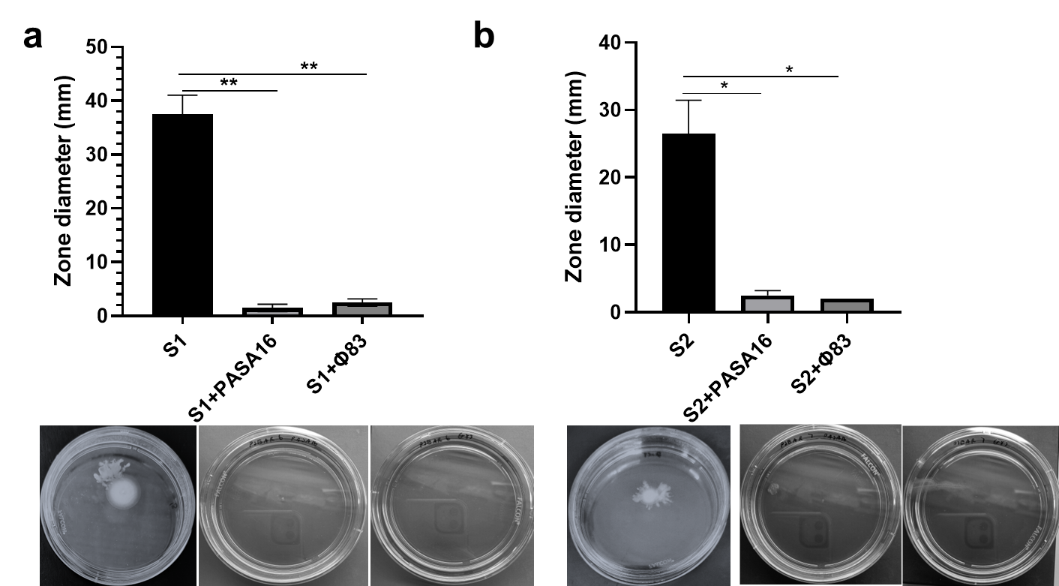
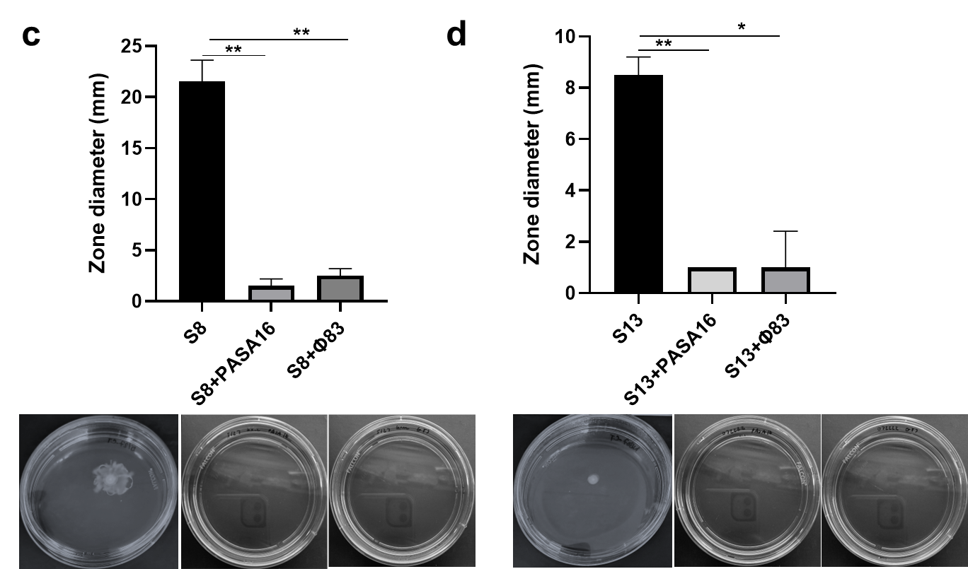
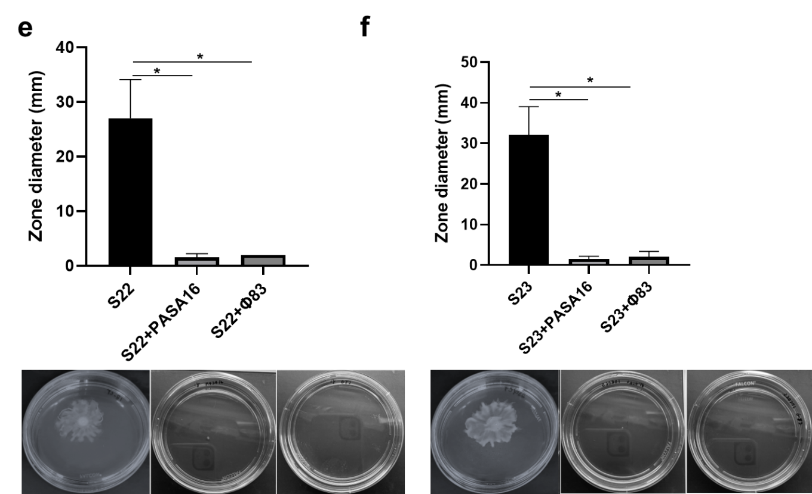
Supplementary Figure 5. Bacteriophage inhibits swimming motility in P. aeruginosa clinical isolates. a, Pre-phage isolates S1, S2 treated with bacteriophage PASA16, Φ83 and swimming motility were analysed after 16 to 18 h of growth at 37°C and zone diameter was measured in millimetres. Images were taken and compared post-phage treatment. (c, d) Mid-treatment isolates S8 and S13 treated with bacteriophage PASA16, Φ83 and swimming motility were analysed. Images were taken and compared post-phage treatment. (e, f) Long-term treatment isolates S22 and S23 treated with bacteriophage PASA16, Φ83 and swimming motility were analysed. Images were taken and compared post-phage treatment. All the experiments were performed in replicates and asterisks indicate significant differences between the means and the control at P < 0.05 by analysis of variance followed by unpaired t-test using GraphPad Prism 9.5.

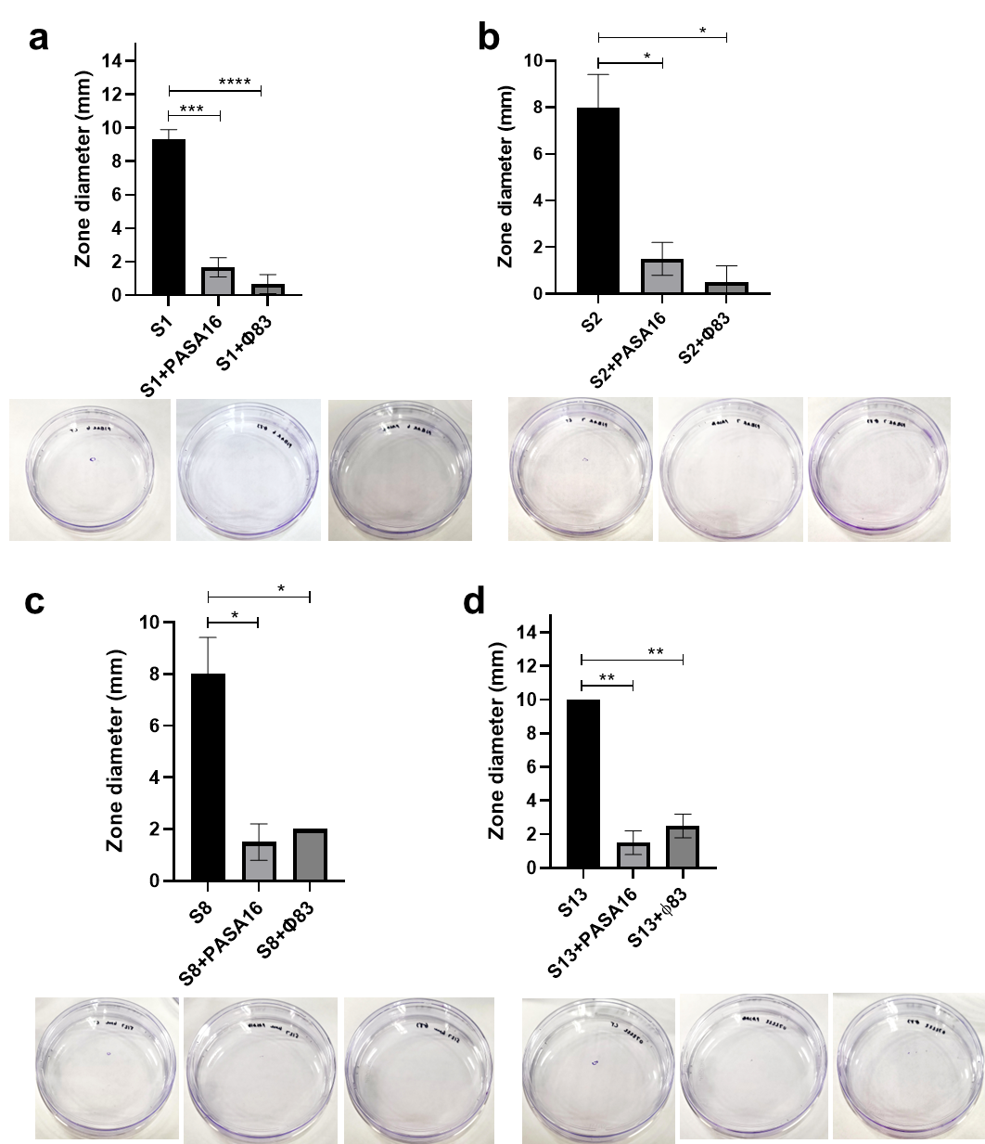

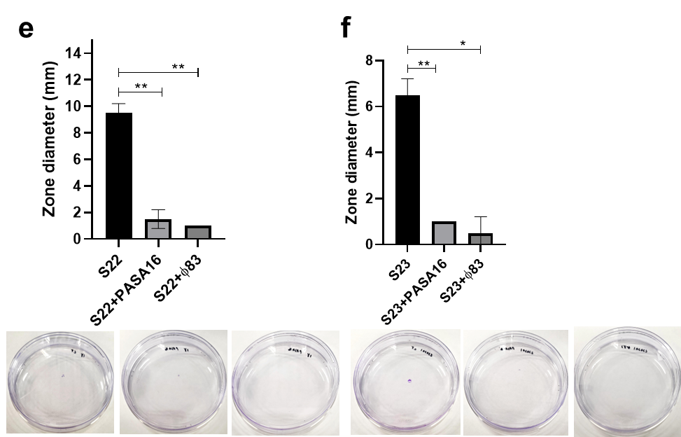
Supplementary Figure 6. Bacteriophage inhibits twitching motility in P. aeruginosa clinical isolates. (a, b) Pre-phage isolates S1 and S2 treated with bacteriophage PASA16, Φ83 and twitching motility were analyzed after 16 to 18 h of growth at 37°C and strained with crystal violet (CV) and zone diameter was measured in millimetres (mm). Images were taken and compared post-phage treatment. (c, d) Mid-treatment isolates S8 and S13 treated with bacteriophage PASA16, Φ83 and twitching motility were analyzed. Images were taken and compared post-phage treatment. (e, f) Long-term treatment isolates S22 and S23 treated with bacteriophage PASA16, Φ83 and twitching motility were analyzed. Images were taken and compared post-phage treatment. All the experiments were performed in replicates and asterisks indicate significant differences between the means and the control at P < 0.05 by analysis of variance followed by unpaired t-test using GraphPad Prism 9.5.

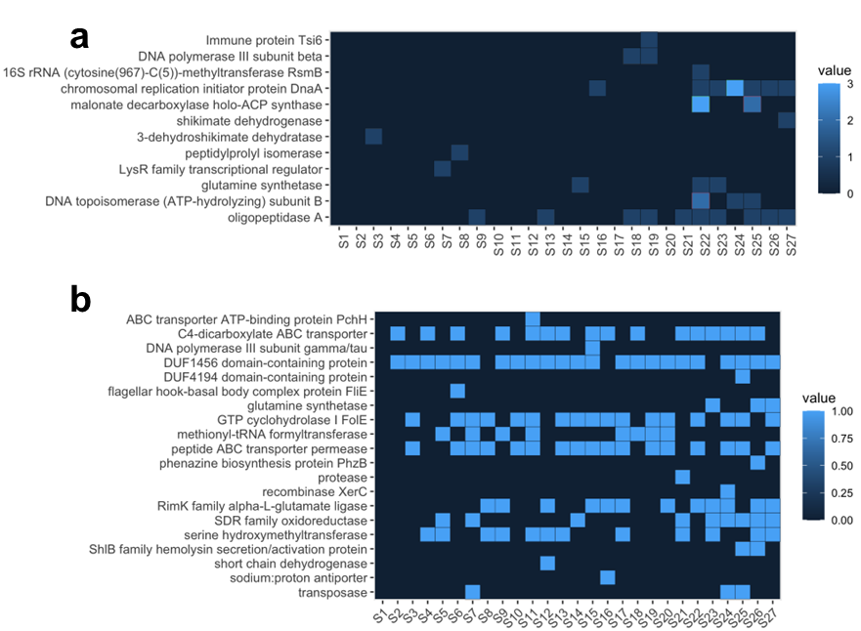

Supplementary Figure 7. Genotypic characterization of P. aeruginosa patient isolates. a, Heatmap showing the number of mutations incurred per gene in each of the 27 sequenced isolates. Each row in the heatmap corresponds to a gene, while each column corresponds to a sequentially isolated Pseudomonas. b, Presence-absence matrix showing gene deletions and pseudogenes across the 27 Pseudomonas isolates pre- and post-phage infection. Gene deletions were inferred based on the absence of a gene that’s present in the first Pseudomonas isolate. Pseudogenes were inferred based on the presence of one or more mutations that results in frameshifts affecting greater than 10% of the resulting proteins sequence, in addition to an increased rate of nonsynonymous mutations, compared to synonymous mutations (dN/dS > 0.2).

Supplementary Information
A 96-year-old male with multiple comorbidities including aortic stenosis, diastolic heart failure, Parkinson's disease, and Factor V Leiden, presented with a chronic Pseudomonas aeruginosa infection and complex hardware in both the hip and ipsilateral knee. Past medical and surgical history demonstrated a chronic infection with multiple surgeries and extended use of intravenous (IV) antibiotics (Fig. 1a). Bilateral total knee arthroplasties were performed 20 years previously, followed by staged bilateral total hip arthroplasties 15 years previously. The patient’s course was complicated by aseptic loosening requiring revision left total hip arthroplasty more than a decade prior to presentation. One year before the initial infection, the patient sustained a periprosthetic femur fracture status post-open reduction internal fixation with a plate that extended from the greater trochanter to the distal femur (Fig. 1b-e).
A chronic P. aeruginosa PJI of the knee and ipsilateral hip developed. The patient was diagnosed with a left total knee arthroplasty Pseudomonas acute PJI three years prior to initial presentation, and treated with a debridement and antibiotics with implant retention (DAIR) with 6 weeks of IV piperacillin-tazobactam followed by chronic suppressive antibiotic treatment with oral ciprofloxacin. Approximately 1 year later, he was then diagnosed with PJI of the ipsilateral hip caused by quinolone-sensitive Pseudomonas aeruginosa (Fig. 1f, g). Concordant synovial fluid cultures obtained from left knee arthroplasty showed that his original Pseudomonas aeruginosa isolates were now fluoroquinolone-resistant. He underwent a second DAIR of both the left knee and hip with intravenous piperacillin-tazobactam therapy. Chronic suppression was no longer feasible given the bacteria isolated from his knee arthroplasty were resistant to all oral antibiotic options. There were multiple attempts to discontinue intravenous antibiotics but this resulted in symptomatic infection. A draining sinus then developed at the left knee arthroplasty, and a third and fourth set of DAIR procedures were completed. Unfortunately, each time intravenous antibiotics were discontinued, the patient developed either worsening of his draining sinus, a painful joint, and/or concerns for sepsis. During each of these recurrences and multiple surgical interventions, the cultures continued to be positive for MDR Pseudomonas.
Combination Treatment with DAIR and Bacteriophage Therapy
The patient presented to our institution approximately 2 years after the initial PJI diagnosis with a MDR Pseudomonas PJI and complex implants with limited treatment options. Comorbidities and risk factors included the patient’s advanced age, aortic stenosis, diastolic heart failure, Parkinson's disease, and Factor V Leiden complicated by thromboembolic disease. Given limited treatment options, FDA-expanded access was obtained to start bacteriophage therapy. Cultures were obtained and two bacteriophages (PASA16 and Φ83)^{1,2} (Adaptive Phage Therapeutics (APT), Bethesda, MD) were identified with planktonic and biofilm activity against the P. aeruginosa clinical isolate tested. Titers of phages used were 4.7 x 10¹⁰ plaque-forming units (PFU)/mL (PASA16) and 7.5 x 10⁹ PFU/mL (Φ83) were selected largely based on limiting endotoxin exposure. The intraarticular dosing with a total volume of 10mL and intravenous delivery with a total volume of 50mL were used. A DAIR of the left total hip arthroplasty (THA) and total knee arthroplasty (TKA) was completed using standard technique³. A combination of a single intra-articular dose at the time of surgery and one week of daily intravenous dosing was then administered. Antibiotic therapy was initiated with IV cefepime and then IV piperacillin-tazobactam secondary to the development of side effects on the former antibiotic for a combined total of 6 weeks based on intraoperative sensitivities.

Supplementary Table 1. Determination of cell count and inflammatory markers in patient post-phage treatment.

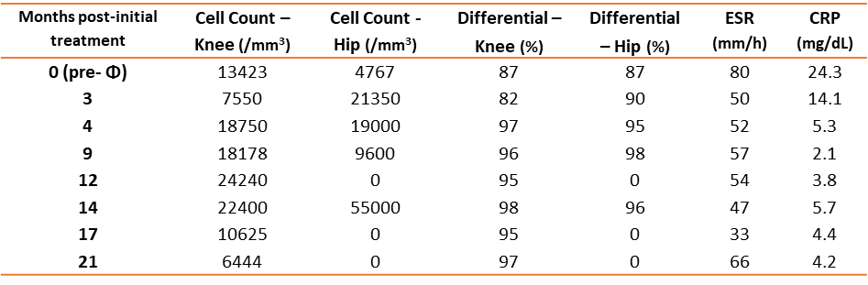

Supplementary Table 2. PASA16 and Φ83 showed bacteriolytic activity on the host strain (C10) and the patient’s MDR P. aeruginosa isolates.

Phagogram of PASA16 and Φ83 on patient strains.
Patient samples | PASA16 | Φ83
Host strain (C10) | 6.0x10¹¹ | 2.1x10¹⁰
S1 | 6.0x10⁷ | 4.0x10⁷
S2 | 1.2x10⁸ | 4.0x10⁷
S8 | 4.0x10⁷ | 2.0x10⁸
S13 | 2.1x10⁷ | 2.3x10⁸
S22 | 4.0x10⁷ | 2.0x10⁶
S23 | 4.0x10⁷ | 6.2x10⁷

Supplementary Table 3. Clinical isolates and their antibiotic resistance pattern.
Clinical isolate/  Antibiotic resistance | Aminoglycoside |  |  | Β-lactamase |  | Cephalosporin |  | Fluoroquinolone |  | Carbapenem
Clinical isolate/  Antibiotic resistance | Amikacin | Gentamicin | Tobramycin | Aztreonam | Piperacillin/  Tazobactam | Cefepime | Ceftazidime | Levofloxacin | Ciprofloxacin | Meropenem
S1
S2
S3
S4
S5
S6
S7
S8
S9
S10
S11
S12
S13
S14
S15
S16
S17
S18
S19
S20
S21
S22
S23
S24
S25
S26
S27

References
- Onallah, H., et al. Refractory Pseudomonas aeruginosa infections treated with phage PASA16: A compassionate use case series. 4, 600-611. e604 (2023).
- Viazis, S., Akhtar, M., Feirtag, J., Brabban, A. & Diez‐Gonzalez, F.J.J.o.A.M. Isolation and characterization of lytic bacteriophages against enterohaemorrhagic Escherichia coli. 110, 1323-1331 (2011).
- Shah, N.B., et al. Benefits and adverse events associated with extended antibiotic use in total knee arthroplasty periprosthetic joint infection. 70, 559-565 (2020).

