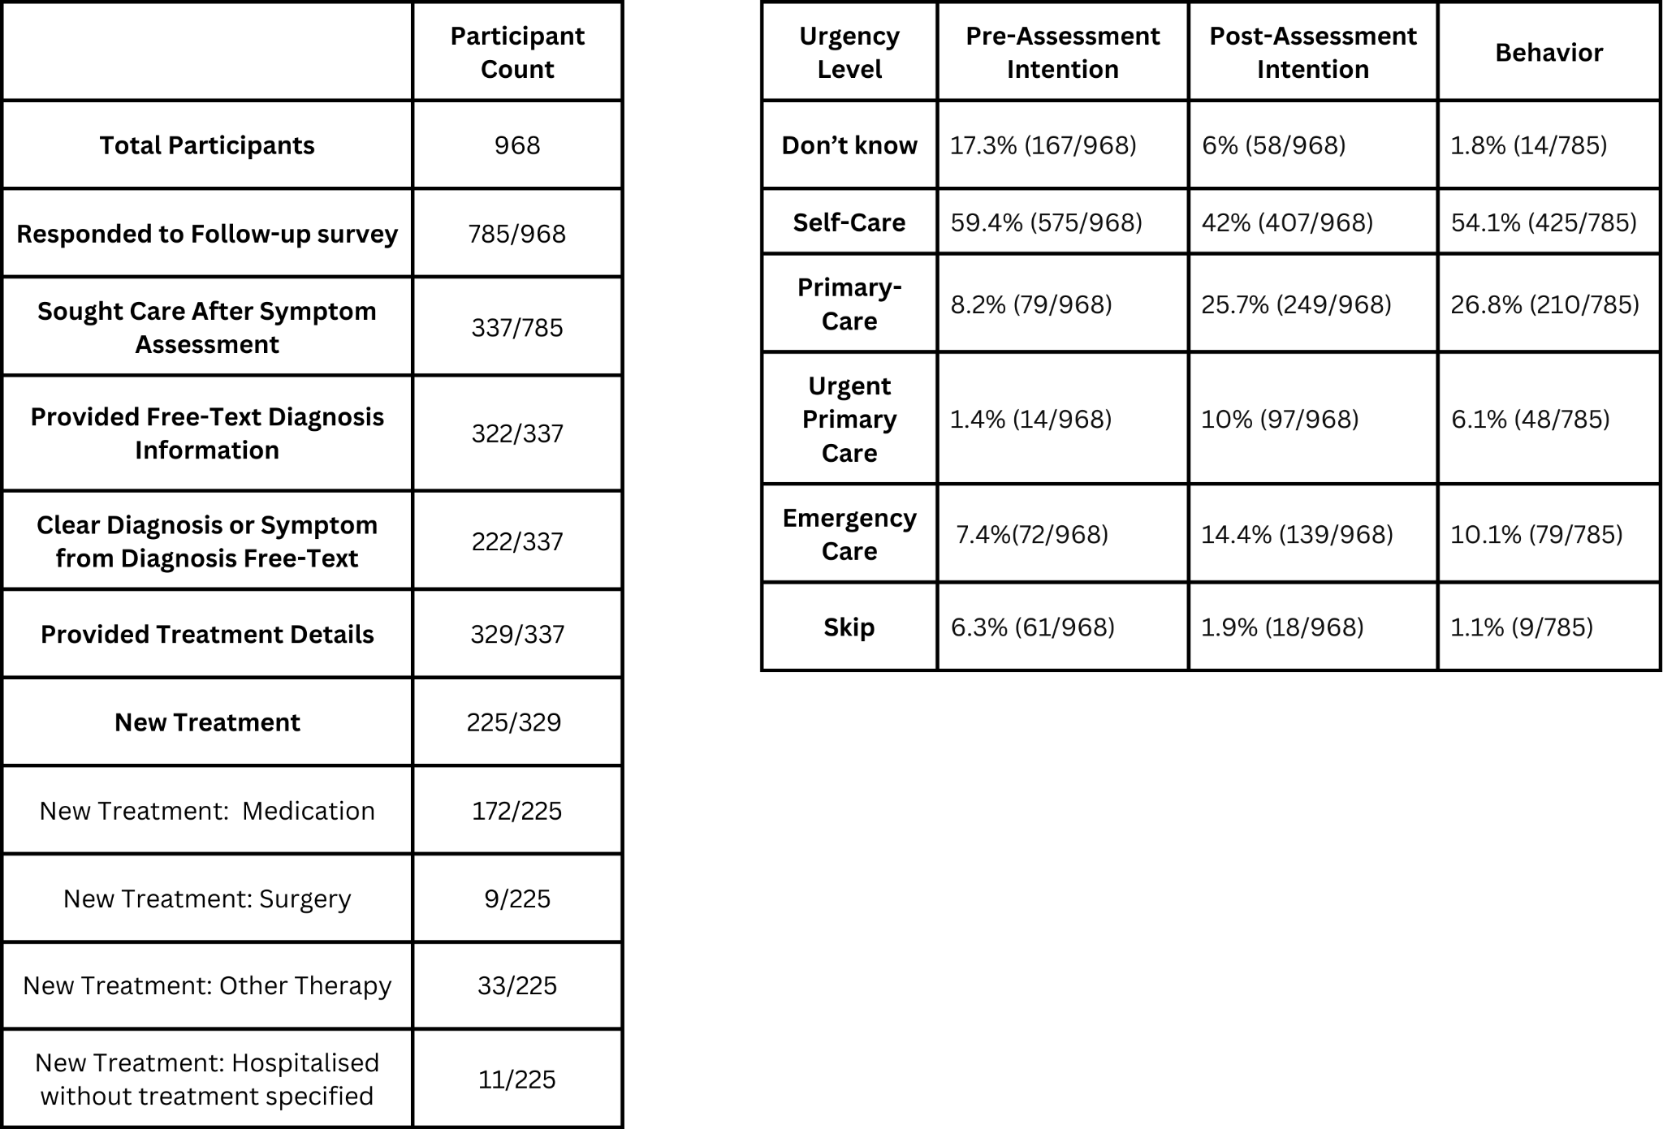
Table 2. Participants' healthcare intentions before and after the symptom assessment, one week later, and the treatments received

