Supplementary Information
Periodic One-Dimensional Subsurface Channels Induced by Ordered Oxygen Vacancies on CeO₂ (110)

Guanxing Li^{1,2,3}, Xiaojuan Hu^{1,3}, Chen Zou¹, Songda Li¹, Zhong-Kang Han^{1*}, Wentao Yuan^{1*}, Ze Zhang¹, Yong Wang^{1*}

¹Center of Electron Microscopy and State Key Laboratory of Silicon Materials, School of Materials Science and Engineering, Zhejiang University, Hangzhou, 310027, China.
²Current Address: School of Applied and Engineering Physics, Cornell University, Ithaca, NY 14853, USA
³These authors contributed equally.
Correspondence Email: hanzk@zju.edu.cn; wentao_yuan@zju.edu.cn; yongwang@zju.edu.cn;

This Supplementary Information file includes:

Materials and methods
Fig. S1 – S3
Table S1

Materials and methods
Sample preparation
The CeO₂ nanoparticles used in our experiments were prepared through a hydrothermal method¹. Typically, 0.868 g of Ce(NO₃)₃·6H₂O (analytical purity, Macklin) was dissolved in 5 mL of deionized water, then 8.40 g of NaOH was dissolved in 35 mL of deionized water. Next, the two solutions were mixed and stirred for 30 min, and then transferred to a Teflon bottle and sealed into a hydrothermal reactor (50 mL). After heated at 180 ℃ for 24 h, the precipitates were obtained by centrifugation, followed by washing with deionized water and ethanol for several times. Last, the as-synthesized products were dried at 60 ℃ in air for 12 h.

Sample characterization
The scanning transmission electron microscopy (STEM) characterizations were performed on an FEI Titan G2 80-200 ChemiSTEM microscope (200 kV), equipped with a spherical aberration corrector, which could provide a spatial resolution of ~0.8 Å. The convergence semi-angle was set to ~21 mrad and the screen beam current was ~0.6 nA. The low-order aberrations were adjusted to an acceptable level: Cs < 0.5 μm, A1 < 2 nm, A2 < 20 nm, B2 < 20 nm.

A double tilt heating holder (DENSsolutions, Wildfire D6) and the SiN_{x} heating chips were used in the in-situ heating process. We heated the sample to 900 ℃ by a rate of ~5 ℃/s and kept for 5 minutes under the e-beam blanking before acquiring images. To minimize the effect of e-beam, we calibrated the instrument beside our interested area and only moved to illuminate it when taking images. No notable electron beam damage was found on the samples during the whole characterization process.

Computational details
All density functional theory (DFT) calculations were performed using the VASP (Vienna Ab-initio Simulation Package) code^{2,3}. The spin-polarized DFT+U methodology^{4,5} was applied in combination with the generalized gradient approximation (GGA) of Perdew-Burke-Ernzerhof (PBE)⁶. A U-value of 5.0 eV, which is within the appropriate range for reduced ceria-based systems⁷, was selected to account for the localized electrons associated with Ce³⁺ ions. The projector augmented wave (PAW) potentials² were employed, incorporating Ce (4f, 5s, 5p, 5d, 6s) and O (2s, 2p) electrons as valence states, with a plane-wave cutoff set at 400 eV. The CeO₂ (110) surface was represented by a slab model consisting of seven atomic layers. For simulations of the CeO₂ (110) surface without any oxygen vacancies, a 3×4 supercell was employed, comprising 252 atoms. A vacuum space of 18 Å was introduced to prevent interactions with its periodic replicas. In the process of geometry optimization, the bottom two layers were kept fixed, allowing the remaining atoms in the supercell to relax. A 1×1×1 gamma-point-centered k-points mesh was used. Geometries were optimized until total energy differences and atomic force convergence criteria fell below 10⁻⁴ eV and 0.05 eV/Å, respectively.

To obtain distinct configurations of the reduced Ce³⁺ sites, a two-step relaxation procedure was employed. Initially, selected Ce⁴⁺ ions were substituted with Ce³⁺ ions, employing PAW potentials where the 4f¹ state was shifted to the core, accompanied by non-spin polarized calculations. The resulting relaxed structure was further optimized using the standard Ce⁴⁺ PAW potentials and spin-DFT.

The formation energy (Ef) of SVs on the CeO₂ (110) surface was computed using the equation:
$$Ef=E_{CeO_{2}-Vos}+n∙\frac{1}{2}∙E_{O_{2}}-E_{CeO_{2}}$$
where E_{CeO2-Vos}​ represents the energy of the CeO₂ (110) surface with Vos, n is the number of vacancies, E_{O2} ​is the energy of an O₂ molecule, and E_{CeO2} ​is the energy of the pristine CeO₂ (110) surface. Using CE model, the formation energy (Es) for any configuration can be calculated with the equation:
$$E_{s}=\sum_{α}{m_{α}J_{α}X_{sα}}$$
where the summation is performed over all symmetrically inequivalent interactions (clusters), denoted as 0, 1, 2, …, n-body clusters. The term m_{α} represents the multiplicities, indicating the number of clusters that are equivalent by symmetry to cluster α. J_{α} represents the effective cluster interactions (ECIs), and X_{sα} represents the correlations, which is the probability of finding the cluster α in the configuration s. The ECIs are determined by fitting the predicted energies to the calculated DFT energies of the structures in the training data set. Here, the least absolute shrinkage and selection operator (LASSO) approach⁸ are employed to avoid overfitting and select the optimal cluster set. In this approach, the objective function minimized is:
$$η={\left\|E_{predicted}\left(J_{α}\right)-E_{calculated}\right\|}_{2}^{2}+λ{\left\|J_{α}\right\|}_{1}$$
Here, the first term represents the mean square error between the predicted and calculated energies, and the second term is the l₁ regularization term. The hyperparameter λ is obtained by minimizing a leave-one-out cross-validation error.

The CE is carried out utilizing the CELL code [http://sol.physik.hu-berlin.de/cell], which facilitates an iterative compressed sensing-based cluster expansion workflow, as detailed in references^{9–11}. Canonical Metropolis Monte Carlo (MC) samplings are performed to obtain the distribution of Vos and Ce³⁺ across the top three atomic layers of the CeO₂ (110) surface.

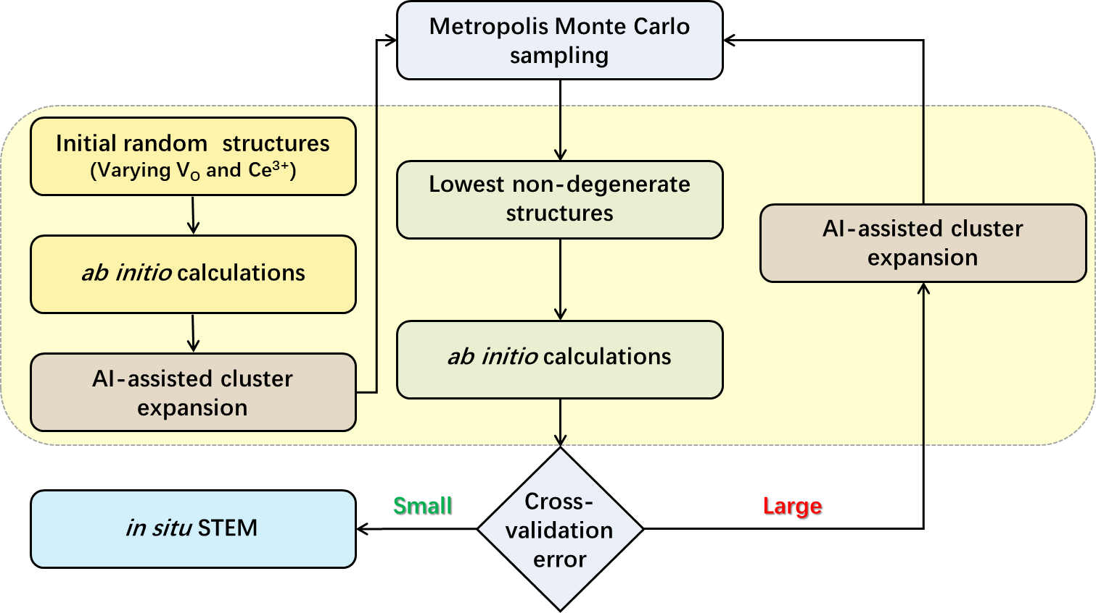

Fig. S1 A flowchart of the methodology employed in the structure searching process. It includes the random structure generation, ab initio calculations, and cluster-expansion modeling, followed by Metropolis Monte Carlo sampling for finding the lowest non-degenerate structures. The active-learning loop that encompasses the iteratively adding low-energy structures and retraining the model is shown.

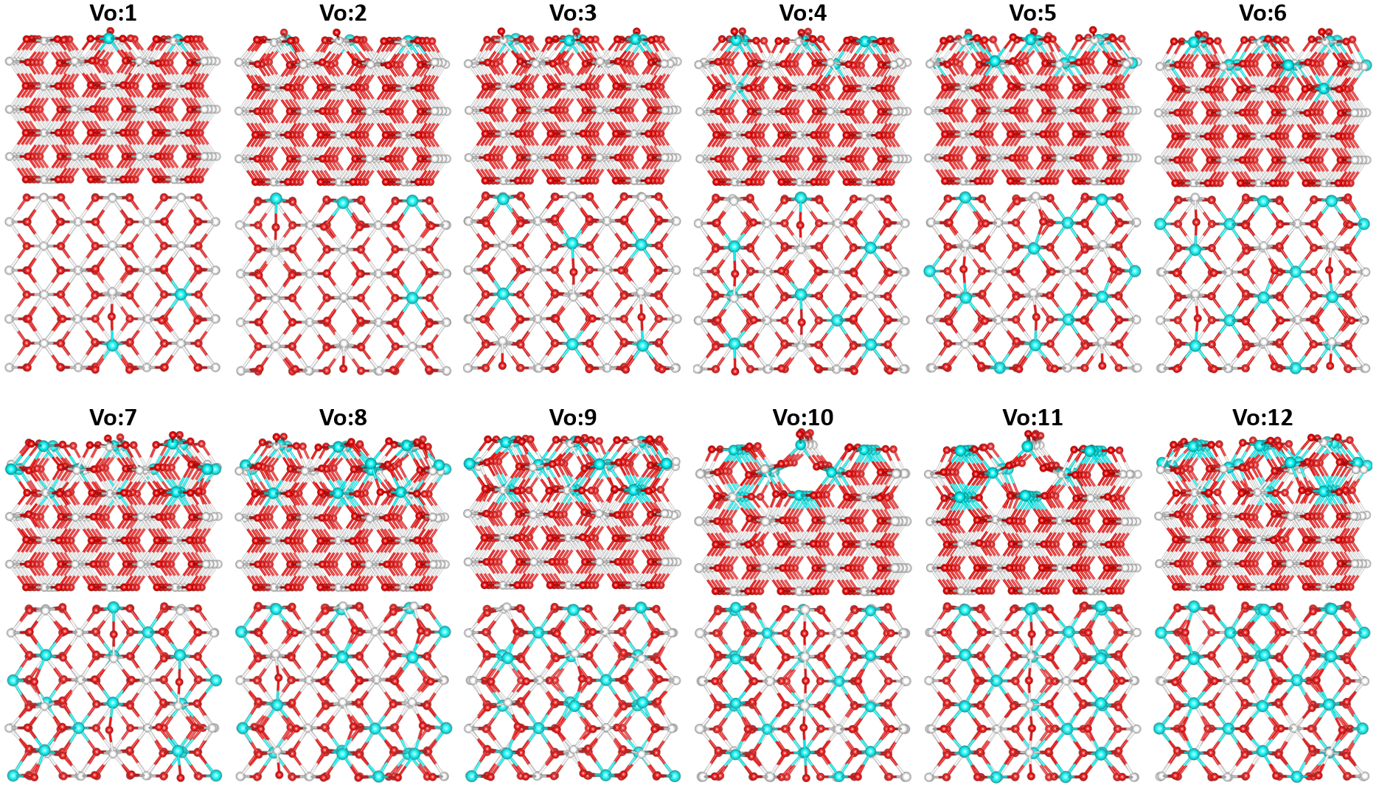

Fig.S2 Top view and side view of the most stable configurations with 1 Vo (Θ = 1/72), 2 Vo (Θ = 1/36), 3 Vo (Θ = 1/24), 4 Vo (Θ = 1/18), 5 Vo (Θ = 5/72), 6 Vo (Θ = 1/12), 7 Vo (Θ = 7/72), 8 Vo (Θ = 1/9), 9 Vo (Θ = 1/8), 10 Vo (Θ = 5/36), 11 Vo (Θ = 11/72), and 12 Vo (Θ = 1/6). Ce⁴⁺, Ce³⁺ and oxygen atoms are depicted in white, blue, and red.

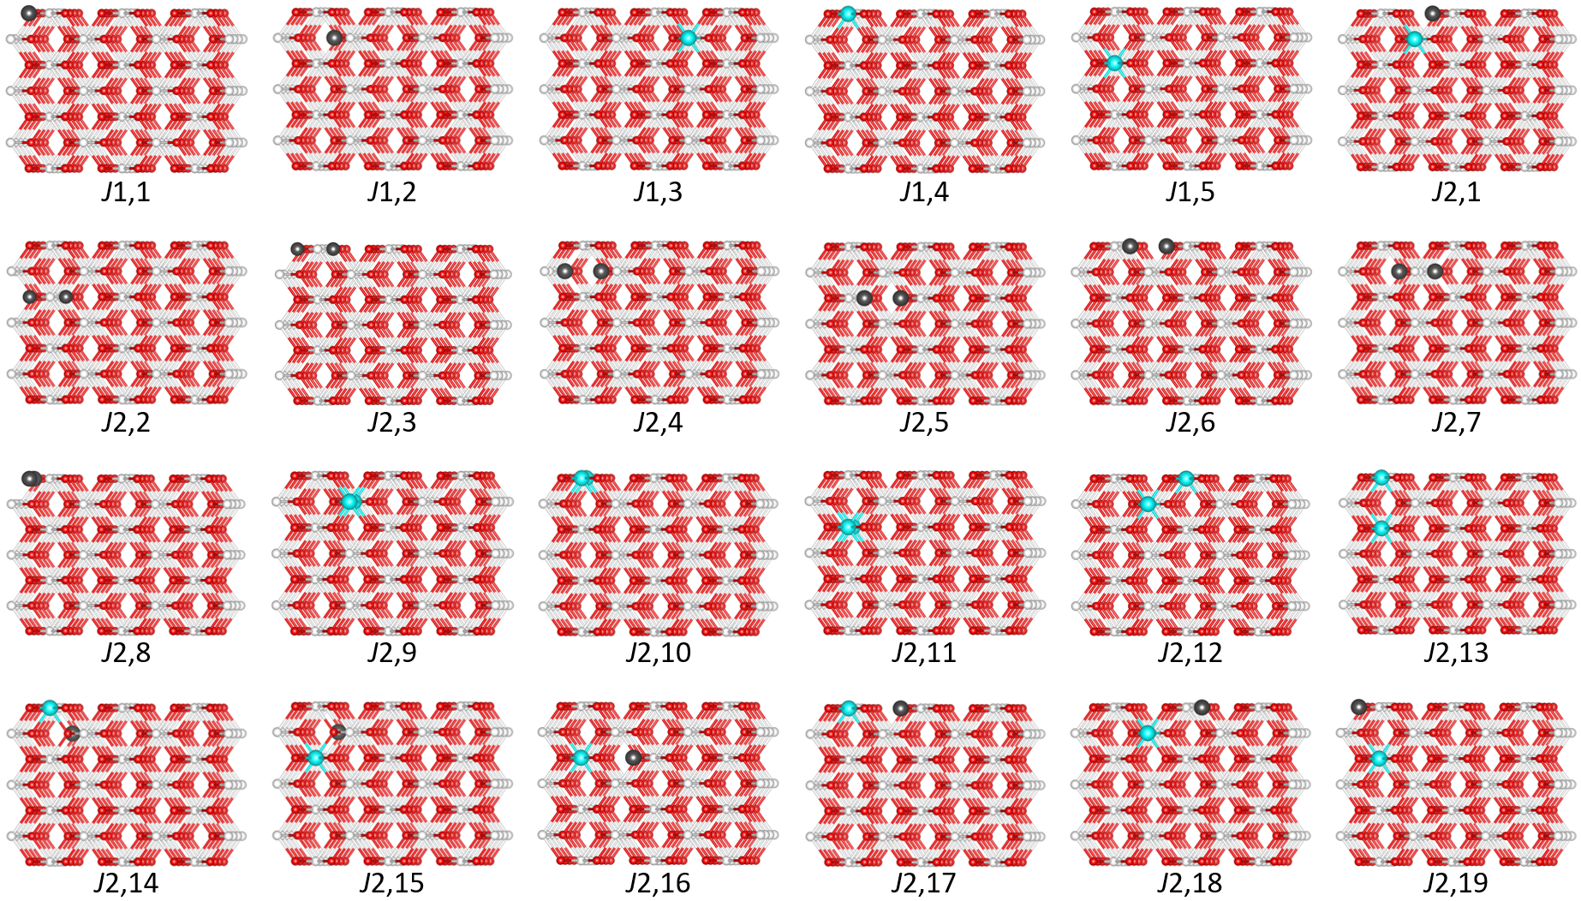
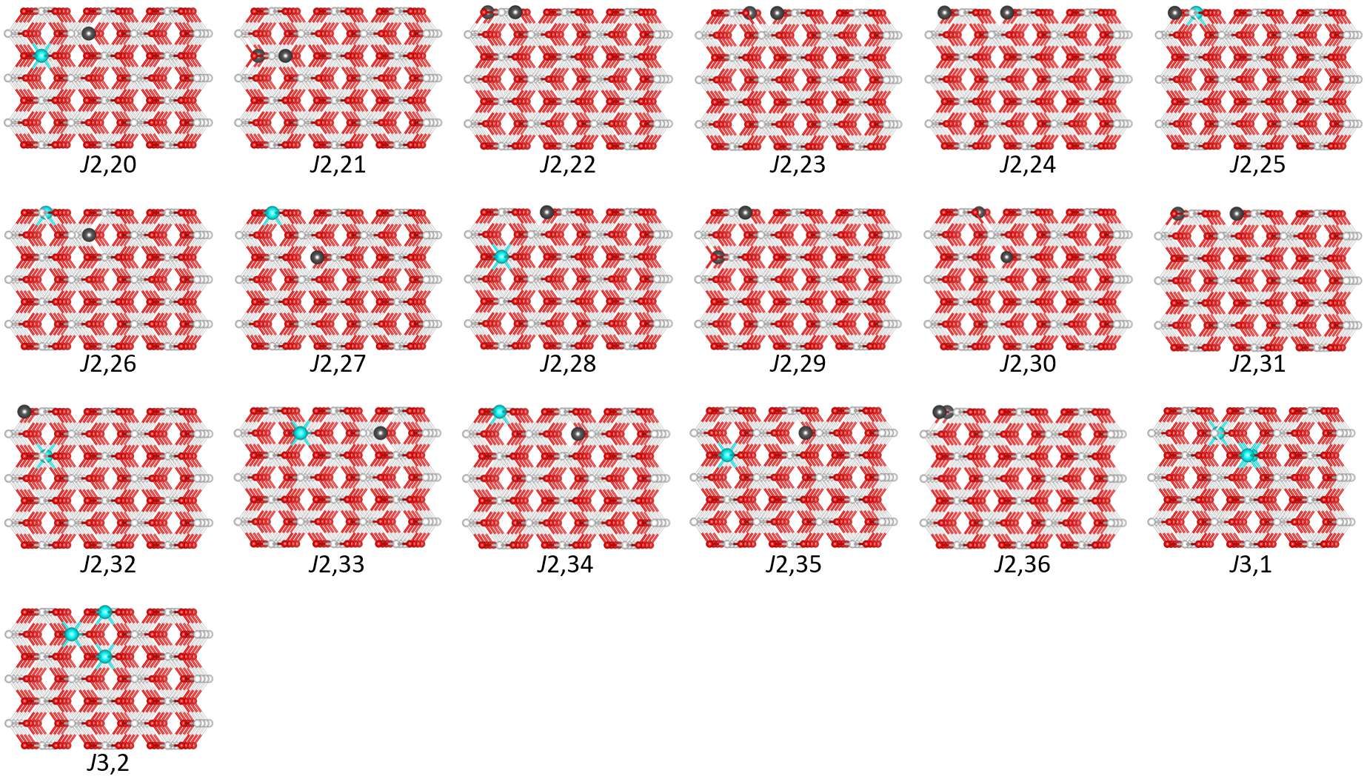

Fig.S3 One-, two- and three-point clusters selected in the final CE model. Ce⁴⁺, Ce³⁺, vacancies and oxygen atoms are depicted in white, blue, black and red.

Table S1. ECI value of each cluster in eV per atom. Positive values correspond to repulsion, and negative to attraction.
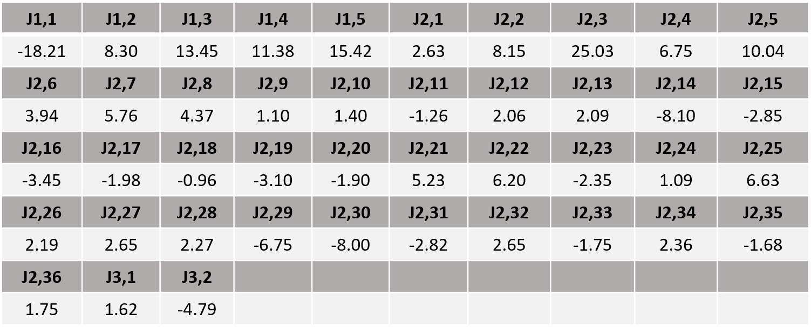

References
1. Mai, H.-X. et al. Shape-Selective Synthesis and Oxygen Storage Behavior of Ceria Nanopolyhedra, Nanorods, and Nanocubes. J. Phys. Chem. B 109, 24380–24385 (2005).
2. Kresse, G. & Joubert, D. From ultrasoft pseudopotentials to the projector augmented-wave method. Phys. Rev. B 59, 1758–1775 (1999).
3. Kresse, G. & Furthmüller, J. Efficient iterative schemes for ab initio total-energy calculations using a plane-wave basis set. Phys. Rev. B 54, 11169–11186 (1996).
4. Dudarev, S. L., Botton, G. A., Savrasov, S. Y., Humphreys, C. J. & Sutton, A. P. Electron-energy-loss spectra and the structural stability of nickel oxide: An LSDA+U study. Phys. Rev. B 57, 1505–1509 (1998).
5. Cococcioni, M. & De Gironcoli, S. Linear response approach to the calculation of the effective interaction parameters in the LDA+U method. Phys. Rev. B 71, 035105 (2005).
6. Perdew, J. P., Burke, K. & Ernzerhof, M. Generalized Gradient Approximation Made Simple. Phys. Rev. Lett. 77, 3865–3868 (1996).
7. Castleton, C. W. M., Kullgren, J. & Hermansson, K. Tuning LDA+U for electron localization and structure at oxygen vacancies in ceria. The Journal of Chemical Physics 127, 244704 (2007).
8. Hastie, T. & Tibshirani, R. Discriminant Analysis by Gaussian Mixtures. Journal of the Royal Statistical Society Series B: Statistical Methodology 58, 155–176 (1996).
9. Sarker, D., Han, Z.-K. & Levchenko, S. V. Iterative cluster expansion approach for predicting the structure evolution of mixed Ruddelsden-Popper oxides La_{2−x}Sr_{x}Ni_{1−y}Fe_{y}O_{4±δ}. Phys. Rev. Materials 7, 055802 (2023).
10. Han, Z.-K., Yang, Y.-Z., Zhu, B., Ganduglia-Pirovano, M. V. & Gao, Y. Unraveling the oxygen vacancy structures at the reduced CeO₂(111) surface. Phys. Rev. Materials 2, 035802 (2018).
11. Han, Z.-K. et al. First-principles study of Pd-alloyed Cu(111) surface in hydrogen atmosphere at realistic temperatures. Journal of Applied Physics 128, 145302 (2020).

