APPENDIX
Figure 5: ACF
The ACF for the collected hourly Relative Search Volumes (RSVs) by Pytrends, analyzed for 100 lags, reveals a periodic behaviour with a 24-hour cycle (Figure 5).
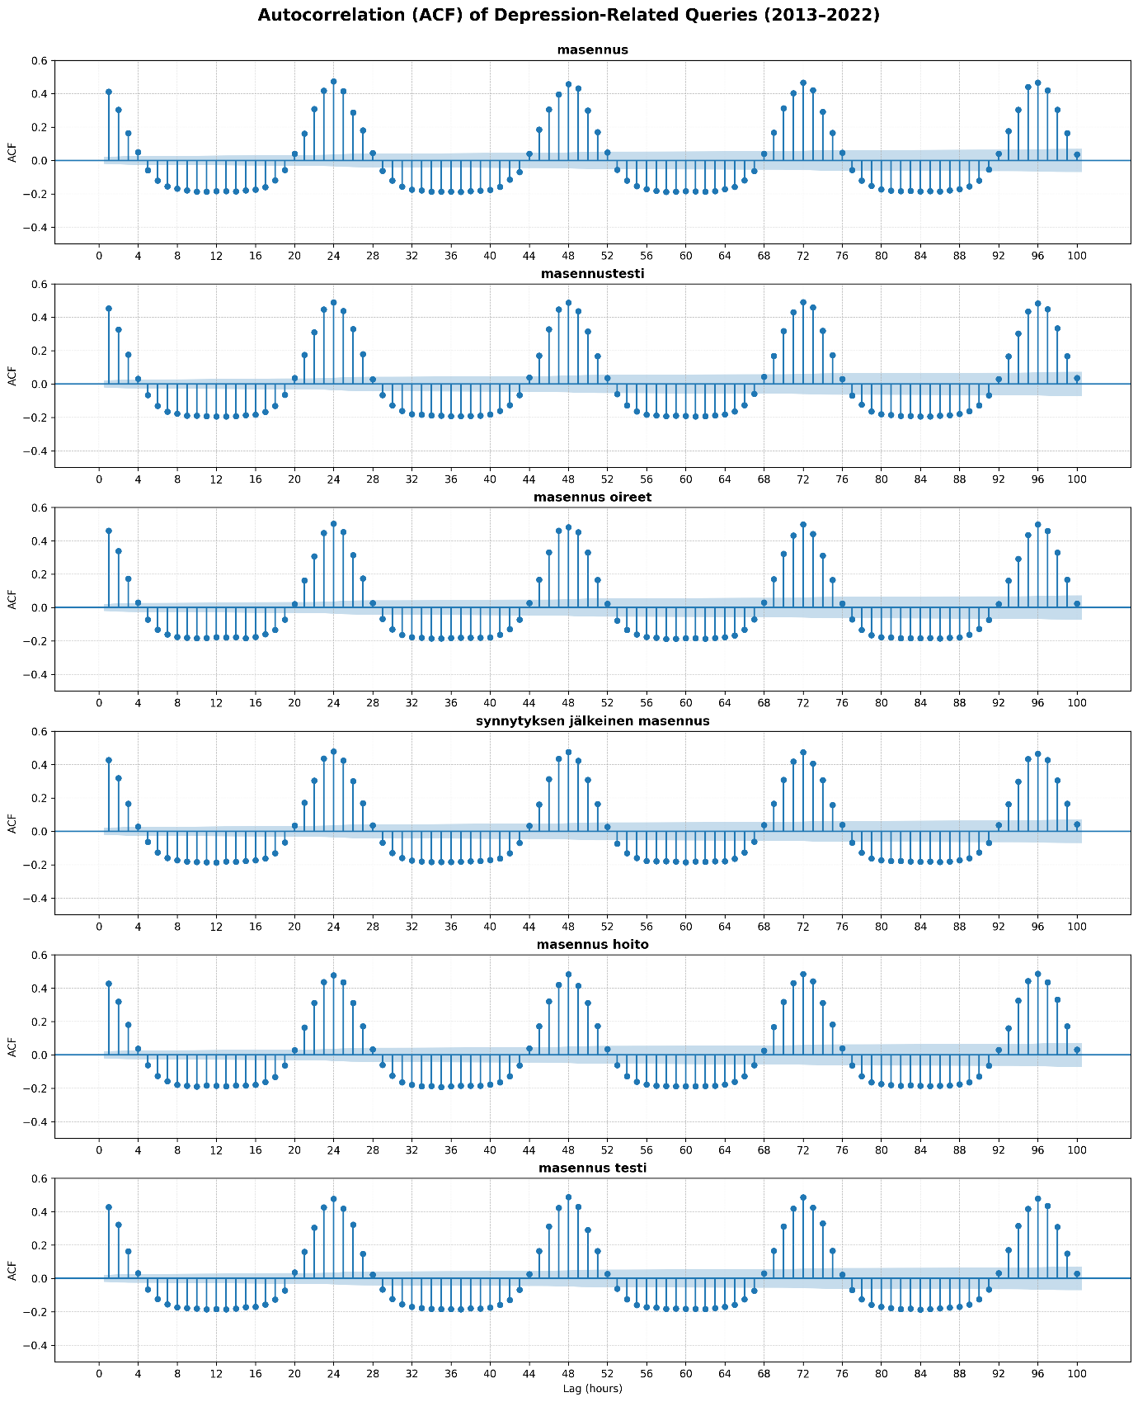
Figure 5. Autocorrelation Function (ACF) for hourly Relative Search Volumes (RSVs) collected by Pytrend, analyzed for 100 lags, revealing a periodic behaviour with a 24-hour cycle.

Figure 6: Diurnal Patterns Across Quarters
The year is divided into four quarters: the first (January–March), the second (April–June), the third (July–September), and the last (October–December). The hourly RSVs acquired via Pytrends are plotted against the hours of the day. The plots demonstrate that the most popular times for individuals to search for the terms consistently occur at night, with only slight variations across the quarters (Figure 6).
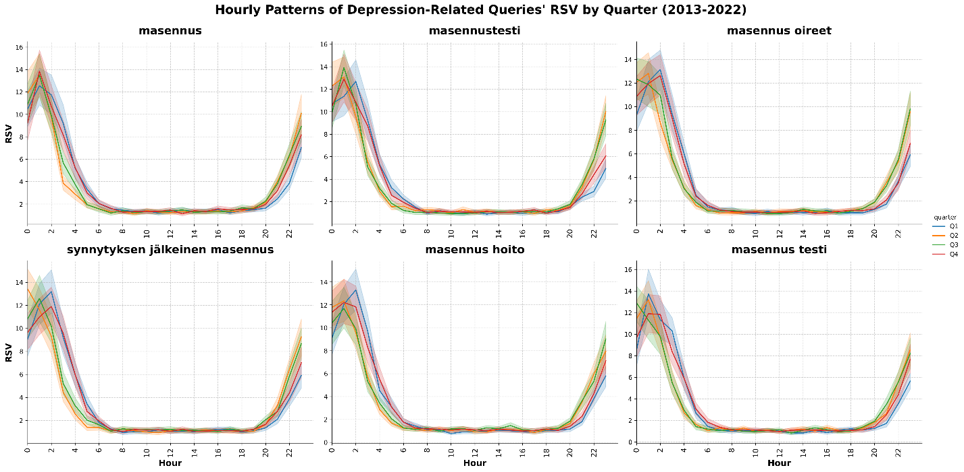
Figure 6. Hourly Relative Search Volumes (RSVs) for all four quarters of the year against hourly intervals

Figure 7: Normalized Daily Search Volumes
The normalized daily search volumes, obtained using the GHT-API for all terms, exhibit an approximately normal distribution, as illustrated in Figure 7. This indicates that the data are symmetrically distributed around the mean, with minimal skew or outliers.
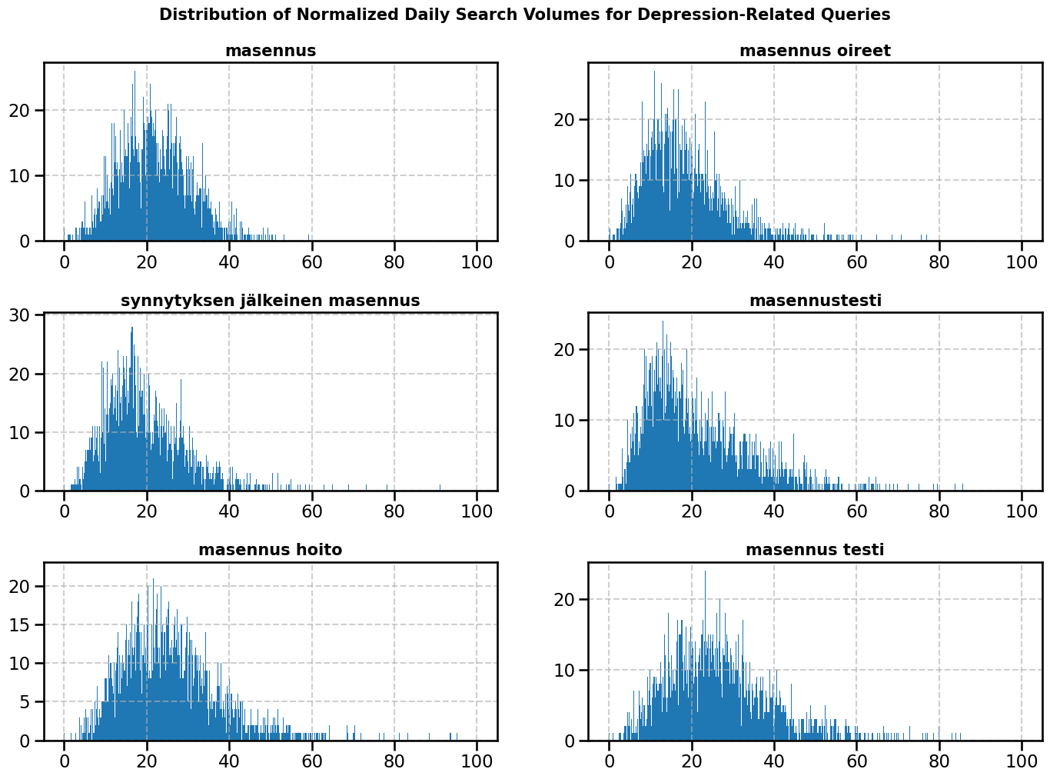
Figure 7. Histogram of daily search volume of the term queries. Histogram showing the normalized daily search volumes obtained using the GHT-API for all terms, which are approximately normally distributed.
Figure 8: Box Plot of Average Search Volumes
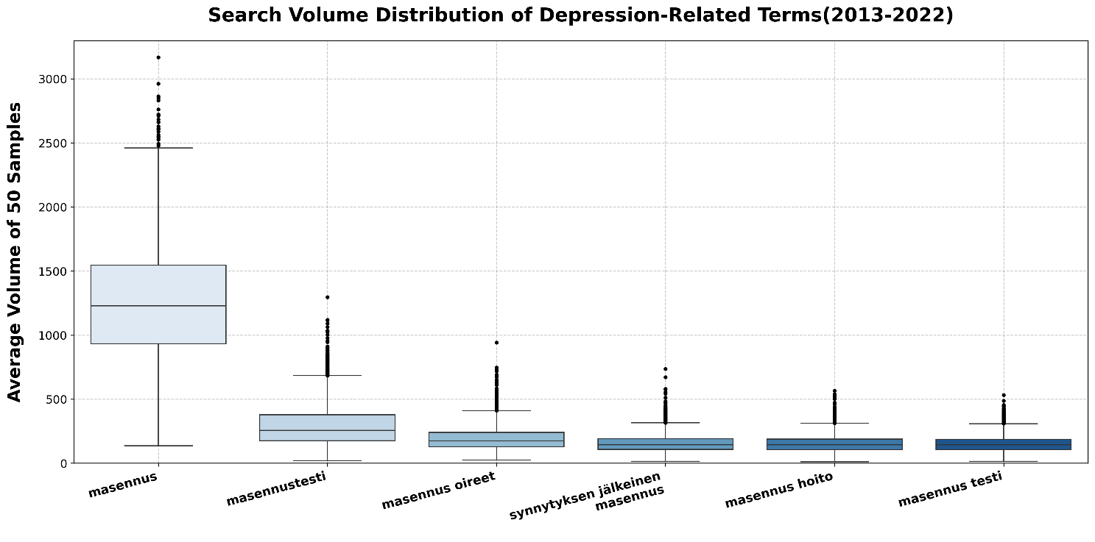
The box plot in Figure 8 depicts the average search volumes for all terms over the past 10 years. The term "masennus" has the highest mean search volume, exceeding that of the other query terms by more than four times.
Figure 8. Box plot of the average daily search volume across 50 samples for various terms.

Figure 9: Seasonal Patterns in Average Search Volumes
Seasonal patterns in the average search volumes are depicted in Figure 9. The average volume of 50 samples, calculated for each quarter and plotted against time, reveals a distinct bimodal curve for the terms "masennus" and "masennustesti," with peaks in spring and autumn and lower activity during summer.

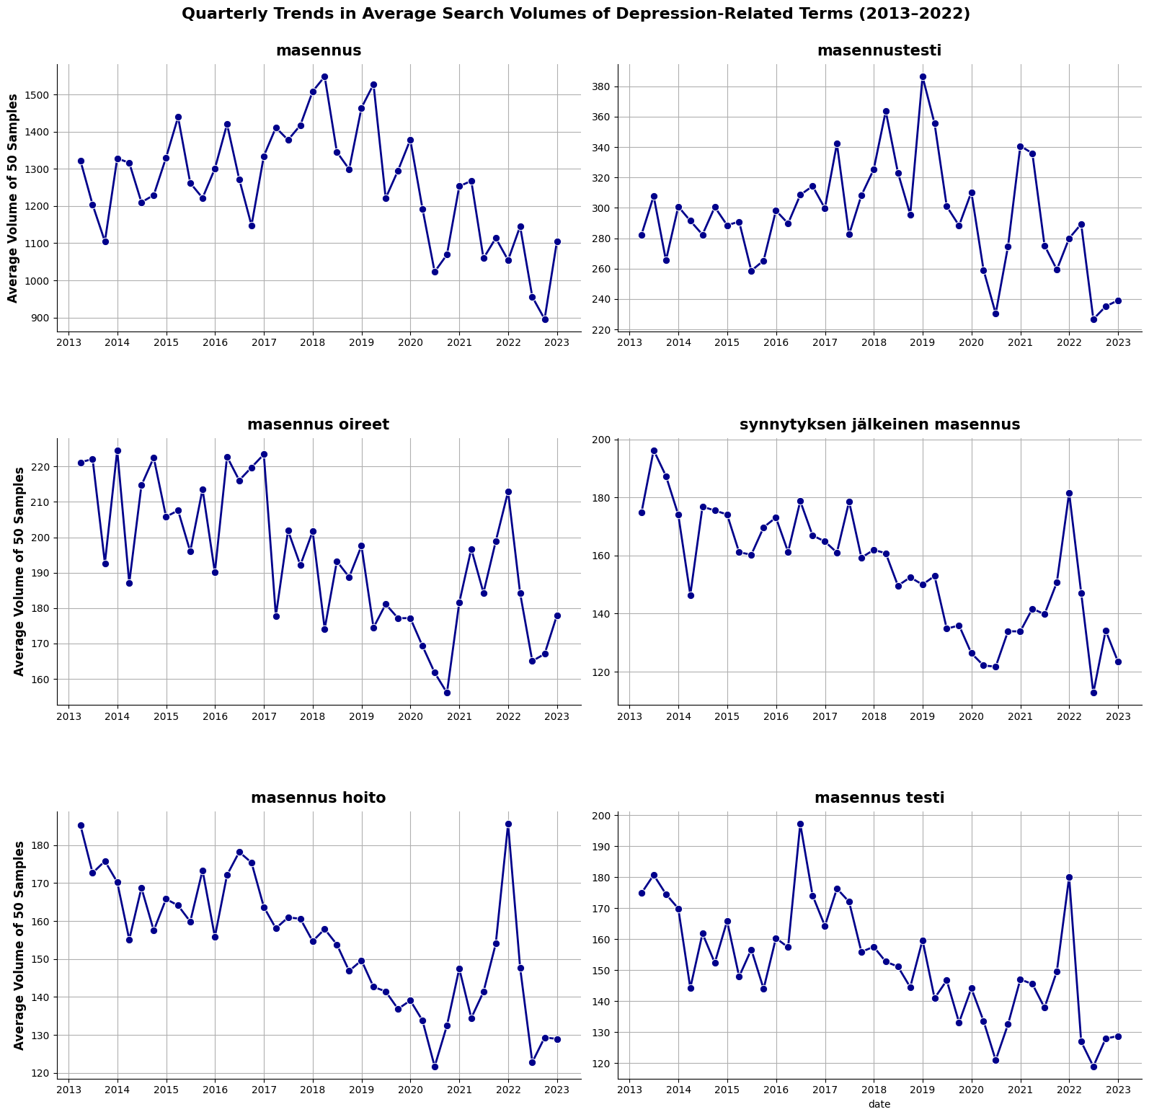
Figure 9. Seasonal patterns in average search volume: The plot shows the average volume of 50 samples, averaged for each quarter and plotted against time. The terms "masennus" and "masennustesti" notably follow a bimodal curve.

