Supplementary Information
to ‘Continental slivers in oceanic transform faults controlled by rift inheritance’
Attila Balázs^{1,*}, Taras Gerya¹ & Gábor Tari²
¹ Department of Earth and Planetary Sciences, Institute of Geophysics, Geophysical Fluid Dynamics Group, ETH Zürich, 8048 Zürich, Switzerland;
² OMV Upstream, Vienna, 1020, Austria
*Corresponding author: attila.balazs@eaps.ethz.ch

Contents:
Supplementary figures
Caption for supplementary videos

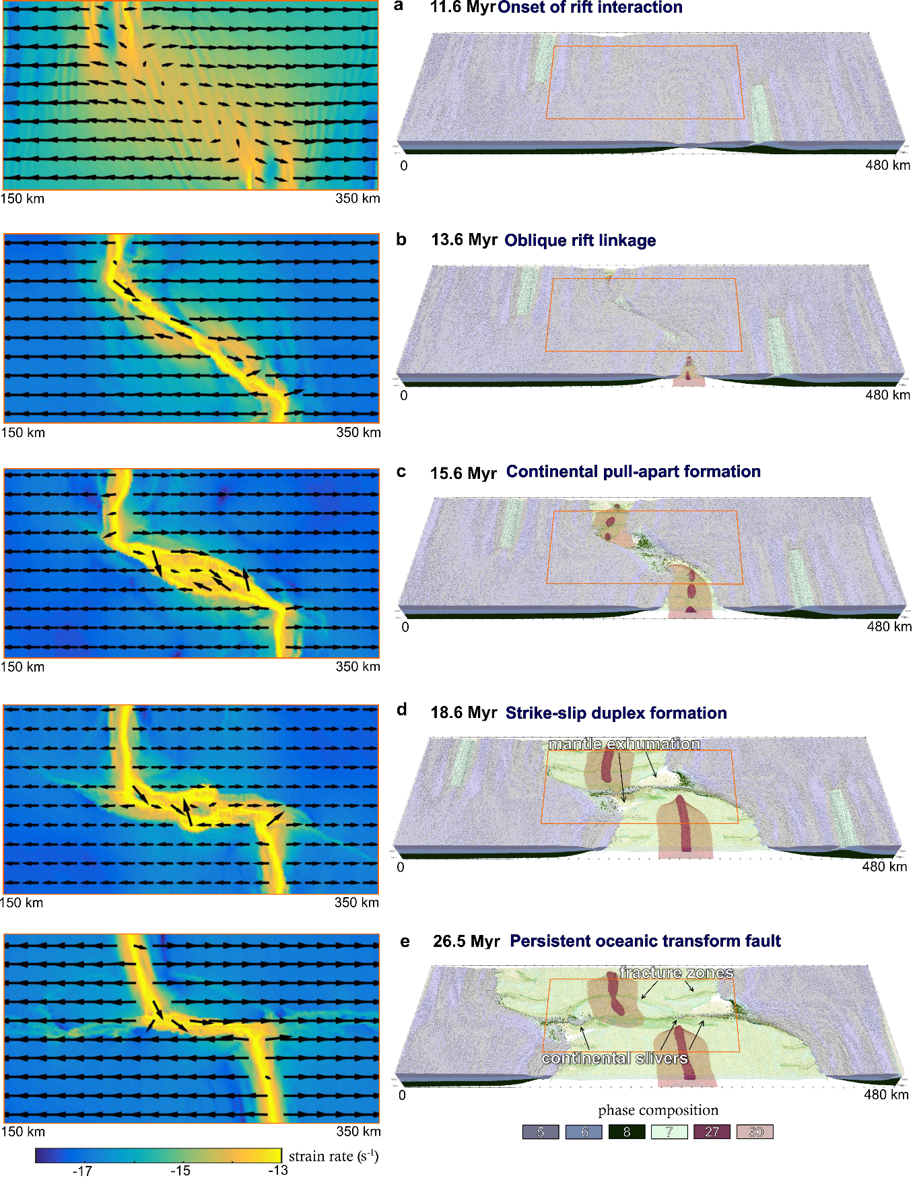
Fig. S1 Reference model evolution of the formation and evolution of continental slivers in oceanic transform faults. Results are simulated by 3D magmatic-thermo-mechanical geodynamic and coupled surface processes models and shown by strain rate and velocity field on horizontal maps and rock composition (setup is shown in Extended Data Fig. 2). Sediments are transparent in this figure. WZ: inherited weak fault zones in the crust. Phase composition 5: continental upper crust, 6: continental middle crust, 7: oceanic upper crust (basalt), 8: continental lower crust, 27: molten basalt, 30: partially molten peridotite.
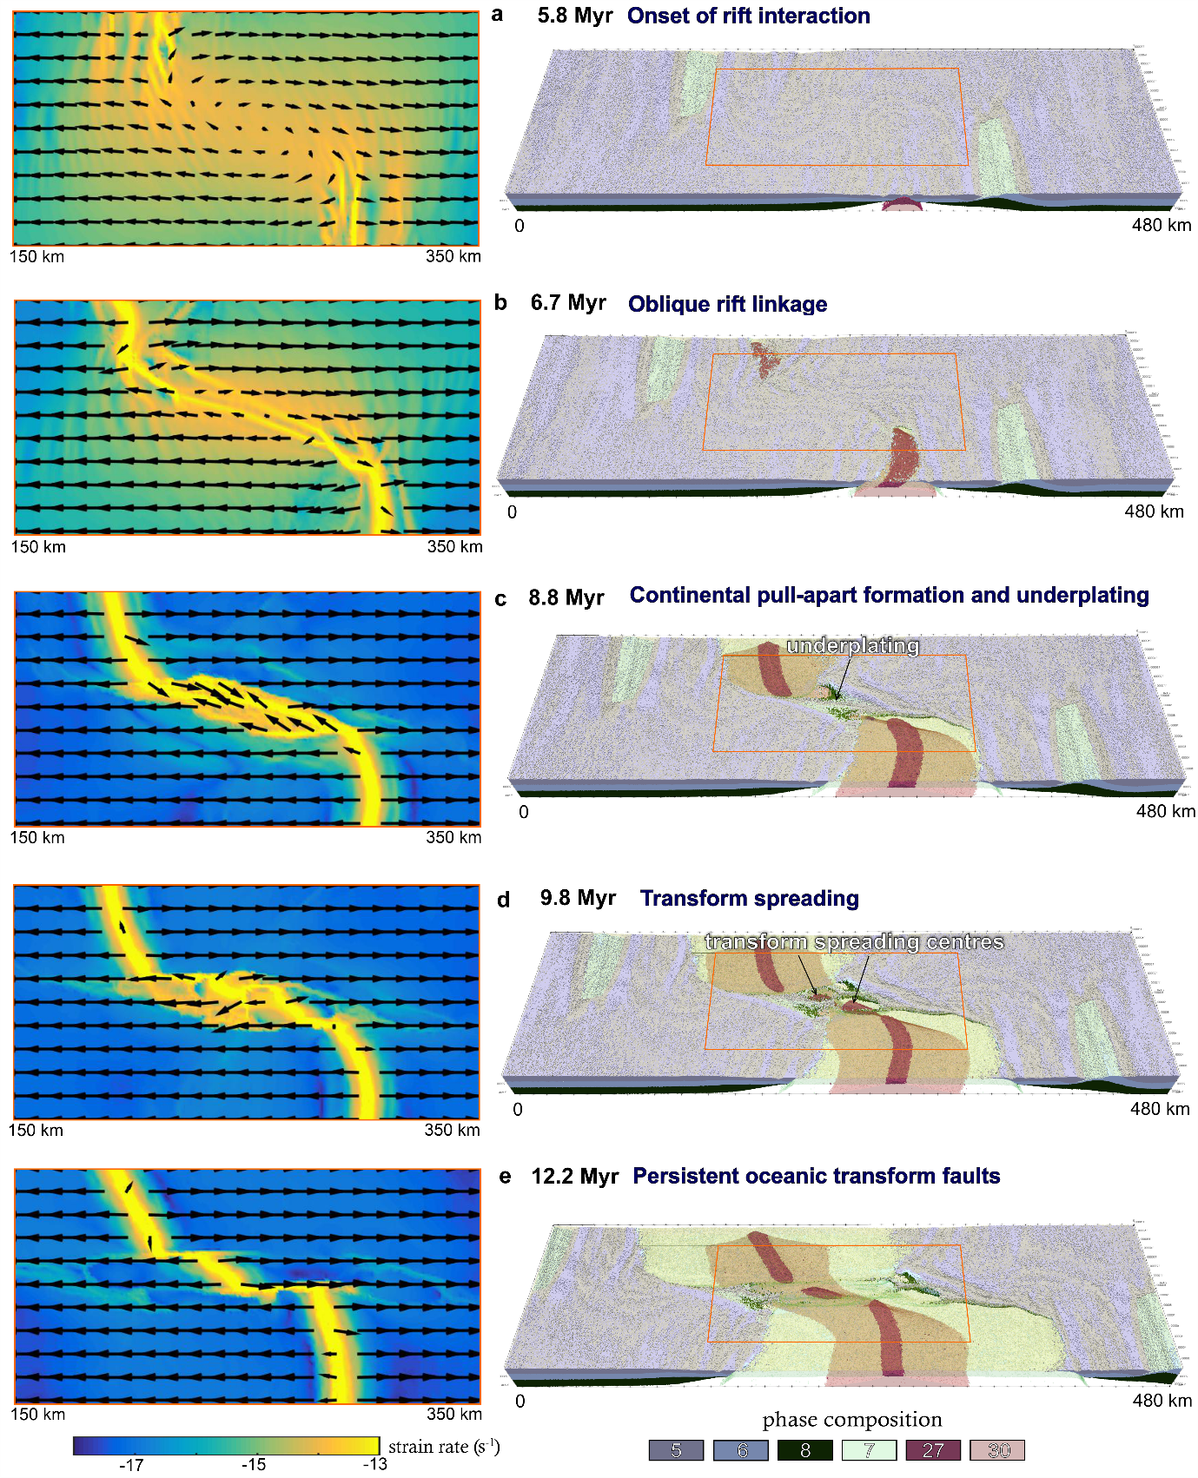
Fig. S2 Evolution of an intra-transform spreading ridge. Results of model fht are simulated by 3D magmatic-thermo-mechanical geodynamic and coupled surface processes models and shown by strain rate and velocity field on horizontal maps and rock composition (setup is shown in Extended Data Fig. 2). Sediments are transparent in this figure. WZ: inherited weak fault zones in the crust. Phase composition 5: continental upper crust, 6: continental middle crust, 7: oceanic upper crust (basalt), 8: continental lower crust, 27: molten basalt, 30: partially molten peridotite.
Video S1. Crustal evolution of the reference model.
VideoS2. Effective viscosity evolution of the reference model.
VideoS3. Crustal evolution of the model with faster divergence velocity and higher mantle temperature gradient (model fht).
VideoS4. Effective viscosity evolution of the model fht.

