Supporting Information
Timed batch inputs unlock significantly higher yields for enzymatic cascades
Miglė Jakštaitė¹, Tao Zhou^{1,2}, Frank H. T. Nelissen¹, Wilhelm T.S. Huck^{,1}, Bob van Sluijs^{,1,3}
- Institute for Molecules and Materials, Radboud University, Nijmegen, AJ, The Netherlands.
- School of Biotechnology and Key Laboratory of Industrial Biotechnology of Ministry of Education, Jiangnan University, Wuxi 214122, China
- Machine Learning lab, University of Amsterdam, Science park 900, Amsterdam, The Netherlands.
Contents

1. Preliminary experiments and experimental set-up. 3
1.1 Preliminary batch reactions. 3
1.2 Microfluidic reactor and control unit. 6
1.3 Materials and compounds used. 7
1.4 HPLC. 7
1.5 Plasmid Preparation. 8
1.5.1 Phosphoriboisomerase (Ribose-5-phosphate isomerase) (PRI). 8
1.5.2 Phosphoribosyl pyrophosphate synthetase (5-phospho-D-ribosyl-α-1-pyrophosphate synthase) (PRPPS). 9
2. PPP model and active learning pipeline. 11
2.1 Kinetic model of the PPP network. 11
2.2 Optimal Experimental Design. 12
2.3 Model builder and AMICI. 13
2.4 Algorithm settings and code. 14
3. Supporting Analysis. 14
3.1 In silico study of PPP ERN. 14
3.2 Overview of the in vitro experimental designs. 17
3.3 Additional analyses of the in vitro test data. 21
3.4 Application of the model to unlock higher yields in batch. 23
4. Supporting information references. 26

Tables and figures main text.
Figure 1. An overview of time dependent batch experiments and PPP network.
Figure 2. An Overview of active learning procedure.
Figure 3. Application of the active learning procedure to train informative models.
Figure 4. Application of trained models to unlock higher yields in batch.

Figures and Tables supporting information.
Supplementary tables
Table S1. Overview of all enzymes used in this work 3
Table S2. Overview of five preliminary batch experiments. 3
Table S3. Overview of the stock concentrations for both OED experiment 17
Table S4. Overview of the stock concentrations for time-dependent experiments 23
Table S5. Measured concentrations of final experiment at 120 minutes + 30 minutes as added control 25

Supplementary figures
Figure S1. Summarizes the individual batch experiments 4
Figure S2. The output concentrations of PPP cascade in batch 5
Figure S3. A CSTR with connected tubes and y-connectors 6
Figure S3. Experimental flow set-up consists of syringe pumps connected to a CSTR 6
Figure S5. Separation of four standard molecules by HPLC 8
Figure S6. An in silico study exploring active learning of PPP cascade in flow. 15
Figure S7. Overview of the inputs used for the in silico study. 16
Figure S8. The test data as generated by the model for the in silico analysis of Figure S6. 17
Figure S9. Calibration curves correlating concentrations of ATP, ADP, AMP and NADP species 17
Figure S10. Manually designed 250 minutes of the first iteration of the active learning workflow.. 18
Figure S11. The relative concentration of the enzymes inside the reactor over time 19
Figure S12. Overview of the fit of the data to the first iteration of the active learning workflow 20
Figure S13. $R2$ value for the fit of the model during the 3rd step in the workflow, model training. 20
Figure S14. Training two models one including the inhibition of PRPPS by ADP. 21
Figure S15. Overview of 3 models and model selection process 21
Figure S16. Shows a quantitative analysis of the model prediction with respect to the data 23
Figure S17. ATP hydrolysis with and without enzymes present 24
Figure S18. AMP calibration curve. 25

Preliminary experiments and experimental set-up.

Preliminary batch reactions.
Table S1. Overview of all enzymes used in this work. Most enzymes were purchased from Sigma-Aldrich. a) PRI and PRPPS enzymes were expressed and purified in-house (supplementary information 1.5).
Enzyme | Abbreviation | Product no.
Hexokinase | HK | H4502
Glucose-6-phosphate dehydrogenase | G6PDH | G8529
6-Phosphogluconic dehydrogenase | 6PGDH | P4553
Phosphoriboisomerase | PRI | - ª
Phosphoribosyl pyrophosphate synthetase | PRPPS | - ª

Table S2. Overview of five batch experiments including only PRPPS enzyme (exp. 1), more (exp. 2-4) or all PPP cascade enzymes (exp. 5) and their substrates. Total reaction volume 200 µL.
Experiment number | Enzyme | [Enzyme] | Substrate | [Substrate]/ µM
1 | PRPPS | 0.048 µg/µL | ribose-5-phosphate | 500
1 | PRPPS | 0.048 µg/µL | ATP | 1500
2 | PRI | 0.17 µg/µL | ribulose-5-phosphate | 500
2 | PRPPS | 0.048 µg/µL | ATP | 1500
3 | 6PGDH | 0.005 U/µL | 6-phosphoglucoronate | 500
3 | PRI | 0.17 µg/µL | ATP | 1500
3 | PRPPS | 0.048 µg/µL | NADP | 1500
4 | G6PDG | 0.005 U/µL | glucose-6-phosphate | 500
4 | 6PGDH | 0.005 U/µL | ATP | 1500
4 | PRI | 0.17 µg/µL | NADP | 1500
4 | PRPPS | 0.048 µg/µL
5 | HK | 0.005 U/µL | Glucose | 500
5 | G6PDH | 0.005 U/µL | ATP | 1500
5 | 6PGDH | 0.005 U/µL | NADP | 1500
5 | PRI | 0.17 µg/µL
5 | PRPPS | 0.048 µg/µL

In a batch experiment all five PPP network enzymes (HK, G6PDH, 6PGDH, PRI and PRPPS) together with substrate glucose and cofactors ATP and NADP were mixed and let to react for 120 min at 30 °C while shaking. At every 0, 5, 10, 20, 40, 60 and 120 min reaction time point a sample (20 µl) was taken from each reaction tube, quenched using guanidinium chloride (8 M, 60 µl), where sample to guanidinium chloride ratio was 1:3 and vortexed. After this all samples were centrifuged for 5 min at 10x1000 rpm, the supernatant (30 µl) was analysed offline by HPLC. Chromatographic analysis included integration of four substrate, intermediate or product cofactor peaks¹ (Figure S5). Another cascade product NADPH is not depicted in the plot due to difficulties in peak overlapping and separation with the peak of guanidinium chloride.
To demonstrate how PPP network enzymes influence AMP formation over time, five individual batch experiments were performed (Figure S2). We started from the last enzyme PRPPS in the cascade in the first experiment and added one extra enzyme for every new experiment until we formed a full cascade of five enzymes. Figure S1 and S2 summarize the results.
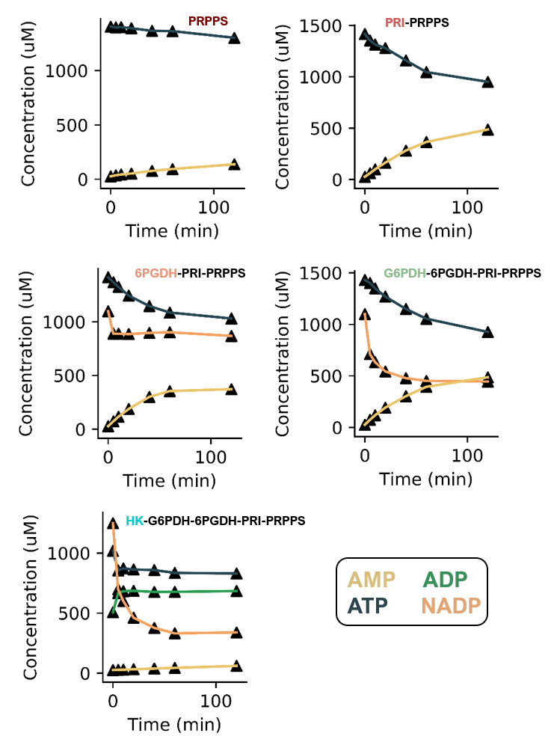
Figure S1. The output concentrations of PPP cascade in batch experiment over 120 min reaction time at 30 °C from the top right to bottom, only PRPPS enzyme reaction, PRI-PRPPS enzyme reaction, 6PGDH-PRI-PRPPS enzyme reaction, G6PDH-6PGDH-PRI-PRPPS enzyme reaction and full cascade of HK-G6PDH-6PGDH-PRI-PRPPS enzyme reaction.

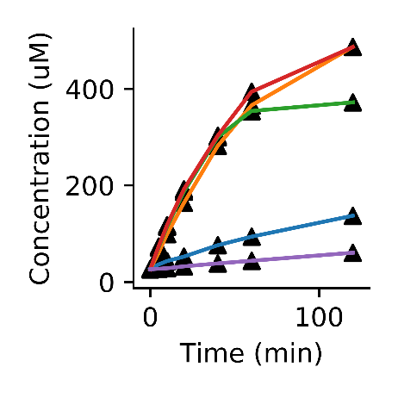
PRPPS
PRI-PRPPS
6PGDH-PRI-PRPPS
G6PDH-6PGDH-PRI-PRPPS
HK-G6PDH-6PGDH-PRI-PRPPS
AMP
Figure S2. Summarizes the individual batch experiments from Figure S1. In this instance we plot the AMP concentration for different batch experiments. Each trace is denoted by the enzymes that were added to the batch mixture i.e., from PRPPS to PRI-PRPPS to 6PGDH-PRI-PRPPS, to G6PDH-6PGDH-PRI-PRPPS to HK-G6PDH-6PGDH-PRI-PRPPS.

Microfluidic reactor and control unit.
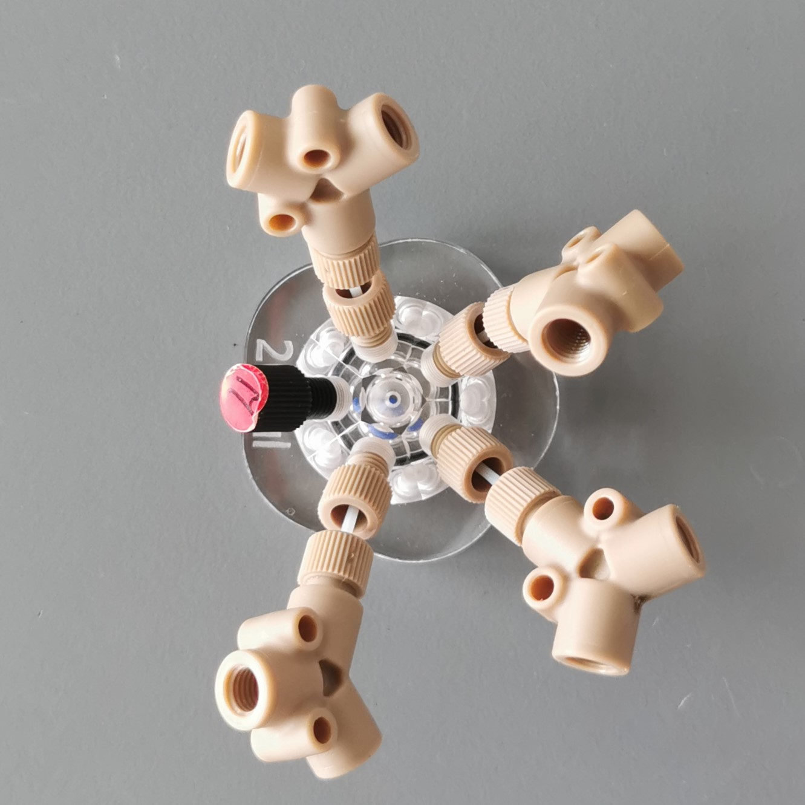
Figure S3. A CSTR with connected tubes and Y-connectors
A CSTR (volume 121 µl) made from poly (methyl methacrylate) and consisting of four inlets, which were doubled to eight by using Y connectors (P-513, PEEK, Upchurch Scientific), short tubes consisting of nuts (LT-115x, PEEK, Upchurch Scientific) and tubing (DENE3400516, PTFE, internal diameter 0.50 mm, external diameter 1.60 mm), and one outlet was connected to the outlet tube (109 µl and 69 µl for the first and second experiment, respectively, see Figure S3. Enzyme and substrate input flow rates changing every 12 or 15 min were controlled by Cetoni neMESYS syringe pumps and Hamilton syringes. Enzyme and substrate stock concentrations can be found in Table S3.
Reactor content was sampled by collecting droplets at the outlet (39 µl and 29 µl for the first and second flow experiment, respectively) using a fraction collector and the time of each drop was recorded using IR detector (Figure S4). The infrared sensor was fitted to the fraction collector head to precisely monitor the time drops were collected, control software can be found (https://GitHub.com/Will-Robin/labrador).Samples from the CSTR outlet tube were dropped directly into a guanidinium chloride solution (8 M, 117 µl and 87 µl for the first and second flow experiment, respectively), where sample to guanidinium chloride ratio was 1:3, and quenched immediately. Quenched samples were centrifuged for 5 min at 10x1000 rpm, the supernatant (30 µl) was transferred to the micro insert of HPLC vial and measured by HPLC. Calibration curves for ATP, ADP, AMP and NADP species can be found in Figure S9.
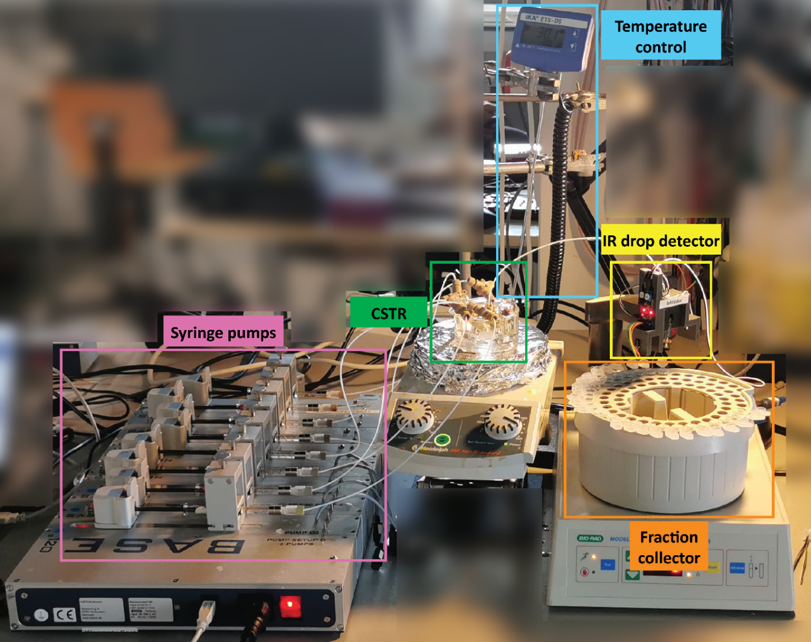
Figure S4. Experimental flow set-up consists of syringe pumps connected to a CSTR, which is under a temperature control of 30 °C. Every drop of the reaction outflow is collected by fraction collector at a known time point with the help of IR drop detector.

1.3 Materials and compounds used.
Hexokinase (HK), glucose-6-phospahte dehydrogenase (G6PDH), 6-phophogluconic dehydrogenase (6PGDH), adenosine triphosphate (ATP), adenosine diphosphate (ADP), adenosine monophosphate (AMP), nicotinamide adenine dinucleotide phosphate (NADP), D-glucose-6-phosphate (G6P), 6-Phosphogluconic acid (6PGA), D-ribulose-5-phosphate (Ru5P), MgCl₂, CaCl₂, guanidinium chloride (GnCl) and potassium phosphate dibasic were purchased from Sigma Aldrich. Potassium phosphate monobasic, D-ribose-5-phosphate (Ro5P) and 5-Phospho-D-ribose 1-diphosphate (PRPP) were purchased from Chem Cruz. 4-(2-Hydroxyethyl)piperazine-1-ethanesulfonic acid (HEPES) was purchased from Fluorochem. D-glucose was purchased from Merck. Water was obtained from a Millipore system. All chemicals were used without further purification.

1.4 HPLC.
HPLC analyses were performed on a Shimadzu Nexera X3 instrument. Conditions: Inertsil ODS-4 C18 column (3 μm pore size, 150 × 4.6 mm; GL Science) and a guard column (3 μm pore size; 10 × 4.6 mm) at 40 °C. We prepared elution solution A as 50 mM aqueous potassium phosphate (pH 6.0) buffer filtered over a 0.22 µm membrane, solution B as 100% MeOH. The elution gradient was as follows: 100% solution A for 2 min; 0–12.5% linear gradient of solution B for 8 min; 12.5% solution B for 2 min; 12.5–40% linear gradient of solution B for 6 min; 40% solution B for 2 min; 40–0% linear gradient of solution B for 3 min and 100% solution A for 7 min. The flow rate was maintained at 1 mL/min, injection volume was 10 µL, 15 µL and 20 µL for batch, first and second flow experiments, respectively. Ultraviolet detection at 254 nm.
Detectable compounds ATP, ADP, NADP, and AMP, are shown in Figure S5. The background signal of guanidinium chloride (GnCl) was subtracted from calibration and experimental samples. Peaks were identified by comparison to standard samples and concentration of each analyte was obtained by integrating peak areas and using calibration curve in a range of 10–400; 10-500 or 10-1000 µM of each standard.
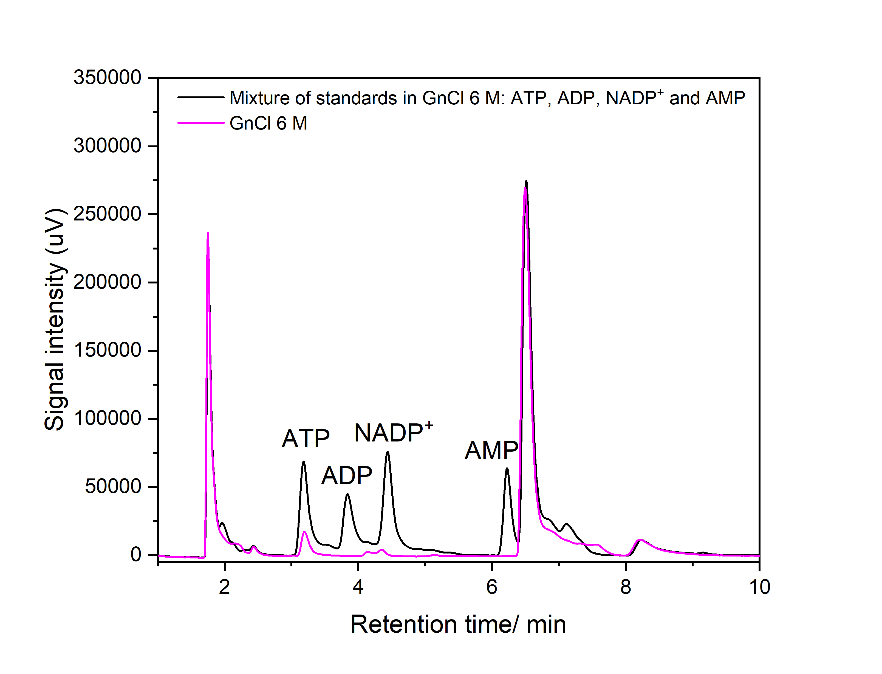
Figure S5. Separation of four standard molecules by HPLC. Mixture: 100 µM each of ATP, ADP, NADP and AMP in guanidinium chloride (GnCl) 6 M (black) and GnCl 6 M (pink). 10 µL injection volume, ultraviolet detection at 254 nm.

1.5 Plasmid Preparation.

1.5.1 Phosphoriboisomerase (Ribose-5-phosphate isomerase) (PRI).
The gene for phosphoriboisomerase (PRI) was amplified from Escherichia coli K12 derived XL-1 blue competent cells using primers:
RpiA-Fw: 5’TTAGTCAGTCATATGACGCAGGATGAATTGAAAAAAGCAGTAGG3’
RpiA-Rv: 5’ATAGATAGCCTCGAGTCATTTCACAATGGTTTTGACACCGTCAG3’
Sequences in bold and underlined indicate the restriction sites for subsequent cloning into a pET15b expression vector. The sequence in italics indicates the introduced stop codon. The PCR mixture contained 1 µM of each primer, 0.2 mM dNTPs, 0.25 ul of competent E. coli cells and 2 U of Pfu DNA polymerase in its standard reaction buffer. Mixture was cycled for 25 times between 95°C (30s), 58°C (30s) and 72°C (1min). Agarose gel analysis of the reaction product showed a single band around 650 bp as expected. DNA was purified using a PCR product purification kit (Qiagen). DNA (2 µg) was digested with NdeI and XhoI, purified over agarose gel using a Qiaquick gel extraction kit (Qiagen) and subsequently ligated into a dephosphorylated NdeI+XhoI digested pET28a vector introducing an N-terminal hexahistidine tag. Ligation reactions were transformed to E. coli TOP10 cells and recombinant plasmids were checked on insert and subsequently transformed into E. coli BL21(DE3) for protein expression. Bacteria were cultivated in 1 liter of LB media at 30°C to OD600nm ~0.7 upon which protein expression was induced by adding IPTG to 0.5 mM. Cells were further cultivated overnight at 18°C and then harvested by centrifugation for 10 minutes at 5000 rpm in a Beckman JA-10 rotor. All subsequent steps were at 4°C unless otherwise noted. The pellet was resuspended in 40 mL buffer A (50 mM HEPES, 500 mM NaCl, 5 mM β-mercaptoethanol, 5% glycerol at pH 7.5) containing 20 mM imidazole, 20 µg/mL PMSF and 1 mg/mL lysozyme. The cell suspension was sonicated for 45 seconds at 17 micron amplitude for 8 times with pause intervals of 1 minute on ice. Lysate was centrifuged for 30 minutes at 17000 rpm in a Beckman JA25.50 rotor. Cleared supernatant was loaded onto a 5 mL Ni2+-sepharose HP column (GE Healthcare) that was pre-equilibrated in buffer A containing 20 mM imidazole. The column was washed with 25 ml of buffer A containing 50 mM imidazole and bound proteins were eluted with buffer A containing 300 mM imidazole and collected in fractions of ~1 mL. Fractions were analyzed on SDS-PAGE and fractions containing RpiA (5 in total) were pooled and dialyzed in a 3.5 kDa MWCO dialysis tubing against 1 liter of 20 mM potassium phosphate buffer, pH 7.2, refreshing the dialysis buffer once. Enzyme isolate became opaque and a precipitate was visible. The isolate was centrifuged for 1 minute at 14000 rpm in a table top centrifuge to pellet the precipitate. Opaque supernatant was pipetted into a fresh tube and stored at 4°C. Activity was estimated by a protocol adapted from Wood et. al. (Anal. Biochem. 33, 297-306, 1970). In short, 1 mL of a mixture containing 100 mM triethanolamine pH 7.4 and 10 mM ribose-5-phosphate was equilibrated at 37°C in a quartz cuvette in a Cary300Bio spectrophotometer and monitored at a wavelength of 290 nm. Isomerization was initiated by mixing in 1 µL of a suitable dilution of the enzyme isolate and the number of units was calculated from the rise in absorbance using 0.072 as molar extinction coefficient for the change of ribose-5-phosphate into ribulose-5-phosphate.

1.5.2 Phosphoribosyl pyrophosphate synthetase (5-phospho-D-ribosyl-α-1-pyrophosphate synthase) (PRPPS).
Bacterial strain: Escherichia coli H0561 / pHO11
Mode of expression: Constitutive expression of PPRPS

Colonies of E. coli HO561/pHO11 were grown overnight at 37°C from glycerol stock on a LB-agar plate containing 100 μg/ml ampicillin (amp¹⁰⁰). 5 ml of LB + amp¹⁰⁰ was inoculated with a single colony and cultivated at 37°C for 13 hours and then used to inoculate 1 liter of LB + amp¹⁰⁰. After cultivation for 12 hours at 37°C, cells were harvested by centrifugation for 20 minutes at 6000 g in a JA-10 rotor (Beckman) at 4°C. All subsequent steps were carried out at 4 °C unless otherwise noted. The cells were resuspended in 40 ml of lysis buffer (50 mM potassium phosphate buffer (pH 7.5), 2 mM β-mercaptoethanol and 200 μg/ml lysozyme (Sigma-Aldrich). Cells were sonicated ten times for 30 seconds with chilling intervals on ice of two minutes. The lysate was centrifuged at 31000 g for 20 minutes in a JA-20 rotor (Beckman) to remove cellular debris. A 0.1 volume of 20% streptomycin sulphate was added to the supernatant and stirred for 15 minutes on ice. This solution was heat-shocked at 55°C for 5 minutes and immediately cooled to 0°C for 10 minutes. The precipitate was removed by centrifugation at 31000 g for 30 minutes. The supernatant was brought to 35% saturation with (NH₄)₂SO₄, stirred for 15 minutes on ice and centrifuged for 30 minutes at 31000 g. The pellet was dissolved in 25 ml of buffer A (50 mM potassium phosphate buffer (pH 7.5) + 2 mM β-mercaptoethanol). The pH of this solution was adjusted to 4.6 by adding cold 1 M acetic acid and then immediately centrifuged at 31000 g for 10 minutes. The pellet was dissolved in 4 ml of buffer A + 50% glycerol and stored at -20°C.

Spectrophotomeric PRPPS assay
Assayed in a 1 ml reaction in a 1 ml Quartz cuvette (Varian):
- 100 mM Potassium phosphate buffer, pH = 7.6
- 5 mM Ribose-5-phosphate
- 3 mM ATP
- 0.8 mM Phosphoenolpyruvate (PEP)
- 10 mM MgCl₂
- 142 mM KCl
- 0.3 mM β-NADH (freshly prepared, obtained from Sigma)
- 2 U Lactate dehydrogenase (Sigma)
- 2 U Pyruvate kinase (Sigma)
- 2 U Adenylate kinase
The mixture was incubated at 37°C and monitored at 340 nm wavelength in a Cary300Bio (Varian, Middelburg, The Netherlands) until a steady baseline was obtained. The reaction was started by the addition of 2 µl of a PRPPS solution and the decrease in absorbance was measured as a function of time. The activity of the PRPPS was determined using the molar extinction coefficient decrease due to the oxidation of β-NADH by lactate dehydrogenase.

(OD_{t1} – OD_{t2}) * 10³ * F_{v}
U =
ε * (t₂-t₁) * 2 * V_{enzyme}
Where U is the number of calculated units denoted as µmol.min⁻¹.µl⁻¹, ε is 6220 mol⁻¹.l.cm⁻¹, F_{v} is the dilution factor of the added enzyme solution, (t₂-t₁) is the time over a linear interval in minutes and V is the volume of added enzyme solution in µl.

Reaction specifications
ATP + Ribose-5-Phosphate → PRPPS → PRPP + AMP
AMP + ATP → adenylate kinase → 2 ADP
2 ADP + 2 PEP → pyruvate kinase → 2 pyruvate + 2 ATP
2 pyruvate + 2 β-NADH → lactate dehydrogenase → 2 lactate + 2 β-NAD⁺

Overall reaction: 1 PRPP → 2 NAD⁺
For more information we refer the reader to ref 11.

2. PPP model and active learning pipeline.

2.1 Kinetic model of the PPP network.
BRENDA reports the following for the enzymes in the reactor:
- HK: Hexokinase from rabbit muscle follows an induced fit mechanism, where glucose binding induces a conformational change in the enzyme, positioning ATP for an efficient phosphoryl transfer. The mechanism involves key steps of substrate binding, conformational change, nucleophilic attack on ATP, transition state stabilization, and product release¹².
- G6PDH: G6PD in Saccharomyces cerevisiae catalyzes the oxidation of glucose-6-phosphate to 6-phosphoglucono-δ-lactone, with the concurrent reduction of NADP⁺ to NADPH. The reaction involves substrate binding, hydride transfer, and product release¹³.
- 6PGDH: 6-phosphogluconic dehydrogenase in the pentose phosphate pathway follows an ordered sequential mechanism. NADP⁺ binds first, followed by 6-phosphogluconate, which is then oxidized and decarboxylated to produce ribulose-5-phosphate, NADPH, and CO₂¹⁴⁻¹⁵.
- PRI: Ribose-5-phosphate isomerase catalyzes the conversion of ribulose-5-phosphate to ribose-5-phosphate through a mechanism involving substrate binding, enediol intermediate formation, proton shifting, and product release¹⁶.
- PRPPS: Phosphoribosyl pyrophosphate synthetase (PRPP synthetase) follows an ordered sequential mechanism. ATP binds first to the enzyme, followed by ribose-5-phosphate. The enzyme then catalyzes the transfer of the pyrophosphate group from ATP to ribose-5-phosphate, forming PRPP and AMP¹⁷.
We trained and tested different models. This section and Supporting Information 3.3 describe the relevant results of the coarse graining procedure. The model in the main text utilizes Bi-Bi Ordered Equilibrium equations for enzymes and is best described in Cook and Cleland;² this term is present in the overall flux for a reversible reaction inside the CSTR summarized by Equation S1.

$$\frac{dX_{i}}{dt}=V_{Forward}- V_{reverse}+ {Kf}_{in,I}X_{in,stock }-Kf*X_{i}$$ | (S1)

Where the Bi-Bi Ordered Equilibrium forward and reverse reactions are noted by V (with different kinetic rates), and the inflow ${Kf}_{in,I}$ and outflow $Kf$ are proportional to the stock concentration and the concentration in the reactor respectively. For irreversible enzymatic reactions $V_{reverse}=0$. The inflow rate of input substrates is modelled and accounts for individual syringes connected to the CSTR reactor. Thus, the concentration of the input substrate in a syringe is larger than the final concentration in the reactor (as multiple syringes are connected to the CSTR) and is modelled according to Equation S2.
$$\left[X_{ss}\right]= X_{in,stock }\frac{{Kf}_{in,I}}{kf}$$ | (S2)

Where ${[X}_{ss}]$is the concentration of a single substrate that flows into the reactor at steady state. ${Kf}_{in,I}$is the flowrate of a specific substrate/syringe combination that flows into the reactor. $X_{in,stock }$is the stock concentration of the substrate. Each ${Kf}_{in,I}$ i.e., substrate/syringe combination contributes to the total flowrate $Kf$. The total flow rate (flow out of the reactor) that applies to all species is defined as.
the sum of all ${Kf}_{in,I}$ given by Equation S3.
$$kf= \frac{\sum_{i=1}^{i}{{Kf}_{in,I}}}{volume}$$ | (S3)

Finally, the term for an ordered equilibrium random reaction is given by Equation S4².
$$V=\frac{\left[S1\right]\left[S2\right][Enzyme ]k_{cat}}{K_{a}K_{b}+K_{b}\left[S1\right]+\left[S1\right][S2]}$$ | (S4)

The allosteric inhibition is subsequently a term; $= (\frac{[i]}{ki}+1)$, is multiplied with the denominator of this flux term V. Note we assume that this is the most reasonable interpretation for each enzyme; recent studies have indicated that some enzymes e.g., hexokinase might have more conformational freedom than previously reported. However, incorporating separate, combinations of conformational states lead to over parameterized mathematical models ¹⁸⁻¹⁹.

2.2 Optimal Experimental Design.
The model of the pentose phosphate pathway is defined by a series of ordinary differential equations defined in Equation S5.
$$\frac{dX}{dt}=f\left(x,t,u,p\right)$$ | (S5)

Where X represent the states in the set of ODEs x the individual state, t the time, u the control parameter and p the kinetic parameters. Most optimal experimental design problems utilize the Fisher information matrix. This matrix can be computed from the sensitivities of the parameters p towards the observed species x according to Equation S6³⁻⁵.

$$\frac{d}{dt}\frac{∂x}{∂p_{i}}= \frac{∂f\left(x,u,p\right) }{∂x}\frac{∂x}{∂p_{i}}+\frac{∂f\left(x,u,p\right) }{∂p_{i}} for i=1,…,N_{p}$$ | (S6)
Where $\frac{∂f\left(x,u,p\right) }{∂x}$ is the Jacobian, $\frac{∂x}{∂p_{i}}$ the sensitivity coefficients and $\frac{∂f\left(x,u,p\right) }{∂p_{i}}$ the parameter sensitivities. Note, we end up with an additional $N_{p}$ * $N_{x}$ number of sensitivity ODEs. By differentiating the original ODEs with respect to the parameters we effectively map how much each parameter contributes to the rate of change in the observed species. The sensitivity matrix can subsequently be obtained by stacking these sensitivities towards different observables at different times according to:
$$S=\left[\begin{aligned}\begin{matrix}\frac{∂y_{j1}}{∂p_{1}}(t_{1}) & ⋯ & \frac{∂y_{j1}}{∂p_{N_{p}}}(t_{1}) \\ ⋮ & & ⋮ \\ \frac{∂y_{j1}}{∂p_{1}}(t_{N_{t}}) & ⋯ & \frac{∂y_{j1}}{∂p_{N_{p}}}(t_{N_{t}})\end{matrix} \\ \begin{matrix}\frac{∂y_{j2}}{∂p_{1}}\left(t_{1}\right) & ⋯ & \frac{∂y_{j2}}{∂p_{N_{p}}}\left(t_{1}\right) \\ ⋮ & & ⋮ \\ \frac{∂y_{j2}}{∂p_{1}}\left(t_{N_{t}}\right) & ⋯ & \frac{∂y_{j2}}{∂p_{N_{p}}}\left(t_{N_{t}}\right)\end{matrix}\end{aligned}\right]$$
Where $y$is are the subset of observable states x, $p$ the parameter and $t$the time point of the observation up to $t_{N_{t}}$ and $j$ the index corresponding to individual experiments. Thus, each column is a parameter, each row is a time point, where new observables and experiments are added to columns.
The Fisher information matrix is subsequently computed according to Equation S7³⁻⁵.
$$F= {SS}^{T}$$ | (S7)

According to Cramer-Rao, the inverse of F provides a lower bound to the parameter covariances⁵. This FIM is local, thus the computed information criterion needs a model that has some prior knowledge of the system. Practically we are using the sensitivities of the parameters we are trying to estimate as an input for F, thus if the initial parameter values used in the design of the pulse sequence are very far from their true value so will the accuracy of the computed information criterion (resulting in less informative data).⁶ Therefore we utilized the batch experiment from Figure S1 to set parameters that reflect the experimental time scales (i.e. setting a boundary for the model). For this work we utilized D-optimal design, calculating the determinant of F, where $D = max_{D}⁡(F)$ (E-optimality is also an option, computing the smallest eigenvalue of F which represents the direction with the least variance between sensitivity).

2.3 Model builder and AMICI.
The models were generated automatically by the custom software, one simply needs to define the enzyme, substrates and products and provide which type of rate a law applies. Currently the model builder supports 3 different experimental set-ups and combinations of 9 different rate laws.
Since the flow set up uses syringes, and there is a limited number of syringes available not every species can have its own syringe in practice. Thus, the model builder assigns a species to the syringe of the user’s preference. To build a model, the user gives the network in the following form
R1 = [ [REVERSIBLE: TRUE FALSE], [RATE EQUATION], [ENZYME ID], [SUBSTRATES IDs], [RPODUCT IDs], [ACTIVATOR IDs], [INHIBITORS IDs] ]
R2 = [ [REVERSIBLE: TRUE FALSE], [RATE EQUATION], [ENZYME ID], [SUBSTRATES IDs], [RPODUCT IDs], [ACTIVATOR IDs], [INHIBITORS IDs] ]
Where the network becomes [R1, R2, R3 etc]. For more information see: http://GitHub.com/huckgroup/OED/ERN. To compile the models to C++ we utilize AMICI a publicly available differential equation solver package. It interfaces with Python, Matlab and C++⁶. Some parts of the software were repurposed from previous work²¹⁻²³

2.4 Algorithm settings and code.
The algorithm^{7-8,21} utilizes a multi-start approach using Latin hypercube sampling to sample 1500 parameter sets. The boundaries of the parameter values span 6 orders of magnitude (0.001,50). The set parameters e.g., the enzyme stock concentrations, substrate stock concentrations and reactor volume can be found in Table S3. The models, data e.g., parameter estimates, precise input concentrations and flow rates for the experiments can be found in the Source Data on the GitHub repository.

3. Supporting Analysis.

3.1 In silico study of PPP ERN.
We explored different scenarios for the active learning workflow by training models on in silico data to learn what to prepare experimentally. Figure S6a shows 2 scenarios for the active learning set-up, in one scenario enzymes concentrations remain constant throughout the experiment (beaded filter set-up), where enzymes stay in the reactor by means of a filter and do not flow out and only substrates are perturbed. In the free set-up enzymes and substrates are free to flow into and out of the reactor. We created two optimally designed training datasets for each of these scenarios (Figure S7): one where transients are measured and another where only steady states are measured. The model was trained on different lengths of each of the datasets and subsequently tested with a new pulse experiment (Figure S8), consistent with the active learning workflow shown in the main text (Figure 2 and Figure 3).
Figure S6b subsequently shows the relative prediction error of each scenario. As expected, utilizing free enzymes within the active learning pipeline is more informative, resulting in a >4 fold lower prediction error⁴⁰. We also probed the effect of ADP inhibiting PRPPS by training a model that did not include this interaction. If ADP does not inhibit PRPPS it becomes easier to train a model, since less informative data from other scenarios could be used to train an equally predictive model.
In Figure S6c we opted to further explore the information gained within the transient free enzyme dataset since that mirrors our experimental in vitro set-up. We trained a kinetic model which includes a term for PRPPS inhibition with different sizes of training data comprising short and long experiment runtimes. The time series plots show the prediction of AMP and ADP, ATP and NADP test data (shaded area). As experimental runtimes increase, the prediction error of the model declines, this decline levels off after 240 minutes.

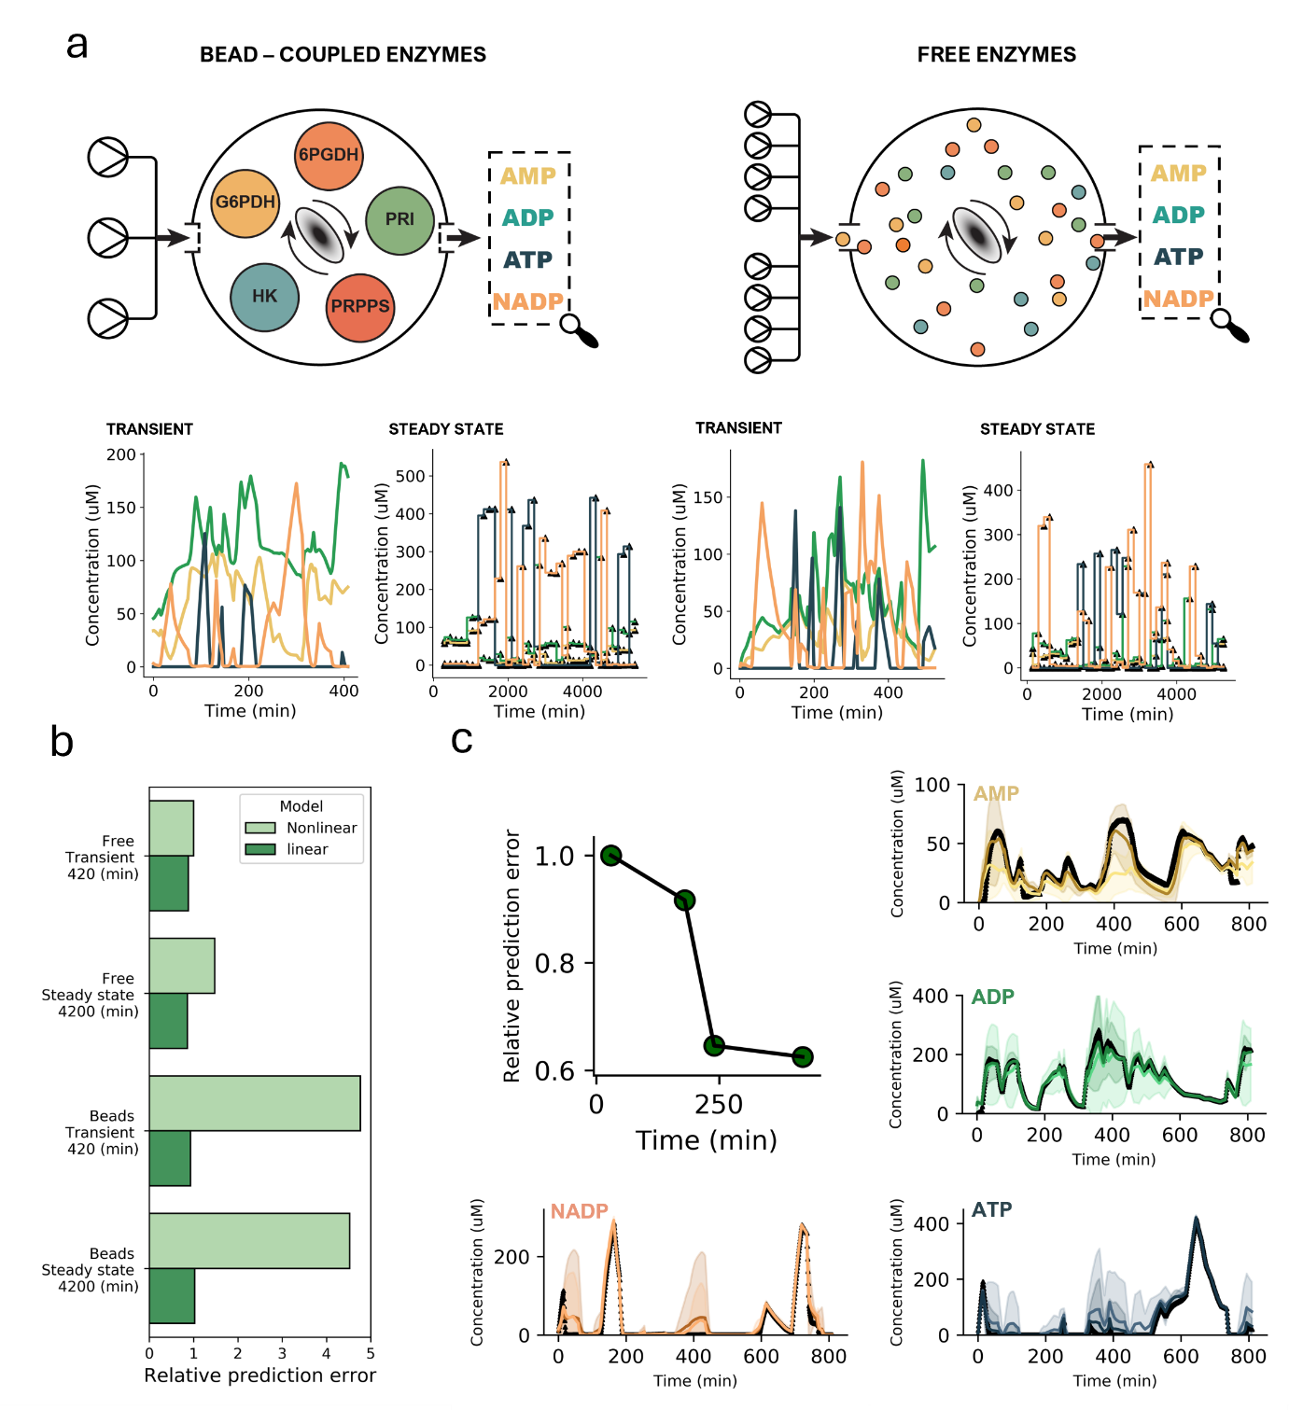
Figure S6. An in silico study exploring the difference between two strategies to control catalysis inside reactors. a) in scenario 1 the PPP pathway enzymes are coupled to beads; three substrates can be pulsed into the reactor. In scenario 2 enzymes are free and flow into the reactor. For each scenario we subsequently created two training datasets in silico, one where transients are measured for an optimally designed experiment and one where only its steady state is measured. For each of the four datasets the inputs were altered 35 times. b) Shows the difference in the prediction error for the scenarios after 420 minutes (transient) or 4200 minutes (steady state) of training, for a model that includes an inhibition reaction between ADP and PRPPS (nonlinear) and one that does not (linear), simulations of best fits to training data, n = 10. c) Focusses on the transient free enzyme OED dataset, by plotting the relative prediction error for different lengths of training data. After the training dataset contains 240 minutes of data this prediction error no longer becomes smaller. The time course test data (black diamonds) and the model predictions serve as a visual reference to the relative prediction error. The shaded areas represent the uncertainties (3 standard deviations). The lighter time course prediction in each time series plot is the trained on 30 minutes of in silico data, (more uncertainty), the darker time course prediction is trained on 240 minutes of in silico data, for both simulations based on best fit to training data, n = 10.
With this in silico exploration, we could a priori set an experimental requirement and define a simple hypothesis. First, this analysis indicates an experimental runtime of at least 240 minutes is preferred to train the model in a single iteration. Second, Figure S6c shows that this preferred runtime holds true when ADP inhibits PRPPS, however, less informative data can also be used if there is no emergent network behavior. From this we can assume the opposite holds true as well, that any model inaccuracies after including 240 minutes of actual in vitro data in the training dataset are likely due to additional nonlinear effects that have not been accounted for but are not as strong. Effects that likely stem from either emergent network behaviour or environmental factors which cannot be easily gleaned from public databases. Finally, the capacity to change the enzyme concentration and measure transients is key to an informative experiment.
Figure S7 is a support figure for Figure S6 and shows the inflow profiles for each of scenarios described. Note that for the bead-coupled enzymes the concentration of the enzymes inside the reactor does not change. Figure S8 subsequently shows the time-series data for the in silico test data. The test data and the data from the 4 scenarios were created by a model with the same kinetic rate constants to mimic in vitro experiments and not bias the outcome to these constants.

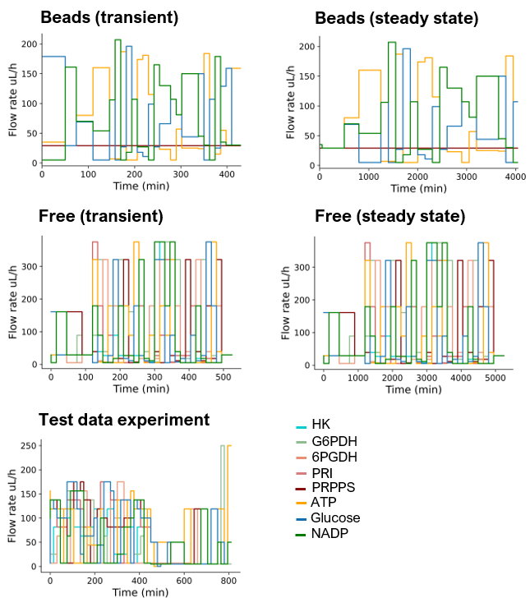
Figure S7. Overview of the inputs used for the in silico study.
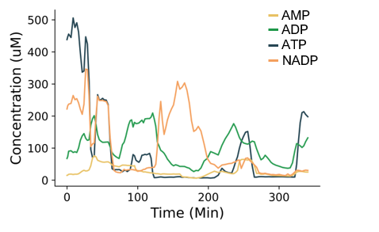
Figure S8. The test data as generated by the model for the in silico analysis of Figure S6. The quantification of the prediction error uses this data.

3.2 Overview of the in vitro experimental designs.
Table S3. Overview of the stock concentrations for both OED experiments, the relative enzyme concentrations indicate a change in enzyme concentrations.
Experiment number | Enzyme | [Relative Enzyme] | [Absolute Enzyme] | Substrate | [Substrate] (µM)
Iteration 1 | HK | 0.66 | 0.02 U/µL | ATP | 4000
Iteration 1 | G6PDH | 0.66 | 0.02 U/µL | GLUCOSE | 4000
Iteration 1 | 6PGDH | 0.66 | 0.0675 U/µL | NADP | 4000
Iteration 1 | PRI | 1 | 1.7 µg/µL
Iteration 1 | PRPPS | 0.66 | 0.648 µg/µL
Iteration 2 | HK | 1 | 0.03 U/µL | ATP | 2000
Iteration 2 | G6PDH | 1 | 0.03 U/µL | GLUCOSE | 2000
Iteration 2 | 6PGDH | 1 | 0.10125 U/µL | NADP | 2000
Iteration 2 | PRI | 1 | 1.7 µg/µL
Iteration 2 | PRPPS | 1 | 0.972 µg/µL

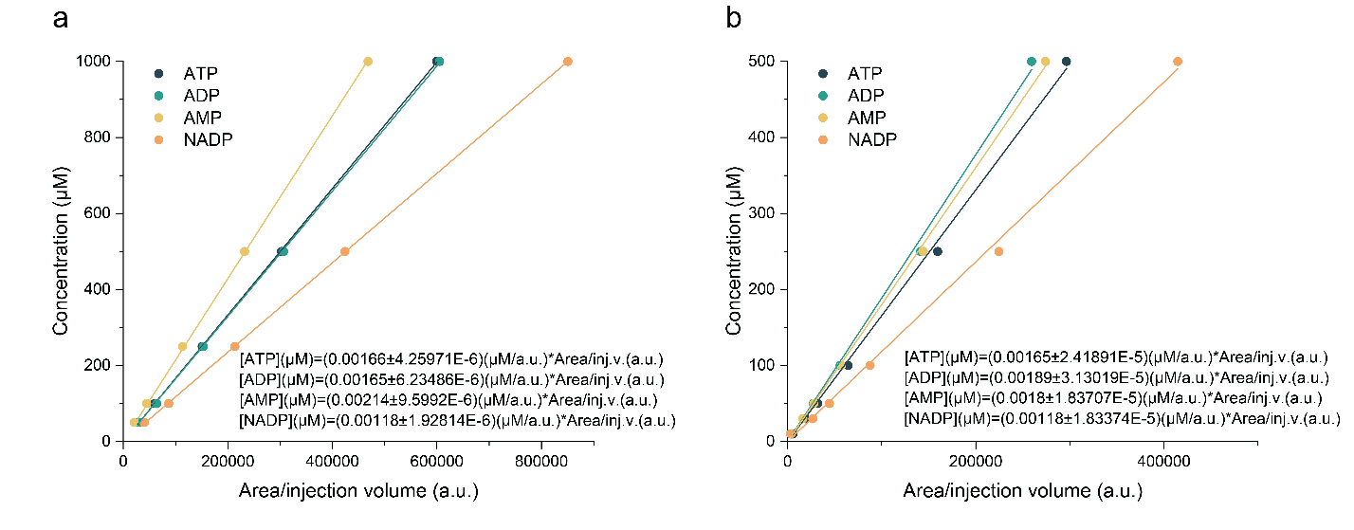
Figure S9. Calibration curves correlating concentrations of ATP, ADP, AMP and NADP species to values of HPLC peak area/injection volume for flow experiments: a) iteration 1 and b) iteration 2.
Figure 3 of the main text shows the first and second iteration of the active learning process. For the first experiment, the algorithm takes over after 180 minutes. The first 180 minutes of the experiment were designed manually. Mainly verify that the experimental set-up works, and the results make sense (something which is hard to gauge when everything is perturbed). Figure S10 clarifies which part of the first optimally designed experiment was manually designed (up to minute 250).
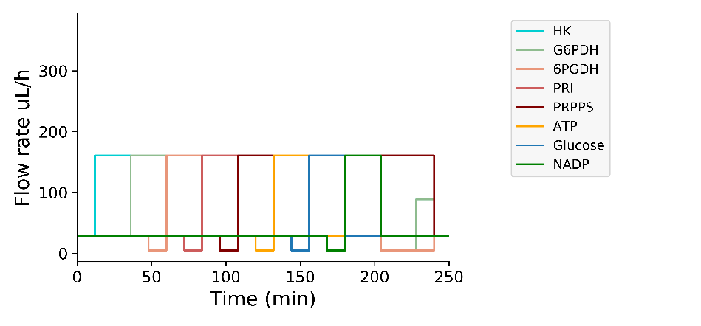
Figure S10.Shows the manually designed 250 minutes of the first iteration of the active learning workflow. This part of the experiment was not designed by the algorithm. Its output serves as a human interpretable time course with which we can ascertain if the experimental set-up behaves as expected. For example, at minute 150 we spike ATP, in the ATP measurement we indeed observe an increase from thereon.
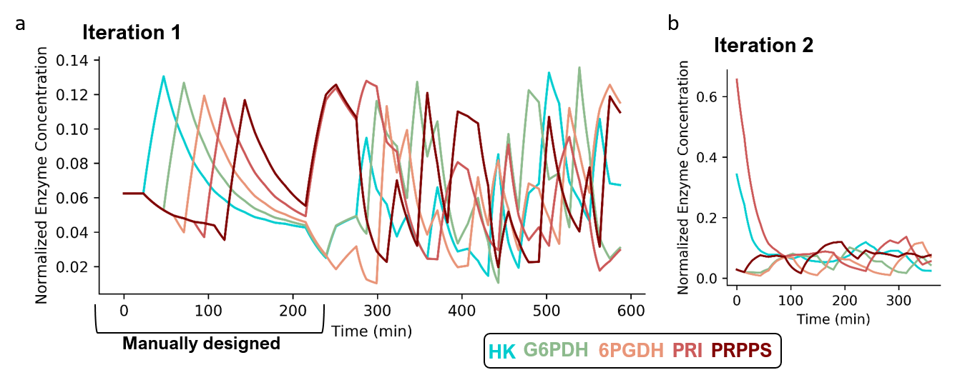
Figure S11. The relative concentration of the enzymes inside the reactor over time, Iteration 1 (a) has a manually designed part (0-220 minutes). Second iteration of the OED workflow (b).
Finally Figure S11 highlights the nonlinear nature of the inputs by plotting the concentrations of the enzymes themselves over time. This is a more intuitive representation, although the model optimizes the parameters that control the flow rate, that reflects the changing enzyme concentrations inside the reactor over time (note the concentrations are normalized).
Figure S12 shows the results of the trained model on the first OED iteration akin to the main text but includes goodness of fit bar plot (Figure S12c) The model fits the input metabolites remarkably well for such a complex experiment. ADP is also appropriately mapped by the model. For AMP some of the minor fluctuations are not a perfect quantitative match (qualitatively it does, Figure S12a), as if it cannot keep up with the rapid fluctuations introduced by the inflow profile. This already hints at additional regulatory interactions that affect the flux as indicated by the in silico analysis, should the model not map onto the data perfectly. Figure S13 shows that the overall R² value of the fit is 0.77 (3 outliers for ATP) and 0.892 for the test of the model.
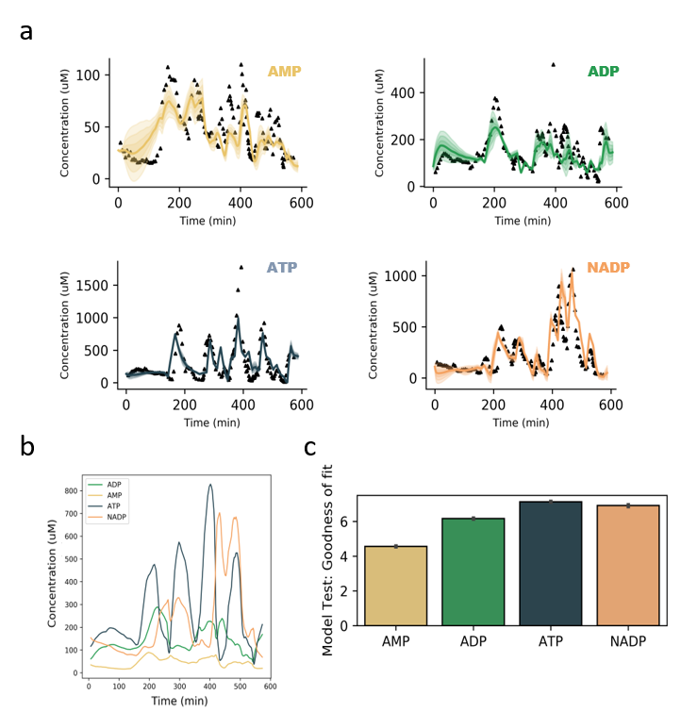
Figure S12. Overview of the fit of the data to the first iteration of the active learning workflow. a) Shows the fit of the individual observables to the data. b) Summarizes the data as relative to one another. c) Shows the goodness of fit of the model (defined as the square root of the least squares estimates). Note that the mechanistic model cannot track all the changes observe in the data for AMP. Indicating its structure is not fast enough to track the constantly changing environment.
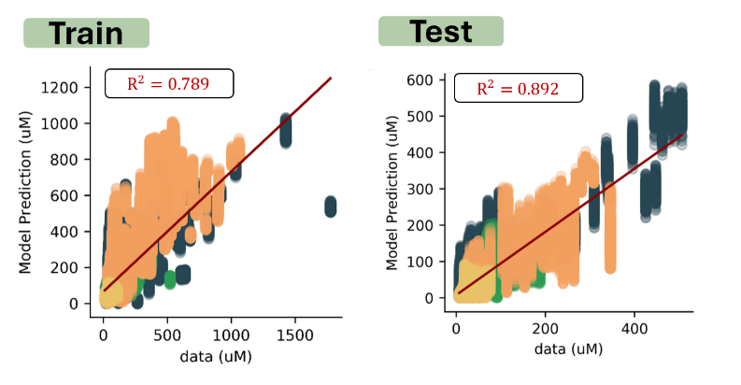
Figure S13. Left; $R^{2}$ value for the fit of the model, there are 2 outliers in the ATP concentrations. Right; R² of the model to the test data 0.892, the model prediction is on the y-axis, the x-axis shows the HPLC data.
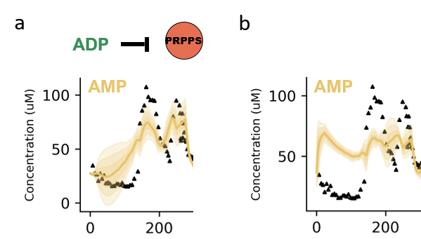
Time (min)
Time (min)
Figure S14. Training two models one including the inhibition of PRPPS by ADP, and one includes no inhibition. Literature overwhelmingly supports the inhibition of the PRPPS enzyme this inhibition is supported by the data obtained from the first iteration of the experimental design procedure already. a) Model fit to data of model that includes PRPPS inhibition. b) Does not have any inhibition term.
The BRENDA database reports on many interactions between enzymes and small molecules. However, some of these interactions have only been observed in a single organism, thus we do not know if this holds true for our specific version of the enzymes as well, additionally more recent research has shown that HK can have a multitude of conformational states¹⁹. In Figure S14 we tested a model without ADP inhibition, which clearly shows poor fits, suggesting that ADP interactions should be kept.

3.3 Additional analyses of the in vitro test data.
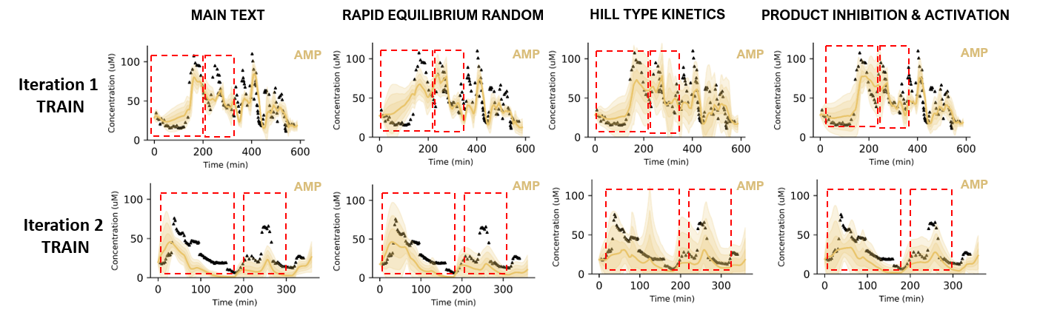
Figure S15. Overview of 3 models, all include production inhibition terms for each enzyme. The first row shows the convergence for the train dataset the second row for the test dataset. The time windows we chose to compare quantitatively in Figure S15 are shown in red. A difference can already be observed, suppose we use hill time kinetics, the responses become more dynamic, but the uncertainty also increases.
BRENDA reports that substrate or product inhibition can occur (albeit for different organisms). It is not inconceivable that products or substrates slow down the required conformational changes of the enzymes especially in a highly dynamic environment, akin to a buffering effect or ‘traffic jam’ on the enzyme¹⁹⁻²⁰. Therefore, we also tested models with added nonlinear substrate and product inhibition terms for each enzyme catalysis of its substrate Figure S15, especially AMP. Thus, we tested kinetic descriptions with Hill coefficients and/or added an activation term for PRPPS and other enzymes and/or expanded the reaction mechanism for all enzymes (reverse equilibrium random kinetics). For the first the source of the nonlinearities can be described using an equation that has no biochemical derivation, it simply maps the sensitivity of substrate conversion given a specific condition inside the reactor. The results are only marginally better in some instances in some time windows, nothing captures these effects ‘perfectly’, therefore the simpler model that includes ADP inhibition was selected.
The flux equation for these models is given by the generalized kinetic description (Equation S8)¹⁰.
$$V=\frac{\left[S1\right]\left[S2\right][Enzyme ]k_{cat}}{Km_{1}Km_{2}(1+ \frac{S1}{Km_{1}})^{n}(1+ \frac{S2}{Km_{2}})^{m}}$$ | (S8)
The equation for the reverse equilibrium random kinetics is given by Equation S9².
$$V=\frac{\left[S1\right]\left[S2\right][Enzyme ]k_{cat}}{KiKb+Ka\left[S2\right]+Kb\left[S1\right]+\left[S1\right][S2]}$$ | (S9)

To give another non-visual comparison we computed the relative goodness of fit for these models for two time windows, 0-200 minutes for the training data and 200-300 minutes for the test data. Figure S16 summarizes these results relative to the main model (absolute difference right bar plot, relative difference left bar plot). It indicates that for some experimental windows (denoted by the red box in Figure S15), these models might be better. The full models are uploaded as SBML files and stored in the GitHub repository.

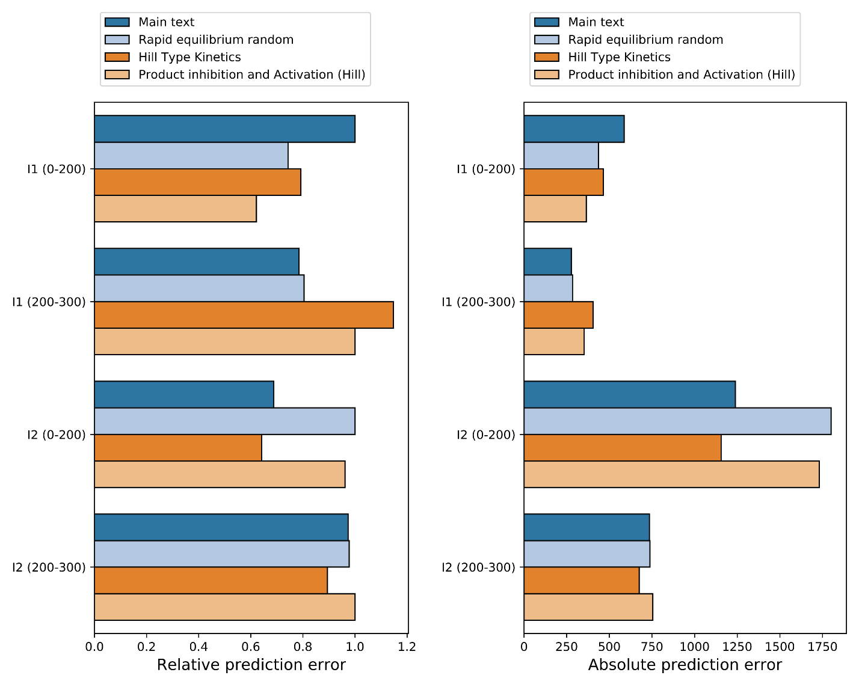
Figure S16. Shows a quantitative analysis of the model prediction with respect to the data. We calculated the least squared errors and plotted as a bar chart (relative and absolute, left and right bar plot respectively) for the time window 0-200 minutes in the training dataset and 200-300 minutes in the test dataset. The model with an activation term concerns the activation of PRPPS by G6P (multiplying the numerator by (1 + [act]/ka)^{n}. For both the first and second model all enzymes are inhibited (or can be) by their own products. The reverse equilibrium random model simply changes the mechanics from ordered to random (adding 2 additional parameters per flux term). Though there are additional degrees of freedom for the last model it does not improve the fit. Overall, this analysis highlights the notion that models on average perform similar but differ in their capacity to map specific regions of the dynamic landscape.

3.4 Application of the model to unlock higher yields in batch.
Here we report the conditions of the final experiments and some additional controls namely the prevalence (or lack thereof) of ATP hydrolysis in buffer. This ensures the observed yield increases can be attributed to the time-dependent inputs as designed by the models. Figure S17 shows the concentrations of ATP in presence of all 5 enzymes (blue) and in the absence of enzymes (orange). We note that the spontaneous hydrolysis of ATP is negligible over the course of the experiment. Notwithstanding that the effect of any spontaneous hydrolysis would very likely mean that the ratio between the control and optimized batch experiment shrinks since there is a base ‘production’ term for AMP which lowers the relative fold change difference. This would render the optimized batch experiments less effective. In total we optimized 100 time dependent batch experiments and selected 3 with different stock concentrations, we manually verified with the other trained models (Figure S15) if a similar difference between optimized and control experiment occurs. The input profile of the batch experiments chosen can be found in the Source Data.
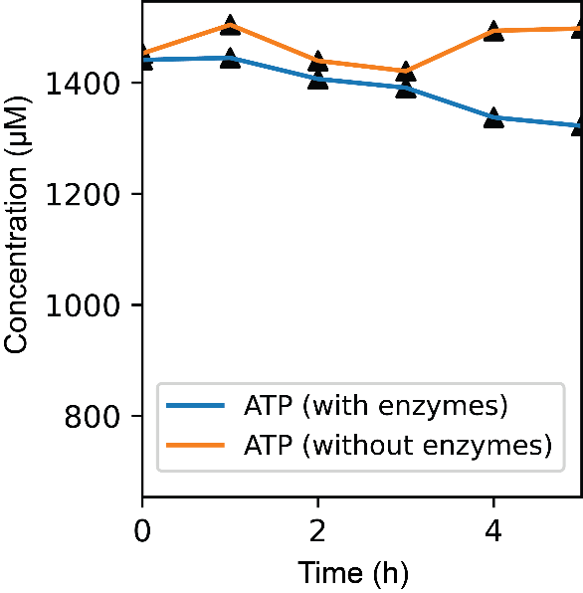
Figure S17. ATP hydrolysis to ADP and AMP over time at 30 °C while shaking: in present of all five PPP enzymes: HK, G6PDH, 6PGDH, PRI and PRPPS (blue) and in absence of PPP enzymes (orange).
Control vs optimized exp in batch description
Optimized time-dependent input experiments and control experiments were performed in batch conditions as described in Supporting information 1.1 except that in control experiments all inputs were added at t=0, while in optimized experiments inputs were added at specific times and volumes as shown in Figure 4a of the main text. Enzyme and substrate stock concentrations are shown in Table S4. At 120 and 150 min reaction time points samples from control and optimized reaction tubes were taken, quenched and measured as described in Supporting information 1.4. Calibration curve for AMP is shown in Figure S18.
Table S4. Overview of the stock concentrations for time-dependent experiments, the relative enzyme concentration is in comparison to Iteration 2 experiment for OED experiment (Table S3).
Experiment number | Enzyme | [Relative Enzyme] | [Absolute Enzyme] | Substrate | [Substrate] (µM)
1 | HK | 0.15 | 0.0045 U/µL | ATP | 4000
1 | G6PDH | 0.15 | 0.0045 U/µL | GLUCOSE | 4000
1 | 6PGDH | 0.15 | 0.1519 U/µL | NADP | 4000
1 | PRI | 0.15 | 0.2550 µg/µL
1 | PRPPS | 0.15 | 0.1458 µg/µL
2 | HK | 0.85 | 0.0255 U/µL | ATP | 3500
2 | G6PDH | 0.85 | 0.0255 U/µL | GLUCOSE | 3500
2 | 6PGDH | 0.85 | 0.0861 U/µL | NADP | 3500
2 | PRI | 0.85 | 1.4450 µg/µL
2 | PRPPS | 0.85 | 0.8262 µg/µL
3 | HK | 0.45 | 0.0135 U/µL | ATP | 2500
3 | G6PDH | 0.45 | 0.135 U/µL | GLUCOSE | 2500
3 | 6PGDH | 0.45 | 0.0456 U/µL | NADP | 2500
3 | PRI | 0.45 | 0.765 µg/µL
3 | PRPPS | 0.45 | 0.4374 µg/µL
Figure S18. Calibration curve correlating concentrations of AMP species to values of HPLC peak area/injection volume for time-dependent control and optimized batch experiments.
Assess state of the batch reaction after sampling.
The model simulated 2 hours of time dependent inputs, to confirm that the system is at steady state or near steady state we took an additional sample 30 minutes after the model determined the reaction to be completed (i.e. the reaction needs to be stopped) at 150 min. Table S5 indicates only minor variations in the concentration of the final product AMP, indicating that the reaction approached thermodynamic equilibrium.
Table S5. Measured AMP concentrations for control and optimized experiments 1-3 at 120 and 150 min time points.
Experiment number |  | [AMP] (µM)
Experiment number |  | At 120 min | At 150 min
1 | Control | 11 | 14
1 | Optimized | 27 | 27
2 | Control | 43 | 49
2 | Optimized | 175 | 168
3 | Control | 17 | 22
3 | Optimized | 97 | 105

4. Supporting information references.
- Nakajima, K., et al. Simultaneous determination of nucleotide sugars with ion-pair reversed-phase HPLC. Glycobiology, 20(7), 865–871 (2010).
- Cook, P. F., & Cleland, W. W. Enzyme kinetics and mechanism. Garland Science (2007).
- de Aguiar, P. F., et al. D-optimal designs. Chemometrics and Intelligent Laboratory Systems, 30(2), 199–210 (1995).
- Sinkoe, A., & Hahn, J. Optimal experimental design for parameter estimation of an IL-6 signaling model. Processes, 5, 49 (2011).
- Fernandez Villaverde, A., et al. Assessment of prediction uncertainty quantification methods in systems biology. IEEE/ACM Transactions on Computational Biology and Bioinformatics, 15455963 (2023).
- Fröhlich, F., et al. AMICI: High-performance sensitivity analysis for large ordinary differential equation models. Bioinformatics, 37(20), 3676–3677 (2021).
- van Sluijs, B., Zhou, T., Helwig, B., Baltussen, M. G., Nelissen, F. H., Heus, H. A., & Huck, W. T. S. Iterative design of training data to control intricate enzymatic reaction networks. Nature Communications, 15(1), 1602 (2024).
- van Sluijs, B., Maas, R. J., van der Linden, A. J., de Greef, T. F., & Huck, W. T. S. A microfluidic optimal experimental design platform for forward design of cell-free genetic networks. Nature Communications, 13(1), 3626 (2022).
- Willemoës, M., Hove-Jensen, B., & Larsen, S. Steady-state kinetic model for the binding of substrates and allosteric effectors to Escherichia coli phosphoribosyl-diphosphate synthase. Journal of Biological Chemistry, 275(45), 35408–35412 (2000).
- Rohwer, J. M., Hanekom, A. J., & Hofmeyr, J. S. A universal rate equation for systems biology. In Proceedings of the 2nd International Symposium on Experimental Standard Conditions of Enzyme Characterizations (ESEC 2006) (pp. Beilstein Institute, Frankfurt am Main, Germany) (2007).
- Arthur, P. K., Alvarado, L. J., & Dayie, T. K. Expression, purification, and analysis of the activity of enzymes from the pentose phosphate pathway. Protein Expression and Purification, 76(2), 229–237 (2011).
- Toews, C. J. Kinetic studies with skeletal-muscle hexokinase. Biochemical Journal, 100(3), 739–744 (1966).
- Velasco, P., et al. Purification, characterization, and kinetic mechanism of glucose-6-phosphate dehydrogenase from mouse liver. The International Journal of Biochemistry, 26(2), 195–200 (1994).
- Hanau, S., et al. 6-Phosphogluconate dehydrogenase mechanism: Evidence for allosteric modulation by substrate. Journal of Biological Chemistry, 285(28), 21366–21371 (2010).
- Rippa, M., et al. 6-Phosphogluconate dehydrogenase: The mechanism of action investigated by a comparison of the enzyme from different species. Biochimica et Biophysica Acta (BBA) - Protein Structure and Molecular Enzymology, 1429(1), 83–92 (1998).
- Chen, J., et al. Ribose-5-phosphate isomerases: Characteristics, structural features, and applications. Applied Microbiology and Biotechnology, 104, 6429–6441 (2020).
- Switzer, R. L. Phosphoribosylpyrophosphate synthetase and related pyrophosphokinases. In P. D. Boyer (Ed.), The Enzymes (3rd ed., Vol. 10, pp. 607–629) (1974).
- Larion, M., et al. Order–disorder transitions govern kinetic cooperativity and allostery of monomeric human glucokinase. PLoS Biology, 10(12), e1001452 (2012).
- Molnes, J., et al. Binding of ATP at the active site of human pancreatic glucokinase: Nucleotide-induced conformational changes with possible implications for its kinetic cooperativity. The FEBS Journal, 278(13), 2372–2386 (2011).
- Rondelez, Y. Competition for catalytic resources alters biological network dynamics. Physical Review Letters, 108(1), 018102 (2012).
- Sakai, A., et al. Cell-free expression system derived from a near-minimal synthetic bacterium. ACS Synthetic Biology, 12(6), 1616–1623 (2023).
- Hu, X., et al. ARTseq-FISH reveals position-dependent differences in gene expression of micropatterned mESCs. Nature Communications, 15(1), 3918 (2024).
- Hu, X., et al. Protocol for simultaneous detection of mRNAs and (phospho-) proteins with ARTseq-FISH in mouse embryonic stem cells. STAR Protocols, 5(4), 103336 (2024).

