Table captions
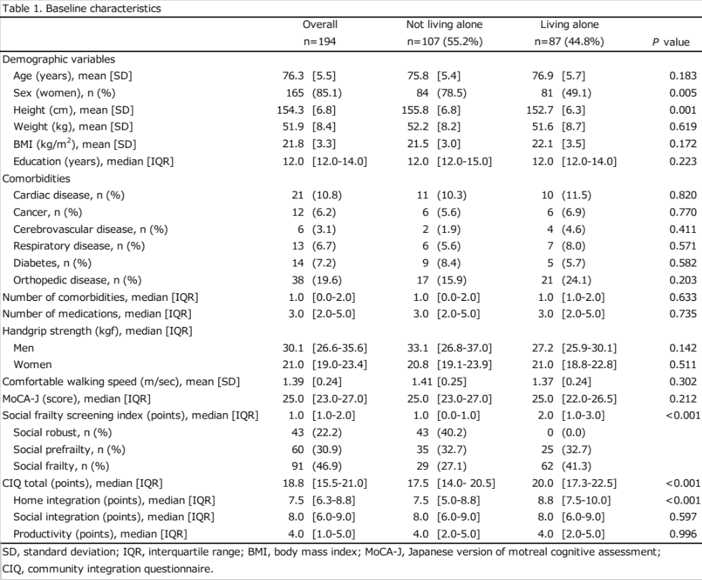
Table1. Baseline characteristics

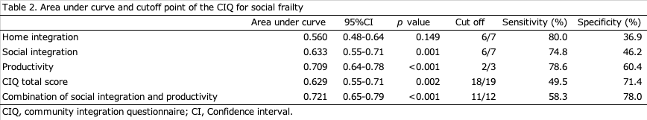
Table2. Area under curve and cutoff point of the CIQ for social frailty

