Supplementary Information

Phage-host interaction dynamics in a full-scale wastewater treatment plant: significant impact of bleaching treatment

This file includes Figures S1 to S6.

Supplementary Figure 1 of 6.
Figure S1. Principal coordinate analysis (PCoA) ordination of bacterial community composition before and after the addition of bleach with 95% confidence ellipse.

Supplementary Figure 2 of 6.
Figure S2. Taxonomy distribution of predictable hosts associated with the identified viral clusters (VCs).

Supplementary Figure 3 of 6.
Figure S3. Virus-host pairs (VHPs) displaying inverse host and virus abundance changing patterns before (2007-2009) and after (2010-2015) the bleaching event. The symbols above the bars denote significance levels as follows: “***” represents P < 0.001, “**” represents P < 0.01 and > 0.001, “*” represents P < 0.05 and > 0.01.

Supplementary Figure 4 of 6.
Figure S4. Linear regression of log-transformed viral and host abundances (RPKM) of the virus-host pairs (VHPs) associated with sludge foaming before (2007-2009) and after (2010-2015) the bleaching event. The black dashed line represents a slope of 1 and the gray dashed line represents the linear regression relationship over the whole sampling period (2007-2015).

Supplementary Figure 5 of 6.
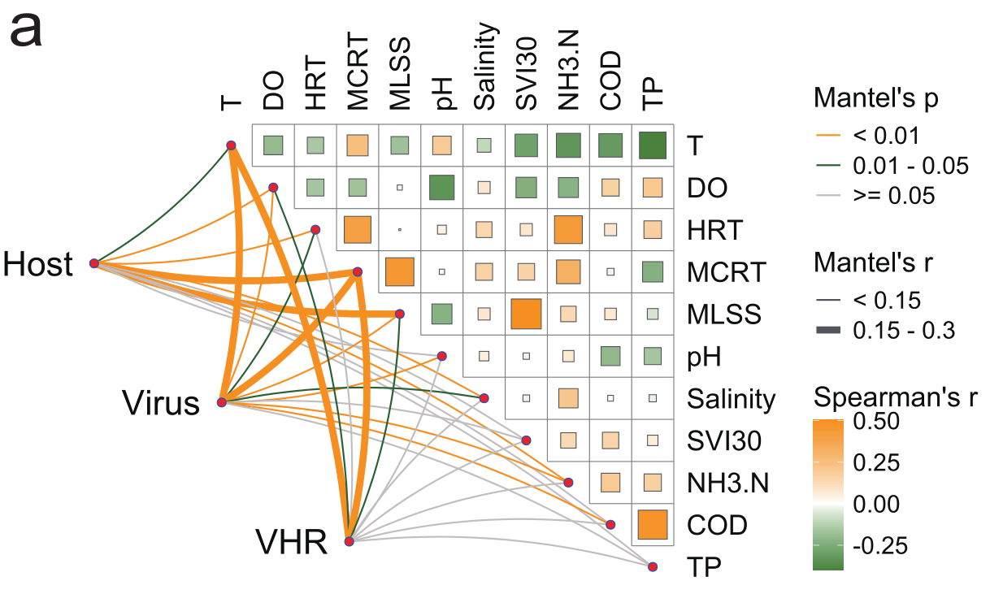
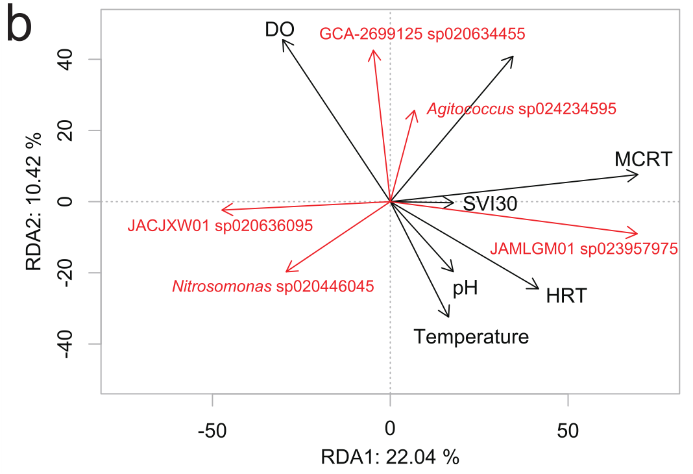
Figure S5. Correlations between environmental factors and virus-to-host ratios (VHRs). (a) Correlation matrix of environmental factors and Mantel test results. The upper triangle shows the pairwise comparisons of environmental factors, with a color gradient denoting Spearman’s correlation coefficient. Host abundances, virus abundances and VHRs were related to each environmental factor using a Mantel test. Line color represents statistical significance, and line width denotes Mantel’s r statistic for the corresponding distance correlations. (b) dbRDA analysis of the correlation between VHR and various environmental factors. The red vectors represent virus-host pairs, while the black vector lines represent environmental factors.

Supplementary Figure 6 of 6.
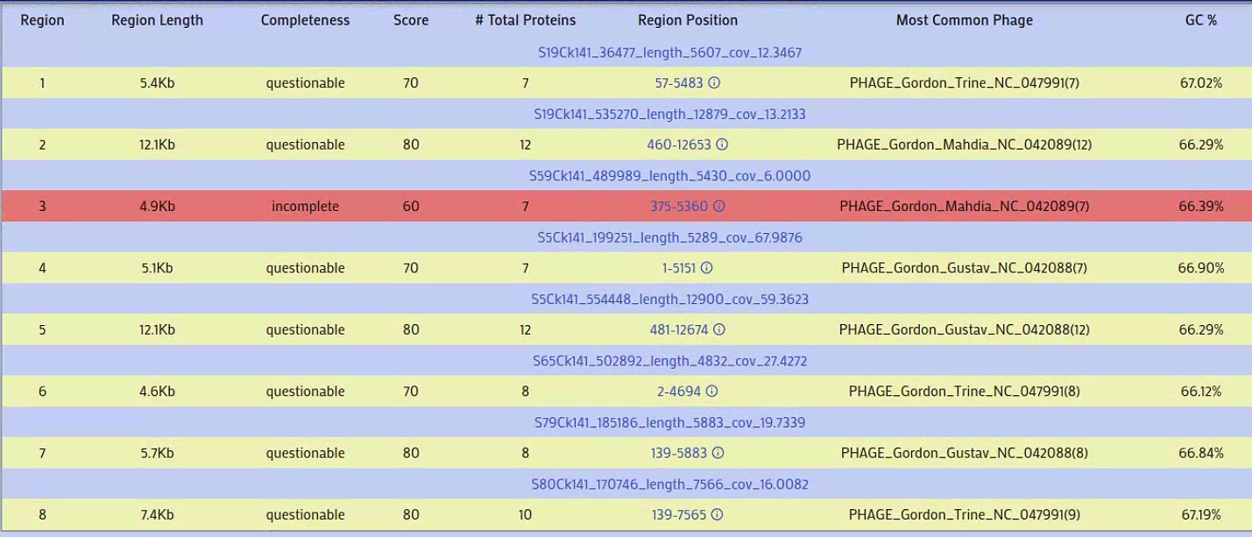
Figure S6. PHASTEST analysis for the Gordonia sp020438995-related viral cluster.

