Structural and Biochemical Characterization of Grimontia hollisae Thermostable Direct Hemolysin with DNA Reveals First Vibrio Hemolysin with Nuclease Activity

Supplementary Information
Table of contents
- Supplementary Tables
Supplementary Table 1. Nucleic acid substrates used for nuclease activity, LC-ESI-MS analysis and Bio-Layer Interferometry (BLI). ……………………………………………………………………2
Supplementary Table 2. Crystallization conditions of different Gh-TDH-DNA complexes. ……….3
Supplementary Table 3. Crystallographic data and refinement statistics. …………………………..4
- Supplementary Figures
Supplementary Fig. 1. Ribonuclease activity of Gh-TDH. ………………………………………….5
Supplementary Fig. 2. Characterization of the base preference of Gh-TDH nuclease activity. …….6
Supplementary Fig. 3. Effect of divalent metal ions on Gh-TDH 3'–5' nuclease activity. ………….7
Supplementary Fig. 4. Superposition of the Gh-TDH (blue, PDB entry: 4WX3) and complex I (green) structures. …………………………………………………………………………………………...8
Supplementary Fig. 5. Kinetic binding curves of Gh-TDH variants interacting with stem-loop DNA. ………………………………………………………………………………………………..9
Supplementary Fig. 6. The water molecules in the active site and the proposed mechanism of DNA cleavage. …………………………………………………………………………………………...10

1
Supplementary Table 1. Nucleic acid substrates used for nuclease activity, LC-ESI-MS analysis and Bio-Layer Interferometry (BLI).
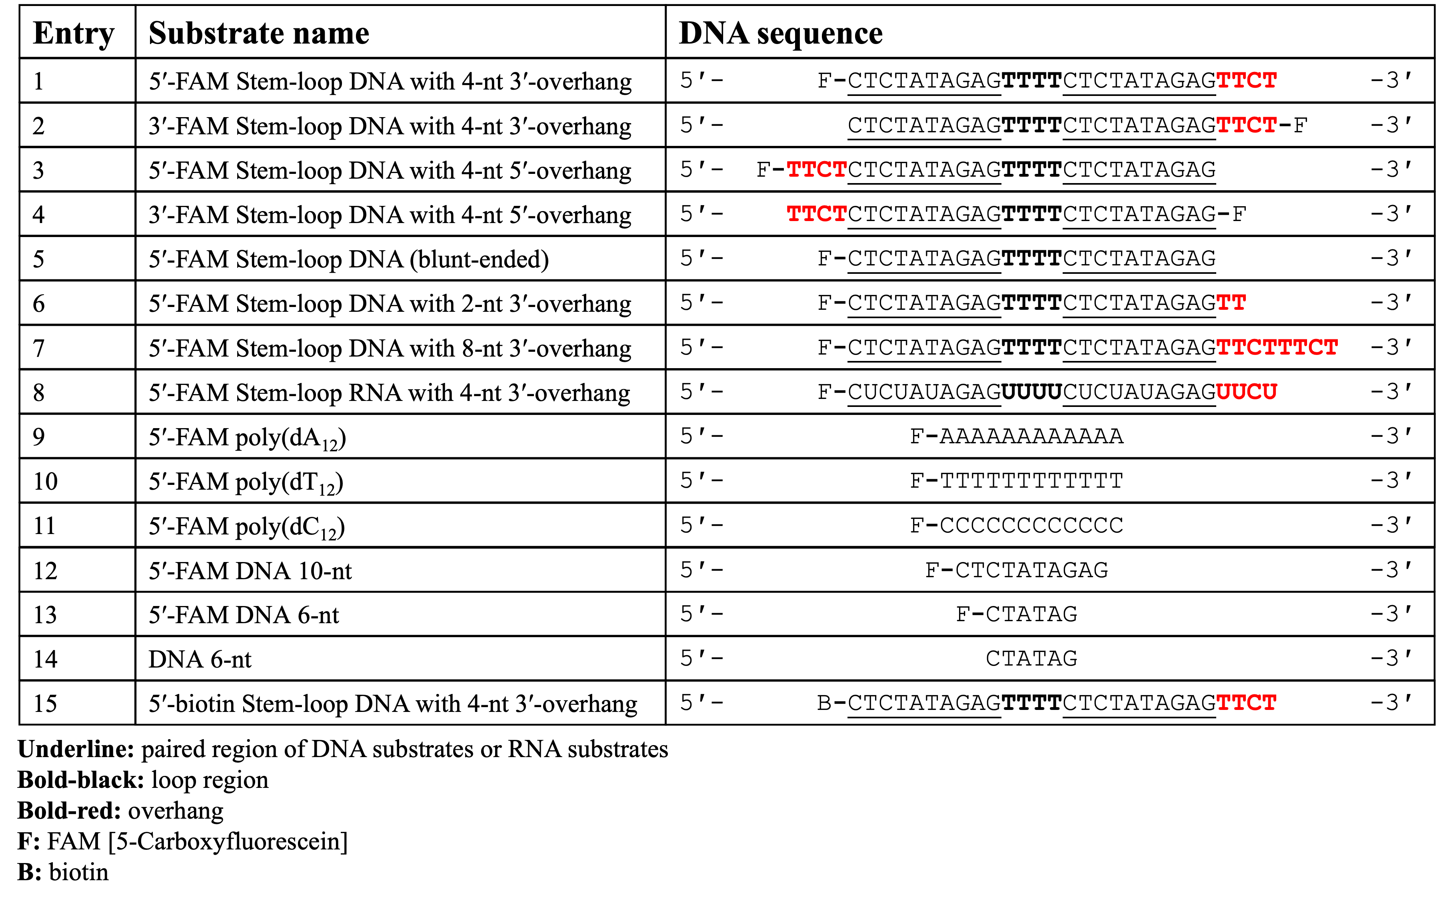

2
Supplementary Table 2. Crystallization conditions of different Gh-TDH-DNA complexes.
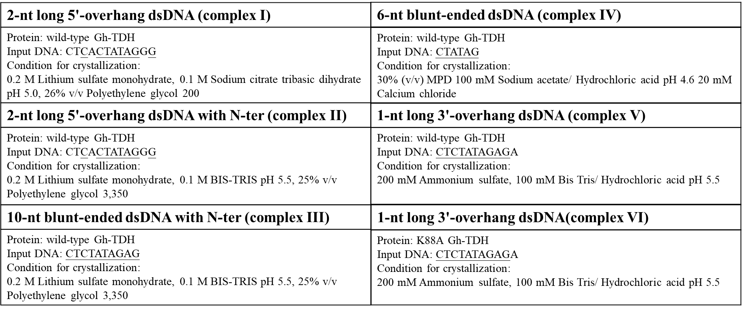
Underline: paired region of DNA substrates

3
Supplementary Table 3. Crystallographic data and refinement statistics.
 | Complex I | Complex II | Complex III | Complex IV | Complex V | Complex VI
Data collection
Space group | P42₁2 | P42₁2 | P42₁2 | C222₁ | P2₁ | P2₁
Cell dimensions
a, b, c (Å) | 79.65, 79.65, 74.24 | 79.71, 79.71, 74.85 | 79.73, 79.73, 75.43 | 112.84, 122.56, 60.84 | 79.79, 61.64, 113.46 | 81.60, 61.66, 113.28
α, β, γ (°) | 90.00, 90.00, 90.00 | 90.00, 90.00, 90.00 | 90.00, 90.00, 90.00 | 90.00, 90.00, 90.00 | 90.00, 104.67, 90.00 | 90.00, 106.62, 90.00
Resolution (Å) | 25.70–1.58 (1.61–1.58) | 25.22–1.37 (1.42–1.37) | 25.07–1.42(1.47–1.42) | 27.67–1.82 (1.85–1.82) | 28.23–2.32 (2.40–2.32) | 29.78–2.71 (2.74–2.69)
R_{sym} or R_{merge} | 6.8 (82.5) | 4.5 (48.7) | 5.8 (58.8) | 7.2 (47.2) | 5.2 (34.1) | 8.8 (43.3)
I / σΙ | 41.3 (3.8) | 37.5 (4.0) | 31.7 (2.8) | 26.0 (3.6) | 20.4 (3.0) | 11.0 (2.1)
Completeness (%) | 100.0 (100) | 100.0 (100.0) | 99.7 (100.0) | 99.9 (98.6) | 99.2 (99.3) | 85.1 (98.0)
Redundancy | 12.4 (12.5) | 8.9 (8.9) | 7.9 (7.9) | 7.3 (6.6) | 3.3 (3.1) | 2.7 (3.0)
Refinement
Resolution (Å) | 25.70–1.58 | 25.22–1.37 | 25.07–1.42 | 27.67–1.82 | 28.23–2.32 | 29.78–2.71
No. reflections | 31868 | 47798 | 43011 | 33650 | 41292 | 20729
R_{work} / R_{free} | 0.185/0.197 | 0.186/0.199 | 0.185/0.205 | 0.165/0.195 | 0.215/0.251 | 0.248/0.317
No. atoms
Protein | 1241 | 1300 | 1252 | 2467 | 4810 | 4713
DNA | 243 | 243 | 202 | 119 | 446 | 446
Water | 148 | 212 | 174 | 218 | 187 | 62
B-factors
Protein | 14.4 | 15.3 | 15.9 | 21.9 | 33.3 | 46.7
DNA | 45.6 | 35.9 | 40.8 | 50.8 | 77.2 | 86.3
Water | 25.5 | 28.2 | 26.3 | 31.0 | 34.8 | 38.2
R.m.s. deviations
Bond lengths (Å) | 0.0035 | 0.0036 | 0.0047 | 0.0093 | 0.0073 | 0.0049
Bond angles (°) | 1.15 | 1.18 | 1.20 | 1.47 | 1.46 | 1.15
4
Supplementary Fig. 1. Ribonuclease activity of Gh-TDH. a, Comparison of Gh-TDH nuclease activity on DNA and RNA. Specific activity against DNA (Fig. 1a, lane 3) and RNA was measured with 5 µM Gh-TDH. Mean ± SD (n = 3) was shown. b, Serial dilutions of Gh-TDH (1.25, 2.5, 5, 10, and 20 µM) were incubated with 0.5 µM FAM-labeled stem-loop dsRNA substrate.
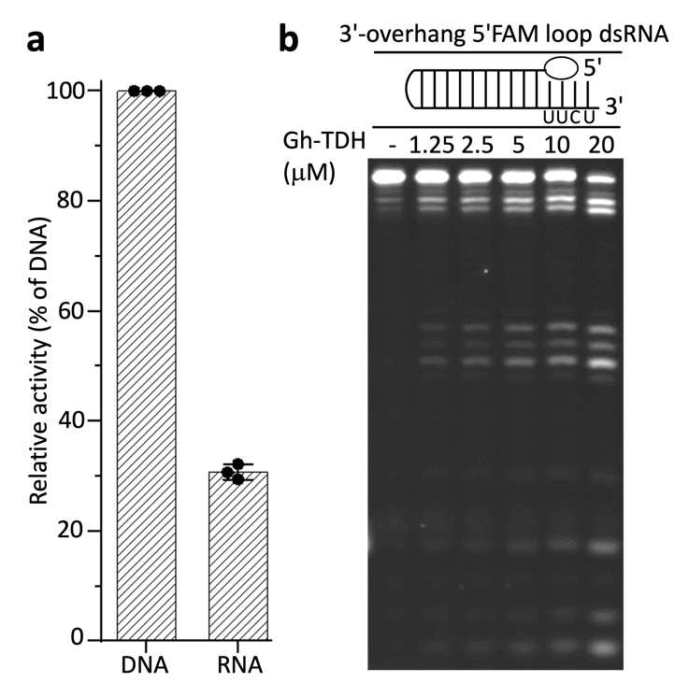

5
Supplementary Fig. 2. Characterization of the base preference of Gh-TDH nuclease activity. a, Nuclease activity of Gh-TDH digested poly(dA₁₂). b, Nuclease activity of Gh-TDH digested poly(dT₁₂). c, Nuclease activity of Gh-TDH digested poly(dC₁₂). 10 µM Gh-TDH and poly(dN₁₂) were incubated at 37 ºC for 60 min, with gel samples taken every 10 min. All ssDNA was cleaved by Gh-TDH until 3 nucleotides remain.
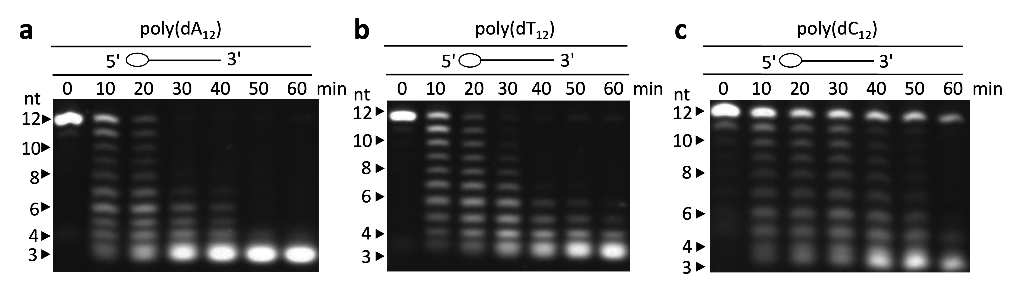

6
Supplementary Fig. 3. Effect of divalent metal ions on Gh-TDH 3'–5' nuclease activity. a, Effect of different divalent metal ions on Gh-TDH nuclease activity. b, Concentration-dependent effects of Mg²⁺ on Gh-TDH nuclease activity. c, The final product of DNA after Gh-TDH cleavage. The final DNA product length matches that of the synthetic nucleotide CTA 3-mer (lane M).
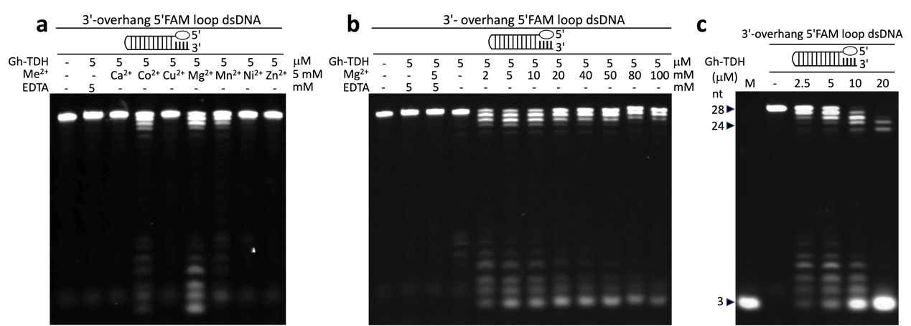

7
Supplementary Fig. 4. Superposition of the Gh-TDH (blue, PDB entry: 4WX3) and complex I (green) structures. a, The central pore size of both structures was calculated based on the distance of the α-carbon on Gly12 in the tetrameric Gh-TDH. The rotation axes of Protomer I in both Gh-TDH and complex I are highlighted in red text. The red arrow shows the counterclockwise rotation and conformational change of tetrameric Gh-TDH, taking the conformational change of β6 as an example. b, Detailed view of the conformational change in the β-hairpin (⁸⁷YKDG⁹⁰) between Gh-TDH and complex I.
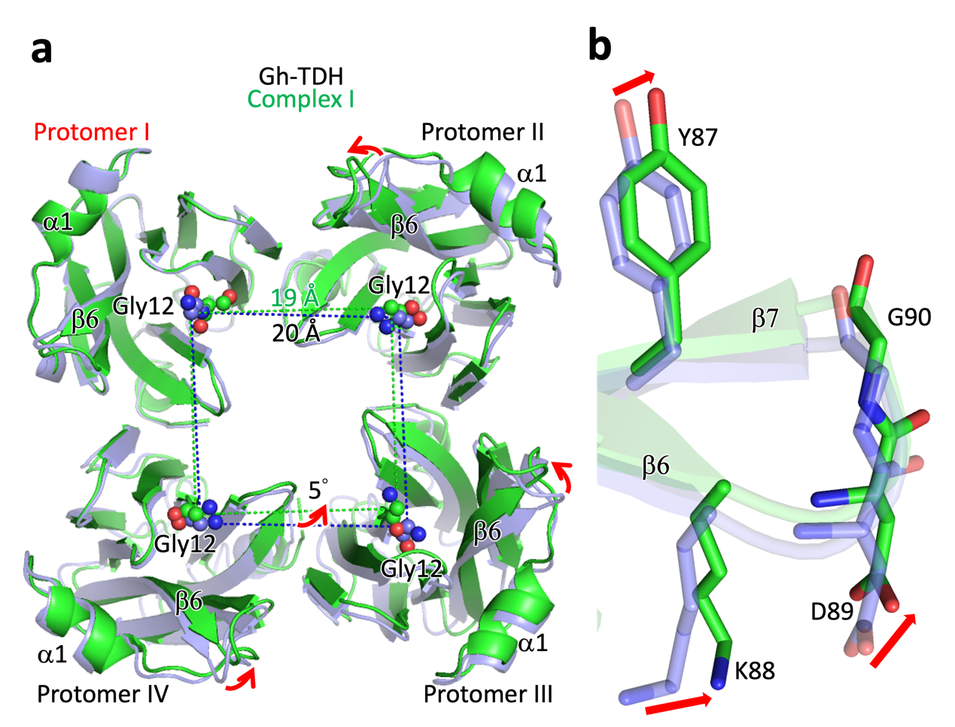

Supplementary Fig. 5. Kinetic binding curves of Gh-TDH variants interacting with stem-loop DNA. a, and b, Binding curves of 5′-biotin stem-loop DNA with 4-nt 3′-overhang to Gh-TDH WT and the K88A variant. The x-axis represents the reaction time, while the y-axis indicates the BLI signal. The binding curves of five protein concentrations (10, 20, 30, 40, and 50 μM) are colored in brown, yellow, green, blue-green and dark blue, respectively. c, The K_{D}, K_{on}, K_{off} value of stem-loop DNA with WT and the K88A variant.
8
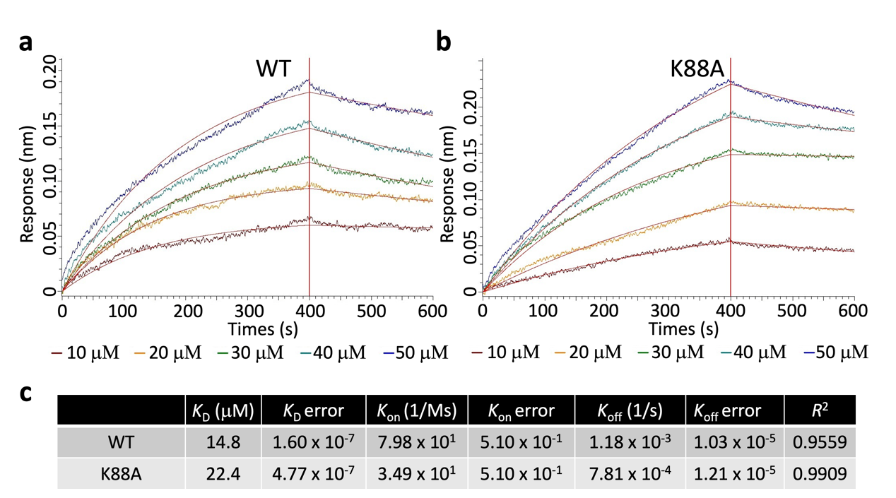

9
Supplementary Fig. 6. The water molecules in the active site and relative nuclease activities of the selected mutants. Local view of the proposed active site in a–f, complexes I–VI. DNA are displayed in white sticks. Putative residues involved in DNA cleavage are shown in blue sticks. The cartoon is in a transparent mode. The omitted electron density maps (2F_{o}−F_{c}, 1.0 σ) of the water network for W₁, W₂, W₃, and W₄ are shown as blue mesh. g, Mutagenesis analysis of the Gh-TDH variants. Relative activities of Gh-TDH variants (D89N, D117N, and D117N/E118Q) were compared with wild-type Gh-TDH in digesting 5′-FAM stem-loop DNA with 4-nt 3′-overhang. Each of the activity assays was performed in triplicate (n=3) and the data were presented as mean value ± standard error of the mean (SEM).
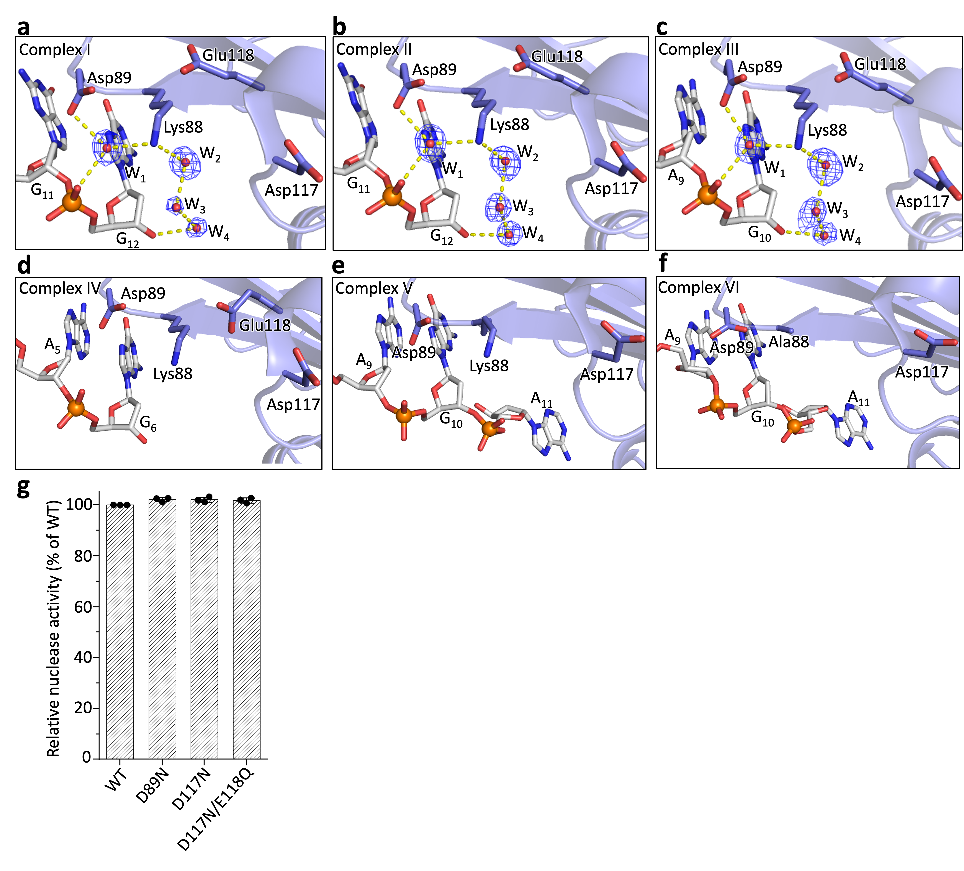
10

