Supplementary Table 1. Trends in number of cases of Birth Asphyxia and mortality in newborns with Birth Asphyxia over 18 months
Quarterly period | Pre- Intervention  OCT-DEC 2019 | Q1  JAN-MAR  2020 | Q2  APR-JUN  2020 | Q3  JUL-SEP  2020 | Q4  OCT-DEC  2020 | Q5  JAN-MAR  2021 | Total
Total live birth | 2223 | 2082 | 2311 | 1869 | 2220 | 1997 | 12702
Birth Asphyxia cases | 460  20.7% | 406  19.5% | 407  17.6% | 360  19.3% | 416  18.7% | 347  17.4% | 2397  18.9%
Apgar score ≤ 3 | 64  13.9% | 49  12.1% | 58  14.3% | 59  16.4% | 70  16.8% | 52  15.0% | 352  14.7%
Deaths in neonates with Birth Asphyxia | 7  1.5% | 11  2.7% | 14  3.4% | 11  3.1% | 19  4.6% | 9  2.6% | 71  2.9%

Supplementary Figure 1. Incidence of Birth Asphyxia each quarter by hospital
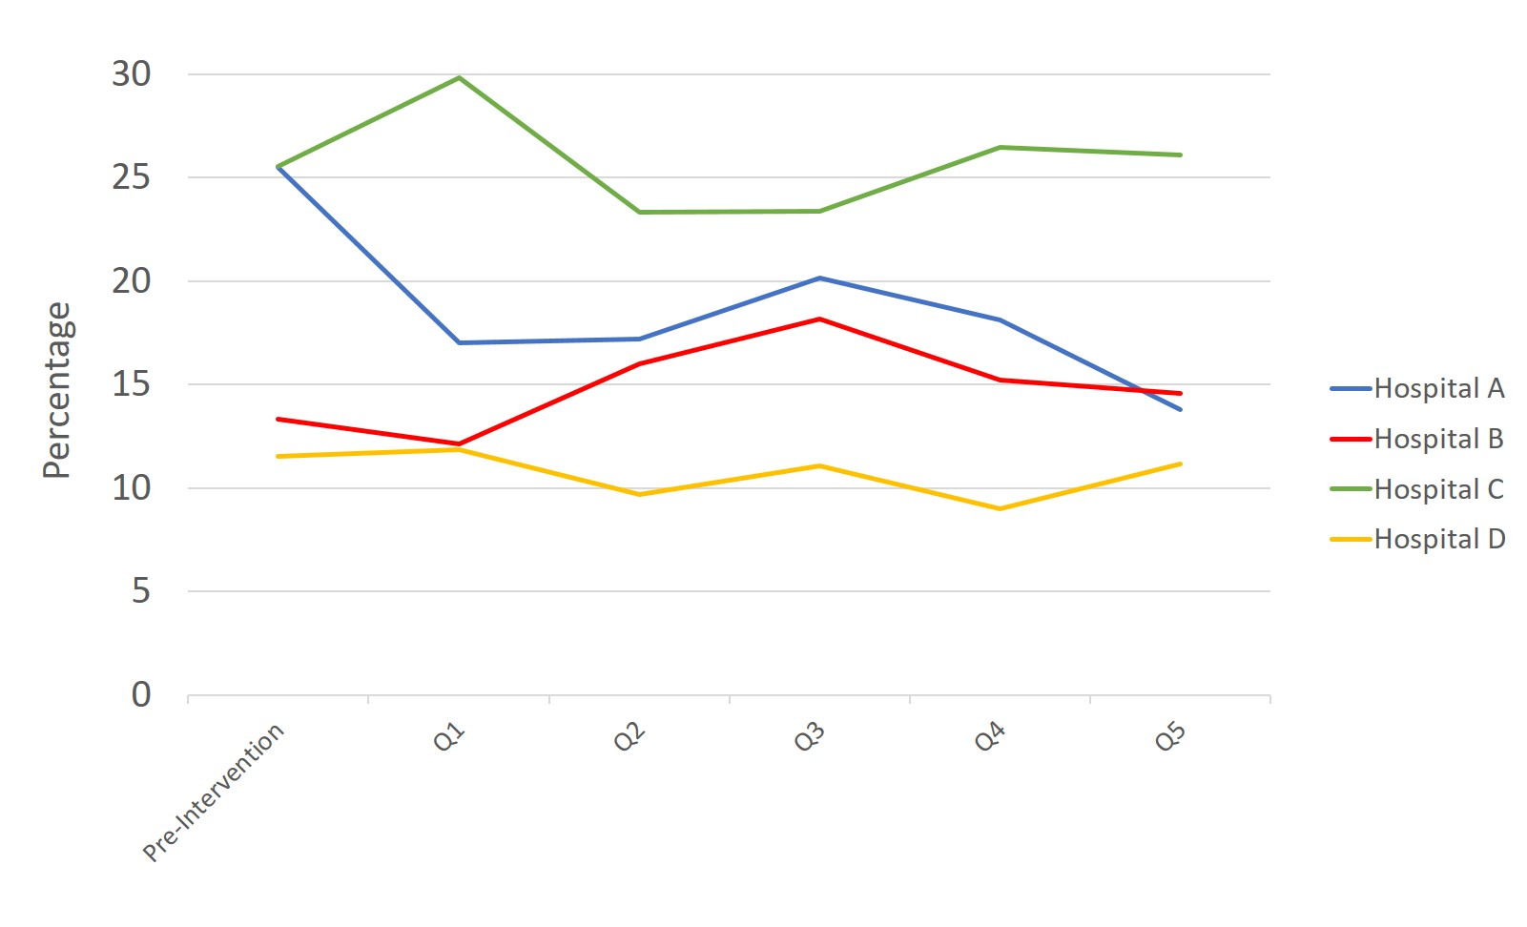

Supplementary Figure 2. Improvement in Apgar score to 7 or more by 5 minutes in newborns in the four Ghana hospitals over 18 months
