List of supplementary Files
- supplementary.docx: Supplementary information to main manuscript
- datasets_formatted.zip: All datasets used in the manuscript formatted to comply OMEx input format
- omex_sydor_comparison.zip: Results generated for the comparison of OMEx and its original implementation by Sydor et al. [1]
- benchmarking_results.zip: All results generated by OMEx for the comparison with other molecule selection methods
- selected_molecule_identification.zip: Output from Workbench4Metabolomics [2] and UniProt [3] queries for the annotation of molecule panels found in the comparison of molecule selection methods

Detailed description of OMEx Algorithm
The Omics Molecule Extractor combines different machine-learning techniques (figure 1). The main objective is to determine a small set of molecules allowing for the best separation of samples (e.g., patients) into their associated categories, for example, control and disease. Diagonal Linear Discriminant Analysis (d-LDA) is used for classification, which has proven to be computationally lightweight but sufficiently accurate on a metaproteomics dataset compared to other classification methods [1]. Molecules for classification are selected based on a p-value filter and a wrapper [1].
The p-value filter performs a statistical test (two-sample t-test) on each molecule independently, to determine molecules with significantly different magnitudes among the categories. The greater the difference in the molecule distribution between the classes, the smaller the p-value of the test. Subsequently, features below a specified p-value cutoff are filtered and provided to the wrapper. The selection of molecules is done in a five-fold cross-validation setting, i.e., four folds of randomly selected samples are used to determine p-values and train the classifier, and one fold is used to test the classifier accuracy. This process is done five times, iterating through the five folds so that each fold has been used for testing once, while remaining folds were used for training, respectively. Classification accuracy is evaluated at different p-value cutoffs (e.g., 0.0001, 0.001, 0.005, etc.) to assess an appropriate cutoff value. Lastly, the average number of selected molecules and average accuracy are reported for each cutoff.
The wrapper iteratively adds molecules to a panel of molecules used for classification. Firstly, the input dataset is divided randomly into five cross-validation folds, of which four are used for training and one for testing. Using data from the training fold, the wrapper starts with molecules with low p-values, adds them to a panel, trains the classifier on this panel, determines classification accuracy using the test fold, repeats until the classifier accuracy does not increase anymore, and reports how often specific molecule panels and individual molecules were chosen by the classifier. Usually, this results in panels containing less than ten molecules. Subsequently, the training and test sets shift to the next fold, and the process is repeated until the complete dataset has been used for testing. As samples are assigned randomly to their folds, the output of each wrapper run can be different, but well-separating molecules will be chosen more likely than others. By repeating the cross-validation step, for example 1,000 times, panels and individual molecules can be ranked by how often they were picked by the classifier.
An advantage of the wrapper over p-value filtering is that combinations of molecules are considered in the classification. However, wrapping is a computationally expensive technique. Therefore, the preceding p-value filtering reduces the total computation time. The most frequently chosen panels/molecules are considered to be potential biomarkers. As a last step, independent test samples are classified using the selected molecules to evaluate their predictive power based on classification metrics (accuracy, precision, recall, f1 score). Additionally, a Principal Component Analysis (PCA) and hierarchical clustering are performed based on the selected molecules to visualize their capability of separating the groups.

Creation of synthetic Datasets
To validate the applicability of the proposed tool, we applied synthetic data to measure the detection rate of relevant molecules identified by our tool. Therefore, we created a synthetic data-set generator that creates several measurement matrices that consist of two groups (e.g., healthy and disease) encoded in the columns and several molecules representing molecules encoded in the rows. Values in some rows will be systematically differently distributed between groupings, the relevant molecules, and values in other rows will be equally distributed between groupings, the non-relevant molecules. The measurement matrix will be presented to the OMEx modules to identify the (hidden) relevant molecule measurements. Subsequently, the prediction will be compared to the ground-truth information from the synthetic data-set generator to evaluate the detection rate. It has to be stated in all clarity that real-life processes are more complex. This artificial evaluation rather indicates the usefulness of the tool in a theoretical/hypothetical sense. Therefore, additional verification of the performance on real-life data is needed, and it can be found in the main paper. The described approach is depicted in figure 1.
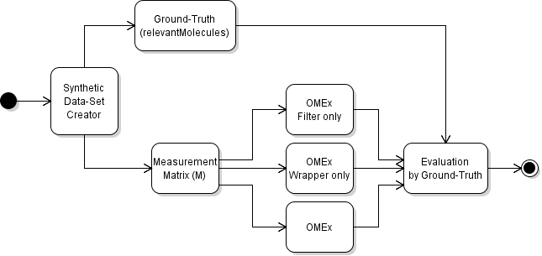
Figure 1: The diagram of the proof-of-concept study of the proposed OMEx tool using a synthetic data set generator.
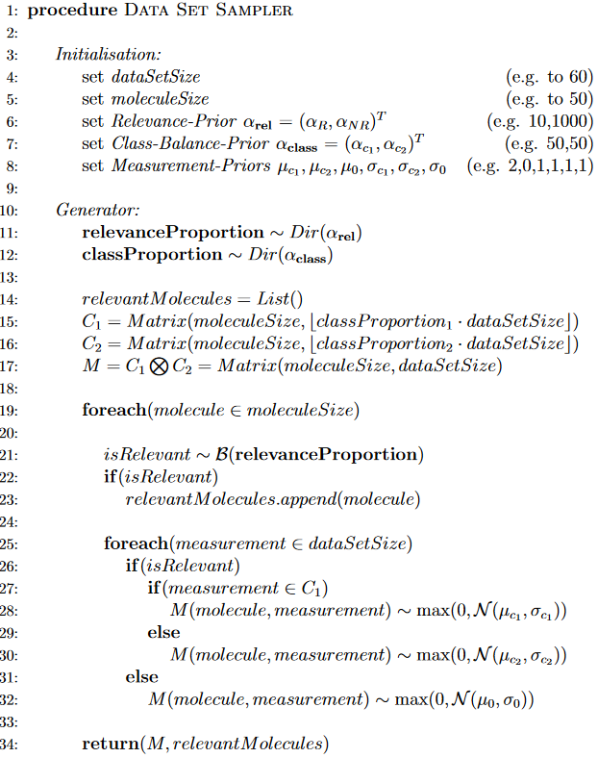
The artificial data generator (see pseudocode in figure 2) is based on exploiting sequences of (pseudo) random numbers. This technique is also known as sampling. For the sampling sequence, we need to introduce some restricting assumptions. Each data point belongs to exactly one group/class, and this assignment follows a Bernoulli-Distribution [B], in case of two classes, e.g., C1 and C2. The balance of these groupings is encoded by the distribution’s parameter that is connected with its Conjugate Prior (a Dirichlet-Distribution [Dir]). Each molecule within the data set belongs to a latent grouping, being either relevant or non-relevant. Therefore, this assignment follows another Bernoulli-Distribution [B] with a distribution’s parameter conjugated to its own Conjugate Prior (a Dirichlet-Distribution [Dir]). We further assume that molecules are drawn from Normal-Distributions [N]. In the case of non-relevant molecules, they follow a shared distribution N(µ0,σ); In the case of relevant molecules, they follow class-specific distributions N(µc1,σ) and N(µc2,σ) (figure 3). The distribution parameters for µ’s and σ’s can be adjusted by the user. We choose the simple parametrization that can be found in figure 2. Further, we restrict sampled values to be non-negative by setting negative samples to zero. This step was incorporated to emulate missing measurements indicated by the zero, exactly as it can be found in the real-life data sets used in our work. With these basic assumptions set, we can create sampled datasets to evaluate the proposed tool by exploiting the information stored about the sampling process. By repeating this procedure multiple times, one can create several artificially generated data sets to evaluate the molecule selection algorithm.

Figure 2 The function generates a sampled data set for the described properties. A tupel will be returned for the measurement matrix itself and a list of the relevant molecules.

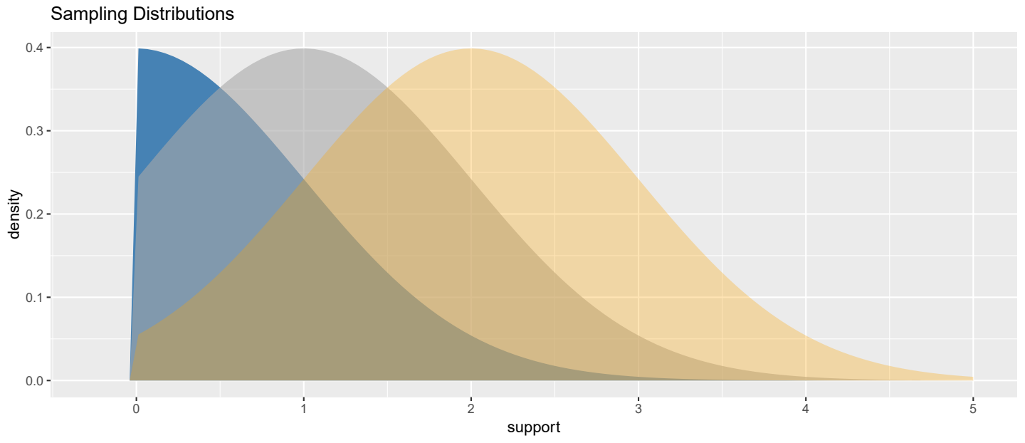
Figure 3 Overlapping distribution of molecules produced by the sampler. The x-axis (support) corresponds to the values that can be sampled for artificial molecules, the y-axis (density) corresponds to the probability of sampling one specific value. Non-relevant molecules share the gray distribution in the middle across both groups. Relevant molecules have class-specific distributions (blue & yellow). All distributions share a reasonable overlap, making the task not unrealistically easy.

Evaluation of the algorithm using synthetic datasets
We applied the sampling approach from section 2 to generate artificial data sets for an initial evaluation of the OMEx modules individually and in combination (https://gitlab.com/kay.schallert/mpa-cloud-server/-/tree/master/src/main/java/service/omex/algorithmtest). All results presented are produced by the parametrization depicted in figure 2 and figure 3 exemplary. Within the analysis, 100 artificial data sets were generated. They were restricted to exactly 60 samples (artificial participants, encoded by the variable dataSetSize) with 50 artificial molecules (encoded by moleculeSize). We enforced an equal class balance by setting αc = (50, 50). In addition, the balance of the molecule relevance is strongly enforced to be unequal in favor of non-relevant molecules by setting αr = (10, 100). The molecule generating distribution was set to three distinct Normal Distributions, with a shared µ0 = 1 for the non-relevant molecules and µc1 = 0 & µc2 = 2 for the class-specific and relevant molecules, respectively. All three distributions are instantiated with the unit variance. This results in distinct yet strongly overlapping boundaries (figure 3).
The generated synthetic datasets were subjected to the filter and wrapper individually, as well as to their combination. The numbers of molecules predicted as “relevant” (positive) and “non-relevant” (negative) by each stage were compared to their ground-truth groupings resulting in a confusion matrix (table 1).
Table 1 Structure of a confusion matrix.
 |  | prediction
 |  | relevant | non-relevant
ground-truth | relevant | # true positive predictions (TP) | # false positive predictions (FP)
ground-truth | non-relevant | # false negative predictions (FN) | # true negative predictions (TN)

From this comparison, we calculated the precision, and recall. Precision (equation 1) describes whether members predicted as positives (i.e., relevant molecules) are correct (equation 2), and recall describes the capability to find all members of the positive group (equation 3).
$Precision=\frac{true positive predictions}{all positive predictions}= \frac{TP}{TP+FP}$ (1)
$Recall=\frac{true positive predictions}{ground truth positives}= \frac{TP}{TP+FN}$ (2)
All three metrics describe ratios and range from 0 to 1 (the higher, the better). A precision of 0 for example, means that only non-relevant molecules were predicted as relevant, while 1 means that all predicted relevant molecules are indeed relevant. Likewise, a recall of 1 means that all relevant molecules were predicted as relevant, 0 means all relevant molecules were predicted as non-relevant.

OMEx – Filter only
The derived confusion matrix for the filter-only strategy can be found in table 1. The overall accuracy of the filter is high (0.97), however it rather reports too many features as too few, as demonstrated by the high recall of 1 and the low precision of 0.75. These extreme results originate from the near optimal design of the synthetic data set generator (only white-noise, no additional ‘hidden’ processes, ‘statistically perfect’ distributions, etc.). Yet, these results also imply that automatic thresholding by classification accuracy is a viable selection strategy and that the implementation of the proposed tool works in its intended way.
Table 2 Confusion matrix derived from the sampling and the filter stage. Entries are the cumulated results of molecule selections from 100 datasets including 50 molecules and 60 samples. The filter stage rather reports too many molecules as too few.
 |  | prediction
 |  | relevant | non-relevant
ground-truth | relevant | 440 | 141
ground-truth | non-relevant | 0 | 4,419

OMEx – Wrapper only
The derived confusion matrix for the wrapper-only strategy can be found in table 2. Still the accuracy is high with a value of 0.96 but it can be stated that the wrapper rather reports too few features as too many, as demonstrated by the low recall of 0.63 and high precision of 0.88. These results indicate that this molecule selection is a suboptimal strategy to identify all relevant features. Even though, the precision is considerably higher compared to the filter, most of the relevant features will not be reported. Furthermore, the computing time is significantly higher and becomes not practical for more than 150 molecules.
Table 3 Confusion matrix derived from the sampling and the wrapper approach. Entries are the cumulated results of molecule selections from 100 datasets including 50 molecules and 60 samples. The wrapper stage rather reports too few molecules as too many.
 |  | prediction
 |  | relevant | non-relevant
ground-truth | relevant | 280 | 35
ground-truth | non-relevant | 160 | 4,525

OMEx (combined Filter & Wrapper)
The derived Confusion Matrix for OMEx (combined strategy of filter and wrapper) can be found in table 3. The results of section 3.1 and 3.2 implied that the filter and the wrapper strategies comprise complementary strengths and weaknesses. Therefore, an initial filter was applied in a (pre-)filtering stage. The p-value threshold value for filtering was selected by maximal accuracy. The remaining molecules were provided to the wrapper stage for a (post-)filtering. The results indicate that the combined approach produces balanced results with a recall of 0.76 and precision of 0.91 at high accuracy of 0.97. Yet, the combined strategy tends to report rather too few molecules as too many. Therefore, users should inspect multiple high-ranking panels instead of exclusively concentrating on the top ranking one.
Table 4 Confusion matrix derived from the sampling and the combined approach of filter and wrapper (OMEx). Entries are the cumulated results of molecule selections from 100 datasets including 50 molecules and 60 samples. The combined approach produces balanced results compared to the individual strategies.
 |  | prediction
 |  | relevant | non-relevant
ground-truth | relevant | 338 | 31
ground-truth | non-relevant | 102 | 4,529

4 Benchmarking OMEx using five omics datasets
OMEx was tested and compared against its original implementation using a stool metaproteomics dataset [1] and against other molecule selection methods using blood proteomics [4], blood transcriptomics [4], urine metabolomics [5], and glial tumor metabolomics [6] datasets (see main manuscript for a detailed description of datasets). A processed version of the blood transcriptomics dataset was used, which had been used in another classification study [7]. All input datasets were formatted to comply OMEx input format (datasets_formatted.zip).
For every run with OMEx, the automatic mode was run based on the default parameters (table 5).
Table 5 Default parameters for every step of OMEx.
Parameter | value
Data input
Non-sparsity fraction | 0.66
Normalize data | true
split a test set from input data | true
Test set fraction | 0.3
Filter
folds | 5
repeats | 1000
Wrapper
Molecule cutoff | As specified by OMEx
folds | 5
repeats | 1000

For the comparison to the original algorithm three group pairings were run (C vs. NASH, C vs. HCC, NASH vs. HCC) with default parameters, except that 2000 wrapper repeats were used. For the same pairings, runs without test set (split a test set from input data = false) and 1000 wrapper repeats were performed.
For the blood proteomics, urine metabolomics and glial tumor metabolomics datasets, default parameters were used, except that wrapper repeats were set to 2000. For the blood transcriptomics dataset normalization was disabled and wrapper repeats were set to 2000.
Configurations can also be inspected when opening the config.json file contained in the output directory of every OMEx run (omex_sydor_comparison.zip, benchmarking_results.zip).

5 Annotation of molecule panels
We provided the selected panels for the blood proteomics, blood transcriptomics, urine metabolomics and glial tumor metabolomics datasets in the main manuscript. No meta information on molecules was contained in the datasets requiring a manual annotation of molecule identifiers.
For the blood proteomics and blood transcriptomics datasets, gene names were contained in the datasets, which were queried in UniProt [3] (date of access: January 20, 2025). For the two metabolomics datasets, molecule m/z values were present in molecule identifiers and could be input into the Annotation LCMS FIAMS tool on the Workflow4Metabolomics platform [2]. Specifically, the “bank-inhouse” tool was used to annotate m/z values. Parameters can be found in the subdirectories for the respective datasets in “selected_molecule_identification.zip”.

References

[1] | S. Sydor, C. Dandyk, J. Schwerdt, P. Manka, D. Benndorf, T. Lehmann, K. Schallert, M. Wolf, U. Reichl, A. Canbay, L. P. Bechmann und R. Heyer, „Discovering Biomarkers for Non-Alcoholic Steatohepatitis Patients with and without Hepatocellular Carcinoma Using Fecal Metaproteomics,“ International Journal of Molecular Sciences, Bd. 23, p. 8841, August 2022.
[2] | F. Giacomoni, G. Le Corguillé, M. Monsoor, M. Landi, P. Pericard, M. Pétéra, C. Duperier, M. Tremblay-Franco, J.-F. Martin, D. Jacob, S. Goulitquer, E. A. Thévenot und C. Caron, „Workflow4Metabolomics: a collaborative research infrastructure for computational metabolomics,“ Bioinformatics, Bd. 31, p. 1493–1495, December 2014.
[3] | A. Bateman, M.-J. Martin, S. Orchard, M. Magrane, A. Adesina, S. Ahmad, E. H. Bowler-Barnett, H. Bye-A-Jee, D. Carpentier, P. Denny, J. Fan, P. Garmiri, L. J. d. C. Gonzales, A. Hussein, A. Ignatchenko, G. Insana, R. Ishtiaq, V. Joshi, D. Jyothi, S. Kandasaamy, A. Lock, A. Luciani, J. Luo, Y. Lussi, J. S. M. Marin, P. Raposo, D. L. Rice, R. Santos, E. Speretta, J. Stephenson, P. Totoo, N. Tyagi, N. Urakova, P. Vasudev, K. Warner, S. Wijerathne, C. W.-H. Yu, R. Zaru, A. J. Bridge, L. Aimo, G. Argoud-Puy, A. H. Auchincloss, K. B. Axelsen, P. Bansal, D. Baratin, T. M. Batista Neto, M.-C. Blatter, J. T. Bolleman, E. Boutet, L. Breuza, B. C. Gil, C. Casals-Casas, K. C. Echioukh, E. Coudert, B. Cuche, E. de Castro, A. Estreicher, M. L. Famiglietti, M. Feuermann, E. Gasteiger, P. Gaudet, S. Gehant, V. Gerritsen, A. Gos, N. Gruaz, C. Hulo, N. Hyka-Nouspikel, F. Jungo, A. Kerhornou, P. L. Mercier, D. Lieberherr, P. Masson, A. Morgat, S. Paesano, I. Pedruzzi, S. Pilbout, L. Pourcel, S. Poux, M. Pozzato, M. Pruess, N. Redaschi, C. Rivoire, C. J. A. Sigrist, K. Sonesson, S. Sundaram, A. Sveshnikova, C. H. Wu, C. N. Arighi, C. Chen, Y. Chen, H. Huang, K. Laiho, M. Lehvaslaiho, P. McGarvey, D. A. Natale, K. Ross, C. R. Vinayaka, Y. Wang und J. Zhang, „UniProt: the Universal Protein Knowledgebase in 2025,“ Nucleic Acids Research, Bd. 53, p. D609–D617, November 2024.
[4] | S. Tasaki, K. Suzuki, Y. Kassai, M. Takeshita, A. Murota, Y. Kondo, T. Ando, Y. Nakayama, Y. Okuzono, M. Takiguchi, R. Kurisu, T. Miyazaki, K. Yoshimoto, H. Yasuoka, K. Yamaoka, R. Morita, A. Yoshimura, H. Toyoshiba und T. Takeuchi, „Multi-omics monitoring of drug response in rheumatoid arthritis in pursuit of molecular remission,“ Nature Communications, Bd. 9, July 2018.
[5] | E. A. Mathé, A. D. Patterson, M. Haznadar, S. K. Manna, K. W. Krausz, E. D. Bowman, P. G. Shields, J. R. Idle, P. B. Smith, K. Anami, D. G. Kazandjian, E. Hatzakis, F. J. Gonzalez und C. C. Harris, „Noninvasive Urinary Metabolomic Profiling Identifies Diagnostic and Prognostic Markers in Lung Cancer,“ Cancer Research, Bd. 74, p. 3259–3270, June 2014.
[6] | D. Chardin, C. Gille, T. Pourcher, O. Humbert und M. Barlaud, „Learning a confidence score and the latent space of a new supervised autoencoder for diagnosis and prognosis in clinical metabolomic studies,“ BMC Bioinformatics, Bd. 23, September 2022.
[7] | S. Ng, S. Masarone, D. Watson und M. R. Barnes, „The benefits and pitfalls of machine learning for biomarker discovery,“ Cell and Tissue Research, Bd. 394, p. 17–31, July 2023.

