Supplementary figures
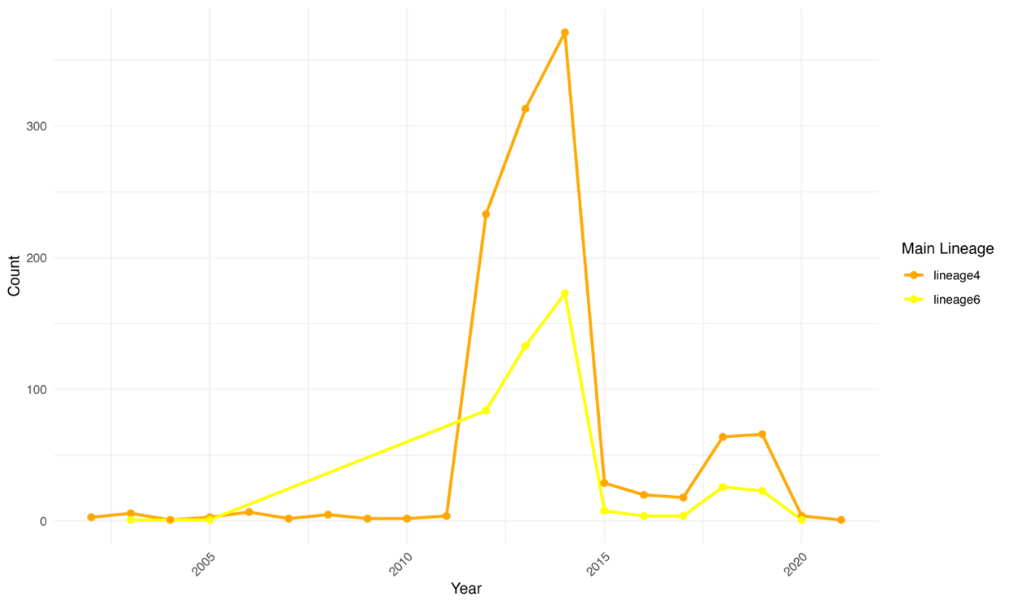

S1 Figure: Distribution of MTBC lineage 6 and 4 from 2002 to 2021.

A
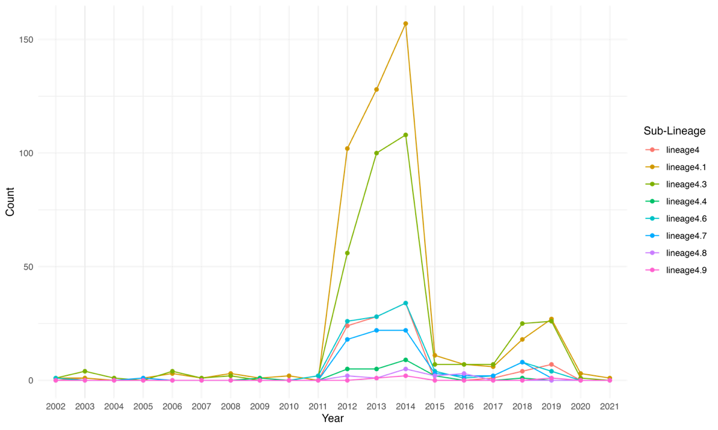

B

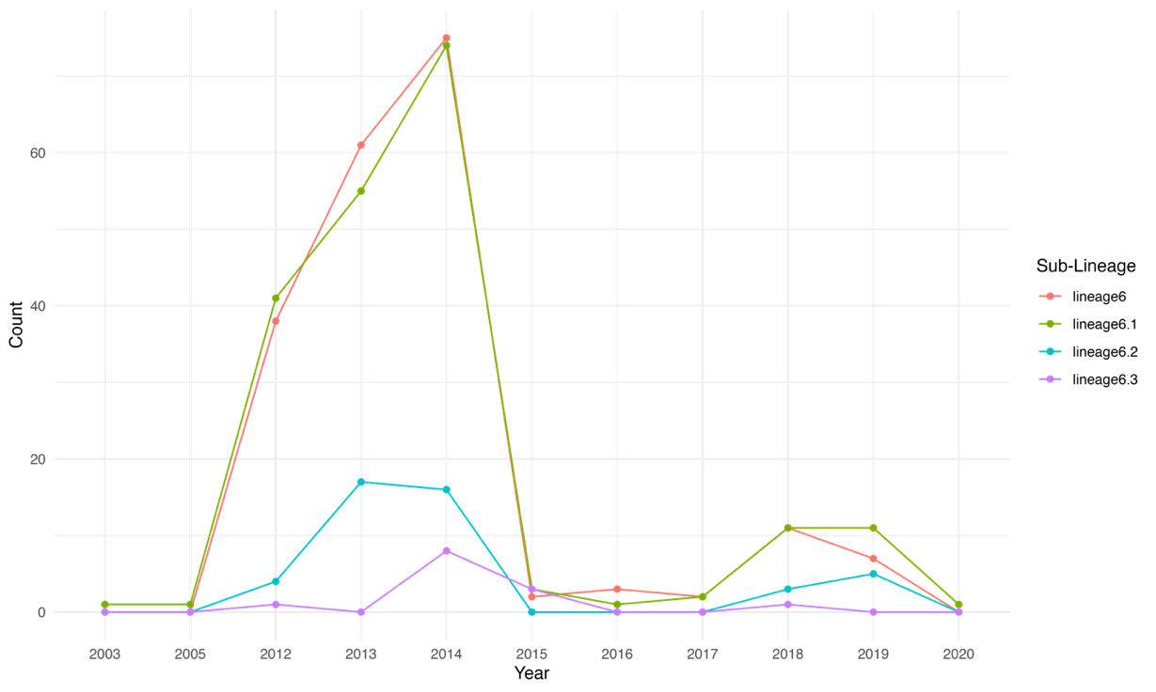

S2 Figure: Distribution of MTBC sub-lineages from 2002 to 2020. (A) MTBC lineage4 and (B) MTBC lineage6

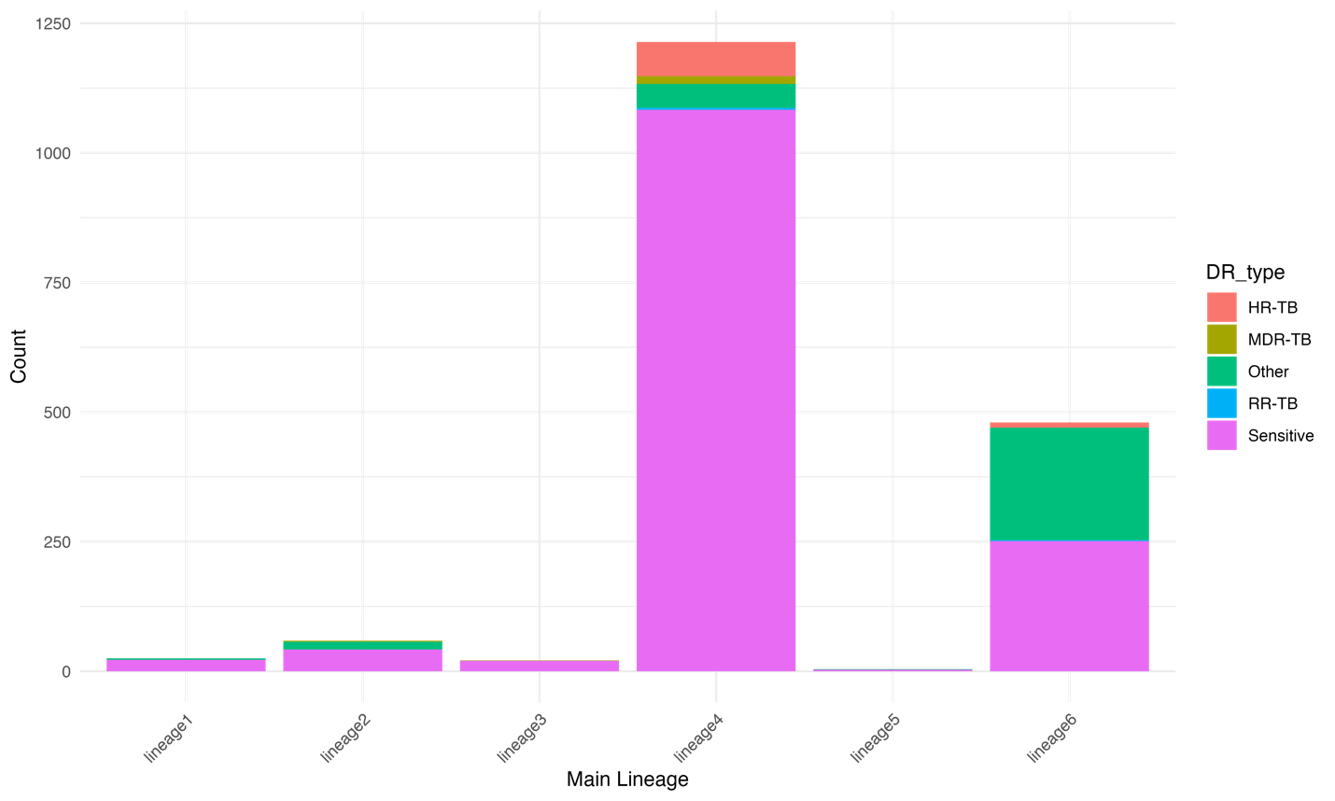

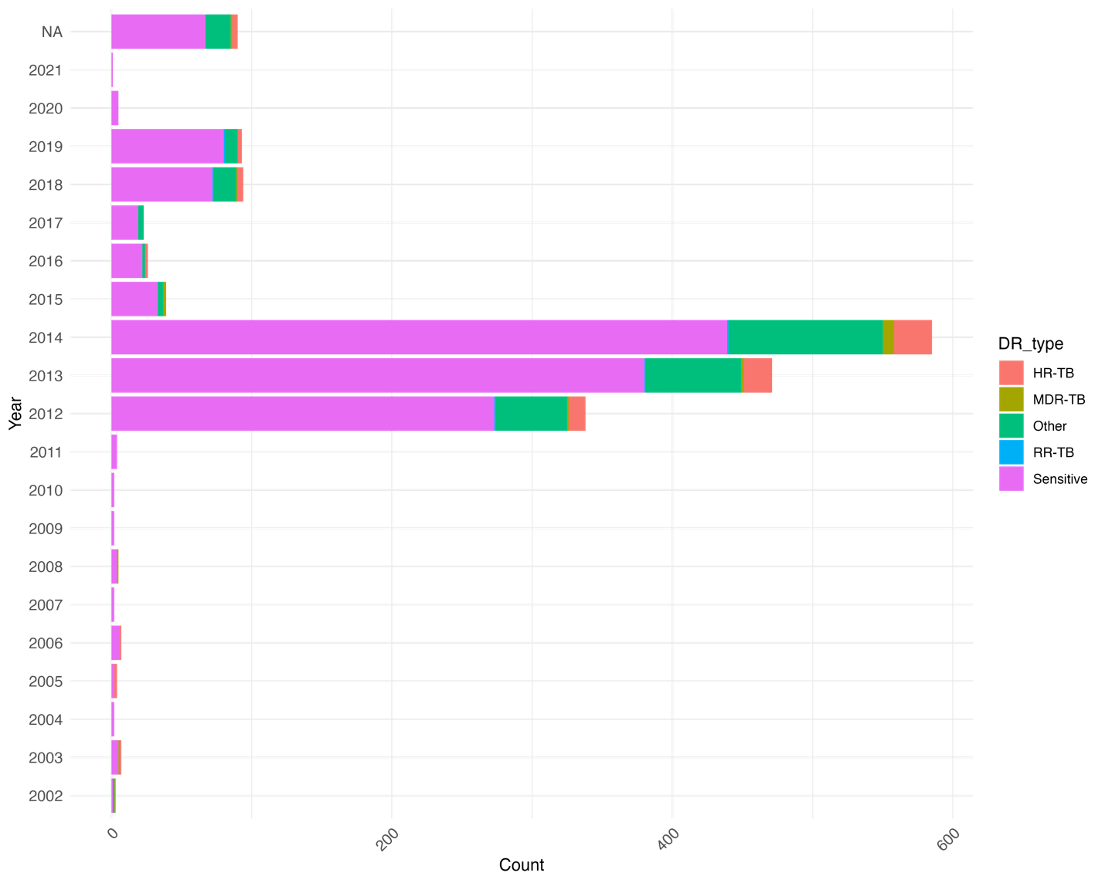
S3 figure: Distribution of drug-resistant strains across MTBC lineages (A) and over time (B) in The Gambia.

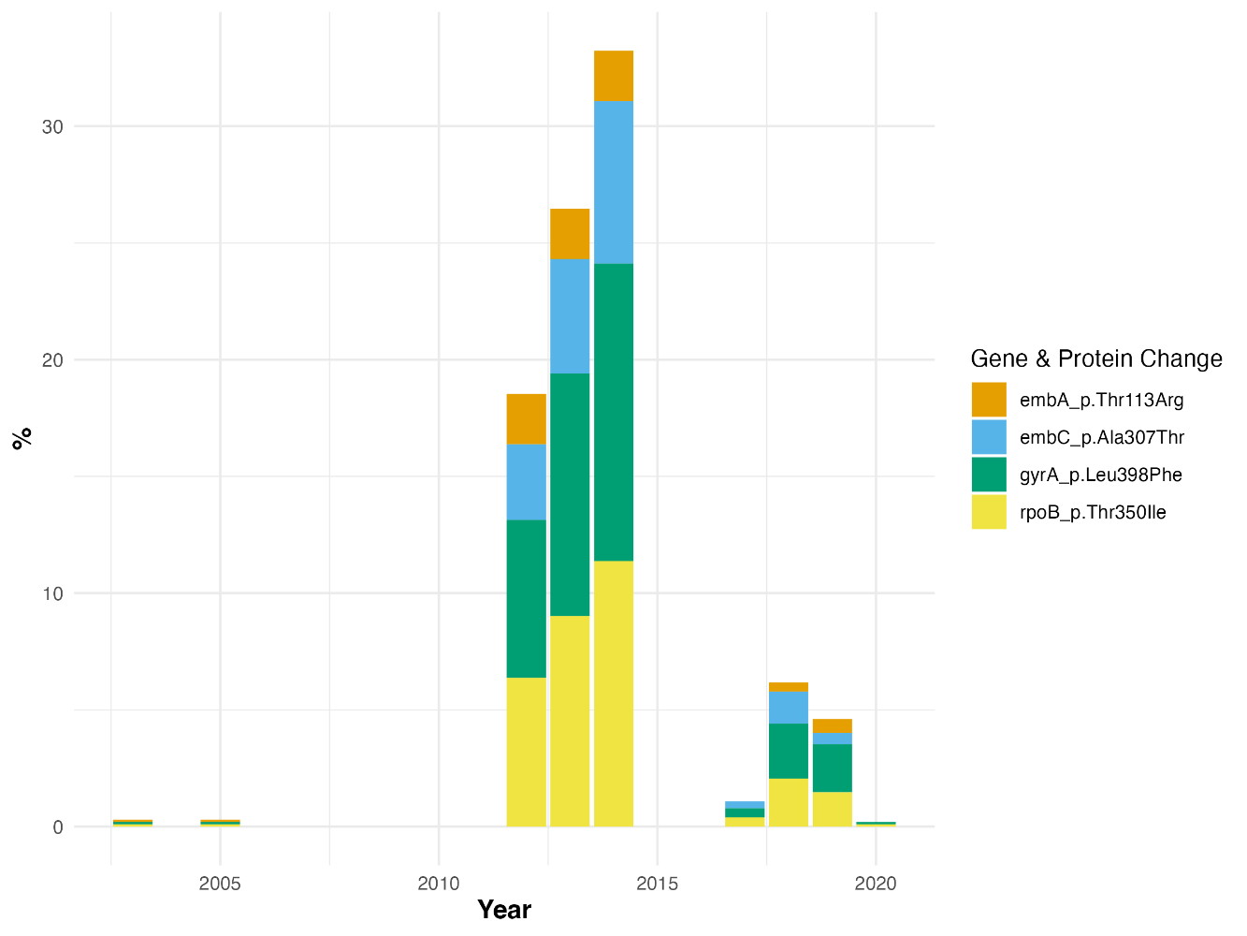

S4 figure: Prevalence of uncertain significance mutations over time

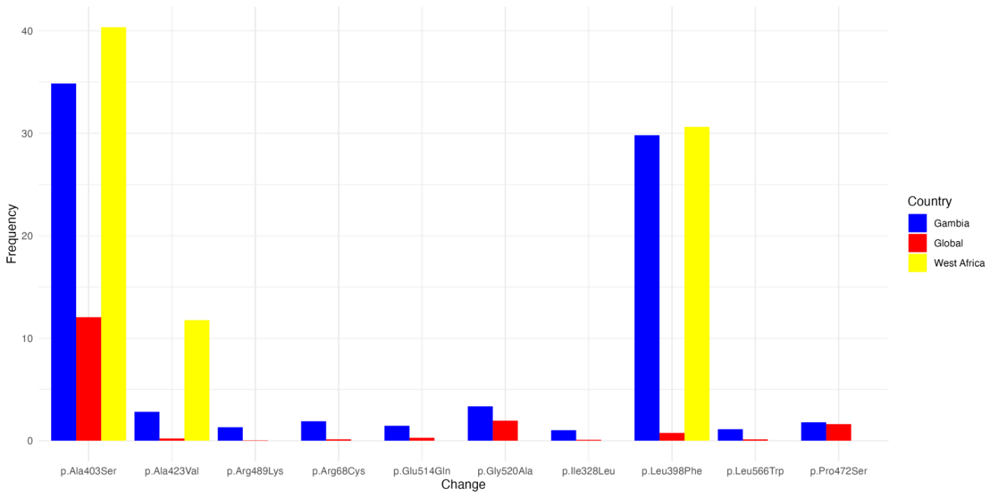
S5 Figure: The prevalence of uncertain significant mutations according to the WHO catalogue in moxifloxacin drug in The Gambia, West Africa and the global database.

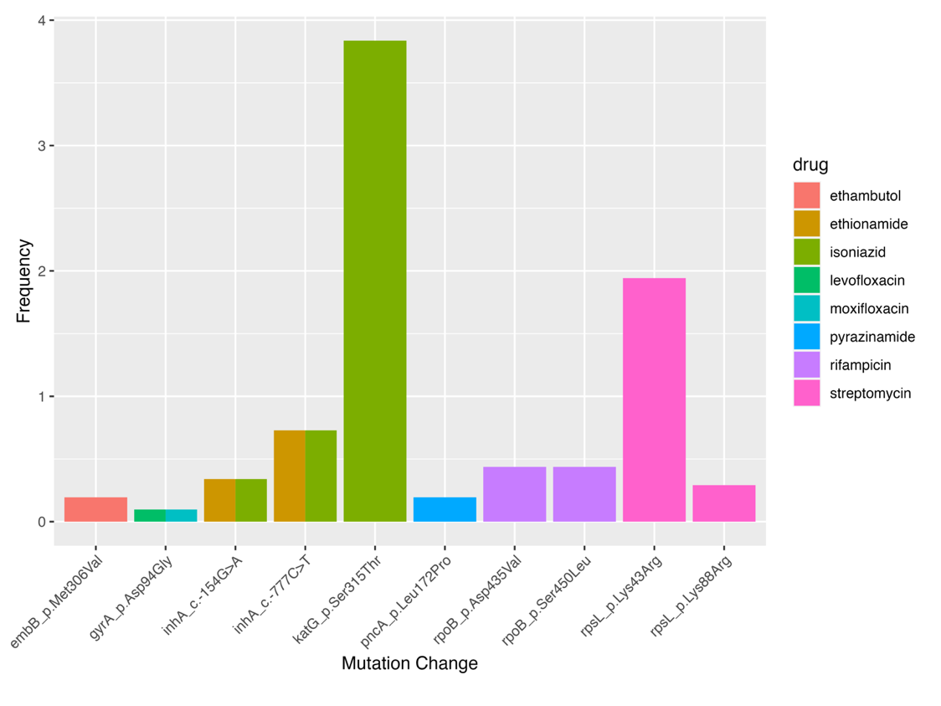

B.
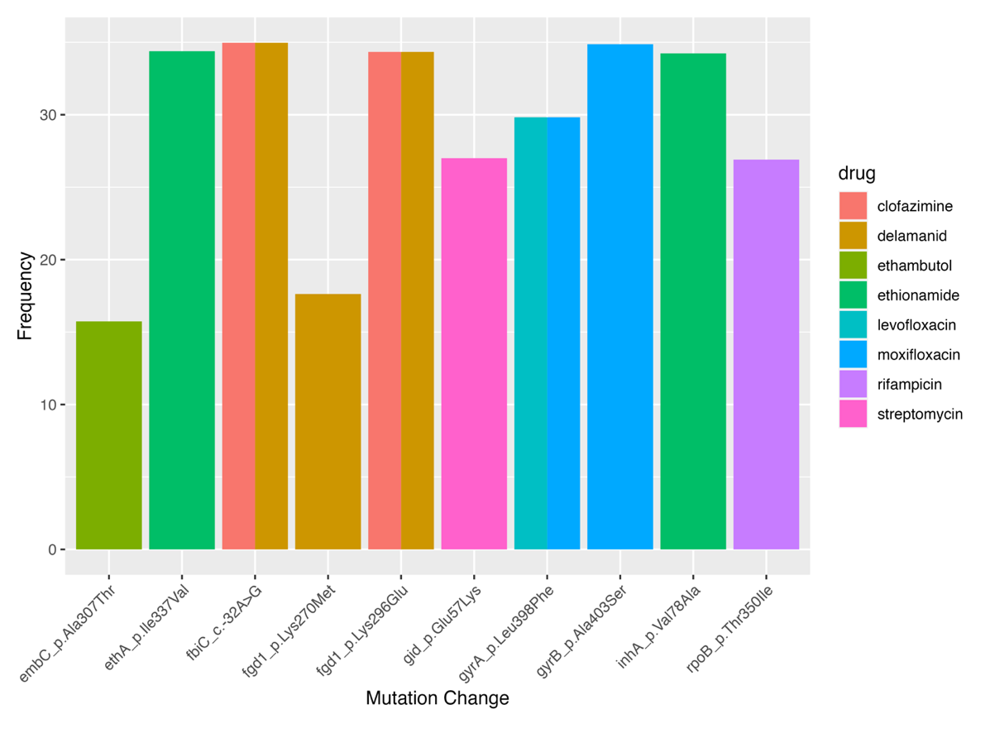
C.
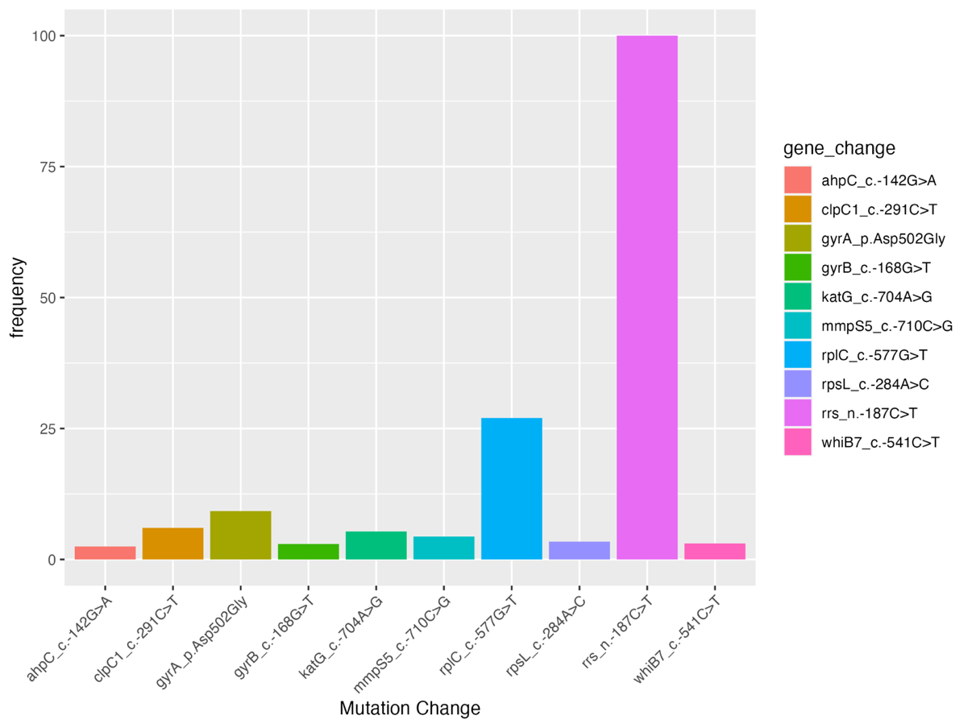
S6 Figure: The distribution of variants across these categories, highlighting their association with specific genes or drugs in The Gambian isolates. The categories are classified based on the WHO catalogue: (A) Associated with resistance, (B) uncertain significance, and (C) Not in the WHO catalogue.

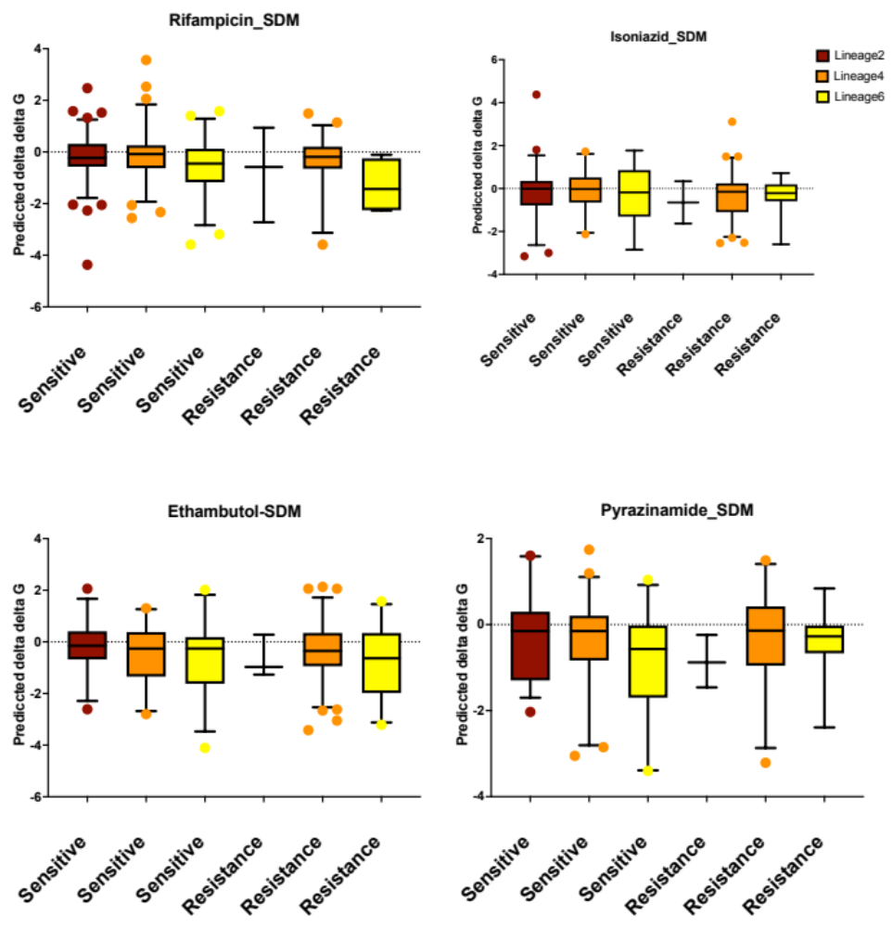
S7 figure: SDM predicted delta delta G of resistant and susceptible mutations per MTBC lineages for the first-line drugs

