Towards global carbon transparency: Spaceborne imaging spectroscopy enables precise CO₂ emission quantification at facility scale
Huayi Wang a^{,f,#}, Ge Han ^{a,f,*}, Zhipeng Pei ^{b,#}, Huiqin Mao ^{c}, Jiaying Ying ^{a,f}, Siwei Li ^{a,f}, Xin Ma ^{b}, Boming Liu ^{b}, Feiyue Mao ª, Wei Gong ^{b,d,e,*}

^{Affiliations:}
a. Hubei Key Laboratory of Quantitative Remote Sensing of Land and Atmosphere, School of Remote Sensing and Information Engineering, Wuhan University, Wuhan 430079, China.
b. State Key Laboratory of Information Engineering in Surveying, Mapping and Remote Sensing, Wuhan University, Luoyu Road No.129, Wuhan 430079, China.
c. Ministry of Ecology and Environment Center for Satellite Application on Ecology and Environment/State Environmental Protection Key Laboratory of Satellite Remote Sensing, Beijing, China.
d. Electronic Information School, Wuhan University, Wuhan, China.
e. Wuhan Institute of Quantum Technology, Wuhan 430206, China.
f. Perception and Effectiveness Assessment for Carbon-neutrality Efforts, Engineering Research Center of Ministry of Education, Institute for Carbon Neutrality, Wuhan University, Wuhan, China.
# those authors contribute equally.
* Corresponding authors.
E-mail: udhan@whu.edu.cn (G.H.), weigong@whu.edu.cn (W.G.)

Contents
Supplementary Notes 3
Supplementary Notes1: Derivation of Matched Filterer Equation 3
Supplementary Notes2: Dataset information 4
Supplementary Notes3: Band selection result 5
Supplementary Notes4: Quality control standard 6
Supplementary Tables 7
Supplementary Figures 16
Supplementary References 24

List of Supplementary Tables
Supplementary Table 1. Statistical table on the inversion of the 163-scene data of the power plant. 7
Supplementary Table 2. Uncertainty results for quantitative inversion of 141 view results. 8
Supplementary Table 3. Comparison of the inversion results of GF-5 and ZY-1 satellites with OCO-2 and PRISMA satellites. 9
Supplementary Table 4. Water Vapour Lookup Table. 10
Supplementary Table 5a. Comparison of the effective observation ratio of GF-5 and ZY-1 satellites with PRISMA satellite. 11
Supplementary Table 6. MODTRAN model parameter settings. 12
Supplementary Table 7. Data information on five satellites with AHSI sensors. 13
Supplementary Table 8. EPA Emissions Inventory Data. 14
Supplementary Table 9. Bands used for CO2 inversion by GF5 & ZY1 satellites. 15

List of Supplementary Figures
Supplementary Figure 1. Overall technology roadmap. 16
Supplementary Figure 2. Schematic diagram of plume quality control. (a) High confidence plume. (b) Medium confidence plume. (c) Low confidence plume. (d) No plume detected. 17
Supplementary Figure 3. Detailed flow chart of plume quality classification. 18
Supplementary Figure 4. Plume extraction process. 19
Supplementary Figure 5. Band selection results graph of GF5 satellite. 20
Supplementary Figure 6. Water vapor transmission rate versus water vapor pressure plot. 21
Supplementary Figure 7. Plot of effective wind speed fitting results based on U.S. power plant results. 22

Supplementary Notes

Supplementary Notes1: Derivation of Matched Filterer Equation
Known $Δ\overset{^}{c}=\underset{Δc}{argmin}(ε^{T}Σε)$
Let $L=ε^{T}Σε={(x_{m}-μ-t⋅Δc)}^{T}Σ^{-1}(x_{m}-μ-t⋅Δc)$
Then $L={(t⋅Δc)}^{T}Σ^{-1}(t⋅Δc)+{(x_{m}-μ)}^{T}Σ^{-1}(x_{m}-μ)-{(t⋅Δc)}^{T}Σ^{-1}(x_{m}-μ)-{(x_{m}-μ)}^{T}Σ^{-1}(t⋅Δc)$
Therefore $\frac{∂L}{∂Δc}=2{(Δc)}^{T}t^{T}Σt-2{(x_{m}-μ)}^{T}Σ^{-1}t$
Let $\frac{∂L}{∂Δc}=0$
Then ${(Δc)}^{T}t^{T}Σ^{-1}t={(x_{m}-μ)}^{T}Σ^{-1}t$
Therefore $Δc={(\frac{{(x_{m}-μ)}^{T}Σ^{-1}t}{t^{T}Σ^{-1}t})}^{T}=\frac{t^{T}Σ^{-1}(x_{m}-μ)}{t^{T}Σ^{-1}t}$

Supplementary Notes2: Dataset information
In this study, Advanced HyperSpectral Imager (AHSI) data of GF-5 series and ZY-1 series were collected for the period from 2019 to 2024. During data preprocessing, radiometric and geometric corrections were performed for the AHSI data. We used the Integral Mass Enhancement (IME) method to calculate the emission intensity. When performing model accuracy validation, the EPA inventory results were used for comparative validation. Finally, this study applies the inversion methodology to several power plant in China.The Advanced Hyperspectral Imager (AHSI) was carried on five satellites, including the two major series of GF-5 and ZY-1. At present, four satellites are still in orbit. AHSI collects spectral data with 30m spatial resolution in the 400nm to 2500nm band, where the data in the Visible and Near-Infrared (VNIR) and Short-Wave Infrared (SWIR) bands are divided into two different TIFF raster files were saved.
The U.S. Environmental Protection Agency (EPA) has launched a Power Plant Emissions Verification Program, which is designed to reduce air pollution from power plants to help protect human health and the environment. EPA collects and provides comprehensive CO₂, NOx, SO₂, and mercury emissions data. This study primarily used CO₂ emissions data from the Clean Air Market Program Data (CAMPD). We used hourly-level power plant facility-scale emission inventories.
In calculating the CO₂ plume intensity, we need to use wind speed data at a height of 10 m to approximate the local wind speed at the moment of plume emission. In this paper, the Historical Weather API (https://open-meteo.com/en/docs/historical-weather-api) was selected as the source of wind speed data, which is based on reanalyzed datasets that use a combination of weather station, aircraft, radar, and satellite observations to provide a comprehensive record of past weather conditions. The spatial resolution of the best model in Historical Weather is about 11 km.
In calculating the CO₂ plume intensity, we need to use atmospheric mass data as an auxiliary data for calculating the CO₂ mass. The dataset used in this study is the hourly data from ERA5, which is the fifth generation of global climate atmospheric reanalysis data from ECMWF, spanning the period from January 1940 to the present.
The EPA emissions inventory is shown in the Supplementary Table 8. EPA Emissions Inventory Data.. The Facility ID in Supplementary Table 8 is provided by the EPA website, and using the facility ID to retrieve emission data will improve the efficiency of the retrieval. Since the EPA inventory uses Local Standard Time (LST) by default, time matching needs to be done by converting the satellite time to LST based on the time zone of the state. Meanwhile, we take the emission data of two adjacent hours of the EPA inventory for linear interpolation based on the minute of the satellite time, in order to obtain a more accurate emission intensity. Finally, the default data unit of short ton per hour for the EPA inventory is converted to ton per hour.

Supplementary Notes3: Band selection result
The wavelength bands used by the five AHSI-loaded satellites are shown in Table 4. Due to the slight difference in the centre wavelength of the AHSI sensors on different satellites, resulting in different gas absorption coefficients calculated after the convolution of the irradiance, the gas absorption coefficients need to be calculated separately for the sensors on each satellite. Overall, we divided the bands into four parts: 1.05 μm, 1.23 μm, 1.57 μm, and 2.02 μm. In previous studies, a single strong absorption band ²⁻⁴ or the full band is usually used for the inversion, but the single band inversion is prone to artifacts, while the full band inversion is effective in reducing the artifacts but leads to low inversion, which needs further correction treatment ⁵. Our proposed quantitative waveband selection can optimise the artifact problem while ensuring the accuracy of the emission inversion results.

Supplementary Notes4: Quality control standard
We classified the plume quality into five types based on how well the inversion results match the wind field and how significant the inversion results are in relation to the background:
High-confidence definition: plume maximum spatially aligned with the emission source, plume direction consistent with wind speed, and plume morphology
Medium-confidence definition: plume maxima are spatially aligned with the emission source, plume path is generally consistent with wind speed; however, some plume may be missing due to geomorphological effects (e.g., drifting over water)
Low confidence definition: high emission values that can be distinguished from the background; however, the plume direction is not well aligned with the wind speed, or the background has more interfering noise
No emission definition: no plume detected; or the detected emission high values clearly match the ground features and are false positives.
Low Wind Definition: A medium or high confidence plume that cannot be quantitatively accounted for using the IME formula because the wind speed is too low.
In addition to the above qualitative analyses, we have also established some quantitative analysis metrics so as to ensure the reasonableness of our plume confidence classification model.
The plume specific emission intensity ($q$) is defined as the ratio of the highest concentration increment value of a Gaussian frequency domain denoised plume ($I_{plume}$) to the uncertainty of the background concentration increment $I_{bkg}$.
$$q=\frac{\max\left(I_{plume}\right)}{std(I_{bkg})}$$
The plume discharge direction deviation ($φ$) is defined as the absolute deviation of the plume maximum from the vector of lines formed by the geometric centre of the plume ($\vec{P}$) from the wind direction provided by the ERA5 reanalysis data ($\vec{U}$).
$$φ=arccos⁡(\frac{\vec{P}∙\vec{U}}{\left|\vec{P}\right|\left|\vec{U}\right|})$$

Supplementary Tables

Supplementary Table 1. Statistical table on the inversion of the 163-scene data of the power plant.
Facility Name | EPA inventory(t/h) | Inversion Error | Estimated Intensity | Quantification | Emission | Clear-sky
Antelope Valley | 717 | -3.1% | 683 ± 123 | 6 | 6 | 8
Craig | 805 | 9.4% | 885 ± 161 | 10 | 11 | 11
Four Corners Steam Elec Station | 1086 | -4.1% | 1027 ± 160 | 8 | 8 | 8
Gallatin | 693 | 1.0% | 699 ± 116 | 1 | 2 | 3
Gerald Gentleman Station | 1025 | 2.2% | 1015 ± 134 | 9 | 10 | 10
Harrington Station | 492 | -16.2% | 423 ± 55 | 5 | 8 | 10
Harrison Power Station | 1202 | -2.2% | 1135 ± 194 | 8 | 9 | 9
Hunter | 678 | 1.2% | 650 ± 115 | 8 | 9 | 9
J K Spruce | 902 | 23.3% | 1110 ± 173 | 10 | 11 | 11
Jim Bridger | 1188 | -21.3% | 877 ± 104 | 7 | 8 | 8
La Cygne | 927 | -3.2% | 888 ± 152 | 7 | 8 | 8
Labadie | 1961 | -12.6% | 1730 ± 300 | 5 | 5 | 5
Laramie River | 909 | 10.1% | 958 ± 142 | 4 | 4 | 4
Martin Lake | 1504 | 11.7% | 1582 ± 247 | 15 | 16 | 16
Oak Grove | 1358 | 12.5% | 1484 ± 210 | 12 | 12 | 12
Sam Seymour | 1211 | 9.6% | 1272 ± 206 | 8 | 8 | 8
Shawnee | 775 | 2.5% | 778 ± 124 | 6 | 7 | 7
Sherburne County | 1252 | 8.5% | 1252 ± 189 | 5 | 5 | 5
Trimble County | 1145 | 13.0% | 1311 ± 170 | 3 | 4 | 5
White Bluff | 866 | -3.2% | 859 ± 159 | 4 | 6 | 6
Total | / | / | / | 141 | 157 | 163

Supplementary Table 2. Uncertainty results for quantitative inversion of 141 view results.
Categories | Scenes | Emission Rate | Total Uncertainty | Uncertainty of IME | Uncertainty of Wind
Total | 141 | 1087 t/h | 170 t/h (15.6%) | 19 t/h (1.7%) | 151 t/h (13.9%)
High Confidence Plume | 49 | 1088 t/h | 179 t/h (16.4%) | 17 t/h (1.6%) | 161 t/h (14.8%)
Medium Confidence Plume | 92 | 1087 t/h | 166 t/h (15.2%) | 20 t/h (1.8%) | 146 t/h (13.4%)
Low Wind Speed (U<3m/s) | 72 | 1091 t/h | 145 t/h (13.3%) | 23 t/h (2.1%) | 123 t/h (11.2%)
High Wind Speed (U≥3m/s) | 69 | 1083 t/h | 196 t/h (18.1%) | 15 t/h (1.4%) | 181 t/h (16.7%)
Weak Emission (Q<1kt/h) | 69 | 1509 t/h | 235 t/h (15.6%) | 21 t/h (1.4%) | 214 t/h (14.2%)
Strong Emission (Q≥1kt/h) | 72 | 683 t/h | 108 t/h (15.8%) | 17 t/h (2.4%) | 91 t/h (13.3%)

Supplementary Table 3. Comparison of the inversion results of GF-5 and ZY-1 satellites with OCO-2 and PRISMA satellites.
Latitude | Longitude | Facility | ID | Satellite | Date | EPA (t/h) | Estimate (t/h) | %Δ | Uncertainty (t/h) | Wind speed (m/s)
32.2597 | -94.5703 | Martin Lake | 1 | GF5A | 20230908 | 2459 | 2799 | 13.80% | 406.4 | 3.48
32.2597 | -94.5703 | Martin Lake | 2 | GF5A | 20240422 | 655 | 647 | -1.21% | 106.6 | 1.28
32.2597 | -94.5703 | Martin Lake | 3 | GF5B | 20220407 | 1336 | 1230 | -7.94% | 130.5 | 6.16
32.2597 | -94.5703 | Martin Lake | 4 | GF5B | 20230717 | 2302 | 2376 | 3.23% | 308.5 | 3.97
32.2597 | -94.5703 | Martin Lake | 5 | GF5B | 20230906 | 2420 | 2066 | -14.62% | 379.5 | 2.72
32.2597 | -94.5703 | Martin Lake | 6 | GF5B | 20231103 | 1350 | 1857 | 37.59% | 402.6 | 2.34
32.2597 | -94.5703 | Martin Lake | 7 | GF5B | 20240213 | 997 | 1517 | 52.18% | 224.9 | 1.3
32.2597 | -94.5703 | Martin Lake | 8 | GF5B | 20240404 | 1003 | 1931 | 92.57% | 295.3 | 3.31
32.2597 | -94.5703 | Martin Lake | 9 | GF5B | 20240601 | 585 | 893 | 52.61% | 143.2 | 1.53
32.2597 | -94.5703 | Martin Lake | 10 | ZY1E | 20210104 | 1209 | 1144 | -5.31% | 176.3 | 1.96
32.2597 | -94.5703 | Martin Lake | 11 | ZY1E | 20210401 | 1080 | 987 | -8.66% | 174.1 | 3.06
32.2597 | -94.5703 | Martin Lake | 12 | ZY1E | 20220303 | 1684 | 1161 | -31.09% | 171.6 | 0.58
32.2597 | -94.5703 | Martin Lake | 13 | ZY1F | 20220802 | 2146 | 2239 | 4.34% | 336.2 | 3.39
32.2597 | -94.5703 | Martin Lake | 14 | ZY1F | 20221120 | 2399 | 1844 | -23.16% | 316.6 | 2.97
32.2597 | -94.5703 | Martin Lake | 15 | ZY1F | 20231210 | 932 | 1036 | 11.17% | 128.0 | 4.79
32.2597 | -94.5703 | Martin Lake | 16 | PRISMA | 20220716 | 1807 | 1451 | -19.70% | 315 | 2.43
32.2597 | -94.5703 | Martin Lake | 17 | PRISMA | 20220923 | 1139 | 1961 | 72.17% | 462 | 1.97
32.2597 | -94.5703 | Martin Lake | 18 | PRISMA | 20220402 | 2399 | 2598 | 8.30% | 983 | 0.94
38.5583 | -90.8361 | Labadie | 1 | ZY1E | 20210925 | 1582 | 1627 | 2.84% | 287.5 | 1.58
38.5583 | -90.8361 | Labadie | 2 | ZY1E | 20220113 | 1672 | 1038 | -37.92% | 162.3 | 1.58
38.5583 | -90.8361 | Labadie | 3 | ZY1E | 20230329 | 2235 | 1715 | -23.27% | 250.8 | 1.58
38.5583 | -90.8361 | Labadie | 4 | ZY1F | 20230704 | 2322 | 2643 | 13.79% | 551.8 | 1.58
38.5583 | -90.8361 | Labadie | 5 | ZY1F | 20231022 | 1993 | 1630 | -18.22% | 246.2 | 1.58
38.5583 | -90.8361 | Labadie | 6 | PRISMA | 07/10/2022 | 2121 | 730 | -65.58% | 182 | 1.81
40.4627 | -107.5912 | Craig | 1 | GF5 | 20190803 | 1233 | 1466 | 18.86% | 247.4 | 3.26
40.4627 | -107.5912 | Craig | 2 | GF5A | 20230916 | 872 | 1251 | 43.40% | 296.6 | 2.24
40.4627 | -107.5912 | Craig | 3 | GF5A | 20231206 | 809 | 879 | 8.65% | 137.3 | 0.92
40.4627 | -107.5912 | Craig | 4 | GF5A | 20240606 | 453 | 461 | 1.69% | 76.5 | 1.35
40.4627 | -107.5912 | Craig | 5 | GF5A | 20240613 | 912 | 979 | 7.29% | 148.5 | 4
40.4627 | -107.5912 | Craig | 6 | GF5B | 20221018 | 754 | 825 | 9.47% | 124.0 | 1.63
40.4627 | -107.5912 | Craig | 7 | GF5B | 20230926 | 717 | 720 | 0.36% | 109.9 | 1.1
40.4627 | -107.5912 | Craig | 8 | GF5B | 20240113 | 1038 | 756 | -27.14% | 204.4 | 2.08
40.4627 | -107.5912 | Craig | 9 | ZY1E | 20230715 | 812 | 1065 | 31.12% | 193.0 | 2.81
40.4627 | -107.5912 | Craig | 10 | ZY1E | 20231007 | 447 | 448 | 0.10% | 74.1 | 1.36
40.4627 | -107.5912 | Craig | 11 | PRISMA | 20220708 | 1245 | 799 | -35.82% | 169 | 2.44
40.4627 | -107.5912 | Craig | 12 | PRISMA | 20210829 | 901 | 776 | -13.87% | 216 | 1.46
40.4627 | -107.5912 | Craig | 13 | PRISMA | 20220823 | 961 | 672 | -30.07% | 171 | 1.69
40.4627 | -107.5912 | Craig | 14 | PRISMA | 20220418 | 864 | 632 | -26.85% | 141 | 2.19
40.4627 | -107.5912 | Craig | 15 | PRISMA | 20210915 | 531 | 555 | 4.52% | 107 | 3.07
34.4236 | -92.1392 | White Bluff | 1 | GF5A | 20240614 | 841 | 720 | -14.46% | 119 | 1.86
34.4236 | -92.1392 | White Bluff | 2 | ZY1E | 20220113 | 817 | 840 | 2.87% | 201 | 2.28
34.4236 | -92.1392 | White Bluff | 3 | ZY1E | 20220726 | 1324 | 1444 | 9.05% | 239 | 3.26
34.4236 | -92.1392 | White Bluff | 4 | ZY1E | 20231104 | 483 | 433 | -10.32% | 76 | 0.86
34.4236 | -92.1392 | White Bluff | 5 | OCO-2 | 08/15/2015 | 1513 | 1917 | 26.70% | 596 | 2.35

Supplementary Table 4. Water Vapour Lookup Table.
Water Vapor (g/cm2) | Transmission Rate (935nm/870nm)
0.00 | 0.80
0.05 | 0.62
0.11 | 0.53
0.20 | 0.46
0.30 | 0.40
0.40 | 0.35
0.55 | 0.30
0.65 | 0.27
0.76 | 0.24
0.90 | 0.21
1.02 | 0.19
1.12 | 0.17
1.24 | 0.15
1.40 | 0.13
1.56 | 0.11
1.76 | 0.09
2.00 | 0.07
2.26 | 0.05
2.46 | 0.04
*The graph of water vapour pressure versus water vapour transmittance is quoted from the work of Liu¹.

Supplementary Table 5a. Comparison of the effective observation ratio of GF-5 and ZY-1 satellites with PRISMA satellite.
Satellite | Effective observation ratio | No. of High Confidence Emission Plume and No. of Clear Sky Observation
Satellite | Effective observation ratio | Craig | Martin Lake | Labadie
PRISMA | 50% | 4/4 | 3/8 | 1/4
GF5 & ZY1 | 62% | 6/6 | 5/10 | 2/5

Supplementary Table 5b. Comparison of the number of views (include cloud-containing images) of GF-5 and ZY-1 satellites with OCO-2 satellite.
Satellite | No. of Observations (2022.10-2024.10)
Satellite | Craig | Martin Lake | Labadie | Total
GF5 & ZY1 | 52 | 29 | 26 | 117
OCO-2 | 1 | 1 | 3 | 5

Supplementary Table 6. MODTRAN model parameter settings.
Card | Parameter | Value
Card: 1 | Model Atmosphere | Mid Latitude Summer (6~8)
Card: 1 | Model Atmosphere | Mid Latitude Winter (12~2)
Card: 1 | Model Atmosphere | 1976 U S Standard (3~5, 9~11)
Card: 1 | Type of Atmospheric Path | Slant Path
Card: 1 | Mode of Execution | Radiance with Scattering
Card: 1 | Surface Albedo | 40% - 50%
Card: 1A | CO2 Mixing Ratio (ppm) | [400, 410, …, 500]
Card: 1A | Water Column Choices | V(g/cm²)
Card: 2 | Aerosol Model Used | Rural - VIS=23km
Card: 3 | Observer Height | GF5: 705km
Card: 3 | Observer Height | ZY1: 778km
Card: 3 | Target Height | 0, 0.05, 0.1, 0.15, 0.2,  0.25, 0.3, 0.4, 0.5, 0.6,  0.8, 1.0, 1.2, 1.5, 2.0,  2.5, 3.0 (unit: km)
Card: 3 | Zenith Angle | ZY1E: 179.64°
Card: 3 | Zenith Angle | GF5&ZY1F: 179.92°
Card: 4 | Initial Frequency (cm⁻¹) | 1e7/b1
Card: 4 | Final Frequency (cm⁻¹) | 1e7/b2

Supplementary Table 7. Data information on five satellites with AHSI sensors.
Satellite | Launch date | Orbital altitude | Spectral resolution | Number of bands | Number of scenes in U.S.
GF5 | 2018.5.9 | 705km | ~8nm | 150 (VNIR)  180 (SWIR) | 3
GF5A | 2022.12.9 | 705km | ~8nm | 150 (VNIR)  180 (SWIR) | 36
GF5B | 2021.9.7 | 705km | ~8nm | 150 (VNIR)  180 (SWIR) | 43
ZY1E | 2019.9.12 | 778km | ~16nm | 76 (VNIR)  90 (SWIR) | 53
ZY1F | 2021.12.26 | 778km | ~16nm | 76 (VNIR)  90 (SWIR) | 28

Supplementary Table 8. EPA Emissions Inventory Data.
Facility Name | State | Facility ID | Latitude | Longitude | Num | EPA Emission Rate(ton/h)
Antelope Valley | ND | 6469 | 47.3710 | -101.8357 | 4 | 515 ± 142
Craig | CO | 6021 | 40.4627 | -107.5912 | 6 | 772 ± 236
Four Corners Steam Elec Station | NM | 2442 | 36.6900 | -108.4814 | 6 | 1078 ± 343
Gallatin | TN | 3403 | 36.3156 | -86.4006 | 3 | 407 ± 202
Gerald Gentleman Station | NE | 6077 | 41.0808 | -101.1408 | 6 | 1096 ± 213
Harrington Station | TX | 6193 | 35.2972 | -101.7475 | 3 | 335 ± 178
Harrison Power Station | WV | 3944 | 39.3844 | -80.3325 | 4 | 1094 ± 719
Hunter | UT | 6165 | 39.1747 | -111.0289 | 8 | 657 ± 229
J K Spruce | TX | 7097 | 29.3091 | -98.3205 | 7 | 977 ± 338
Jim Bridger | WY | 8066 | 41.7378 | -108.7875 | 7 | 1060 ± 454
La Cygne | KS | 1241 | 38.3472 | -94.6467 | 7 | 894 ± 385
Labadie | MO | 2103 | 38.5583 | -90.8361 | 5 | 1961 ± 295
Laramie River | WY | 6204 | 42.1103 | -104.8828 | 4 | 909 ± 391
Martin Lake | TX | 6146 | 32.2597 | -94.5703 | 10 | 1702 ± 570
Oak Grove | TX | 6180 | 31.1850 | -96.4853 | 12 | 1358 ± 410
Sam Seymour | TX | 6179 | 29.9172 | -96.7506 | 8 | 1211 ± 312
Shawnee | KY | 1379 | 37.1517 | -88.7750 | 8 | 674 ± 264
Sherburne County | MN | 6090 | 45.3792 | -93.8958 | 4 | 1191 ± 655
Trimble County | KY | 6071 | 38.5847 | -85.4117 | 4 | 714 ± 415
White Bluff | AR | 6009 | 34.4236 | -92.1392 | 5 | 635 ± 398

Supplementary Table 9. Bands used for CO2 inversion by GF5 & ZY1 satellites.
type | start | end | delete | start2 | end2 | delete2 | start3 | end3 | delete3 | start4 | end4 | delete4
GF5B | 1034 | 1051 | "" | 1202 | 1261 | "5,6" | 1530 | 1615 | "4" | 1943 | 2119 | ""
GF5A | 1039 | 1064 | "" | 1207 | 1258 | "4,5,6" | 1527 | 1620 | "4" | 1948 | 2116 | ""
GF5 | 1038 | 1063 | "" | 1206 | 1257 | "2,4,5,6" | 1528 | 1620 | "4" | 1948 | 2117 | ""
ZY1E | 1039 | 1055 | "" | 1207 | 1257 | "" | 1543 | 1610 | "2" | 1946 | 2115 | ""
ZY1F | 1043 | 1060 | "2" | 1262 | 1279 | "2" | 1531 | 1616 | "" | 1953 | 2121 | ""
*Each row represents the four bands used by a satellite, the numbers in the table are in nm, and the double quotes indicate the index of the band that needs to be omitted for that band.

Supplementary Figures

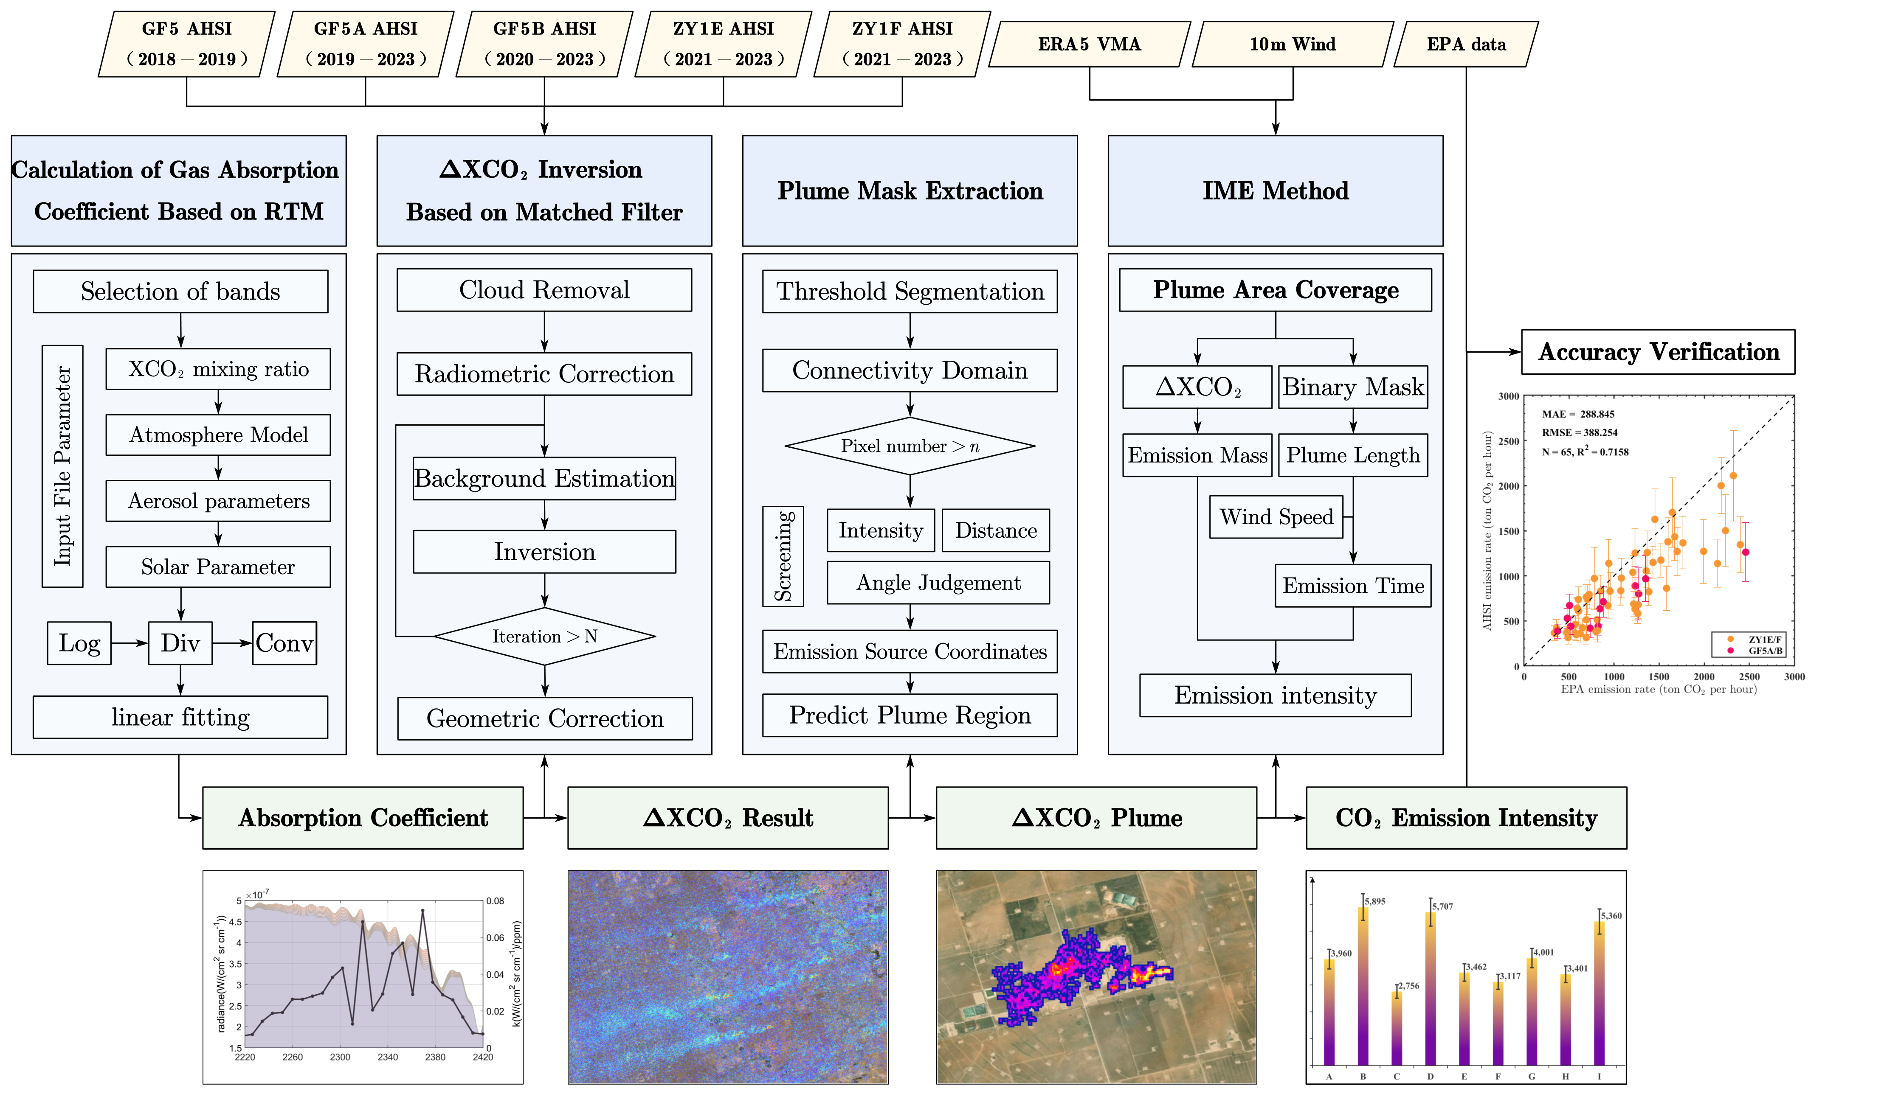
Supplementary Figure 1. Overall technology roadmap.

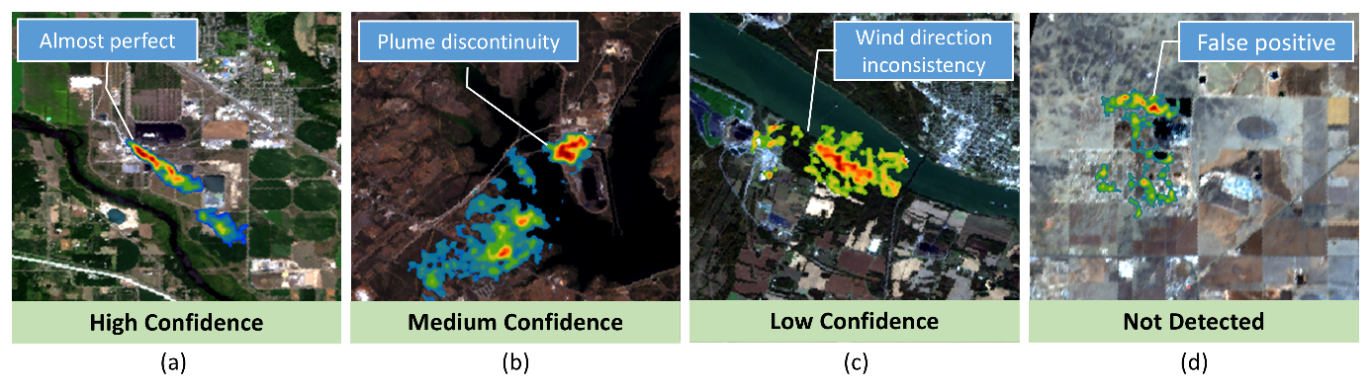
Supplementary Figure 2. Schematic diagram of plume quality control. (a) High confidence plume. (b) Medium confidence plume. (c) Low confidence plume. (d) No plume detected.

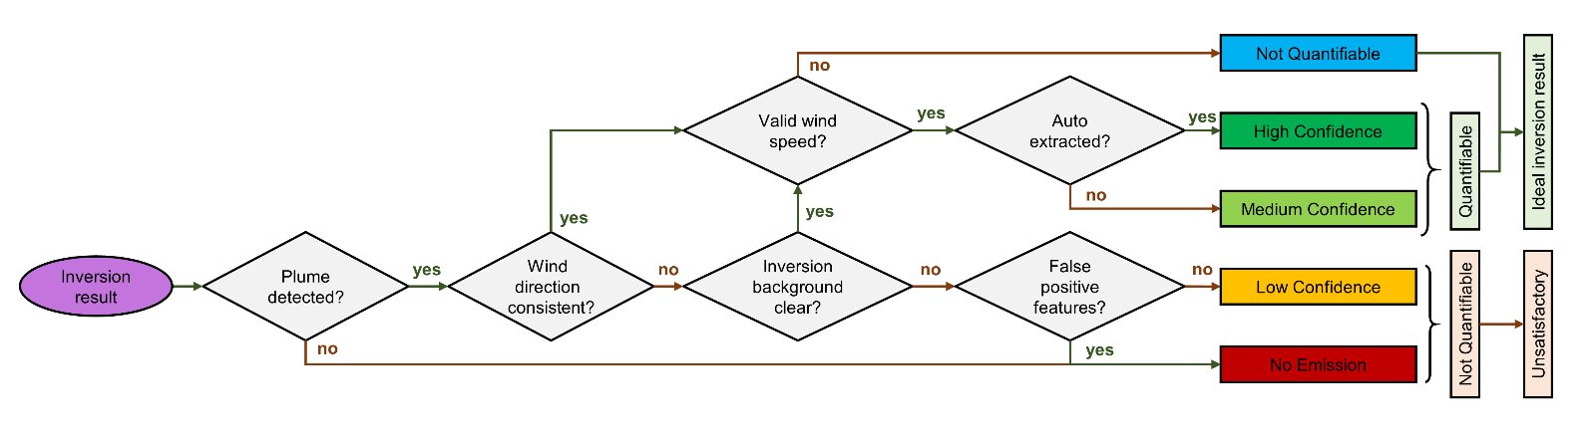
Supplementary Figure 3. Detailed flow chart of plume quality classification.

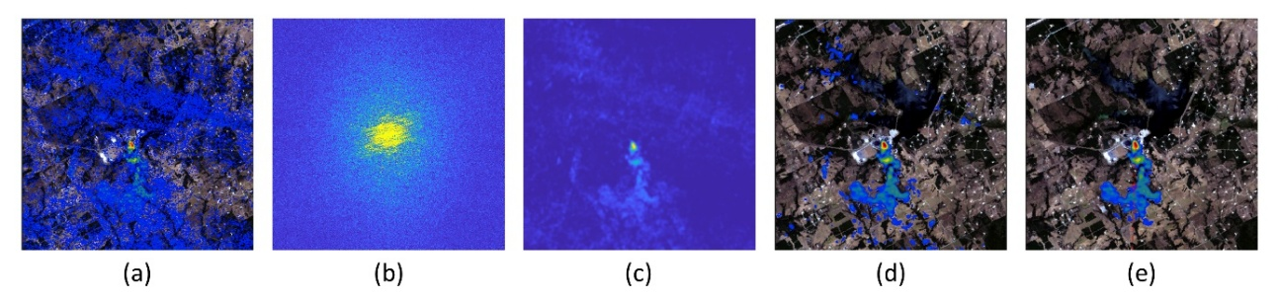
Supplementary Figure 4. Plume extraction process. a Matched filter inversion results. b Fourier transformed frequency domain image. c Gaussian low-pass filtered plume region. d Result of threshold extraction and screening out small plume clumps in the connectivity domain. e Plume clumps judged by combining plume direction and distance weighting.

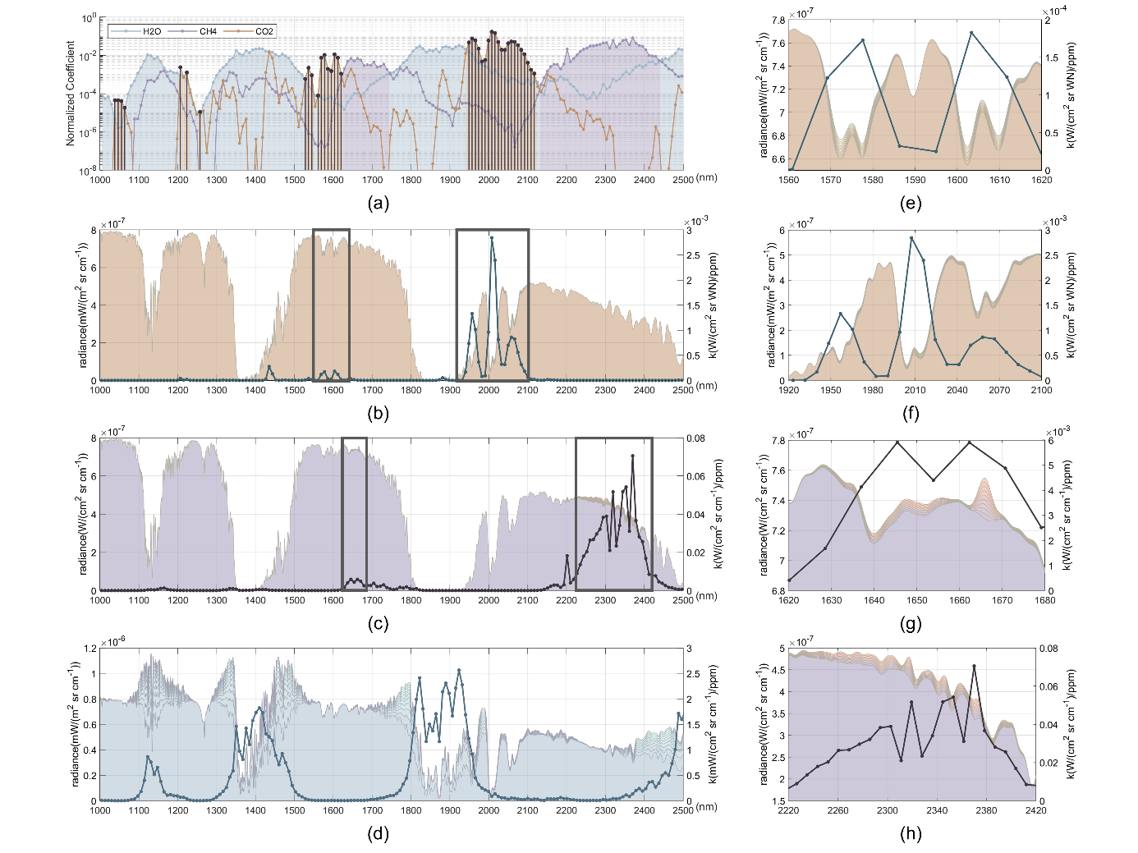
Supplementary Figure 5. Band selection results graph of GF5 satellite. a shows the normalized gas absorption coefficients for CO2 (orange), CH4 (purple) and H2O (blue) are shown, where the colour of the area plot indicates that the corresponding gas absorption feature is most significant in that band. We have labelled the sensitive bands for CO2 using black vertical lines. b represents the results of the absorption coefficient of CO2 gas. The black boxed areas are the weak and strong absorption bands for CO2 gas, respectively, and the details are shown in Figure (e) and (f). c shows the absorption coefficient results for CH4 gas. The black boxed areas are the weak and strong absorption bands for CH4 gas, and the details are shown in Figure (g) and (h). d shows the results of the absorption coefficient of H2O gas. e CO2 weak absorption band result (line), the area plot represents the irradiance result after inputting different CO2 concentration into MODTRAN run. f shows CO2 strong absorption band result (line), the area plot is same as (e). g shows CH4 weak absorption band result (line), area plot shows the irradiance result after MODTRAN run with different CH4 concentration. h shows CO2 weak absorption band result (line), the area plot represents the irradiance result after MODTRAN run with different CO2 concentration input.

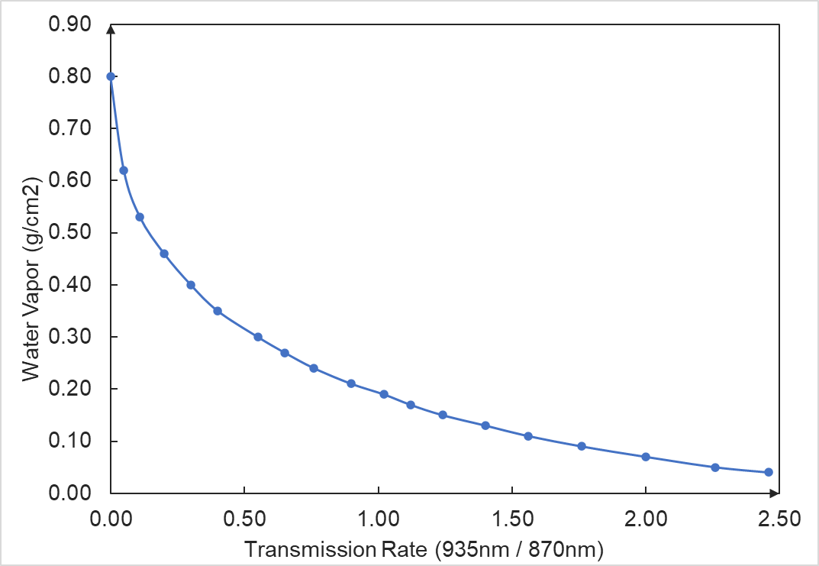
Supplementary Figure 6. Water vapor transmission rate versus water vapor pressure plot.

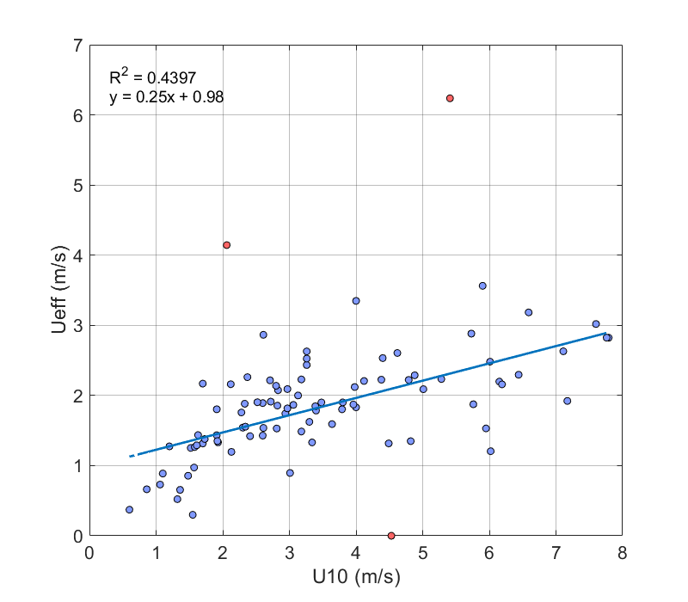
Supplementary Figure 7. Plot of effective wind speed fitting results based on U.S. power plant results.

Supplementary References
1 Yinnian, L. et al. Development of visible and short-wave infrared hyperspectral imager onboard GF-5 satellite. Journal of Remote Sensing(Chinese) 24, 333-344 (2020).
2 Guanter, L. et al. Mapping methane point emissions with the PRISMA spaceborne imaging spectrometer. Remote Sens Environ 265 (2021). https://doi.org:ARTN 112671
10.1016/j.rse.2021.112671
3 Irakulis-Loitxate, I. et al. Satellite-based survey of extreme methane emissions in the Permian basin. Sci Adv 7 (2021). https://doi.org:ARTN eabf4507
10.1126/sciadv.abf4507
4 Cusworth, D. H. et al. Two years of satellite-based carbon dioxide emission quantification at the world's largest coal-fired power plants. Atmos Chem Phys 23, 14577-14591 (2023).
5 Roger, J., Guanter, L., Gorroño, J. & Irakulis-Loitxate, I. Exploiting the entire near-infrared spectral range to improve the detection of methane plumes with high-resolution imaging spectrometers. Atmos Meas Tech 17, 1333-1346 (2024). https://doi.org:10.5194/amt-17-1333-2024

