Supplementary Content:

Supplementary Methods:
Defining Variables
Insurance status was retrieved at time of diagnosis and categorized as uninsured/self-pay, public (including Medicaid and Medicare-only coverage), and private insurance. Using patient zip codes, we estimated distance to institution in miles through methods detailed by the National Ambulatory Medical Care Survey (NAMCS).¹ Estimated median household was retrieved from the US Census Bureau 5-year estimated household income in 2022 inflation-adjusted dollars.² Income classes were divided according to the Pew Research Center reports for 2022.³ Rural Urban Commuting Area (RUCA) codes were categorized in accordance Economic Research Service (ERS) of the United States Department of Agriculture (USDA).³ RUCA classifies U.S. census tracts using measures of population density, urbanization, and daily commuting into four main categories (Metropolitan, Micropolitan, Small town and Rural).
Statistical Analysis
Assumptions for each test was assessed, multivariate cox proportional hazards models were utilized to assess the association of clinical variables and socioeconomic variables with OS. Schoenfeld’s residuals were used in order to assess assumptions of proportionality (Supplementary Content, Table 1S, Figure 1S).⁴
There was a high degree of missing values for MGMT methylation (39%) and IDH mutation (33%) status. We assumed data was missing at random (MAR) due to inconsistent testing before the release of the 2016 WHO Guidelines on Tumors of the Central Nervous System.⁵ We performed multiple imputations using the random forest imputations method and multiple imputations with chained equations (MICE) for missing values of MGMT status and IDH status with 50 iterations.⁶ Convergence diagrams were plotted for each method. Imputation variance and pooled models were assessed for each imputation method to ensure agreement after imputation. Multiple imputation diagnostics and variance analysis can be found in the supplement.

Table 1S. Schoenfeld’s residuals for Multivariate Cox Regression Models
Random Forest Model | chisq | df | p
Sex | 1.249 | 1 | 0.264
high_ADI | 0.605 | 1 | 0.437
income_class | 6.183 | 2 | 0.045
age_cat | 24.65 | 4 | 5.90E-05
african_american | 0.795 | 1 | 0.373
insurance_cat | 6.908 | 2 | 0.032
IDH-Mut | 1.174 | 1 | 0.279
MGMT-methylated | 1.271 | 1 | 0.26
rural | 1.331 | 1 | 0.249
surgical_procedure | 42.627 | 2 | 5.50E-10
chemotherapy | 45.183 | 1 | 1.80E-11
radiotherapy | 52.136 | 1 | 5.20E-13
african_american:insurance_cat | 0.194 | 2 | 0.907
GLOBAL | 99.087 | 20 | 1.80E-12

MICE | chisq | df | p
Sex | 0.6258 | 1 | 0.429
high_ADI | 0.996 | 1 | 0.318
income_class | 5.7912 | 2 | 0.055
age_cat | 30.1305 | 4 | 4.60E-06
african_american | 0.2559 | 1 | 0.613
insurance_cat | 7.3515 | 2 | 0.025
IDH-Mut | 0.0387 | 1 | 0.844
MGMT-methylated | 1.8026 | 1 | 0.179
rural | 2.0546 | 1 | 0.152
surgical_procedure | 36.5169 | 2 | 1.20E-08
chemotherapy | 46.4383 | 1 | 9.50E-12
radiotherapy | 58.5788 | 1 | 2.00E-14
african_american:insurance_cat | 0.4117 | 2 | 0.814
GLOBAL | 101.3728 | 20 | 7.10E-13

Complete Case analysis | chisq | df | p
Sex | 4.66E-05 | 1 | 0.99455
high_ADI | 1.45E+00 | 1 | 0.22853
income_class | 1.57E+00 | 2 | 0.45529
age_cat | 7.45E+00 | 4 | 0.11384
african_american | 1.22E-01 | 1 | 0.72695
insurance_cat | 9.17E+00 | 2 | 0.01019
IDH-Mut | 5.63E-01 | 1 | 0.45317
MGMT-methylated | 2.41E-01 | 1 | 0.62328
rural | 1.55E-01 | 1 | 0.69411
surgical_procedure | 3.61E+00 | 2 | 0.16483
chemotherapy | 1.31E+01 | 1 | 0.00029
radiotherapy | 1.66E+01 | 1 | 4.50E-05
african_american:insurance_cat | 3.83E-01 | 2 | 0.82568
GLOBAL | 3.53E+01 | 20 | 0.01846

Post WHO 2016 | chisq | df | p
Sex | 0.7883 | 1 | 0.37461
high_ADI | 4.5163 | 1 | 0.03357
income_class | 0.9205 | 2 | 0.63114
age_cat | 5.2903 | 4 | 0.25879
african_american | 0.3413 | 1 | 0.55905
insurance_cat | 11.2544 | 2 | 0.0036
IDH-Mut | 1.5516 | 1 | 0.2129
MGMT-methylated | 1.2183 | 1 | 0.26969
rural | 0.0155 | 1 | 0.90096
surgical_procedure | 4.7607 | 2 | 0.09252
chemotherapy | 19.0805 | 1 | 1.30E-05
radiotherapy | 21.7255 | 1 | 3.10E-06
african_american:insurance_cat | 0.0318 | 2 | 0.98421
GLOBAL | 52.1994 | 20 | 0.00011

Table 2S. Pooled Cox Regression for Random Forest Imputation
Pooled cox Proportional Hazards Analysis
Term | Estimate | Std. Error | Statistic | DF | P-Value
SexMale | 0.05291026 | 0.06053455 | 0.87405069 | 980.36915 | 3.82E-01
ADI_NATRANK > 75TRUE | 0.22098405 | 0.06959691 | 3.17519933 | 713.3921 | 1.56E-03
age_cat≥75 | 1.22969736 | 0.14392967 | 8.54373783 | 612.84503 | 1.03E-16
age_cat45-54 | 0.35310925 | 0.12447194 | 2.83685815 | 721.90197 | 4.68E-03
age_cat55-64 | 0.59977806 | 0.11820604 | 5.0740053 | 559.64431 | 5.31E-07
age_cat65-74 | 1.06730217 | 0.12972426 | 8.22746788 | 475.41329 | 1.85E-15
african_american | -0.1757958 | 0.14800804 | -1.1877451 | 968.95253 | 2.35E-01
insurance_catPublic | -0.1811729 | 0.08005416 | -2.2631298 | 780.87515 | 2.39E-02
insurance_catSelf-Pay/Indigent | 0.12527752 | 0.18184071 | 0.68894097 | 1106.19665 | 4.91E-01
IDH-Mut | -0.4578104 | 0.15307009 | -2.9908548 | 328.70944 | 2.99E-03
MGMT-methylated | -0.5924692 | 0.10245693 | -5.782617 | 98.59674 | 8.67E-08
rural | 0.00258907 | 0.07579693 | 0.03415801 | 630.85091 | 9.73E-01
surgical_procedureComplete resection | -0.4668157 | 0.07600114 | -6.1422201 | 774.1259 | 1.30E-09
surgical_procedurePartial Resection | -0.3478059 | 0.08527324 | -4.0787228 | 879.79046 | 4.94E-05
chemotherapyYes | -0.2197899 | 0.13247789 | -1.6590684 | 1086.18591 | 9.74E-02
radiotherapyYes | -0.6812608 | 0.14479848 | -4.7048889 | 898.78694 | 2.94E-06
african_american: Public | 0.22061071 | 0.19828863 | 1.11257366 | 1025.70274 | 2.66E-01
african_american: Self Pay/Indigent | 0.77455086 | 0.43246552 | 1.79101181 | 1050.12313 | 7.36E-02

Table 3S. Pooled Cox Regression for MICE
Pooled cox Proportional Hazards Analysis
Term | Estimate | Std. Error | Statistic | df | p.value
SexMale | 0.05219202 | 0.06247096 | 0.83546063 | 763.0443 | 0.4037199
ADI_NATRANK > 75TRUE | 0.23009093 | 0.06973499 | 3.29509483 | 710.1873 | 0.0016901
age_cat75 | 1.17297999 | 0.15067451 | 7.78486003 | 435.7822 | 5.13E-14
age_cat45-54 | 0.30094866 | 0.12092943 | 2.48863035 | 870.4213 | 0.01300956
age_cat55-64 | 0.53197471 | 0.11355937 | 4.68455142 | 758.7342 | 3.32E-06
age_cat65-74 | 0.99245525 | 0.12706796 | 7.81042878 | 558.7545 | 2.84E-14
african_american | -0.2113588 | 0.15344535 | -1.3774206 | 724.764 | 0.1688075
insurance_catPublic | -0.2122988 | 0.08505148 | -2.6355672 | 720.4628 | 0.00858037
insurance_catSelf-Pay/Indigent | 0.08587514 | 0.18142649 | 0.47333297 | 1120.2047 | 0.6360679
IDH-Mut | -0.572072 | 0.16063905 | -3.5612264 | 122.0569 | 5.27E-04
MGMT-methylated | -0.5806464 | 0.1019292 | -5.6965656 | 102.0117 | 1.19E-07
rural | 0.00460526 | 0.00755304 | 0.6097227 | 659.1512 | 0.513998
surgical_procedureComplete resection | -0.4860164 | 0.07483761 | -6.49428 | 906.6632 | 1.37E-10
surgical_procedurePartial Resection | -0.3522226 | 0.08585348 | -4.102601 | 827.322 | 4.49E-05
chemotherapyYes | -0.2243171 | 0.13635704 | -1.6450717 | 932.111 | 0.1002922
radiotherapyYes | -0.6748838 | 0.14709469 | -4.5880907 | 835.5717 | 5.16E-06
african_american: Public | 0.26464671 | 0.20062459 | 1.31811402 | 940.5318 | 0.1874521
african_american: Self Pay/Indigent | 0.76754055 | 0.43159912 | 1.7783645 | 1062.4099 | 0.07562993

Table 4S. Random Forest Imputation Diagnostics
Term | m | Estimate | Within | Between | Total | dfcom | df | RIV | Lambda | FMI | Relative Efficiency
SexMale | 50 | 0.05291026 | 0.00338909 | 0.00026994 | 0.00366443 | 1197 | 980.36915 | 0.08124344 | 0.07513889 | 0.0770199 | 0.998461971
ADI_NATRANK > 75TRUE | 50 | 0.22098405 | 0.04145556 | 0.00684484 | 0.04843729 | 1197 | 713.3921 | 0.16841488 | 0.14413962 | 0.14652899 | 0.997077983
age_cat75 | 50 | 1.22969736 | 0.17109317 | 0.03535719 | 0.2071575 | 1197 | 612.84503 | 0.21078769 | 0.17409137 | 0.17677357 | 0.996476984
age_cat45-54 | 50 | 0.35310925 | 0.01329678 | 0.02153417 | 0.01549327 | 1197 | 721.90197 | 0.16518923 | 0.1417703 | 0.14413815 | 0.997125523
age_cat55-64 | 50 | 0.59977806 | 0.01129167 | 0.00262843 | 0.01397267 | 1197 | 559.64431 | 0.237432 | 0.19187479 | 0.19474739 | 0.996120164
age_cat65-74 | 50 | 1.06730217 | 0.01305713 | 0.03697307 | 0.01682838 | 1197 | 475.41329 | 0.28882709 | 0.22410073 | 0.22734436 | 0.995473693
african_american | 50 | -0.1757958 | 0.20196271 | 0.01676579 | 0.21906381 | 1197 | 968.95253 | 0.08467456 | 0.07806448 | 0.07996156 | 0.998403322
insurance_catPublic | 50 | -0.1811729 | 0.00560204 | 0.00790811 | 0.00640867 | 1197 | 780.87515 | 0.1439881 | 0.12586503 | 0.12809532 | 0.99744464
insurance_catSelf-Pay/Indigent | 50 | 0.12527752 | 0.03174782 | 0.01292382 | 0.03366045 | 1197 | 1106.19665 | 0.04152191 | 0.03986658 | 0.0415978 | 0.999168736
IDH-Mut | 50 | -0.4578104 | 0.16384521 | 0.06907776 | 0.23430452 | 1197 | 328.70944 | 0.43003585 | 0.30071683 | 0.30493307 | 0.993938307
MGMT-methylated | 50 | -0.5924692 | 0.03956975 | 0.06412203 | 0.10497422 | 1197 | 98.59674 | 1.65289065 | 0.62305269 | 0.63047315 | 0.987547556
rural | 50 | 0.00258907 | 0.00477759 | 0.00094862 | 0.00574518 | 1197 | 630.85091 | 0.20252652 | 0.16841751 | 0.17104141 | 0.996590834
surgical_procedureComplete resection | 50 | -0.4668157 | 0.00503887 | 0.00722845 | 0.00576173 | 1197 | 774.1259 | 0.14632289 | 0.12764544 | 0.12989052 | 0.997408921
surgical_procedurePartial Resection | 50 | -0.3478059 | 0.00654046 | 0.00716728 | 0.00727153 | 1197 | 879.79046 | 0.11177534 | 0.1005377 | 0.10257548 | 0.99795269
chemotherapyYes | 50 | -0.2197899 | 0.01674117 | 0.00793349 | 0.01755039 | 1197 | 1086.18591 | 0.0483369 | 0.04610817 | 0.04785974 | 0.999043721
radiotherapyYes | 50 | -0.6812608 | 0.0189587 | 0.00196853 | 0.0209666 | 1197 | 898.78694 | 0.10590902 | 0.09576648 | 0.09777191 | 0.998048378
african_american: Public Insurance | 50 | 0.22061071 | 0.03683174 | 0.00243789 | 0.03931838 | 1197 | 1025.70274 | 0.06751365 | 0.06324383 | 0.06506507 | 0.99870039
african_american: Indigent | 50 | 0.77455086 | 0.1764483 | 0.01037071 | 0.18702643 | 1197 | 1050.12313 | 0.05995029 | 0.05655953 | 0.05835123 | 0.998834336

Table 5S. MICE Diagnostics
SexMale | m | Estimate | Within | Between | Total | dfcom | df | RIV | Lambda | FMI | Relative Efficiency
ADI_NATRANK > 75TRUE | 50 | 0.05219202 | 0.00339298 | 0.00049965 | 0.00390262 | 1197 | 763.0443 | 0.15020393 | 0.13058895 | 0.13285883 | 0.99734987
age_cat75 | 50 | 0.23009093 | 0.00415766 | 0.00069148 | 0.00486297 | 1197 | 710.1873 | 0.16964192 | 0.14503748 | 0.14743506 | 0.99705997
age_cat45-54 | 50 | 1.17297999 | 0.01721763 | 0.05377628 | 0.02270281 | 1197 | 435.7822 | 0.31857937 | 0.24160803 | 0.24506484 | 0.99512261
age_cat55-64 | 50 | 0.30094866 | 0.01311919 | 0.00147523 | 0.01462393 | 1197 | 870.4213 | 0.11469748 | 0.10289561 | 0.10494984 | 0.9979054
age_cat65-74 | 50 | 0.53197471 | 0.01119683 | 0.00166558 | 0.01289573 | 1197 | 758.7342 | 0.15173007 | 0.131741 | 0.13402069 | 0.99732675
african_american | 50 | 0.99245525 | 0.01304317 | 0.00304225 | 0.01614627 | 1197 | 558.7545 | 0.23790994 | 0.19218679 | 0.19506283 | 0.9961139
insurance_catPublic | 50 | -0.2113588 | 0.02022608 | 0.03254312 | 0.02354548 | 1197 | 724.764 | 1.25211692 | 0.55597332 | 0.56307452 | 0.98886392
insurance_catSelf-Pay/Indigent | 50 | -0.2122988 | 0.00556607 | 0.00090439 | 0.00648854 | 1197 | 720.4628 | 1.57781949 | 0.61207524 | 0.61946346 | 0.98776235
IDH-Mut | 50 | 0.08587514 | 0.03175609 | 0.00113674 | 0.03291557 | 1197 | 1120.2047 | 0.19019022 | 0.15979817 | 0.16233596 | 0.99676379
MGMT-methylated | 50 | -0.572072 | 0.01145807 | 0.14065528 | 0.02580491 | 1197 | 122.0569 | 0.16573148 | 0.14216952 | 0.14454097 | 0.99711751
rural | 50 | -0.5806464 | 0.00403037 | 0.0062345 | 0.01038956 | 1197 | 102.0117 | 0.03651194 | 0.03522578 | 0.03694368 | 0.99926167
surgical_procedureComplete resection | 50 | 0.00460526 | 0.00479322 | 0.00089375 | 0.00570484 | 1197 | 659.1512 | 0.10349677 | 0.09378983 | 0.09578223 | 0.99808802
surgical_procedurePartial Resection | 50 | -0.4860164 | 0.00507538 | 0.00051499 | 0.00560067 | 1197 | 906.6632 | 0.12844676 | 0.11382616 | 0.11596069 | 0.99768615
chemotherapyYes | 50 | -0.3522226 | 0.00653183 | 0.00082254 | 0.00737082 | 1197 | 827.322 | 0.09576555 | 0.08739602 | 0.08934788 | 0.99821623
radiotherapyYes | 50 | -0.2243171 | 0.01696827 | 0.00159311 | 0.01859324 | 1197 | 932.111 | 0.1257711 | 0.11171996 | 0.11383851 | 0.9977284
african_american: Public | 50 | -0.6748838 | 0.01921958 | 0.00236987 | 0.02163685 | 1197 | 835.5717 | 0.16411476 | 0.14097816 | 0.14333888 | 0.99714142
african_american: self Pay/Indigent | 50 | 0.26464671 | 0.03681793 | 0.00336499 | 0.04025023 | 1197 | 940.5318 | 0.08150116 | 0.07535929 | 0.07724149 | 0.99845755
 | 50 | 0.76754055 | 0.17638825 | 0.00969563 | 0.1862778 | 1197 | 1062.4099 | 0.0506669 | 0.05309029 | 0.05486784 | 0.99890385

Table 6S. Patient Demographics
Characteristic | N = 1,464¹
Age at Diagnosis (years) | 60 ± 14
< 45 | 211 (14%)
≥75 | 185 (13%)
45-54 | 231 (16%)
55-64 | 392 (27%)
65-74 | 445 (30%)
Sex
Female | 648 (44%)
Male | 816 (56%)
Race
White | 1,224 (84%)
Black | 155 (11%)
Other | 85 (5.8%)
Married | 1,033 (71%)
Insurance Status
Indigent/Self Pay | 51 (3.5%)
Medicaid | 111 (7.6%)
Medicare | 590 (40%)
Private | 712 (49%)
Median Household Income (USD) | 50,055 (42,285, 59,264)
Vital Status
Alive | 249 (17%)
Deceased | 1,215 (83%)
IDH status
IDH-Mut | 92 (6.3%)
IDH-WT | 890 (61%)
Unknown | 482 (33%)
MGMT status
Methylated | 344 (23%)
Unknown | 576 (39%)
Unmethylated | 544 (37%)
Extent of Resection
Biopsy | 430 (29%)
Complete resection | 671 (46%)
Partial Resection | 363 (25%)
History of Radiotherapy | 1,235 (84%)
History of Chemotherapy | 1,219 (83%)
ADI National Percentile Rank | 66 (46, 84)
RUCA
Metropolitan | 1,062 (73%)
Micropolitan | 225 (15%)
Rural | 51 (3.5%)
Small Town | 126 (8.6%)
Distance from Institution
<60 | 617 (42%)
≥200 | 149 (10%)
60-200 | 698 (48%)
Overall Survival (months) | 13.78 (12.99 - 14.76)
¹ n (%); Median (IQR); Mean ± SD

Table 7S. Results of Multivariate Cox Regression Analysis

Random Forest |  |  |  | Complete Case Analysis |  |  |  | Normal MICE |  |  |  | Post WHO Guidelines (2017 to present)
Characteristic | HR¹ | 95% CI¹ | p-value | Characteristic | HR¹ | 95% CI¹ | p-value | Characteristic | HR¹ | 95% CI¹ | p-value | Characteristic | HR¹ | 95% CI¹ | p-value
Sex |  |  |  | Sex |  |  |  | Sex |  |  |  | Sex
Female | — | — |  | Female | — | — |  | Female | — | — |  | Female | — | —
Male | 1.06 | 0.94, 1.19 | 0.3 | Male | 1.08 | 0.92, 1.27 | 0.4 | Male | 1.03 | 0.92, 1.16 | 0.6 | Male | 1.05 | 0.87, 1.26 | 0.6
ADI |  |  |  | ADI |  |  |  | ADI |  |  |  | ADI
Low ADI | — | — |  | Low ADI | — | — |  | Low ADI | — | — |  | Low ADI | — | —
High ADI | 1.25 | 1.09, 1.43 | 0.001 | High ADI | 1.32 | 1.09, 1.60 | 0.005 | High ADI | 1.21 | 1.06, 1.38 | 0.005 | High ADI | 1.26 | 1.01, 1.56 | 0.039
Income Class |  |  |  | Income Class |  |  |  | Income Class |  |  |  | Income Class
Lower Class | — | — |  | Lower Class | — | — |  | Lower Class | — | — |  | Lower Class | — | —
Middle Class | 0.96 | 0.82, 1.12 | 0.6 | Middle Class | 0.8 | 0.64, 0.99 | 0.043 | Middle Class | 0.98 | 0.83, 1.14 | 0.8 | Middle Class | 0.73 | 0.57, 0.93 | 0.012
Upper Class | 2.26 | 0.72, 7.11 | 0.2 | Upper Class | 2.3 | 0.55, 9.56 | 0.3 | Upper Class | 2.2 | 0.70, 6.92 | 0.2 | Upper Class | 2.31 | 0.55, 9.66 | 0.3
Age |  |  |  | Age |  |  |  | Age |  |  |  | Age
< 45 | — | — |  | < 45 | — | — |  | < 45 | — | — |  | < 45 | — | —
45-54 | 1.4 | 1.12, 1.75 | 0.003 | 45-54 | 1.4 | 0.99, 1.98 | 0.054 | 45-54 | 1.25 | 1.00, 1.57 | 0.05 | 45-54 | 1.45 | 0.96, 2.19 | 0.081
55-64 | 1.84 | 1.49, 2.26 | <0.001 | 55-64 | 2.24 | 1.62, 3.09 | <0.001 | 55-64 | 1.63 | 1.32, 2.00 | <0.001 | 55-64 | 2.3 | 1.57, 3.36 | <0.001
65-74 | 2.99 | 2.39, 3.74 | <0.001 | 65-74 | 4.27 | 2.97, 6.14 | <0.001 | 65-74 | 2.44 | 1.95, 3.04 | <0.001 | 65-74 | 4.7 | 3.10, 7.12 | <0.001
≥75 | 3.56 | 2.76, 4.60 | <0.001 | ≥75 | 4.47 | 2.96, 6.77 | <0.001 | ≥75 | 2.85 | 2.20, 3.68 | <0.001 | ≥75 | 4.06 | 2.51, 6.56 | <0.001
African American |  |  |  | African American |  |  |  | African American |  |  |  | African American
Other | — | — |  | Other | — | — |  | Other | — | — |  | Other | — | —
African American | 0.87 | 0.66, 1.15 | 0.3 | African American | 0.82 | 0.49, 1.35 | 0.4 | African American | 0.8 | 0.60, 1.05 | 0.11 | African American | 0.95 | 0.56, 1.61 | 0.8
Insurance Category |  |  |  | Insurance Category |  |  |  | Insurance Category |  |  |  | Insurance Category
Private | — | — |  | Private | — | — |  | Private | — | — |  | Private | — | —
Public | 0.81 | 0.70, 0.93 | 0.004 | Public | 0.68 | 0.54, 0.86 | 0.001 | Public | 0.84 | 0.72, 0.97 | 0.016 | Public | 0.64 | 0.50, 0.83 | <0.001
Self-Pay/Indigent | 1.14 | 0.81, 1.62 | 0.4 | Self-Pay/Indigent | 0.58 | 0.30, 1.10 | 0.1 | Self-Pay/Indigent | 1.15 | 0.81, 1.64 | 0.4 | Self-Pay/Indigent | 0.57 | 0.29, 1.09 | 0.09
IDH status |  |  |  | IDH status |  |  |  | IDH status |  |  |  | IDH status
Wild Type | — | — |  | Wild Type | — | — |  | Wild Type | — | — |  | Wild Type | — | —
Mutant | 0.65 | 0.50, 0.83 | <0.001 | Mutant | 0.61 | 0.42, 0.87 | 0.007 | Mutant | 0.51 | 0.41, 0.63 | <0.001 | Mutant | 0.64 | 0.43, 0.96 | 0.032
MGMT status |  |  |  | MGMT status |  |  |  | MGMT status |  |  |  | MGMT status
Unmethylated | — | — |  | Unmethylated | — | — |  | Unmethylated | — | — |  | Unmethylated | — | —
Methylated | 0.53 | 0.47, 0.60 | <0.001 | Methylated | 0.51 | 0.43, 0.61 | <0.001 | Methylated | 0.59 | 0.52, 0.66 | <0.001 | Methylated | 0.5 | 0.41, 0.61 | <0.001
Rural |  |  |  | Rural |  |  |  | Rural |  |  |  | Rural
Not Rural | — | — |  | Not Rural | — | — |  | Not Rural | — | — |  | Not Rural | — | —
Rural | 1.02 | 0.89, 1.17 | 0.8 | Rural | 0.87 | 0.72, 1.07 | 0.2 | Rural | 0.99 | 0.86, 1.13 | 0.9 | Rural | 0.89 | 0.71, 1.11 | 0.3
Extent of Resection |  |  |  | Extent of Resection |  |  |  | Extent of Resection |  |  |  | Extent of Resection
Biopsy | — | — |  | Biopsy | — | — |  | Biopsy | — | — |  | Biopsy | — | —
Complete resection | 0.65 | 0.56, 0.74 | <0.001 | Complete resection | 0.58 | 0.46, 0.71 | <0.001 | Complete resection | 0.63 | 0.55, 0.73 | <0.001 | Complete resection | 0.53 | 0.42, 0.68 | <0.001
Partial Resection | 0.74 | 0.63, 0.86 | <0.001 | Partial Resection | 0.72 | 0.58, 0.91 | 0.005 | Partial Resection | 0.72 | 0.62, 0.85 | <0.001 | Partial Resection | 0.68 | 0.53, 0.87 | 0.002
Chemotherapy |  |  |  | Chemotherapy |  |  |  | Chemotherapy |  |  |  | Chemotherapy
No | — | — |  | No | — | — |  | No | — | — |  | No | — | —
Yes | 0.78 | 0.60, 1.00 | 0.047 | Yes | 0.78 | 0.56, 1.08 | 0.14 | Yes | 0.73 | 0.56, 0.94 | 0.016 | Yes | 0.89 | 0.62, 1.28 | 0.5
Radiotherapy |  |  |  | Radiotherapy |  |  |  | Radiotherapy |  |  |  | Radiotherapy
No | — | — |  | No | — | — |  | No | — | — |  | No | — | —
Yes | 0.5 | 0.39, 0.66 | <0.001 | Yes | 0.27 | 0.19, 0.38 | <0.001 | Yes | 0.54 | 0.41, 0.71 | <0.001 | Yes | 0.23 | 0.16, 0.33 | <0.001
African American * Insurance |  |  |  | African American * Insurance |  |  |  | African American * Insurance |  |  |  | African American * Insurance
African American * Public | 1.21 | 0.83, 1.76 | 0.3 | African American * Public | 0.93 | 0.51, 1.72 | 0.8 | African American * Public | 1.31 | 0.90, 1.91 | 0.2 | African American * Public | 0.84 | 0.44, 1.60 | 0.6
African American * Self-Pay/Indigent | 1.85 | 0.81, 4.22 | 0.14 | African American * Self-Pay/Indigent | 3.71 | 0.90, 15.2 | 0.069 | African American * Self-Pay/Indigent | 1.92 | 0.84, 4.37 | 0.12 | African American * Self-Pay/Indigent | 2.23 | 0.43, 11.5 | 0.3
¹ HR = Hazard Ratio, CI = Confidence Interval |  |  |  | ¹ HR = Hazard Ratio, CI = Confidence Interval |  |  |  | ¹ HR = Hazard Ratio, CI = Confidence Interval |  |  |  | ¹ HR = Hazard Ratio, CI = Confidence Interval

Table 8S. Domains of ADI Used in Calculation
Education | Income | Housing | Household Characteristics
% Population aged 25 years or older with less than 9 years of education  % Population aged 25 years or older with at least a high school diploma  % Employed population aged 16 years or older in white-collar occupations | Median family income in US dollars  Income disparity  % Families below federal poverty level  % Population below 150% of federal poverty level  % Civilian labor force population aged 16 years and older who are unemployed | Median home value in US dollars  Median gross rent in US dollars  Median monthly mortgage in US dollars  % Owner-occupied housing units  % Occupied housing units without complete plumbing | % Single-parent households with children younger than 18  % Households without a motor vehicle  % Households without a telephone  % Households with more than 1 person per room

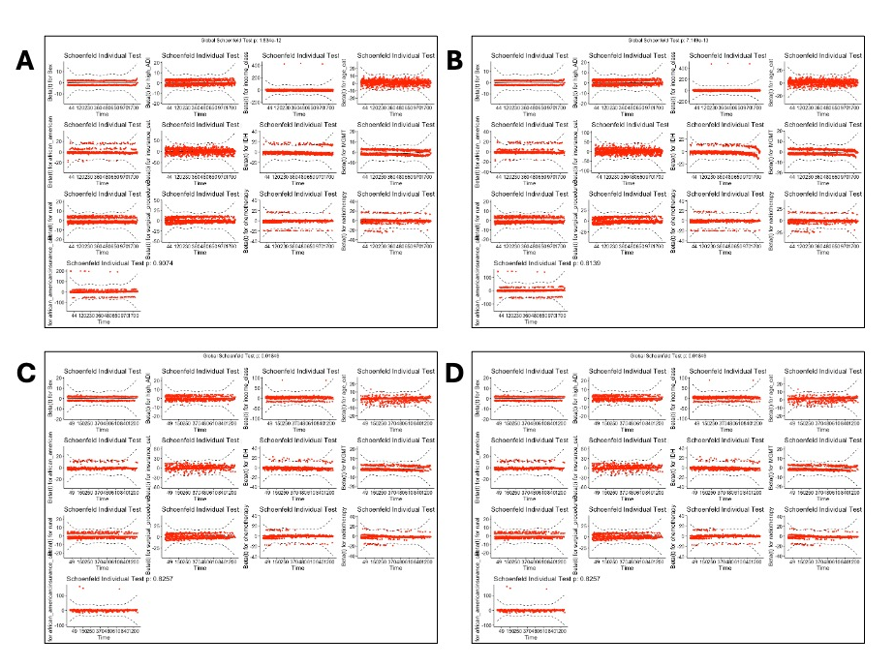
Figure 1S. Schoenfeld’s Residuals for A. Random Forest imputed B. MICE imputed C. Complete Case D. Post-2016 WHO Guidelines cohorts.
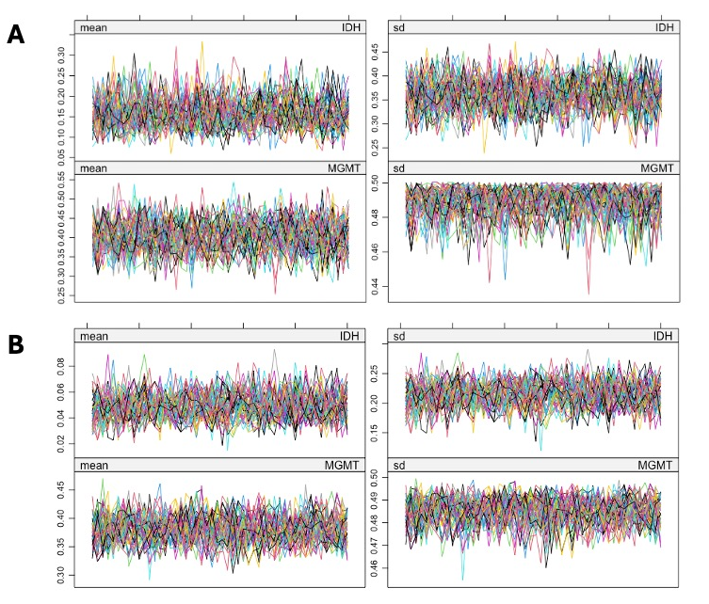
Figure 2S. Convergence Plots for A. Random Forest imputation B. MICE

1. NAMCS/NHAMCS - Ambulatory Health Care Data Homepage. 2023.
2. Bureau USC. Data from: ACS 5-Year Estimates Subject Tables
Income in the Past 12 Months (in 2022 Inflation-Adjusted Dollars). 2022.
3. Kochhar R, Sechopoulos S. How the American middle class has changed in the past five decades. Pew Research Center blog. https://www.pewresearch.org/short-reads/2022/04/20/how-the-american-middle-class-has-changed-in-the-past-five-decades/
files/68/how-the-american-middle-class-has-changed-in-the-past-five-decades.html
4. In J, Lee DK. Survival analysis: part II - applied clinical data analysis. Korean J Anesthesiol. Oct 2019;72(5):441-457. doi:10.4097/kja.19183
5. Louis DN, Perry A, Reifenberger G, et al. The 2016 World Health Organization Classification of Tumors of the Central Nervous System: a summary. Acta Neuropathol. Jun 2016;131(6):803-20. doi:10.1007/s00401-016-1545-1
6. Sterne JAC, White IR, Carlin JB, et al. Multiple imputation for missing data in epidemiological and clinical research: potential and pitfalls. BMJ. 2009;338:b2393. doi:10.1136/bmj.b2393

