Table S1.Features for CT,T1WI,T2WI and FS T2WI model
Features
exponential_glrlm_LongRunLowGrayLevelEmphasis_CT
log-sigma-1-0-mm-3D_firstorder_Kurtosis_CT
exponential_glrlm_RunVariance_T2
wavelet-HLL_firstorder_RootMeanSquared_CT
log-sigma-3-0-mm-3D_glszm_LargeAreaHighGrayLevelEmphasis_T2
original_shape_MinorAxisLength_CT
log-sigma-5-0-mm-3D_gldm_LargeDependenceHighGrayLevelEmphasis_T2FSE
log-sigma-3-0-mm-3D_gldm_DependenceVariance_T2FSE
log-sigma-5-0-mm-3D_firstorder_Kurtosis_CT
log-sigma-1-0-mm-3D_glrlm_ShortRunHighGrayLevelEmphasis_T1
squareroot_firstorder_Kurtosis_CT
squareroot_firstorder_10Percentile_T2FSE
logarithm_firstorder_Skewness_T2FSE
lbp-3D-m1_glrlm_GrayLevelNonUniformityNormalized_T2FSE
squareroot_firstorder_Skewness_CT
squareroot_glcm_ClusterShade_T2
squareroot_glszm_ZoneEntropy_CT
log-sigma-5-0-mm-3D_gldm_DependenceVariance_T2
log-sigma-5-0-mm-3D_glrlm_LongRunHighGrayLevelEmphasis_CT
wavelet-LHL_firstorder_Range_T2FSE
wavelet-HLH_glszm_ZoneEntropy_T2
wavelet-HHL_glszm_ZoneEntropy_T1
logarithm_glszm_GrayLevelVariance_CT
squareroot_gldm_LargeDependenceHighGrayLevelEmphasis_CT
squareroot_glcm_ClusterShade_T1
square_gldm_DependenceVariance_T2
wavelet-HLL_glszm_HighGrayLevelZoneEmphasis_CT
wavelet-LHL_gldm_LargeDependenceHighGrayLevelEmphasis_T2FSE
exponential_firstorder_Minimum_CT
wavelet-LHL_firstorder_Skewness_CT
wavelet-LHL_gldm_LargeDependenceHighGrayLevelEmphasis_CT
wavelet-HLL_glcm_ClusterShade_T1
exponential_glcm_Correlation_CT
original_firstorder_10Percentile_T2
squareroot_firstorder_10Percentile_T2
wavelet-LHL_firstorder_Median_T1
logarithm_glszm_SizeZoneNonUniformityNormalized_CT
exponential_glszm_ZoneVariance_CT
wavelet-HLH_glszm_ZoneEntropy_T2FSE
log-sigma-5-0-mm-3D_firstorder_Maximum_CT
exponential_glszm_LowGrayLevelZoneEmphasis_T2FSE
log-sigma-3-0-mm-3D_firstorder_Skewness_T1
wavelet-HLL_firstorder_Skewness_T2FSE
wavelet-LHH_glszm_ZoneEntropy_T2FSE
wavelet-LHL_firstorder_Mean_T1
wavelet-LHL_gldm_LargeDependenceHighGrayLevelEmphasis_T2
wavelet-HLH_gldm_DependenceVariance_CT
log-sigma-4-0-mm-3D_firstorder_RootMeanSquared_T2
log-sigma-1-0-mm-3D_glszm_HighGrayLevelZoneEmphasis_CT
wavelet-LLH_glcm_Imc2_CT
square_gldm_DependenceNonUniformityNormalized_T1
exponential_ngtdm_Strength_CT
log-sigma-3-0-mm-3D_ngtdm_Busyness_T1
square_glrlm_RunVariance_T2
wavelet-LHL_glrlm_RunEntropy_CT
wavelet-LHL_glszm_LargeAreaLowGrayLevelEmphasis_T1
original_firstorder_Minimum_T2
wavelet-HLH_firstorder_Minimum_T2FSE
exponential_ngtdm_Busyness_CT
log-sigma-1-0-mm-3D_gldm_LargeDependenceLowGrayLevelEmphasis_T1
wavelet-HLL_gldm_DependenceVariance_CT
original_firstorder_10Percentile_CT
wavelet-LHH_ngtdm_Busyness_CT
wavelet-HLH_glcm_ClusterProminence_T2
wavelet-HLH_firstorder_Median_CT
wavelet-HLL_firstorder_Skewness_T2
wavelet-LHH_ngtdm_Busyness_T1
exponential_glszm_SmallAreaEmphasis_CT
wavelet-LLH_glcm_Imc1_CT
wavelet-HLL_ngtdm_Busyness_CT
wavelet-HHL_gldm_DependenceVariance_CT
wavelet-HLH_glcm_ClusterProminence_T1
exponential_ngtdm_Coarseness_CT
square_firstorder_Skewness_T1
original_glszm_LargeAreaHighGrayLevelEmphasis_T2
exponential_glcm_MCC_T1
wavelet-LLL_glszm_LargeAreaHighGrayLevelEmphasis_T1
wavelet-LLH_glcm_Correlation_CT
wavelet-LHL_glcm_Imc2_T1
wavelet-HLL_glcm_Imc2_CT

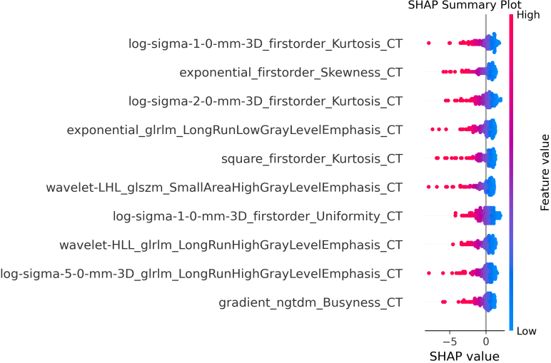
Fig s1.SHAP summary plot for CT model
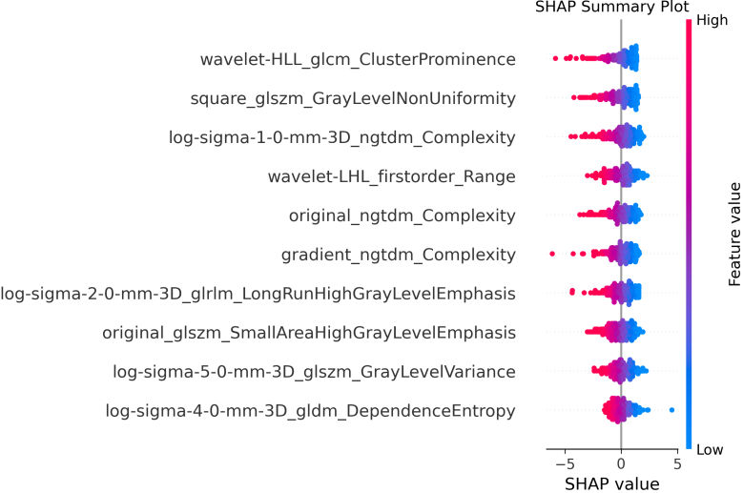

Fig s2.SHAP summary plot for T1WI model
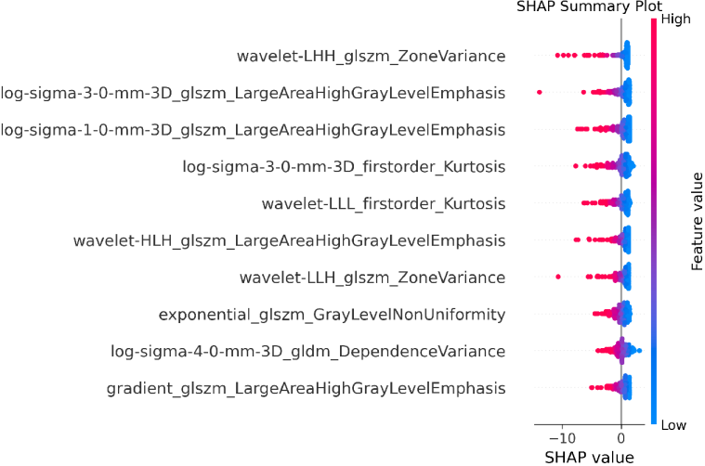
Fig s3.SHAP summary plot for T2WI model

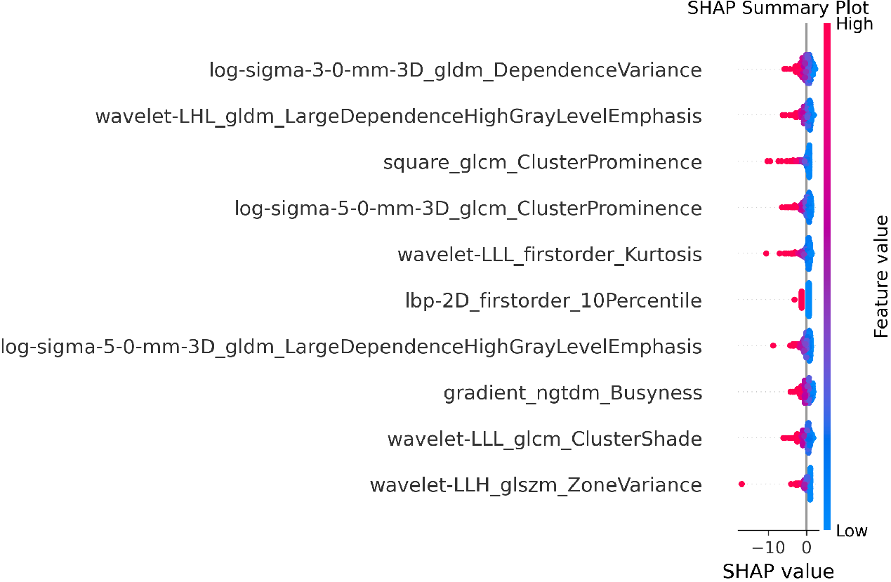
Fig s4.SHAP summary plot for FS T2WI model
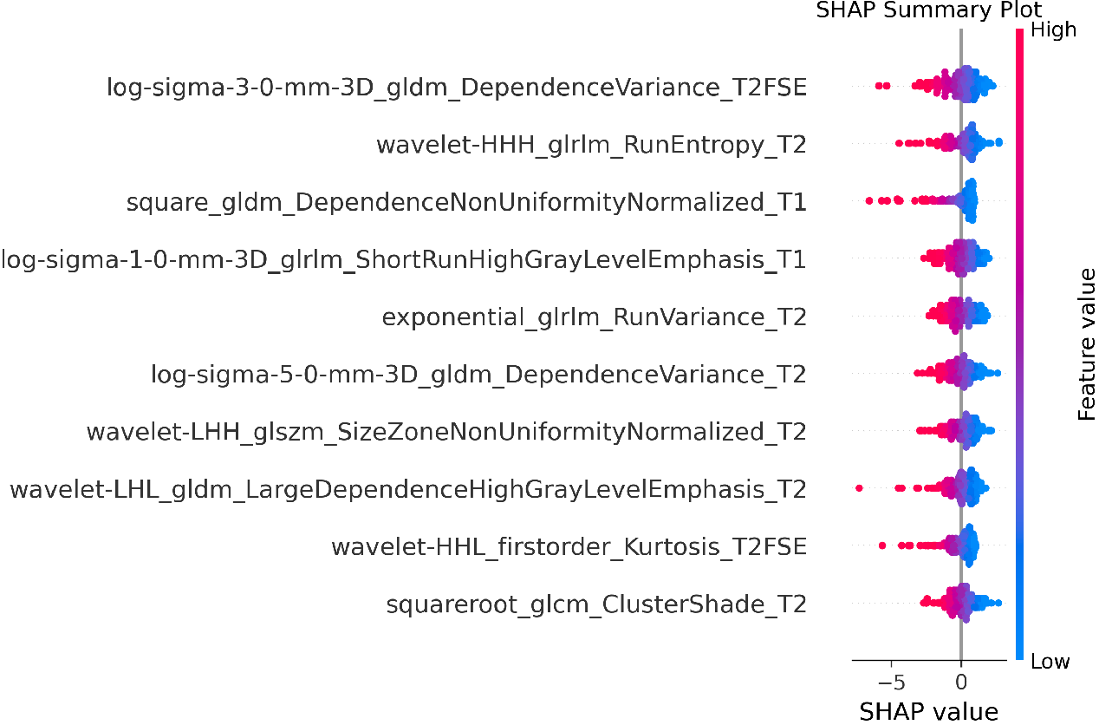
Fig s5.SHAP summary plot for T1WI,T2WI and FS T2WI model

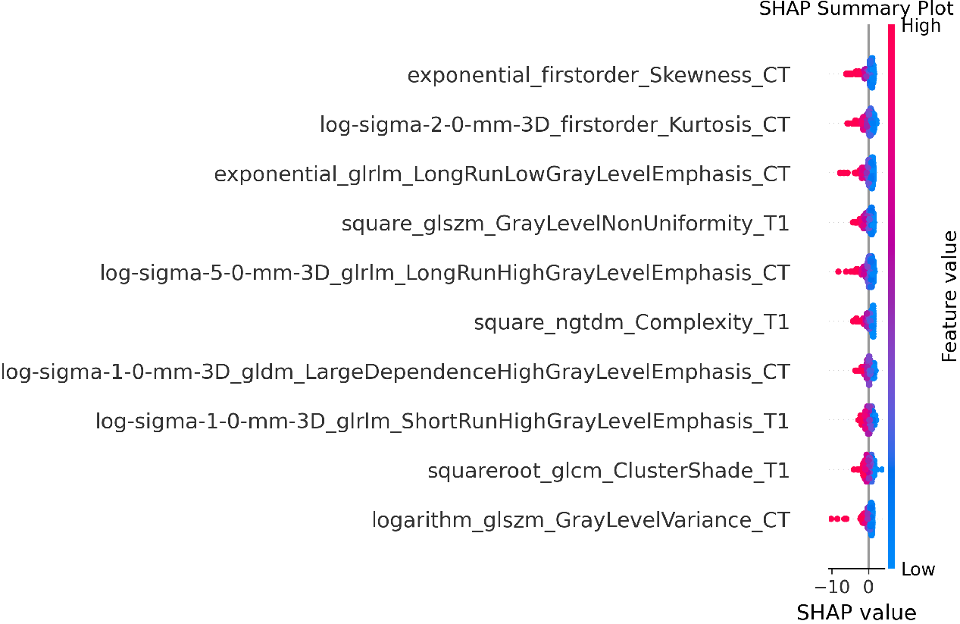
Fig s6.SHAP summary plot for CT and T1WI model

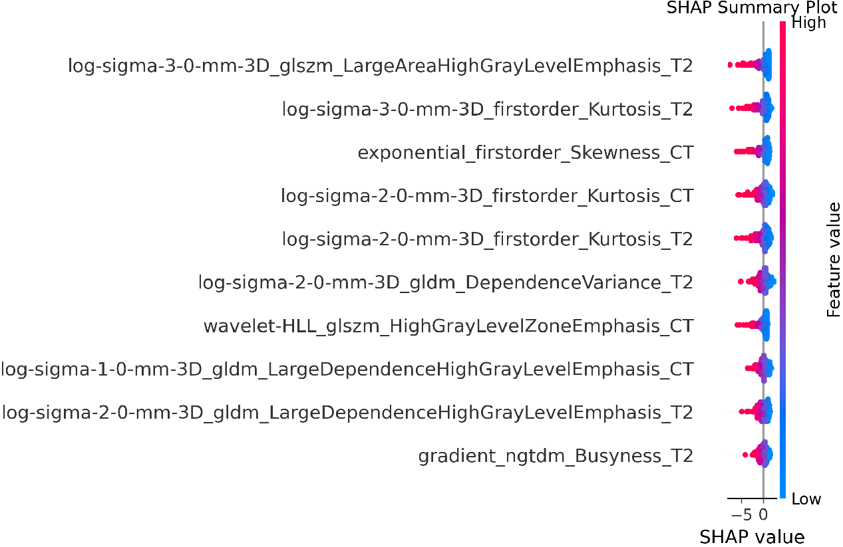
Fig s7.SHAP summary plot for CT and T2WI model
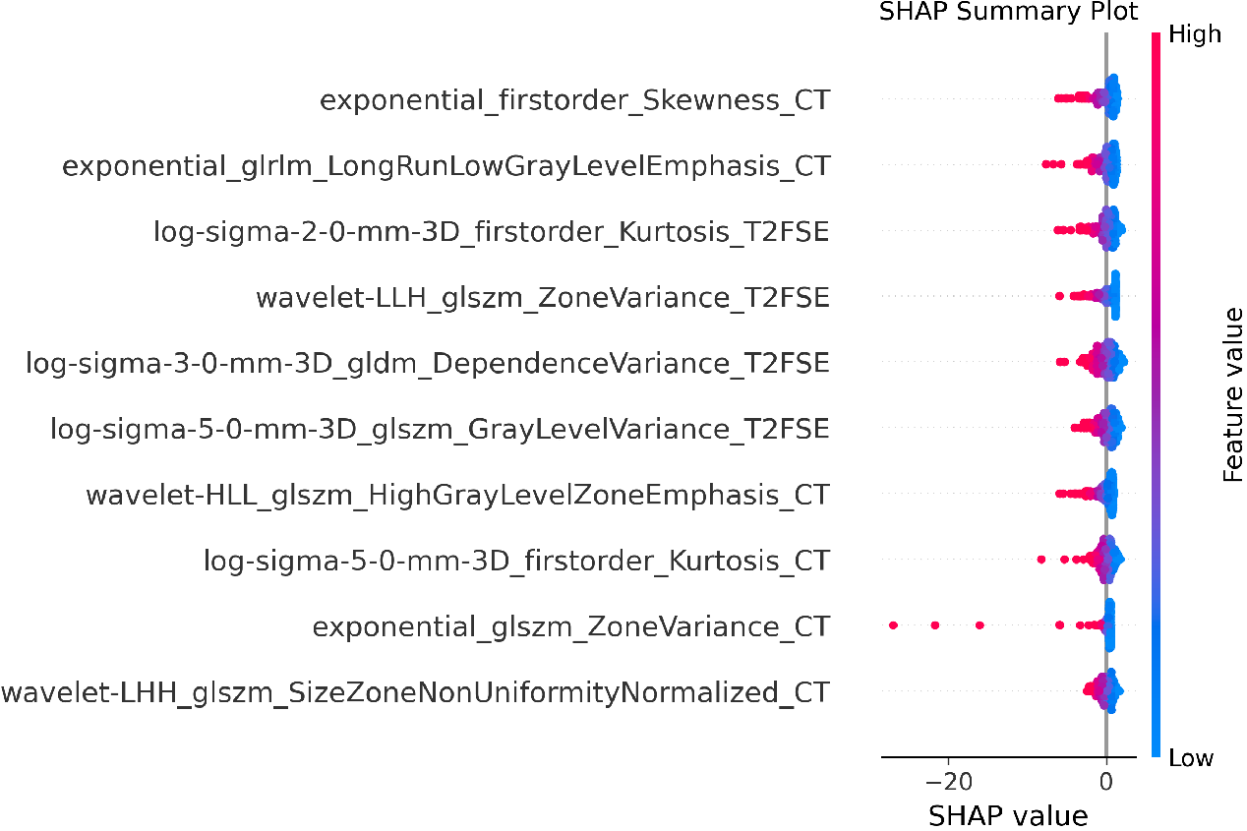
Fig s8.SHAP summary plot for CT and FS T2WI model

