Supplemental Information for:
Electrical tuning of optical Stark effect in monolayer WS₂
Xiu Zhang ^{1,2,3}, Tingxiao Qin¹, Junzhi Zhu^{1,2,3}, Haiyun Huang^{1,2,3}, Mengdi Zhang¹, Baixu Xiang⁴, Qihua Xiong^{1,4,5,6}*, and Haiyun Liu¹*
¹ Division of Quantum State of Matter, Beijing Academy of Quantum Information Sciences, Beijing 100193, China;
² Beijing National Laboratory for Condensed Matter Physics, Institute of Physics, Chinese Academy of Sciences, Beijing 100190, China;
³ School of Physical Sciences, University of Chinese Academy of Sciences, Beijing 100049, China;
⁴ State Key Laboratory of Low-Dimensional Quantum Physics and Department of Physics, Tsinghua University, Beijing 100084, China;
⁵ Frontier Science Center for Quantum Information, Beijing 100084, China;
⁶ Collaborative Innovation Center of Quantum Matter, Beijing 100084, China.
*To whom correspondence should be addressed.
Emails: Q.X. qihua_xiong@tsinghua.edu.cn and H.L. liuhy@baqis.ac.cn

S1. Sample fabrication and characterization
S2. Steady-state RC measurements
S3. TAS results under resonant excitation
S4. TAS results by below-resonance excitation and pump-probe with opposite circular polarization (OCP) configuration
S5. The optical Stark effect at different gate voltages
S6. Transient RC spectra and the OSE-induced blue shift from -50 to 50 V
S7. The optical Stark effect as a function of pump fluence at 0 V
S8. Transient RC spectra and the OSE-induced blue shift as a function of pump fluence

S1. Sample fabrication and characterization
The back-gated device consists of ML-WS₂, encapsulated by few-layer hexagonal boron nitride (hBN) on both the top and bottom sides (Fig. S1(a)). The high-quality ML-WS₂ was prepared on a polydimethylsiloxane (PDMS) stamp by mechanical exfoliation from commercially sourced bulk material (HQ Graphene). The ML-WS₂ samples were then carefully transferred from the PDMS stamp onto the Au electrodes deposited on 285 nm SiO₂/Si p-type dry oxide substrates, ensuring that smooth, seamless large area monolayers were obtained during the transfer process. The electrodes were fabricated by laser direct writing technology. First, the polymethyl Methacrylate (PMMA) masks were spin-coated on the substrates, and the patterned electrical contact areas were defined on the masks by laser writing. Subsequently, 5 nm Cr/ 60 nm Au electrical contacts were deposited by thermal evaporation. After being dissolved in organic solvent and cleaned by oxygen plasma, the pre-fabricated electrodes were finally finished. To control the doped electron density of the devices in our experiments, a back-gate voltage was applied to the Si substrate with ML-WS₂ grounded.
The Raman spectrum (Fig. S1(b)) exhibits two first-order Raman peaks labeled as E_{2g} and A_{1g}, along with other resonant structures. The peaks at approximately 354.6 and 418 cm⁻¹ agree with the in-plane and out-of-plane vibrations with E_{2g} and A_{1g} symmetries, respectively. These peak frequencies are consistent with the previous Raman measurements¹ in ML-WS₂.
The photoluminescence (PL) spectrum at room temperature (Fig. S1(c)) presents a characteristic Lorentzian curve, displaying a strong excitonic emission peak at ~2.01 eV with a full width at half-maximum of 23.8 meV, which is consistent with previous report².
Figure S1: (a) Photomicrograph of the back-gated device. (b) Raman spectrum of ML-WS₂ on SiO₂ substrate excited by a 532 nm laser line at room temperature. The red triangles denote other resonant structures. (c) PL spectrum of ML-WS₂ at room temperature. The dashed curve presents a Lorentzian fit.

S2. Steady-state RC measurements
In the reflectance contrast (RC) experiments, we employed a home-built spectroscopy setup to measure the reflectivity spectra from the sample and substrate. The broadband light from a tungsten quartz halogen source was focused onto the sample by a 100× objective (NA= 0.7), creating a spot of ~3 μm in diameter on the sample. The reflected light from the back-gate device was collected by the same objective and detected by a spectrometer equipped with a grating (600 lines mm⁻¹) and a liquid nitrogen-cooled charge-coupled device (CCD). The measurements were performed at temperatures from 77 to 295 K. We estimate the electron density $n$ by means of the standard capacitance analysis as:
$n=\frac{Q}{S}=\frac{Sε_{0}U}{S(\frac{d_{1}}{ε_{1}}+\frac{d_{2}}{ε_{2}})×1.602×{10}^{-19}}$ (1)
where Q is the quantity of electric charge, S is the overlap between ML-WS₂ and silicon contributing to the formation of capacitance, $ε_{0}$ is the dielectric constant in vacuum, $ε_{1}$ and$ε_{2}$ are the relative dielectric constants of SiO₂ and hBN, respectively, $d_{1}$ and $d_{2}$ are thicknesses of SiO₂ and hBN, respectively. Here we use $d_{1}\sim$ 285 nm, $d_{2}\sim$25 nm, $ε_{1}\sim$4, $ε_{2}\sim$2.2, yielding an injected hole density of ~ 3.65 × 10¹² cm⁻² at a gate voltage of -50 V.
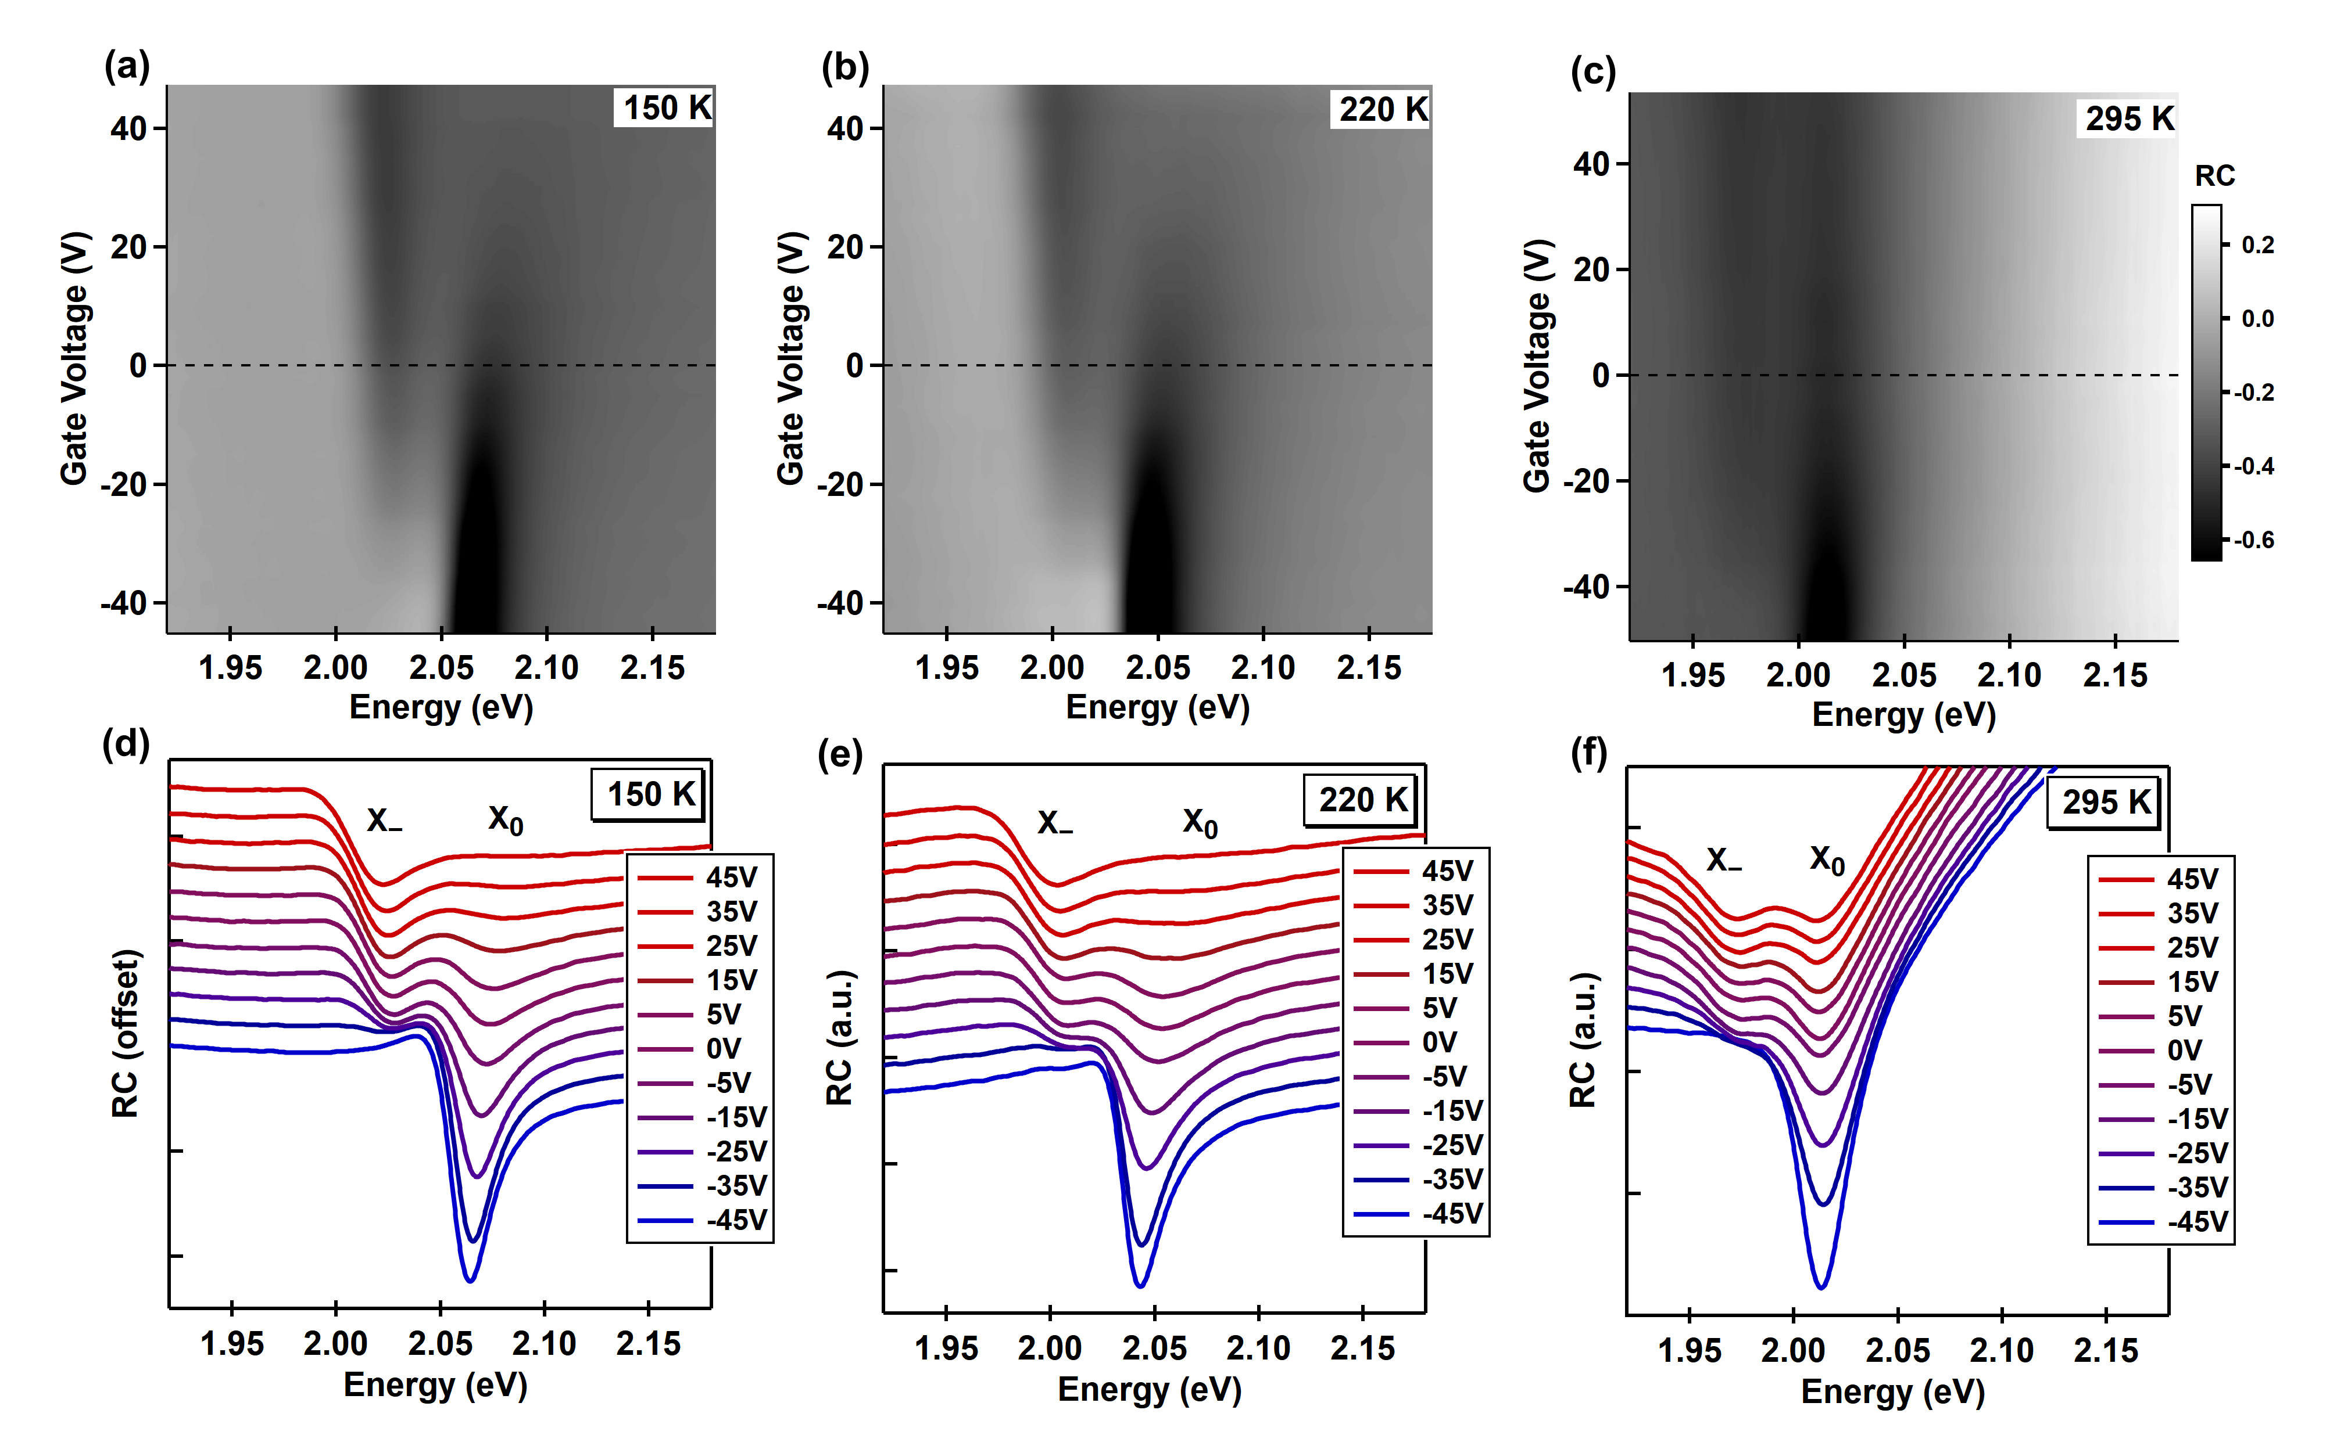
Figure S2: Steady-state RC spectra of ML-WS₂ as a function of gate voltage at temperatures of 150, 220 and 295 K.

S3. TAS results under resonant excitation
To examine the dynamics of A exciton and trion species, we present the evolution of their spectra as a function of delay time and energy, as shown in Fig. S3. The TAS 2D plots depict transient reflection changes at different gate voltages, with linearly polarized pump and probe beams. The measurements were conducted with pump fluence of ~30 μJ/cm², pump photon energy of 2.09 eV, temperature at 77 K. The populations of both neutral A exciton and trion build up rapidly, reaching their maxima at approximately ~0.3 ps after initial photoexcitation, and subsequently decay over longer timescales. With the gate voltage varying from -50 to 50 V, the trion (E_{T} = 2.05 eV) population significantly increases, concurrent with the reduction of A exciton (E_{A} = 2.09 eV) intensity. The prominent ground state bleaching (GSB, ΔR/R > 0) signatures of A exciton and trion are induced by the phase-space filling (Pauli blocking³), while the photoninduced absorption (PIA, ΔR/R < 0, at 2.02 eV) feature is attributed to the exciton–exciton interaction⁴.
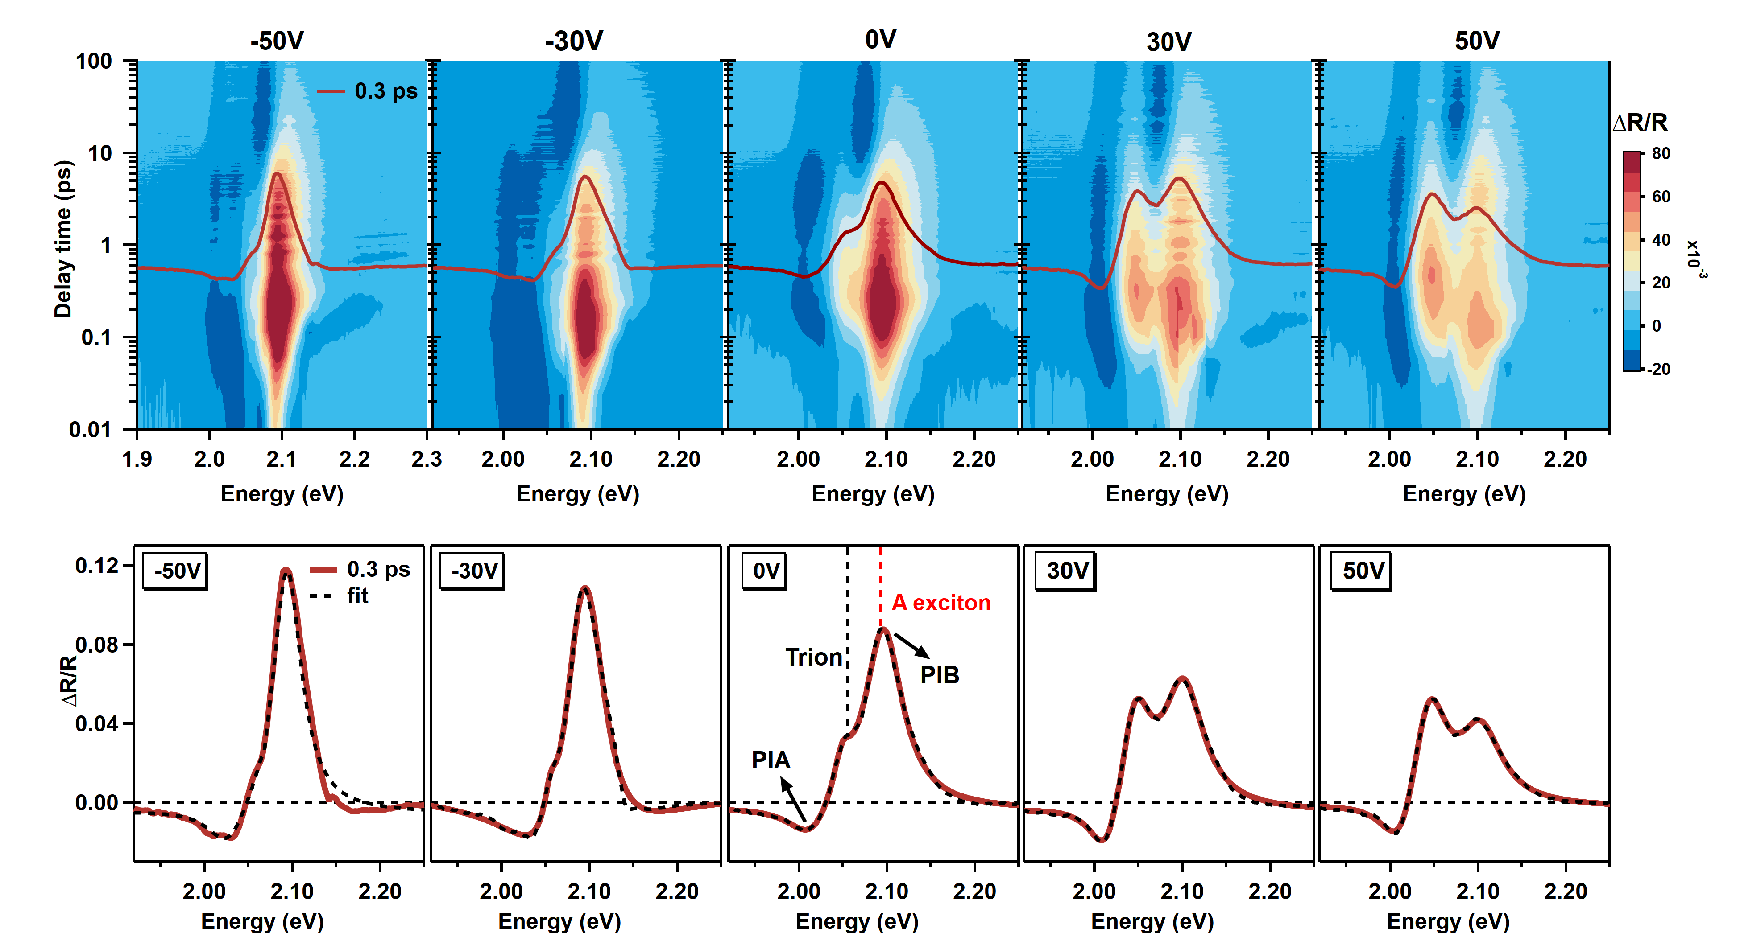
Figure S3: TAS results of ML-WS₂ under resonant excitation at different gate voltages. The upper panels display 2D plots of reflection changes. The lower panels present cuts at 0.3 ps and Lorentzian fits.

S4. TAS results by below-resonance excitation and pump-probe with opposite circular polarization (OCP) configuration
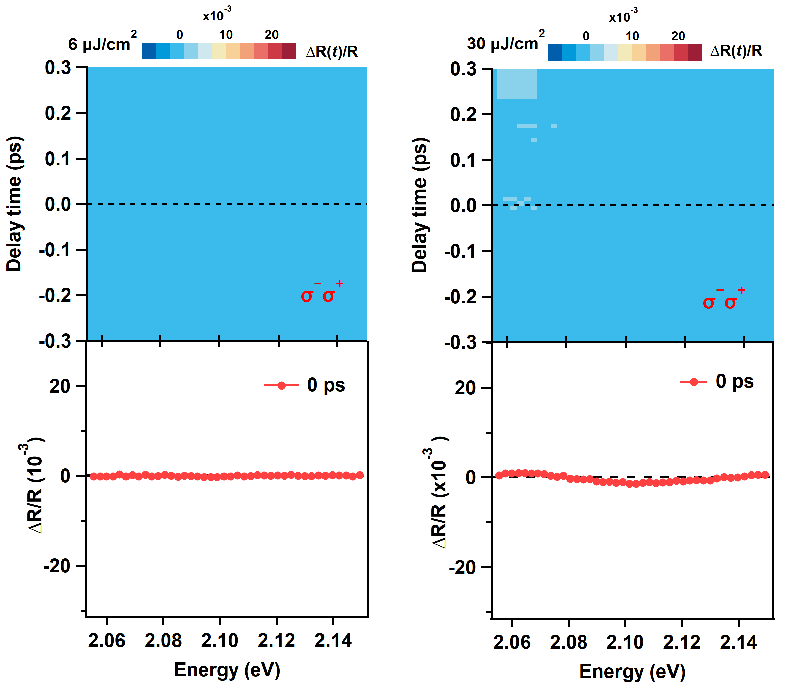
Figure S4: Upper panels present TAS images of ML-WS₂ with OCP configuration at pump fluences of 6 uJ/cm² and 30 uJ/ cm². The pump photon energy is 1.82 eV, well below the trion and A exciton, and pump-probe polarization configuration is σ-σ+. Lower panels show transient curves at 0 ps extracted from upper panels.

S5. The optical Stark effect at different gate voltages
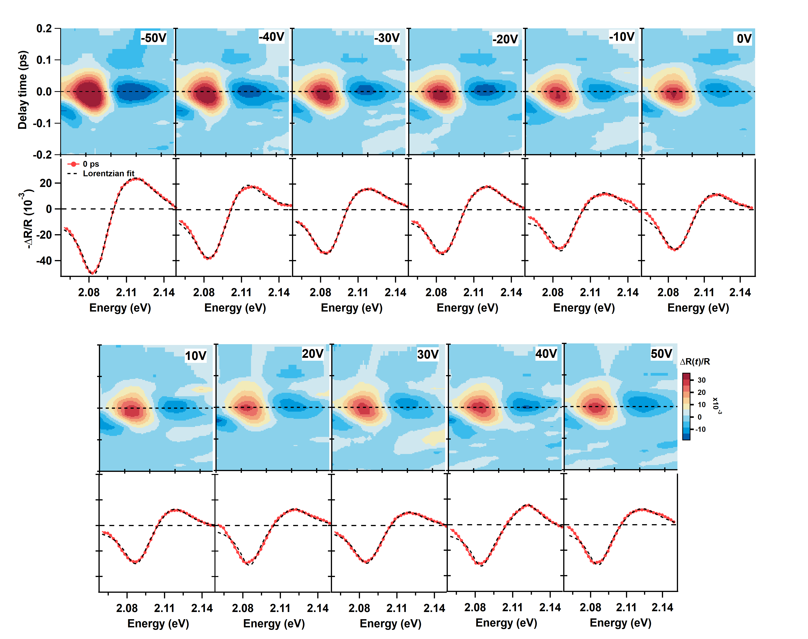
Figure S5: Systematic TAS images from -50 to 50V with an interval of 10 V. The pump photon energy is 1.82 eV, with pump-probe polarization configuration σ-σ-. The red curves present transient reflection changes at 0 ps. The dashed lines are Lorentzian fit with a blue shift.
S6. Transient RC spectra and the OSE-induced blue shift from -50 to 50 V
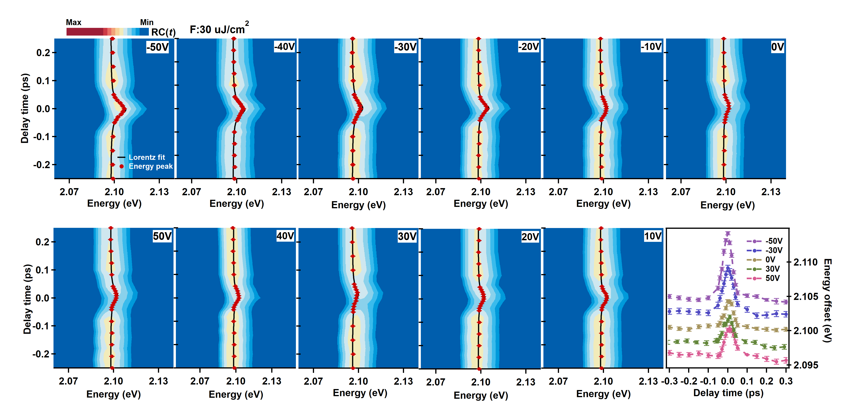
Figure S6: Transient RC images derived from Fig. S5 by integrating the steady-state RC spectrum. The red dots are peak positions obtained from Lorentzian fits.
S7. The optical Stark effect as a function of pump fluence at 0 V
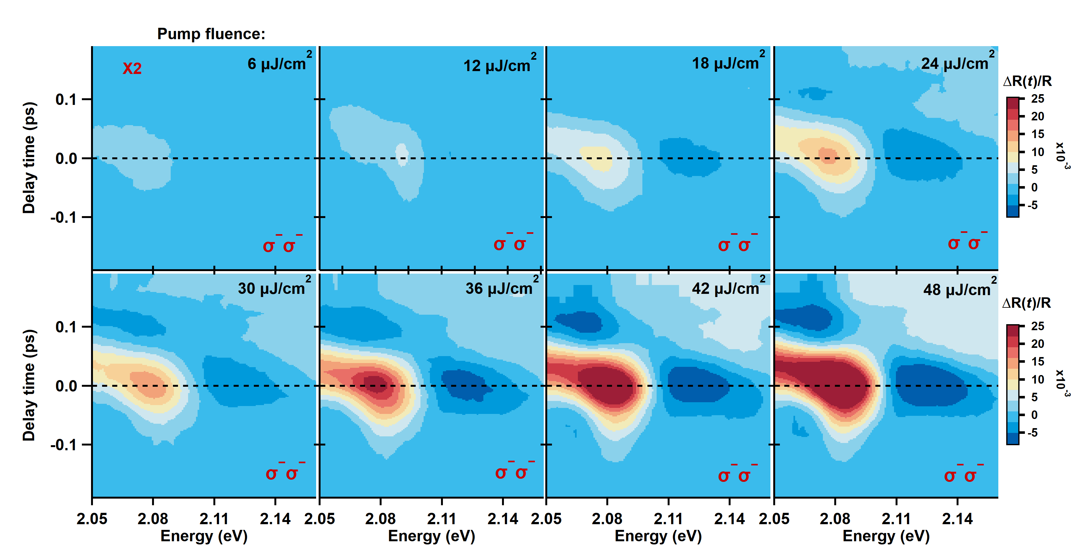
Figure S7: Fluence-dependent ΔR/R images as a function of pump fluence, with gate voltage at 0 V, pump photon energy of 1.82 eV, and pump-probe polarization configuration σ-σ-.
S8. Transient RC spectra and the OSE-induced blue shift as a function of pump fluence
Figure S8: Left images are the transient RC spectra converted from Fig. S7, by integrating with the steady-state RC spectrum. The red dots are peak positions obtained from Lorentzian fits. Right panel shows the OSE-induced blue shift as a function of pump fluence, extracted from left images.
1. Liu, H. L. et al. Deep-ultraviolet Raman scattering spectroscopy of monolayer WS₂. Sci. Rep. 8, 11398 (2018).
2. Zhu, B., Chen, X. & Cui, X. Exciton binding energy of monolayer WS₂. Sci. Rep. 5, 9218 (2015).
3. Wang, H., Zhang, C., Chan, W., Manolatou, C., Tiwari, S.& Rana, F. Radiative lifetimes of excitons and trions in monolayers of the metal dichalcogenide MoS₂. Phys. Rev. B 93, 045407 (2016).
4. Schmitt, R. S., Chemla, D. S. & Miller, D. A. Theory of transient excitonic optical nonlinearities in semiconductor quantum-well structures. Phys. Rev. B 32, 6601-6609 (1985).

