SUPPORTING INFORMATION
Pt nanoparticles breathe and reversibly detach from Al₂O₃ in hydrogen

Daniele Bonavia, Alberto Ricchebuono, Paolo Lazzarini, Eleonora Vottero, Riccardo Pellegrini, Andrea Piovano, Celine Chizallet, Pascal Raybaud, Catherine Dejoie, Ivo Alxneit, Stefano Checchia, Davide Ferri, Elena Groppo

1. Description of the cell used for in situ XRD and PDF measurements
2. High-resolution XRD of the Al₂O₃ support
3. Construction and optimization of the Pt₃₄/γ-Al₂O₃ and Pt₅₅/γ-Al₂O₃ models
4. Determination of the average Pt crystal size from PDF data
5. Monitoring the reduction process: additional plots
6. Comparison of the PDF patterns at the end of the reduction process in gas and liquid phase for both catalysts
7. Simulated PDF patterns for Pt_{x}H_{y}/Al₂O₃ models in the two extreme hydrogenation states

1. Description of the cell used for in situ XRD and PDF measurements
The flow-through cell used in this work consists of a stainless-steel body coupled to two symmetric end plates (Figure S1). The central body hosts a 9 mm³ sample compartment, where the catalyst powder is loaded between two quartz wool plugs; two 45 W heating resistors; and a thermocouple placed in contact with the sample compartment. The sample is sandwiched between two fluorinated rubber gaskets (Grenoble-Alpes Elastomers, France) and two glassy carbon windows (HTW, Germany). The cell can heat the sample up to 180°C while allowing leak-free flow of either liquid or gaseous feeds. The exit window allows a maximum 2θ angle of 60° between the centre of the sample volume and the steel rim of the window.
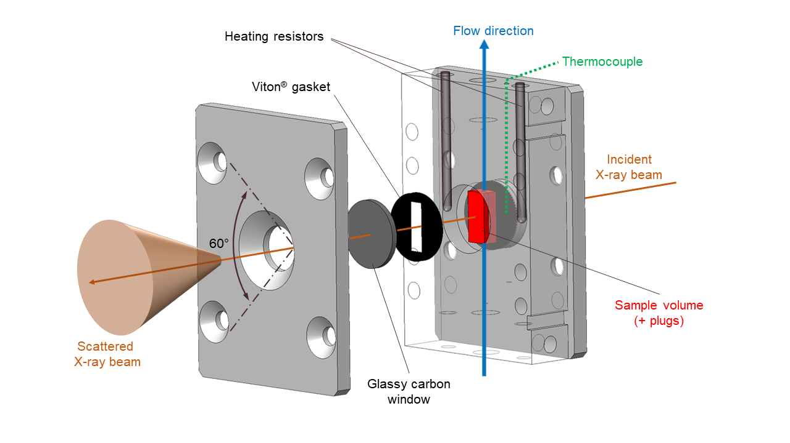Figure S1. Exploded schematic of the flow-through cell employed for in situ XRD and PDF measurements, either in gas or liquid phase.

2. High-resolution XRD of the Al₂O₃ support
High-resolution powder-diffraction was collected at the ID22 beamline of the ESRF using the 13-crystal multianalyzer stage.¹ Samples were the Pt/Al₂O₃ sample studied in this work and four bare Al₂O₃ samples (Figure S2), all supplied by Chimet S.p.A. (Viciomaggio, Italy). The bare Al₂O₃ samples were the mixed-phase alumina used in Pt/Al₂O₃, and three samples containing predominantly θ, δ, or γ phases, respectively.
Fits were carried out in Topas v7.² The alumina phase was refined in a Le Bail-type fit using as initial model the phase δ1(s.g. P2₁2₁2₁) reported by Kovarik et al.³ The fcc Pt phase was refined simultaneously varying lattice parameter, Pseudo-Voigt peak width, scale factor, and a Debye-Waller factor. Intrinsic line broadening due to instrumentation was first modelled on the pattern of a NIST standard powder (Cr₂O₃ SRM-674b), collected in the same setup, and then deconvoluted during these fits. Crystallite sizes were calculated from the peak integral breadth using the Double-Voigt approach.⁴

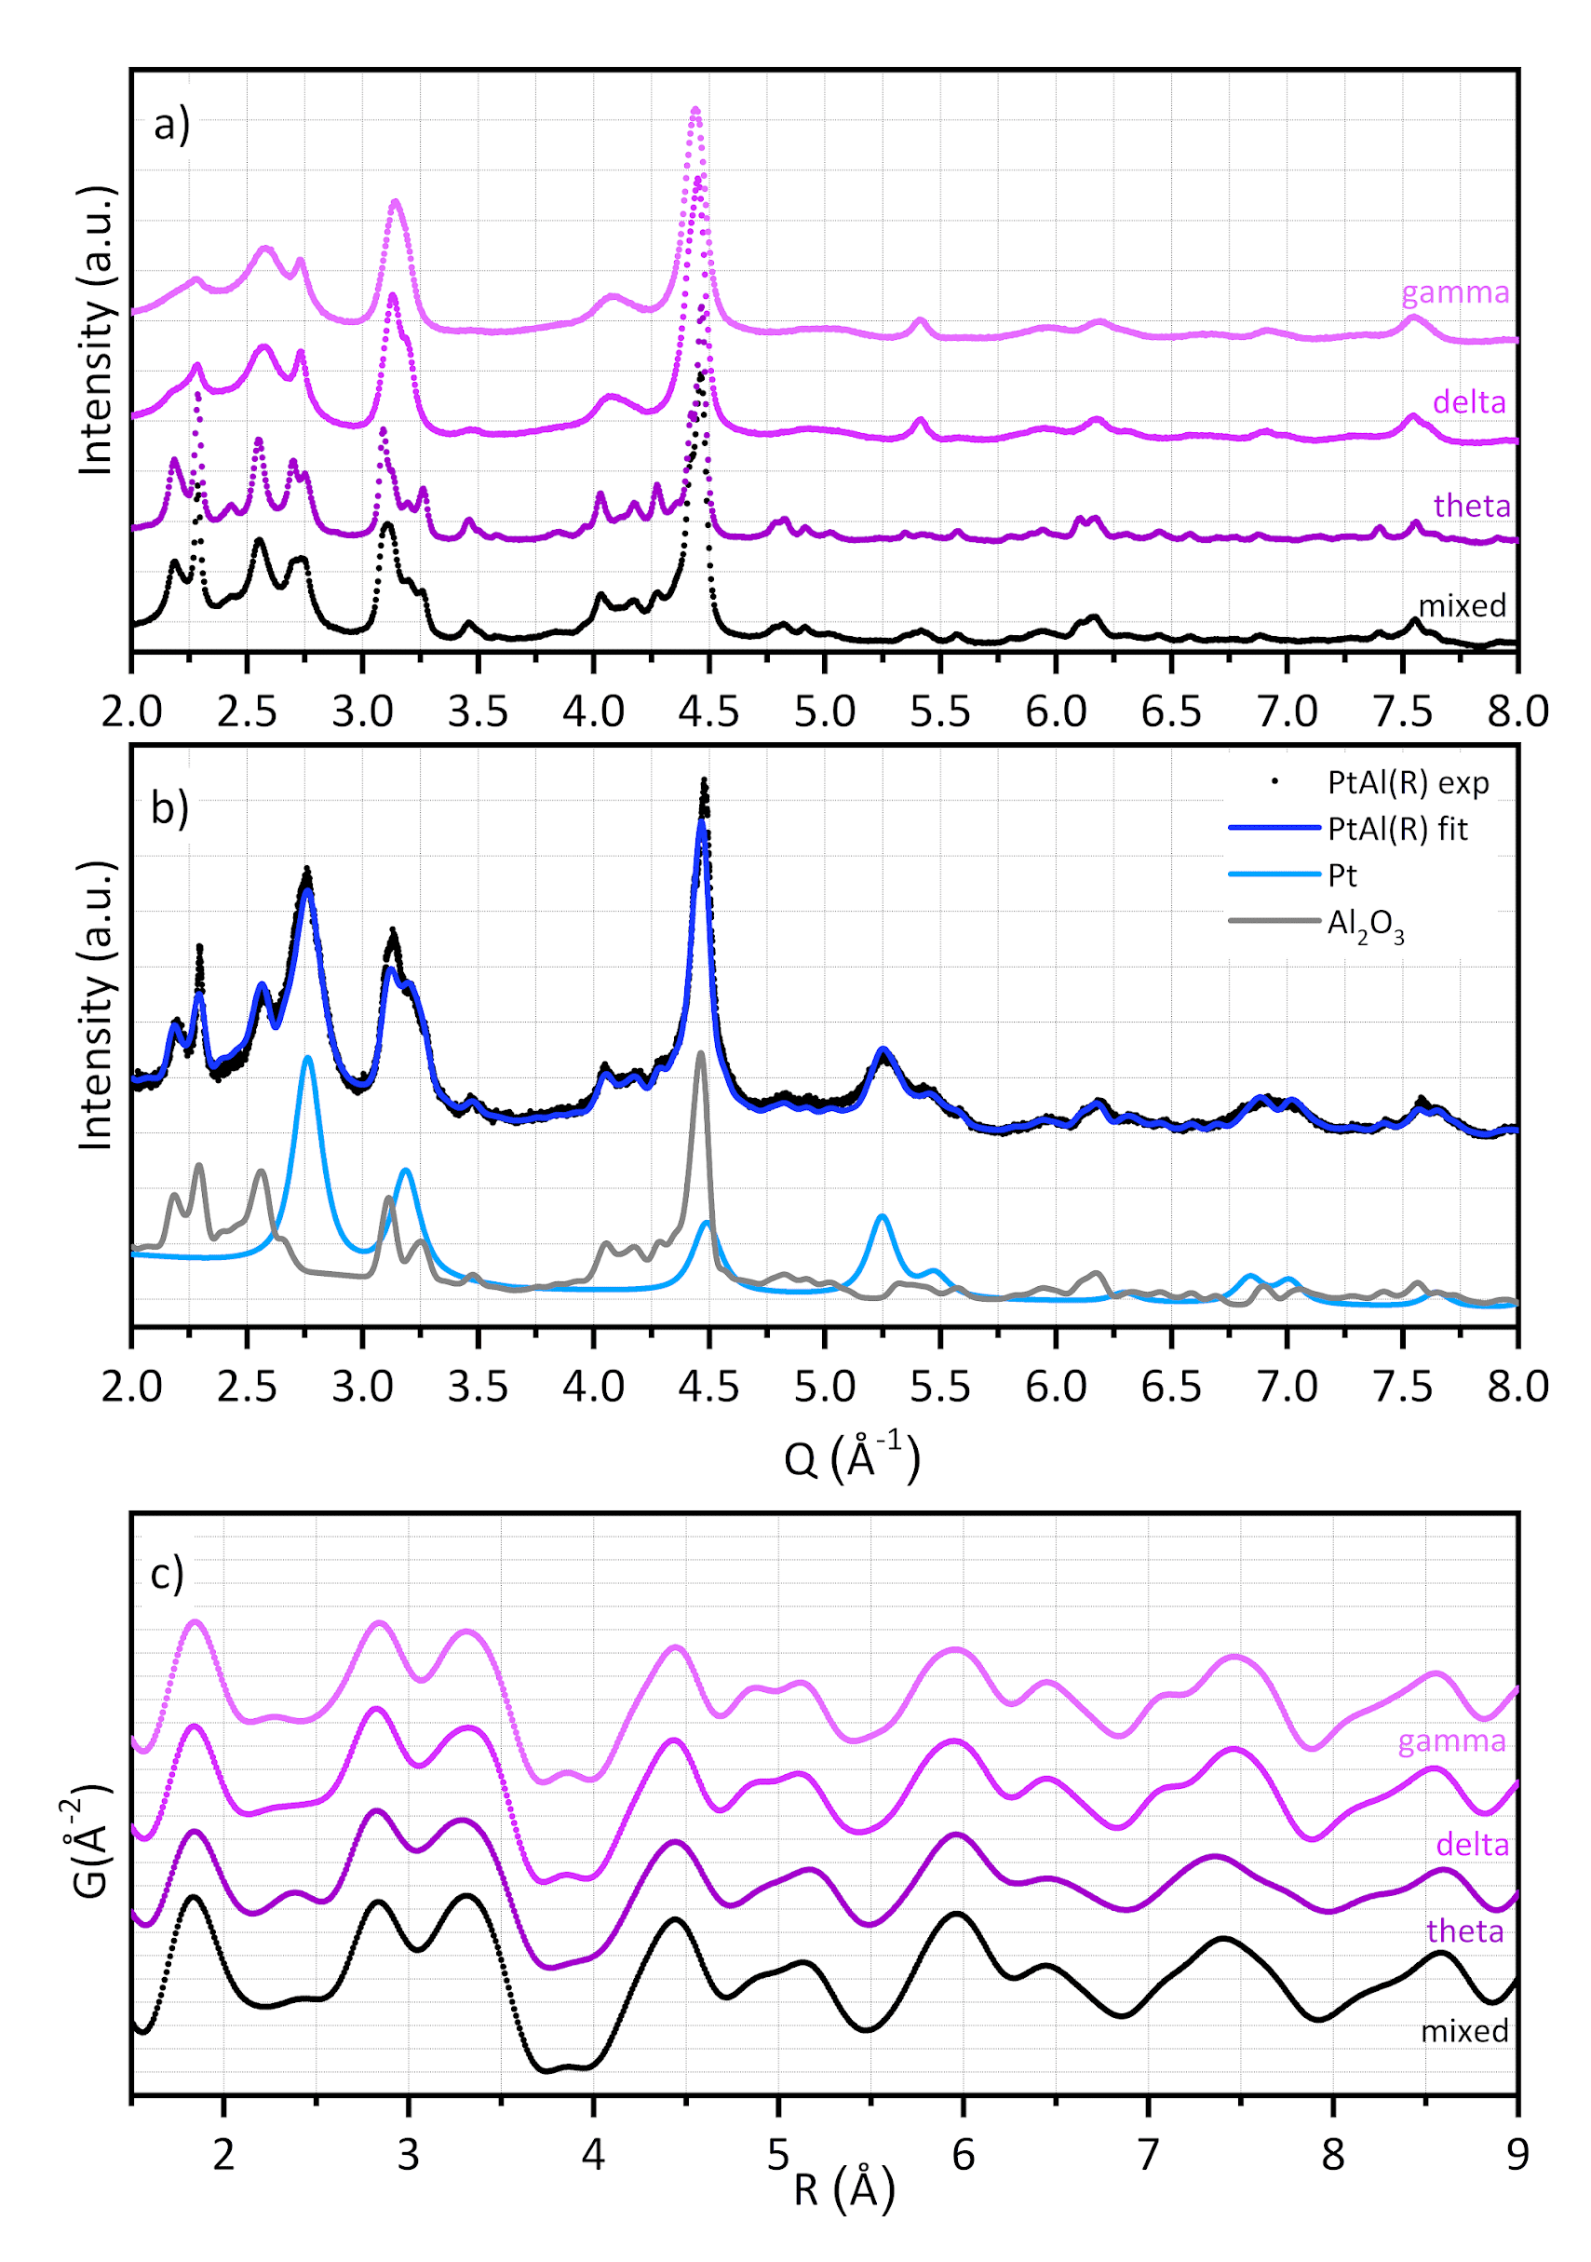
Figure S2. (a) Experimental high-resolution XRD patterns of the alumina support (mixed) compared to those of three Al₂O₃ samples containing predominantly θ, δ, or γ phases, respectively. (b) Experimental high-resolution XRD pattern of as-received PtAl(R) (black dots), total fit (blue) and individual contributions of Pt (light blue) and Al₂O₃ (grey) phases. The Al₂O₃ contribution was modeled using the intergrowth structure proposed by Kovarik et al.⁵ (P2₁2₁2₁ symmetry). Data are expressed in Q (=4πsin(θ)/λ; λ=0.1265 Å; θ is half of the Bragg angle). (c) PDF patterns of the alumina support (mixed) compared to those of three Al₂O₃ samples containing predominantly θ, δ, or γ phases, respectively.

3. Construction and optimization of the Pt₃₄/γ-Al₂O₃ and Pt₅₅/γ-Al₂O₃ models
While the Pt₁₃H_{y}/γ-Al₂O₃, Pt₃₄H₅₄/γ-Al₂O₃ and Pt₅₅H₄₄/γ-Al₂O₃ models were described previously,^{6, 7} the Pt₃₄/γ-Al₂O₃ and Pt₅₅/γ-Al₂O₃ models are reported herein for the first time. Pt₃₄/γ-Al₂O₃ was constructed starting from a truncated cuboctahedron deposited on alumina (100) surface (support model from refs.^{8, 9}). Pt₅₅/γ-Al₂O₃ was constructed starting from a cuboctahedron deposited on the same alumina surface through the Pt(100) facet (this appeared to generate a more stable cluster than when depositing it through the Pt(111) facet of the cuboctahedron). A four-layer support model was used, the two top-ones being relaxed with the cluster, and the dimensions of the orthorhombic cell were 16.714 x 16.787 x 30 Å³. The VASP code^{10, 11} was used for the geometry optimizations in the framework of the density functional theory, made with the PBE¹² exchange correlation functional and PAW¹³ pseudopotentials, with a cutoff of 400 eV. A convergence criterion on the energy of the SCF cycles of 10⁻⁶ eV and a convergence criterion on forces of 0.02 eV/Å were chosen. The calculations were made at the Γ point, and with a dipolar correction on the z-axis (perpendicular to the slabs).

4. Determination of the average Pt crystal size from PDF data
The PDF of the as-received PtAl(R) and of the PtAl(R) and PtAl samples after reduction in either gas phase or liquid phase was fitted using an fcc Pt phase using Topas Academic v7 (see Manuscript). The PDF was calculated after subtraction of the pattern of the undeposited mixed-phase Al₂O₃ acquired at the same temperature and under the same chemical conditions. Fits on the PDF of a NIST Cr₂O₃ standard were used to refine the parameters related to instrumental resolution and Q-termination, which were then fixed in the fit to the samples’ PDF.
For the Pt phases we refined lattice parameter, scale factor, a Debye-Waller factor accounting for correlated nearest-neighbour displacements, and a factor accounting for dampening of the PDF intensity based on the size of a spherical nanoparticle:
$Y=π R^{2}\frac{\left(\frac{1}{4}\frac{R^{3}}{r}-3\frac{R}{r}+4\right)}{\left(4πR^{2}\right)} if R≤2r Y=0 if R>2r$
where r is the radius of the nanoparticle, R is the real space axis in G(R), and Y is the multiplicative scale factor applied to the PDF.

Table S1. Lattice parameters and average crystal size for the Pt NPs before reduction (pristine), and after isothermal reduction at 120 °C, either in gas or in liquid phase, as determined by analyzing the experimental PDF patterns.
 | PtAl(R) |  | PtAl
 | Lattice pars.  (Å) | Cryst. size  (nm) | Lattice pars.  (Å) | Cryst. size  (nm)
As such | 3.9149(2) | 3.3(1)^{(a)} | - | -
H₂-red (gas) | 3.9147(2) | 3.7(1) | 3.9146(2) | 2.3(1)
H₂-red (liquid) | 3.9152(3) | 3.4(1) | 3.9152(7) | 2.3(1)
^{(a)} 2.8 nm from analysis of XRD patterns

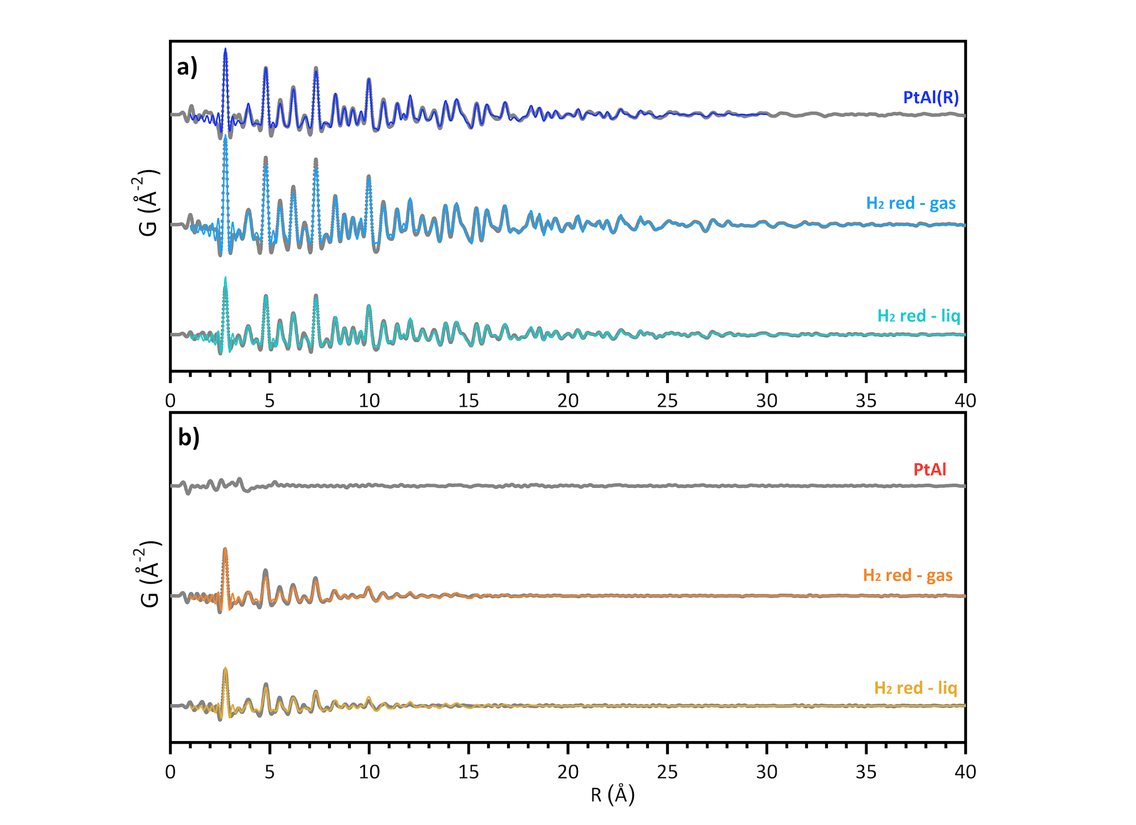
Figure S3. Experimental full PDF patterns (grey dots) of (a) PtAl(R) and (b) PtAl at ambient conditions, after reduction in H₂/Ar at 150°C, and after reduction in H₂/cyclohexane at 70°C, and their fit (lines) performed using a spherical-particle model for Pt NPs. Curves are offset for the sake of clarity. The fit of the pattern of PtAl was not performed because the signal is structureless.
5. Monitoring the reduction process: additional plots
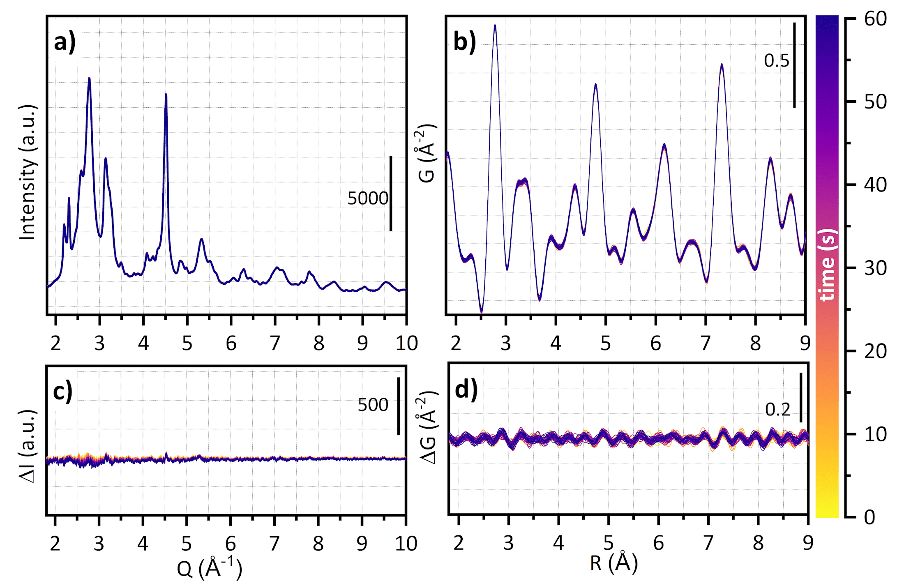
Figure S4. Time-evolution of the (a) XRD and (b) PDF patterns of PtAl(R) during the isothermal reduction in H₂/Ar at 150°C. Time evolution (yellow to blue) of differential (c) XRD and (d) PDF patterns obtained upon subtracting the last pattern before H₂ was admitted. 1 pattern/s collected during the first 60 s of reaction.

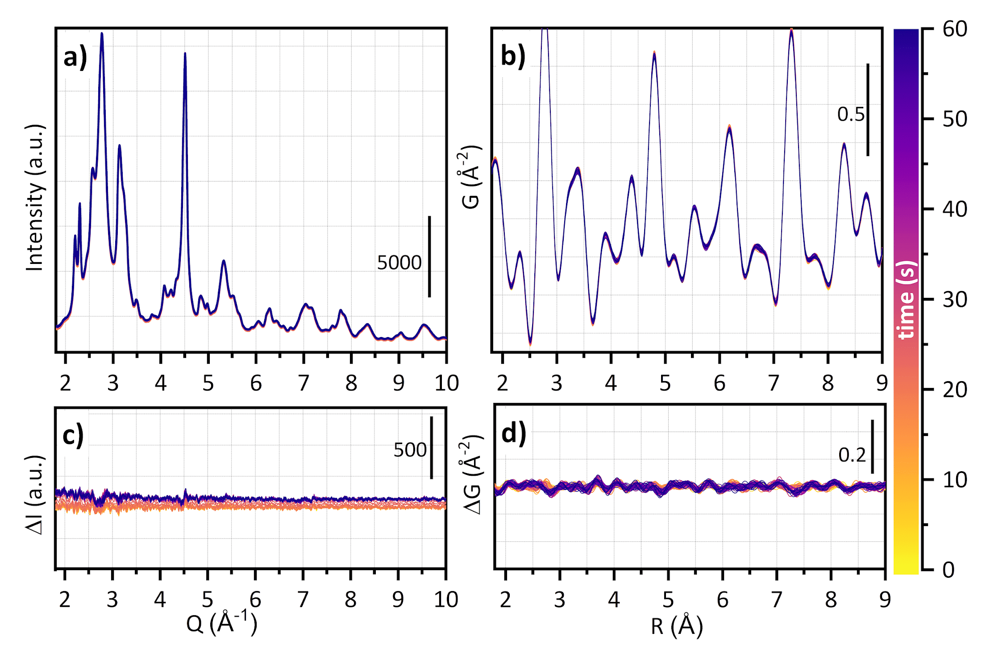
Figure S5. Time-evolution of the (a) XRD and (b) PDF patterns of PtAl(R) during the isothermal reduction in H₂/cyclohexane at 70°C. Time evolution (yellow to blue) of difference (c) XRD and (d) PDF patterns obtained upon subtracting the last pattern before H₂ was admitted. 1 pattern/s collected during the first 60 s of reaction.

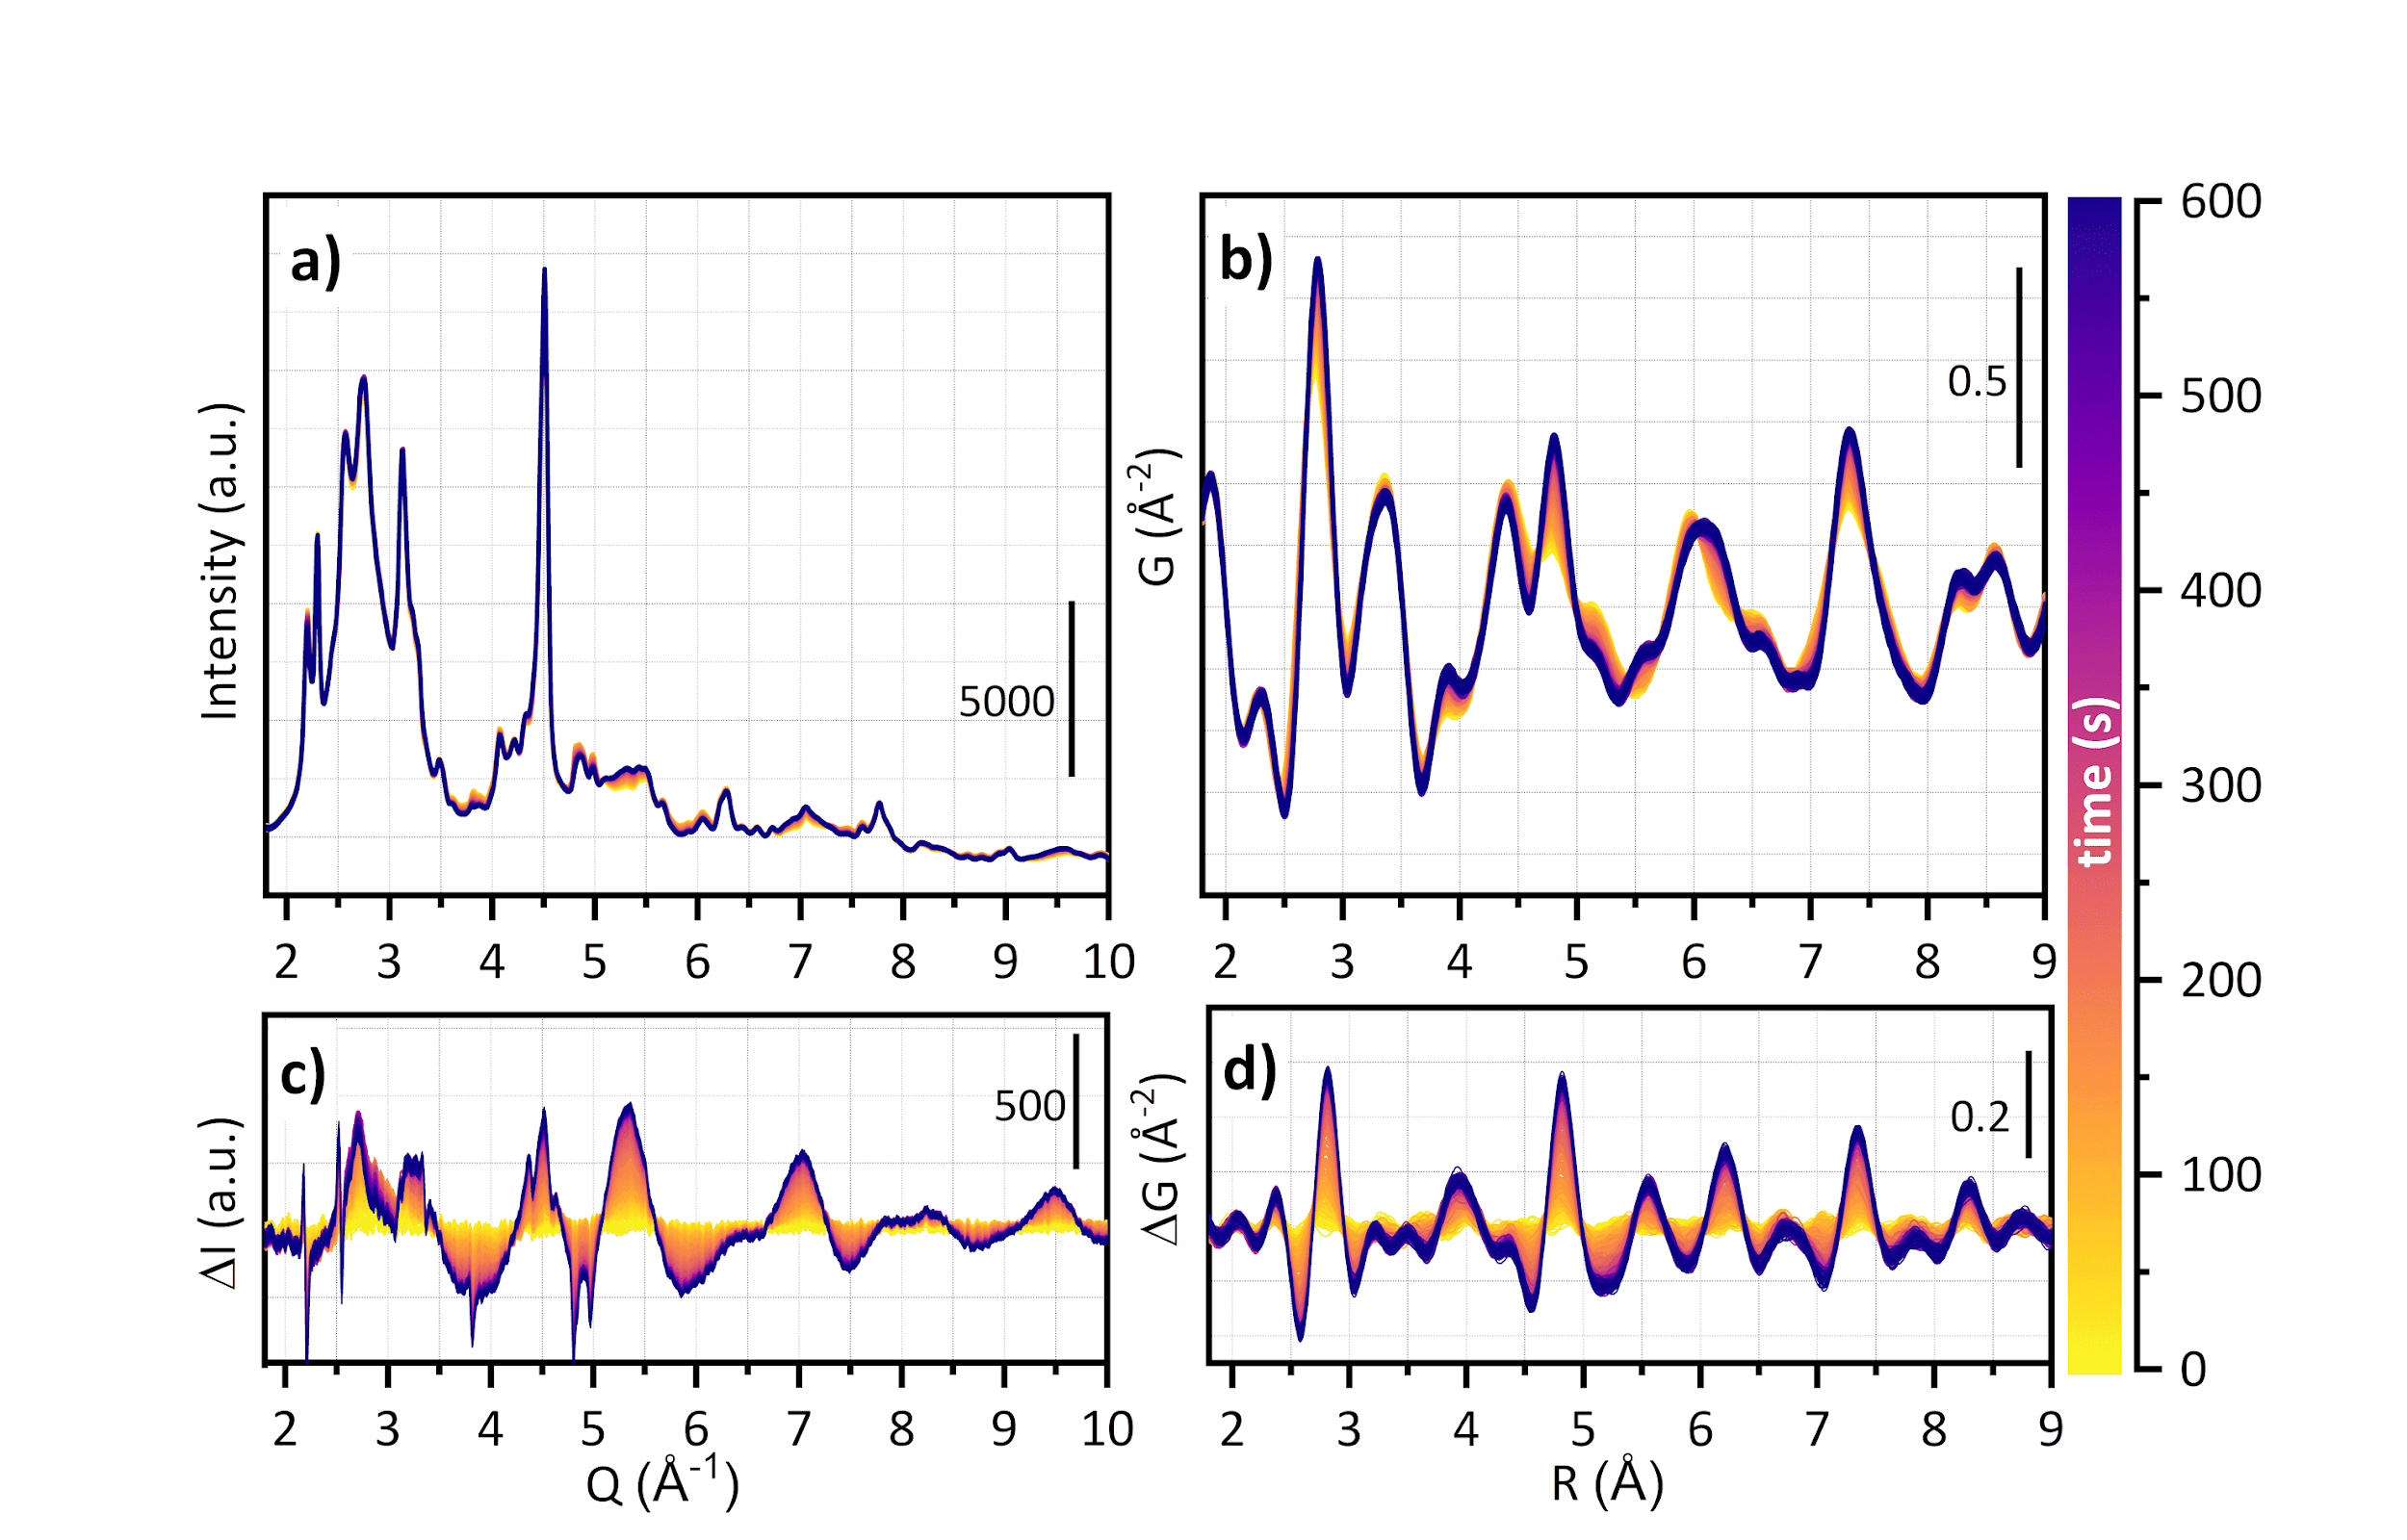
Figure S6. Time-evolution of the (a) XRD and (b) PDF patterns of PtAl during the isothermal reduction in H₂/cyclohexane at 70°C. Time evolution (yellow to blue) of difference (c) XRD and (d) PDF patterns obtained upon subtracting the last pattern before H₂ was admitted. 1 pattern/s collected during the first 10 min of reaction.

6. Comparison of the PDF patterns at the end of the reduction process in gas and liquid phase for both catalysts
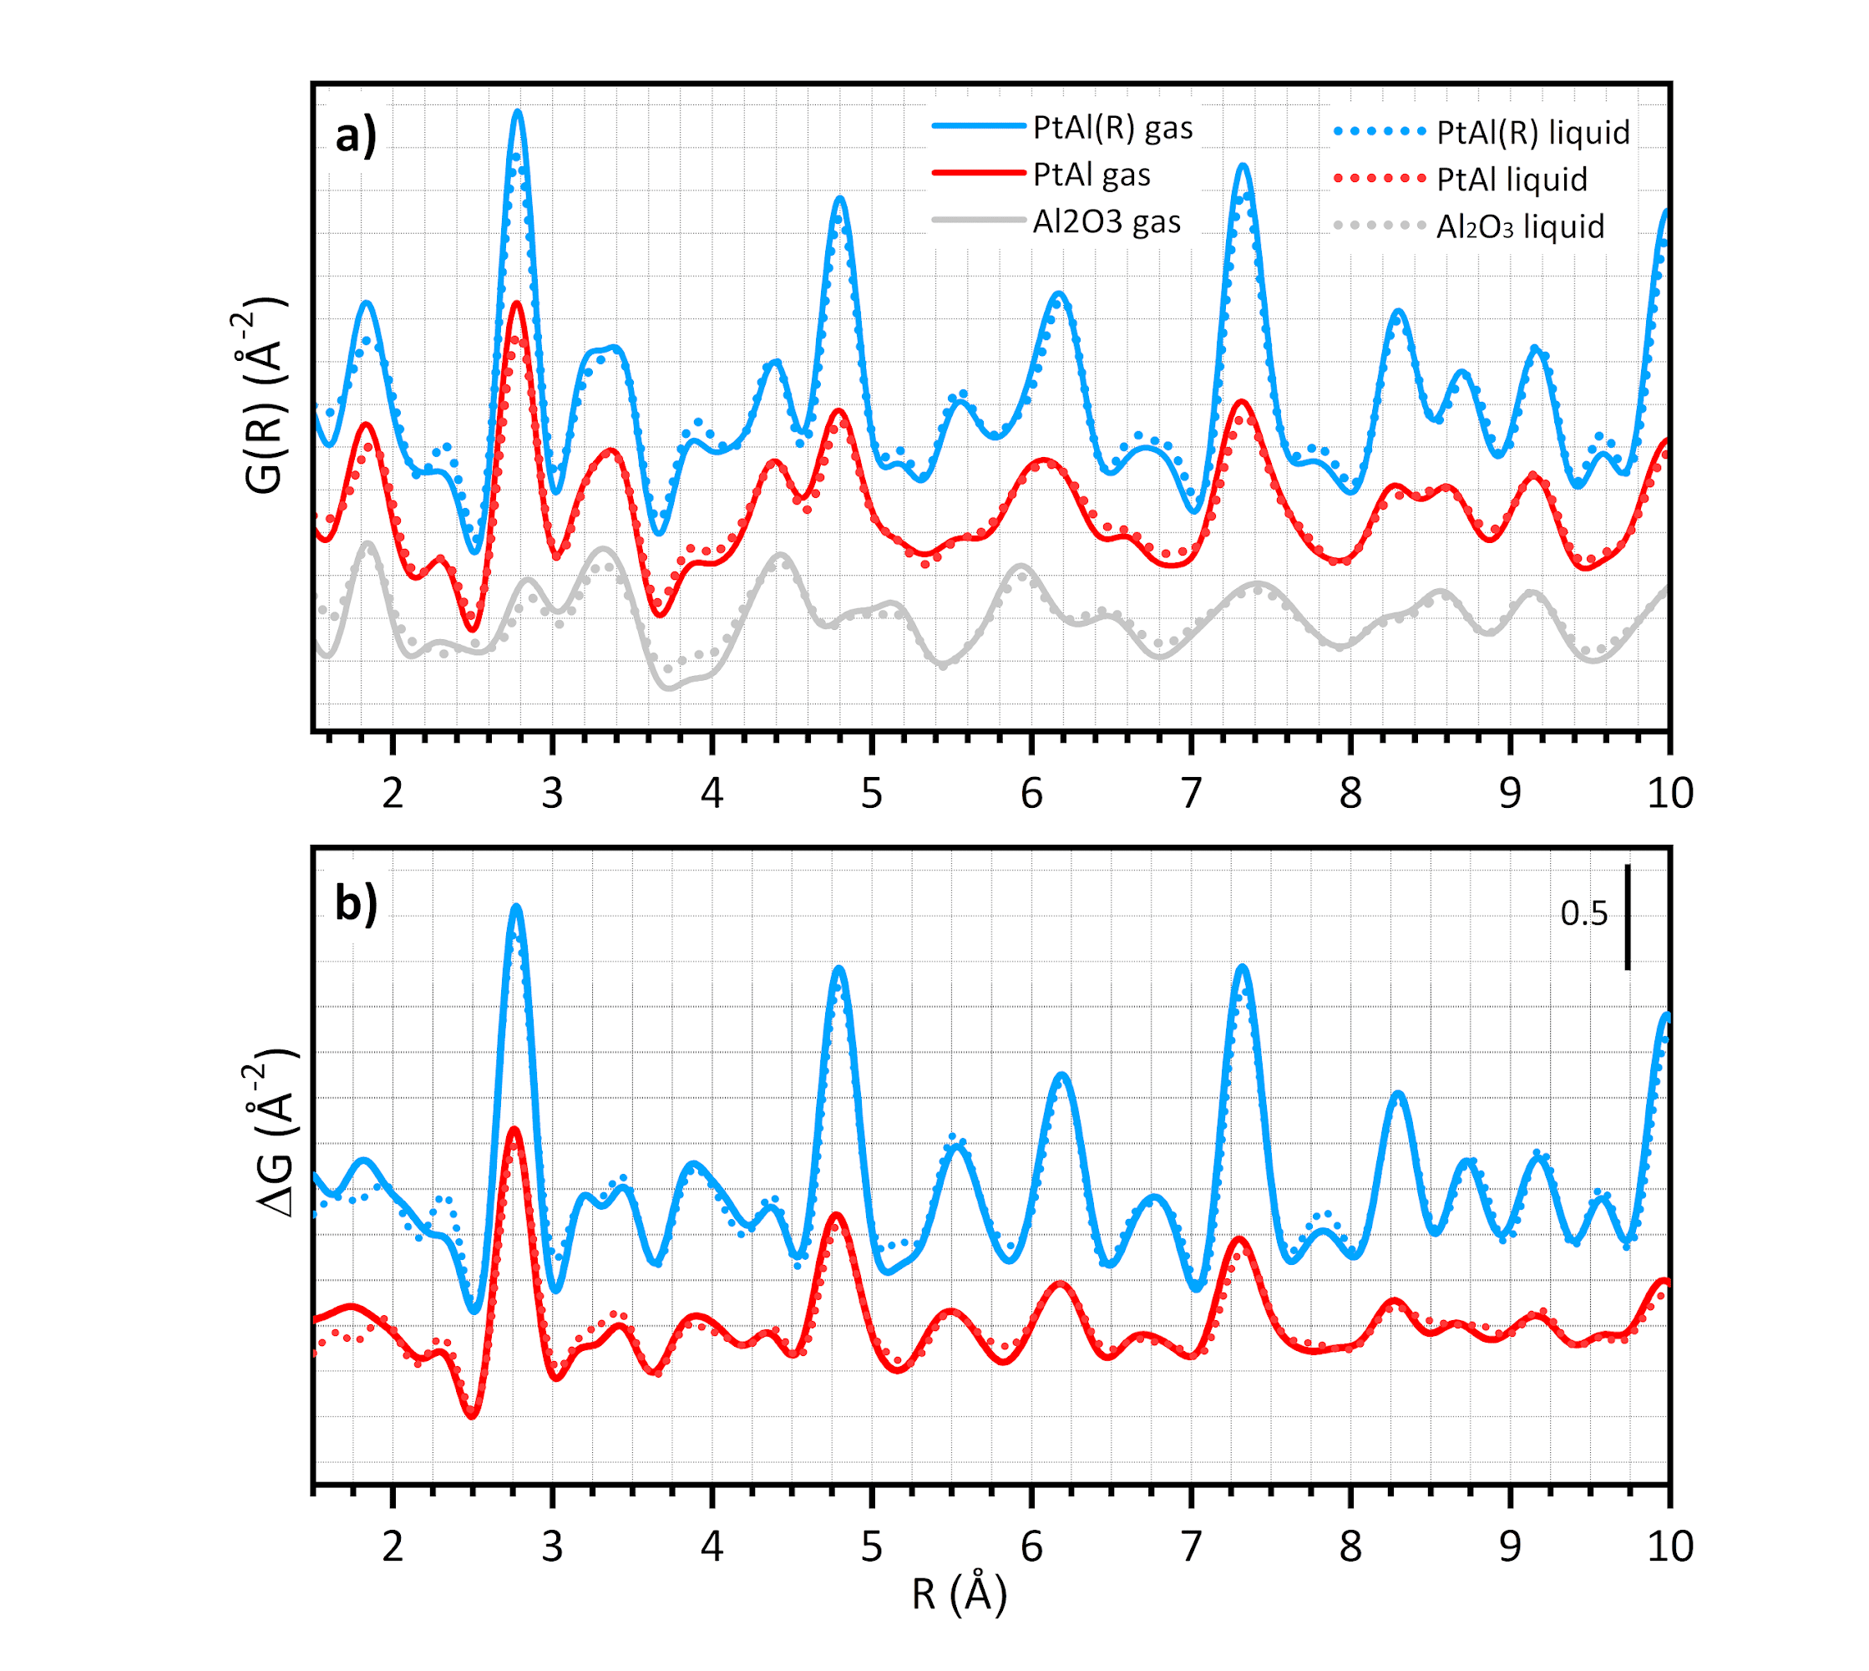
Figure S7. PDF patterns (a) of PtAl(R) (blue) and PtAl (red) catalysts at the end of the isothermal reduction, in H₂/Ar flow at 150 °C (gas, full lines) and in H₂-saturated cyclohexane at 70°C (liquid, dotted lines), and Al₂O₃ background subtracted counterparts (b).

7. Simulated PDF patterns
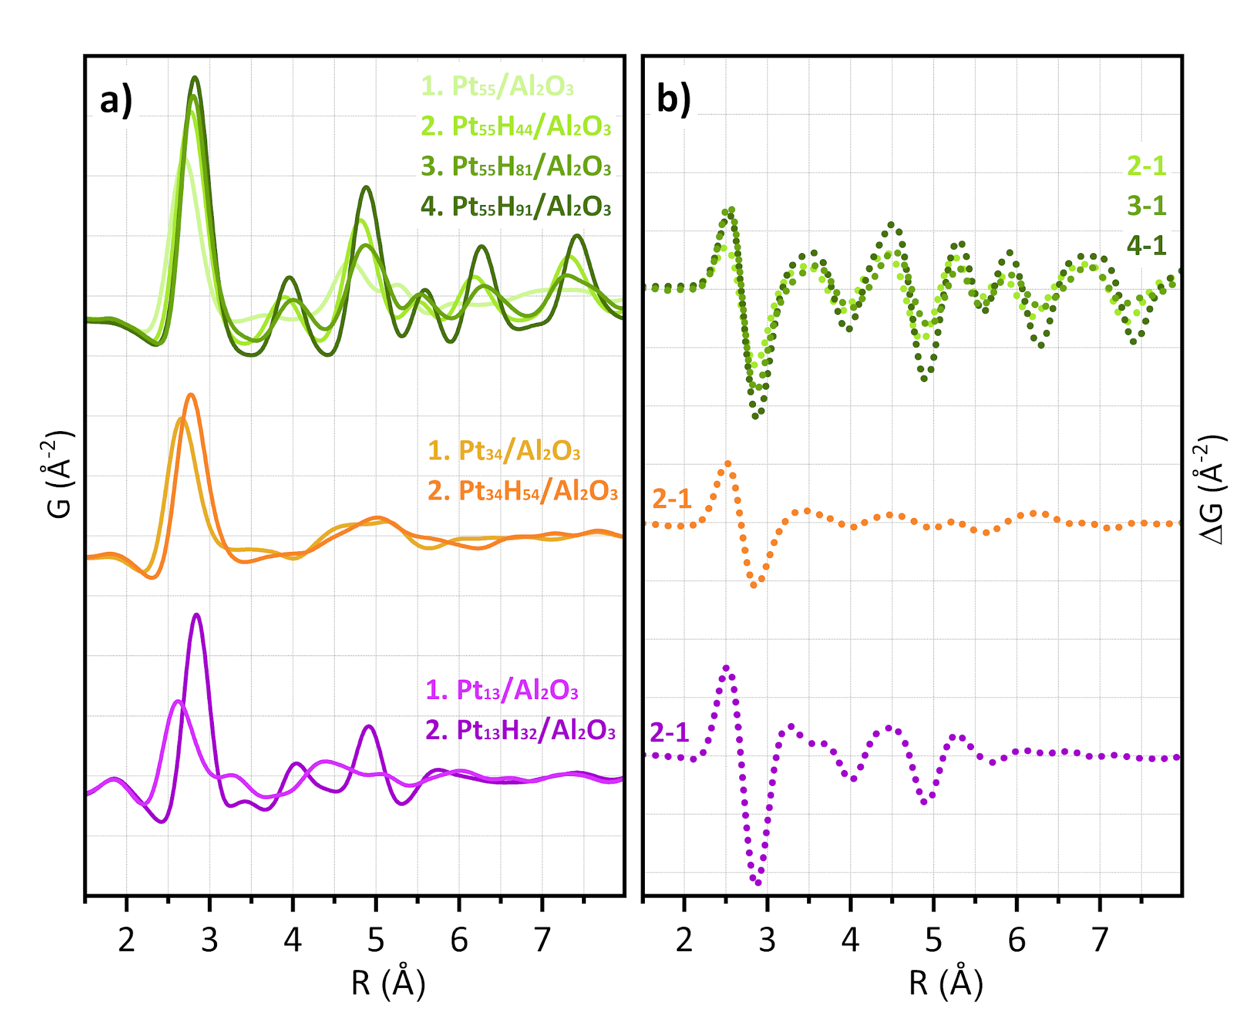
Figure S8. (a) Simulated PDF patterns for the Pt₅₅/Al₂O₃, Pt₃₄/Al₂O₃ and Pt₁₃/Al₂O₃ models and their hydrogenated counterparts and (b) their difference (offset for clarity).

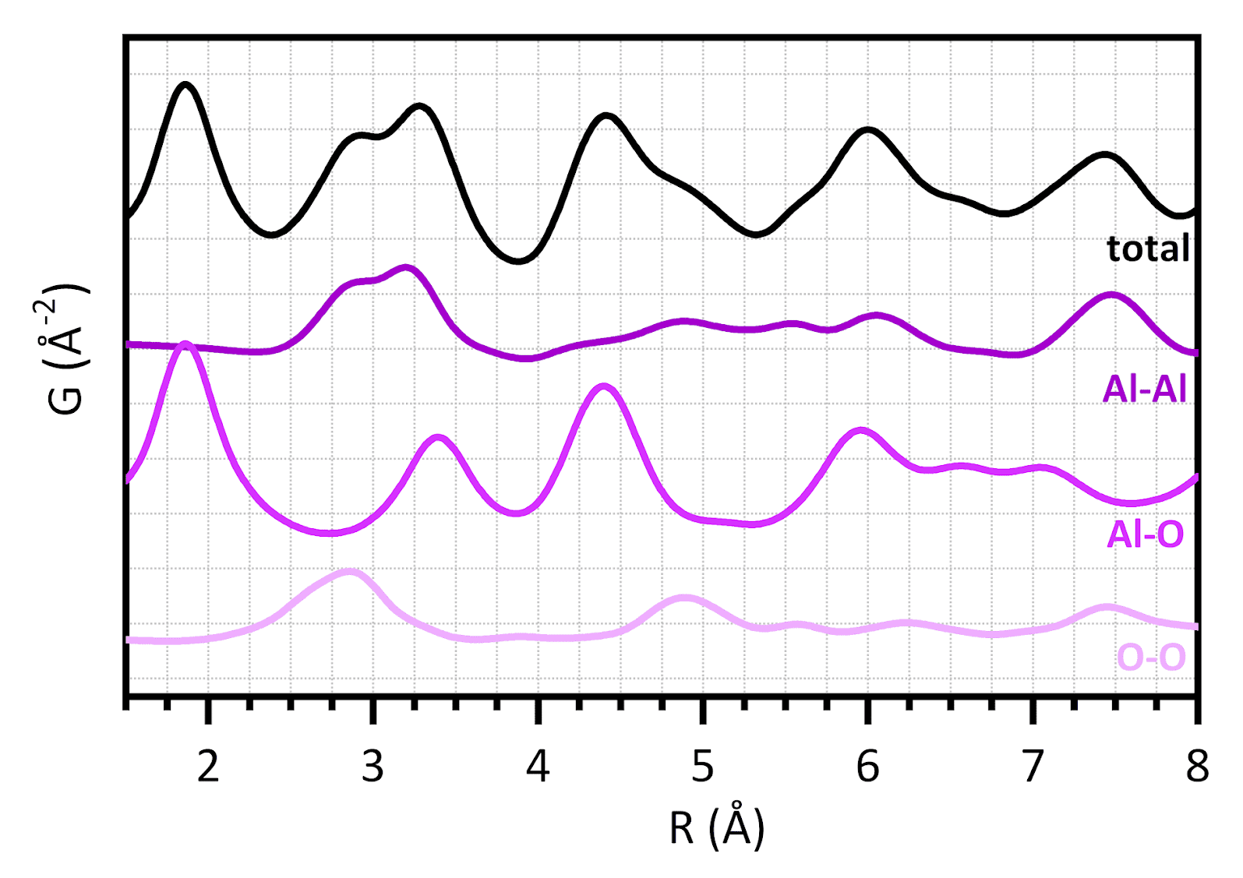
Figure S9. Simulated PDF pattern for the Al₂O₃ slab adopted in the models (black) and single Al-Al, Al-O and O-O contributions. reported in part (a) and (c) their difference (offset for clarity).

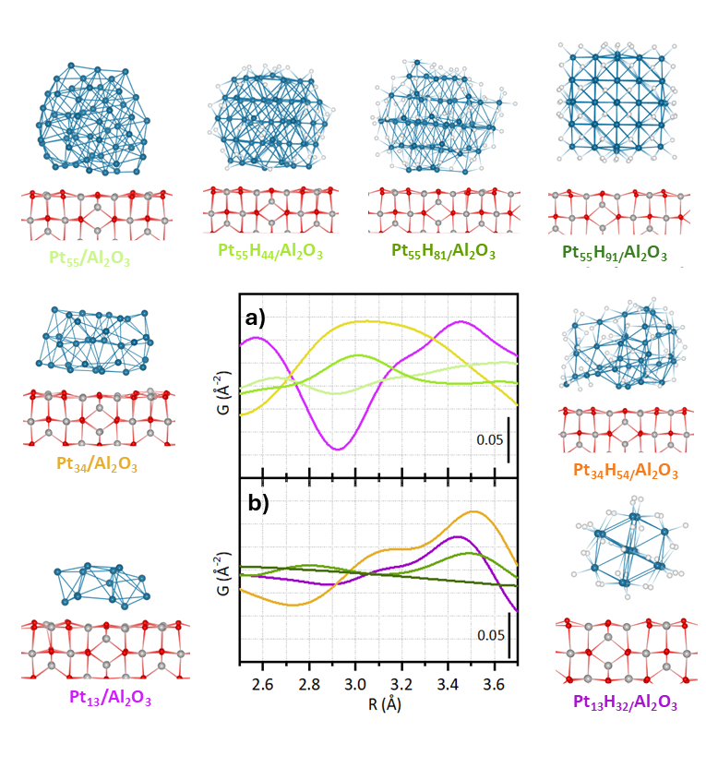
Figure S10. Pt-support contributions to the simulated PDF patterns for (a) the Pt₅₅/Al₂O₃, Pt₃₄/Al₂O₃ and Pt₁₃/Al₂O₃ models and (b) their hydrogenated counterparts (blue: Pt, white: H, red: O, grey: Al).

References
1. Fitch A., et al. ID22 - the high-resolution powder-diffraction beamline at ESRF. J. Synchrotron Radiat. 30, 1003-1012 (2023).
2. Coelho A. TOPAS and TOPAS-Academic: an optimization program integrating computer algebra and crystallographic objects written in C++. J. Appl. Crystallogr. 51, 210-218 (2018).
3. Kovarik L., Bowden M., Andersen A., Jaegers N. R., Washton N., Szanyi J. Quantification of High-Temperature Transition Al2O3 and Their Phase Transformations. Angew. Chem. Int. Ed. 59, 21719-21727 (2020).
4. Balzar D., Ledbetter H. Voigt-function modeling in Fourier analysis of size- and strain-broadened X-ray diffraction peaks. J. Appl. Crystallogr. 26, 97-103 (1993).
5. Kovarik L., Bowden M., Andersen A., Jaegers N. R., Washton N., Szanyi J. Quantification of High-Temperature Transition Al2O3 and Their Phase Transformations. Quantification of High-Temperature Transition Al2O3 and Their Phase Transformations 59, 21719-21727 (2020).
6. Mager-Maury C., Bonnard G., Chizallet C., Sautet P., Raybaud P. H2-Induced Reconstruction of Supported Pt Clusters: Metal–Support Interaction versus Surface Hydride. ChemCatChem 3, 200-207 (2011).
7. Vottero E., et al. Evidence for H2-Induced Ductility in a Pt/Al2O3 Catalyst. ACS Catal. 12, 5979-5989 (2022).
8. Digne M., Sautet P., Raybaud P., Euzen P., Toulhoat H. Hydroxyl Groups on γ-Alumina Surfaces: A DFT Study. J. Catal. 211, 1-5 (2002).
9. Digne M., Sautet P., Raybaud P., Euzen P., Toulhoat H. Use of DFT to achieve a rational understanding of acid–basic properties of γ-alumina surfaces. J. Catal. 226, 54-68 (2004).
10. Kresse G., Furthmüller J. Efficiency of ab-initio total energy calculations for metals and semiconductors using a plane-wave basis set. Comput. Mater. Sci. 6, 15-50 (1996).
11. Kresse G., Hafner J. Ab initio molecular-dynamics simulation of the liquid-metal--amorphous-semiconductor transition in germanium. Ab initio molecular-dynamics simulation of the liquid-metal--amorphous-semiconductor transition in germanium 49, 14251-14269 (1994).
12. Perdew J. P., Burke K., Ernzerhof M. Generalized Gradient Approximation Made Simple. Phys. Rev. Lett. 77, 3865-3868 (1996).
13. Kresse G., Joubert D. From ultrasoft pseudopotentials to the projector augmented-wave method. Phys. Rev. B 59, 1758-1775 (1999).

