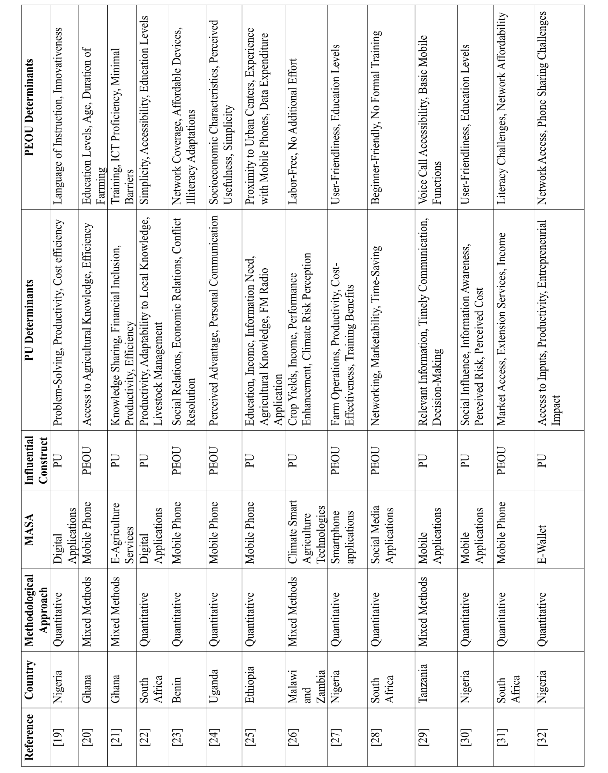
Appendix Summary of primary studies selected for review

