Effect of electro-acupuncture on gut microbiome in cisplatin-induced premature ovarian failure mice
Qi-da He^{1,2}, Jing-jing Guo³† , Qi Zhang³, Yuen-ming Yau³, Yue Yu^{1,2}, Zheng-hong Zhong^{1,2}, Zi-yan Tong ^{1,2},Zong-bao Yang^{3*} and Min Chen ^{1,2*}
¹Faculty of Chinese Medicine, Macau University of Science and Technology, Macau 999078, China
†Jing-jing Guo is the Co-first author.
*Correspondence: mchen@must.edu.mo; yangzb@xmu.edu.cn
Full list of author information is available at the end of the article.

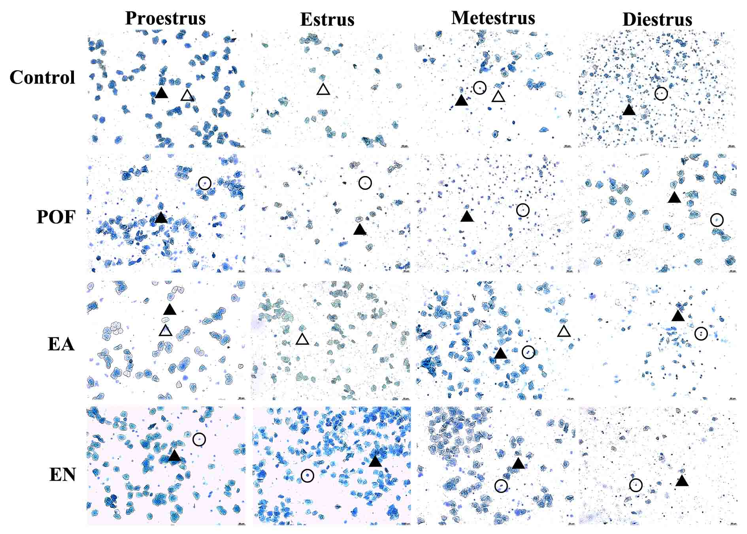
Fig.S1 The vaginal exfoliated cells reflected different estrous cycle in each group. Nucleated epithelial (black triangle), cornified epithelial (blank triangle), and leukocytes (circle).
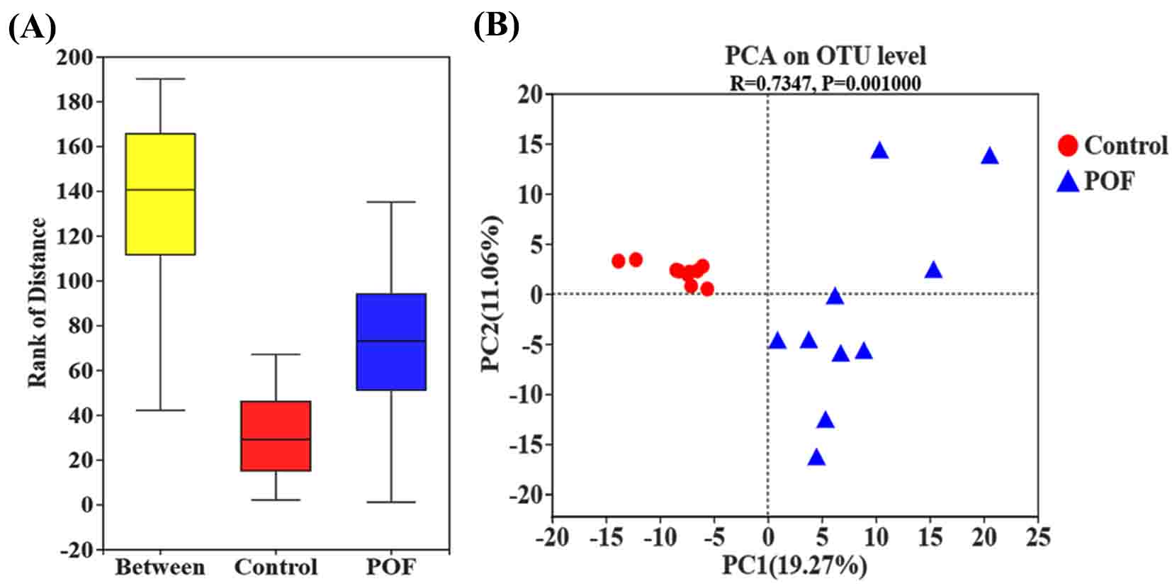 Fig.S2 ANOSIM and PCA analysis in (A and B) the control group and POF group.

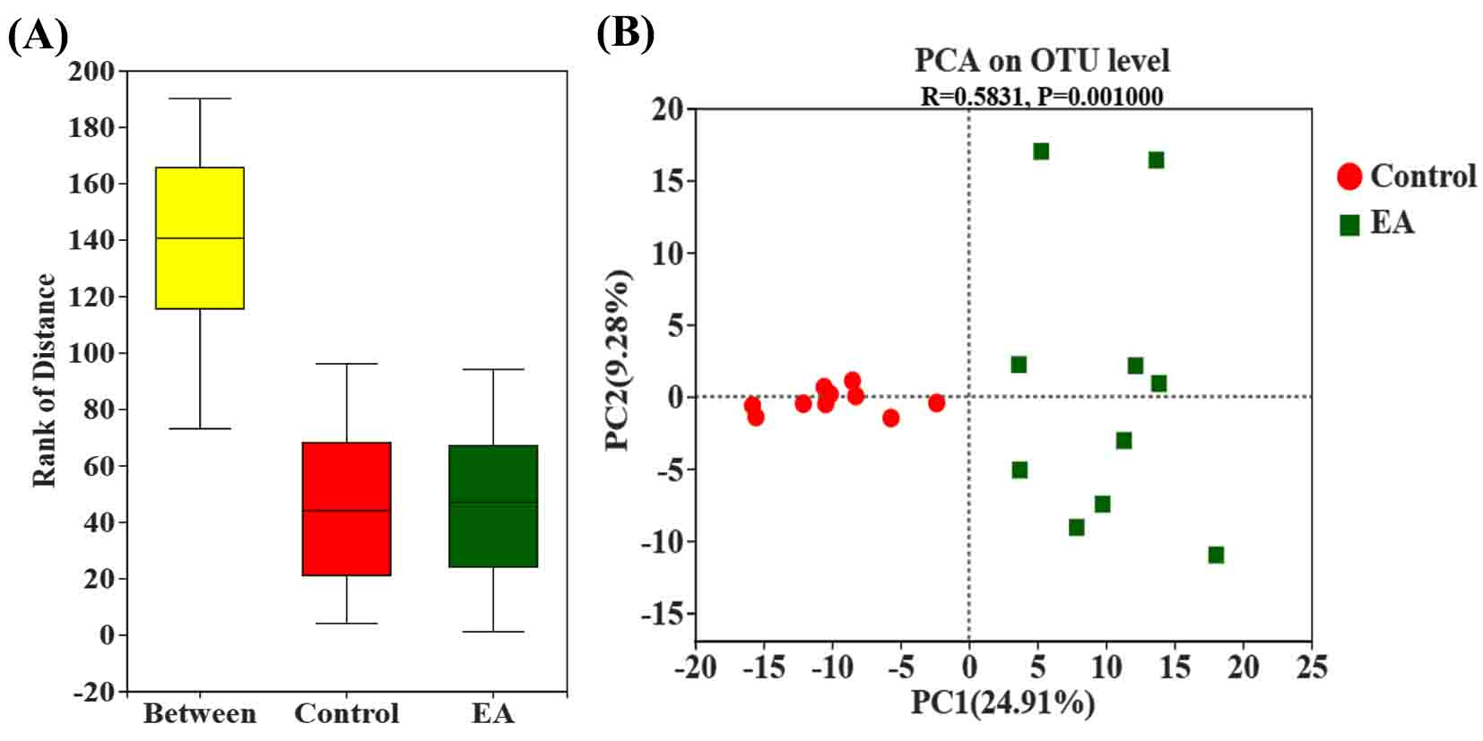
Fig.S3 ANOSIM and PCA analysis in (A and B) the control group and EA group.

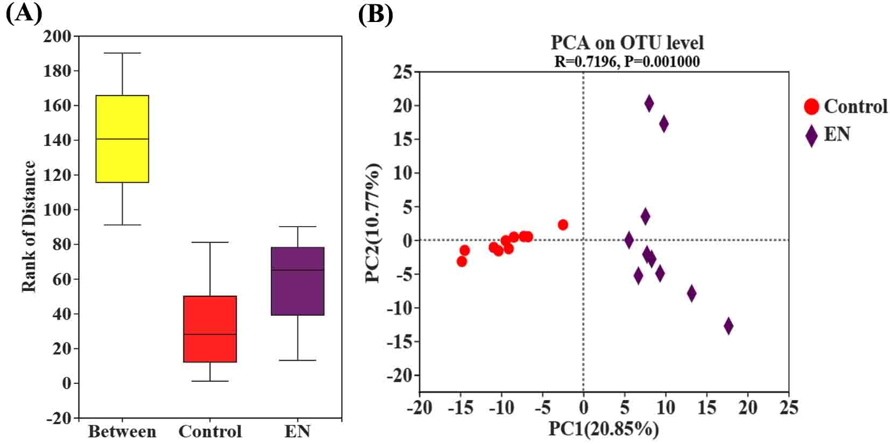
Fig.S4 ANOSIM and PCA analysis in (A and B) the control group and EN group.

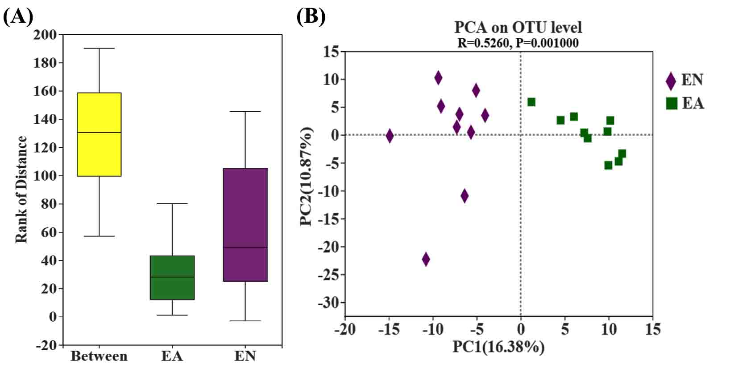
Fig.S5 ANOSIM and PCA analysis in (A and B) the EA group and EN group.

Acknowledgements
The research was supported by the Science and Technology Development Fund, Macau SAR (file No.: 0010/2019/A)

Authors’ Contributions
Q-DH, Z-BY and MC designed the project; Q-DH, J-JG, QZ, Z-ZH and YY conducted the experiments; YY and MC analyzed all data; Q-DH and Z-YT wrote original draft preparation; Z-BY and MC revised the manuscript. All authors had read and agreed to the published version of the manuscript.

Funding
The Science and Technology Development Fund, Macau SAR (file No.: 0010/2019/A).

Availability of data and materials
All data of this study were supplied from the corresponding author (Min Chen, mchen@must.edu.mo) upon reasonable request.

Ethics approval and consent to participate
The study was approved by the Animal Care and Use Committee of Xiamen University (Permit Number: SCXK: 2018-0003).

Consent for publication
The manuscript is approved by all authors for publication.

Competing interests
All authors have no competing interests with respect to the manuscript.

Author details
¹ Faculty of Chinese Medicine, Macau University of Science and Technology, Weilong Road, Taipa, Macau 999078, China. ² State Key Laboratory of Quality Research in Chinese Medicines, Macau University of Science and Technology, Weilong Road, Taipa, Macau 999078, China. ³ Department of Traditional Chinese Medicine, Xiamen University, Xiang'an South Road, Xiang'an District, Xiamen 361000, China.

