In silico analysis of doxorubicin analogues conjugated to polysorbate 80 for sustained and targeted delivery to the brain

D. K. S. Lekshmi ^{a,c}, Arsha S Nair ^{b,c} , A. Jayakrishnan ^{c}, Sandhya K.S.^{c*}
ª Department of Chemistry, Sree Narayana College for Women, Kollam-691001, Kerala, India
^{b} Department of Chemistry, University of Kerala, Kariavattom, Thiruvananthapuram-695581, Kerala, India
^{c} Department of Chemistry, SN College Chathannur, Kollam-691579, Kerala, India

Supporting Information
Table SI1 Binding affinity of twelve DOX ligands with target proteins
DOX  Ligands | Molecular Formula | 2IG0 | 3LGF | 3LGL | 4RG2 | 3PG7 | 3LH0 |  | 4HBM
 |  | Affinity (kcal/mol)
R1 | C₂₇H₂₉NO₁₁ | -7.08 | -8.60 | -7.55 | -8.85 | -7.75 |  | -7.81 |  | -6.14
R2 | C₂₉H₃₀BrNO₁₂ | -6.85 | -8.94 | -7.47 | -8.42 | -9.35 |  | -7.84 |  | -6.27
R3 | C₂₉H₃₀ClNO₁₂ | -5.96 | -8.91 | -7.37 | -8.09 | -7.87 |  | -6.19 |  | -6.37
R4 | C₃₄H₃₂BrNO₁₄S | -6.43 | -8.49 | -5.96 | -10.06 | -11.10 |  | -6.01 |  | -6.50
R5 | C₃₀H₃₂ClN₃O₁₃ | -5.98 | -9.12 | -7.02 | -7.82 | -9.06 |  | -7.09 |  | -6.33
R6 | C₃₄H₃₂ClNO₁₄S | -8.16 | -8.88 | -7.17 | -10.53 | -12.02 |  | -7.80 |  | -9.50
R7 | C₃₀H₃₂BrN₃O₁₃ | -6.89 | -9.69 | -5.98 | -8.01 | -9.24 |  | -6.32 |  | -8.07
R8 | C₂₉H₃₀FNO₁₂ | -6.13 | -9.35 | -7.68 | -7.78 | -8.59 |  | -6.17 |  | -7.40
R9 | C₃₄H₃₂FNO₁₄S | -6.55 | -7.97 | -6.22 | -9.29 | -10.19 |  | -5.82 |  | -7.47
R10 | C₃₀H₃₂FN₃O₁₃ | -6.97 | -8.23 | -6.29 | -7.67 | -9.07 |  | -6.06 |  | -6.72
R11 | C₂₈H₃₁NO₁₂ | -6.15 | -8.12 | -7.10 | -7.96 | -8.81 |  | -6.83 |  | -6.29
R12 | C₂₈H₂₉NO₁₃ | -7.29 | -7.06 | -5.70 | -8.47 | -7.85 |  | -6.64 |  | -7.59

Notable Binding Affinity Highest Binding Affinity

Figure SI1 Best 3D interaction diagram with a surface color by hydrogen bond type of best three DOX ligands with 3PG7: a) R6_3PG7 b) R4_3PG7 c) R9_3PG7

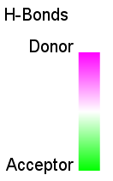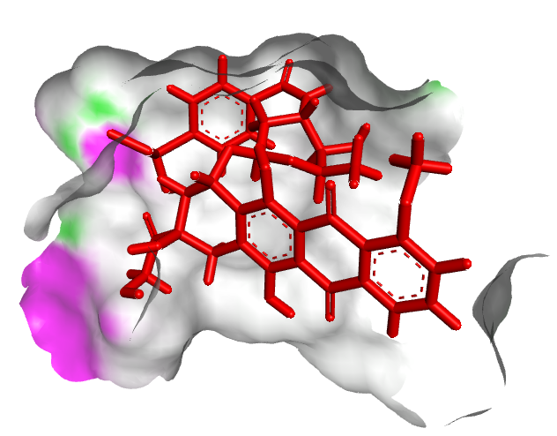
a)
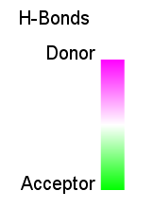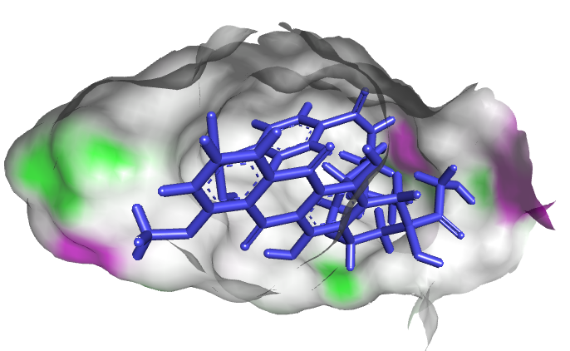
b)

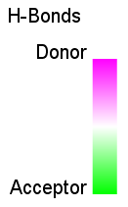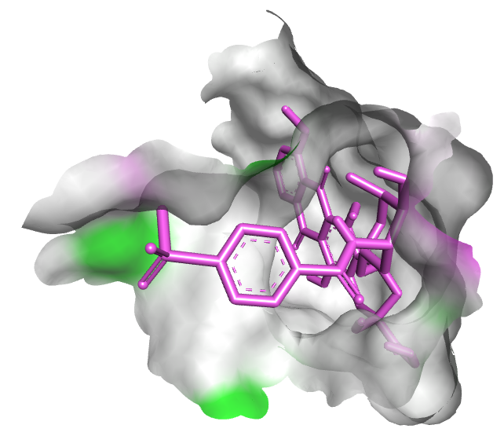
c)

Table SI2 ADMET AI Properties of twelve DOX ligands

ABSORPTION
Property | R1 |  |  | R2 |  |  | R3 |  |  | R4 |  |  | R5 |  |  | R6 |  |  | R7 |  |  | R8 |  | R9 |  | R10 |  | R11 |  | R12
HIA | 0.94 |  |  | 0.93 |  |  | 0.90 |  |  | 0.87 |  |  | 0.91 |  |  | 0.90 |  |  | 0.93 |  |  | 0.95 |  | 0.84 |  | 0.89 |  | 0.78 |  | 0.54
Oral Bioavailability | 0.53 |  |  | 0.57 |  |  | 0.58 |  |  | 0.53 |  |  | 0.73 |  |  | 0.62 |  |  | 0.74 |  |  | 0.61 |  | 0.67 |  | 0.70 |  | 0.42 |  | 0.40
Aqueous Solubility | -3.70 |  |  | -4.36 |  |  | -4.05 |  |  | -3.61 |  |  | -3.81 |  |  | -4.27 |  |  | -4.12 |  |  | -3.71 |  | -3.81 |  | -3.71 |  | -3.50 |  | -3.47
Lipophilicity | 0.03 |  |  | 1.28 |  |  | 1.28 |  |  | 1.32 |  |  | 1.42 |  |  | 1.32 |  |  | 1.71 |  |  | 0.81 |  | 1.18 |  | 1.28 |  | -0.13 |  | -0.13
Hydration Free Energy | -12.61 |  |  | -12.44 |  |  | -12.40 |  |  | -12.50 |  |  | -12.68 |  |  | -12.30 |  |  | -12.15 |  |  | -12.96 |  | -11.97 |  | -12.25 |  | -13.25 |  | -13.50
Cell Effective Permeability | -6.40 |  |  | -6.21 |  |  | -6.19 |  |  | -6.22 |  |  | -5.92 |  |  | -6.03 |  |  | -5.89 |  |  | -6.06 |  | -5.78 |  | -5.86 |  | -6.49 |  | -6.31
PAMPA Permeability | 0.36 |  |  | 0.33 |  |  | 0.29 |  |  | 0.23 |  |  | 0.26 |  |  | 0.30 |  |  | 0.27 |  |  | 0.38 |  | 0.22 |  | 0.26 |  | 0.27 |  | 0.15
P-glycoprotein Inhibition | 0.31 |  |  | 0.48 |  |  | 0.46 |  |  | 0.67 |  |  | 0.39 |  |  | 0.67 |  |  | 0.47 |  |  | 0.40 |  | 0.55 |  | 0.38 |  | 0.26 |  | 0.16
DISTRIBUTION
Property |  |  | R1 |  |  | R2 |  | R3 |  |  | R4 |  |  | R5 |  | R6 |  | R7 |  | R8 |  |  | R9 |  | R10 |  | R11 |  | R12
BBB Penetration |  |  | 0.06 |  |  | 0.14 |  | 0.11 |  |  | 0.06 |  |  | 0.15 |  | 0.06 |  | 0.18 |  | 0.22 |  |  | 0.12 |  | 0.17 |  | 0.07 |  | 0.11
Plasma PB Rate |  |  | 73.88 |  |  | 93.53 |  | 88.93 |  |  | 99.32 |  |  | 88.84 |  | 97.75 |  | 92.57 |  | 84.53 |  |  | 90.71 |  | 85.88 |  | 75.61 |  | 77.99
Volume Of Distribution |  |  | 22.85 |  |  | 25.42 |  | 26.36 |  |  | 24.27 |  |  | 18.15 |  | 21.41 |  | 18.06 |  | 24.97 |  |  | 19.82 |  | 17.99 |  | 24.81 |  | 21.16
METABOLISM
Property |  | R1 |  |  | R2 |  | R3 |  | R4 |  |  | R5 |  |  | R6 |  | R7 |  |  |  | R8 |  |  | R9 |  | R10 |  | R11 |  | R12
CYP1A2 Inhibition |  | 0.05 |  |  | 0.07 |  | 0.07 |  | 0.05 |  |  | 0.03 |  |  | 0.04 |  | 0.04 |  |  |  | 0.04 |  |  | 0.06 |  | 0.03 |  | 0.04 |  | 0.03
CYP2C19 Inhibition |  | 0.03 |  |  | 0.10 |  | 0.10 |  | 0.11 |  |  | 0.06 |  |  | 0.10 |  | 0.10 |  |  |  | 0.04 |  |  | 0.04 |  | 0.05 |  | 0.05 |  | 0.02
CYP2C9 Substrate |  | 0.01 |  |  | 0.02 |  | 0.01 |  | 0.02 |  |  | 0.03 |  |  | 0.03 |  | 0.04 |  |  |  | 0.02 |  |  | 0.03 |  | 0.03 |  | 0.01 |  | 0.03
CYP2C9 Inhibition |  | 0.03 |  |  | 0.08 |  | 0.07 |  | 0.16 |  |  | 0.09 |  |  | 0.12 |  | 0.13 |  |  |  | 0.06 |  |  | 0.09 |  | 0.08 |  | 0.04 |  | 0.04
CYP2D6 Substrate |  | 0.01 |  |  | 0.01 |  | 0.01 |  | 0.01 |  |  | 0.02 |  |  | 0.01 |  | 0.02 |  |  |  | 0.02 |  |  | 0.03 |  | 0.02 |  | 0.02 |  | 0.01
CYP2D6 Inhibition |  | 0.03 |  |  | 0.06 |  | 0.07 |  | 0.07 |  |  | 0.08 |  |  | 0.05 |  | 0.09 |  |  |  | 0.04 |  |  | 0.04 |  | 0.08 |  | 0.05 |  | 0.04
CYP3A4 Substrate |  | 0.44 |  |  | 0.45 |  | 0.44 |  | 0.51 |  |  | 0.32 |  |  | 0.49 |  | 0.36 |  |  |  | 0.46 |  |  | 0.39 |  | 0.36 |  | 0.43 |  | 0.30
CYP3A4 Inhibition |  | 0.11 |  |  | 0.21 |  | 0.25 |  | 0.07 |  |  | 0.33 |  |  | 0.10 |  | 0.33 |  |  |  | 0.10 |  |  | 0.08 |  | 0.27 |  | 0.08 |  | 0.03

EXCRETION
Property | R1 | R2 | R3 | R4 | R5 | R6 | R7 | R8 | R9 | R10 | R11 | R12
Half Life | 38.25 | 95.41 | 84.50 | 142.00 | 78.26 | 125.54 | 82.30 | 64.89 | 129.60 | 72.83 | 64.84 | 55.67
Drug Clearance(Hepatocyte) | 31.80 | 12.90 | 5.74 | 5.54 | -8.53 | 11.20 | -6.54 | 6.99 | 3.89 | -11.62 | 26.16 | 3.64
Drug Clearance(Microsome) | 42.29 | 53.28 | 45.59 | 50.05 | 37.51 | 41.21 | 45.32 | 38.46 | 31.51 | 39.54 | 46.09 | 38.35

TOXICITY
Property | R1 | R2 | R3 | R4 | R5 | R6 | R7 | R8 | R9 | R10 | R11 | R12
Carcinogenity | 0.02 | 0.06 | 0.06 | 0.08 | 0.15 | 0.09 | 0.16 | 0.07 | 0.17 | 0.15 | 0.03 | 0.03

Table SI3 ADMET AI Properties of PS80

ABSORPTION
HIA | Oral  Bioavailability | Aqueous  Solubility | Lipophilicity | Hydration  Free Energy | Cell Effective Permeability | PAMPA Permeability | P-glycoprotein  Inhibition
0.97 | 0.50 | -4.12 | 2.51 | -8.06 | -5.52 | 0.77 | 0.91

DISTRIBUTION
Blood Brain Barrier Penetration | Plasma Protein Binding Rate | Volume of Distribution
0.45 | 91.08 | 1.25

METABOLISM
CYP1A2 Inhibition | CYP2C19 Inhibition | CYP2C9 Substrate | CYP2C9 Inhibition | CYP2D6 Substrate | CYP2D6 Inhibition | CYP3A4 Substrate | CYP3A4 Inhibition
2.96e-03 | 0.08 | 0.01 | 0.17 | 0.03 | 0.01 | 0.77 | 0.43

EXCRETION
Half Life | Drug Clearance (Hepatocyte) | Drug Clearance (Microsome)
61.42 | 87.81 | 98.01

TOXICITY
Carcinogenity | 0.04

Table 4 ADMET AI Properties of twelve DOX-PS80 conjugated ligands

ABSORPTION
Property |  | R1  PS80 |  |  | R2  PS80 |  |  | R3  PS80 |  | R4  PS80 | R5  PS80 |  | R6  PS80 |  | R7  PS80 |  | R8  PS80 | R9  PS80 | R10  PS80 | R11  PS80 | R12  PS80
HIA |  | 1.00 |  |  | 1.00 |  |  | 1.00 |  | 1.00 | 1.00 |  | 1.00 |  | 1.00 |  | 1.00 | 1.00 | 1.00 | 1.00 | 1.00
Oral Bioavailability |  | 0.78 |  |  | 0.80 |  |  | 0.82 |  | 0.82 | 0.88 |  | 0.82 |  | 0.87 |  | 0.79 | 0.83 | 0.85 | 0.75 | 0.72
Aqueous Solubility |  | -5.42 |  |  | -5.94 |  |  | -5.82 |  | -5.37 | -6.45 |  | -5.34 |  | -6.53 |  | -5.87 | -5.52 | -6.41 | -4.99 | -5.31
Lipophilicity |  | 2.69 |  |  | 3.34 |  |  | 3.42 |  | 3.09 | 3.52 |  | 2.86 |  | 3.60 |  | 3.07 | 3.19 | 3.52 | 2.70 | 2.43
Hydration Free Energy |  | -10.62 |  |  | -9.86 |  |  | -9.60 |  | -10.60 | -8.67 |  | -10.50 |  | -8.66 |  | -9.70 | -9.82 | -8.33 | -10.29 | -10.20
Cell Effective Permeability |  | -5.56 |  |  | -5.60 |  |  | -5.59 |  | -5.44 | -5.37 |  | -5.42 |  | -5.37 |  | -5.44 | -5.32 | -5.28 | -5.39 | -5.63
PAMPA Permeability |  | 0.61 |  |  | 0.53 |  |  | 0.49 |  | 0.48 | 0.43 |  | 0.48 |  | 0.41 |  | 0.61 | 0.50 | 0.46 | 0.64 | 0.51
P-glycoprotein Inhibition |  | 0.93 |  |  | 0.94 |  |  | 0.94 |  | 0.96 | 0.93 |  | 0.96 |  | 0.93 |  | 0.95 | 0.96 | 0.93 | 0.95 | 0.91
DISTRIBUTION
Property | R1  PS80 |  |  | R2  PS80 |  |  | R3  PS80 |  | R4  PS80 |  | R5  PS80 |  | R6  PS80 |  | R7  PS80 |  | R8  PS80 | R9  PS80 | R10  PS80 | R11  PS80 | R12  PS80
BBB Penetration | 0.45 |  |  | 0.76 |  |  | 0.70 |  | 0.62 |  | 0.70 |  | 0.61 |  | 0.69 |  | 0.75 | 0.57 | 0.69 | 0.48 | 0.64
Plasma PB Rate | 103.56 |  |  | 116.90 |  |  | 115.21 |  | 117.29 |  | 114.67 |  | 116.41 |  | 115.80 |  | 116.08 | 116.29 | 115.16 | 104.33 | 110.92
Volume Of Distribution | 15.59 |  |  | 16.32 |  |  | 15.91 |  | 15.49 |  | 8.90 |  | 15.31 |  | 8.40 |  | 15.87 | 16.74 | 9.17 | 14.44 | 16.61
METABOLISM
Property |  |  | R1  PS80 |  |  | R2  PS80 |  | R3  PS80 |  | R4  PS80 | R5  PS80 | R6  PS80 |  | R7  PS80 |  | R8  PS80 |  | R9  PS80 | R10  PS80 | R11  PS80 | R12  PS80
CYP1A2 Inhibition |  |  | 0.06 |  |  | 0.07 |  | 0.07 |  | 0.10 | 0.05 | 0.09 |  | 0.06 |  | 0.06 |  | 0.07 | 0.05 | 0.03 | 0.04
CYP2C19 Inhibition |  |  | 0.30 |  |  | 0.26 |  | 0.26 |  | 0.32 | 0.24 | 0.30 |  | 0.26 |  | 0.23 |  | 0.27 | 0.23 | 0.19 | 0.16
CYP2C9 Substrate |  |  | 0.04 |  |  | 0.03 |  | 0.03 |  | 0.06 | 0.05 | 0.06 |  | 0.06 |  | 0.03 |  | 0.06 | 0.05 | 0.03 | 0.04
CYP2C9 Inhibition |  |  | 0.60 |  |  | 0.52 |  | 0.51 |  | 0.65 | 0.53 | 0.63 |  | 0.56 |  | 0.51 |  | 0.59 | 0.51 | 0.54 | 0.47
CYP2D6 Substrate |  |  | 0.05 |  |  | 0.04 |  | 0.04 |  | 0.04 | 0.07 | 0.05 |  | 0.07 |  | 0.04 |  | 0.05 | 0.07 | 0.03 | 0.03
CYP2D6 Inhibition |  |  | 0.02 |  |  | 0.02 |  | 0.02 |  | 0.02 | 0.01 | 0.02 |  | 0.01 |  | 0.02 |  | 0.02 | 0.01 | 0.01 | 0.01
CYP3A4 Substrate |  |  | 0.81 |  |  | 0.78 |  | 0.78 |  | 0.79 | 0.77 | 0.78 |  | 0.77 |  | 0.80 |  | 0.79 | 0.79 | 0.83 | 0.74
CYP3A4 Inhibition |  |  | 0.41 |  |  | 0.46 |  | 0.52 |  | 0.38 | 0.69 | 0.38 |  | 0.67 |  | 0.42 |  | 0.43 | 0.66 | 0.35 | 0.34

EXCRETION
Property | R1  PS80 | R2  PS80 | R3  PS80 | R4  PS80 | R5  PS80 | R6  PS80 | R7  PS80 | R8  PS80 | R9  PS80 | R10  PS80 | R11  PS80 | R12  PS80
Half Life | 30.16 | 49.29 | 41.21 | 77.61 | 40.40 | 71.63 | 45.09 | 33.95 | 70.42 | 30.97 | 28.08 | 25.68
Drug Clearance(Hepatocyte) | 81.89 | 79.88 | 74.28 | 85.09 | 83.59 | 84.21 | 83.52 | 85.49 | 78.87 | 85.20 | 86.43 | 82.05
Drug Clearance (Microsome) | 126.91 | 116.96 | 114.80 | 106.25 | 121.03 | 102.58 | 122.43 | 110.60 | 106.83 | 124.92 | 127.70 | 116.36

TOXICITY
Property | R1  PS80 | R2  PS80 | R3  PS80 | R4  PS80 | R5  PS80 | R6  PS80 | R7  PS80 | R8  PS80 | R9  PS80 | R10  PS80 | R11  PS80 | R12  PS80
Carcinogenity | 0.09 | 0.12 | 0.14 | 0.17 | 0.31 | 0.17 | 0.29 | 0.16 | 0.26 | 0.31 | 0.06 | 0.06

Figure SI2 Radial plots of twelve DOX ligands and PS80

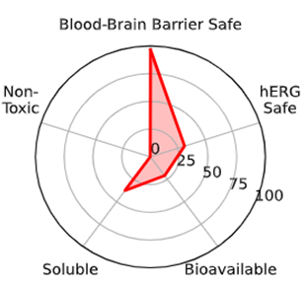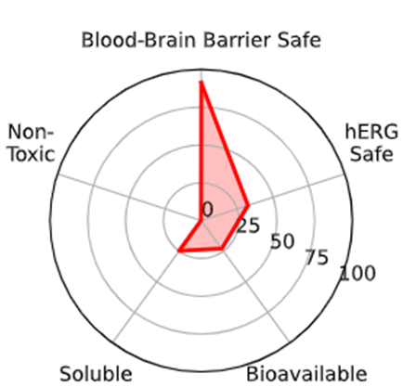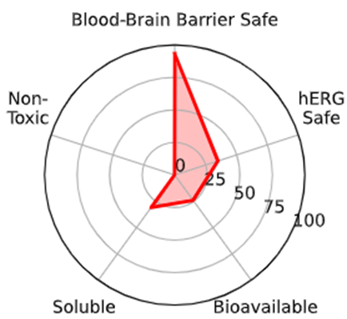
R1 R2 R3

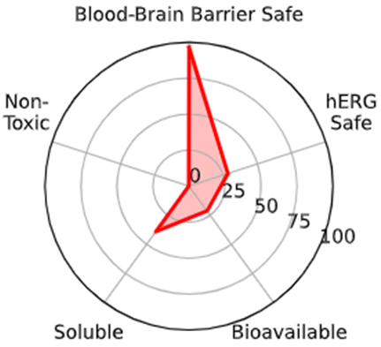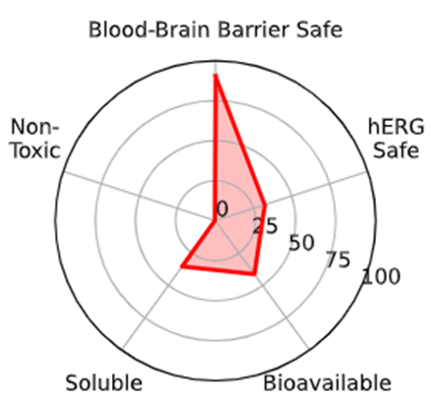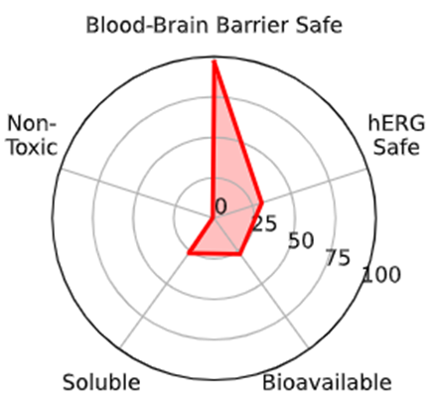
R4 R5 R6

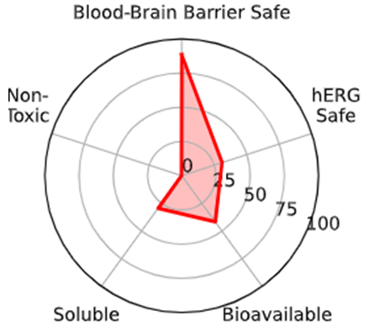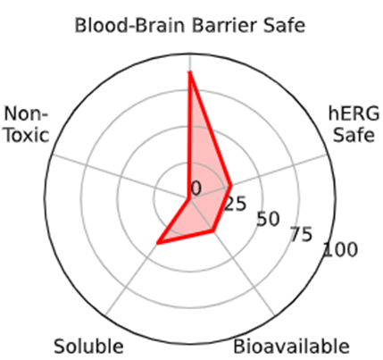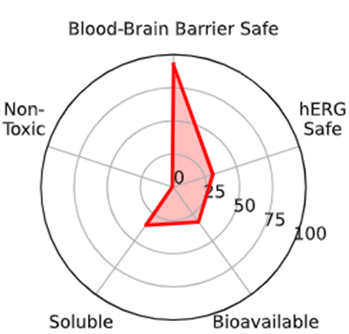
R7 R8 R9

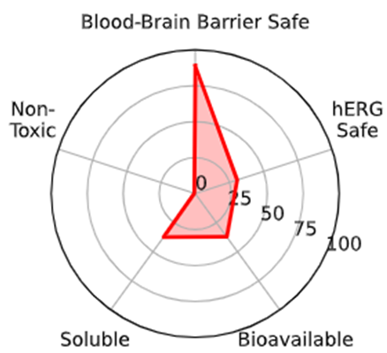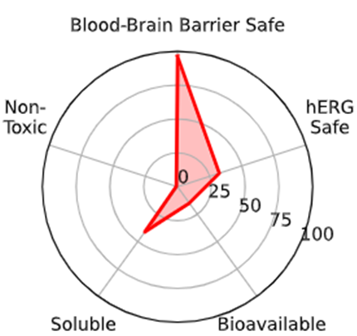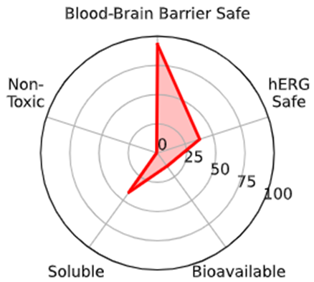
R10 R11 R12
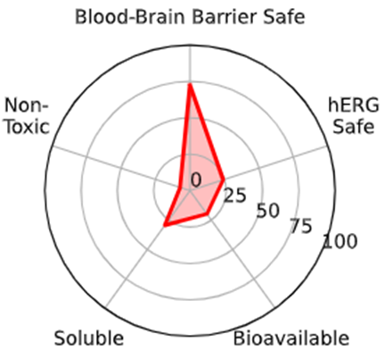
PS80

Figure SI3 Radial plots of twelve DOX-PS80 conjugated ligands
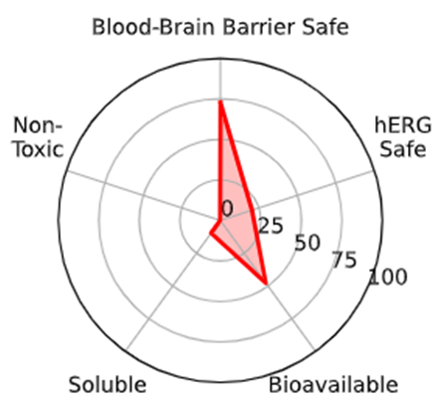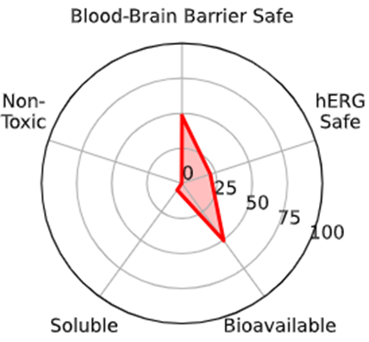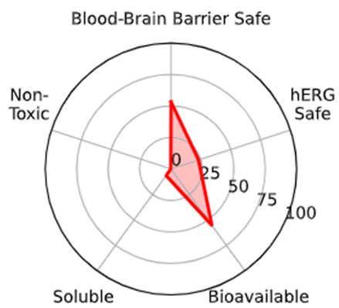
R1- PS80 R2-PS80 R3- PS80
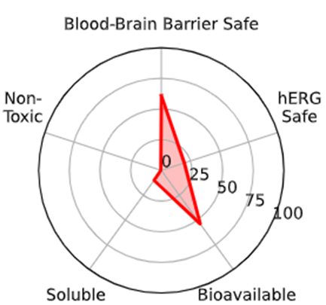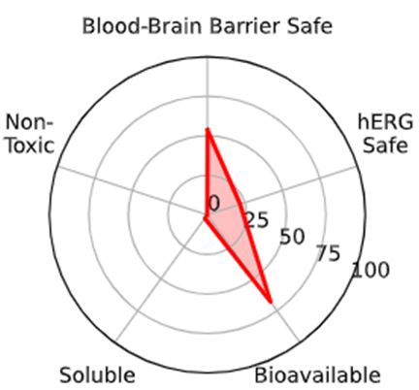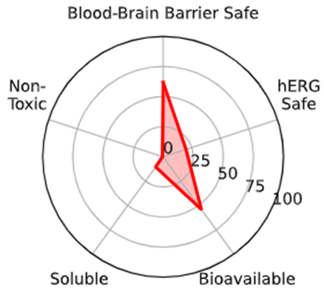
R4- PS80 R5- PS80 R6- PS80
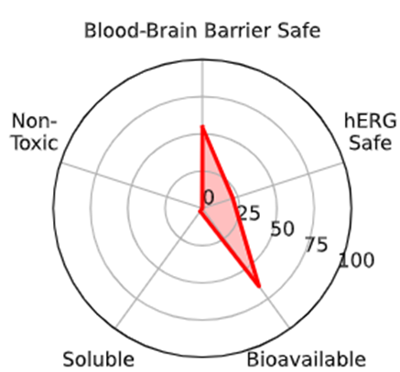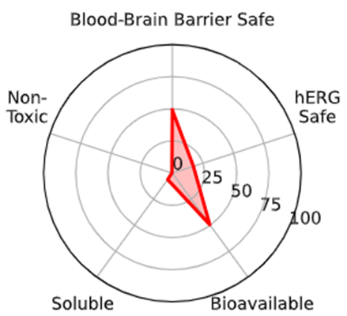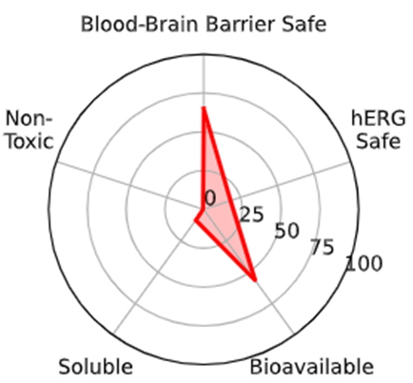
R7- PS80 R8- PS80 R9- PS80
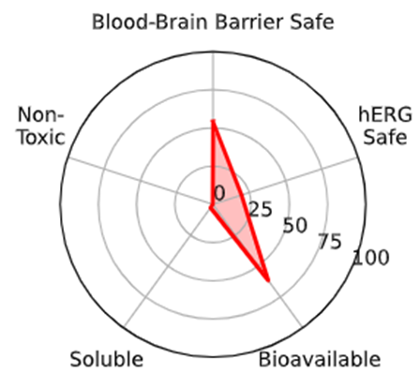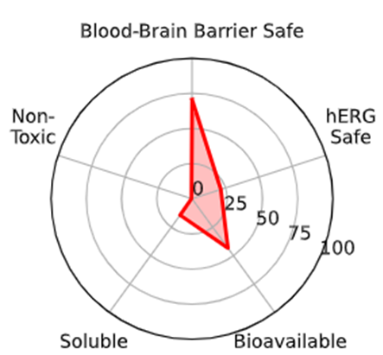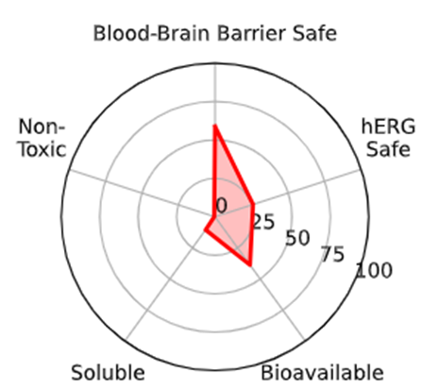
R10 - PS80 R11 - PS80 R12- PS80

